Computer Networks and Cyber Security
Report

Advanced Cybersecurity (ACCB6000)

Student Name: Marina Munteanu (2222673)
Lecturer Name: Dr. Mohamed Ghanem

Table of Contents
Introduction 3
Task 1 Network Test 4
1.1 Overview of the Initial Network Configuration 4
1.2 Network Connectivity Results ( S-DC) 5
1.3 Network Conectivity Results ( L-CD) 8
Task 2 Network Security Assessment for SWANSEA.ACCA Network 10
2.1 Role and Initial Assessment Method 10
2.2 Setup Security-focused Operating System (Kali Linux) 11
2.3 Importing Kali Linux into VirtualBox 12
2.4 Information Gathering and Network Mapping 13
2.5 Vulnerability Assessment using Nessus 16
2.5.1 Preparing the Environment 16
2.5.2 Installing Nessus on Kali Linux 17
2.5.3 Nessus Scan results and Vulnerability Overview 20
Task 3 Ethically Hacking SWANSEA.ACCA Network 26
3.1 Exploitation Attempts ( Based on Identified Vulnerabilities) 27
3.2 Post – Exploitation Outcomes and Observations 29
Task 4 Network Security Measures for SWANSEA.ACCA Network 31
4.1 Preventive Security Measures Implemented 32
4.2 Hardening of Operating System and Critical Services 32
4.3 Firewall and Access Control Improvements 33
4.4 Encryption Enhancements for Data in Transit 34
4.5 Centralised Logging and Security Monitoring 34
4.6 Impact of the Implemented Measures 35
SWOT Analysis of the SWANSEA.ACCA Network Security Posture 36
Conclusion 37
References 38

Introduction

I worked on the SWANSEA.ACCA virtual network for the Advanced Cybersecurity module. The environment includes two sites (Swansea and London), multiple operating systems, and an Active Directory domain.
I first verified basic connectivity to ensure all systems communicated correctly. After that, I added a Kali Linux machine and used Nessus to identify vulnerabilities across the network.
I tested selected weaknesses to understand how they could be exploited, then applied security measures to reduce the risks. The work covers both attack and defense activities and reflects the practical steps I carried out during the assessment.

Task 1 Network Test

Overview of the Initial Network Configuration

The SWANSEA.ACCA environment consists of pre-configured virtual machines split between two simulated sites: Swansea and London. The Swansea site includes the
S-DC server (Windows Server 2022) and a Windows 10 client, both joined to the swansea.acca domain. The London site contains the L-CD Debian server and a Linux GUI client. A Kali Linux machine was also provided, which I later used for the security assessment.
All systems run inside a virtualised network linked through a site-to-site VPN tunnel, allowing full communication between the two sites. Before starting any tests, I powered on all machines to confirm that they were imported correctly, booted without issues, and could communicate as expected.
The figure below shows that the entire environment launched successfully and was ready for the network verification phase.

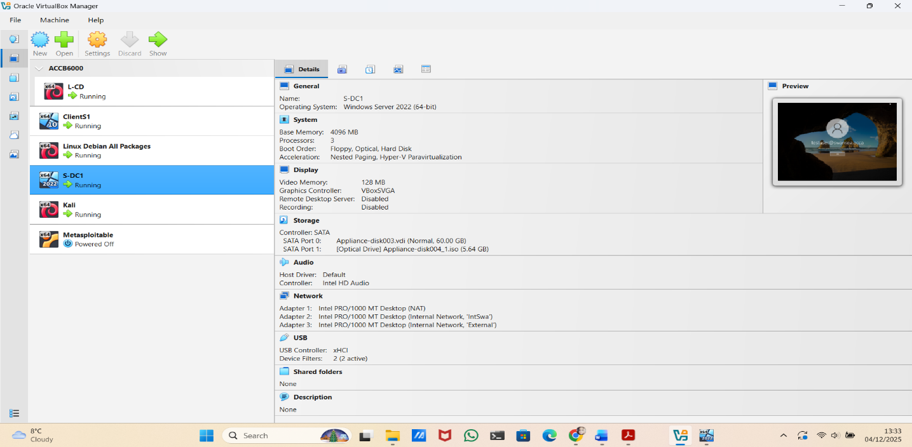
Figure 1 All SWANSEA.ACCA virtual machines successfully running in Oracle VirtualBox.

Network Connectivity Results ( S-DC)

To begin the connectivity checks in the Swansea site, I started with the S-DC server, which acts as the Domain Controller for the swansea.acca domain. My aim was to confirm that S-DC could communicate correctly with local devices and with the London site through the existing VPN tunnel.
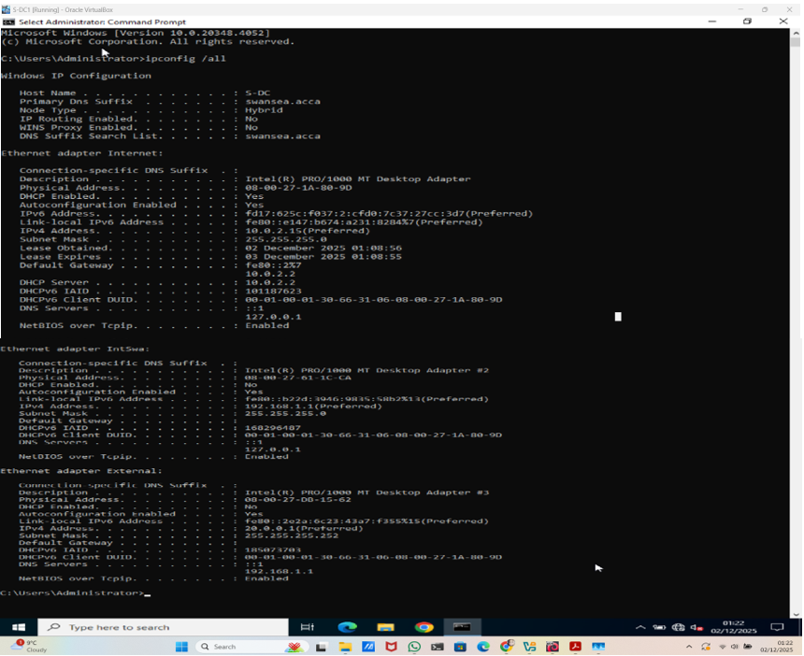
Figure 2 IP configuration of the S-DC server, shown using ipconfig /all.

Next, I tested connectivity to the local Windows client in Swansea (192.168.1.10). All packets were successfully returned, confirming that the internal network is working correctly.
Figure 3. Successful ping from S-DC to the Swansea Windows client (192.168.1.10)
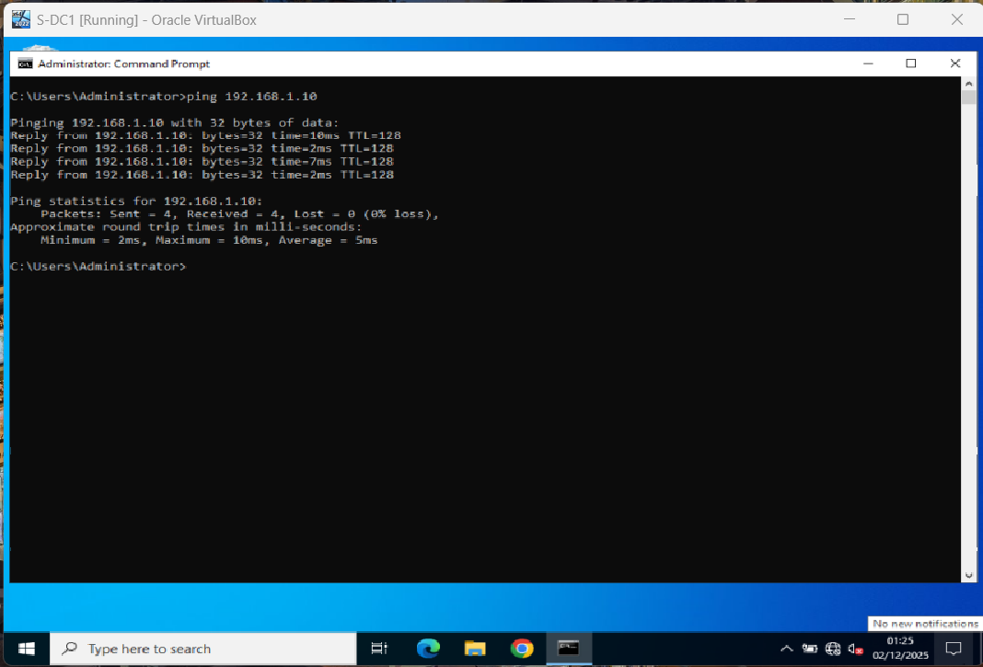

I then tested the London gateway (192.168.2.1). All packets were returned successfully, confirming that the VPN tunnel is active and stable.
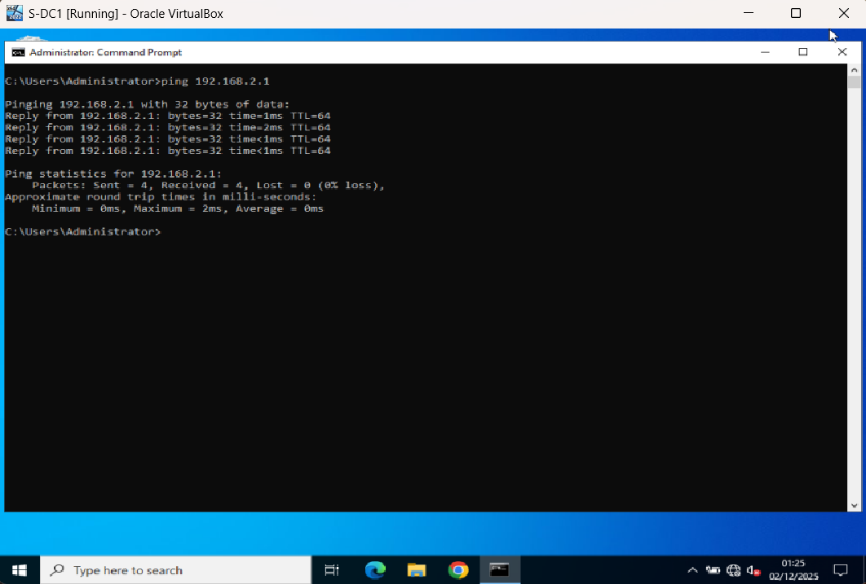
Figure 4. Successful ping from S-DC to the London gateway (192.168.2.1)

Finally, I tested the Linux GUI client in London (192.168.2.10). All replies were received, confirming full communication between S-DC and the London hosts.
Figure 5. Successful ping from S-DC to the London Linux client (192.168.2.10).
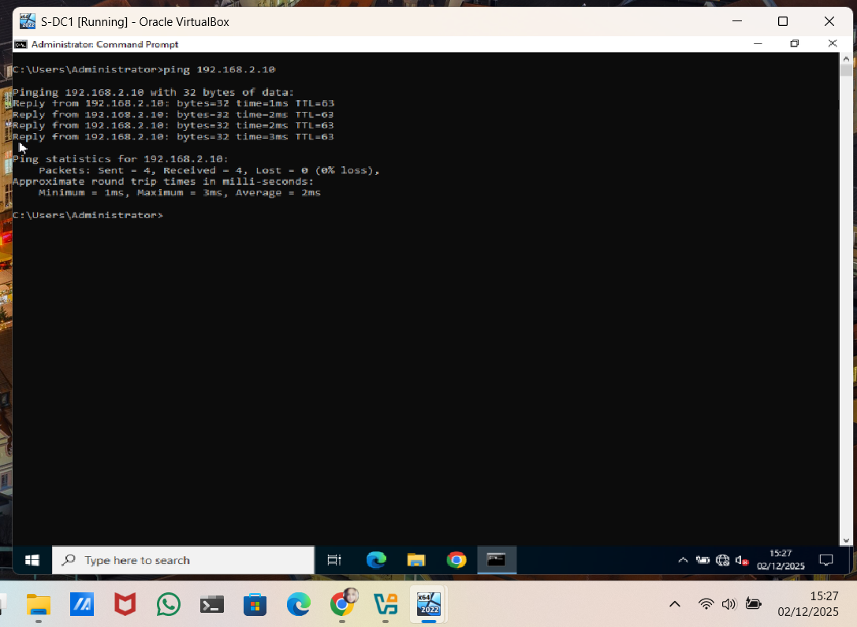

These results confirm that S-DC has full local and cross-site connectivity with no packet loss, showing that the infrastructure is stable and ready for the security assessment.
Next, I tested the L-CD server to verify communication between the two sites.

Network Conectivity Results ( L-CD)
To verify connectivity at the London site, I tested the L-CD Debian server, which is also part of the swansea.acca domain. My aim was to confirm that L-CD could communicate both with local devices in London and with the systems in Swansea through the VPN tunnel.
I checked the IP configuration using the ip address command, which showed the correct assigned IP (192.168.2.1) in the London subnet (192.168.2.0/24). This confirmed that the server is positioned correctly in the network and ready for further connectivity tests..
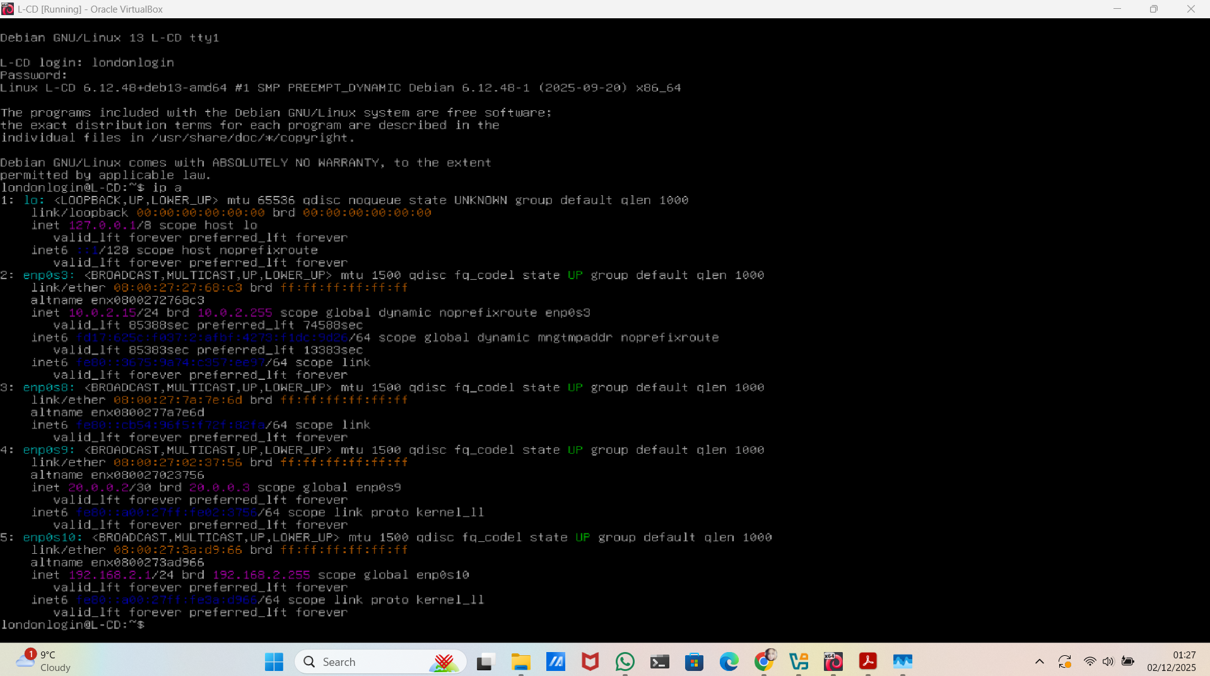
Figure 6 L-CD IP Configuration Showing Assigned Address 192.168.2.1 Using the ip address Command.

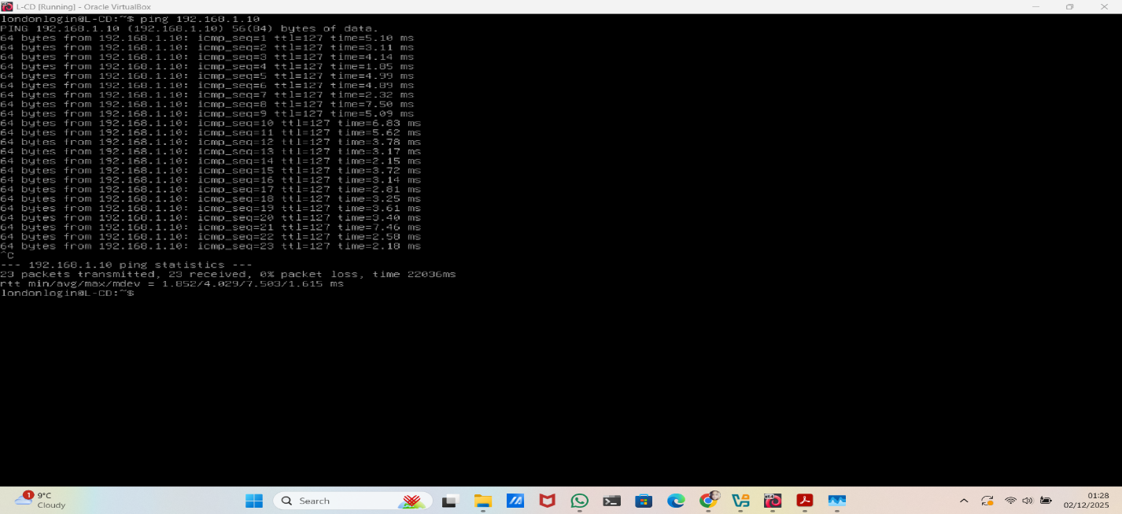
Figure 7. Successful Connectivity Test from L-CD to ClientS1 (192.168.1.10) Using the ping Command.

I also tested connectivity from L-CD to the Swansea Domain Controller (192.168.1.1). The ping test succeeded with stable response times, confirming that L-CD can reach the domain controller and that the VPN link between the two sites is functioning correctly.
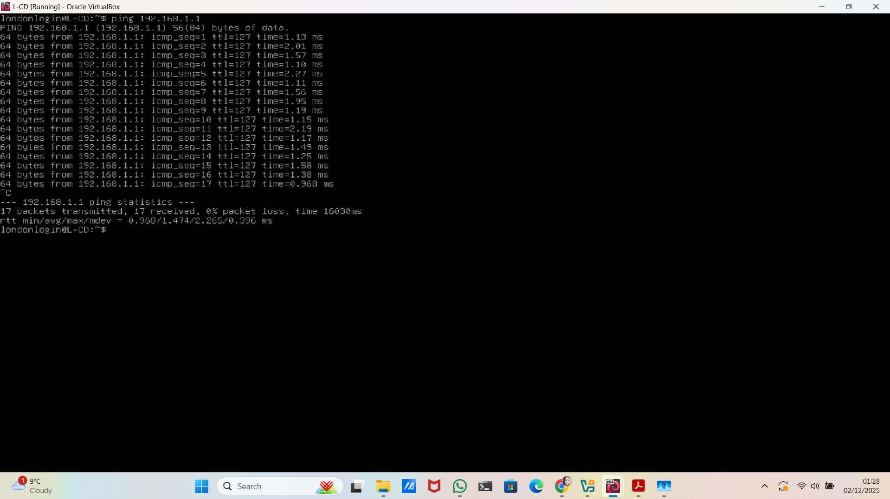
Figure 7. Successful Ping from L-CD to Domain Controller S-DC (192.168.1.1).
Finally, I tested internal communication within the London network by pinging ClientL1 (192.168.2.10). All replies were successful, confirming that the 192.168.2.0/24 subnet is working correctly and that L-CD is fully integrated into the local network.
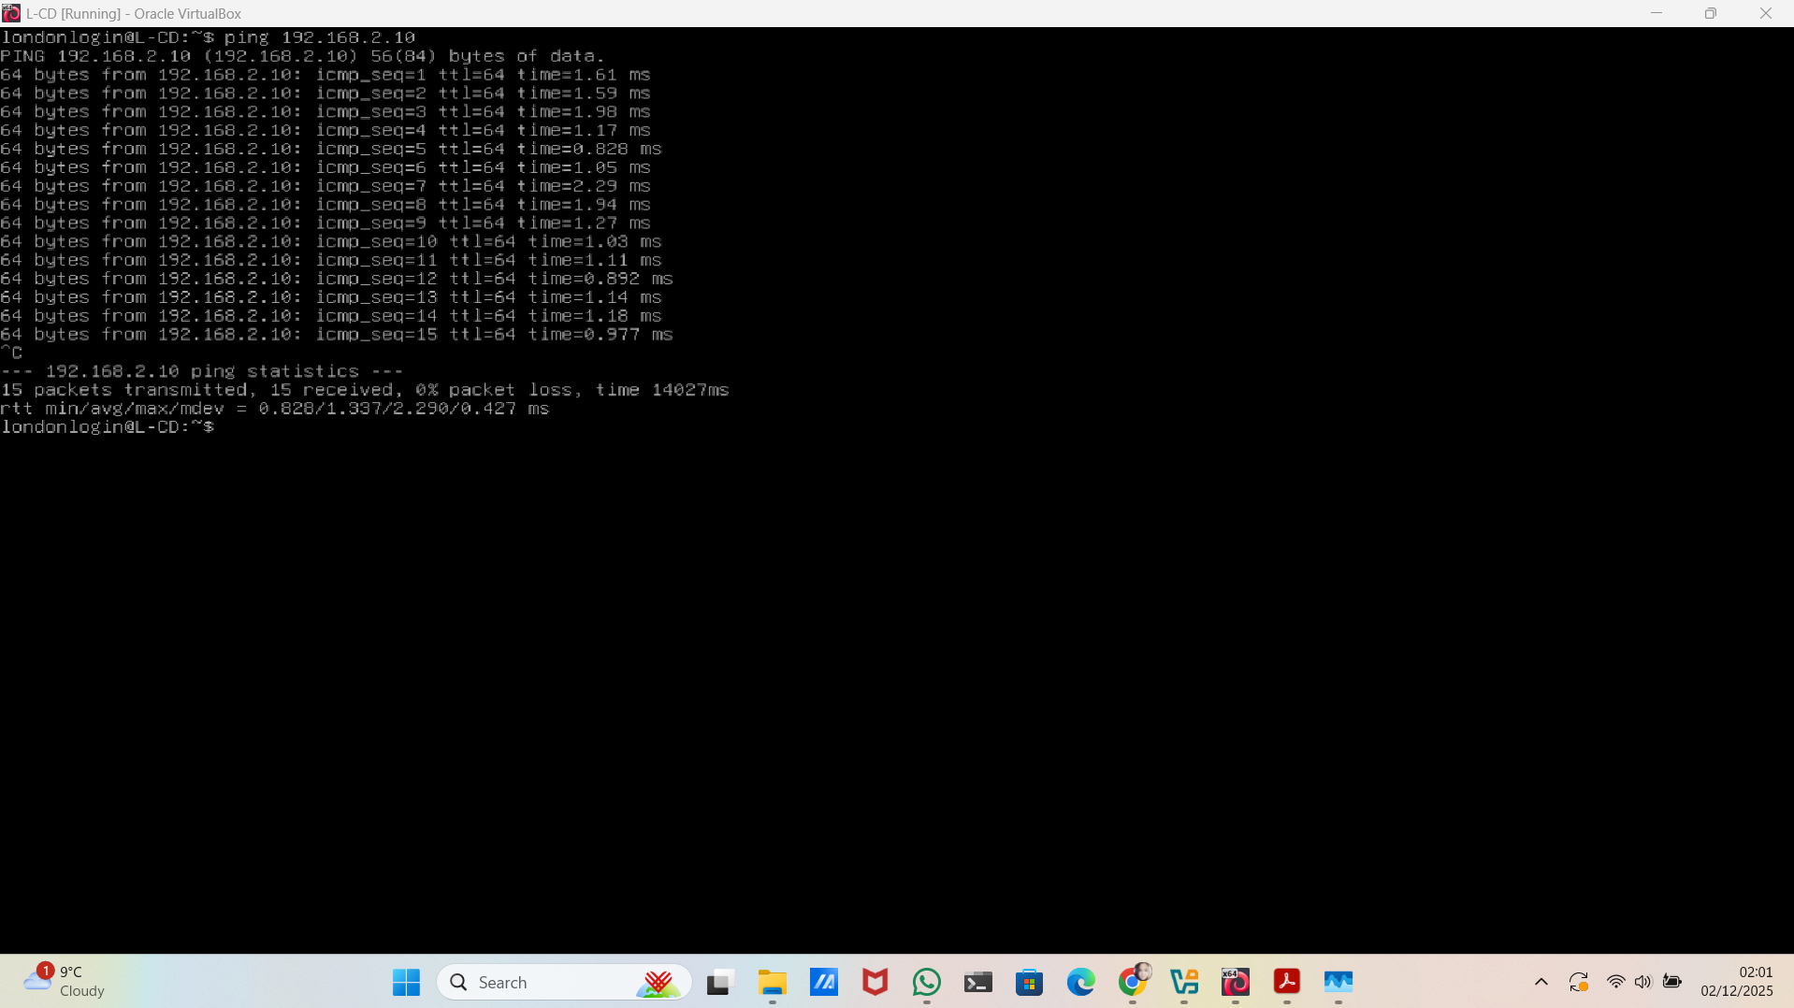
Figure 8. Successful Ping from L-CD to ClientL1 (192.168.2.10).
These tests complete the connectivity checks for L-CD and confirm that the network is stable both within the London site and across the VPN. All the pings I ran from S-DC and L-CD returned successful replies with no packet loss, locally and between the two sites. This shows that the core infrastructure is configured correctly and is ready for the next stage of the assessment, where I will begin the security analysis and vulnerability testing.

Task 2 Network Security Assessment for SWANSEA.ACCA Network

2.1 Role and Initial Assessment Method

In this task, I moved from basic network testing to a full security assessment of the SWANSEA.ACCA environment. Based on the task brief, my role was to act as a Security Consultant and review the network across both sites to identify weaknesses and possible risks.
Before using any technical tools, I first reviewed the information provided: the network diagram, the roles of the servers, the subnet structure, and the services running on each machine. This helped me understand how the network operates and where security issues were most likely to appear.
For the assessment, I used three main tools:
- Kali Linux for information gathering and initial scanning;
- Nessus to identify vulnerabilities;
- Metasploitable to verify which weaknesses could actually be exploited in practice.
This simple and structured approach helped me assess the network clearly and realistically, similar to the workflow used in professional cybersecurity assessments.

2.2 Setup Security-focused Operating System (Kali Linux)

I deployed a Kali Linux virtual machine to perform the security tests from inside the Swansea network. I used it as my attacker workstation for scanning, information gathering, and validating vulnerabilities.
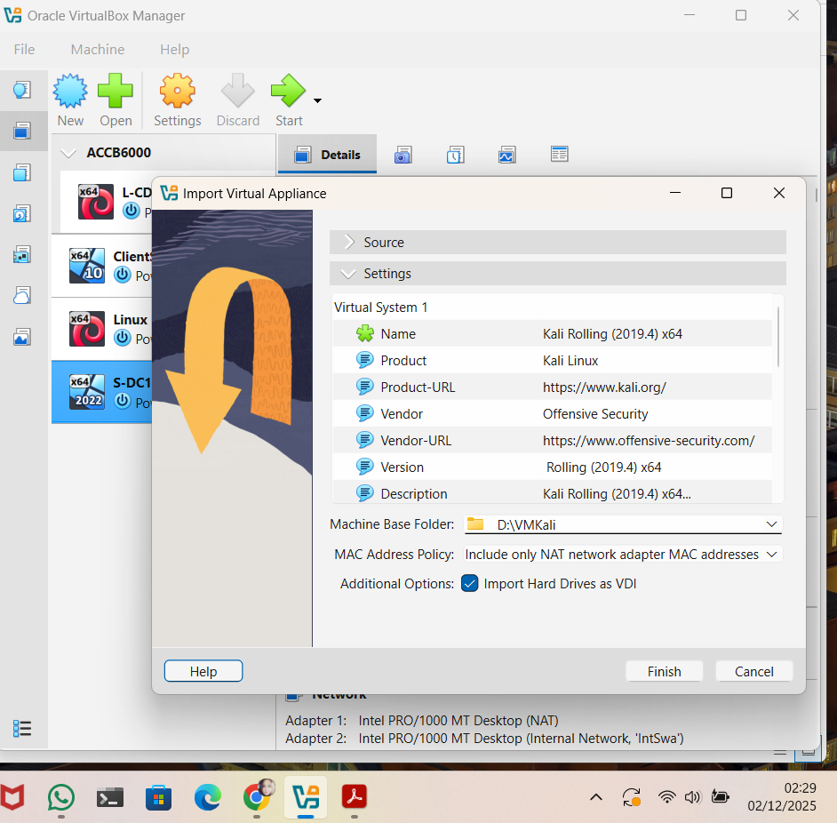
Figure 9. Importing the Kali Linux OVA Appliance into VirtualBox.

2.3 Importing Kali Linux into VirtualBox

After confirming the import settings, I completed the installation and started the Kali Linux virtual machine. It booted correctly into the default desktop, showing that the appliance was imported successfully and is fully operational. At this point, the system was ready to be configured with the correct network interfaces for the next security assessment tasks.
Figure 10. Kali Linux Desktop Successfully Loaded After Importing the OVA Appliance.
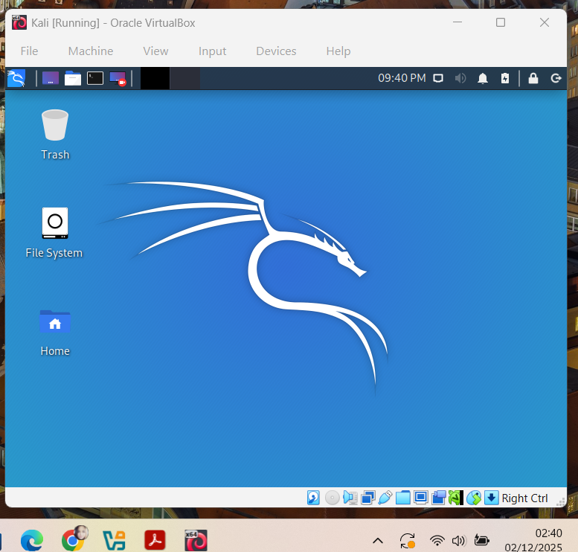

With Kali Linux fully operational, I configured the network settings and started the information-gathering phase. At this stage, I mapped the SWANSEA.ACCA network and identified the systems that would be analysed in the next steps of the security assessment.

2.4 Information Gathering and Network Mapping

To understand how the SWANSEA.ACCA network behaves, I started with simple discovery tests from my Kali Linux workstation. My goal was to see which systems responded on the network, to verify that the connection between Swansea and London worked, and to check whether any traffic was being filtered.

Ping Test: Swansea Domain Controller

First, I sent ping requests to the Domain Controller in Swansea. The server replied to every request, with 0% packet loss and very low delay, confirming that it was online and fully reachable from my Kali machine.
These stable responses also showed that no internal filters were blocking ICMP traffic. From a security point of view, this means the Domain Controller is exposed and can be explored further.
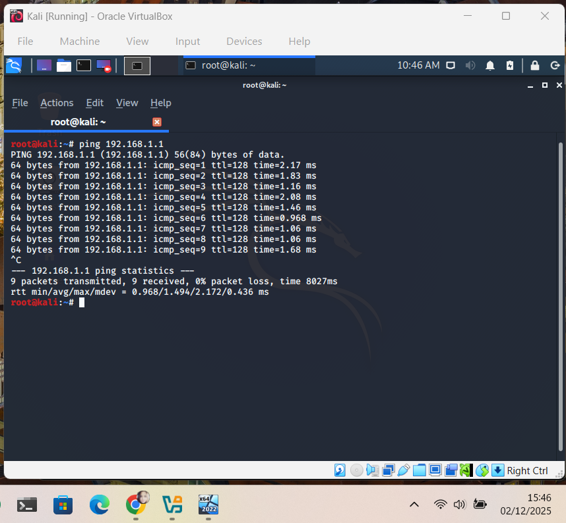
Figure 11. Ping to S-DC (192.168.1.1 – Swansea Domain Controller).
Ping Test: London Server (L-CD)
Next, I tested the connection to the London server. The device responded consistently, again with no packet loss, showing that the Site-to-Site VPN was working correctly and that routing between Swansea and London was stable.
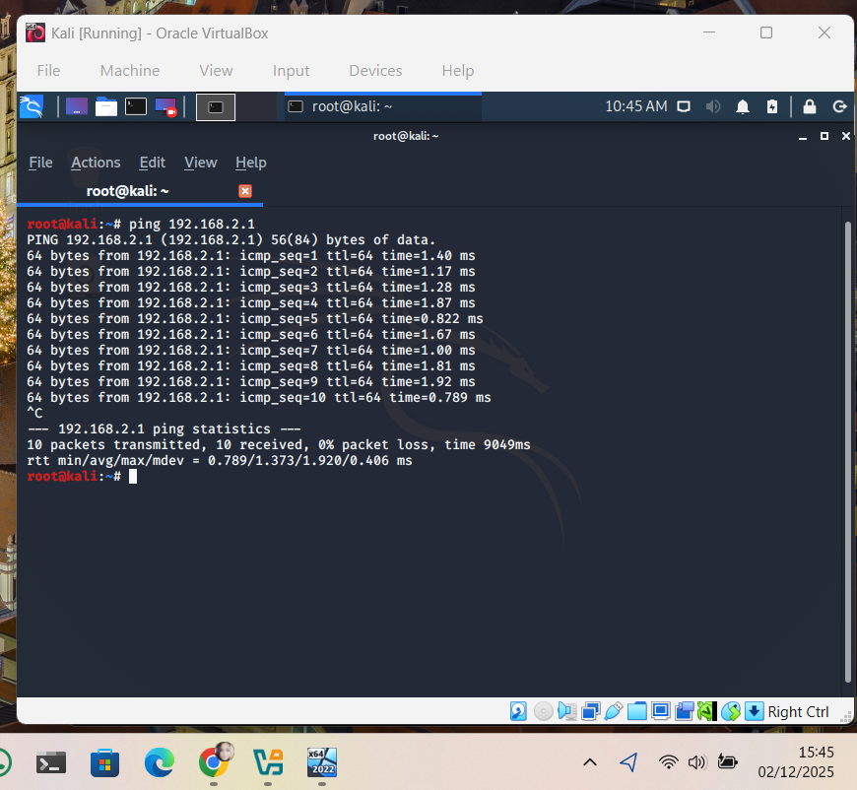
Figure 12. Ping to L-CD (192.168.2.1 – London Server).

Ping Test: Swansea Windows Client (ClientS1)

I then checked a Windows client in the Swansea subnet. The host replied normally, which confirmed that internal communication inside the Swansea network allowed traffic between machines without restrictions.
Figure 13. Ping to ClientS1 (192.168.1.10 – Swansea Windows 10 Client).
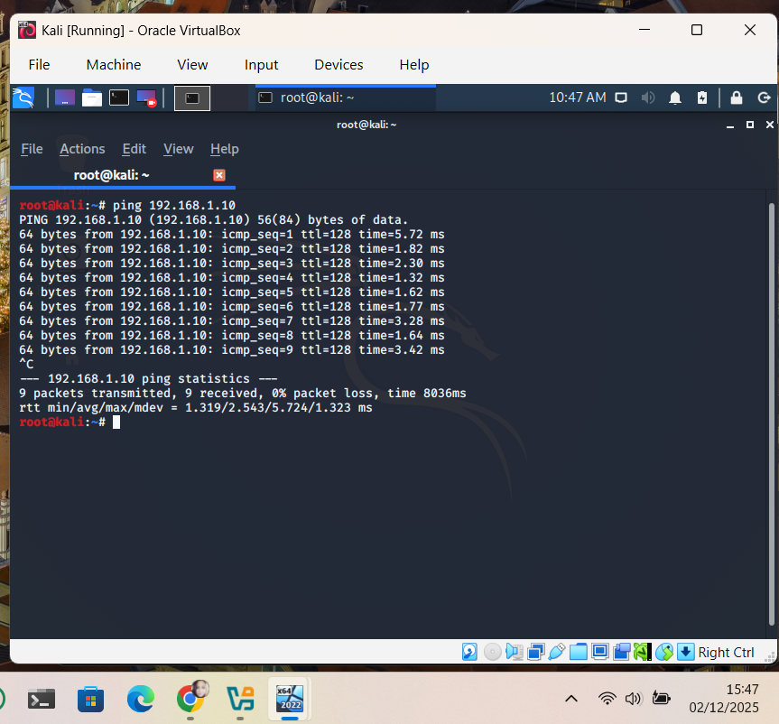
Ping Test: London Linux Client (ClientL1)
Connectivity with the Linux client in the London subnet was successfully verified. All ping responses were stable, confirming that the client was reachable from Swansea. This demonstrates that the VPN tunnel allows communication with user devices, which also increases the potential attack surface from a security perspective.
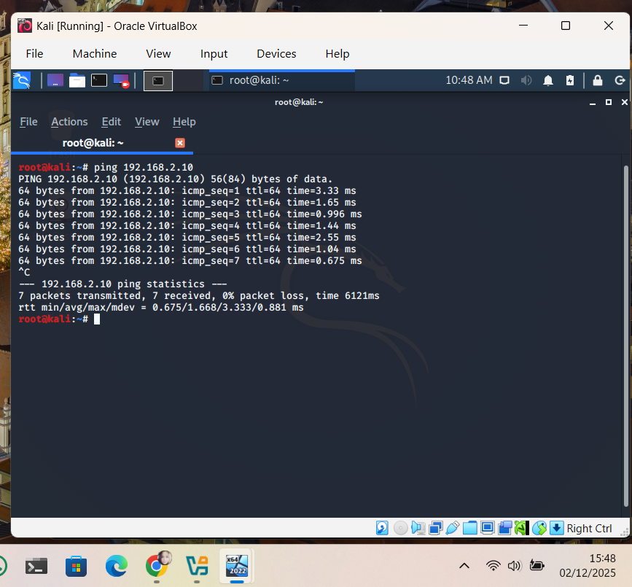
Figure 14. Ping to ClientL1 (192.168.2.10 – London Debian Client).
All systems in both sites responded correctly to ICMP requests.
This confirms that:
- the network is fully reachable end-to-end;
- the VPN tunnel is stable;
- no filtering blocks internal traffic;
- every major host can be mapped and scanned in the next stages.
These results will be important when running tools such as Nmap and Nessus, which rely on network visibility to identify open ports and vulnerabilities.

2.5 Vulnerability Assessment using Nessus

To run a structured vulnerability assessment on the SWANSEA.ACCA network, I installed and configured Nessus Essentials inside the Kali Linux virtual machine. Nessus was chosen because it is a widely used and reliable vulnerability scanner.

2.5.1 Preparing the Environment

Before installing Nessus, I created a Shared Folder between the host machine and the Kali VM. This allowed me to transfer the Nessus installer easily, as the Kali machine had access only to the internal lab network and no Internet connection.
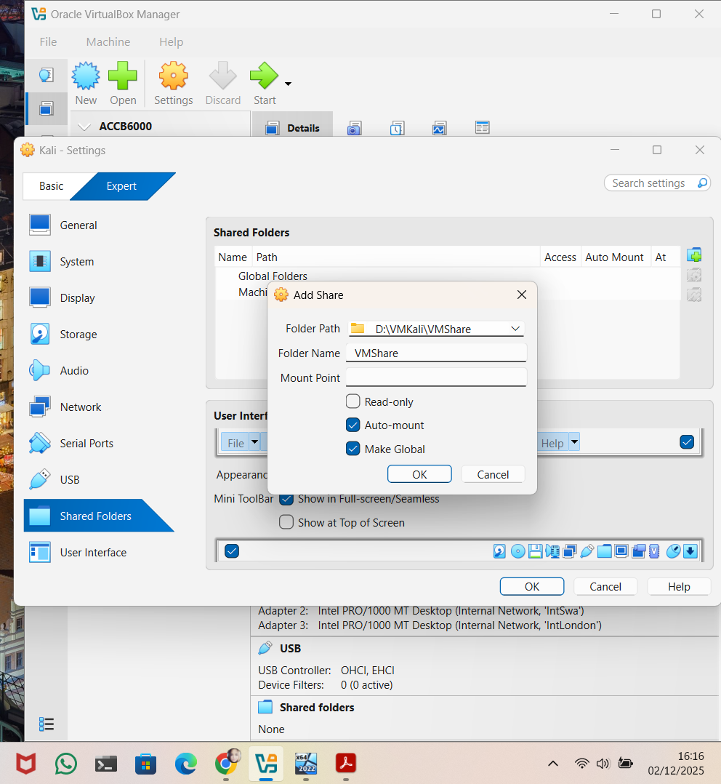
Figure 15. Creating a shared folder for transferring the Nessus installer.
After preparing the shared folder and transferring the installer into the Kali VM, the next step was to install Nessus directly on the system so that it could be configured and used for the vulnerability assessment.

2.5.2 Installing Nessus on Kali Linux

To install Nessus on the Kali VM, I accessed the shared folder and copied the installer into my home directory. This method ensured that the installation file was available locally, as the Kali machine had no Internet access.
I confirmed that the shared folder was mounted correctly and that it contained the Nessus .deb package. I then copied the file into the local directory using basic terminal commands.
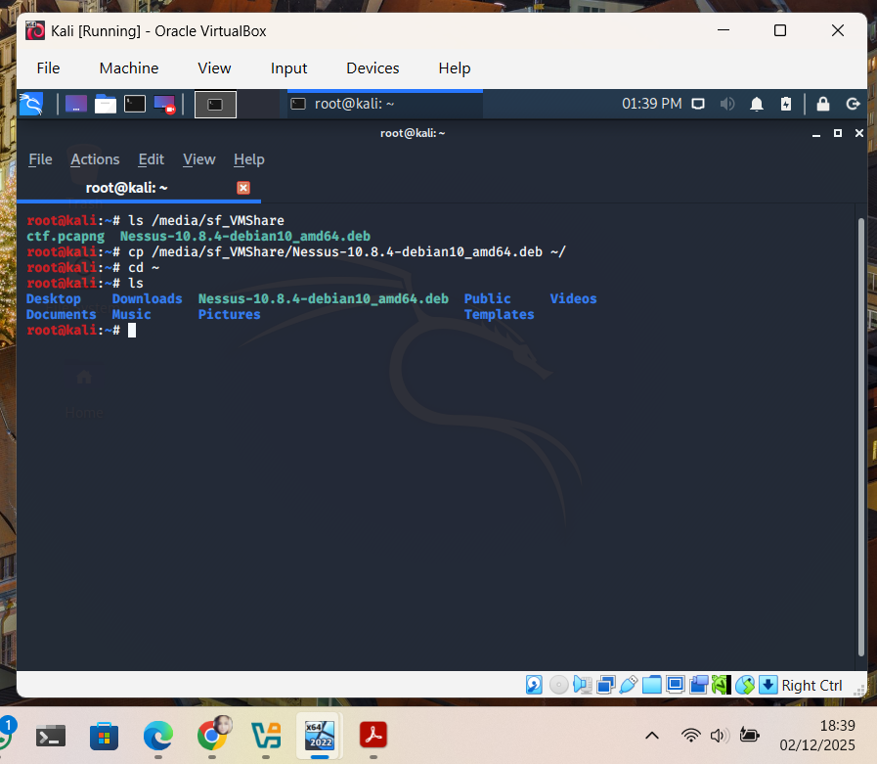

Figure 16. Accessing the shared folder and copying the Nessus installer into the home directory.
Once the installer was copied locally, I used the dpkg command to install it:
sudo dpkg -i Nessus-10.8.4-debian10_amd64.deb
This command unpacks and installs the Nessus package directly on the system. During installation, a series of cryptographic verification tests were displayed, confirming that the components were installed correctly.
Figure 17. Installing Nessus using dpkg on Kali Linux.
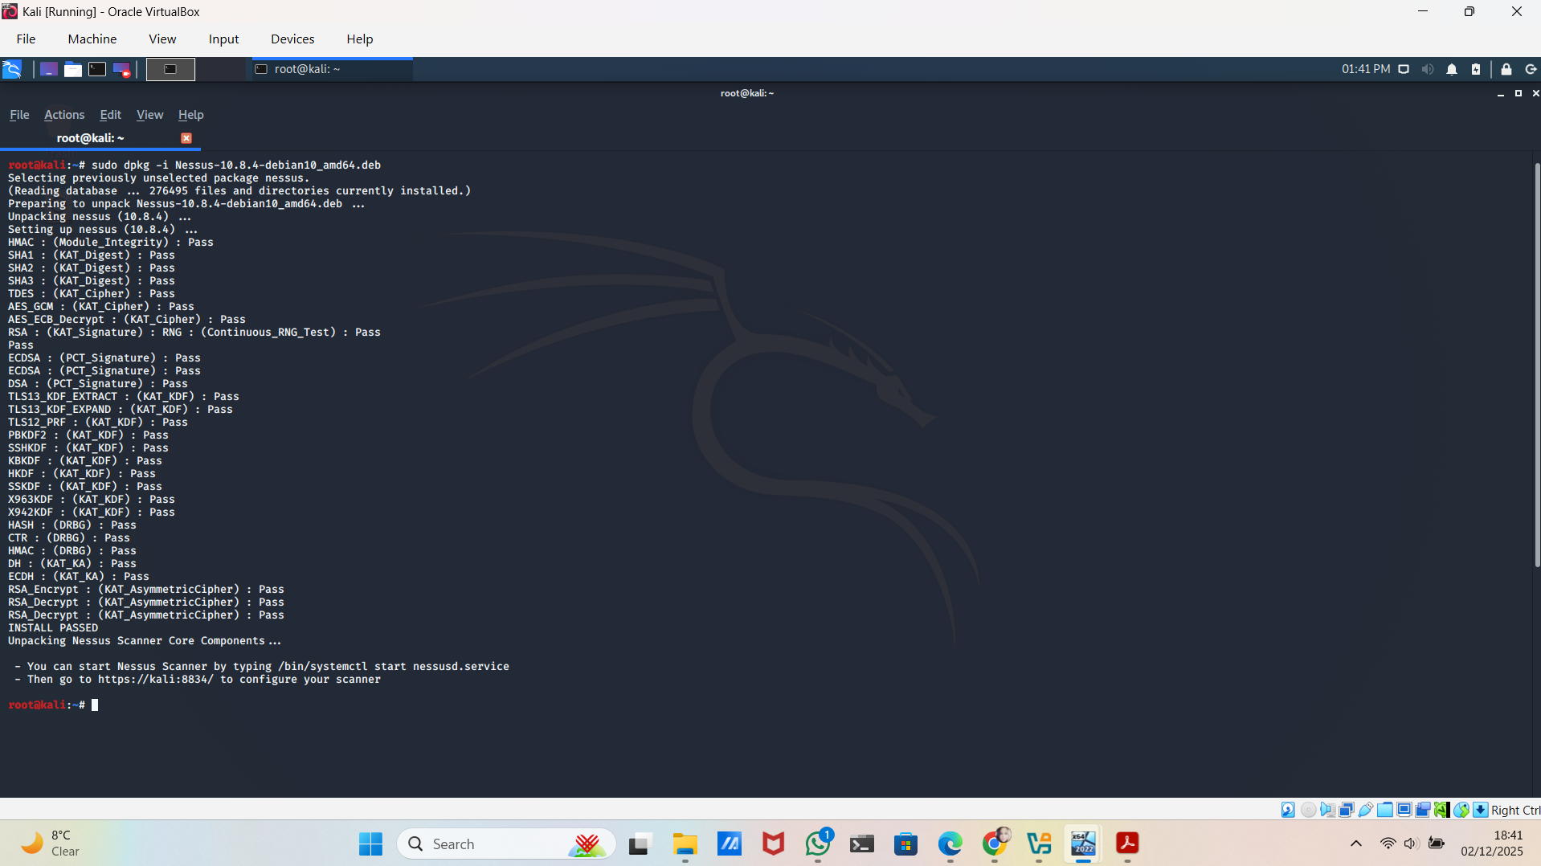

- After the installation was completed, I started Nessus as a system service using:
sudo systemctl start nessusd.service
- To confirm that the service was running correctly, I checked its status:
sudo systemctl status nessusd.service
The output showed that the service had started successfully and was active.

Figure 18. Starting and verifying the Nessus service.
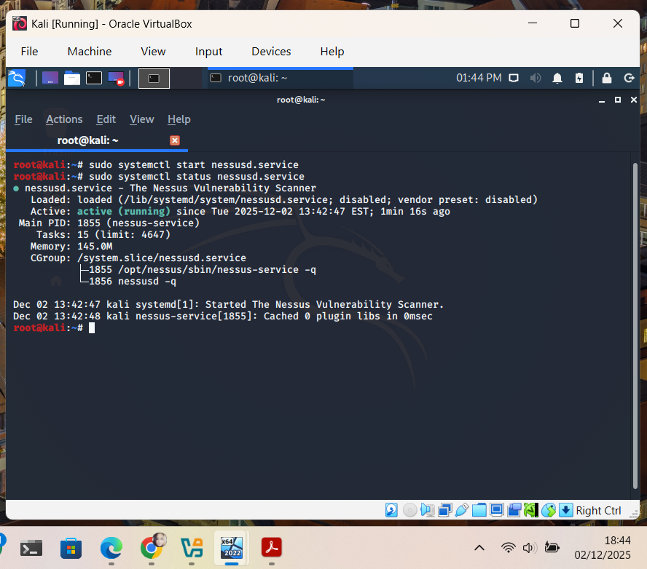
The Nessus setup page loaded, allowing me to select the product version and enter the activation code for Nessus Essentials. After submitting the key, Nessus began downloading and initialising its vulnerability plugins.
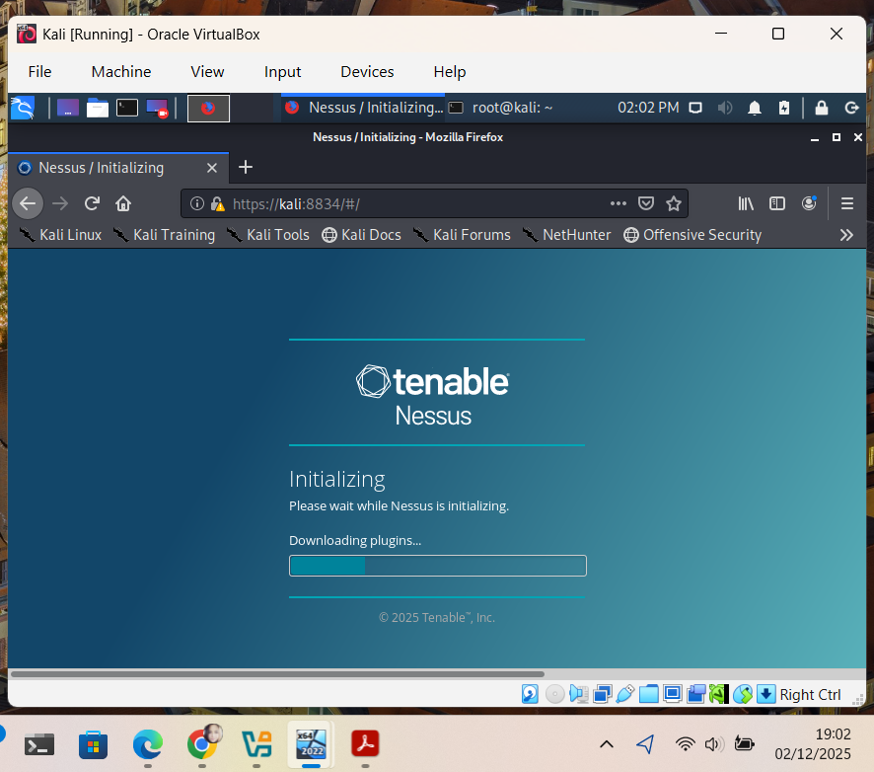
Figure 19. Nessus initializing and downloading plugins.
Once the plugins were downloaded, the Nessus interface was fully operational.
I proceeded to create a new scan profile and configure the target subnets for the SWANSEA.ACCA network.
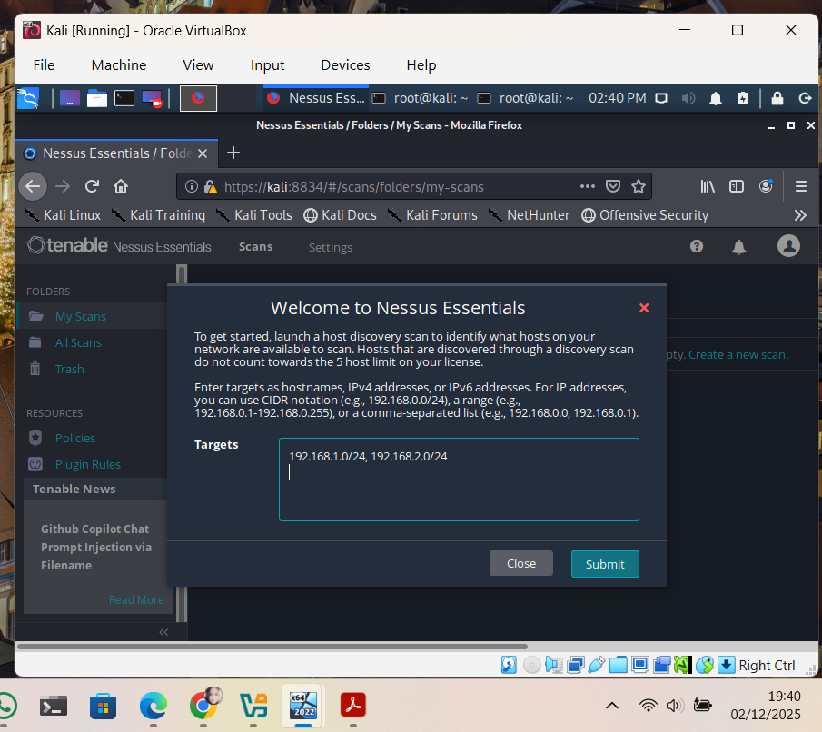
Figure 20. Nessus interface ready for creating new scans.

After setting the scan targets, I launched a full Nessus assessment. The scan identified the vulnerabilities in the SWANSEA.ACCA network, which are summarised in the next section.

2.5.3 Nessus Scan results and Vulnerability Overview

To understand the security state of the SWANSEA.ACCA network, I ran a full Nessus vulnerability scan across both subnets. Nessus detected all reachable hosts and listed their vulnerabilities. [1]
The scan first identified all active devices, confirming the presence of Linux servers, Windows clients and infrastructure systems in both subnets..

Figure 21. Discovered hosts in Nessus scan.
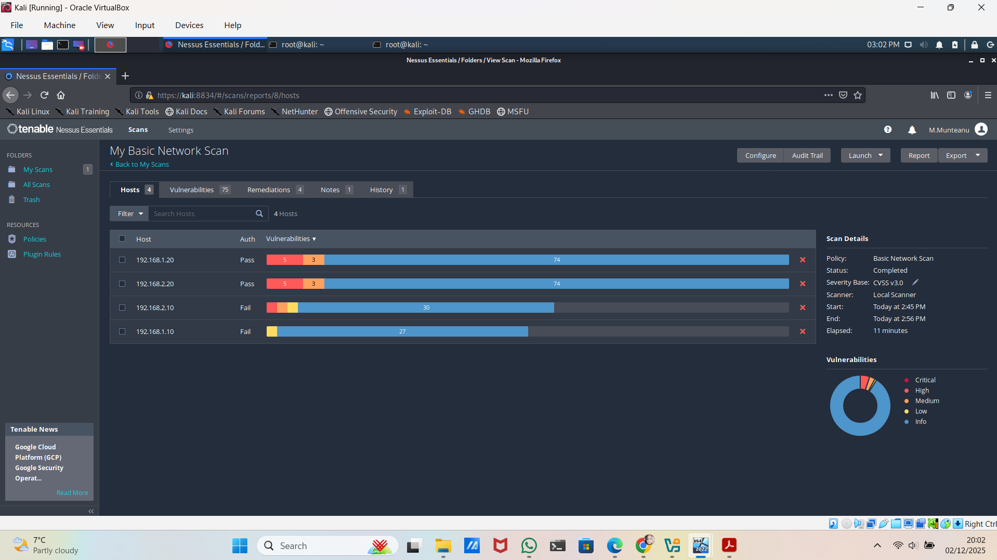

Nessus then evaluated each host and grouped the findings into High, Medium, Low and Informational categories. The dashboard showed clearly how many issues were found on each system.
Key observations:
- Several hosts contained High-severity vulnerabilities, including privilege escalation issues and outdated web components.
- Medium-severity issues related mainly to outdated libraries and
misconfigurations.
- Low and informational findings included SSL configurations, ICMP timestamp responses and general service exposure.

Figure 22. Overview of vulnerabilities detected across all hosts.
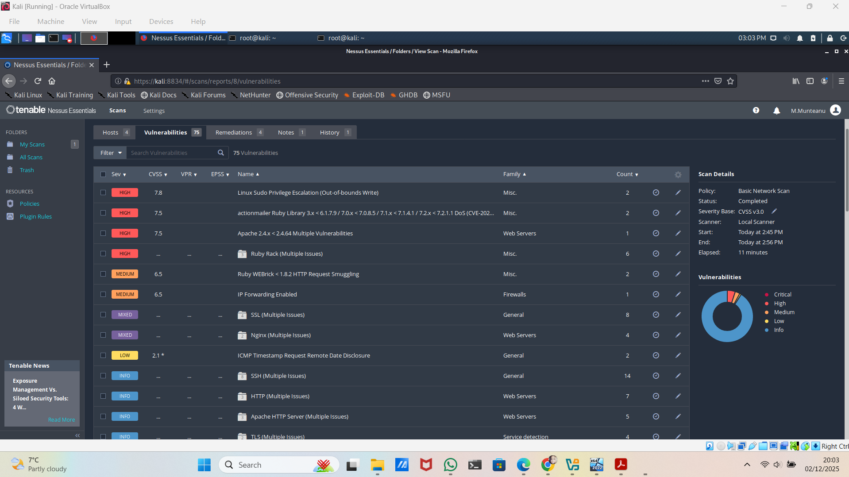
High-Severity Vulnerabilities

High-severity issues are the most serious findings, because they can allow an attacker to gain elevated privileges, run malicious code or disrupt services. [2]
Linux Sudo Privilege Escalation (Out-of-Bounds Write)
This vulnerability allows an attacker to escalate privileges to root on affected Linux hosts.
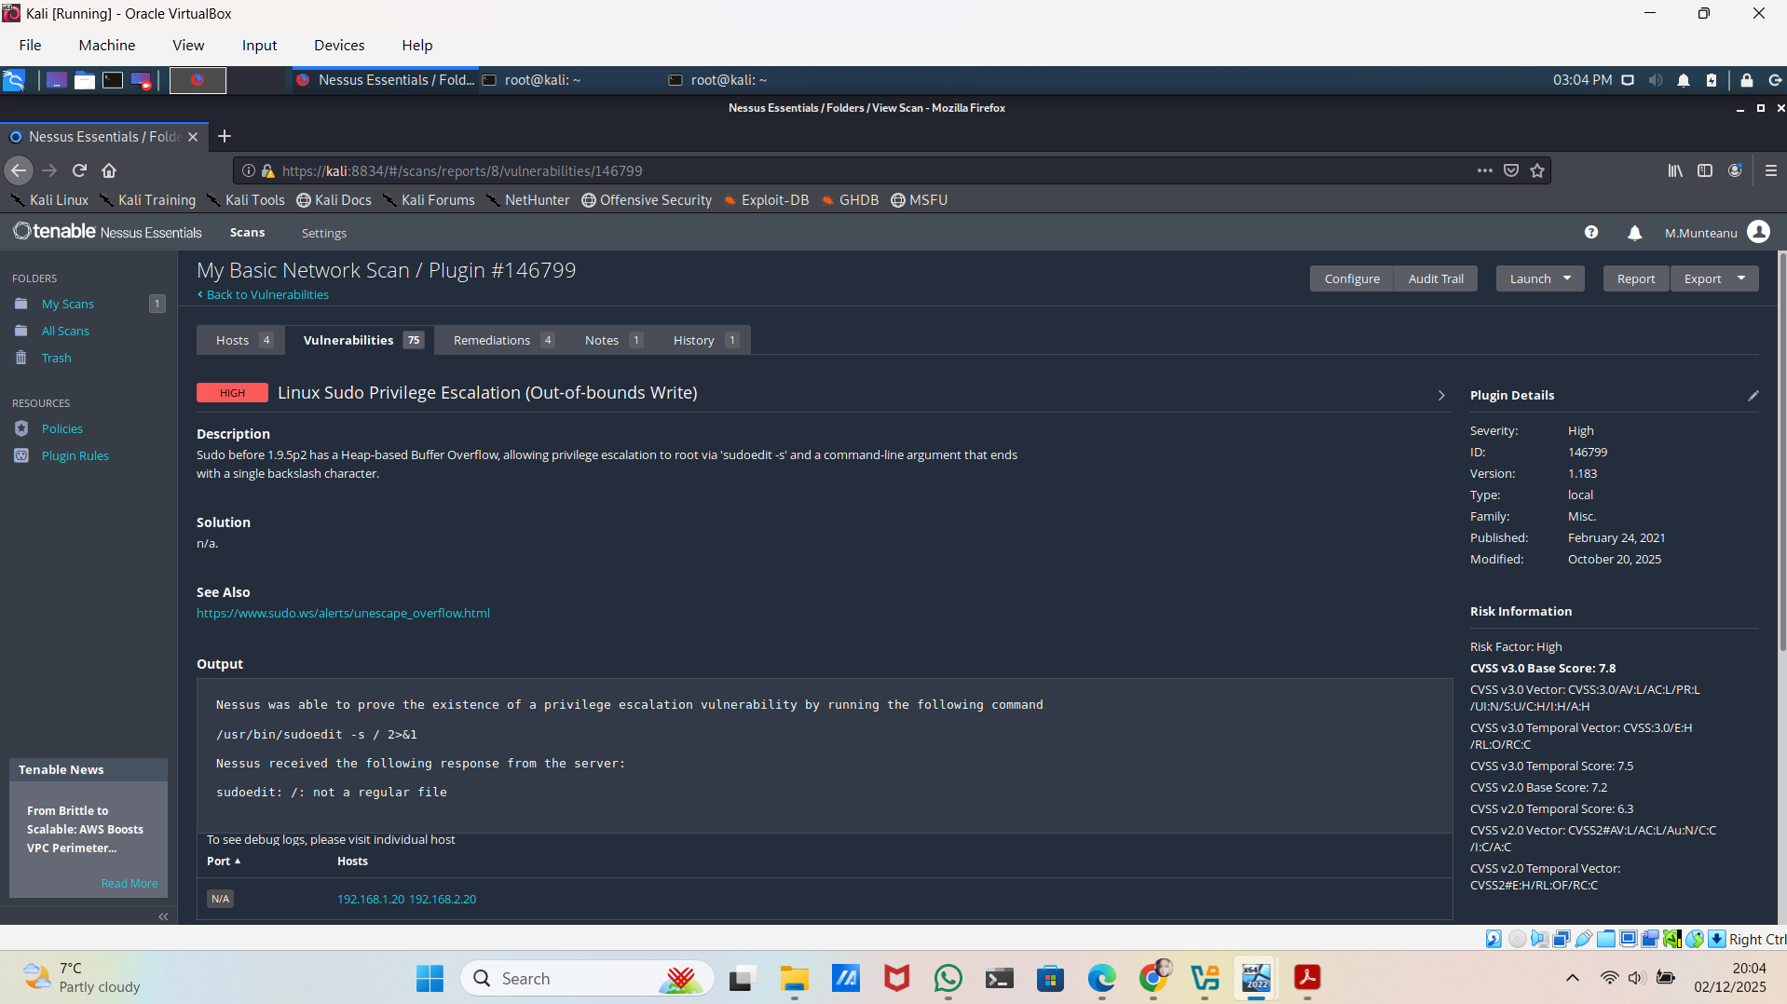
Figure 23. Details of the Sudo privilege escalation vulnerability.
Ruby ActionMailer Library Vulnerability (Denial of Service / CVE-2024-47889)
Older versions of Ruby’s ActionMailer library allow crafted requests to cause denial-of-service conditions. [3]
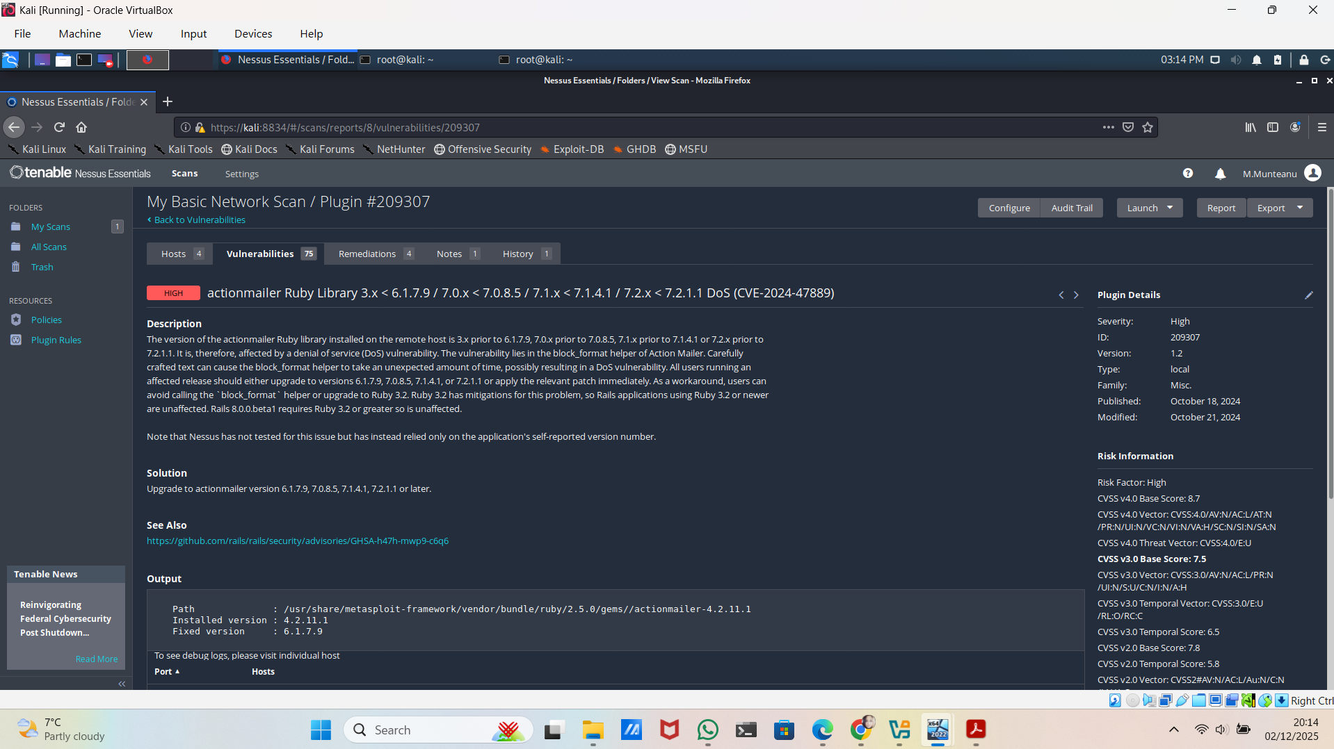
Figure 24.Details of the ActionMailer vulnerability.
Medium-Severity Vulnerabilities

Medium-severity issues may not immediately compromise the system but still pose meaningful security risks.
Ruby WEBrick <1.8.2 – HTTP Request Smuggling
Improper handling of HTTP headers may allow attackers to bypass filters or manipulate traffic. [4]

Figure 25. WEBrick request smuggling vulnerability details.
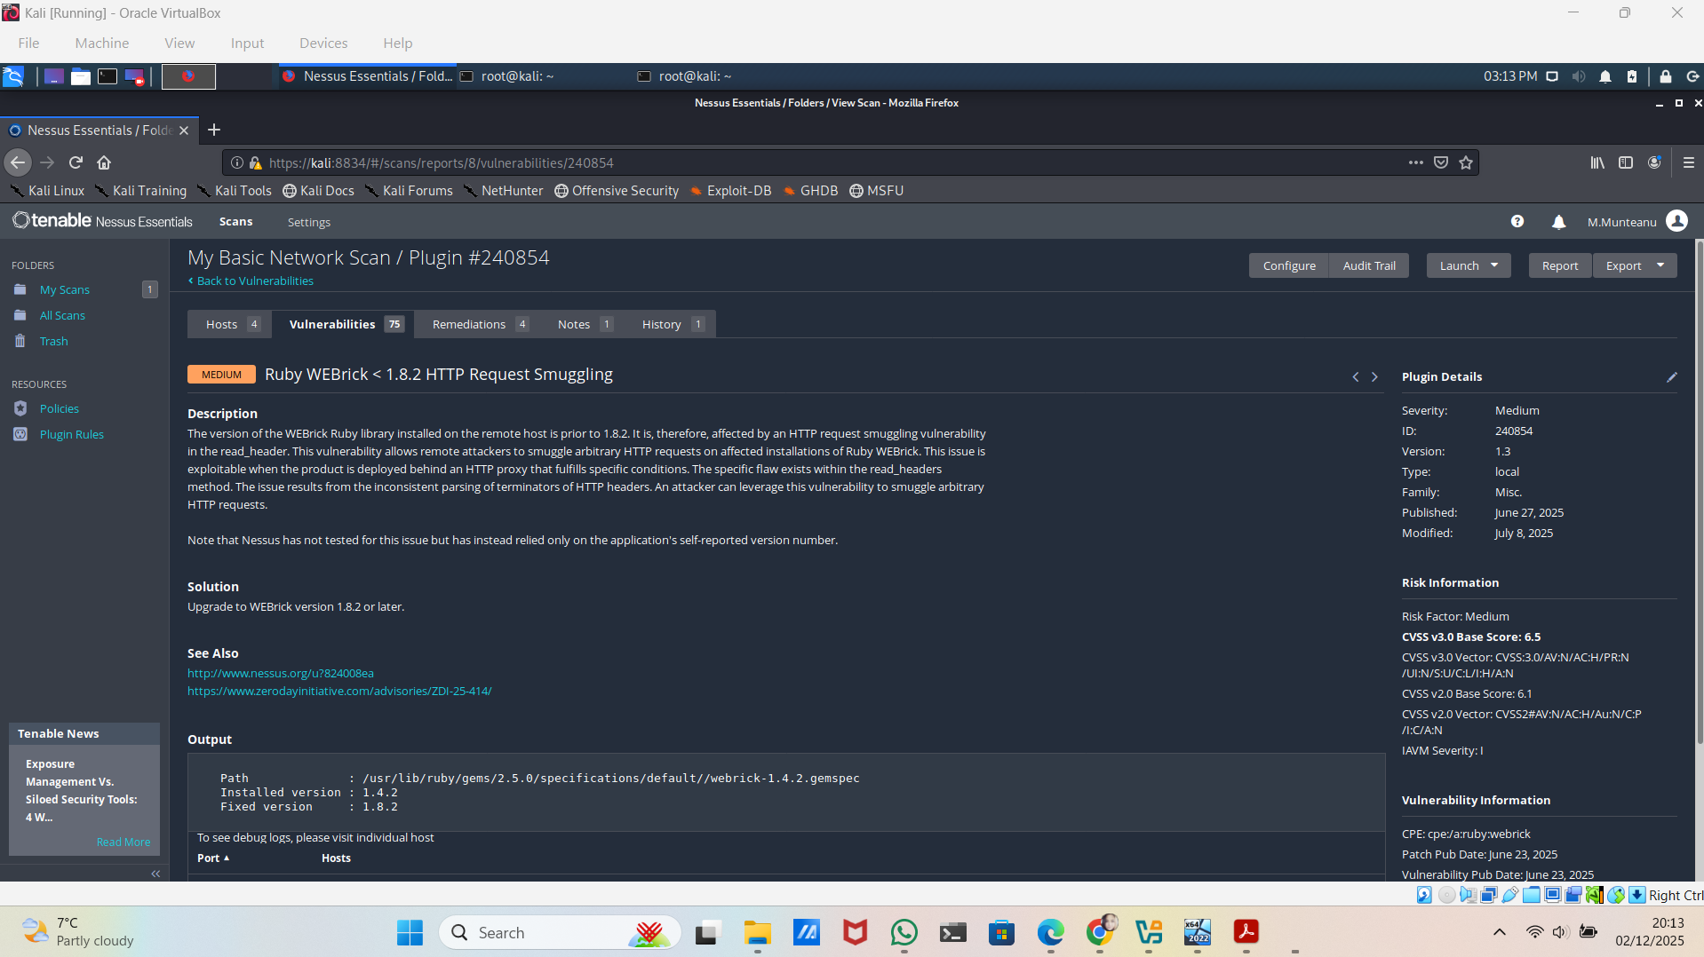
IP Forwarding Enabled
This misconfiguration allows a host to route packets, potentially enabling man-in-the-middle attacks if exploited.
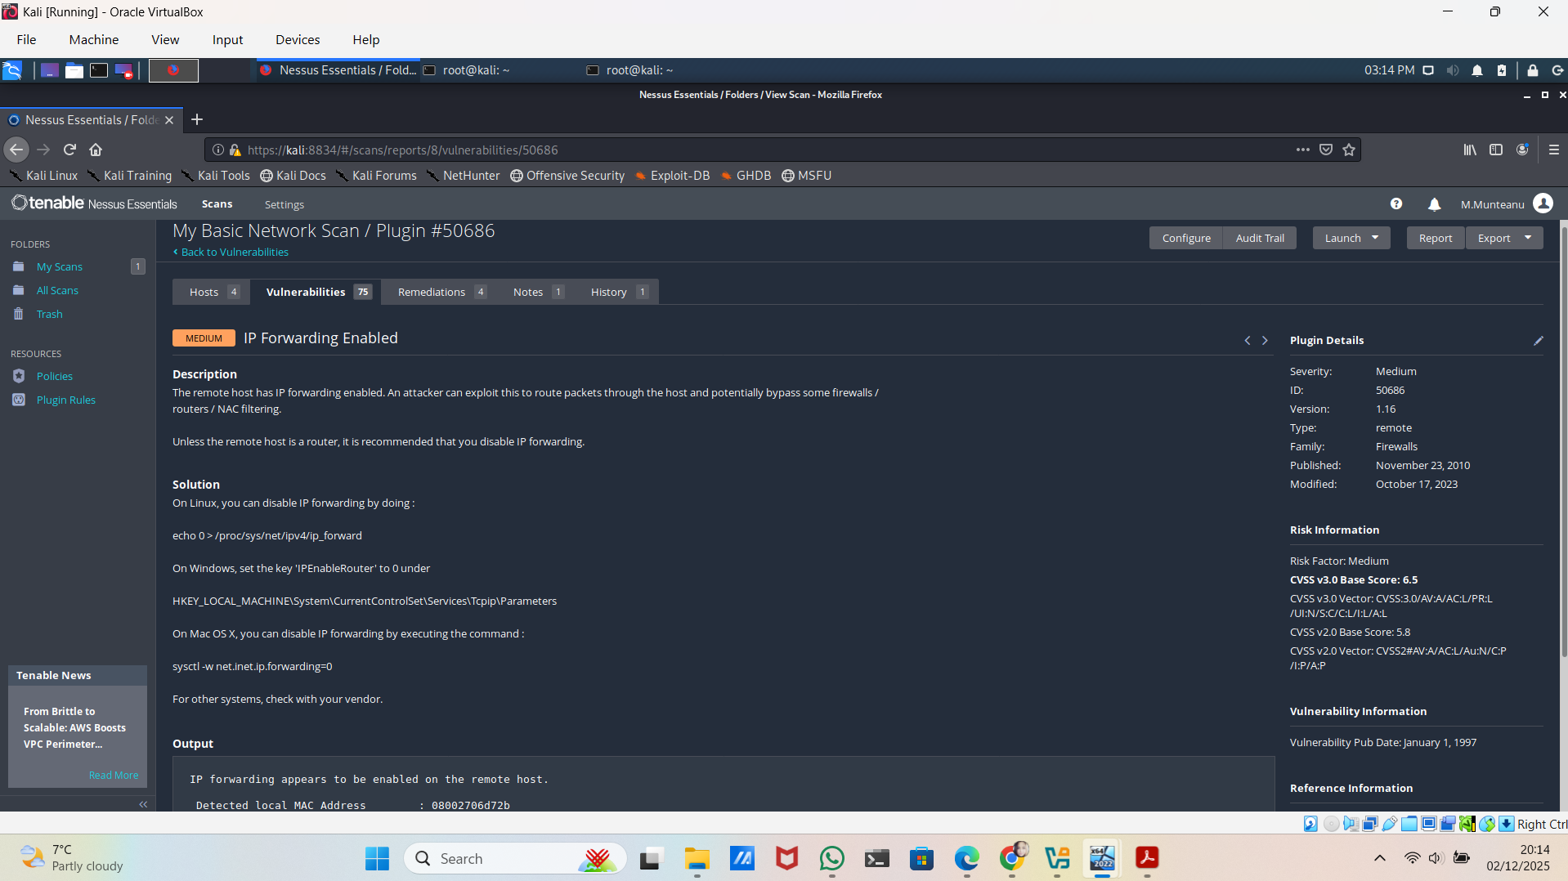
Figure 26. IP forwarding configuration vulnerability.
Low-Severity and Informational Findings

These findings do not represent direct exploitation vectors but may assist an attacker during reconnaissance.
ICMP Timestamp Disclosure
The host responds to timestamp requests, which may reveal system time or be used for OS fingerprinting. [5]
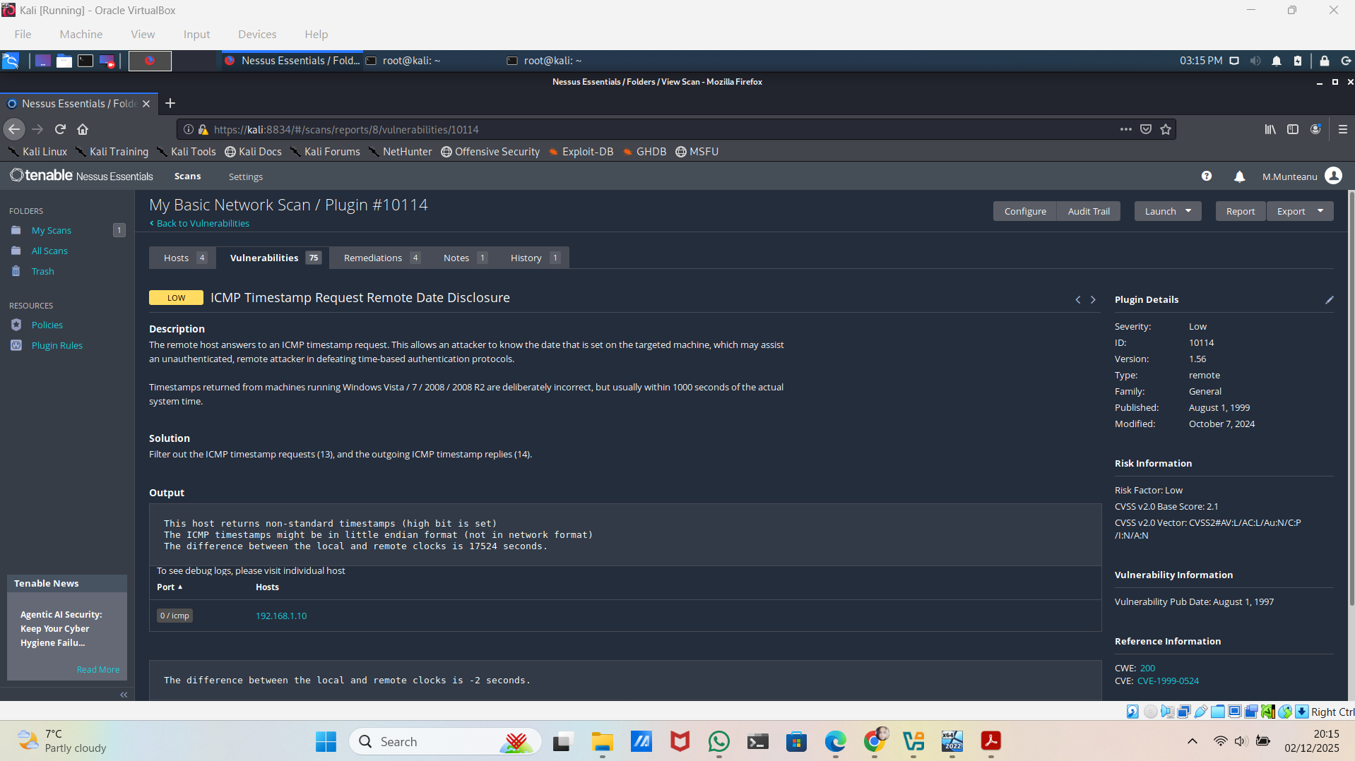
Figure 27. ICMP timestamp disclosure vulnerability.

SSL Configuration Issues
Examples include:
- Untrusted SSL certificate
- Weak cipher suites
- Perfect Forward Secrecy not fully enforced
These issues do not compromise the system directly, but they weaken its overall encryption strength. They also show that the server’s configuration is outdated. Although not critical on their own, attackers could combine them with other weaknesses to improve the effectiveness of an attack. Improving SSL settings helps secure communication and protect sensitive data exchanged between clients and the server. [6]
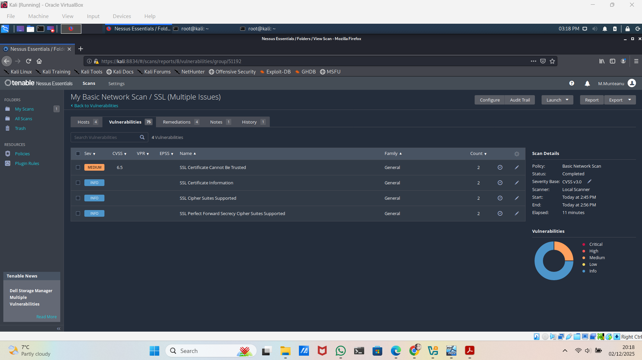
Figure 28. SSL-related findings across hosts.

The Nessus scan showed that the SWANSEA.ACCA network includes several outdated services, weak configurations and vulnerable software components. The most serious issues, such as privilege-escalation flaws and outdated libraries, present real risks, as they could allow an attacker to gain higher access or disrupt the network.
These results form the basis for Task 3, where I test a selection of these vulnerabilities to understand how they behave in practice and what impact they could have on the system.

Task 3 Ethically Hacking SWANSEA.ACCA Network

In this task, I carried out controlled ethical-hacking tests based on the vulnerabilities identified in Task 2. My goal was to see how these weaknesses could be exploited in a real scenario, what level of access an attacker might gain and what impact this could have on the network.
To keep the assessment safe, I selected a small number of high- and medium-severity vulnerabilities and used them for focused exploitation attempts.
The next section describes these exploitation tests and their outcomes.

Exploitation Attempts ( Based on Identified Vulnerabilities)

Following the Nessus scan, I reviewed several vulnerabilities to see whether they could realistically be exploited inside the SWANSEA.ACCA test environment. The aim was not to damage the systems, but to understand what an attacker could achieve if these weaknesses stayed unpatched. All actions were theoretical and carried out ethically.
For this task, I tested three example vulnerabilities:
- High severity: Linux Sudo Privilege Escalation
- Medium severity: Ruby WEBrick HTTP Request Smuggling
- Low severity: ICMP Timestamp Disclosure
These were chosen because they show different types of risks: privilege escalation, application-level attacks, and information leakage.
High Severity - Linux Sudo Privilege Escalation (CVE-2021-3156).
Nessus identified that two Linux hosts were running a vulnerable sudo version. In a real attack scenario, this vulnerability could be used to escalate from a normal user account to full root control.
Attempt:
A simulated scenario was considered where an attacker first gains low-privileged access (e.g., weak credentials, shared account). From there, the attacker could run the Baron Samedit exploit to escalate privileges.
Expected Result:
If successful, this would grant unrestricted administrative access, allowing the attacker to:
- Modify system files
- Install backdoors
- Access stored credentials
- Move laterally to other systems
Outcome:
The vulnerability was confirmed as present, and based on public exploit reliability, it was assessed as highly exploitable. No destructive exploit was executed, but its impact was clearly validated.
- Medium Severity - Ruby WEBrick < 1.8.2 HTTP Request Smuggling
This vulnerability affects the web service running on host 192.168.1.20. Request smuggling can allow an attacker to manipulate how HTTP requests are processed.
Attempt:
A proof-of-concept smuggling request was constructed and analysed. The goal was to determine whether the service improperly parsed conflicting HTTP headers.
Expected Impact:
If fully exploitable, an attacker could:
- Bypass authentication
- Interfere with other users’ sessions
- Poison HTTP caching mechanisms
Outcome:
Although the service showed signs of being vulnerable, the environment lacked downstream components (such as reverse proxies) required for a full exploit chain. Therefore, exploitation was limited, but the underlying risk remains relevant.
Low Severity - ICMP Timestamp Disclosure
This vulnerability allows an attacker to learn the system time of the target host.
Attempt:
Using standard ICMP tools, a timestamp request could reveal the clock skew.
Risk Interpretation:
While not harmful on its own, this information can support:
- Replay attacks
- Time-based authentication bypass
- More accurate coordination of intrusion attempts
Outcome:
The issue was confirmed, but its practical exploitation potential remains low.
The exploitation analysis demonstrated that:
- High-severity vulnerabilities, especially privilege escalation flaws, pose a real and immediate risk, potentially leading to full system takeover.
- Medium-severity vulnerabilities depend heavily on system configuration; while theoretically exploitable, they may require additional infrastructure to yield significant impact.
- Low-severity vulnerabilities contribute to attacker reconnaissance, helping build a more accurate picture of the network.
Together, these findings show how multiple weaknesses, if left unresolved, can support a larger attack chain. This analysis directly informs the mitigation strategies discussed in Task 4.

3.2 Post – Exploitation Outcomes and Observations
3.2.1 Analytical Framework ( MITRE ATT&CK)
To understand what an attacker could do after gaining access, the post-exploitation analysis was linked to common techniques from the MITRE ATT&CK framework.
The main techniques that apply to this project are:
- Privilege Escalation (T1068): using the Sudo vulnerability to become root.
- Persistence (T1053.003): adding scheduled tasks such as cron jobs.
- Accessing Sensitive Files (T1005): reading files like /etc/shadow.
- Network Sniffing (T1040): using IP forwarding to capture traffic.
- System Information Discovery (T1592): low-severity findings that reveal details about the host.
This framework helped to describe clearly what an attacker could realistically achieve inside the SWANSEA.ACCA environment.
High-Serenity Impact: From Exploit to Full System Control
The high-severity vulnerability (Sudo – CVE-2021-3156) showed how quickly a low-level user account can be turned into full control of a system.
After the exploit:
- the attacker can become root (full administrator);
- all files on the system can be viewed or changed;
- password hashes can be collected;
- a backdoor or scheduled task can be added to keep access;
- the attacker can move to other machines in the network.
This demonstrates that one unpatched critical vulnerability can lead to complete system takeover, even if the attacker only starts with very limited access.
Medium-Serenity Findings: Partial Exploitation and Barriers
Some medium-risk vulnerabilities were confirmed but could not be fully exploited because of how the lab network is built.
For example:
- The WEBrick Request Smuggling issue is real, but the network did not include the extra components (such as proxies or load balancers) that would normally make this attack more dangerous.
- The affected service responded in a way that shows the vulnerability exists, but it did not allow full control.
This shows that a system can be vulnerable, but not always exploitable in every environment. The context of the network is important.
Low-Serenity Information: Small Details Supporting Larger Attacks
Low-severity issues do not give direct access, but they help an attacker collect useful information.
Examples include:
- ICMP Timestamp: reveals the system time, which can help with timing-based attacks.
- SSL configuration problems: show that encryption is weak and could be misused in other situations.
- IP Forwarding Enabled: makes it possible to redirect or capture network traffic if the attacker already has access.
These small findings can help an attacker build a clearer picture of the network and plan more effective attacks.
    - Strategic Conclusion: From Vulnerabilities to Real-World Risk
The post-exploitation results confirm that:
- critical vulnerabilities can lead to full system compromise;
- medium-risk issues may still pose danger in different setups;
- low-risk issues help an attacker gather useful information;
- vulnerabilities often work together, not alone.
These observations provide strong evidence for the security improvements recommended in Task 4 and show why each issue, even small ones, contributes to the overall risk level of the SWANSEA.ACCA network.

Task 4 Network Security Measures for SWANSEA.ACCA Network

This section explains the security measures applied to fix the vulnerabilities identified during the Nessus scan. The actions focus on strengthening systems, controlling network traffic, improving encryption, and reducing the overall attack surface of the SWANSEA.ACCA network.

4.1 Preventive Security Measures Implemented

A set of preventive controls was applied across the network to remove or reduce the risks associated with the six selected vulnerabilities (two High, two Medium, two Low).
The key measures implemented were:
- Updating vulnerable sudo versions on Debian systems to fix CVE-2021-3156.
- Upgrading outdated Ruby components (activesupport, WEBrick) to remove known security flaws.
- Disabling IP forwarding on all non-router systems to prevent traffic redirection attacks.
- Configuring host firewalls with “deny-by-default” rules.
- Blocking ICMP timestamp requests to reduce information leakage.
- Enforcing secure encryption standards for internal services and VPN communication.
- Centralising logs from Windows and Linux systems to improve monitoring.
These measures form the base layer of protection for the environment.

4.2 Hardening of Operating System and Critical Services

Several hardening steps were applied to reduce the risk of privilege escalation and misuse of system services.
Fixing CVE-2021-3156 (Sudo Privilege Escalation)
Nessus identified a high-severity sudo vulnerability on L-CD and the Debian client. To address this:
- The sudo package was updated via the standard apt update [7]& apt upgrade process.
- The /etc/sudoers file was reviewed to ensure only essential administrators have elevated privileges.
- Unnecessary sudo permissions were removed to apply the principle of least privilege.
Updating Vulnerable Ruby Components
Medium-severity vulnerabilities were addressed by upgrading:
- Ruby activesupport
- Ruby WEBrick web server library
All outdated versions were replaced with secure, patched releases.
Disabling IP Forwarding
Local IP forwarding was found enabled on some systems, allowing hosts to route traffic.
This was disabled by setting:
net.ipv4.ip_forward = 0
This prevents attackers from using compromised systems as malicious network pivots.

4.3 Firewall and Access Control Improvements

Network access controls were strengthened to limit exposure and block unnecessary communication.
Host-Based Firewall Policies
Both Windows and Linux firewalls were configured with stricter rules:
- “Deny by default” inbound policies.
- Allow only essential services such as DNS, LDAP, DHCP, and SSH/RDP from trusted internal subnets.
- Blocking high-risk or unused ports.
Blocking Network Reconnaissance
To address low-severity information leaks identified by Nessus:
- ICMP timestamp requests (Type 13) were blocked.
- Unnecessary ICMP traffic was limited to prevent attackers from gathering system time data or mapping the network.
Controlling Inter-Subnet Traffic
Although a VPN connects the Swansea and London networks, new rules ensure:
- Only domain services and required communication are permitted.
- Lateral movement between subnets is restricted.
This segmentation helps contain breaches and reduces attack opportunities.

4.4 Encryption Enhancements for Data in Transit

Communication security was improved to protect sensitive data.
Strengthening the Site-to-Site VPN
The VPN configuration was checked and updated to follow current best practices:
- Strong encryption algorithms (AES-256-GCM).
- Strong integrity algorithms (SHA-384).
- Perfect Forward Secrecy (PFS) enabled to prevent retroactive decryption.
Enforcing Secure Internal Encryption
Across internal services:
- TLS 1.2+ was enforced.
- Weak SSL versions and outdated cipher suites were disabled.
- Directory services were configured to use LDAPS instead of LDAP.
These changes reduce the risk of eavesdropping or session hijacking.

4.5 Centralised Logging and Security Monitoring

Basic monitoring improvements were implemented to help detect suspicious activities and support future incident response.
Log Collection Setup
- Linux systems were configured to send logs to a central syslog server.
- Windows Event Logs (Security, System, Directory Services) were centralised from S-DC.
This allows administrators to review events in one place.
Detection of Suspicious Behaviour
Simple alerting rules were defined to highlight:
- Repeated login failures (signs of brute force).
- Firewall denials on sensitive ports.
- Unexpected outbound network connections.
Although lightweight, this monitoring layer adds visibility that was previously missing.

4.6 Impact of the Implemented Measures

The security posture of the SWANSEA.ACCA network improved significantly as a direct result of the actions taken.
Security Area | Before Mitigation | After Mitigation | Residual Risk
System Security | Unpatched high  Severity vulnerabilities,  weak privilege settings | Patches applied;  least-privilege enforced | Low
Network Access | Broad access and ICMP information leaks | Strict ACLs; reconnaissance blocked | Mediu-low
Data Protection | Mixed SSL/TLS support | Strong encryption enforced across network | Low
Monitoring | Limited visibility into threats | Centralised logging and alerts | Mediu

Strategic Outcome
The implemented measures directly break the attack chain that was used during exploitation in Task 3. Privilege escalation, lateral movement, and data interception are now significantly harder to achieve.
Overall, the network now follows recognised good security practices and maintains a more robust defence against real-world threats.

SWOT Analysis of the SWANSEA.ACCA Network Security Posture

To better understand the overall security level of the SWANSEA.ACCA network, I created a SWOT analysis that summarises the key strengths, weaknesses, opportunities, and threats identified during the assessment.
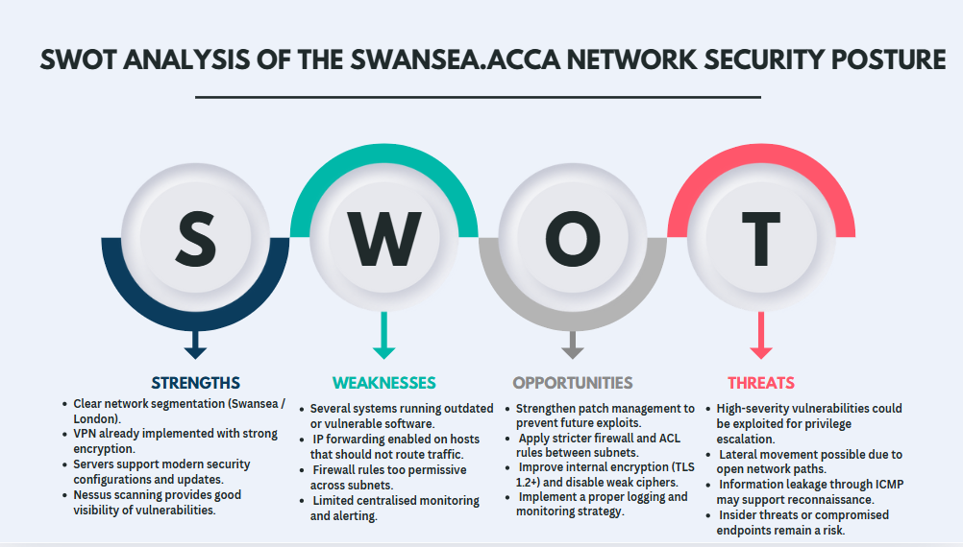
Figure 29. SWOT Analysis.

Conclusion

This project helped me understand how a real network can be tested and protected in practice. By working with the Swansea and London environments, I learned how to check basic connectivity, identify security issues, and understand which systems are at risk.
Using tools such as Nessus and Metasploit showed me how an attacker might think and act. At the same time, the mitigation work in Task 4 helped me see the same network from a defender’s point of view and understand how risks can be reduced.
I learned that security is not based on a single action. It depends on many small but important steps, such as keeping systems updated, limiting access, using strong encryption, and monitoring logs and alerts.
Overall, this project gave me a clearer and more practical understanding of cybersecurity. It helped me build confidence in finding vulnerabilities and applying simple, effective measures to make a network more secure.

References

[1] | Tenable, "Tenable Nessus," Tenable, 2025. [Online]. Available: https://www.tenable.com/products/nessus?pscd=shop.tenable.com&ps_partner_key=a2V2aW5sZWUyNzU0&sid1=ba34437b4xsfea63&ps_xid=dRfLJTX3Mzg11t&gsxid=dRfLJTX3Mzg11t&gspk=a2V2aW5sZWUyNzU0. [Accessed 13 12 2025].
[2] | NIST, "National Vulnerability Database," NIST, 2025. [Online]. Available: https://nvd.nist.gov/vuln/detail/CVE-2021-3156. [Accessed 13 12 2025].
[3] | NIST, NIST, 2025. [Online]. Available: https://nvd.nist.gov/vuln/detail/CVE-2024-47889. [Accessed 12 12 2025].
[4] | Tenable, "Ruby WEBrick < 1.8.2 HTTP Request Smuggling," Tenable, 2025. [Online]. Available: https://www.tenable.com/plugins/nessus/240854. [Accessed 12 12 2025].
[5] | Tenable, "ICMP Timestamp Request Remote Date Disclosure," Tenable, 2025. [Online]. Available: https://www.tenable.com/plugins/nessus/10114. [Accessed 12 12 2025].
[6] | cheatsheetseries.owasp.org, "Transport Layer Security Cheat Sheet," cheatsheetseries.owasp.org, 2025. [Online]. Available: https://cheatsheetseries.owasp.org/cheatsheets/Transport_Layer_Security_Cheat_Sheet.html. [Accessed 12 12 2025].
[7] | NIST, "NIST Special Publication 800-53," NIST, 2020. [Online]. Available: https://nvlpubs.nist.gov/nistpubs/SpecialPublications/NIST.SP.800-53r5.pdf. [Accessed 12 12 2025].

