
NTRODUCTION TO WEB AND DATABASE CONCEPTS
ACCA4023

Akinwunmi Akinyemi Olabisi
2515474

TABLE OF CONTENTS
Contents
TITLE PAGE 1
TABLE OF CONTENTS 2
INTRODUCTION 3
SCENARIO ANALYSIS 4
ENTITY-RELATIONSHIP DIAGRAM 5
DATA STRUCTURE DEVELOPMENT 5
TABLES: 5
CONSTRAINTS 8
RELATIONSHIPS: 9
NORMALIZATION COMPLIANCE 11
NORMAL FORMS 12
QUERY DEVELOPMENT 13
QUERY 1: MEDICATION LOW IN STOCK 13
QUERY 2: TOTAL SALES PER CUSTOMER 14
QUERY 3: TOTAL SALES PER MEDICATION 15
QUERY 4: EXPIRED MEDICATION 15
VALIDATION AND TESTING 16
DATA INTEGRITY TEST: 16
VALIDATION RULE: 18
QUERY TESTING: 19
RELATIONSHIP TESTING: 19
CHALLENGES, LIMITATIONS AND IMPROVEMENTS 20
Reference List 21

INTRODUCTION
The scenario given is one that highlights why businesses need to adopt and implement well-structured business databases. There is a huge advantage in storing data on a database as opposed to managing business information manually. The “Med-link Pharmacy” sees the need to digitalize their record keeping, therefore bettering the veracity of their data which will enhance their effectiveness in meeting consumer needs.
Manual method of storing data (paper based or traditional file system) comes with a myriad of disadvantages such as data redundancy (which leads to wastage of storage and resources), data inconsistency, lack of data flexibility, poor data security and poor data sharing and availability [1]. Manual systems may seem effective initially but as the amount of data grows, it becomes prone to errors that can damage businesses and in the case of healthcare businesses cause harm to the consumer.
A database management system (DBMS) is a collection of programs that manages the
database structure and controls access to the data stored in the database [2]. It serves to provide safe and consistent data which can be transformed to information which is used to make informed decisions by stakeholders.
On a database, data constraints can be applied thereby reducing the occurrence of errors and inconsistencies, processes can be automated reducing human burden and increasing efficiency and data can be normalized which stops the unnecessary duplication of data and therefore prevents waste of digital resources.
This scenario will test my ability to create, normalise and structure databases.

SCENARIO ANALYSIS
The database for the pharmacy will include customer information, sales information, medication information and supplier information. Customer information will include the consumer’s demographic data such as first name, last name, phone number, address and date of birth. These are important to confirm the customer’s identity and make decisions based on geographical data (address). The customer’s date of birth can be used to assess the client’s age for drugs that are contraindicated for older people such as certain Central Nervous System medications [3].
Sales information will reflect drugs sold and revenue generated. Medication information includes customer’s prescription, medication stock available, type of medication, price of medication and date of expiry. This allows for automated monitoring of medication available, customer’s prescription and sales. This also streamlines effort to adhere with regulatory compliance by monitoring for expired drugs [4]. Supplier information consists of the details of the suppliers for each of the drugs for ease of restocking of medication.

ENTITY-RELATIONSHIP DIAGRAM
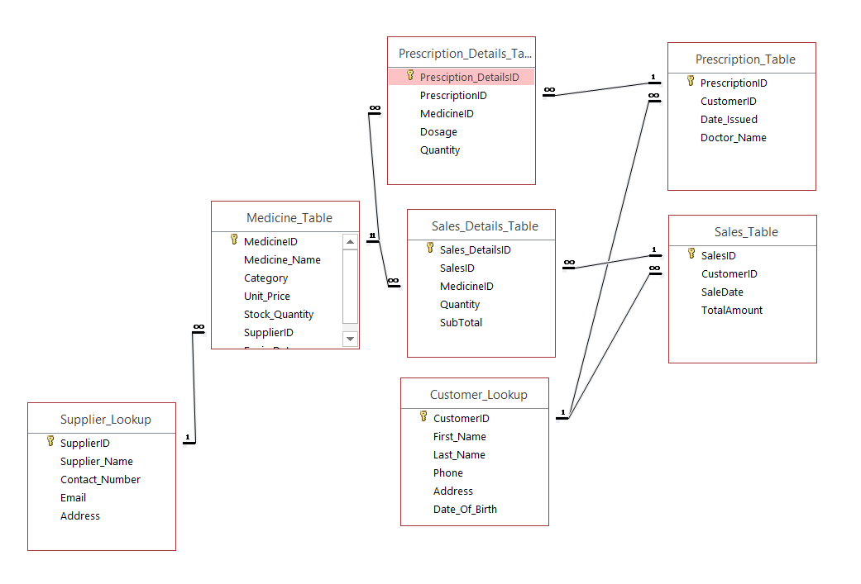
The diagram shows the relationship between the tables.
1 indicates PK (primary key)
∞ indicates FK (foreign key)
1------∞ indicates a 1 to many relationship

DATA STRUCTURE DEVELOPMENT

TABLES:
Tables/entities created and their columns are:
- Customer Lookup: attributes are CustomerID (PK), First Name, Last Name, Phone, Address, Date of Birth.
- Medicine Table: attributes are MedicineID (PK), Medicine Name, Category, Unit Price, Unit Price, Stock Quantity, SupplierID (FK), Expiry Date
- Prescription Table: attributes are PrescriptionID (PK), CustomerID (FK), Date Issued, Doctor Name
- Prescription Details Table: attributes are Pescription DetailsID (PK), PrescriptionID (FK), MedicineID, Dosage, Quantity.
- Sales Table: attributes are SalesID (PK), CustomerID (FK), Sales Date, Total Amount.
- Sales Details Table: attributes are Sales DetailsID (PK), SalesID (FK), MedicineID (FK), Quantity, SubTotal.
- Supplier Lookup: attributes are SupplierID (PK), Supplier Name, Contact Number, Email, Address
Database design refers to the activities that focus on the design of the database structure that will be used to store and manage end-user data[2]. According to [2], a proper database design is characterized by its ability to be queried efficiently, to remove redundant data, how well errors are avoided, how easily additional data can be added and the ease of navigation. These principles guided my decision making when designing my database.

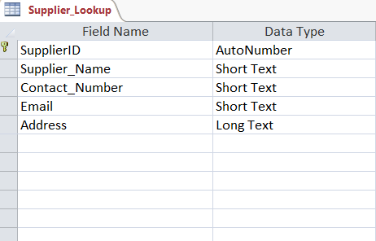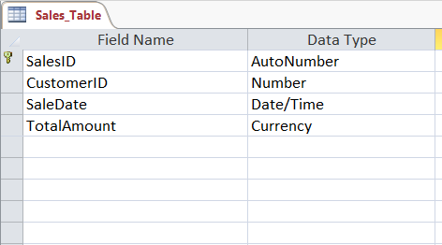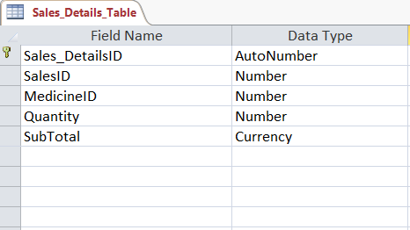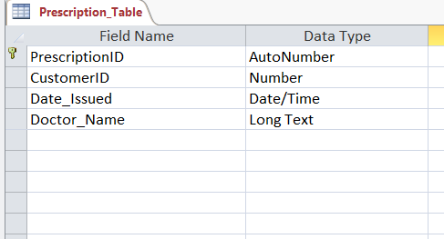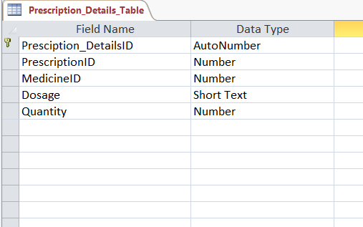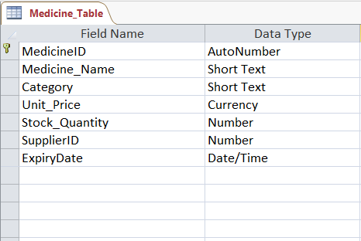

CONSTRAINTS:
- Elements in each table were set to required to avoid the occurrence of null values.
- Validation rules were applied to numerical attributes eg Unit Price Quantity etc, they were set so that negative values could not be entered.
- Data Type was properly specified for each attribute
- ID were set to AutoNumber to avoid repetition and adhere to uniqueness of primary key.

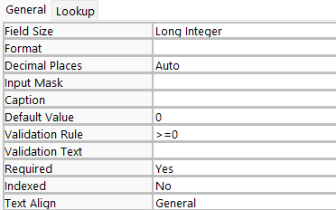

RELATIONSHIPS:
A relationship is an association between entities. The entities that participate in a relationship are also known as participants, and each relationship is identified by a name that describes the relationship [2].
Relationships created between the entities:
- SUPPLIER supplies MEDICINE (1 to many, a supplier can provide more than one drug)
- MEDICINE is prescribed in PRESCRIPTION (1 to many, a medication can be prescribed to various people)
- MEDICINE is sold in SALES ( 1 to many, a medication can be sold multiple times)
- PRESCRIPTION is detailed in PRESCRIPTION DETAILS (1 to many, a prescription can have more than one medication on it)
- SALES is detailed in SALES DETAIL TABLE(1 to many, a sale can contain multiple medications)
- CUSTOMER gets PRESCRIPTION (1 to many, a customer can get multiple prescriptions)
- CUSTOMER makes SALE (1 to many, a customer can buy multiple times)

Cardinality expresses the minimum and maximum number of entity occurrences associated with one occurrence of the related entity [2]. Cardinality is the quality of a relationship that defines the number of instances in one entity that relate to the instances of another [5].
There are three types of cardinality:
- One to One: This indicates that a record within one entity might only be referenced by one record in the other entity [5]. Simply put, the records for both the primary key column and foreign key column are unique and the same as the primary key.
- One to Many: depicts situations in which each record within one entity relates to multiple records in another entity [5]. The records in the primary key are unique, while the records in the foreign key may be repeated.
- Many to many: show that one or more records within both entities can be connected [5]. This indicates that the records in both the foreign key and the primary key are not unique and are repeated.
The ideal cardinality chosen for this database was one to many. One to one cardinality is unnecessary and inefficient (it should just be one table), many to many gives redundant data and cannot be well-queried.
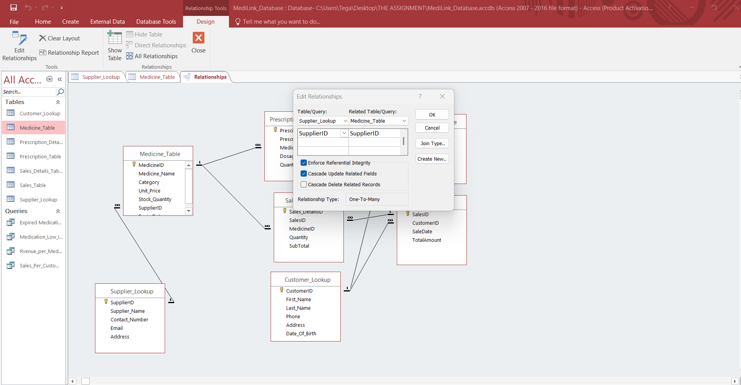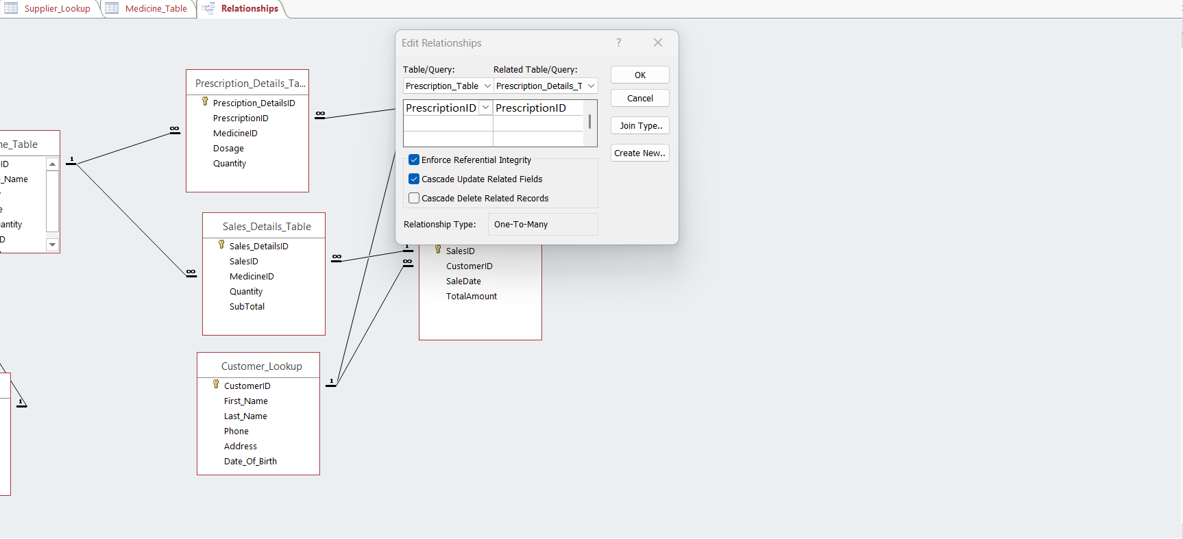

NORMALIZATION COMPLIANCE
Normalization is a process for evaluating and correcting table structures to minimize data redundancies, thereby reducing the likelihood of data anomalies [2]. It reduces data redundancy and inefficiency. It aids in proper querying of the database. The principles of normalization include:
- A table should have a single subject when applicable. CUSTOMERS Table contains details pertaining to the customers
- Data in tables (each cell) should contain single values, not multiple values. Eg. Separation of First Name and Last Name
- No data should be stored meaninglessly in multiple tables, this reduces redundant data and allows for easy updating of database.
- All non-prime attributes in a relation (table) are dependent on the primary key—the entire primary key and nothing but the primary key [2]

NORMAL FORMS
1st Normal form (1NF) refers to a relation in tabular format where key attributes have been identified (primary key, foreign key), no multiple values in a cell and each complete row is unique. [6].
In this case, it is reflected by the separation of First and Last Name in Customers Table and the identification of primary keys in all the tables.
2nd Normal Form refers to a relation where the conditions for 1NF is met and partial dependency is completely eliminated. Simply put, if your table has a combined primary key, then the rest of the non-prime attributes must depend on both combined primary keys and not only one. A great way to fix this is to split the table into two, therefore splitting the combined primary keys. Example is the Sales Details table: Instead of having both Sales ID and Medical ID as combined primary keys which will cause partial dependency for Unit Price, I separated the tables.
3rd Normal form refers to a relation where the requirements for 2NF are met and no non-prime column depends on another non-prime column. Separating the Supplier Table from the Medication table deals with this. Supplier’s details will have been reliant on SupplierName not on MedicineID (PK).

QUERY DEVELOPMENT

QUERY 1: MEDICATION LOW IN STOCK
Tables Used: Medicine Table and Supplier Lookup
Function: It shows medications that are low in stock (<50). This is a quick and automated way to tell when a particular medication is low in stock. The query consists of all the medications that meet the <50 criteria and their respective supplier information.
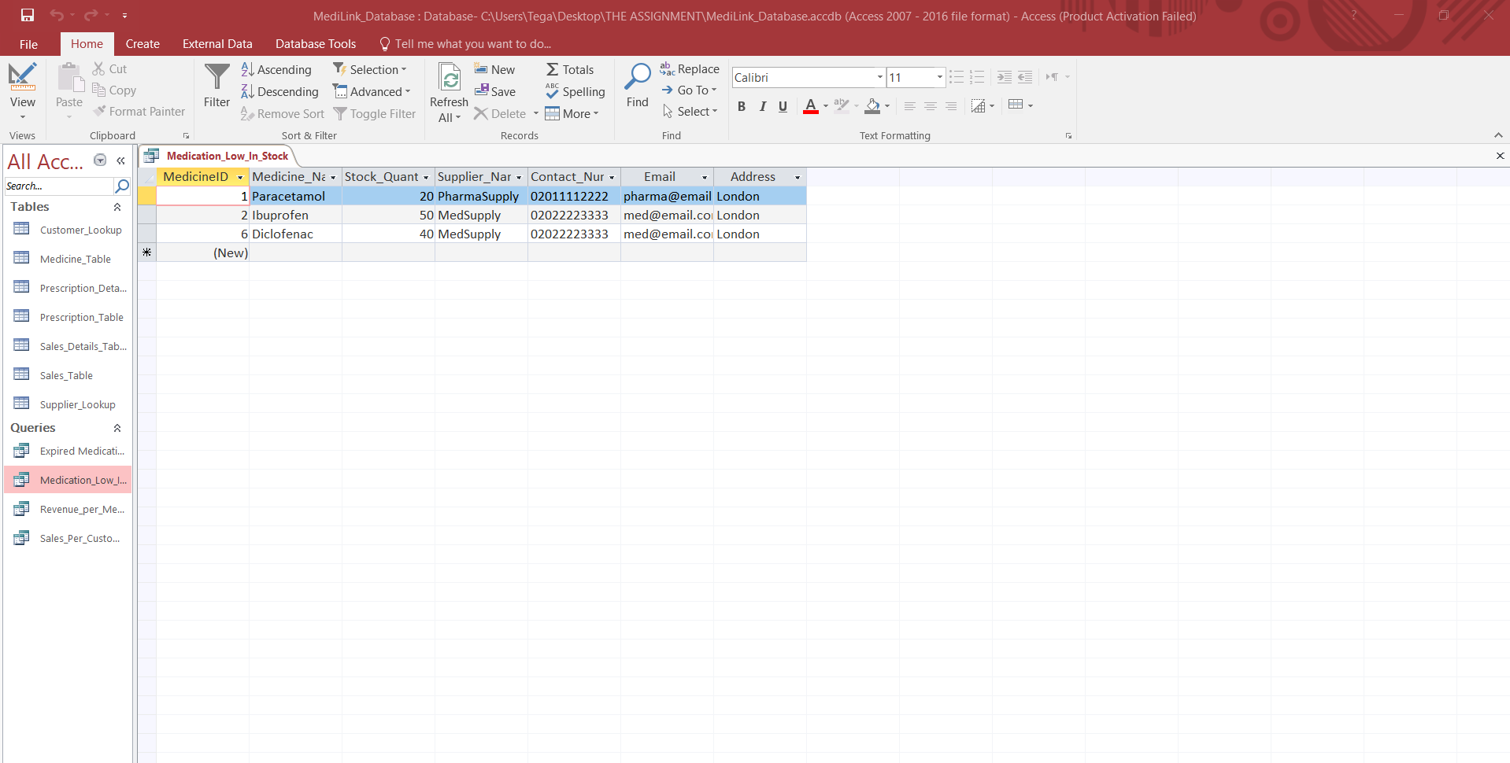
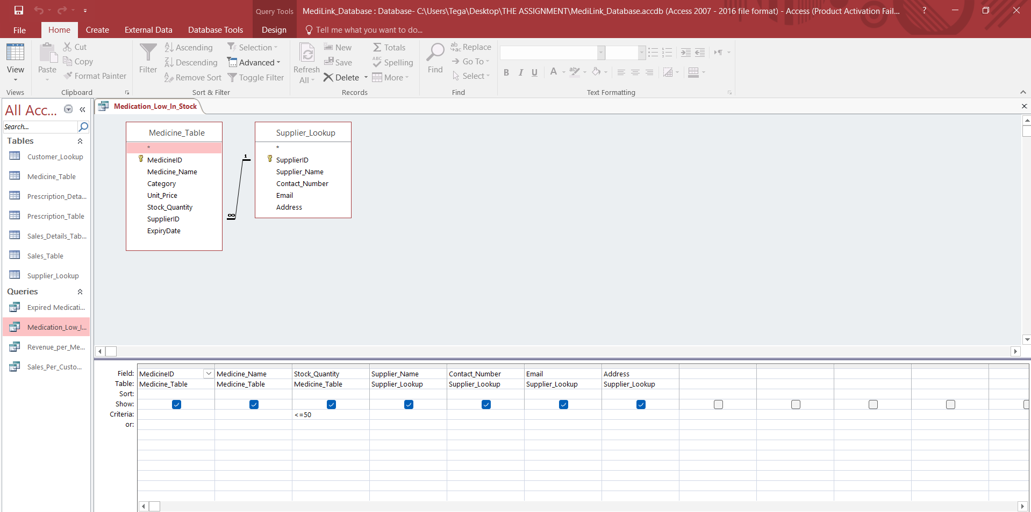

QUERY 2: TOTAL SALES PER CUSTOMER
Tables Used: Customer Table, Sales Table
Function: It shows how much is earned per customer, therefore identifying valuable customers
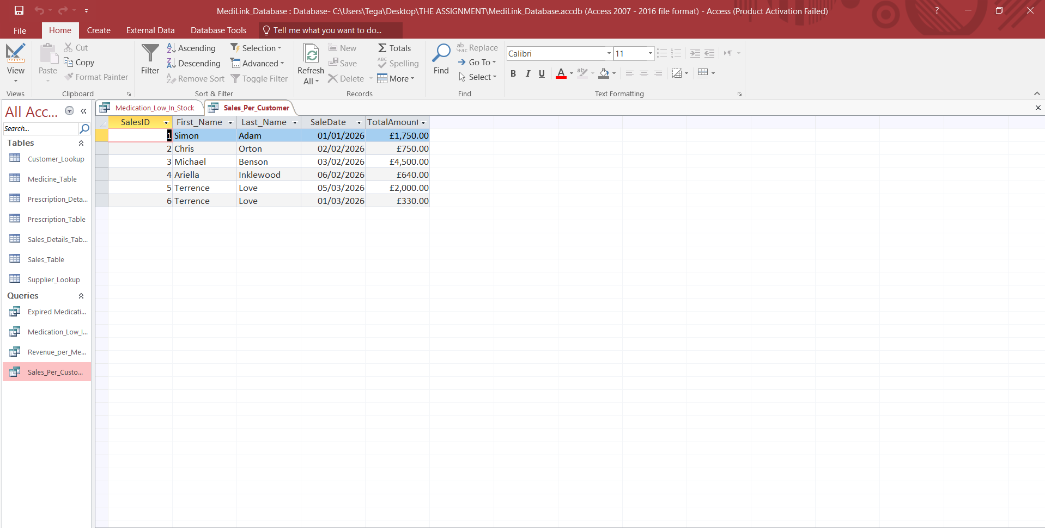
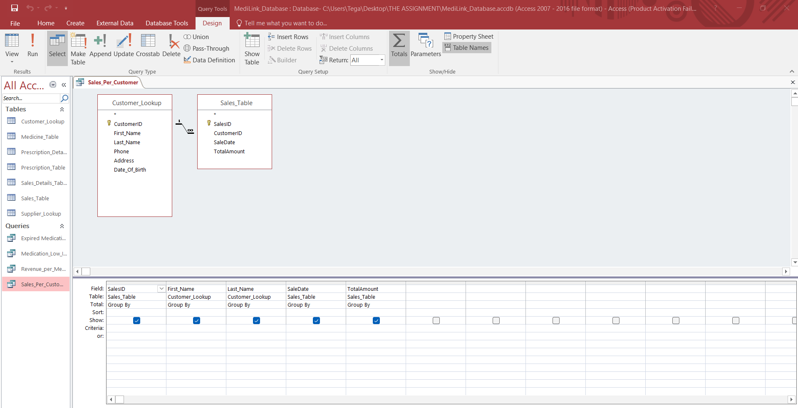

QUERY 3: TOTAL SALES PER MEDICATION
Tables Used: Medicine Table, Sales Details Table
Function: It shows the medication that generates the highest amount of revenue.
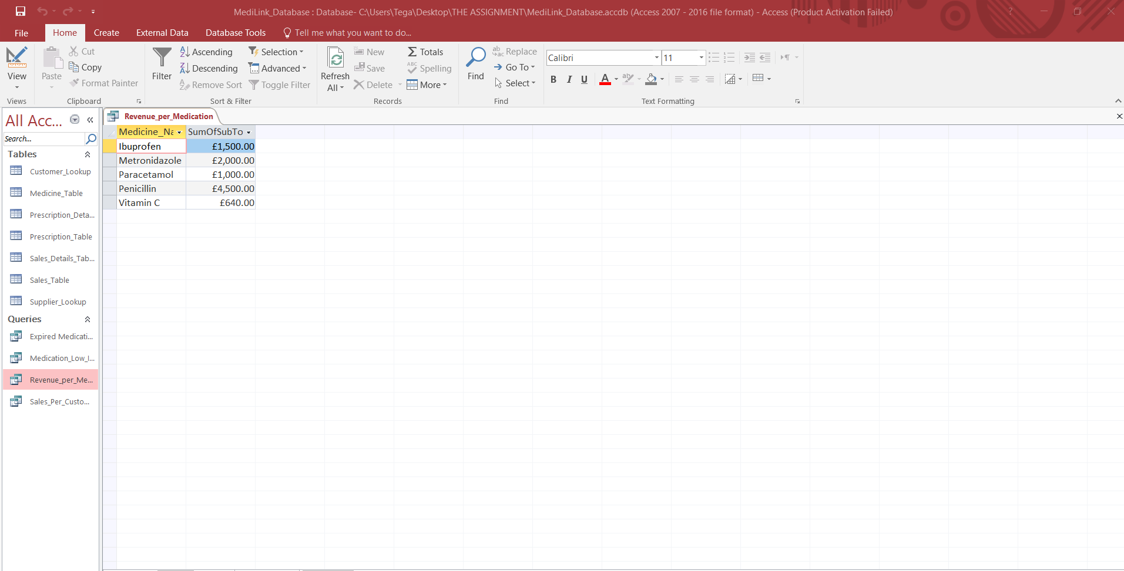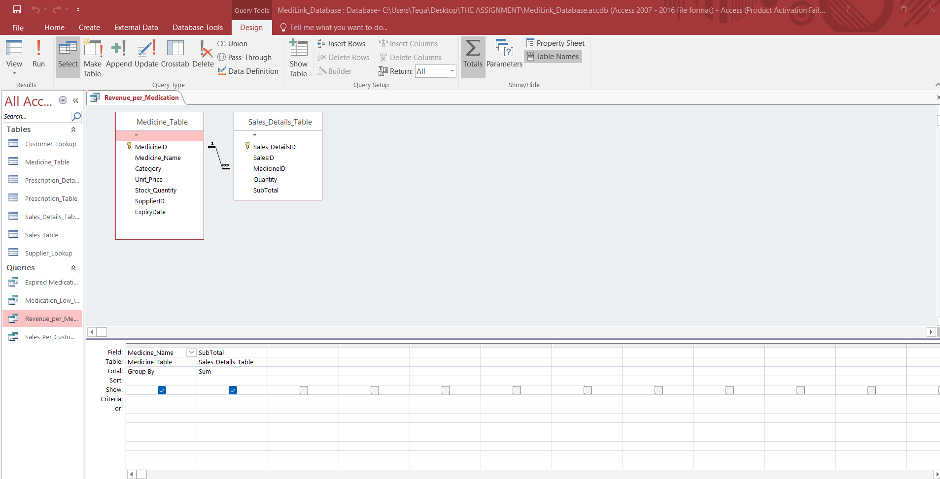

QUERY 4: EXPIRED MEDICATION
Tables used: Medicine Table, Supplier Table
Function: It shows if any medication is expired and the supplier’s information. This fosters compliance with regulatory and legal guidelines.
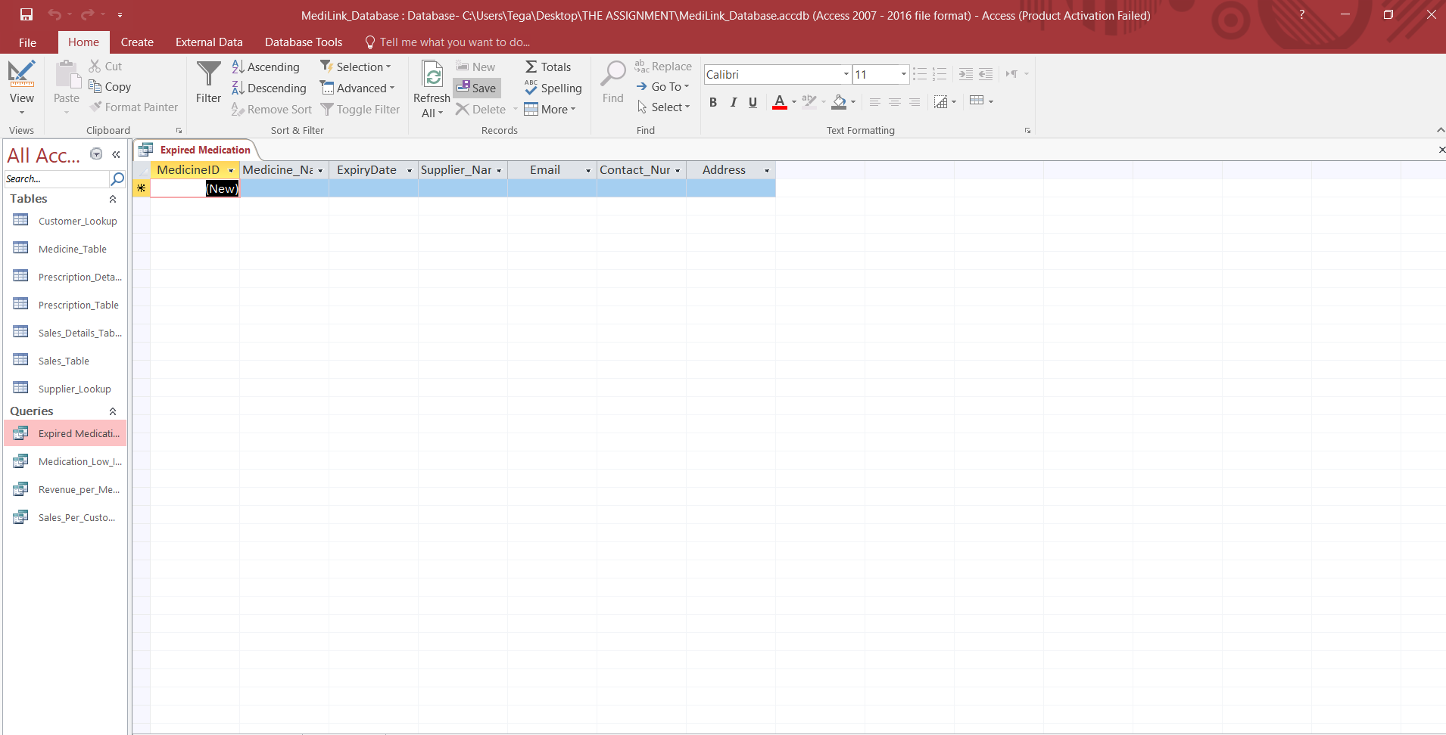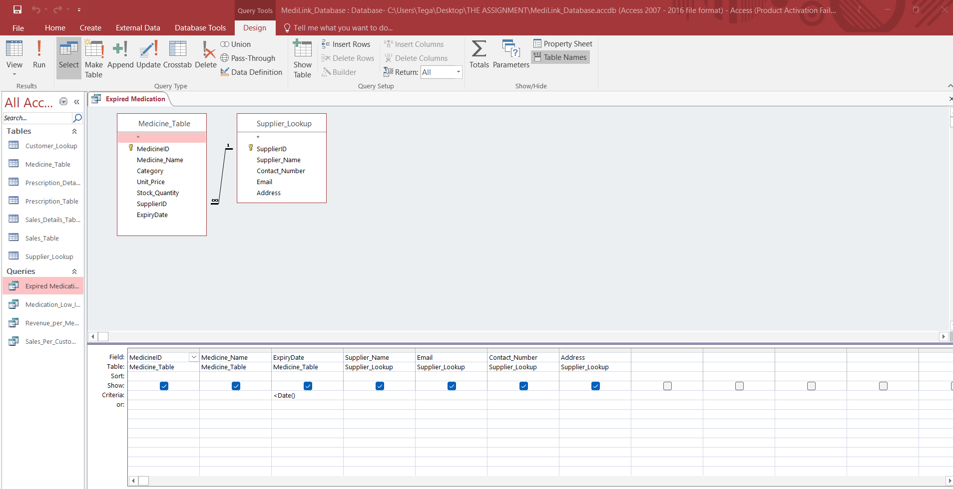

VALIDATION AND TESTING

DATA INTEGRITY TEST:
I tested my application of key constraints by attempting to insert a sales data with a CustomerID not registered under Customer.CustomerID. The database gave an error message, proving the functionality of the data constraint.
The database also gives an error message when I try to input the wrong data type.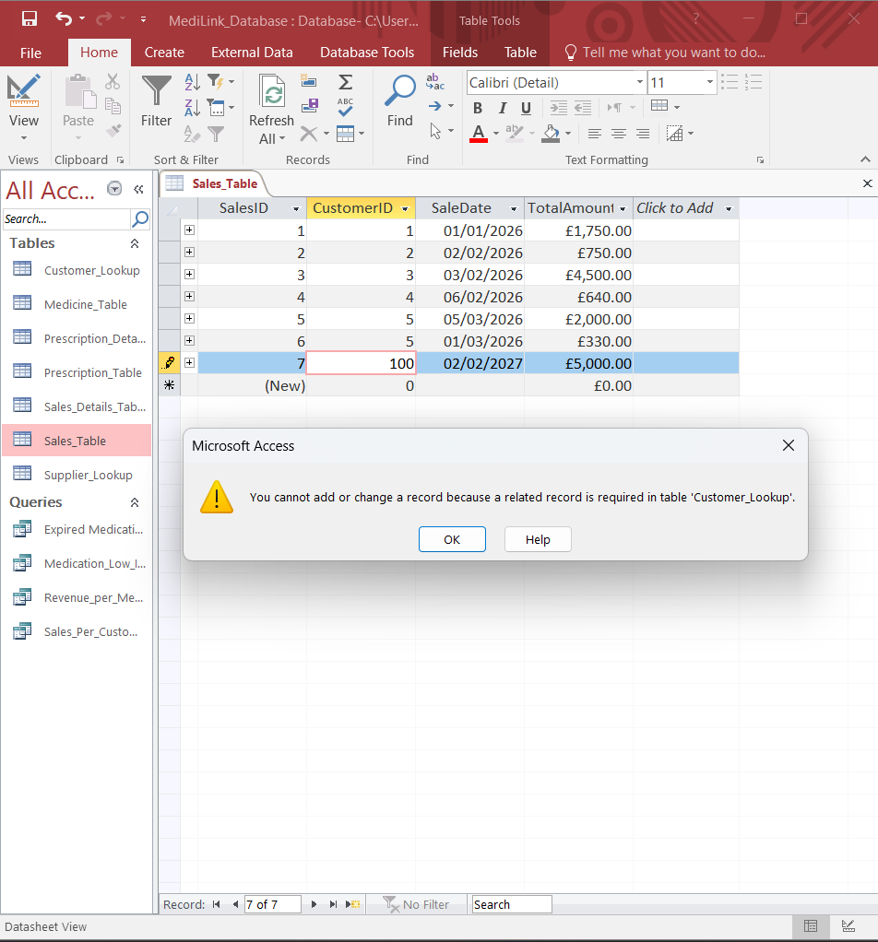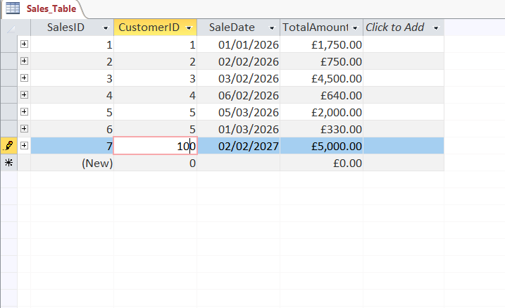

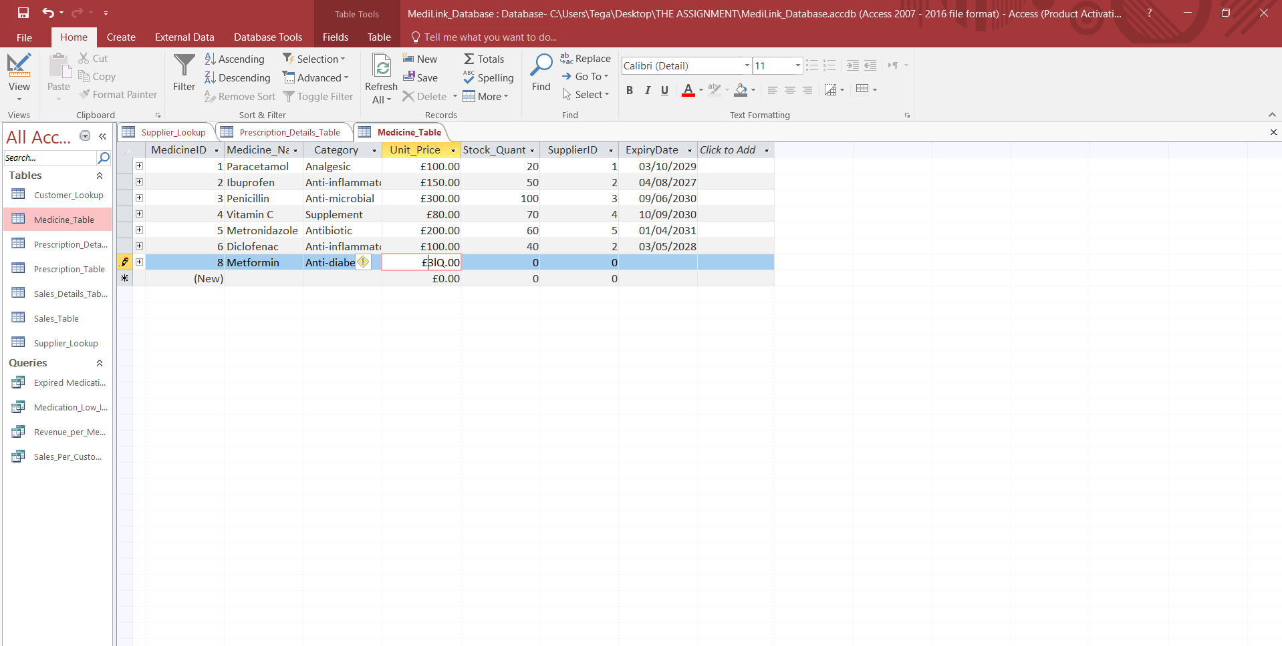

VALIDATION RULE:
I attempted to input a negative number into the Stock Quantity attribute under the Medicine Table. It gave an error message.

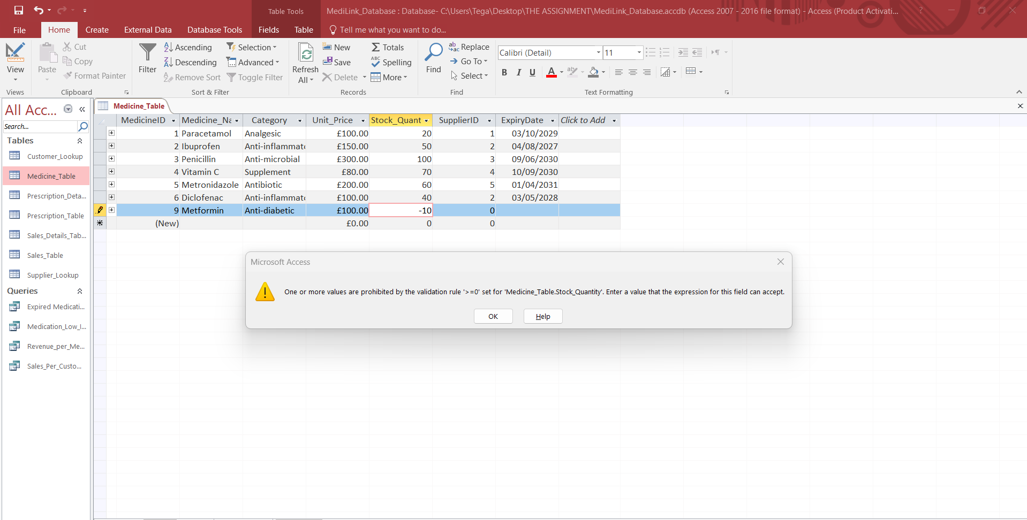

QUERY TESTING:
I compared all the queries I ran with the tables to ensure they worked properly. For example, the Low Stock query is noted to be running fine.

RELATIONSHIP TESTING:
I attempted to delete a customer’s data through the Sales Table. It gave an error message. This shows restriction on deleting and changing records to preserve data integrity.
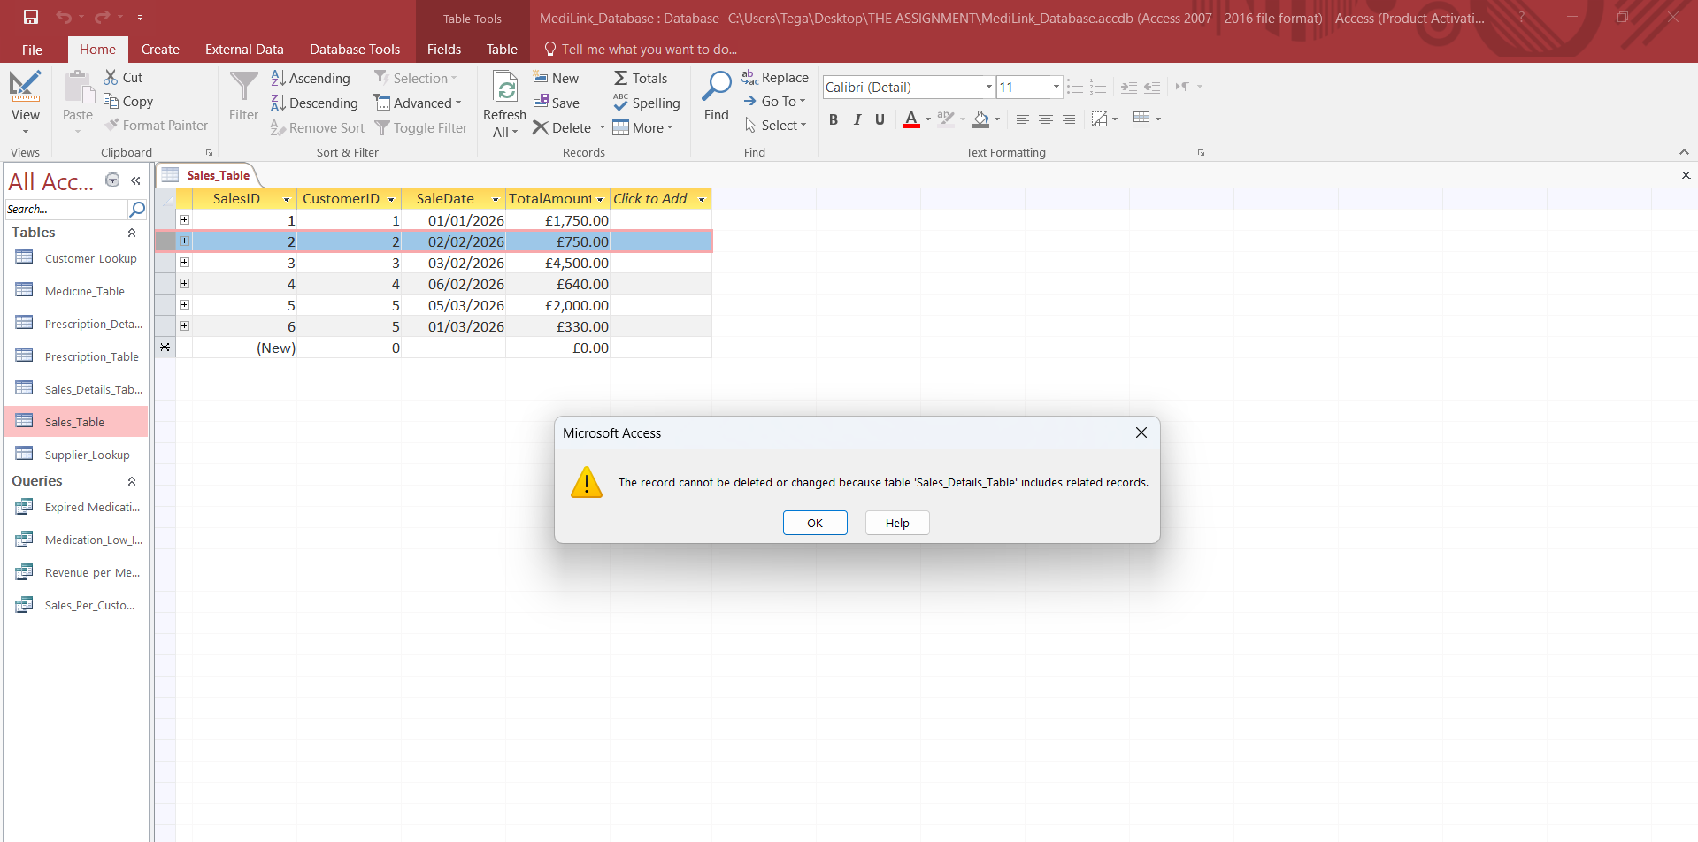

CHALLENGES, LIMITATIONS AND IMPROVEMENTS
The exercise gave me a hands-on experience in creating a database. I learnt what it means to structure a database and bring out useful insights from it. However, it was not without its challenges.
Limitation of Microsoft Access Relationship View: The Access Relationship View gives a well-defined entity relationship model, however it does not fully comply with the Crow’s Foot Model for ER.
Real Case Scenario: It is worth pointing out that the process will first start from cleaning and pre-processing of already existing data for the MediLink Pharmacy before the process of database modelling.
Further Automation of Process: Further automate the database so when there is a new sale, it automatically reduces from the number of items in stock in the Medicine table.

Reference List
[1] K. Laudon and J. Laudon, Management Information Systems: Managing the Digital Firm, 16th ed. Pearson, 2020, p. 234.
[2] C. Coronel and S. Morris, Database Systems: Design, Implementation, & Management, 13th ed. Cengage Learning, 2019.
[3] Cleveland Clinic, “Medications on the Beers Criteria List,” Cleveland Clinic, May 3, 2023. [Online]. Available: Beers Criteria Article. [Accessed: Mar. 28, 2026].
[4] Total Pharmacy Supply, “Pharmacy Regulatory Compliance: What You Need to Know,” Total Pharmacy Supply Blog, Feb. 26, 2024. [Online]. Available: https://totalpharmacysupply.com/blog/pharmacy-regulatory-compliance-what-you-need-to-know/. [Accessed: Mar. 28, 2026].
[5] IBM, “What is an Entity Relationship Diagram (ERD)?,” IBM Think, [Online]. Available: https://www.ibm.com/think/topics/entity-relationship-diagram. [Accessed: Mar. 28, 2026].
[6] GeeksforGeeks, “Normal Forms in DBMS,” GeeksforGeeks, Nov. 20, 2025. [Online]. Available: https://www.geeksforgeeks.org/dbms/normal-forms-in-dbms/. [Accessed: Mar. 28, 2026].

