Transcription Exercise

Approach
For this exercise, the opening page of the text of Peniarth MS 28 will be transcribed. The manuscript has been digitalised by the National Library of Wales, and so the online copy has been used. This has allowed for close study without the use of a magnifying glass, as the zoom function is excellent on the National Library’s viewer. The approach taken to complete the exercise was to spend some time first simply attempting to read the document several days in a row, to allow the eye to acclimatise to the handwriting, before beginning the transcription itself. For the transcription, square brackets have been used to indicate where abbreviations have been extended, and dashes have been used to indicate where the letter cannot be made out. Where the first part of a word is at the end of a line, with the second part on the next line, a back slash has been used to indicate this. In the few places where red ink has been used in the original, red has also been used to replicate this in the transcription. The document is primarily in Latin, but some words have been given in Welsh, and italics have been used for these. The document has two columns of writing, and this has been replicated as well. There are twenty six lines of text, and these have been numbered in the transcription. Due to expanding the abbreviations, the evenness of the second column’s left hand side has been sacrificed in a few places in order to keep the words on their numbered line. Also, note that narrower than usual margins are being used for this document, to aid in keeping the lines to their corresponding number.
Context
As mentioned in the last assignment, Peniarth MS 28 is a Latin version of the medieval Welsh laws. There are a number of versions of the laws, and the majority of these are in Welsh. Earlier scholars attempted to divide these by regions, but the modern convention is to call these after the names of the scribe mentioned, giving three main groups: Iorwerth, Blegywryd and Cyfnerth. The Latin texts then form a further group, and there is a final group of ‘Other’ that do not clearly fit into one of the previously mentioned groups.
The scholarly designation for Peniarth MS 28 is Latin A, and at one time, it was considered to be the earliest extant manuscript of the laws, and was believed to be written in the late twelfth century. Various reasons have been offered for this date. A few scholars over the years have given later dates, and Huws more recently has argued for a date in the mid to late thirteenth century. He gives several reasons for this, including markers from the handwriting itself; the fact that the first line of text on each page is written below the ruled line (this can be seen more clearly on some of the later folios than on the one chosen for this exercise) and evidence regarding the possible exemplars of the image of the king which is, again, on a later page than the one chosen for the exercise. He does, however, also point out some features which are ‘old-fashioned’ in the handwriting, but notes that it is not unusual to spot archaic features in manuscripts that originate from Wales. In the notes that follow after the transcription, an attempt will be made to note some of these markers.
Transcription
1 Incipit p[ro]logus in leges istas [et] similit[us] obseruantes benedixe/
2 lib[ro] legu[m] howel da. runt. hec iuditia scripta sunt. Explicit
3 BRittannie leges rex p[ro]logus. Incipit liber legum. Quest[us]
4 howel qui cogno[m]i[n]aba/ --- curia sua Rex / officiales curie.
5 tur bonus .i. [id est] da. regni ---sumpsit exordium. disponens inea
6 sui .s. [scilicet] gwynedoturu[m]. .xx[ti] iiii[or]. ministros officiales quor[um] primus
7 powyssor[um]. atq[ue] dext[ra]/ est . penteylu. s[e]c[on]d[u]s offeyrat teylu . terti[us]
8 lium sapientiu[m]. et in uno loco an[te] suum dysteyn . quart[us] Braudur llys . quint[us] hebo/
9 tribunal ---gr-g-tor[um] uno consen/ gyt . sextus pengwastraut . septim[us] penke/
10 su et diligen-- qu[i]- - omni natione me/ nyt . octavus gwas stauell. non[us] dysteyn re/
11 dio circit[er] te---- constituit. Acci/ gine. decimus offeyrat regine. undecimus
12 uit de quol-b- p—p[er] suu[m] Regnum bard teylu. duodecim[us] gostegwr. terti[us]decim[us]
13 sex uiros au---ate et scientia et om[ne]s deressaur eneu-at. quant[us] decim[us] deressaur
14 epi[scopi] archiepi[scopi] ---es. et sacerdotes tocius stauell. quint[us] decim[us] moruyn stauell. sext[us]
15 wallie pottentes ad locum qui dicit[ur] decim[us] gwastraut awyn. septimusdecim[us]
16 ty gweyn aR taf. et ibi demorati sunt cannuyllyt. octauusdecim[us] trullyat. non[us]
17 x[ur]l dieb[us] et x[ur]l noctib[us]. in pane et aqua. decim[us] medyd. vicesim[us] suydwr.vicesimus
18 et tunc temp[er]auer[un]t reditione[m] fore facti p[ri]mus coccus. vicesimus s[e]c[un]d[u]s troydyau-
19 .i[d est]. cosp. sup[er]flua diminuere que errant vicesimus t[er]tius medic. vicesimusq[ua]rtus
20 inpl[ur]ib[us] reditionib[us] foref[ac]ti . ita feceru[n]t gwastraut regine. Hii .xx[ti] iiii[or]. teR quoli/
21 p[re]t[iu]m uni[us]cui[us]q[ue] rei et inditiu[m] congruu[m] bet in anno. debent indum[i]ta sua a rege
22 de qualibet re. Tunc surrexerunt om[ne]s et regina h[abe]re. lanea .s[cilicet]. atege. et linea a regi/
23 archiepi[scopi] epi[scopi] abb[at]es. et sacerdotes i[n]dueru[n]t na et hoc in natali et pascha et pentecos[te]
24 uestes sua[s] et in steterunt baccl[er]is cu[m] Rex debet regine tertiam p[ar]te lucri ce p[ro]p[ri]a
25 crucib[us] et ca[n]delis. et. ex co[m]muni consi/ terra. Ministri [q]u[into]? u[no]? regis debent similit[er] t[er]tia
26 lio exco[m]municaueru[n]t transgredie---s p[ar]te lucrorum ministris regine.
Notes
- The content of the page is consistent with other texts of the Welsh laws. The first column (and the first few lines of the second column) is the prologue, which tells of Hywel Dda and his attempt to write down the laws. The bulk of the second column then is the typical first section of the laws of the court, which gives the list of the twenty-four officers of the court.
- The need to include the Welsh word ‘da’ along with the Latin ‘bonus’ in line 5 seems to possibly indicate that either the scribe or the original translator, if they were not the same person, was Welsh, since there seems to be no particular reason to include it unless the person translating has the name firmly in their head as Hywel Dda.
- The text has been slightly obscured at lines 9-14, first column, due to green ink from the drawing on the reverse side leaking through, as well as what looks to be a fold or wrinkle in the page, although this is hard to tell from the digitalised image. There is a hole in the page at the beginning of lines 4 and 5 in the second column, which again obscures some of the letters.
- One of the markers that Huws considers would not have been present if the manuscript had been written before 1200 is the degree to which ‘the marked fusion of counter-curved adjacent strokes’, i.e. biting, is used. This can be seen in several places on this page, including in line 6, column a, in the ‘do’ of ‘gwynedoturum’ and in line 7, column a, in the ‘de’ of the final word.
- Another of Huws’ indicators is the long-tailed g, which he says would not have been seen in Wales until at least the mid-thirteenth century. A long-tailed g can be seen in the final ‘regine’ of the second column, line 26.
- Several of the markers that Huws considers archaic can also be seen on this page, such as the consistent use of the ampersand, and the use of a majuscule R in places. An example of the majuscule R can be seen in the second column, line 20, in ‘ter’, and the ampersand is used throughout the page.
- The use of Welsh for the officers of the court is interesting, and whilst not unusual in the Latin text of the laws, some do translate these into Latin as well. In the assignment preceding this one, Huws’ speculations regarding the manuscript being prepared for Archbishop Pecham were discussed. If Huws is correct in this, it would have been logical for the scribe to translate these into Latin, since this might have helped to normalise the Archbishop’s reaction to them. This is too tenuous of an observation to offset Huws’ speculations, but it bears noting nonetheless.
- It is interesting to note that the person who makes the mead (the ‘medyd’, line 17) precedes the medical officer (the ‘medic’, line 19) in the list of the officials of the court. Does this reflect the ability of drink to go further in aiding the wellbeing of society in the middle ages than the doctor?
Closing Statement
The presence of the long-tailed g in particular does seem to indicate that Huws is correct in dating this manuscript to the thirteenth century rather than the twelfth. It is difficult to derive any wider historical insights from this one page alone, especially on the basis of the handwriting, though. It would be interesting to revisit the Latin texts more fully, to see if other assertions made by earlier scholars are also open to criticism.

Bibliography
Books
Cappelli, A., Lexicon Abbreviaturarum (Leipzig: J. J. Weber, 1928)
Marshall, H., Palaeography for Family and Local Historians (Phillimore, 2004)
Journal Articles
Edwards, G., ‘Presidential Address: The Royal Household and the Welsh Lawbooks’, Transactions of the Royal Historical Society, 13 (1963), 163–76
Emanuel, H.D., ‘The Latin Texts of the Welsh Laws’, Welsh History Review Special Number: The Welsh Laws (1963), 25-32
Huws, D., 'Leges Howelda at Canterbury', National Library of Wales Journal, XIX (1976), pp. 340-4
See below for an image of the page transcribed.
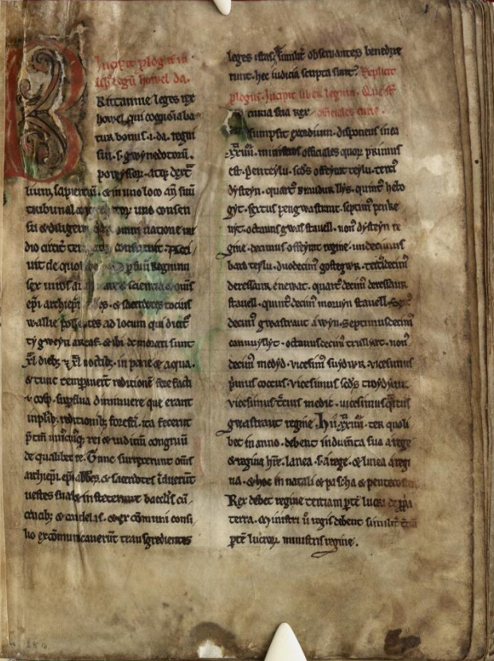

Available at https://www.library.wales/discover/digital-gallery/manuscripts/the-middle-ages/laws-of-hywel-dda#?c=&m=&s=&cv=12&xywh=-705%2C-317%2C5207%2C4793, last accessed 7 January 2022. A copy of this page will be included at the end of the assignment, but it is suggested that the online version would be easier for the markers to use.
For the full list of the various manuscripts and the group they fall into, see http://cyfraith-hywel.cymru.ac.uk/en/llawysgrifau-disgrifiadau.php, last accessed 9 January 2022.
See, for example, H.D. Emanuel, ‘The Latin Texts of the Welsh Laws’, Welsh History Review Special Number: The Welsh Laws (1963), 25-32.
ibid.
Daniel Huws, 'Leges Howelda at Canterbury', The National Library of Wales Journal, XIX (1976), pp. 340-4.
ibid.
ibid.
For the typical contents of the tractates and sections of the Welsh laws, see http://cyfraith-hywel.cymru.ac.uk/en/canllaw-traethigau--hafan.php, last accessed 9 January 2022.
For more on the officers of the court, see Goronwy Edwards, ‘Presidential Address: The Royal Household and the Welsh Lawbooks’, Transactions of the Royal Historical Society, 13 (1963), 163–76, as well as the website listed above.
Huws, fn. 5.
ibid.
Edwards, fn. 9.
This speculation comes from the article already cited.

