Personal Development Portfolio
LCHS4009 Professional Development within Health and Social Care

Name: Tahmina Sultana
Student number: 2431922
Module code: LCHS4009
Module Title: Health and
Social Care
Lecture`s name: Dr. Bernice Ejiogu
Date: 13 July 2026

Table of Contents
Task 1: Curriculum Vitae 4
Task 2: Personal Statement 6
Task 3a: SWOT Analysis 7
Task 3b: Personal Development Plan 8
Task 4: Critical Reflection Using Gibbs’ Reflective Cycle 10
Reference List 12

Chosen Job Vacancy
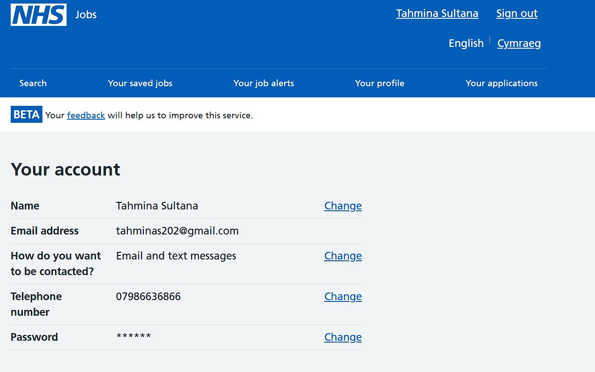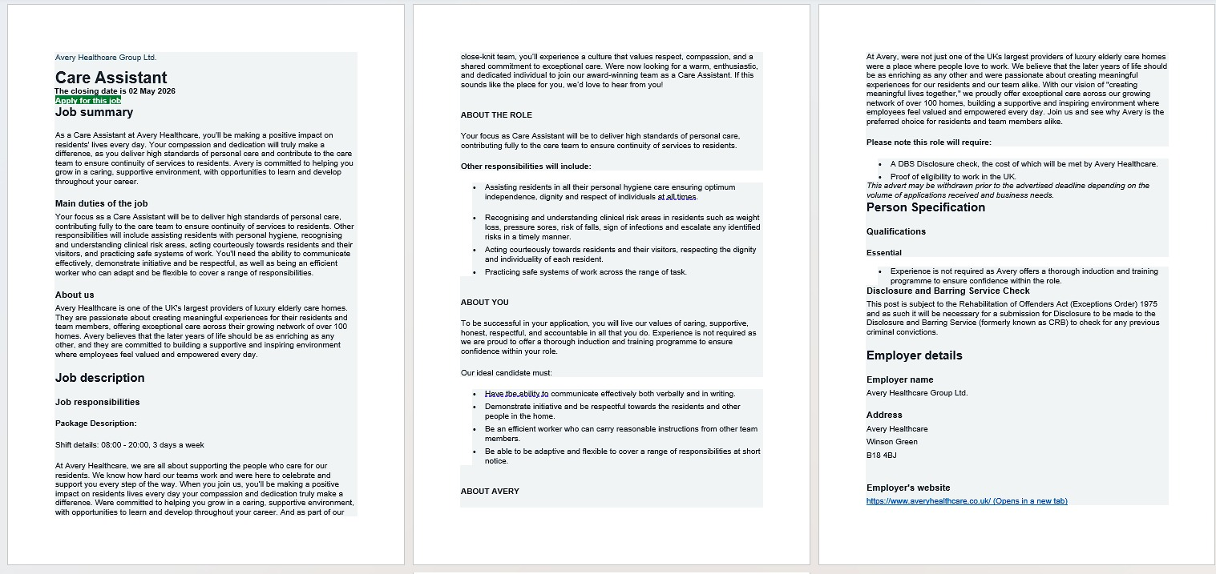

Task 1: Curriculum Vitae
Tahmina Sultana
Birmingham, UK | 07986636866 | tahminas202@gmail.com
Personal Profile
Health and Social Care students with a strong interest in older adult care and future progression within nursing or professional care practice. I am skilled in communication, teamwork and empathy through academic study, customer service experience, and voluntary work. Understands the importance of dignity, confidentiality, equality, and person-centered care when supporting vulnerable people. Resolute, organised, and willing to learn through supervision, induction, and workplace training. Seeking a Care Assistant role to develop practical care skills and contribute positively to residents’ wellbeing.
Education
- BSc (Hons) Health and Social Care, University of Wales Trinity Saint David, Birmingham, UK
2025 to 2026
- Level 4 Health and Social Care, University of Wales Trinity Saint David, Birmingham, UK
2024 to 2025
- Secondary Education, Birmingham Metropolitan College, Birmingham, UK
GCSE English, Grade 3, 2019 to 2021
GCSE Math’s, Grade 4, 2023 to 2024
GCSE Science, Grade 4, 2017 to 2018
Relevant Modules
- Care of Older Persons
- Safeguarding in Health and Social Care
- Communication in Professional Practice
- Health Promotion and Wellbeing
- Employability Skills in Health and Social Care
Key Skills
- Person-centered care awareness
- Effective communication with vulnerable individuals
- Empathy and compassion
- Teamwork and collaboration
- Observation and reporting skills
- Time management and organization
- Basic digital documentation
- Respect for dignity, confidentiality, and equality

Work Experience
Customer Service Assistant, Children’s Society Charity Shop, Kingstanding, Birmingham, UK, 2025
- Communicated respectfully with customers from diverse backgrounds.
- Managed several tasks in a busy environment while being still calm and organised.
- Demonstrated patience, empathy and professionalism when dealing with challenging situations.
- Collaborated with colleagues to support daily shop activities and provide good service.
- Developed confidence in listening, problem solving and responding to people’s needs.
Voluntary Experience
Community Volunteer, Manor House, Great Barr, Birmingham, UK, 2010 to 2021
- Supported community activities for individuals from diverse backgrounds.
- Demonstrated respect, empathy and understanding when interacting with others.
- Collaborated with other volunteers to complete tasks and support community events.
- Developed confidence in teamwork, communication, and helping others.

Achievements
- Completed academic presentations on employability skills within health and social care.
- Developed reflective practice skills using professional reflection models.
- Improved teamwork and communication skills through academic and voluntary activities.
Interests and Hobbies
- Reading about health, wellbeing, and elderly care.
- Community volunteering and supporting others.
- Fitness and keeping a healthy lifestyle.
References
Available upon request.

Task 2: Personal Statement
I am seeking employment in Avery Healthcare Group Ltd as a Care Assistant as I would like to gain some firsthand skills in health and social care. This shift is important to me as it involves helping residents with dignity, patience and respect and aiding them to remain independent in their day-to-day lives. The company Avery Healthcare is oriented towards good resident experience and welcoming care settings that are focused on my interests to offer respectful and person-centered help (Avery Healthcare, no date).
Safeguarding, communication, dignity, confidentiality, and person-centered care are areas that my Health and Social Care studies have enabled me to understand. I have also been able to understand that quality care must be based on individual needs of the person and not on all residents equally. This is important as people living in an area might have varying tastes, communication requirements, illnesses, health status, and degree of autonomy. The Care Quality Commission (2025) describes the fact that person-centered care is to be based on the needs and preferences of people. Knowing this information is important as a Care Assistant is constantly in close contact with residents and needs to be able to offer them safe and sensitive help.
The Children Society Charity Shop is one of the places where I had a customer service experience, which can be considered as one of the instances of my communication and empathy. The case was one of aiding customers with various backgrounds with some required patience and giving a clear explanation. My role was to react in a respectful manner as I was controlling the shop environment. I spoke slowly, I used simple words, I stayed calm and I also ensured that the customer was listening to what I told him. This led to professional and customer-supportive interaction. This was a lesson in which effective communication is reached through listening, patience and switching my style.
The second example is based on my voluntary experience at Manor House, where I aided the community activities. The scenario entailed dealing with individuals with varied communication channel styles and confidence. My job was to make people feel that they belong, as they work as a team. I helped others by listening, being patient and collaborating with other volunteers. It left me more certain of the power of teamwork, and more educated about the meaning of exhibiting dignity in little ways, like allowing time to the other person, respecting decisions and not making assumptions. This correlates with the 6Cs of care, particularly care, compassion, and communication (NHS England, 2015).
One of the three examples relates to protection and risk awareness bought during my studies. During class activities and case discussions, I realised that I need to be able to find issues like poor hygiene, pressure, sore risks, falls, risks of infection and behavior change. I had a job finding out what to report and why. I was taught that Care Assistant cannot neglect even minor changes as early reporting will enable residents to remain unharmed. The NMC (2018) emphasizes the need to keep safety and be professional. Reliability, respect, readiness to learn and a calm attitude would be some of the attributes that I would bring to Avery Healthcare in addition to my continued growth through induction and supervision.

Task 3a: SWOT Analysis
SWOT analysis will enable me to know my internal strengths and weaknesses, external opportunities, and threats about the Care Assistant position within the Avery Healthcare Group Ltd. This would prove beneficial since the job requires one to aid vulnerable elderly residents and is part of a care team and responds to evolving care requirements safely. The SWOT also helps me find areas for my Personal Development Plan.
STRENGTHS | WEAKNESSES
Effective communication skills  • Supports clear communication with residents, families, and staff.  • Helps report changes in health, mood, or behavior quickly.  Empathy and compassion  • Supports dignity, trust, and person-center care.  • Helps residents feel emotionally supported (NHS England, 2015). | Limited professional experience  • Limited direct care home experience.  • May affect confidence with personal care and recognising risks such as infection, falls, or pressure sores.  Confidence in challenging situations  • Residents may become confused, anxious, distressed, or unwell.  • Supervised practice and training are needed to respond calmly and safely.
OPPORTUNITIES | THREATS
Training and development  • Avery Healthcare offers induction and development opportunities (Avery Healthcare, no date).  • Training can build practical care skills and safe practice.  Career progression within healthcare  • The role can build experience in older adult care.  • It can improve confidence, communication, and professional standards. | High competition for roles  • Other applicants may have more direct care experience.  • A strong CV, personal statement and interview preparation are needed.  Emotional demands of the job  • Care work can be emotionally demanding when residents are distressed or unwell.  • Resilience, reflection, and workplace support are needed (Access, 2025).
Overall, the SWOT analysis shows that I have useful strengths, especially communication, empathy, and teamwork. However, it also shows that I need to build direct care experience and confidence in challenging situations. These weaknesses will be addressed in my Personal Development Plan through training, feedback, practice, and reflection.

Task 3b: Personal Development Plan
This Personal Development Plan is based on the weaknesses found in my SWOT analysis. It focuses on improving confidence in challenging care situations, building direct care experience, and strengthening communication and documentation skills. PDP is useful because it turns reflection into clear goals, actions, and progress checks (Quality Assurance Agency for Higher Education, 2011).
Goal | Linked SWOT weakness | Action | Timescale | Resources | Monitoring and evaluation
Improve confidence in challenging or high-pressure care situations | Confidence in challenging situations | Attend induction training, practice scenario-based exercises and shadow experienced staff when supporting residents. Use Gibbs’ reflective cycle after tricky situations to find what went well and what needs improvement. | 0 to 6 months | Avery Healthcare induction, mentor support, tutor feedback, and reflective journal | Review confidence every month. Ask for feedback from a supervisor, mentor or tutor and record progress in a reflective journal.
Build practical care experience and recognise clinical risks | Limited professional experience | Gain care-related experience through employment or volunteering. Complete mandatory training on falls, infection prevention, pressure sore risks, and reporting concerns. Read CQC guidance on person-centered care and safe support (Care Quality Commission, 2025). | 6 to 12 months | Workplace training, CQC guidance, Skills for Care guidance and supervisor support | Keep a checklist of completed training. Ask a supervisor to confirm progress and reflect on how well risks are found and reported.
Strengthening communication and documentation skills | Limited professional experience and confidence in care communication | Practice professional communication during volunteering, study activities, and workplace tasks. Improve written accuracy by checking records, notes, and academic work carefully before submission. | 12 to 24 months | UWTSD academic support, workplace feedback, NMC Code and Skills for Care guidance | Review written feedback from tutors or supervisors. Track improvements in clarity, accuracy and confidence when communicating with others.
This PDP shows that my main development needs are practical experience, confidence, and communication. These goals are achievable because they are linked to training, supervision, feedback, and reflection over the next two years.

Task 4: Critical Reflection Using Gibbs’ Reflective Cycle
Introduction
This reflection uses Gibbs’ reflective cycle to evaluate my Component 1 presentation. Gibbs’ model helps reflection move from description to feelings, evaluation, analysis, and conclusion (Gibbs, 1988). This reflection considers my performance and lecturer feedback honestly.
Description
In Component 1, I completed a presentation linked to professional development in health and social care. It included critical thinking, reflection, and professional practice. I completed the task and included relevant points, but the feedback showed that the work was not strong enough. I had to enhance the aspects of critical thinking, referencing, practical application and delivery.
Feelings
I was nervous before the presentation as I was concerned that I did not feel I was going to forget what I had to say and that I could not articulate my ideas. The presentation put pressure on me since I would have been pleased to conduct the task. This had an impact on my confidence and over-reliance on slides. Another aspect that I was not so confident in explaining critical thinking in a caring practice setting. The comments were fair, and after feedback, I was disappointed, but I understood the comments.
Evaluation
There are things that I did well. I made the presentation, selected a topic which was pertinent and displayed some elementary knowledge about professional practice. I was also able to prove my capability in presentation and preparation of information. But there were definite flaws. There was a lack of critical analysis with the presentation being descriptive. I expounded concepts yet not necessarily talked about the reasons why they would be relevant in real life. My reference for Harvard needed improvement as not all citations and reference list were formatted. My presentation could have been enhanced with eye contact, more articulation, and confidence.
Analysis
The biggest problem was that I only had a basic understanding of the topic but did not put it to practical use. Critical thinking does not simply entail defining something. It entails doubting information, applying evidence, and describing the impacts of the decisions on practice. This is important in health and social care since lack of good judgement might impinge on safety, dignity, and wellbeing.
The NMC (2018) emphasizes the importance of effective practicing and supporting safety, which proves that the practice of care involves effective communication, evidence-based thinking, and honest reflections. According to my feedback, I should have more explicit connections between evidence and care situations and theory. To demonstrate how critical thinking is used, I could have better demonstrated how it works by illustrating how I could identify the reason to change my mindset to safeguarding issues when reporting the deteriorating status of a resident or when I could raise concerns about unsafe practice. This taught me that I need to be prepared, provide feedback and be completely honest with myself to improve.
Conclusion
Part 1 helped me to find out what development was needed. I should work on critical analysis, reference and confidence of presentations and examples. Another lesson that I gained is that reflection should always be truthful. In case I state that my performance is more advanced than it was, I will not get better. Candid feedback will enable me to accept responsibility to develop.
Action Plan
My SMART plan will be to practice thrice before my next presentation and make a note of one-time practice seeing the pace, confidence, and eye contact. I will have two care examples in any future presentations so that my work will be more practical. I will refer checks (UWTSD Harvard) a week with my submission date and peer/tutor feedback. I will also keep a brief Gibbs reflection, at the end of every assessment.

Reference List
Access (2025) Performance management. Available at: https://www.acas.org.uk/performance-management (Accessed: 18 June 2026).
Avery Healthcare (no date) About Avery Healthcare. Available at: https://www.averyhealthcare.co.uk/about-us/ (Accessed: 18 June 2026).
Care Quality Commission (2025) Regulation 9: Person-centered care. Available at: https://www.cqc.org.uk/guidance-regulation/providers/regulations-service-providers-and-managers/health-social-care-act/regulation-9 (Accessed: 18 June 2026).
Gibbs, G. (1988) Learning by Doing: A Guide to Teaching and Learning Methods. Oxford: Further Education Unit, Oxford Polytechnic.
NHS England (2015) Compassion in Practice: The 6Cs. Available at: https://www.england.nhs.uk/6cs/wp-content/uploads/sites/25/2015/03/cip-6cs.pdf (Accessed: 18 June 2026).
NHS Jobs (2026) Care Assistant. Available at: https://beta.jobs.nhs.uk/candidate/jobadvert/L0034-26-2203 (Accessed: 18 June 2026).
Nursing and Midwifery Council (2018) The Code: Professional Standards of Practice and Behavior for Nurses, Midwives and Nursing Associates. London: NMC. Available at: https://www.nmc.org.uk/globalassets/sitedocuments/nmc-publications/nmc-code.pdf (Accessed: 18 June 2026).
Quality Assurance Agency for Higher Education (2011) A Toolkit for Enhancing Personal Development Planning Strategy, Policy, and Practice in Higher Education Institutions. Second end. Available at: https://www.qaa.ac.uk/docs/qaas/enhancement-and-development/personal-development-planning-toolkit.pdf?sfvrsn=5d47f581_14 (Accessed: 18 June 2026).
Skills for Care and Skills for Health (not date) Code of Conduct for Healthcare Support Workers and Adult Social Care Workers in England. Available at: https://www.skillsforcare.org.uk/resources/documents/Support-for-leaders-and-managers/Managing-people/Code-of-conduct/Code-of-Conduct.pdf (Accessed: 18 June 2026).

