PROFESSIONAL DEVELOPMENT PORTFOLIO

Module: LCHS4009 – Professional Development within Health and Social Care

Assignment Title: Personal Development Portfolio

Student Name: Mihaela Valkova

Student ID: 2243479

Programme: Certificate of Higher Education Skills for the Workplace (Health and Social Care)

Lecturer: Olubukola Adegbite

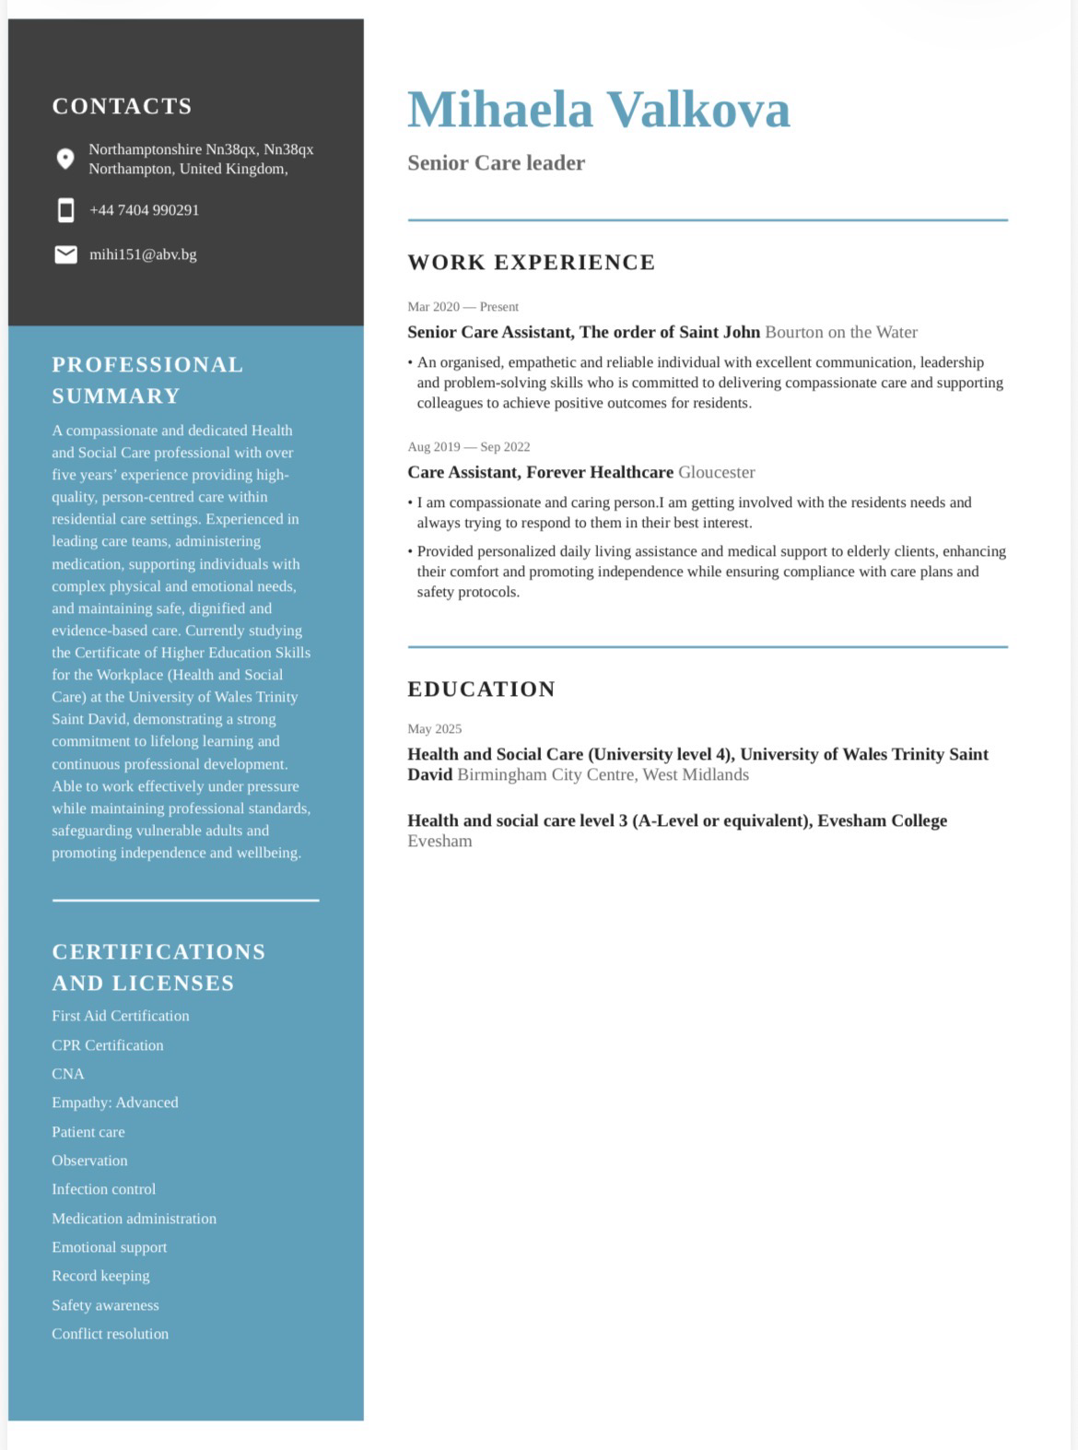
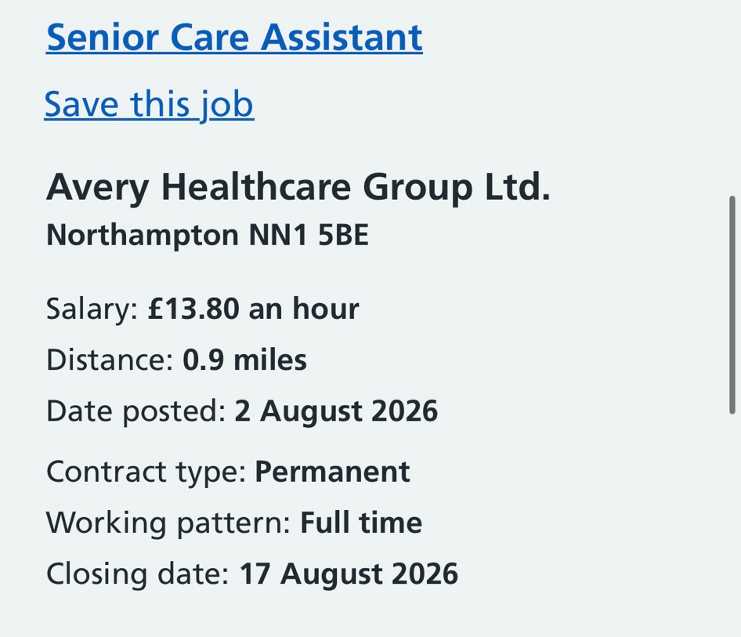

Job Advertisement

Job Title: Senior Care Assistant

Employer: Avery Healthcare

Location: Northampton

Job Summary

The Senior Care Assistant role involves leading care staff during shifts while delivering safe, compassionate and person-centred care to older adults. The successful applicant is expected to supervise care assistants, administer medication, maintain accurate care records, support residents with personal care, communicate effectively with multidisciplinary teams and families, and promote dignity, independence and wellbeing. The employer seeks applicants with excellent communication, leadership, teamwork and organisational skills together with experience working within residential care settings.

Task 1 – Professional Curriculum Vitae

Mihaela Valkova

Address: Northampton, Northamptonshire

Telephone: 07404990291

Email: mihi151@abv.bg

Personal Profile

Compassionate and highly motivated Health and Social Care professional with over five years of experience working within residential care. Experienced in leading care teams, coordinating daily care delivery, administering medication and promoting person-centred care for older adults with diverse physical and emotional needs. Currently studying the Certificate of Higher Education Skills for the Workplace (Health and Social Care) at the University of Wales Trinity Saint David to further develop my professional knowledge, leadership skills and career progression within the health and social care sector.

I am recognised as a reliable, organised and empathetic individual who works effectively under pressure while maintaining high standards of dignity, respect and safeguarding. I am passionate about improving the quality of life of vulnerable individuals and continually developing my professional practice through lifelong learning

Education

University of Wales Trinity Saint David

Certificate of Higher Education Skills for the Workplace (Health and Social Care)

2025 – Present : Relevant Modules
- Professional Development within Health and Social Care
- Psychology in Health and Social Care
- Communication in Health and Social Care
- Safeguarding and Professional Practice
Employment History

Care Leader
The Orders of St John Care Trust
March 2020 – 2026

Key Responsibilities

- Led care staff during daily shifts to ensure safe, effective and person-centred care.
- Administered medication in accordance with organisational policies and best practice.
- Supported residents with personal care while promoting dignity, independence and choice.
- Maintained accurate care documentation and electronic care records.
- Liaised with nurses, GPs, families and multidisciplinary teams regarding residents’ care.
- Supported and supervised junior members of staff.
- Ensured compliance with safeguarding procedures and infection prevention policies.
- Responded effectively to emergencies and changing resident needs.
- Promoted a positive, compassionate and respectful care environment.

Key Skills

- Leadership and Team Management
- Excellent Communication Skills
- Person-Centred Care
- Safeguarding Adults
- Medication Administration
- Dementia Care
- Care Planning
- Record Keeping
- Infection Prevention and Control
- Risk Assessment
- Problem Solving
- Organisation and Time Management
- Emotional Resilience
- Compassion and Empathy
- Teamwork
- Professional Training

- Moving and Handling
- Medication Administration
- Safeguarding Adults
- Infection Prevention and Control
- Fire Safety
- Basic Life Support
- Equality, Diversity and Inclusion
- Mental Capacity Act
- Dementia Awareness

Personal Qualities

- Compassionate
- Honest
- Professional
- Patient
- Reliable
- Adaptable
- Responsible
- Calm under pressure
- Positive attitude
- Strong work ethic

Interests

- Continuing Professional Development
- Health Promotion
- Reading healthcare literature
- Gardening and sustainable food growing
- Spending quality time with family
- Community wellbeing

Task 2 – Personal Statement

I am a compassionate, dedicated and hardworking Health and Social Care professional with over five years of experience working within residential care. Throughout my career, I have developed a strong commitment to providing high-quality, person-centred care that promotes dignity, independence and wellbeing. I am applying for the position of Senior Care Assistant because I am passionate about supporting older adults to live fulfilling lives while contributing positively to a multidisciplinary team that values professionalism, respect and continuous improvement.
My professional experience as a Care Leader at The Orders of St John Care Trust has allowed me to develop a wide range of practical and leadership skills. During my employment, I was responsible for supervising care staff, administering medication, supporting residents with personal care, maintaining accurate care records and ensuring that care was delivered safely and compassionately. I regularly communicated with residents, their families, nurses, GPs and other healthcare professionals to ensure that each individual’s needs were met through a person-centred approach. These responsibilities strengthened my ability to work under pressure, prioritise tasks effectively and make informed decisions while maintaining high standards of care.

Alongside my professional experience, I am currently studying for a Certificate of Higher Education Skills for the Workplace (Health and Social Care) at the University of Wales Trinity Saint David. My studies have enhanced my understanding of safeguarding, communication, leadership, ethics and evidence-based practice. They have also strengthened my critical thinking and reflective skills, enabling me to evaluate my own performance and identify areas for continuous professional development. I believe that combining academic knowledge with practical experience enables me to deliver safe, effective and compassionate care that meets current professional standards.

One of my greatest strengths is my ability to build trusting relationships with residents and their families. I understand that every individual has unique physical, emotional, cultural and social needs, and I always strive to provide personalised care that respects their preferences, values and independence. I am also a calm and resilient individual who remains professional during challenging situations. My colleagues have often recognised me as reliable, organised and approachable, qualities that have enabled me to lead shifts effectively while supporting other members of the care team.

I recognise the importance of lifelong learning within health and social care. The sector is continuously evolving through new legislation, research and best practice guidance, making continuous professional development essential. I actively seek opportunities to improve my knowledge through university study, mandatory training and reflective practice. My long-term career ambition is to continue progressing into leadership positions within health and social care while maintaining the highest standards of compassionate, person-centred practice. I hope to undertake further professional qualifications that will enable me to take on greater responsibility and contribute to improving the quality of care provided to vulnerable adults.

I believe my combination of practical experience, academic study, leadership skills and genuine compassion makes me a strong candidate for the Senior Care Assistant role. I am committed to delivering safe, respectful and high-quality care while supporting colleagues and promoting positive outcomes for residents. I would welcome the opportunity to contribute my knowledge, experience and enthusiasm to your organisation while continuing to develop professionally within a supportive and forward-thinking healthcare environment.

Task 3a – SWOT Analysis

A SWOT analysis is a strategic planning tool used to evaluate an individual’s Strengths, Weaknesses, Opportunities and Threats. It supports self-awareness and helps identify areas for professional growth (Gürel & Tat, 2017). Conducting a SWOT analysis enables healthcare professionals to reflect on their current abilities and develop realistic strategies to improve their practice.
SWOT Analysis
Strengths | Weaknesses | Opportunities | Threads
Over 3 years experience as a care leader | Limited NHS experience | University education and further qualifications | Staff shortages within healthcare
Strong leadership and communication skills | Public speaking confidence | Continuing professional development | Risk of burn out
Compassion and person centred approach | Balancing studying family and career responsibilities | Carer progression into senior leadership roles | Changed in legislation and professional standards
Excellent team work and organisation skills | Desire to strengthen advance leadership knowledge | Growing employment opportunities within healthcare | Increasing complexity of residents needs

Strengths

One of my greatest strengths is my extensive practical experience in residential care. Having worked as a Care Leader for over five years, I have developed strong leadership skills while supervising care staff, administering medication and ensuring high standards of person-centred care. This experience has strengthened my confidence in decision-making, delegation and supporting colleagues during busy shifts.

Another strength is my communication skills. Throughout my career, I have worked closely with residents, families, nurses, GPs and multidisciplinary teams. Effective communication is essential within health and social care because it promotes continuity of care, reduces misunderstandings and improves patient outcomes (NICE, 2023).

I am also compassionate, patient and empathetic. I understand the importance of treating every resident with dignity, respect and kindness while encouraging independence wherever possible. These qualities have helped me build trusting relationships with residents and their families.

Finally, I have demonstrated commitment to continuous professional development by studying for a Certificate of Higher Education in Health and Social Care while balancing family responsibilities. This demonstrates resilience, determination and effective time management.

Weaknesses

Although I have developed leadership experience within residential care, I recognise that I have limited experience working within NHS settings. Healthcare environments vary considerably, and I would benefit from gaining broader experience working alongside different multidisciplinary teams.

Public speaking is another area I wish to improve. While I am confident communicating with residents and colleagues, delivering presentations to larger groups can sometimes affect my confidence. Improving these skills will enhance my ability to educate colleagues and participate confidently in meetings and professional development activities.

I also recognise that balancing university studies, family life and professional responsibilities can occasionally be challenging. Continuing to improve my organisational and time-management skills will help me maintain a healthy work-life balance while achieving my academic and professional goals.

Opportunities

The health and social care sector offers numerous opportunities for career progression and lifelong learning. Completing my Certificate of Higher Education will strengthen my professional knowledge and improve my employability for senior positions.

Regular training opportunities, including safeguarding, dementia care, leadership and medication management, will allow me to enhance my knowledge and maintain safe, evidence-based practice.

Another opportunity is the increasing demand for skilled health and social care professionals across the UK. This provides excellent career prospects, including progression into Deputy Manager, Registered Manager or Nursing Associate roles.

Participating in reflective practice, supervision and continuing professional development (CPD) will enable me to continually improve my professional competence and provide higher-quality care.

Threats

One significant threat within health and social care is staff shortages. Increased workloads can place pressure on care professionals, potentially affecting staff wellbeing and the quality of care delivered.

Another challenge is the rapidly changing nature of legislation, professional standards and clinical guidance. Healthcare professionals must continually update their knowledge to ensure safe and lawful practice.

Burnout is also a recognised risk within the care sector. Caring for vulnerable individuals can be emotionally demanding, making it essential to maintain resilience, seek support when needed and practise effective self-care.

Finally, increasing complexity of residents’ health conditions requires continual learning to ensure care remains evidence-based and person-centred

Task 3b – Personal Development Plan (PDP)

A Personal Development Plan (PDP) is an important tool that enables healthcare professionals to identify learning needs, set realistic goals and monitor progress throughout their careers. The following SMART goals have been developed based on my SWOT analysis and are designed to support my professional development over the next two years.

Development Goal (SMART) | Actions | Resources Required | Timescale | Success Criteria / Evaluation
Goal 1: Improve my leadership and management skills to prepare for progression into a Deputy Manager role within two years. | Complete leadership and management training, shadow senior managers, attend supervision sessions, seek regular feedback from experienced managers. | Employer training, university learning materials, Skills for Care resources, mentor support. | 24 months | Successful completion of leadership training, positive manager feedback, increased confidence in supervising staff and managing shifts.
Goal 2: Improve my confidence and effectiveness in public speaking and professional communication within the next 12 months. | Volunteer to lead team meetings, deliver university presentations, participate in communication workshops and practise reflective speaking. | University presentation opportunities, online communication courses, lecturer feedback. | 12 months | Increased confidence when presenting, improved presentation grades and positive feedback from lecturers and colleagues.
Goal 3: Expand my clinical knowledge by completing at least four Continuing Professional Development (CPD) courses in dementia care, safeguarding, medication management and person-centred care over the next two years. | Complete accredited CPD courses, attend webinars, read current NICE guidance and reflect on learning within a professional portfolio. |  | Ongoing

Conclusion

Completing this SWOT analysis has enabled me to reflect critically on my current knowledge, skills and professional attributes in relation to the Senior Care Assistant role. While I have developed strong leadership, communication and person-centred care skills through my previous experience, I recognise the importance of continuing professional development to address areas for improvement. The Personal Development Plan provides clear and achievable goals that will support my career progression and enable me to deliver high-quality, evidence-based care while meeting the expectations of employers and professional standards.

Task 4 – Reflection Using Gibbs’ Reflective Cycle (1988)

Reflection is an essential component of professional practice within health and social care because it enables practitioners to evaluate their experiences, identify areas for improvement and enhance future performance (Gibbs, 1988). Reflective practice supports continuous professional development and contributes to the delivery of safe, person-centred care. This reflection uses Gibbs’ Reflective Cycle to evaluate my experience of delivering a university presentation.

Description

As part of my Certificate of Higher Education in Health and Social Care, I was required to prepare and deliver a presentation to my classmates and lecturer. The presentation involved researching evidence-based information, organising key points into a clear PowerPoint presentation and communicating the information confidently within the allocated time. The purpose of the presentation was to demonstrate academic knowledge, communication skills and the ability to critically evaluate information relevant to health and social care practice.

Feelings

Before delivering the presentation, I felt extremely nervous and anxious. Speaking in front of a group has always been one of my weaker areas, and I was concerned that my nerves would affect my performance. I worried about forgetting information, speaking too quickly and appearing unconfident.

However, once I began speaking, my confidence gradually increased. Seeing that the audience was listening attentively helped me remain focused. By the end of the presentation, I felt proud that I had completed it successfully despite my initial anxiety. Receiving positive feedback from my lecturer and classmates increased my confidence and demonstrated that preparation can significantly reduce anxiety.

Evaluation

Several aspects of the presentation went well. My slides were well organised, visually clear and supported the information I was presenting. I maintained professional language, answered questions appropriately and remained within the required time limit. The research I had undertaken allowed me to explain the topic confidently and support my points with relevant evidence.

The presentation also highlighted areas requiring improvement. Although I communicated clearly, I noticed that I occasionally spoke too quickly because of nervousness. At times I relied heavily on my presentation slides rather than maintaining consistent eye contact with the audience. I also realised that greater confidence when speaking spontaneously would improve audience engagement.

Overall, the experience was positive because it increased my confidence while identifying practical areas for future development.
Analysis

This experience reinforced the importance of preparation, communication and reflective practice within professional development. Effective communication is recognised as a fundamental skill for health and social care professionals because it promotes understanding, teamwork and positive outcomes for service users (NICE, 2023). Delivering presentations also develops confidence, leadership and the ability to communicate complex information clearly.

According to Gibbs (1988), reflection allows individuals to learn from experience rather than simply repeating it. By analysing both the positive and negative aspects of my presentation, I have gained a deeper understanding of my strengths and areas requiring improvement.

The presentation also strengthened transferable skills that are essential within health and social care settings. As a Care Leader, I regularly communicate with colleagues, residents, relatives and multidisciplinary professionals. Developing greater confidence when presenting information will improve my ability to lead team meetings, provide guidance to colleagues and contribute effectively during professional discussions.

Furthermore, the experience highlighted the importance of lifelong learning. Health and social care professionals must continually develop their knowledge and communication skills to ensure they provide safe, evidence-based and person-centred care. Reflective practice enables professionals to adapt their behaviour, improve performance and maintain high standards throughout their careers.

Conclusion

Reflecting on this experience has helped me recognise that although public speaking remains an area for improvement, I successfully demonstrated effective preparation, organisation and subject knowledge. The presentation increased my confidence and showed that careful planning and practice can significantly improve performance.

I have also recognised that developing stronger presentation skills will benefit my future career, particularly as I progress into leadership roles where clear communication and confidence are essential. This experience has encouraged me to continue challenging myself by participating in future presentations and seeking constructive feedback to improve further.

Action Plan

Following this reflection, I have identified several actions that will support my future professional development.

Firstly, I will continue volunteering to deliver presentations during my university studies to increase my confidence when speaking in front of groups. Repeated exposure will help reduce anxiety and improve my communication skills.

Secondly, I will practise maintaining eye contact, controlling my pace of speech and relying less on presentation slides. Recording myself during rehearsals will allow me to identify areas requiring improvement before future presentations.

Thirdly, I will seek regular feedback from lecturers, colleagues and peers following presentations and professional discussions. Constructive feedback will help me identify strengths and implement changes to improve future performance.

Finally, I will continue engaging in reflectivet practice throughout my career. Maintaining a reflective diary will enable me to evaluate my experiences, monitor my progress and identify opportunities for continuous professional development. This will support my ambition of progressing into senior leadership roles within health and social care while maintaining the highest standards of professional practice.

References
Gibbs, G. (1988) Learning by Doing: A Guide to Teaching and Learning Methods. Oxford: Oxford Polytechnic.
Gürel, E. and Tat, M. (2017) ‘SWOT analysis: A theoretical review’, The Journal of International Social Research, 10(51), pp. 994–1006.
Health and Care Professions Council (2024) Standards of Conduct, Performance and Ethics. London: HCPC.
National Institute for Health and Care Excellence (2023) Shared decision making. NICE Guideline NG197. London: NICE.
Nursing and Midwifery Council (2018) The Code: Professional Standards of Practice and Behaviour for Nurses, Midwives and Nursing Associates. London: NMC.
Skills for Care (2024) Continuing Professional Development for Adult Social Care. Leeds: Skills for Care.
Skills for Care (2024) Leadership in Adult Social Care. Leeds: Skills for Care.
Department of Health and Social Care (2023) Care Workforce Pathway for Adult Social Care. London: DHSC.
Weston, K. (2023) Reflective Practice in Health and Social Care. 4th edn. London: Learning Matters.
Brooker, D. and Latham, I. (2023) Person-Centred Dementia Care. 3rd edn. London: Jessica Kingsley Publishers.

