Cian West
2004900
Advanced Character Animation

Assignment Video

https://youtu.be/XtL1aWAKmiM?si=KWrpjtHcgH2OGTbq

Background

For the animations I will be creating, I will be looking at my ‘Independent Project’ idea for elements I can animate. My ‘Individual Project’ follows a knight going up against a human infected by a parasitic creature. The knight uses several different techniques at first which the creature avoids by keeping its distance, but once it comes in to attack by slashing and spitting acid, which although does render the knights shield useless, it leaves itself open, and the knight sees an opportunity to strike, beheading the creature in one slash.
Creating these animations will help in constructing my final project as I will have worked on movements that I deem to be some of the most important and allow me to take the skills forward for the ‘Independent Project.’ This will therefore speed up the process of creation, increase my confidence, which will reduce mistakes and lower stress which will increase the workflow.
For these animations I will be using a low poly basic model. It is simple to use but works well. It also works since both of my ‘Individual Project’ characters are make, and the model I will be using for these three movements is also male.
The first movement I want to create is of a model cautiously walking forward, as if to be quiet. They will be stood up, not crouched, and hunched a little bit forward. They will be walking slowly as to get across that they do not want to alert anyone. I want to make their movements heavy as they will be wearing armour in the Major Project animation. I do struggle with walk cycles, as I normally get the timing and foot positioning, so this animation will be out of my comfort zone. This is the reason I am choosing it though, as more practice and attention to it will improve my skills ready for the ‘Independent Project.’
The second movement I will be creating is of a model crouched down, but then gets up hastily after looking behind it. For this movement I want to get across that this person is stumbling to get up, as if they are drunk. I want to go with this as I want my creature in my ‘Individual Project’ to be having some difficulty controlling its host, as it is still getting used to controlling them. I do not want to overdo this though, as if I did I might run into the problem of it looking too comedic. This is more in my comfort zone, although the foot positioning will be a challenge for me as I regularly make the feet look as though they are not on the same plain. The rest though, is something I feel I can do. I believe I can do well with the timing on this one specifically as it is not like a walk cycle, in the sense that the timing is the most important aspect.

My last movement will be of the model swinging a sword. These will be basic sword swinging techniques. There will be a multitude of techniques, such as, thrusting, slashing, etc. I want to get across that this person is experienced, so I will be focusing on making these slashes and thrusts weighted and powerful. I will be using a primitive rectangle for the sword and attaching it to the hands. This will prove to be the most difficult animation for me; therefore, I will need to focus on this one a little bit more than the others. I have never animated a model with an object attached to it. I will be gaining the most knowledge from this animation due to what I have just gone over previously. Since I want to animate different sword fighting techniques, I will be separating them into their own animations and not one long animation. This will ensure that I do not have to worry about creating a smooth transition between each and can focus on the main animations.

I have chosen these movements as I believe understanding how to create them will help significantly in creating my ‘Individual Project’. These animations will also be the most challenging, so understanding them earlier on will benefit me.
For research, walk cycles will be of benefit to me. More specifically slower walks with weighted movements. Also, traditional sword fighting techniques used by knights in the medieval era. I want to home in on making it feel accurate to how they would have fought in history. For the crouched to standing movement, it will be best to investigate studying real life movements of humans. I can investigate how people move when drunk too.

Research

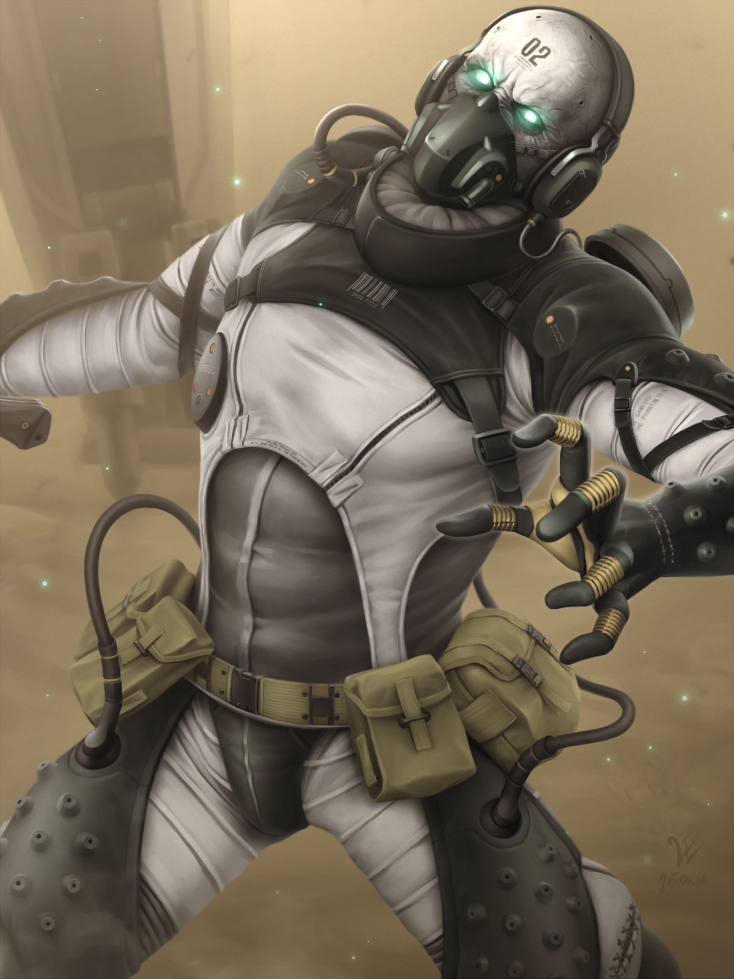
For research I have investigated a multitude of different areas. Including clips from films and games to photos for sword-fighting techniques. For uncanny and unnatural movements, I looked at the videogame ‘Metal Gear Solid V: The Phantom Pain’. Specifically, the antagonists the ‘Parasite Units’, also known as ‘The Skulls’. Their speed does not offer any significance to my animation, but their rigid and awkward movements do. The image to the left shows how they look.

I also looked at a scene from ‘The Grudge’ from 2004. This scene had the antagonist crawling down the stairs in an incredibly strange and inhuman manner, in which the antagonist movements were shaken and jittered. It was not as extreme as what I am going for in my animation, but it is perfect for the style I am after.

Another scene from a film I investigated was one from ‘In the Mouth of Madness’ it involves a woman on all fours with her head and body twisted in an inhuman way as she follows the protagonist around.

Another area of research is walking cycles. These will help train my understanding of timing and fluidity. Kevin Parry is a suitable place to start with this in mind. I cannot find the specific movement I may be looking for, but a slower paced one will nonetheless be of immense help in the portrayal of caution.

For my sword fighting animation I have looked at steps of the process to achieve the movements I want. For the animation I am doing specifically, I have looked at sword thrusting movements.

In addition to the sword fighting animation, I investigated how to attach objects to a model. At first I looked at written tutorials to follow along with but found that angle to be confusing to follow. I moved onto YouTube videos afterward which was far more helpful for me to follow along with.

Infected Human Animations

When creating the movements for the creature I decided to add some flares of rigidness and abruptness to the movements. Making it uncanny in its expressions through its movements and body language. This helps capture the idea of the strange and disconnection this creature has to human movements. I also add some completely inhuman movements to the animations too. This includes joints bending in impossible ways for humans and rotating a full 360-degree cycle.

Knight Animations

I animated the walk cycle for the knight before I had figured out how to attach objects to models, resulting in its empty hands. The animation I figured this out for was the sword fighting. I struggle a great deal with walk cycles, due to my timing always being off in some way or another. I posed the walk cycle as if the character were holding a sword and shield. I believe even without these two objects present, that I still get this across. Something I believe I do not get across is the idea that the character is walking ‘cautiously’. The pose, yes. With it’s bent legs and torso turned slightly to better place himself behind his shield. But the speed and timing no. They feel too quick to be considered cautious.

Changes

I decided to change the ‘eating to standing’ animation from one singular animation to two separate ones. This creates a snappier and more to the point animations. This result is more suitable for the animation reels. The image below displays the animation was one single animation.

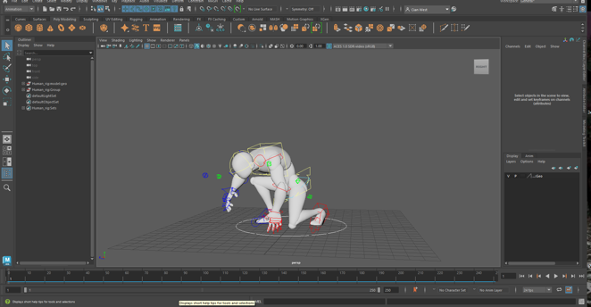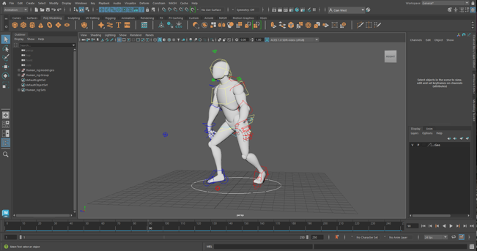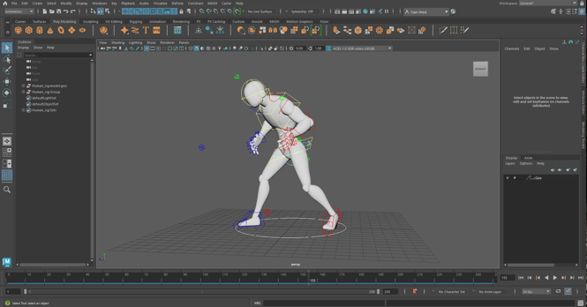

When it came to the addition of the jittery movements, those came after separating the animation into 2 different clips. I had done an animation with streamlined movements; I had done this as I did not think of having those rigid and unnatural movements beforehand. I got the idea for those flares from feedback with my lecturer. It helped with isolating the two scenes which allows for viewers to focus on the smaller details between each more. Also, I had to redo those jittery movements too, since I selected the incorrect ‘Delete by history’ box. This caused the animation to disappear, but the IKs still moved with what I had animated.

Another change I made was scrapping one of the sword-fighting animations. This was due to me struggling a great deal with getting what I wanted from it. I could not position the arms in a manner I was happy with. Animating those arm movements were more difficult though due to having a challenging experience with the arms clipping through the body. I am keeping the thrust attack animation as I believe I will have more success with that one, as the movement is more straightforward for me. Here is the pose I had done for the original sword fighting animation.

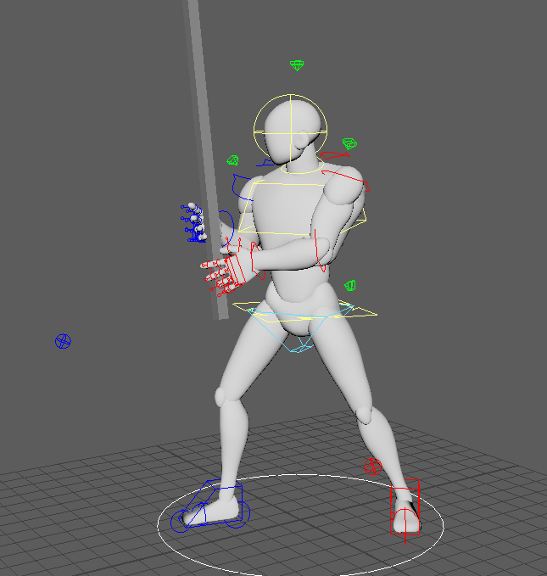

Graph Editor

I was able to use the graph successfully in the process of animating. I did find certain sections to be a bit of a struggle, since trying to find the correct axis when it came to the movements with the rotate tool. These movements were only subtle to correct the position of limbs and such. During the time I was using the graph editor I had found out you could change the selected point to only move up/down or right/left if you clicked on the right option. This was so helpful and cut down the time it would have taken if I had not found that option. This image is of my crouched eating animations graph editor.

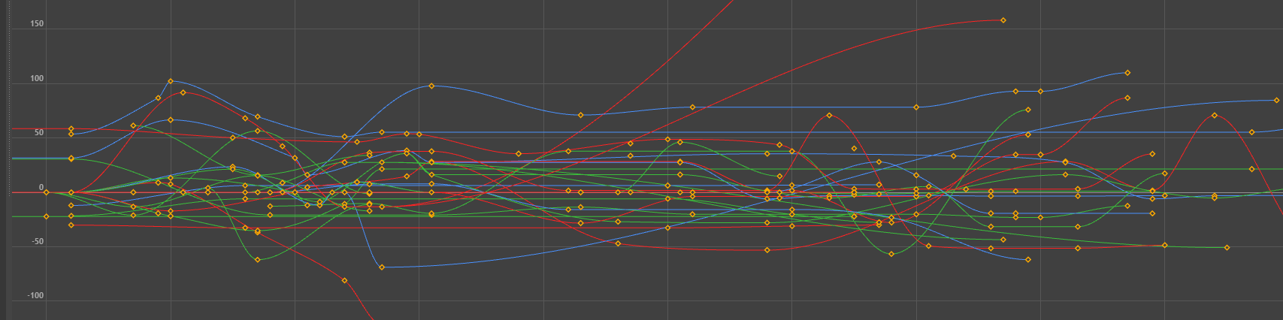

Conclusion

For the crouched animation and standing up animation, I believe I got across the idea of this character moving in an unnatural way without it coming across as a mistake when animating, I also find the timing of certain actions to be decent too, for example the start of the eating animation, which showcases the character hunched over and gorging on something. I believe this animation works as there is good pacing to it. Also, the frantic nature of this character works due to short, keyed movements. An area I believe I could have improved upon would be the execution of the rigid and jittery actions. On one hand I believe it does translate but on the other, I would like for it to really get the idea across that this creature inhabiting this human Is foreign to moving its host's body. Exaggeration is present in these two animations, from their gestures to their poses. The timing of certain actions is also heavily exaggerated too. There are overlapping actions within these animations too. From fingers moving whilst the arms are, to the legs effecting the torso.

Moving on to the walk cycle, I am happier with the results of my efforts with this animation more than my previous attempts at walk cycles in the past. Although the timing can be improved, this is a step in the right direction for improving upon the foundation of my knowledge on walk cycles and their intricacies. Another area I did a decent job with is the smaller details in the upper body movements. I tried focusing more on having more subtleties to add more weight and depth to the overall animation and believe I achieved that to a certain extent. Although more research will be necessary in understanding those micro movements when walking more. Another thing to talk on would be the lack of objects in the scene. If I had known how to add object to models, making it look like their holding on to something, I could have really gone beyond with the result. I did not add any objects afterwards since there are necessary actions to attach objects that I do not think would have worked with a finished and animated model since the object needs to be at a 90-degree angle to attach properly and the character is needed to be in an A-pose or T-Pose when attaching.

When it comes to the sword fighting animation, I am disappointed in the fact that I could not accomplish multiple animations of different sword fighting techniques done due to having a really challenging time with posing and timing with the ‘overhead sword slash’ animation. I just could not get the positioning of the limbs to work how I wanted them to. After completing the thrust animation, I can say that I am not too fond of the outcome. Although it was more forgiving to me than trying to animate the overhead slash animation. It still proved to be a challenge. Getting the hands to line up on the object that is supposed to be the aword was incredibly frustrating and the result could have been better. The posing is stiff and feels unnatural and the actions are slow. Overall, this is my least favourite animation out of the few that I have done, but the experience was still needed and appreciated for future work. I did succed in using secondary actions though since the pull back and resting on the shoulder emphasises this characters main action.

Overall, I am happy with the end results of my work but can see and understand that there are things I could have done better, and if given the knowledge, could have achieved more. Areas I believe I will need to better myself in, are, timing and having more understanding of how the body moves and how the body reacts in subtle ways to those movements. I was able to gain more of an understanding of the graph editor too whilst working through the animations, which will be an incredibly useful and Important skill when working on my independent project. I believe the process of working through this module will be extremely Important to the progress I make on my independent project.

I used staging for all these animations as they are easy to read and understand. The camera is fully focused on the main character and positioned to show everything that is of importance that the character is doing.

References

https://youtu.be/gL5p7Orf-ko?si=YkHxHH9diXrOF-hm

https://youtu.be/xQDoiMq5HzU?si=SSGR8GeNpzcZce88

https://villains.fandom.com/wiki/%22Skulls%22_Parasite_Unit

https://www.deviantart.com/woodvile/art/MGSV-Skulls-Mist-564586094

