Name: Kalpana Chiranjilal Mahawar
Student number: 2133406
Course Name: MBA- General Management
Module: International Business (LCMB7014)
Lectures’ name: Jean Wang
Date of Submission:
Word count:

Table of Contents:

- Introduction________________________________________

- International Business Strategy of Harley Davidson__________________________________________
2.1. VRIO Analysis in Global Market______________________________
2.1.1. Different Consumer groups
2.1.2 Purchase behaviour of consumers

2.2. International Business strategy of Harley Davidson_________________
2.2.1. Bartlett & Ghoshal Model of International Strategy

- Economic and Political View of Australia____________________________________
  - Economic overview
  - Main sectors of Industry
  - Foreign Trade
  - Political Outline
3.5. U.S-Australia Relations
3.6. Bilateral Economic Relations

- Legal Considerations in Australia- Business Perspective____________________________________
  - Legal Consideration in Australia
  - Fair Trading
  - Business Contracts and Data
  - Intellectual property regulations
  - Employment Laws

6. Market Structure of Australia
6.1. Hofstede Dimension Comparison between Australia and United States
6.2. Harley Davidson in Australia________________________________________
6.2.1. Harley-Davidson in Australia- A visual Ethnography in Australia
6.2.2. Harley-Davidson Rules The Road Bike Market...In Australia

6.3. Entry- Strategy in Australia_________________________________________

- Recommendations__________________________________________
- Conclusion_________________________________________________
- References_________________________________________________

Executive Summary:
This detailed analytical report focuses on the Critical Analysis of the Internationalisation of the American Motorcycle Company- Harley Davidson. It Highlights the International Business Strategy implemented by Harley Davidson related to the home country United States and the Host Country Australia using analytical tool like Diamond porter Model to gain the competitive advantage in the market by competing with its rival market, Royal Enfield (Home country- India). It also analyses the political, economic and social situation of the host country, Australia and how it impacts the business directly and indirectly in a positive or negative sense. The Appropriate Entry mode of the company into the host market is also discussed in detail and how has it proven an advantage to the revenue and the business. Harley- Davidson has a huge fan following around the world and is one of the world’s largest manufacturers of Motorcycles with varied models of premium bikes. However, automobile industry being dynamic in nature has to be on the front- foot to cope with the changing market maintaining the brand image and the goodwill of the customers and the green-CSR technology to create the least impact to the environment. Since Automobiles contribute maximum to the pollution in the Environment, the Green- CSR is essential in order to sustain the reputation of the firm and to balance the business simultaneously.

Introduction:
The detailed report focuses on the American Motorcycle Manufacturing firm- Harley Davidson, which is one of the leading motorcycle companies based in United States and known for its traditional heavyweight with engine carrying capacity of greater than 700 cc premium bike. The report highlights the Political, economic and social aspects of Australia and how it impacted the business for Harley Davidson in Australia. The economic and political ties and the Trade relations between the two countries, i.e, The United States and Australia has benefited for the motorcycle brand and many other goods and services in terms of export and import and providing employment to large number of Population. The International Business strategy used by Harley Davidson to gain the competitive advantage in the market is also discussed. HD uses multi-domestic International Business strategy with low global integration since the parts and equipment for the motorcycle are only available and made in U.S and it does not have to deal with other nations to ensemble and its only area of focus is the trade relation with other country. It has high local responsiveness since they are not ready to compromise on their “Made in America” title and the aura.

Childhood friends William S Harley and Arthur Davidson had early fascination of bikes and they started working in their workshop to build their motorcycle, which was not up to the expectations. However, they worked on it and launched their first bike in January 1905. Harley Davidson sold 20,000 bikes to the soldiers during world war I and after its huge success it was sales continued in World War II as well. By 1920, Harley Davidson became the largest manufacturer of motorcycle in the world with 28, 189 machines produced and dealers in 67 countries. Harley Davidson also went through the period of Great Depression from 1929 to 1933 but they were able to survive the depression period and modified the design and engine. “The Company has survived numerous ownership arrangements, periods of poor economic health and product quality as well as fierce global competition. It has now become one of the world’s largest motorcycle manufacturer and iconic brand with brand loyalty”.

The VRIO Analysis for the Harley Davidson has also been done in detail in order to highlight how Valuable, Rare and Imitable is the motorcycle brand and it stand out and has deeply rooted the beliefs and gained customer’s trust.

The fair-trading practices in Australia, ease of doing business, the employment laws, legal structure of the country and the fair practices are critically analysed baes on the statistics and how it favours the U.S market to launch its business for more than 100 years. The Business Culture is also discussed which helped U.S firm adhering to similar cultural values and beliefs. The report also emphasis on the market entry strategy, i.e, of Harley Davidson in Australian Market and its Market structure.

International Business Strategy of Harley Davidson:

Different Customer Groups for Harley Davidson
Harley Davidson switched its business strategy to customer- oriented when its Japanese Motorcycle competitor and gained the customer’s loyalty with the image of high quality and lower-priced motorcycle. The detailed feedback from customers by conducting questionnaires and Interviews to change the strategy and the changes have been made on the basis of desire and customer’s expectations.

Demographic- Harley Davidson focus on the men aged between 18-25 . However, the Harley Davidson Street used by the company was to penetrate different market in the US and other countries as well. They are planning to target women as well who are fond of motorcycle (Pugliese & Cagan, 2002)

Geographic: Harley Davidson has not only focused on nice Audience in US, but also different audience that include women like Caucasian women, and people over 35 years of age. They have also made their entry into Australia market (Teerlink & Ozley, 2000).

Purchasing Behaviour of Harley Davidson’s Consumers:
When talking about consumer loyalty, Harley Davidson has very loyal customers because costumers do not purchase the bike because they do not have other options in market but only when they are intended to purchase them. The consumers are Passionate bikers from all over the world, sometimes they wear the T-shirt of the company logo (Coutinho, Mesquita, & Muylder, 2018). Harley’s hogs accounts for more than 10% of the U.S. bike purchases and more than 50% of the heavyweight motorcycle market. During several years, the purchase even exceeded the Production. As per Multiple Feedbacks carried out, that Consumers not only just purchase the motorcycle but also relate the symbol of status to the same, for instance the Users of this bikes are known to be “strongest and toughest man on road”. Harley rekindles the passions and declares the customer’s freedom which is the core competence of the company.

VRIO Analysis:

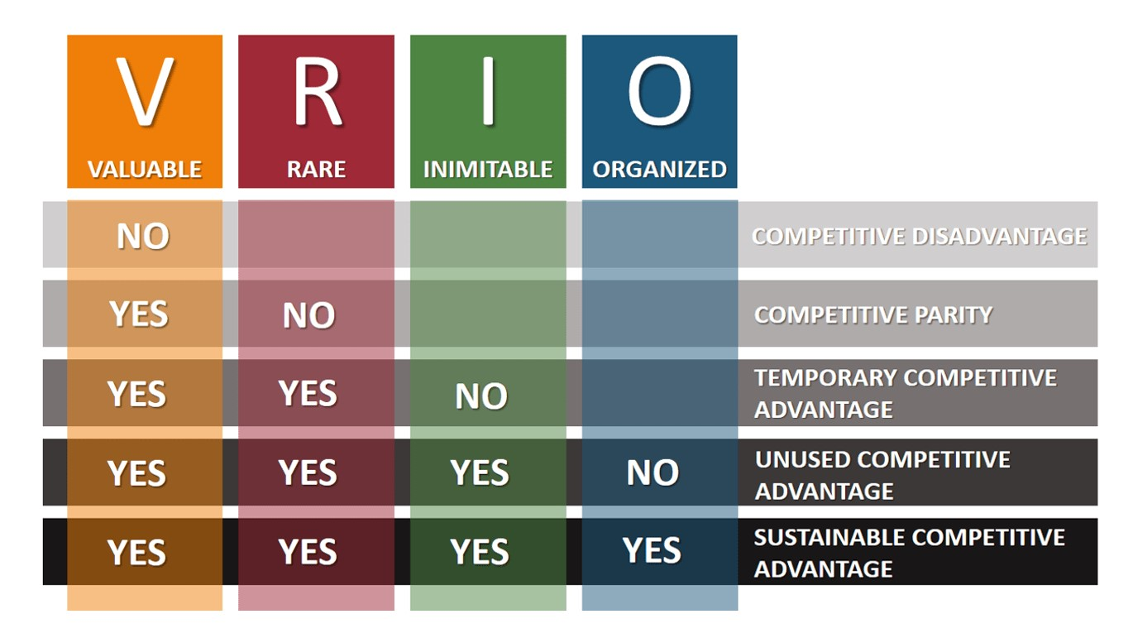
Image Source: https://www.essay48.com/assets/images/long-article/img3.jpg

“The VRIO is a strategic tool used to evaluate the resources of the company and determine its strategic advantage and competitive advantage and develop a sustainable long term competitive advantage.” The factors in VRIO that are used to analyse the competitive advantage are:

- Valuable
- Rare
- Inimitable
- Non- Substitutable/ Organization

VRIO in Global Market (Case Study-Harley Davidson):
Valuable: Harley- Davidson is a valuable brand because of its reputation among costumers, relationship with suppliers and ability to raise capital.

Brand Image for stakeholders and consumers: HD has a defined corporate social responsibilities action by regularly engaging in social responsibilities actions and makes them transparent. All the stakeholders are made aware about the company’s activities and the changes made. HD engages in CSR which help them to develop a competitive advantage and sustainable business goals. HD contain high brand integrity and has an image of a premium and royal product. The brand value lies in the loyalty of the customers. HS is also identified by its High Brand recognition.

Relationship with Suppliers: HD has excellent distribution system where they had successfully provided products to the countries where there are no operating units. They maintain a string relation with their suppliers with strict standards. And the distribution method is highly efficient.

Ability to raise Capital: HD is a firm with huge conjunction. They are able to raise the capital through internal resources and sources which is eventually important for the company’s expansion.

Rare: Harley- Davidson is a firm that possess a rare nature because of its Premium range of motorcycles.

International Presence: HD has considerable presence in multiple countries because of the rare image that it carries in its model and design. This has allowed HD to expand the market and not only gain exposure to higher financial strength but also to varied cultures and international recognition.

Innovative approach: The Innovative approach to foster to the look and comfort to the riders has allowed HD to gain Competitive advantage in the market. There are very rare motorcycle company that meet these criteria as majority of them lack the royal look of the model.

Imitable: This quality makes it difficult for the competitors to imitate them and hence this is one of the competitive advantages for any firm.

Quality product and competitive pricing: The Quality of HD is so high that others find it almost difficult to imitate. HD have efficient production capacities that operated at economies of scale and have controlled operational costs. However, the price of the product is such that only customers with above-average income can afford.
Customer Experience: HD provides very unique customer experience by offering them high brand engagement with the experience that is memorable. The company engages with customers at multiple occasions and provide them integrated approach.

Organization: Some of the organizational traits that Harley- Davidson possess is very unique and allows them to exploit the market that its competitors lack.

Financial Strength: The strong financial backup of HD has helped them to exploit opportunities for new product developments. They are also able to focus on innovation because of its financial strength.

Technological Integration and advancement: The Technological Integration and advancement has allowed HD to maintain efficiency in its various business process and operations. It has also been helpful in logistic management.

Employee training: HD provides in- house training to its employees so that they can their desired job position and responsibilities. They also help them in professional and personal growth. They have a strong and committed workforce.

Production Capacity: HD has high production capacity. They have streamlined process helps in cutting the production cost and inventory management system provides a competitive advantage to the company.

Organizational Culture: HD has a supportive and Innovative Organizational culture because they not only focus on the business development but also on the employee development. They employees work in team and share a great bonding.

Harley Davison’s regional Expansion and International Business Strategy (Bartlett & Ghoshal Model of International Strategy):

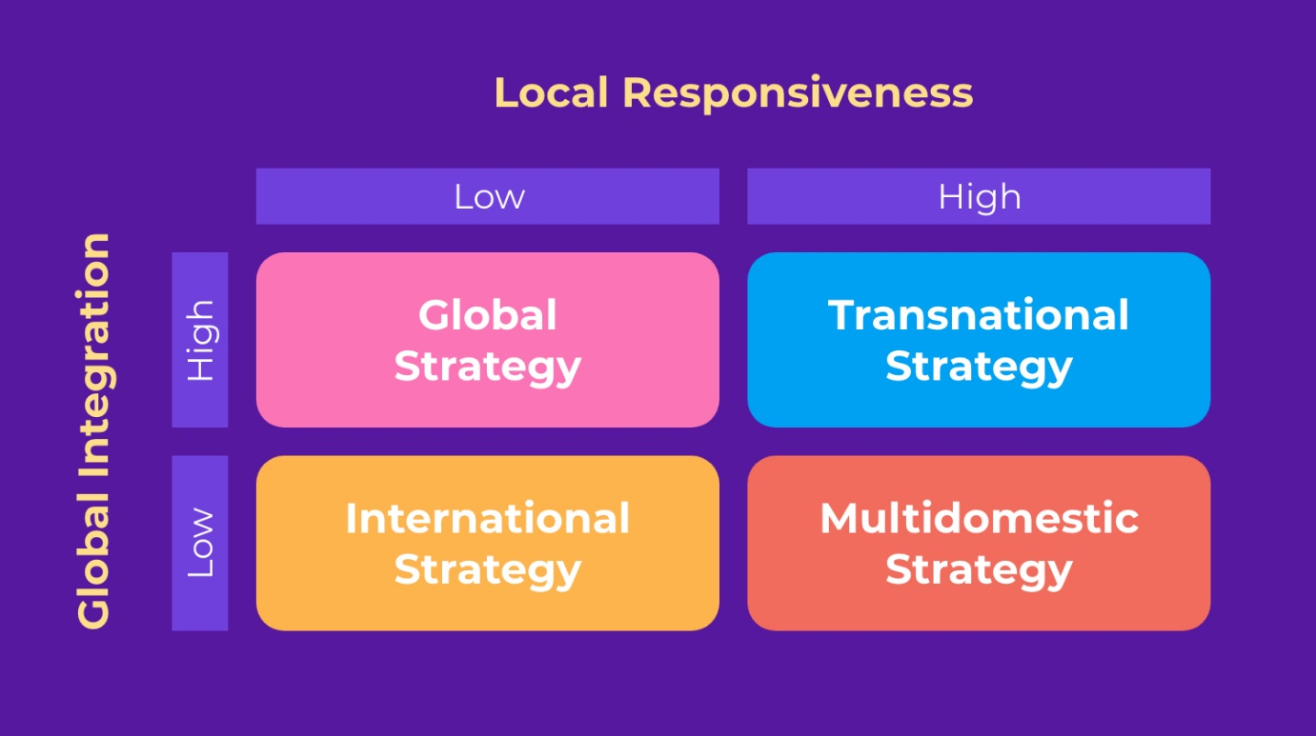

As per the report in 2010, Harley Davidson has its market in over 67 countries including North America, Europe, Asia Pacific and Latin America. Harley Davidson maintains the balance between the brand loyalty in its existing customer and the expansion of different market. Hence the Internationalisation Strategy that Harley Davidson uses is the Multidomestic Strategy. It targets the customers of a particular age group and gender. They do not have a broad Global integration and do not possess high pressure of the same because their production unit in only in United States despite of trading in different regions all across the world, the global integration is quite low as they do not have to ensemble for the resources from another country. Also, they have a smaller number of competitors in the global market that can compete with them and niche target market. Their response to the local needs is high, the consumer base in U. S. is always the highest and the most brand loyal because HD never fails to meet the demand of the U.S. Consumer and always focus on maintaining the “American by birth” image. By producing in the home country itself, they are providing employment to larger number of people including students which in turn boost the economy.

Harley Davidson main focus is bringing the piece of American dream overseas which is their core competence as well. They have worked on different markets by creating different marketing strategy to attract different segments of the customers. For instance, in Japan, HD offers more shinier and more complete tool kits compared to the United States. They have influenced Japanese and German market. Harley Davidson once thought of implementing the International Strategy through joint venture with other firms like Porsche, however they changed their mind and stick to the Multidomestic strategy because they wanted to represent the American Dream in other nations and if it would have manufactured or ensembled at any other place, the authenticity of “Made in U.S.A” would have been in question.
Recommendations: Harley Davidson if focus on overseas production would prove advantageous, because it will result in shorter turnover period. The Production and the shipping cost could be decreased.

Why is Australia an important market for Harley Davidson?
Aussies are fond of off-road bikes like Yamaha, Ducati, Kawasaki and Suzuki compared to the premium bikes like Harley- Davidson and Royal-Enfield (India). Hence it is a challenging market for Harley Davidson because of its style and model that Australian consumers usually do not prefer. That is also the reason that HD only holds 8.9% market share in Australia while Honda holds 24.6% market share as per 2020 report. It has also been noted that the sale of motorcycle in Australia in 2020 and 2021 has been low and prices are too high. The waiting time for bikes like BMW R nineT, a Yamaha Tenere 700 or an African Twins is too long for the consumers. HD may take advantage of this by selling the bikes in lesser time, because its demand is not too high in the country, hence the supply could be efficient and won’t be surplus, considering production and supply ratio of HD, which states that the production is less than the supply, it can prove advantageous to export in the market where other companies are unable to meet the demand. However, thinking the preference of Aussie consumers for off-road bikes it would be difficult to compete with the other companies like Honda and Suzuki, hence it is very crucial to understand the culture and needs of the country first and the modifications might be done according to the needs without compromising the traditional pattern of the model. The premium bikes are heavy to ride while more comfortable when it comes to long rides compared to the long-term unhealthy effects of the off-road bikes, hence to exploit the market with the competitive advantage convincing the consumers realise what is sustainable for them can bring a big change in the Australian market.

Economic and Political Overview of Australia

Economic Overview:
Australia was one of the highest growing economies among developed nations and has the most interrupted economy in the last 26 years since it never faced the recession when there was financial crisis going in other countries during 2007- 2008. Australia ranks 13th in the world’s economy with increasing contribution to GDP after covid during which the GDP growth amounted to -2.4%, however it bounced back to 3.5% in 2022.
The main sectors that amount to major economy in Australia are spending by Business and Government, large scale exports of agricultural products and a robust financial structure. However, the least contribution is from Household and consumer sector since citizen struggle with low wages and for any developed country, 60% of the economy is covered by the consumer spending which is not a case with Australia. As per the report of IMF October 2021, GDP for Australia is expected to grow to 4.1% in 2022 and 2.6% IN 2023. Post Pandemic recovery is difficult for developed nation as business were hampered to a greater extent due to rise in the Liquidation of the businesses. Also, the trade and border restrictions imposed by various nations, industries and firms during covid has created a huge insolvency in the business and is still continued for few considering the nature of the industries, for instance, education and tourism.
The rate of Inflation in Australia in 2021 was 2.5% compared to the pre pandemic level of 1.65 in 2019 and is expected to stabilise at 2.1% in 2022 and 2.2% in 2023 as per the World Economic outlook, 2022. There is the huge deficit in the government budget for the years 2020(pandemic time) which is -7.9% and 2021(post pandemic time) which is 8.1%, expected to recover to -5.8% in 2022 and -3.8% in 2023.
Support from Fiscal Policies like infrastructure spending, tax breaks and social transfers are lined up to boost the economy of Australia, the investment corporate profits, favourable taxation and the higher demand of infrastructure and services may benefit the economy. The tourism and education sector is expected to regain the momentum and the government is increasing its economic integration with the Asian and European countries to boost the economy through these sectors. Since China was the main source of covid as per WHO, the tense relationship with China hampered the business hugely.
The main challenge since Covid was in the areas like Employment, economy and public health. According to AMS (Australian Bureau of Statistics), the unemployment rate was 6.5% during pandemic compared to 5.2% pre pandemic and is expected to decrease to 4.8% in 2022 and 4.7% in 2023.

Main Indicators | 2020 | 2021 (e) | 2022 (e) | 2023 (e) | 2024 (e)
GDP (billions USD) | 1.00 | 1.00 | 1.00 | 1.00 | 1.00
GDP (Constant Prices, Annual % Change) | -2.1 | 4.9 | 3.8 | 1.9 | 1.8
GDP per Capita (USD) | 52 | 63 | 66 | 68 | 69
General Government Balance (in % of GDP) | -7.9 | -6.2 | -3.5 | -3.1 | -2.6
General Government Gross Debt (in % of GDP) | 57.2 | 58.4 | 56.7 | 58.6 | 60.5
Inflation Rate (%) | 0.9 | 2.8 | 6.5 | 4.8 | 2.9
Unemployment Rate (% of the Labour Force) | 6.5 | 5.1 | 3.6 | 3.7 | 4.2
Current Account (billions USD) | 32.48 | 51.45 | 36.61 | 13.35 | -9.27
Current Account (in % of GDP) | 2.4 | 3.1 | 2.1 | 0.7 | -0.5
Source: IMF – World Economic Outlook Database, October 2021
Note: (e) Estimated Data

Main Sectors of Industry:
The traditional business of Australia is Trading and is recently industrialised and has small scale of manufacturing operations. The industrial sector contributes to only 25.5% GDP and provides employment to just 19% of the population (World bank 2022). The Manufacturing industry comprises of food industry (27% of the workforce in 2021), machinery and equipment (20%), metal processing and metal goods (around 16%), the chemical and petrochemical industry(more than 10%) and building materials like wooden furniture and other ceramics(17% workforce).
The agriculture industry provided employment to 2.5% workforce and contributed to 2.1% of the GDP (World bank, 2022). Agriculture and mining are the main sectors of Australia’s economy and is one of the largest exporters of wool, meat, wheat and cotton.
The service sector holds the presiding position in the economy contributing to 66.3% of the GDP and employing 77.7% of the workforce as per World bank 2022. The Business and Financial growth has been the biggest growth in the sector. The fear in investors is still there considering the surge during covid times, however many economists has predicted that the GDP might rise to 4.7% globally.

Breakdown of Economic Activity By Sector | Agriculture | Industry | Services
Employment By Sector (in % of Total Employment) | 2.6 | 19.1 | 78.4
Value Added (in % of GDP) | 1.9 | 25.7 | 66.0
Value Added (Annual % Change) | -8.0 | n/a | 0.3

Source: World Bank - Latest available data.

Political Overview:
Australia is a Liberal Political party. The Current prime minister is Scott Morrison, who will lead the Liberal- National Coalition government until the next election in 2022.
The Main Political parties of Australia comprises of The Liberal Party, The National Party, The Australian Labor party, The former two parties are Conservative and center-right. The Australian Labor party is social democrat and Centre left.
The Executive part of Australia recognizes the British Monarch as its emperor. Queen Elizabeth II was the head of the state and is appointed as Governor general in Australia with a symbolic Function. The Prime Minister, the head of the Government, runs business of the state and appoints the cabinet. The Prime Minister is the elected leader of the party.
The Legislative Power of the Australian politics is bicameral and composed of the senate with 76 members and the House of Representatives with 151 members who are elected for a six-year term. The Prime Minister and the Cabinet are responsible for parliament of which they must be elected members.

How does Law and Regulations help to do business in Australia?
Australia rank in ease of doing business is high because of the tax rates, government incentives and transport regulations. Australia’s households have high disposable income and has a large consumer base. One of the richest and Technology- friendly economy in the world. The Government spend A$70 billion in federal, state and local grants to Australian based companies. They also provide huge number of incentives to non- Australian based companies. As per the report by Accenture, it is found that the average effective corporate tax rate is 20.6% which is almost 10% lower than the general tax rates of other countries like USA and UK. The Government also support R&D by providing Incentives, of almost A$20, Eligible small companies can claim a refundable tax equivalent to their corporate tax and Eligible larger companies can claim a non- refundable tax offset equivalent to their total business expenditure.

U. S Relations with Australia:

Border relations:
Australia and US are Friends and business partners. The countries have lot more in common like democratic values, interests and language. Economic and trade relations are vibrant and strong. 2020 was the year of the 80th Anniversary of diplomatic relations between the countries and their partnership promotes the peace and stability in Indo-Pacific region around the world.
The Bilateral ties between the two countries have a strong base of cooperation. Australia and U.S. have been with each other since more than 100 years since world war I. In 2021, the three countries Australia, New Zealand and U.S. marked the 80th anniversary of their ANZUS Treaty which was created to maintain the peace among three nations and fight against terrorism, which was invoked by Australia in September 2001 after terrorist attack in New York.

After the terrorist attack, the two countries have moved towards closer defense and security ties. In August 2014, both the countries signed U.S- Australia Force Posture Agreement at the Annual United states Ministerial Consultations (AUSMIN). They also signed joint statement for defense co-operation. The U.S and Australia shared common ties in navigation, aviation and marine including south China sea. Both the countries are engaged in trilateral engagement for infrastructure partnership with Japan and India is also a part of the collaboration. In September 2021, Australia, United Kingdom and The United States announced a trilateral security partnership (AUKUS) which aims to provide Australia with a standard armed, nuclear powered submarine capability. The aim of the partnership is to provide advanced military capabilities to strengthen security in the Indo-pacific region.

Not just the border relations, U.S and Australia also share a long history of cooperation in other sectors like Fulbright Program which is a scholarship program between the two countries and more than 5,000 Australians and Americans have received the scholarship. The countries have also signed tax and defence cooperation treaties and health cooperation agreement, space, science and Technologies.

Bilateral- Economic Relations:
In January 2005, the fair-trade Agreement (FTA) between US- Australia came into force where the export of services and goods from U.S to Australia increased by almost 90% to 100% after 2004. In 2021, the trade of goods and services with Australia was US$61.1 billion. As per U.S Department of commerce, the export of goods and services to Australia supported more than 172,000 U.S Jobs in 2020. The Goods include machinery, vehicles, optical and medical instruments. The services include financial services, telecommunication, computer, IT and computer software licences.
Australia has proven profitable and tempting market for U.S Companies because of its low barrier to entry, similar legal and corporate framework. The two-way Foreign Direct Investment (FDI) totals $261.5 billion. In 2020, the total stock of Australia’s FDI into U.S was $98.0 billion. As per the government of Australia, U.S is Australia’s largest foreign investor. In 2021, the U.S. FDI position in Australia was $163.5 billion, led by finance and insurance and manufacturing companies.
U.S Forms have been operating in Australia for more than 100 years and employs more than 300,000 Australians. US Firms are also the highest taxpayers, wage payers and contributor of GDP of any foreign country operating in Australia.
Australia and U.S has signed mutual international organizations like United Nations, ASEAN Regional Forum, Asia- Pacific Economic cooperation (APEC), G-20. International Monetary Fund (IMF), Organization for Economic and Cooperation and Development (OECD), World bank, World Trade Organization (WTO) and North Atlantic Treaty Organization (NATO)

Legal Considerations When Doing Business in Australia:
Australia is one of the attractive economies and favourite for the foreign investment in the world. Apart from having an excellent GDP and a good job market, it also focuses on relationship with world’s most productive economies like U.S and UK, making it easier for them to make Australia as their Export Hub to continents including Asia and Europe. Because of its free trade agreement, it allows businesses from all the parts of the world to enter into its market, high standard of living and skilled talent pools to help the business prosper.

Does the Free Trading agreement mean that there are no barriers to firms in Australia for doing business. One of the biggest challenges of doing business in Australia is competing with local businesses and getting the grips of business laws.

Legal Considerations in Australia- Business Law
Some regranulations are listed below that a business has to take care of when doing business in India.

Director: While incorporating business in Australia, a firm must have at least one Australian director who is the resident of the country. If not possible, a nominee director could act to help with the trade in the country.
Licenses: Licence is required to legally operate the business in the country, however working with the local business analyst can help to speed up the process otherwise it might take too long. For instance, in the Australian Mining sector a special permit needs to be taken to prove that someone is competent to launch a safe mining operation.
Foreign Investors and Annual Reports: As a foreign investor, they had to follow the Foreign Investment policy. According to law in Australia, business organizations must report information about shareholders, directors, company executives and the company’s financial position in an annual return and depending on the scenario of the firm, this information may be displayed to public. In addition, the tax regulations must be followed and tax must be paid on time.
Confidentiality: Shareholders and directors’ identity are easily available on Australian Business register, in order to increase the business transparency and reduce the scope of corruption. This can be dangerous sometimes, hence in such cases, a nominee director of Australian resident can be useful to maintain the confidentiality.

Fair Trading:
There are range of laws and regulations for businesses of all shapes and sizes covering everything from product standards, competition, price regulations, trade measurement, product labelling, prize display and warranties and refunds to protect citizens and businesses as per “The Competition and Consumer Act 2020(CCA)”.

Business Contracts:
Unlike the other countries where contracts are bonded legally by making written contracts, Australia’s culture provides a more relaxed and informal approach, according to which a fee in exchange of a service binds a legal contract and it can be in the form of written agreement or hand shake. When collecting and keeping the personal data of the customers in business, a firm must adhere to the privacy laws. In Australia, the laws are similar to European Union’s General Data Protection Act.

Intellectual Property regulations:
A successful business requires strong brand identity and intellectual property rights and it is the responsibility of the company to take steps to protect the intellectual property to its brand name, trademark, business operations, franchise documents and its innovative business ideas.

Australian government offers complete IP protection service that include registration and enforcement services, dispute resolution processes, pursuing infringement and tortious actions as well as drafting of commercial/ intellectual property agreements like license agreement, assignment agreement and contractual provisions designed to preserve and protect IP rights. The ongoing IP Practice includes Managing several large trade mark portfolios and instructing agents around the world to file and oppose trademarks, dealing with various IP disputes in Australia and around the world including disputes between franchisee and franchisor, advising on selective distribution networks and their associated competition law issue, working with the international life sciences companies in ensuring that all the relevant IP assets are registered in Australia.

Talking about Harley- Davidson, its model and look is one of the its competitive advantage and its “American by birth” image is its trademark that it wanted to carry throughout the world. Australian government has been supportive to Harley Davidson to provide the intellectual property regulation in Australia while doing business.

Employment Laws:

Anti-Bullying: Australia has strong laws for harassment at professional place, which makes it a safer country for the employees and easier place for the directors and top management since they rarely have to deal with bullying and harassment.
Dismissal: Australia has brought out the small Business Fair Dismissal code, which offers guidelines to small and medium- sized businesses on how to dismiss employees on legal grounds. According to the rules, if any employee worked for the organization for more than six months and they claim for unfair dismissal, the firm must be in place to defend themselves.
Obligations: An Employer is Australia, must ensure their employees are paid the correct wages and on time, reimburse the employees for business related expenses and follow the work health and safety (WHS) regulations to create a safe and healthy environment for employees.
Insurance: As an Australian Business owner, the firm must have a worker insurance-compensation for each of the employees whether they are temporary or full-time staff.
Working with Children: There should be children check before entering into an industry that require children or young people at workplace. However, child labour is not illegal in some sectors in Australia.

Market Structure of Australia:
The place where goods and services are traded for cash or any other equivalent is referred to as a Market. Market is not just limited to the place; in economic sense it extends to the area where sellers and consumers operate.

The Australian market has a diverse economy ranging from different industries, market structure and public companies. An important determinant to an active economy is the market structure which includes monopoly, duopoly, monopolistic competition and oligopoly market. All the structure are unique and they can be categorized on the basis of degree of competition, pricing strategy and profit to the firm. The market structure focus on all the crucial factors of the business sector like number of firms and customers, the product type and influence on the market.
The Monopoly market is the one where there is no alternate option for a certain product or service. In such scenario, they enjoy the freedom to alter the price of goods and services without considering the market conditions and variations. If Australia, the electricity supply, the water supply and the public utilities are solely under the control of government. For instance, Sydney airport is the monopoly market in Australia, due to its strategic position in the Australian’s aviation market, because it is the sole airport which offers quality services to the passengers.

Oligopoly market is a place where there are limited number of competitors and is defined by the couple of firms delivering the almost all the yields. Talking about the Oligopoly market in Australia, it is one of the most common Market types. The Structure is because of the entry barrier due to financial resources and governmental regulations. Some of the oligopoly market in Australia are Coca- cola, Carlton United, Hoyts and Bridgestone. In the Market structure, the degree of product differentiation is high and advertising is the main feature of this structure. Telecommunication industry in Australia is also an oligopoly market structure, before the entry of other network providers Vodafone and Optus, Telstra was the sole company in the sector. It is noted that most of the markets in Australia are oligopoly market. As per the study conducted by UBS, the industries operating in Oligopoly market has 4.9% better performance than other companies.

If in an Oligopoly market, the number of entities are limited to two then it is termed as Duopoly market. For instance, the grocery sector in Australia was a duopoly market before the entry of German entity. It has now become oligopoly with competition from Costco, Aldi and SPAR. However, it has been assumed that the oligopoly market is going to be diminished from Australia’s market structure.

Monopolistic market is another type of market in Australia which is much widespread and central. This structure is considered as the perfect form of market structure because there is no limitation to entry and the departure of the firm and the product has similar but its own differentiating characteristics. This market is vulnerable to the dynamics in the market, the focus is on increasing the goodwill of the product and its brand value (Zhang and duan, 2010). For Instance, Starbucks left the Australian market after serving for eight years, because they were not able to compete with the local competitors who had hands on the taste preference of the Australians. Starbucks provided more standardized taste and even the price was too high.

It is observed that the market structure of Australia is mainly Oligopoly or duopoly. The Monopolistic market exists but is only limited to the public sectors.

Hofstede Dimension Comparison between Australia and United States:

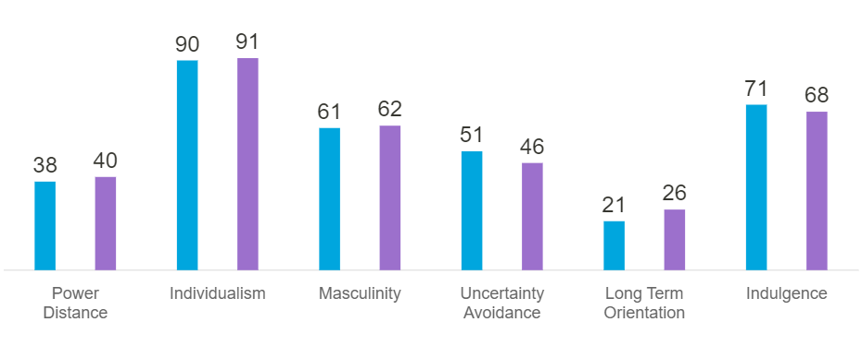

- Power Distance:
This is the factors which states that all the individuals in the societies are not equal and it is endorsed by the followers as well as the leaders. Australia scores low compared to U.S in this area, which is 36 as compared to 40 for U.S. That means in Australia, almost everyone is treated equally and their opinion matters while in U.S it is a bit more hierarchical.

- Individualism:
This is the factor which determine how much is the individualistic/ groupism approach in the market. Australia and US both stand at same place at 90 and 91 respectively which shows that both the countries follow the same culture of individualistic approach rather than a group approach where people only look after themselves or their family.

- Masculinity:
This factor determines from the gender perspective. The society where female has equal rights to men are considered more successful. Australia and U.S both have similar high ranking of 61 and 62 which states that they are Masculine society where winners are considered more powerful and people are proud of their success in both the countries.

- Uncertainty avoidance:
This is the factor where society has to do with the way that the future is never known to anyone and can’t be predicted accurately. Australia scores 51 while U.S scores 46 in this, which states that Australia is at intermediate level with avoiding the uncertainties of future while U.S is below the intermediate level and they are more relaxed to uncertain future compared to Australian.

- Long term Orientation:
This dimension describes how each society has to maintain links with its past while dealing with the challenges of the present and future. Australia scores 21 here, which states that they have normative culture, U.S also score low, i.e. 26, hence both the countries have great respect for their tradition, save less for the future and focus on achieving quick results.

- Indulgence:
This is the factor which measures the indulgence of an individual and the level to which they are socialized. Australia ranks high at 71 and U.S at 68, which states that their indulgence is good and people like to enjoy their life and take things easily.

Harley Davidson in Australia

A Visual Ethnography
Harley Davidson is a widely recognized iconic (American) symbol of Freedom, however Harley- Davidson has a global recognition in the world including Australia. More than three years of fieldwork in Australia, the brand has demonstrated absurd reality. Although, Australia is one of America’s greatest fans, there is rising tide of anti- Americanism in Australia (Shilkin 2002). Distinctly, Australian values are being eroded by the US culture, Disregard of any anti- Americanism sentiment, the work shows hardly Davidson to be readily embraced by a mainstream Australian subculture.
Contradictory to the American Harley- Davidson Community where riders are majorly male with beard look, Australian HOG are comprise of even professionals like lawyers and police officers and even women sometimes. Therefore, Australian HOG are classified as an ageless and classless subculture, where riders simply wanted to have fun and enjoy the participation in the HOG Subculture.

Australian Harley- Davidson brand is with the local director of marketing, Adam wright. He is looking for the sales, retail and operational roles looking after development of Harley- Davidson’s Australian distributor network. After a short period in London, he was given opportunity to lead Harley- Davidson’s project management in Sydney 2000 Olympic games, he then became the sales and marketing director for Harley Davidson in Australia. Australia was the first country outside the U.S. to establish a dealer network in 1917, wright committed to give a fresh image to the brand while still upholding its American heritage. Harley Davidson broke its Audience reach to women and young adults and 1 million Australian motorcycle license holders that don’t currently own their mode of transport.

Harley Davidson rules the Road Bike Market in Australia

As per the reports of FCAI, increase of 20.9% in the sales of motorcycle was recorded in Australia in 2021 with 8784 units sold, while off- road bikes recorded 88.9% boost with 11,642 bikes sold.

As per the reports of 2015, Harley Davidson was selling like a pancake in Australia with enough sales to supplant Honda as the best- selling, road-going motorcycle brand in the Land Down under. Harley Davidson like the became the market leader in terms of market shares and sales in Australia in the first half of 2015. From January to June 2015, Harley sold out 4,566 units in Australia, a steady improvement from 3,985 units sold in the first half of 2015. Two Harley models, i.e. Street 500 and the Softail- ke1819 are the most famous among Australian customers. As of June 2020, around 205 units of the Harley Davidson XG500 has been sold in Australia between January and June 2020. This represents an increase of 6.8% in 2020 figures and accounts for 30.17 percent of all the units sold in 2021. Harley- Davidson’s breakout is Australia’s biggest selling road bike outside of NBC110 Honda.

For a long time, Harley Davidson was considered purely as an American brand that was not successful to establish its image globally compared to its competitors. Success of HD in Australia has given them a great market value not just in Australia but globally as well. HOG would play a role by arranging events like racing competition and rallies across the world to create the brand awareness.

Harley Davidson in Australia- Eclectic Paradigm

More and more companies nowadays decide to expand their business by crossing domestic borders and relocating certain value chain activities abroad. There are two reasons for the expansion of the business, firstly, the companies are looking for natural, financial, technological and human resources, secondly the company is looking to expand to new customers or new market. Companies are looking to increase efficiency to create economies of scale to cut costs per unit.

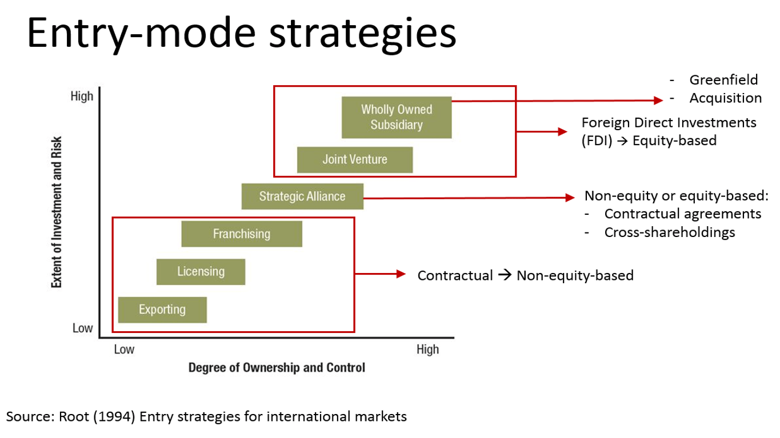

The various type of entry mode includes exporting, licencing, franchising, forming a strategic alliance, joint venture, acquiring, investment (start-up). The last three requires huge equity and therefore considered as Foreign Direct Investment (FDI).
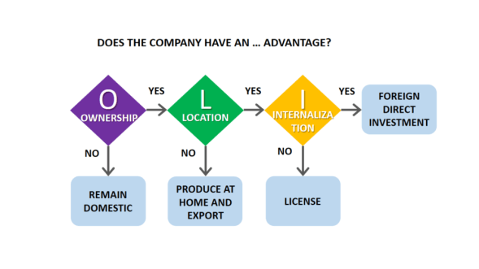
Exporting- Companies when selling their products/ services to foreign country is referred to as Exporting method.
Licensing- Companies when use their trademark or patent of other organization in foreign market is referred to as Licensing.
Joint Venture- Companies when enter foreign market with the help of partnership with domestic firm of that country is referred to as Joint venture.
Foreign Direct Investment(FDI)- When companies invest large sum of capital in foreign country, it is referred to as Foreign Direct Investment.

Harley Davidson has already established its operation in Asia-pacific region and in 2005, they founded their representative office in Shanghai, China and opened eight new dealership centres in China. In all the continents including Asia-pacific and Europe the entry method used is either exporting or wholly owned subsidiary. Talking about Australia, Harley- Davidson expanded its market in Australia in 1917 outside U.S. and hence Australia became 2nd country for HD after U.S.

What Advantage does Harley has when talking about the host country-Australia?

Ownership advantage-Yes
Any company needs an ownership advantage in order to overcome the liability of foreignness. Ownership refers to as possession of a certain valuable, rare, hard- to- imitate and organizationally embedded resources that allows a company to gain competitive advantage compared to foreign rivals, For instance of Harley Davidson, the model, look and the design of the counterpart bike is the competitive advantage. Also its brand value and reputation owing to the loyal customers who just does not purchase HD for the sake of transport but for a status. Hence, HD has Ownership advantage in the host country- Australia.

Location Advantage- No
The host country must offer compelling geographical advantage to make it worthwhile to undertake FDI. Yes, Australia was offering the advantages like cheap raw materials, a cheap labour compared to U.S. because of the cheap value of Australian dollar compared to U.S dollars. Also since Australians are more physically tough and technologically advanced at the same time, there is availability of skilled labour and Australia is providing the least taxes, but it was the decision of HD to not launch their production plant in any other country apart from U.S to maintain its “American by birth”, image.

Internationalization- Yes
Internationalization has to do with the supply chain or the value chain. Sometimes the company prefer external party supply chain rather than in-house due to the fact that they are better at it, are able to develop it at cheaper rate, have more local market knowledge, or because they want to focus more on other areas like Marketing and design. The company continues to establish long-term, mutually beneficial relationship with it suppliers. Through a continued focus on collaboration and strong relationship with suppliers the company believes it will be positioned to achieve strategic objectives and quality improvement. HD purchases all its raw materials, steel and aluminium castings, forgings, steel sheets and bars. They also purchase certain motorcycle components like electric fuel injection, battery, wheels, tires, seats, etc.
The company operates a manufacturing facility in Australia for producing wheels, HD has restructured these operations by transitioning some amount of wheel production to other existing suppliers to produce complex, high-finish wheels in a cost-effective manner.

Recommendations:
Harley Davidson has not captured Asian motorcycle market fully, especially India. Recently, the company entered in Indian market with 12 new models and Asia was dominated by Japanese companies like Honda and Yamaha, however, the customers are not happy with the quality of these bikes and the service. Indians are fond of classic bike and they have their own company, i.e. Royal Enfield. India is a great market for HD considering the customer’s preference but not in terms of the geography because of the crowded roads where it would be difficult for the riders to feel the adventure. But India is a land of mountains and highways, hence it can prove a successful venture in India with either joint venture with Royal Enfield or through Licensing/Franchising because of the current market structure of India.

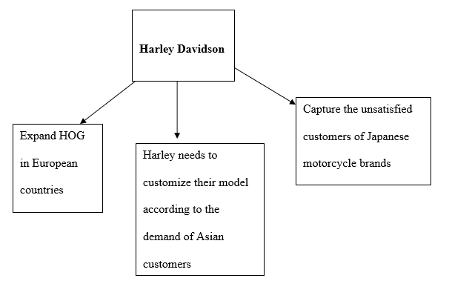

There are three ways by which HD can seize global opportunity, firstly, by Expanding HOG in European countries like Australia, secondly, by customizing their model as per Asian customer’s demand and thirdly, capturing the unsatisfied needs of Japanese motorcycle brands.

Conclusion:
The detailed report has highlighted the International Business strategy that Harley-Davidson has used to gain the competitive advantage in the global market and expand its business globally into countries like Australia and China. There is an analysis of how the Australian market, the political scenario, cultural aspect, ease of doing business has helped HD to establish the market in Australia which is physically too far from its home country, U.S. The market Structure of Australia gives reader an overview of what type of business would prove to be successful. There is a comparison of the two countries in terms of the business culture and their ranking on global level and it is noted that the two countries have many similarities in their culture. There is an analysis of the entry mode of HD in other markets including Australia along with the factors that has proven advantage for its operation successfully.

