
APPENDIX GA36c

LEVEL 6 ASSESSMENT SPECIFICATION

Student name: | Ashton Kerr | Student ID number: | 2520865
Programme: | BSc Construction Management  BSc Quantity Surveying
Module: | Advanced Construction Technology
Module code: | ACBA 6009 | Contribution to Overall Module Assessment (%): | 50%
Lecturer: | Rhodri Thomas | Internal Verifier: | Ian Brown
Assignment Title: | Case study report with drawings | Word count (or equivalent): | 2,500 words (+/-10%)
Submission deadline: | 28/4/2026 | Return date of provisional marks & written feedback: | Within 20 days of submission
Submission method: | All written assessments, where practical and possible, must be submitted via Turnitin unless otherwise instructed by the Lecturer. (Please DO NOT put this assessment specification into Turnitin or it will match many similarities with other students’ submissions.)  Alternative submission method (if applicable):  Late submission of the assessment will result in a late penalty mark:  Work which is submitted up to 1 week late will be capped at 40% for the first attempt and will be awarded a mark of 0% for re-assessment. Late submission penalties may be lifted only if there is an approved extenuating circumstances claim.  Work submitted more than 1 week late will be considered as a non-submission and will not be marked. The work may be considered as a submission for reassessment if offered by an Examining Board or if there is an approved extenuating circumstances claim.
Academic honesty / referencing: | Academic honesty is required. In the main body of your submission you must give credit to authors on whose research and ideas your work is based. Append to your submission a reference list that indicates the books, articles, etc. that you have used, cited or quoted in order to complete this assessment.

Module Learning Outcomes
(from module syllabus)
- Critique the application of the processes and procedures involved in the design and production of complex construction projects;
- Appreciate and recognise whole-life performance of buildings and civil engineering infrastructure, their care and management.

TASK DESCRIPTION

Use of Generative AI in Assessment
(Lecturer to indicate Yes or Not against each element)

RESEARCH | For this assessment, you can use Generative AI to support you in research, including searching for bibliography, using tools to summarise, compare and interrogate materials. | Yes ☒  No ☐
STRUCTURE | For this assessment, you can use Generative AI to support you in structuring your submission, including creating a draft argument structure, identifying parts and headings, etc. | Yes ☒  No ☐
PROOFREADING | For this assessment, you can use Generative AI to check your own text/creation for grammatical and syntactical mistakes, including rephrasing of your own work within specific standards. | Yes ☐  No ☒
WRITING | For this assessment, you can use Generative AI to create text for submission. | Yes ☐  No ☒
CREATIVE | For this assessment, you can use Generative AI to create creative materials, such as images. | Yes ☐  No ☒
PROGRAMING | For this assessment, you can use Generative AI to create and check code. | Yes ☐  No ☒
NONE | For this assessment, you are not allowed to use any type of Generative AI support. This includes research support, structure support, writing/proofreading support and creative support. | Yes ☐  No ☒

TASK DESCRIPTION

You have been tasked with critically reviewing the Dylan Thomas Centre in Swansea, with the aim of explaining how a project of this type could be improved using current technologies.

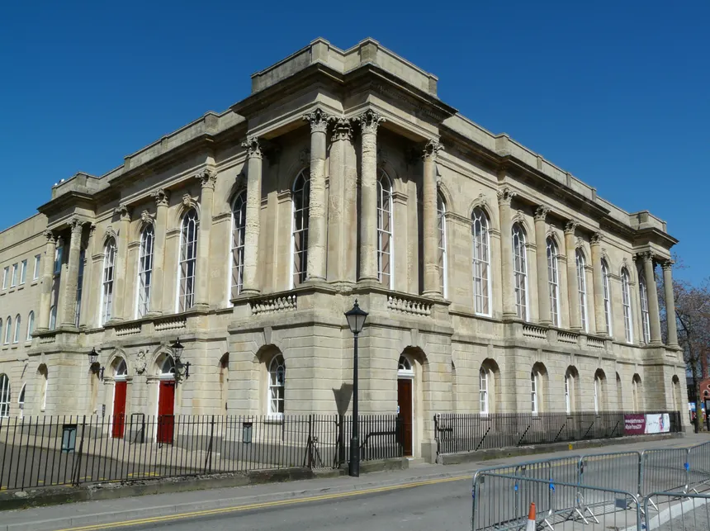

- Discuss the benefits of using BIM and other technologies to plan work and mitigate risk but also to effectively manage maintenance, retrofit, repair and refurbishment.

- Explore how modern technologies such as smart buildings, scanning, AI and digital twins etc can be used to manage energy use, evaluate whole life performance and improve facility and asset management.

- Explain how the DTC could be retrofitted to incorporate these technologies and successfully improve its facilities management.

Guidance for this assessment

Use a suitable report format including all standard sections including (but not limited to) front sheet, table of contents and reference section.
Consider age related defects and “wear and tear” on this type of building, think about how modern technologies be used to help maintain these buildings more effectively.

GUIDANCE FOR Students IN THE COMPLETION OF TASKS

NOTE: The guidance offered below is linked to the five generic assessment criteria overleaf.

- Engagement with Literature Skills
Your work must be informed and supported by scholarly material that is relevant to and focused on the task(s) set; you should make use of scholarly reviews and primary sources, where appropriate (for example, refereed research articles and/or original materials appropriate to the discipline). You should provide evidence that you have accessed a wide range of sources, which may be academic, governmental and industrial; these sources may include academic journal articles, textbooks, current news articles, organisational documents, and websites. You should consider the credibility of your sources; academic journals are normally highly credible sources while websites require careful consideration/selection and should be used sparingly. Any sources you use should be current and up-to-date, mostly published within the last five years or so, though seminal/important works in the field may be older. You must provide evidence of your research/own reading throughout your work, using a suitable referencing system, including in-text citations in the main body of your work and a reference list at the end of your work.

Guidance specific to this assessment: Make sure you reference a wide variety of sources. They don’t need to be limited to the UK. Many innovative construction methods are being pioneered abroad. Cite case studies and methods from across the world.

- Knowledge and Understanding Skills
At level 6, you should be able to demonstrate coherent and detailed knowledge and a systematic understanding of the subject area, at least some of which is informed by the latest research and/or advanced scholarship within the discipline. You should be aware of the uncertainty, ambiguity and limits of knowledge. Your work must demonstrate the growing extent of your knowledge and systematic understanding of concepts and underlying principles associated with the subject area. Knowledge relates to the facts, information and skills you have acquired through your learning. You demonstrate your understanding by interpreting the meaning of the facts and information (knowledge). This means that you need to select and include in your work the concepts, techniques, models, theories, etc. appropriate to the task(s) set. You should be able to explain the theories, concepts, etc. meaningfully to show your understanding. Your mark/grade will also depend upon the extent to which you demonstrate your knowledge and understanding; ideally each should be complete and detailed, with comprehensive coverage.

Guidance specific to this assessment: Comprehensively explain a variety of methods and explain their advantages and disadvantages.

- Cognitive and Intellectual Skills
You should be able to: critically evaluate evidence, arguments, assumptions, abstract concepts and data some of which are at the forefront of a discipline (and that may be incomplete) to devise and sustain arguments, to make judgements and/or solve problems; describe and comment upon particular aspects of current research, or equivalent advanced scholarship, in the discipline Your work must contain evidence of logical, analytical thinking, evaluation and synthesis. For example, to examine and break information down into parts, make inferences, compile, compare and contrast information. This means not just describing what! But also justifying: Why? How? When? Who? Where? At what cost? At all times, you must provide justification for your arguments and judgements. Evidence that you have reflected upon the ideas of others within the subject area is crucial to you providing a reasoned and informed debate within your work. Furthermore, you should provide evidence that you are able to make sound judgements and convincing arguments using data and concepts. Sound, valid conclusions are necessary and must be derived from the content of your work. Where relevant, alternative solutions and recommendations may be proposed.

Guidance specific to this assessment: Justify your decisions, cite regulations, case studies or scientific research to reinforce your specifications, it may be that some of these technologies aren’t suitable to the case study.

- Practical Skills
At level 6, you should be able to apply the methods and techniques that you have learned to review, consolidate, extend and apply your knowledge and understanding, and to initiate and carry out projects. You will deploy accurately established techniques of analysis and enquiry relevant to the discipline, and apply them in complex and unpredictable contexts, to devise and sustain arguments and/or to solve problems. You should be able to frame appropriate questions to achieve a solution - or identify a range of solutions. You should be able to demonstrate how the subject-related concepts and ideas relate to real world situations and/or a particular context. How do they work in practice? You will deploy models, methods, techniques, and/or theories, in that context or circumstances, to assess current situations, perhaps to formulate plans or solutions to solve problems, or to create artefacts, some of which may be innovative and creative. This is likely to involve, for instance, the use of real world artefacts, examples and cases, the application of a model within an organisation and/or benchmarking one theory or organisation against others based on stated criteria. You should show awareness of the limitations of concepts and theories when applied in particular contexts.

Guidance specific to this assessment: Show your ability to research, present, explain, evaluate and propose effective technologies.

- Transferable Skills for Life and Professional Practice
Your work must provide evidence of the qualities and transferable skills necessary for graduate-level employment requiring the exercise of initiative and personal responsibility and decision-making in complex and unpredictable circumstances. This includes demonstrating: the learning ability for professional development to advance existing skills and acquire new competences of a professional nature that will enable you to assume significant responsibility within organisations; that you can initiate and complete tasks and procedures, whether individually and/or collaboratively; that you can use appropriate media to effectively communicate information, arguments and analysis in a variety of forms to specialist and non-specialist audiences; fluency of expression; clarity and effectiveness in presentation and organisation. Work should be coherent and well-structured in presentation and organisation.

Guidance specific to this assessment: Produce an effective report which is clear, concise and interesting. Use images to illustrate your points.

Student FEEDBACK FORM

This section details the extent to which the assessment criteria are demonstrated by you, which in turn determines your mark. The marks available for each category of skill are shown. Lecturers will use the space provided to comment on the achievement of the task(s), including those areas in which you have performed well and areas that would benefit from development/improvement.

Generic Assessment Criteria | Marks available | Marks  awarded
1. Engagement with Literature Skills | 10
2. Knowledge and Understanding Skills | 15
3. Cognitive and Intellectual Skills | 30
4. Practical Application Skills | 35
5. Transferable Skills for Life and Professional Practice | 10

Assessment Mark (Assessment marks are subject to ratification at the Exam Board. These comments and marks are to give feedback on module work and are for guidance only until they are confirmed. ) | Late Submission Penalties (tick if appropriate) |  | %
 | Up to 1 week late (40% Max) |  | %
 | Over 1 week late (0%) |  | %

GENERIC ASSESSMENT CRITERIA

Level 6
In accordance with the Framework for Higher Education Qualifications, at the end of Level 6 students should have coherent and detailed knowledge and a systematic understanding of their subject area, at least some of which is informed by the latest research and/or advanced scholarship within the discipline. They will be able to accurately deploy established techniques of analysis and enquiry within a discipline, using their conceptual understanding to devise and sustain arguments and/or to solve problems. They should be aware of the uncertainty, ambiguity and limits of knowledge. They should be able to critically evaluate evidence, arguments, assumptions, abstract concepts and data (that may be incomplete), to make judgements, and to frame appropriate questions to achieve a solution - or identify a range of solutions. They will apply the methods and techniques that they have learned to review, consolidate, extend and apply their knowledge and understanding, and to initiate and carry out projects. They will have the ability to manage their own learning, and to make use of scholarly reviews and primary sources (for example, refereed research articles and/or original materials appropriate to the discipline). They will demonstrate the qualities and transferable skills necessary for employment requiring: the exercise of initiative and personal responsibility; decision-making in complex and unpredictable contexts; the learning ability needed to undertake appropriate further training of a professional or equivalent nature.

Level 6 | FAIL | MARGINAL FAIL | SATISFACTORY  (3rd / Pass) | GOOD  (2.2 / Pass) | VERY GOOD  (2.1 / Merit) | EXCELLENT  (1st / Distinction) | EXCEPTIONAL  (1st / Distinction)
Category | 0-29% | 30-39% | 40-49% | 50-59% | 60-69% | 70-84% | 85-100%
Engagement with literature (including reading, referencing,  academic conventions and  academic honesty) | Little or no evidence of reading and/or reliance on inappropriate sources.  Views and findings mostly unsupported and non-authoritative.  Referencing conventions used incoherently or largely absent. | Poor engagement with essential reading. No evidence of wider reading. Reliance on inappropriate sources, and/or indiscriminate use of sources. Heavily reliant on information gained through class contact. Inconsistent and weak use of referencing. | Engagement with a limited range of mostly relevant and credible sources. Some omissions and minor errors.  Referencing conventions evident though not always applied accurately or consistently. | Engagement with an appropriate range of research-informed literature, including sources retrieved independently. Some over-reliance on texts. Referencing may show minor inaccuracies or inconsistencies. | Engagement with a wide range of research-informed literature, including sources retrieved independently.  Selection of relevant and credible sources. Very good use of referencing, with no/very few inaccuracies or inconsistencies. | Engagement with an extensive range of relevant and credible literature, informed by the latest research. Consistently accurate application of referencing. | Exceptional engagement with an extensive range of relevant and credible literature, informed by the latest research. High-level referencing skills consistently and professionally applied.
Knowledge and understanding (Coherent and detailed knowledge and systematic understanding of the subject area, at least some of which is informed by the latest research and/or advanced scholarship within the discipline.) | Major gaps in knowledge and systematic understanding of the subject matter. Substantial inaccuracies. No awareness of knowledge of the latest research and/or advanced scholarship within the discipline. | Gaps in knowledge, with only superficial systematic understanding. Some significant inaccuracies and/or irrelevant material. No awareness of knowledge of the latest research and/or advanced scholarship within the discipline. | Limited knowledge and systematic understanding of the relevant concepts and principles within the subject area which to some limited extent, is informed by current research and scholarship. | Knowledge is reasonably detailed, accurate with a good systematic understanding of the field of study and to some extent, current research and scholarship. | Knowledge is reasonably extensive coherent and detailed. Exhibits very good understanding of the breadth and depth of established views, and the work is, at least in part, well-informed by current research and scholarship. | Excellent coherent and detailed knowledge and systematic understanding of the principles and theories of current research and scholarship. Clear awareness of challenges to established views and the limitations of the knowledge base. | Exceptionally coherent and detailed knowledge and systematic understanding of the principles and theories of the subject, well-informed by current research and scholarship. A critical, sophisticated and nuanced awareness of the ambiguities and limitations of knowledge.
Cognitive and intellectual skills  (Conceptual and critical thinking, analysis, synthesis and evaluation of research, assumptions, abstract concepts and data (that may be incomplete); logic, argument and judgement.) | Wholly or almost wholly descriptive work. Little or no analysis, synthesis or evaluation.  Failure to develop arguments, leading to illogical or invalid judgements. Unsubstantiated generalisations, made without use of any credible evidence. | Largely descriptive work, with superficial use of critical evaluation. Weak development of arguments and judgements. Information accepted uncritically, uses generalised statements made with scant evidence and unsubstantiated opinions. Ideas sometimes illogical and contradictory. | Limited attempt at critical thinking, analysis, synthesis and evaluation, tending towards description.  Some evidence to support emerging arguments and judgements but these may be underdeveloped or with a little inconsistency / mis-interpretation.  Asserts rather than argues a case. | Some critical thinking, analysis, synthesis and evaluation. Can analyse new and/or abstract concepts and data without guidance.  An emerging awareness of different stances and ability to use evidence (that may be incomplete) to support the argument.  Mostly valid arguments and logical judgements. Some tendency to assert/state opinion rather than argue on the basis of reason and evidence. | Sound critical thinking, analysis, synthesis and evaluation demonstrating critical thinking. Ability to devise and sustain persuasive arguments, and to review the reliability, validity and significance of evidence (that may be incomplete) to make mostly appropriate and valid judgements. | Excellent critical thinking, analysis, synthesis and evaluation. Ability to investigate contradictory or incomplete information and make strong, persuasive, arguments and sophisticated judgements. Some evidence of independent thought and ability to ‘see beyond the question’, suggesting a grasp of the broader field and wider concepts. | Exceptional critical thinking, analysis, synthesis and evaluation based on judiciously selected evidence.  Ability to investigate contradictory or incomplete information and make strong, persuasive, arguments and sophisticated, nuanced, judgements. Evidence of independent thought and ability to ‘see beyond the question’, suggesting an outstanding grasp of the broader field and wider concepts.
Practical skills  (Apply/deploy accurately established tools and techniques; initiate and carry out projects; formulate solutions to solve problems in complex and unpredictable contexts.) | Limited or no use of methods, materials, tools and/or techniques.  Little or no appreciation of the context of the application.  Limited understanding of the application of theory to practice or making appropriate links between the two.  Very weak problem-solving skills in complex and unpredictable contexts. | Rudimentary application of methods, materials, tools and/or techniques but without consideration and competence. Flawed appreciation of the context of the application.  Weak understanding of the application of theory to practice, with only occasional evidence of making appropriate links between the two. Weak problem-solving skills in complex and unpredictable contexts. | An adequate awareness and mostly appropriate application of well-established methods, materials, tools and/or techniques.  Basic appreciation of the context of the application. Theoretical knowledge and understanding applied in practice, but not always making logical links between the two.  Can identify problems and propose basic solutions in complex and unpredictable contexts without fully appreciating the complexity. | A good and appropriate application of standard methods, materials, tools and/or techniques.  Clear appreciation of the context of the application. Mainly consistent, accurate and logical application of theory to practice, making appropriate links between the two  Can identify problems and propose mostly appropriate solutions in complex and unpredictable contexts. | A very good application of a range of methods, materials, tools and/or techniques.  Very good consideration of the context of the application, with perceptive insights. Can identify problems and propose appropriate solutions in complex and unpredictable contexts.  Evidence of some innovation and creativity. | An advanced application of a range of methods, materials, tools and/or techniques.  The context of the application is well considered, and insightful.  Application and deployment extend beyond established conventions. Can identify complex problems and propose excellent solutions. Innovation and creativity evident. | Exceptional levels of application and deployment skills in unpredictable, practical contexts, drawing skilfully on the latest research within the discipline. Can identify complex problems and propose sophisticated solutions. Assimilation and development of cutting edge processes and techniques.
Transferable skills for life and professional practice  (Exercise of initiative and personal responsibility; professional development; initiate and complete tasks and procedures: individually and/or collaboratively; use appropriate media to communicate effectively; fluency of expression; clarity and effectiveness in presentation and organisation.) | Communication medium is inappropriate or misapplied.  Work is poorly structured, disorganised and/or confusingly expressed. Very weak use of language and/or very inappropriate style. Little or no evidence of autonomy (or collaboration, where relevant) in the completion of tasks. Little or no evidence of the skills required in graduate employment. | Communication medium is poorly designed and/or not suitable for the audience.  Work is poorly presented in a disjointed manner. It is loosely, and at times incoherently, structured, with information and ideas often poorly expressed. Weak use of language and/or inappropriate style. Weak independent initiative (or collaboration, if relevant). Limited evidence of the skills required in graduate employment. | Can communicate in a suitable medium but with some room for improvement.  Mostly ordered presentation and structure in which relevant ideas / concepts are reasonably expressed. Work may lack coherence in places. Can work as part of a team, but with limited involvement in group activities.  Demonstrates the basic skills required in graduate employment, with some areas of minor weakness. | Can communicate effectively in a suitable format, but may have minor errors.  Mostly coherent, organised work, in a suitable structure and is for the most part clearly expressed. Can work effectively independently and/or as part of a team, with clear contribution to group activities.  Demonstrates the skills required in graduate employment, with some areas of strength and some of minor weakness. | Can communicate well, confidently and consistently in a suitable format.  Work is coherent, fluent, well-structured and organised. Can work very well autonomously and/or as part of a team, with very good contribution to group activities.  Demonstrates very good graduate employment skills, with just occasional minor weakness. | Can communicate professionally confidently and consistently in a suitable format.  Work is coherent, very fluent and is presented professionally. Can work autonomously with initiative. Where relevant can work professionally within a team, showing leadership skills as appropriate, managing conflict and meeting obligations. Demonstrates excellent graduate employment skills and an appetite for further development. | Can communicate with an exceptionally high level of professionalism.  Work is exceptionally coherent, very fluent and is presented professionally. Can work exceptionally well and professionally within a team, showing advanced leadership skills. Demonstrates exceptional graduate employment skills and an appetite for further development.

THIS DOCUMENT IS ALSO AVAILABLE IN WELSH

Advanced Construction Technology
Semester 2 – Assignment 1
Ashton Kerr – 2520865


Critical Review of The Dylan Thomas Centre (Swansea)

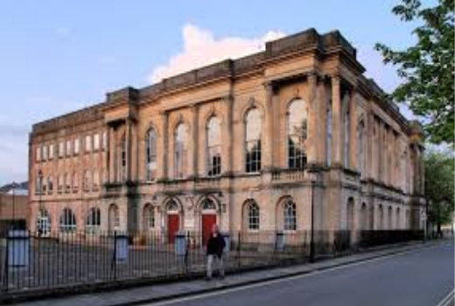
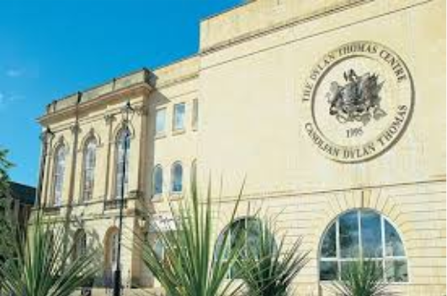
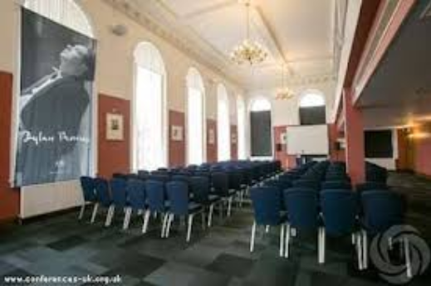

Table of Contents
1.Introduction .................................................................................................................................................................................(Page 13)

2.Building Overview & Conditions.................................................................................................................................................(Page 13-14)

3.Building Information Modelling (BIM)............................................................................................................................................. (Page 14)

4.Digital Twins ............................................................................................................................................................................(Page 15-16)

5.Limitation Of Current Facilities Management................................................................................................................................. (Page 16)

6.BIM Enabled Asset Management ...............................................................................................................................................(Page 16-17)

7.Evaluation ....................................................................................................................................................................................(Page 17)

8.Conclusion ..............................................................................................................................................................................(Page 17-18)

9.References ...................................................................................................................................................................................(Page 19)

1. Introduction
Within this report I intend to critically review and examine the Dylan Thomas Centre in Swansea with a goal of identifying how modern construction technologies can improve the buildings' efficiency, maintenance strategies, and performance. As the Dylan Thomas Centre or (DTC) is a repurposed historic building which has had several different uses across time, the building faces challenges including ageing fabric, ageing energy systems, and reactive maintenance systems.
After a receiving a guided tour of The Dylan Thomas Centre I aim to explore and analyze how Building Information Modelling, digital twins, artificial intelligence (AI), and smart building technologies could support the building in becoming more fit for purpose, sustainable, efficient, and proactive. Highlighting how current technology can help predict maintenance and show real-time performance and energy usage. As the Dylan Thomas Centre is a historic building, the only real option for improvement is retrofitting. That is why in this report I aim to highlight the opportunities I believe are available for this building to benefit.
As a guide, I intend to discuss the following points in detail:
- The benefits of BIM in lifecycle management
- The role of emerging technologies such as digital twins and AI
- The application of these technologies in retrofitting the building.
- Improvements to facilities and asset management.

2.Building Overview & Condition

I would like to begin this report by giving a brief overview of The Dylan Thomas Centre’s history, condition, and usage. The Dylan Thomas Centre was built between 1825 and 1829, formerly as a guildhall. Following the construction of a new civic center, it was later repurposed in 1934. It is situated in Swansea's Maritime Quarter. (Dylan Thomas Centre,2026) it is now an adapted reuse building which is currently leased from Swansea Council to The University of Wales Trinity St David for educational spaces and lecture rooms.
It also includes the museum dedicated to the famous Welsh poet Dylan Thomas. Considering its age, the building itself is actually in good condition, broadly speaking. After a guided tour you can see that the Dylan Thomas Centre’s age does show in certain areas, but despite this it is still charming and useful for its current purpose. There are areas that could be upgraded within the building; there are also areas that could be retrofitted to make the building more fit for purpose. The building fixtures and fittings are obviously old, and with its listed status it would be difficult or impossible to change its exterior and certain internal features. Meaning that the only option to bring this 1825 heritage site up to modern standards, some advanced construction technologies may be required.
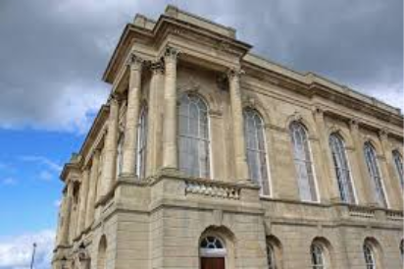
However, while adapting such buildings preserves its heritage, it also introduces a range of operational and technical challenges. It is quite common that older buildings like this one are susceptible to moisture ingress, thermal inefficiency, and general degradation over time. According to (Historic England,2017) this is due to ageing construction methods and materials. In a study during 2020, the UK Green Building Council highlighted these such issues are often caused by lack of insulation and outdated services. Thus, resulting in poor energy performance and increased costs.
My first impression on how to tackle these issues would be the same as anyone else's. Update the windows and doors to improve efficiency. As they do appear run down and worn. But unfortunately, this is a listed building, so any changes that are available are slim to none. Therefore, we must look at more advanced construction technologies to help provide solutions for the DTC.

Furthermore, building pathology research identifies common defects in historic structures, including damp, structural movement, and deterioration of materials . These defects contribute to increased maintenance requirements and can compromise occupant comfort and safety if not addressed effectively.

3.Building Information Modelling (BIM)
For a brief description, Building Information Modelling is a digital process that enables the creation and management of structured information about a building throughout its lifecycle (Eastman, 2018) It provides a centralized data environment that supports collaboration and decision making across design, construction, and operation phases.

BIM significantly enhances planning processes for the good, enabling detailed visualization and simulations of building systems. (Azhar,2011) One key advantage that could lend a hand to the retrofit of the DTC is clash detection. Which identifies conflicts between structural and mechanical components before retrofit work begins. This advanced construction technology reduces the risk of costly errors and delays, making BIM particularly valuable for complicated retrofit projects such as the Dylan Thomas Centre. The advantage is having accurate digital information for stakeholders to plan interventions with minimal disruption to the existing listed structure.
Another advantage of using BIM is its ability to support lifecycle management. By integrating asset data into a single model. This will allow maintenance managers to track and intervene on the condition, location, and view the history of the building (volk, 2014). This facilitates predictive maintenance, where issues are identified and addressed before failure occurs. As a result, operational efficiency is improved and lifecycle costs are reduced.
For the Dylan Thomas Centre, implementing BIM would allow the creation of a comprehensive asset database, enabling more efficient management of building systems and maintenance schedules.
In the context of the Dylan Thomas Centre, BIM would support the integration of modern systems while preserving historic features, ensuring that retrofit options and systems are both effective and sensitive to the buildings heritage and listed status.

4. Digital Twin

A Digital Twin is a dynamic digital representation of a physical asset, continuously updated with real time data from sensors.
Digital twins enable:
- Real time monitoring of building performance
- Simulation of different operational scenarios
- Predictive maintenance through data analytics
According to (Boje,2020), digital twins have the potential to transform facilities management by providing continuous insight into asset performance and enabling proactive decision making. This system could highlight the areas for concern by using real time monitoring, Highlighting areas such as windows left ajar wasting energy, notifying maintenance on the ageing boilers and heating systems, or even just showing how much energy the building itself will need in the colder months in its current state just to budget costs.
Smart building systems go hand in hand with digital twins; Smart Building technologies use interconnected sensors and automation systems to optimize building performance. There are many avenues or options that could potentially be implemented into the Dylan Thomas Centre itself. Such as Smart HVAC systems that adjust based on occupancy, automated lighting systems, and environmental monitoring sensors.
These technologies reduce energy consumption and improve occupant comfort, contributing to more sustainable building operations (Buckman, 2014). When I was on the guided tour of The Dylan Thomas Centre, I noticed that there were no automatic lighting systems in place. There were rooms unoccupied with the heating on, windows open and lights on. Simply pouring money and energy down the drain. By implementing smart technology such as automated lighting, you mitigate the human error element and allow the technology to save you money in the long run. I understand this is not feasible to implement in every room within the Dylan Thomas Centre. However, it would be possible to add these systems to heavily timetabled areas, or rooms and areas with many light fittings to ensure that energy and money are saved where possible.
Smart systems and digital twins further enhance energy management by providing real time data on energy consumption. This allows building operators to optimize performance and reduce carbon emissions.
I was also shown in the main gallery hall where weddings and functions take place. In this hall there is an air conditioning system that was on, the heating was also on at the same time. Implementing a HVAC or an adequate monitoring system that would mitigate this from happening would pay dividends for the operational costs of The Dylan Thomas Centre.
Given the UK’s commitment to achieving net-zero carbon emissions, improving the energy efficiency of existing buildings is essential (UK Green Building Council, 2020). Retrofitting the Dylan Thomas Centre with energy-efficient systems would therefore contribute to broader sustainability goals not just for the university but for the UK Government and the world.
5. Limitations of Current Facilities Management Approaches
Facilities management in older buildings such as The Dylan Thomas Centre is typically formed by reactive maintenance, paper-based asset records, limited performance monitoring, and inefficient energy management.
Reactive maintenance, where repairs are undertaken only after failure occurs, leads to increased costs, unplanned downtime, and disruption to building users (Chartered Institute of Building, 2021). In heritage buildings, this approach can also accelerate deterioration, as minor defects may go unnoticed until they become significant issues.
Furthermore, the absence of centralized data makes it difficult for facility managers to make informed decisions regarding maintenance priorities and resource allocation (Volk, 2014). This lack of integration results in inefficiencies and reduces the overall effectiveness of building management.

6.BIM Enabled Asset Management
The implementation of BIM introduces a centralized digital platform for managing building assets. Each component within the building, such as HVAC systems, lighting, and structural elements, can be embedded with data relating to its specifications, condition, and maintenance history.
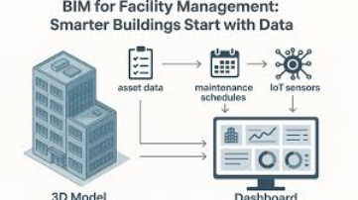
This enables:
- Accurate asset tracking and documentation
- Improved maintenance scheduling
- Enhanced coordination between stakeholders

BIM also supports the concept of “information rich assets,” where facility managers can access detailed data about each component instantly. This reduces time spent locating and diagnosing issues and improves the speed and accuracy of maintenance interventions (Eastman, 2018). For the Dylan Thomas Centre, BIM would provide a comprehensive digital record of the building, enabling more efficient long-term management. Allowing for vital planned maintenance to take place. Being proactive rather than reactive. All in all, this improves organisation, improves maintenance costs, and helps track and document assets. On the flip side, however, a lot of care must be taken if the decision was made to implement this system. The more detailed information you feed BIM, the more accurate and helpful it will be for asset management.
I understand that this will take time, effort and money to implement, but I do believe that a building as old and that requires as much upkeep as The Dylan Thomas Centre should have a high quality asset management plan in place to ensure its longevity for future generations to come.
Whole life performance considers the total cost and environmental impact of a building over its lifecycle. BIM supports this approach by enabling lifecycle assessments and energy simulations (Eastman, 2018)
7. Evaluation
The application of Building Information Modelling and associated digital technologies to the Dylan Thomas Centre presents significant opportunities for improving the buildings management, but also introduces a range of technical, financial, and organizational challenges.
One of the most significant advantages of adopting BIM and digital technologies is the shift from short term, reactive maintenance to long term predictive, value driven asset management. By integrating BIM with Digital Twin technology, facility managers can access real-time performance data and make informed decisions based on predictive analytics rather than historical assumptions. This has clear implications for lifecycle costing. Although initial implementation costs may be high, the reduction in unplanned maintenance, improved energy efficiency, and extended asset lifespan can result in substantial long term savings (Eastman, 2018). In this context, BIM can be seen not simply as a design tool, but as a strategic asset management platform that supports whole-life performance optimization.
However, the extent to which these benefits are highlighted depends heavily on the quality of data input and ongoing management. Poor data input or incomplete modelling can significantly reduce the effectiveness of technology systems, highlighting the importance of robust implementation strategies.
8.Conclusion
This report has critically examined the potential for improving the performance and facilities management of the Dylan Thomas Centre through the application of BIM and emerging digital technologies. The analysis has demonstrated that the building, as a repurposed historic structure, faces a range of challenges including ageing fabric, energy inefficiency, and reliance on reactive maintenance practices. These issues are common in heritage buildings and highlight the need for more advanced and proactive management strategies.
The introduction of BIM provides a foundation for digital transformation, enabling the creation of a centralised and information-rich model of the building. When combined with technologies such as digital twins, smart systems, and artificial intelligence, BIM facilitates real-time monitoring, predictive maintenance, and improved decision-making.
A key finding of this report is that the integration of these technologies can significantly enhance facilities management by shifting from reactive to predictive approaches. This not only reduces operational costs but also extends the lifespan of building assets and improves overall performance. In addition, smart building technologies offer substantial benefits in terms of energy efficiency, supporting sustainability objectives, and reducing environmental impact. However, the report also identifies several challenges that must be addressed. These include high initial costs, technical complexity, the need for skilled personnel, and the constraints associated with working within a historic building. These factors highlight that digital transformation is not simply a technological issue, but also an organisational and strategic one.
In evaluating these factors, I'd like to conclude that the long-term benefits of adopting BIM and digital technologies outweigh the initial challenges. The key to success lies in adopting a phased and carefully planned approach, ensuring that technologies are implemented in a way that is compatible with the Dylan Thomas Centre's heritage and operational requirements.
Ultimately, the application of digital technologies represents a significant opportunity to enhance the resilience, efficiency, and sustainability of the Dylan Thomas Centre. By embracing a data-driven approach to facilities management, the building can be better equipped to meet the demands of the future while preserving its cultural and historical significance.

9. Reference Section
Dylan Thomas Centre (2026) The Dylan Thomas Centre, Building Timeline (Accessed 23/04/26) http://www.dylanthomas.com/dylan-thomas-centre/history-dylan-thomas-centre/#:~:text=The%20center%20opened%20in%201995%20and%20is,was%20replaced%20by%20a%20new%20civic%20center
Historic England (2017) Energy Efficiency and Historic Buildings. (Accessed 23/04/26)
https://historicengland.org.uk/advice/technical-advice/energy-efficiency/
Eastman, C. (2018) BIM Handbook. (Accessed 23/04/26)
https://www.benardmakaa.com/wp-content/uploads/2021/11/BIM-Handbook_-A-Guide-to-Building-Information-Modeling-for-Owners-Designers-Engineers-Contractors-and-Facility-Managers-Wiley-2018.pdf
Azhar, S. (2011) ‘Building Information Modeling (BIM): Trends, Benefits, Risks’, Leadership and Management in Engineering. (Accessed 23/04/26)
https://ascelibrary.org/doi/10.1061/(ASCE)LM.1943-5630.0000127
Volk, R., Stengel, J. and Schultmann, F. (2014) ‘Building Information Modeling (BIM) for existing buildings’, Automation in Construction. (Accessed 23/04/26)
https://doi.org/10.1016/j.autcon.2013.10.023
Boje, C. (2020) ‘Towards a semantic Construction Digital Twin’, Automation in Construction. (Accessed 24/04/26)
https://doi.org/10.1016/j.autcon.2020.103179
Buckman, A.H., Mayfield, M. and Beck, S.B.M. (2014) ‘What is a Smart Building?’, Energy and Buildings. (Accessed 24/04/26)
https://doi.org/10.1016/j.enbuild.2014.01.026#
Chartered Institute of Building (2021) Guide to Good Practice in the Management of Facilities. (Accessed 24/04/26)
https://www.ciob.org/
Wei, T. et al. (2018) ‘Deep reinforcement learning for building HVAC control’, Energy and Buildings. (Accessed 24/04/26)
https://doi.org/10.1016/j.enbuild.2017.11.035

