
University of Wales Trinity Saint David

Student Name: Samera mehmood

Student ID: 2509932

Module Code: LCHS 4008

Module Title: Introduction to Public Health

Lecturer: Gillian Weaver

Assignment Title: The Management, Impact, and Surveillance of Tuberculosis (TB)

TABLE OF CONTENTS

Title
1. Introduction …………………………………………………. 3

2. Measurement and Monitoring Approaches …………………..4

3. Disease Control Strategies ……………………..5

4. Socio-Economic and Community Consequences…………..5

5. Health and Social Care Support Services …………………6

6. Conclusion ……………………………………………………….7

7. References …………………………………………………..8

Introduction
Tuberculosis (or TB) is a deadly contagious disease caused by an aerobic, slow-growing bacterium known as Mycobacterium tuberculosis (MTB), that usually starts an infection in the macrophages (the immune cells) of the lungs. Some common symptoms of TB (active pulmonary TB) are a demonstrable cough that lasts more than three weeks, coughing up blood (hemoptysis) and/or chest pain (NICE Guidelines, 2019). According to the Centers for Disease Control and Prevention (2022), "This pathogen is transmitted via the inhalation of microscopic droplet nuclei, typically 1–5 micrometres in diameter, which are aerosolised when an individual with pulmonary disease coughs or sneezes.

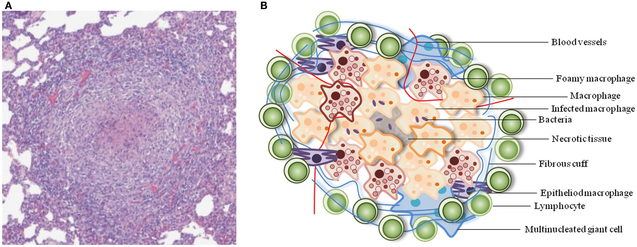
“Figure 1: Microscopic view of Mycobacterium tuberculosis in lung tissue
According to the World Health Organization (WHO), there were an estimated 10.6 million new cases of TB worldwide in 2022. TB case fatality rate (CFR) remains extremely high in lower resource countries (WHO, 2023).

The UK National Health Service (NHS) reported that the UKHSA reported 4380 TB notifications during 2022, for an incidence of 7.8 per 100,000 persons (UKHSA, 2024). Given the epidemiological status of TB, we must all strictly adhere to WHO’s END TB Strategy and aim to reduce TB deaths (by 90%) by 2030 (Uplekar et al, 2015).

Measurement and Monitoring Approaches
Epidemiological surveillance of Tuberculosis (TB) is a cornerstone of a public health response, using NTMS (National Treatment Monitoring System) data from the UK to monitor patient outcomes for each TB notification (UK Health Security Agency 2023). Clinicians must report all suspected TB cases (including new or relapse cases) to local health protection teams by law. Accurate reporting helps to accurately quantify the burden of TB, enabling appropriate allocation of resources in order to mount an effective response (National Institute for Health and Care Excellence 2019). The methods used for diagnosis have shifted from traditional Sputum Smear Microscopy to the use of molecular approaches that are more precise, as Sputum Smear Microscopy often lacks sensitivity for diagnosing pulmonary TB in patients who have fewer bacilli (paucibacillary) or who are coinfected with HIV (Pai et al. 2016). While Sputum Smear Microscopy may take weeks to return results, Nucleic Acid Amplification Testing (NAAT) using the GeneXpert MTB/RIF assays has changed the game in terms of monitoring and can confirm the presence of M. tuberculosis and mutations related to resistance to rifampicin within hours versus weeks (World Health Organization 2023).
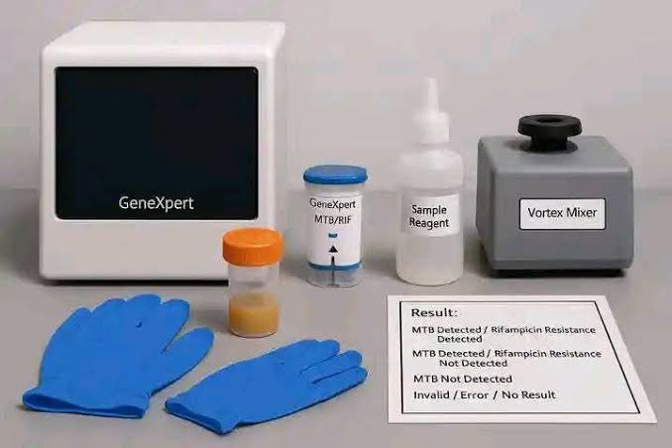
Figure 2: GeneXpert MTB/RIF machine for rapid TB diagnosis and rifampicin resistance testing

Treatment monitoring is performed through Directly Observed Treatment Short-Course (DOTS) framework, which enables adherence to therapy by ensuring that a provider observes each dose administered (Public Health England 2021).Story et al. (2011) explain that “public health agencies have adopted digital health technologies, such as video-observed therapy (VOT), which provides a more flexible yet robust alternative to traditional DOTS.” The monitoring of patients with MDR TB is especially rigorous as several sputum cultures must be collected from each patient to determine whether conversion has occurred in order to prevent further development of molecular resistance (World Health Organization 2023).
Disease Control Strategies
The World Health Organization (2023) says that public health control of TB depends on three things: primary prevention, strict drug protocols, and active case-finding among at-risk groups. The BCG vaccine is still an important part of this plan, but in the UK, the policy has changed from giving all teenagers the vaccine to only giving it to newborns in high-risk groups (UK Health Security Agency, 2023). Pharmacological treatment for active tuberculosis is divided into two phases: an intensive phase that lasts two months and a continuation phase that lasts four months (National Institute for Health and Care Excellence, 2019). Patients receive a quadruple regimen of rifampicin, isoniazid, pyrazinamide, and ethambutol during the intensive phase (Nahid et al., 2016). According to The Lancet (2022), “Isoniazid functions by inhibiting the synthesis of mycolic acids in the bacterial cell wall, while rifampicin targets the beta-subunit of bacterial DNA-dependent RNA polymerase.” Public health officials conduct extensive contact tracing, screening people who have shared airspace with an infectious index case, in order to maintain community control (UK Health Security Agency, 2024). Furthermore, in order to stop dormant bacilli from reactivating, it is critical to detect and treat latent TB infection (LTBI) in high-risk populations, such as those with HIV or those undergoing immunosuppressive therapy (National Institute for Health and Care Excellence, 2019). Biochemical efficacy and public health infrastructure must work together for these controls to be ultimately successful (World Health Organization, 2023).

Socio-Economic and Community Consequences
People often call tuberculosis a “social disease” because how it spreads and what happens after it spreads are closely tied to the community’s economic and social conditions (Wingfield et al., 2014). The social stigma that comes with a TB diagnosis can be very harmful. It can lead to isolation, the end of marriages, and what is called “social death” for the patient (The Lancet, 2022). This fear of being left out makes it hard to get a diagnosis early, because people may hide their symptoms to avoid the shame they think they will feel from the infection (World Health Organization, 2023). The economic burden is often devastating, with evidence indicating that even in nations with free healthcare, the indirect expenses of lost wages and nutritional requirements may surpass 20% of annual household income (Tanimura et al., 2014). In the UK, there are big differences in community health, with TB hitting the poorest 20% of the population the hardest (UK Health Security Agency, 2023). Statistics show that 79% of TB cases in England happen in people who were born outside of the UK. This shows how important it is to screen migrant populations in a way that is sensitive to their culture (UK Health Security Agency, 2024). People who are homeless, in prison, or have a history of drug abuse are more likely to not follow through with treatment and pass on the disease to others (Public Health England, 2021). Community outbreaks are mostly caused by overcrowded and poorly ventilated housing, which illustrates how housing policy affects the epidemiology of infectious diseases (National Institute for Health and Care Excellence, 2019). The Lancet (2019) states that “the intersectionality of poverty, malnutrition, and TB creates a syndemic effect that requires an analytical approach beyond simple medical intervention.” In order to address these effects and break the cycle of poverty and infection, attention must be directed toward the social determinants of health (Craig et al., 2017).

Health and Social Care Support Services
The Multidisciplinary Teams (MDTs) provide complete patient care solutions needed to handle TB’s complicated treatment requirements through their specialized knowledge base (National Institute for Health and Care Excellence, 2019). Team members include TB clinical nurse specialists together with respiratory physicians and microbiologists and social workers who work together to handle both clinical and social elements of the disease (British Thoracic Society, 2022). Social care support functions as a vital component for treatment accessibility because it helps patients establish permanent housing solutions which enable them to follow treatment plans more effectively than using temporary accommodation (UK Health Security Agency, 2023). Story et al. (2011) describe how “in London, the ‘Find and Treat’ mobile X-ray unit exemplifies proactive support by bringing diagnostic services directly to the most marginalized urban populations.” Psychological support reaches the same level of importance as patients need it because they experience depression and anxiety which originates from their extended periods of isolation combined with their battle against medication side effects (British Medical Journal, 2021). The services establish treatment methods that bring patients into their environmental conditions which decreases the possibility of developing drug-resistant bacteria that arise from inconsistent treatment practices (British Thoracic Society, 2022).

Figure 3: Multidisciplinary team (MDT) providing holistic care and social support to TB patient

Conclusion
Tuberculosis still ranks as a leading global health crisis and the solution requires a well-orchestrated and multi-sectoral public health response (World Health Organization, 2023). Importantly, without strong epidemiological surveillance and advanced diagnostic tools such as nucleic acid amplification tests, efforts in tracking and containing the disease might fall short (UK Health Security Agency, 2024).Although the use of drugs and methods like contact tracing to prevent the spread, are the right ways to combat the disease, such measures need to be coupled with a thorough understanding of the socio-economic factors contributing to the spread of the disease (The Lancet, 2022). In fact, the way stigma and poverty affect the results of treatment, among other factors, underscores the need for social care, along with a range of other supports, both from a psychological perspective and more generally (National Institute for Health and Care Excellence, 2019).Tuberculosis eradication in the UK will be impossible without a concerted effort to eliminate health inequities among the most at risk groups including migrants (UK Health Security Agency, 2021). Only a well-rounded strategy that not only deals with the bacteria but also the socio-economic conditions will result in TB elimination as a public health threat (British Thoracic Society, 2022).Tuberculosis can be defeated when medical treatment, social support, and government policies work together effectively.

References
1. Centers for Disease Control and Prevention (2022) Tuberculosis (TB): Transmission and Pathogenesis. Atlanta: CDC.
2. British Thoracic Society (2022) BTS Clinical Statement on the Management of Tuberculosis. London: BTS.
3. Nahid, P. et al. (2016) ‘Official American Thoracic Society/Centers for Disease Control and Prevention/Infectious Diseases Society of America Clinical Practice Guidelines: Treatment of Drug-Susceptible Tuberculosis’, Clinical Infectious Diseases, 63(7), pp. e147-e195.
4. Story, A. et al. (2011) ‘Social risk factors, medical complexity and the need for social care in TB patients’, The Lancet, 377(9783), pp. 2104-2111.
5. Tanimura, T. et al. (2014) ‘Financial burden for tuberculosis patients in low- and middle-income countries: a systematic review’, European Respiratory Journal, 43(6), pp. 1763-1775.
6. Craig, G.M. et al. (2017) ‘The challenge of TB control in the UK’, The Lancet Respiratory Medicine, 5(2), pp. 91-93.
7. British Medical Journal (2021) Psychosocial impacts of chronic respiratory infections in urban settings. London: BMJ Publishing Group.
8. NHS England (2022) Integrated Care Systems: Guidance on health and social care support. London: NHS England.
9. Wingfield, T. et al. (2014) ‘Defining catastrophic costs and comparing their importance for adverse tuberculosis outcomes’, PLOS Medicine, 11(7), p. e1001675.

