Programme: BA (Hons) Business Management
Module: Dissertation
Module code: LCBB6014
TOPIC: THE IMPACT OF LEADERSHIP STYLES ON
EMPLOYEE MOTIVATION AND PERFORMANCE IN THE BEAUTY INDUSTRY
Student name: Mihaela Hermeneanu
Student Number: 2310013

Declaration
I declare that this dissertation is my own original work and has not been submitted for any other academic qualification. All sources of information have been properly acknowledged and referenced. This study has been completed in accordance with the academic guidelines and ethical requirements of the institution.

Signature: Mihaela Hermeneanu
Date: 25/07/2026

Acknowledgement
I want to acknowledge my professors and module leaders from the core of my heart for helping me to accomplish this dissertation. On the other hand, I am also thankful towards the participants who invested their valuable times for the survey process.

Abstract
This study examines the impact of leadership styles on employee motivation and performance in the beauty industry, focusing on salons, spas, and cosmetic clinics. The study introduces the research background, problem statement, aims, objectives, and significance, highlighting leadership as a key factor influencing workforce productivity and service quality. Current study also critically reviewed existing literature on transformational, transactional, democratic, and autocratic leadership styles and their effects on motivation and performance. The chapter also identifies research gaps within beauty businesses and discusses relevant theories, including Transformational Leadership Theory, Maslow’s Hierarchy of Needs, and Herzberg’s Two-Factor Theory, supporting the conceptual framework. This study focused on the effect of leadership styles on employee motivation and performance in the beauty industry. Data were analysed using IBM SPSS software and quantitative data was collected from 50 employees. The results indicated that there was a strong positive correlation between leadership style and employee motivation (r = 0.656) and moderate positive correlation between leadership style and employee performance (r = 0.550). The results of regression analysis showed that leadership style accounted for 43.1% of the variance in employee motivation and 30.3% of the variance in employee performance. The authors conclude that supportive leadership enhances workplace motivation, performance and organisational success.

Table of Contents
CHAPTER 1: INTRODUCTION 8
1.1 Introduction to the research 8
1.2 Origin of the research 8
1.3 Research aim, objectives, and research questions 9
Aim 9
Objectives 9
Research Questions 9
1.4 Problem statement and significance 9
1.5 Rationale of the study 10
1.6 Outline of the study 10
1.7 Summary of the chapter 10
CHAPTER 2: LITERATURE REVIEW 11
2.1 Introduction 11
2.2 Leadership styles in organisations 11
2.3 Employee motivation in the beauty industry 11
2.4 Leadership styles and employee performance 12
2.5 Impact of leadership styles on employee performance 13
2.6 Effective leadership style in the beauty industry 13
2.7 Research gap 14
2.8 Theoretical Overview 14
2.9 Conceptual Framework 15
2.10 Conclusion 15
CHAPTER 3: RESEARCH METHODOLOGY 16
3.0 Chapter Introduction 16
3.1 Research Philosophy 16
3.2 Research Approach 16
3.3 Research Design 17
3.4 Time Horizon 17
3.5 Data Collection and Sampling 17
3.6 Data Analysis 18
3.7 Ethical Considerations 19
3.8 Chapter Conclusion 19
CHAPTER 4: DATA ANALYSIS AND DISCUSSIONS 20
4.1 Chapter Introduction 20
4.2 Findings from data analysis 20
4.2.1 Findings from Google Form Analysis 20
4.2.2 Findings from Statistical Analysis 25
4.3.1 Leadership Styles Commonly Used in Beauty Businesses 31
4.3.2 Leadership Styles and Employee Motivation 31
4.3.3 Leadership Styles and Employee Performance 31
4.3.4 Most Effective Leadership Style and Managerial Implications 32
4.4 Chapter Summary 32
CHAPTER 5: CONCLUSION, LIMITATIONS, AND RECOMMENDATIONS 33
5.1 Conclusion 33
5.2 Recommendations 33
5.2.1 Strengthening Supportive Leadership Practices (Objective 1) 33
5.2.2 Improving Employee Motivation Through Recognition (Objective 2) 34
5.2.3 Increasing Employee Performance Through Training (Objective 3) 34
5.2.4 Encouraging Employee Participation in Decision-Making (Objectives 4 and 5) 34
5.3 Research Limitations 34
5.4 Future Directions 35
Reference List 36

List of Figures
Fig 1.2: Beauty sector growth in the UK 8
Fig 2.8: Maslow’s Hierarchy of Needs 14
Fig 2.9: Conceptual Framework 15
Sampling Technique and Sample Size 18
Fig 4 .2.1.7: Employee recognition and appreciation 24
Fig: 4.2.2: Descriptive Statistics 26
Fig 4.2.4: Correlation Analysis 29
Fig 4.2.5: Multiple Regression Analysis 30

CHAPTER 1: INTRODUCTION

1.1 Introduction to the research
Leadership plays a crucial role in shaping employee behaviour, motivation, and performance, particularly in service-based industries such as the beauty industry. Employee performance in beauty salons/spa and cosmetic clinics has a direct effect on customer satisfaction and quality of service delivery (Ardina et al. 2025). Effective leadership will result in a good working environment where the employees will feel encouraged, respected, and motivated to work (Ned and Umesi, 2023). Various styles of leadership such as transformational, transactional, democratic leadership, and autocratic leadership have varying effects on the attitude of employees, as well as their productivity. The present research evaluates the effect of leadership style on employee motivation and performance within the beauty industry and also analyses the most effective leadership styles.

1.2 Origin of the research
The origin of this research stems from growing concerns about workforce challenges in service industries, particularly in beauty businesses. The beauty sector has witnessed booming business since more people are demanding personal services and well-being.
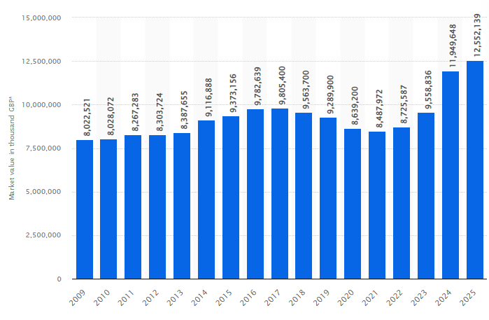

Fig 1.2: Beauty sector growth in the UK
(Source: Statista, 2026)
The beauty cosmetics sector market value was approximately £12.55 billion in 2025 in the United Kingdom economy (Statista, 2026). Although this growth is being realised, the industry is experiencing major workforce problems such as employee turnover, work stress and inconsistent management practices. The obstacles exposed by them prompt the necessity to explore leadership practices that can be used to motivate and retain employees (Manafe et al., 2024). The available literature speaks of leadership within general industries, but there is little research that specifically talks of beauty enterprises. This is a gap that led to the creation of this research.

1.3 Research aim, objectives, and research questions

Aim
To examine the impact of leadership styles on employee motivation and performance in the beauty industry.

Objectives
- To identify the main leadership styles commonly used in beauty businesses.
- To examine the relationship between leadership styles and employee motivation.
- To analyse the impact of leadership styles on employee performance.
- To evaluate which leadership style is perceived as most effective by employees in the beauty industry.
- To provide recommendations for beauty business managers on how to improve employee motivation and performance through effective leadership.

Research Questions
- What leadership styles are commonly used in the beauty industry?
- How do leadership styles influence employee motivation in the beauty industry?
- How do leadership styles influence employee performance in the beauty industry?
- Which leadership style is perceived as most effective by beauty industry employees?

1.4 Problem statement and significance
Employee dissatisfaction, stress, burnout, and turnover issues are becoming problematic in the beauty industry (Shin and Kwon, 2022). Ineffective leadership may have adverse impacts on employee motivation, quality of services provided and business performance. Gallup (2025) indicates that organisations that have a highly engaged employee base are 18% more productive compared to organisations with a disengaged employee base. This shows how crucial strong leadership is when it comes to enhancing employee engagement and performance. Although the importance of leadership is well established, there is only scarce industry-specific evidence in the beauty businesses. The research has importance as it helps fill this gap and also informs about the effect of leadership styles as far as employee performance is concerned.

1.5 Rationale of the study
This research is significant since leadership has a direct influence on the motivation of employees, their performance and retention. In the competitive service industries, when employees are motivated, they will help in customer satisfaction as well as organisational success. Employee turnover could be minimised in businesses that have highly robust leadership practices (Jian et al., 2022). Nevertheless, few confirmation studies have targeted the employees of the beauty industry, including hairstylists, nail technicians and spa workers. This study gives work-specific findings and feasible suggestions to managers on how to enhance workplace efficiency.

1.6 Outline of the study
This study consists of five chapters. Chapter 1 introduces the research background, aim, objectives, problem statement, and rationale. Chapter 2 reviews relevant literature on leadership styles, motivation, and performance. Chapter 3 explains the research methodology, including data collection and analysis methods. Chapter 4 presents findings and analysis from the collected data. Chapter 5 discusses conclusions and recommendations.

1.7 Summary of the chapter
The importance of leadership in the beauty industry was mentioned in this chapter, and it introduced the topic of research. It stated the research aim and objectives, research questions, problem statement, significance and rationale. The structure of the study was also presented in the chapter.

CHAPTER 2: LITERATURE REVIEW

2.1 Introduction
This chapter reviews existing literature related to leadership styles and their influence on employee motivation and performance. It discusses significant theories of leadership, past empirical evidence, and research gaps in the beauty industry. The review assists in providing a theoretical basis for the research.

2.2 Leadership styles in organisations
Leadership style refers to the way leaders guide, influence, and manage employees. According to Hajiali et al, (2022), various leadership styles influence the behaviour of employees and the outcomes of working differently. The typical leadership styles are transformational, transactional leadership, democratic and autocratic leadership.
Transformational leadership is all about inspiring and motivating employees with the aid of vision, support, and empowerment (Suryadi et al. 2024). Leaders promote creativity and self-development. Transformational leadership enhances engagement and motivation in studies. Transactional leadership is based on rewards and punishments (Firda and Ferine, 2023). The employees are motivated by clear expectations and performance rewards. This style can enhance productivity, although it might not facilitate long-term engagement.
Democratic leadership is characterised by involvement of employees in making decisions. It enhances teamwork, communication, and trust (Imran et al. 2025). Under democratic leaders, employees feel that they are appreciated and are more committed. Autocratic leadership entails centralisation of decision-making and little employee involvement. Although it is able to enhance short-term efficiency, it can decrease motivation and job satisfaction (Suryadi et al. 2024). Leadership style can also affect service quality in beauty businesses since interactions of employees are the direct way to affect the customer experiences.

2.3 Employee motivation in the beauty industry
Employee motivation is described as an internal and external influencer of the individual desire to work effectively, stick to organisational objectives and exhibit high productivity (Ahmad et al. 2024). Employee motivation is also especially critical in the beauty industry since the quality of services significantly relies on the attitude of the employees. Hair stylists, beauty therapists, nail technicians and spa workers are employees who deal directly with clients, so their motivation is critical towards achieving good customer experiences.
Motivated employees have a higher chance of upholding professional standards, enhancing technical competencies, establishing good customer relationships, and continually offering quality services. Examples of factors that tend to impact motivation include monetary compensation, acknowledgement, promotion, supportive leadership that supports, training and a favourable workplace environment (Mofu et al. 2024). Employees are likely to be committed and work effectively when they feel appreciated and supported.
The beauty industry has some distinct challenges that may have an impact on employee motivation (Ardina et al. 2025). The employees have to work long and odd hours, do physically demanding tasks, and perform emotional labour to match high customer expectations. Stress and fatigue may be compounded by the pressure to please the clients, uphold the looks and standards, and provide personalised services (Chib et al. 2025). The lack of motivation could lead to burnout, absenteeism, low productivity, and high turnover.
According to Permadi et al. (2024), leadership is a significant factor in determining the motivation of employees by affecting communication, trust, morale and relationships at the workplace. The encouragement, recognition, and emotional support leaders manage to provide to the employees help to foster a positive working environment. Mainly where employees feel valued, respected, and motivated, and thus enhances job satisfaction and performance.

2.4 Leadership styles and employee performance
Employee performance is the degree to which employees fulfill their job obligations and help to attain organisational objectives. Performance in the beauty industry incorporates technical skills, customer service, punctuality, productivity as well as customer retention (Ardina et al. 2025).
Transformational leadership has been linked with an increase in the productivity of employees and an enhanced commitment to an organisation. When leaders convey clear objectives and embrace encouragement, employees deliver better results (Ned and Umesi, 2023).
Transactional leadership has the ability to enhance quantifiable performance using the incentive system. Rewards can be used to encourage employees to meet sales quotas or service objectives. Decision-making employees tend to have a greater sense of ownership and accountability (Sordo and Zattoni, 2024).
Autocratic leadership can enhance compliance in the short-term, but it can hurt performance in the long-term as well as creativity and satisfaction. A very strict leadership style in beauty businesses, in which a personalised contact with customers is required, can impose constraints on the flexibility of employees. Despite numerous studies discussing leadership and performance in different industries, there is very little research done on salons, spas, and cosmetic clinics themselves.

2.5 Impact of leadership styles on employee performance
Leadership styles have a direct impact on the performance of employees through influencing productivity, service delivery and behaviour at the workplace (Pahi et al., 2022). Technical competence, punctuality, professionalism, customer interaction and client retention are also part of employee performance within the beauty industry. According to Garad et al. (2022), transformational leadership has been known to improve performance since workers are motivated to work and develop skills in an effort to realise organisational objectives. Democratic leadership is more beneficial because it leads to employee cooperation and openness where employees can bring their ideas and enhance the quality of their services. Transactional leadership enhances such quantifiable performance through rewards based on performance, like sales or service output. Nonetheless, Agwoje (2023) states that autocratic leadership can have adverse impacts on long-term performance since overly controlling employees may lead to decreased creativity and initiative. Successful leadership will establish a positive workplace where employees will work in a productive and efficient manner.

2.6 Effective leadership style in the beauty industry
Beauty business employees usually operate in stressful industries where customer demands are ever-increasing. Transformational leadership is common among the industries that need services the most,, like beauty and wellness, and is seen as the most effective form of leadership (Lindert et al. 2022). This is a leadership style in which innovation, motivation, and professional development are promoted, as well as good rapport between leaders and employees. Employees need to be encouraged to work by leaders who offer emotional support, recognition and guidance to ensure that they stay motivated and productive (Ned and Umesi, 2023). Democratic leadership is said to be efficient as well since it enhances teamwork and participation of employees in decision-making. This involvement enhances trust and job satisfaction. Even though incentives can enhance short-term performance using transactional leadership, it might not generate sustainable motivation. The autocratic leadership style is considered to be less effective in general since it may decrease the confidence and engagement of employees (Mphaluwa et al., 2025). Thus, the supportive and participative leadership styles are usually viewed to be more helpful in motivating and performance among employees in the beauty industry.

2.7 Research gap
The current body of knowledge proves the presence of a strong impact of leadership on employee motivation and performance, yet some critical gaps exist. The majority of research revolves around healthcare, education, manufacturing and information technology, but little has been done on the beauty industry. Furthermore, motivation and performance tend to be looked at separately rather than together. Irrelevance is further diminished by methodological limitations, such as small samples and industry-wide data. Thus, this research is filling these gaps with attention paid to beauty businesses as a comparative quantitative approach.

2.8 Theoretical Overview
Transformational Leadership Theory is the theory that presents a way leaders can inspire and motivate employees by designing a common vision (Garad et al. 2022). Transformational leaders lay maturity on empowerment, trust and innovation, and they make employees feel important and active. This kind of leadership in the beauty industry can enhance the confidence of the employees, the quality of service and dedication to organisational objectives.
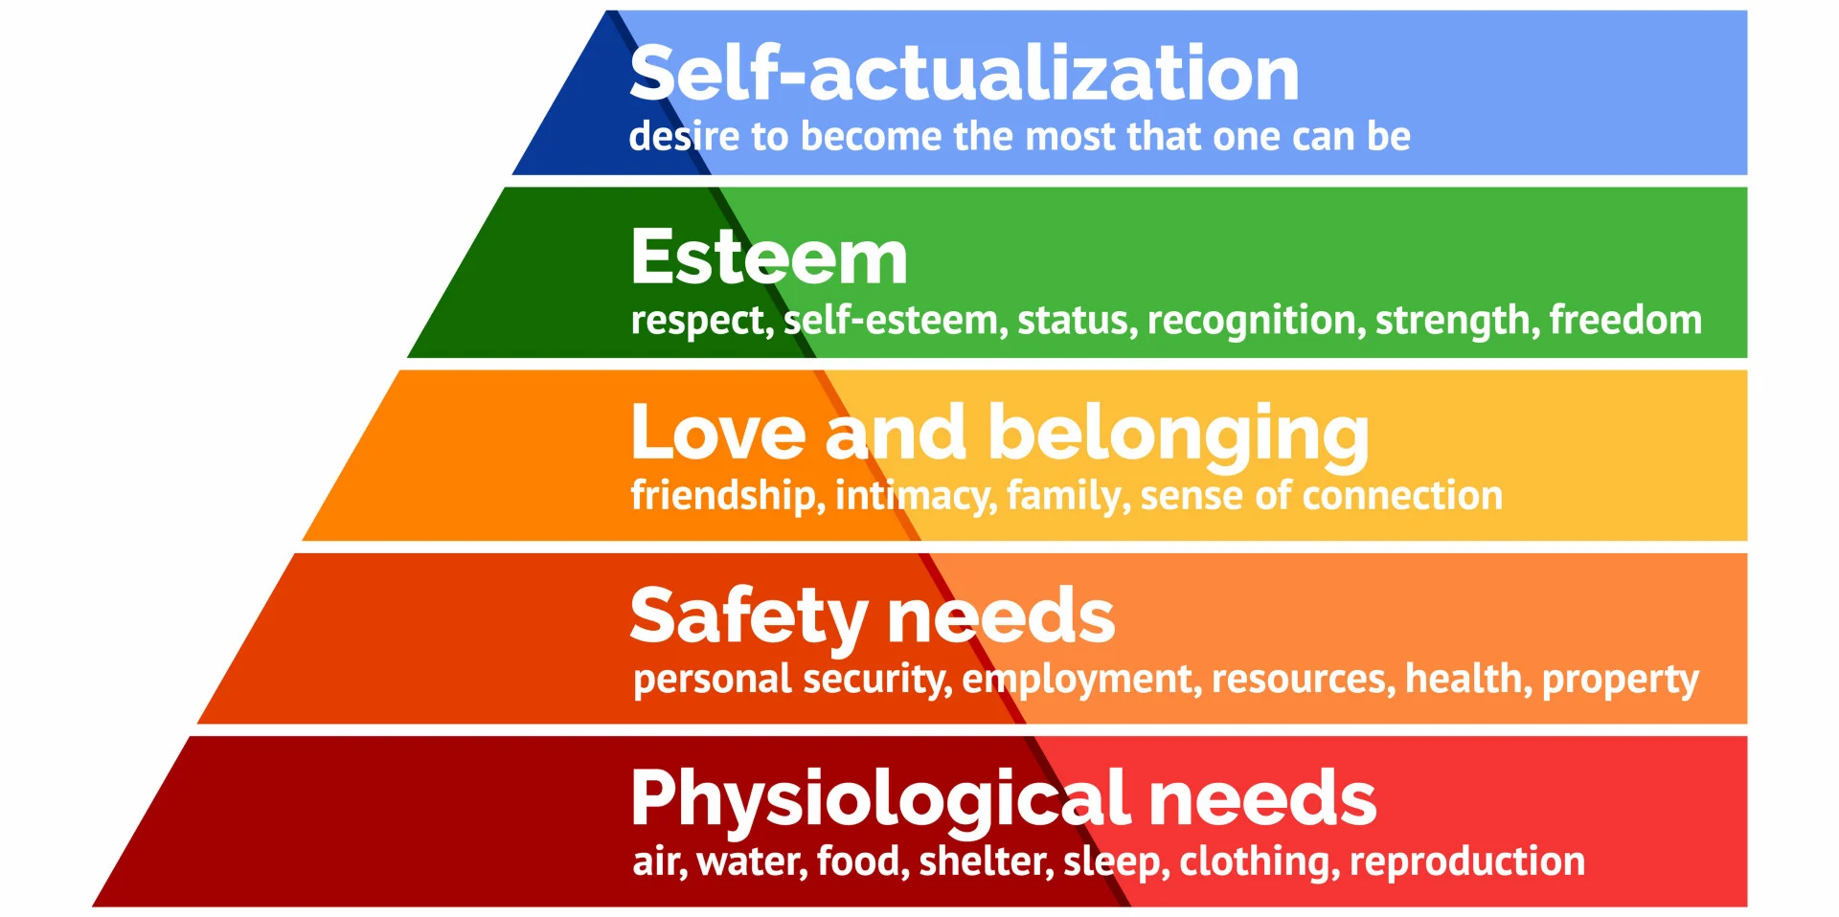

Fig 2.8: Maslow’s Hierarchy of Needs
Source: (McLeod, 2025)
Employee motivation through Maslow’s Hierarchy of Needs describes motivation on five levels of human needs: physiological, safety, social, esteem, and self-actualisation (Heerden and Naicker, 2025). This theory postulates that the motivation of employees will take place when these needs are gradually met. Openness in work environments in the form of good salaries, job safety, rewards, and career advancement leads to increased motivation and performance.
Herzberg’s Two-Factor Theory believes that the factors in the workplace can be classified into hygiene factors and motivators (Ghimire et al. 2024). The Hygiene factors, including salary and working conditions, will help in avoiding dissatisfaction. The motivators will include achievement, recognition and responsibility to increase job satisfaction and motivation.
These theories provide a holistic model of assessing the impact of leadership styles on the motivation and performance of employees within beauty businesses.

2.9 Conceptual Framework
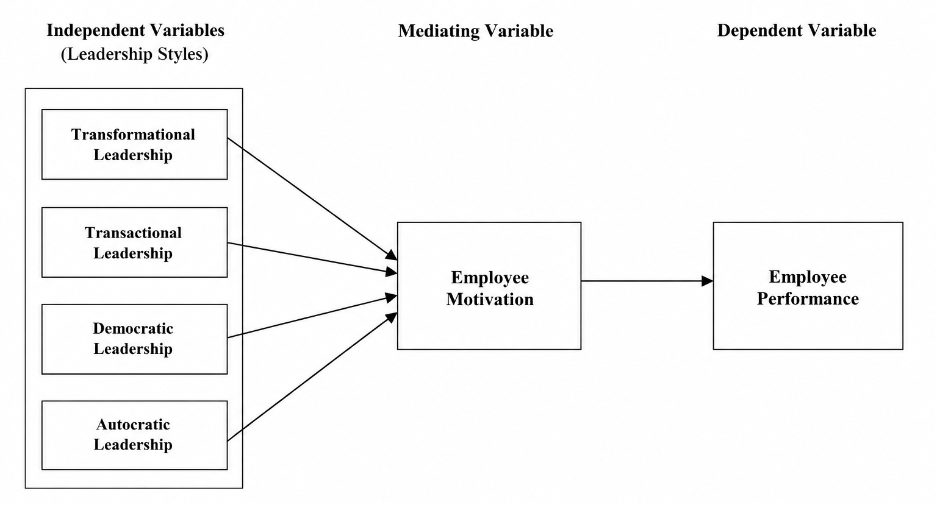

Fig 2.9: Conceptual Framework
Source: (Self-developed)

2.10 Conclusion
This chapter has reviewed the literature on employee motivation, performance, and leadership styles. It emphasised the roles of transformational, transactional, democratic and autocratic leadership and how they affect workplace outcomes. The review also found significant research gaps, in particular, the absence of studies specific to the beauty industry, and a lack of comparative research on various leadership styles. The next chapter of the research provides the foundation of the research, including the research methodology and hypothesis development in terms of relevant theories and the conceptual framework.

CHAPTER 3: RESEARCH METHODOLOGY

3.0 Chapter Introduction
In this chapter, the research methodology that is to be followed to analyse the influence of leadership style on motivating employees and influencing their performance in the beauty industry is explained. It provides the methodological decisions made to reach the research aim and objectives, such as the research philosophy, research approach, research design, time horizon, data collection and sampling strategy, data analysis methods, and ethical considerations. The chapter offers a logical structure for gathering credible and valid quantitative information and makes sure that the results of the research are based on a systematic and logical approach to scientific research.

3.1 Research Philosophy
The research adopted a positivist research philosophy since it is analysing the relationship between leadership style, employee motivation, and employee performance with objective and measurable information. Positivism states that reality can be observed and measured by use of scientific methods so that researchers can test relational associations among variables by use of statistical evidence (Ali, 2024). This philosophy was applicable to this research as it quantified the perceptions of employees in numerical terms and does not necessitate delving into the intimate experiences of employees. IBM SPSS was used to analyse numerical data collected about employees in the beauty industry. Statistical techniques such as descriptive statistics, Cronbach’s Alpha, Pearson correlation, and regression analysis support objectivity, reduce researcher bias, and enhance the reliability and validity of the study findings.

3.2 Research Approach
This study used deductive research method. Deductive research starts from the existing theories and then proceeds to examine the support for the proposed relationships within the data collected (Fife and Gossner, 2024). Theories in leadership and motivation were used to guide this study in order to examine the relationship between leadership style, employee motivation and employee performance in beauty industry. This approach was adopted to find out whether there is a significant effect of leadership style on employee motivation and employee performance (Suhartini and Sary, 2025). The research started with literature review to set up theoretical relationship among the study variables. Based on the literature, the research aim, objectives and research questions were developed. The primary data were subsequently collected by using a structured questionnaire and analyzed using descriptive statistics, reliability analysis, Pearson correlation analysis and multiple regression. The deductive method was suitable as the study involved testing the relationships found in previous studies and not the creation of a new theory (Fife and Gossner, 2024).

3.3 Research Design
The research design was quantitative, and cross-sectional close-ended survey was used to collect the specific perceptions of employees. The quantitative research was needed as the research aimed to numerically and statistically measure the perceptions of the employees and statistically analyse relationships between variables. This design can enable the analysis of vast volumes of structured data effectively (TUMIRAN, 2024).
A structured questionnaire was used as the main research instrument (Taherdoost, 2022). The questionnaire also contains demographic questions and statements related to the leadership style, employee motivation, and employee performance on a five-point Likert scale: 1 = Strongly Disagree, 2 = Disagree, 3 = Neutral, 4 = Agree, and 5 = Strongly Agree.
This survey was cross-sectional, which helped to collect the responses at one point in time and not over a length of time. This gives a showcase of how employees feel about it and is economical in terms of time and money yet still appropriate to be subject to statistical analysis.

3.4 Time Horizon
A cross-sectional time horizon strategy was used in this study (Gamage, 2025). The research did not involve any repeated observations of data collected on participants that are similar. This was suitable as the study aimed at understanding the existing relationship between leadership style, motivation to employees and employee performance. The data collected at one point in time was sufficient to answer the research questions while keeping the study practical within the available time and resources.

3.5 Data Collection and Sampling
Data Collection
The structured online questionnaire was created with Google Forms which was used in collecting responses from the employees. Online survey was selected as it was cheap, convenient to disseminate and convenient for the participants to answer (Quaquebeke et al. 2022). The survey link was shared via social media, WhatsApp groups, online professional networks, and personal mail IDs of the employees in the beauty industry.
The questionnaire was divided into two parts. Part A gathered the demographic data like age and gender. Research variables were measured in Section B. Some of the statements used to determine leadership style include: the manager encouraging teamwork, rewarding good performance, and participation of employees in decision-making. The employee scale measured employee motivation by measuring motivation to work and workplace recognition. Apart from the demographic questions, the other 8 contextual questions used a five-point Likert scale option (Taufique et al. 2026). Employee performance was measured using statements on task completion, customer service quality, and satisfaction with the current workplace and intention to remain in the organisation.
Target Population
The target population included employees working in beauty businesses, such as hairdressers, beauty therapists, nail technicians, makeup artists, reception staff, junior stylists, and salon assistants. Only employees currently working under a supervisor or manager were eligible to participate, as leadership experience is necessary for answering the questionnaire.

Sampling Technique and Sample Size
The research used a non-probability convenience sampling method. The participants were chosen according to their availability and willingness to participate in the survey. This approach was appropriate given the time constraints, limited finances, and limited access to beauty industry workers in the study. The questionnaire was sent online via Google Forms, which made the questionnaire to be more accessible to the participants. Although convenience sampling limits the generalisability of the findings, it is widely used in academic research when access to respondents is limited (Golzar et al. 2022). The survey was completed by 50 employees of the beauty industry. This sample size was sufficient to perform descriptive statistics, reliability analysis, Pearson correlation and multiple regression analysis, which helped answer the research objectives and research questions.

3.6 Data Analysis
Collected data were downloaded from Google Forms, cleaned and coded in Microsoft Excel, and analysed using IBM SPSS Statistics. Summary statistics (frequency and percentages), mean, and Standard deviation were employed to describe demographic variables and questionnaire answers (Hochwald et al., 2023). Reliability analysis was conducted using Cronbach’s Alpha to assess internal consistency, with values above 0.70 indicating acceptable reliability, and the corrected item- total correlation and Alpha were also tested in the case of item deletion. To determine the correlation between characteristics of leadership style, employee motivation and employee performance. On the other hand, Pearson correlation analysis was performed with coefficients of -1 to +1 and significance of 0.05. Apart from that, Multiple regression analysis also performed to measure the predictive effect of leadership style using regression coefficients, R, R², adjusted R², and ANOVA significance.

3.7 Ethical Considerations
This study followed appropriate research ethics to protect participants and maintain research integrity. The participants were given clear information about the purpose of the study, use of data and their rights before filling the participant information sheet (Taherdoost, 2022b). On the other hand, anonymity and confidentiality were ensured as no personal information was collected. The study adhered to GDPR policies by only gathering data that was essential, ensuring that responses were kept securely on password protected systems. Results were reported honestly, without manipulation or misrepresentation to maintain the credibility.

3.8 Chapter Conclusion
This chapter outlined the methodological framework used to examine the impact of leadership style on employee motivation and performance in the beauty industry. Using a quantitative survey of 50 employees, data were analysed through statistical methods while maintaining ethical standards, providing a reliable basis for the next chapter’s findings.

CHAPTER 4: DATA ANALYSIS AND DISCUSSIONS

4.1 Chapter Introduction
The current chapter presents the results of the study with a detailed critical analysis. It will also summarise the findings of the survey and the statistical analysis performed to solve the research objectives and research questions. The key findings will also be discussed in comparison to the existing literature, and a summary of the overall results of the study.

4.2 Findings from data analysis

4.2.1 Findings from Google Form Analysis
(a) Age Distribution
Among the 50 participants, more than 46% were from the age group of 25 to 34 years. On the other hand, 30% were 18 to 24, and 14% were 35 to 44. It shows that the majority of the participants were young.
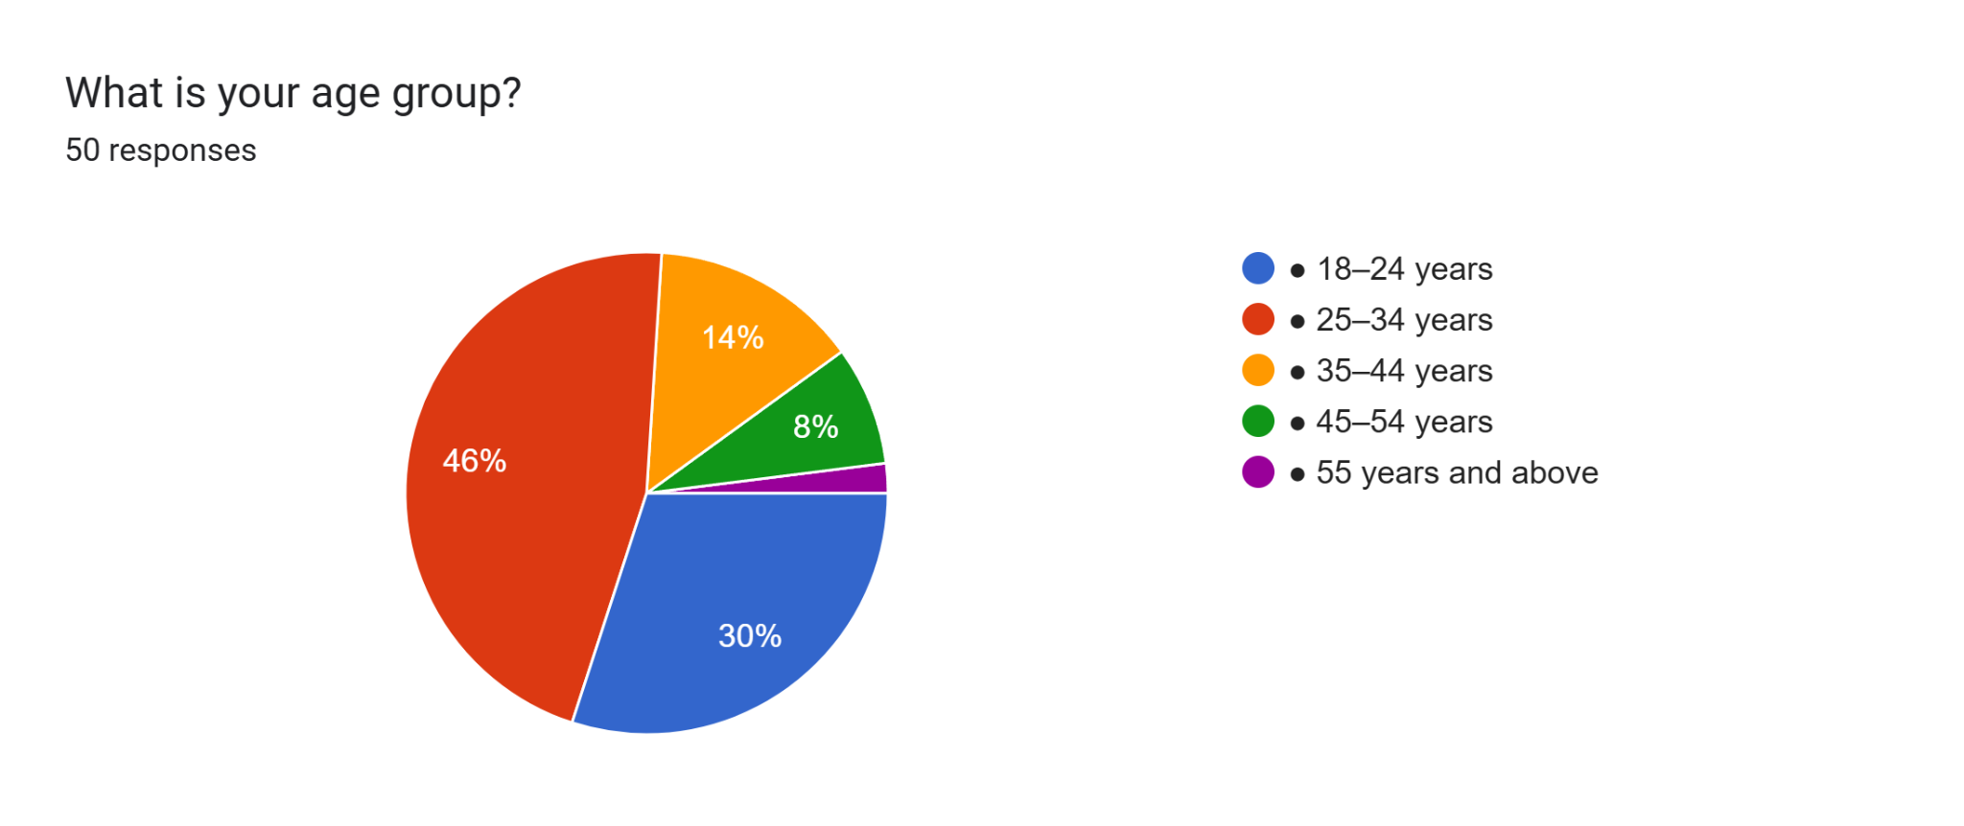
Fig 4.2.1.1: Age Group
(Source: Google Form)
(b) Gender Distribution
The respondents were evenly distributed between male and female, with 48% male and 46% female. Further, 4% did not want to reveal their gender, and 2% chose other gender categories. This is a balanced participation that gives a variety of beauty industry employee perspectives.
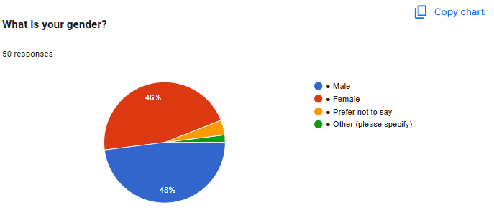
Fig 4.2.1.2: Gender Disribution
(Source: Google Form)
(c) Manager Encourages Teamwork and Collaboration
A majority of respondents reported positive support for teamwork from their manager. 54% agreed, and 10% strongly agreed that managers encouraged teamwork and collaboration. But 22% disagreed, 8% were neutral, and 6% strongly disagreed, suggesting there is more room to enhance collaborative leadership practices.
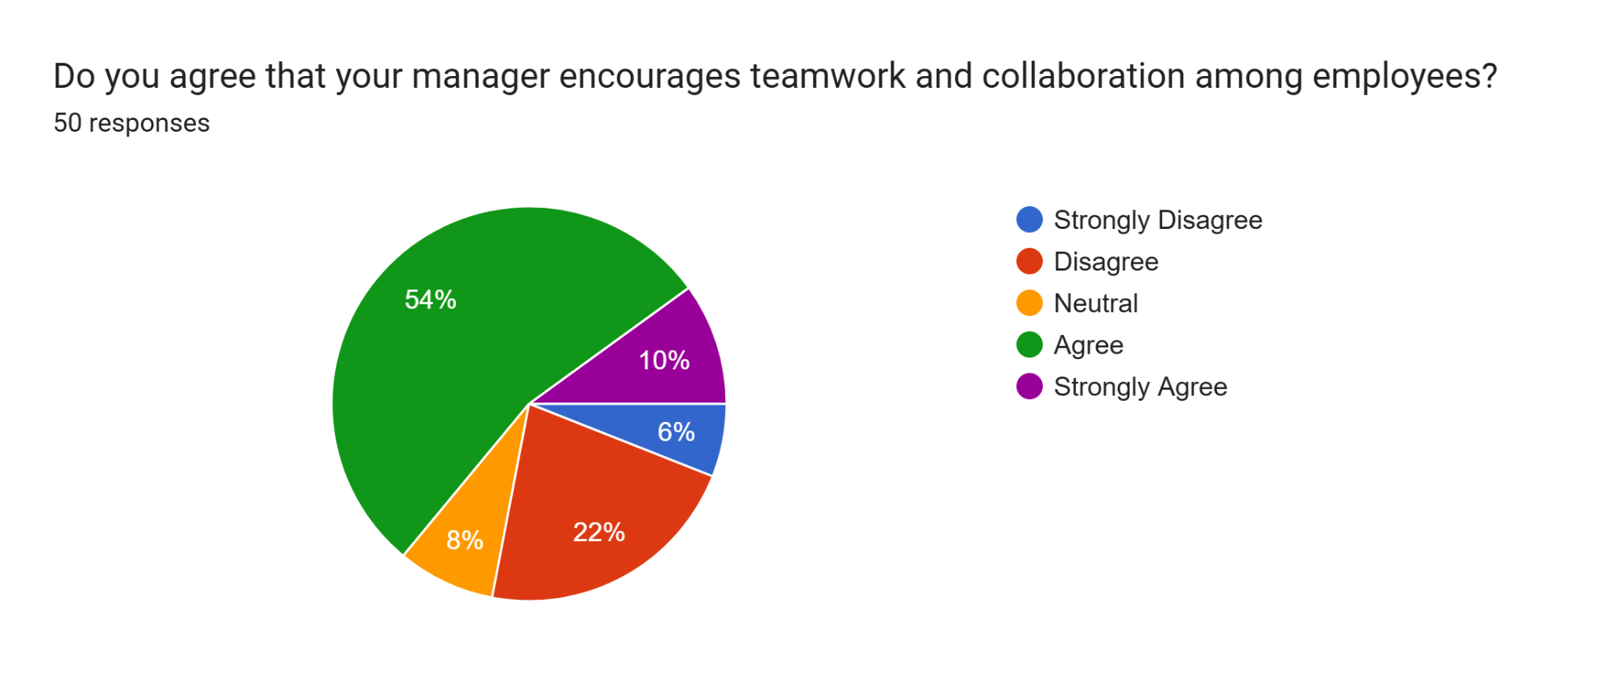
Fig 4.2.1.3: Manager Encouraging Teamwork
(Source: Google Form)
(d) Manager Recognises and Rewards Good Performance
The majority of the employees were recognised for their good work. 54% agreed, and 14% strongly agreed with the statement. Meanwhile, 16% disagreed, 10% remained neutral, and 6% strongly disagreed. The results show that recognition is a common leadership trait in beauty businesses.
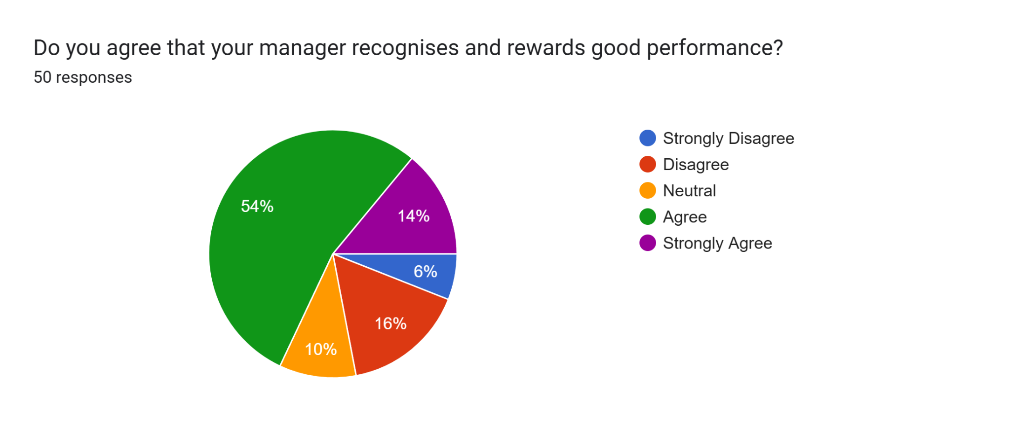
Fig 4.2.1.4: Manager Recognising Performance
(Source: Google Form)
(e) Manager Involves Employees in Decision-Making
Responses to employee involvement were mixed. 46% agreed, and 10% strongly agreed, that managers engaged employees in decision-making. 30% disagreed, 10% were neutral, and 4% strongly disagreed, however. The results indicate that there is still a need to improve employee participation.
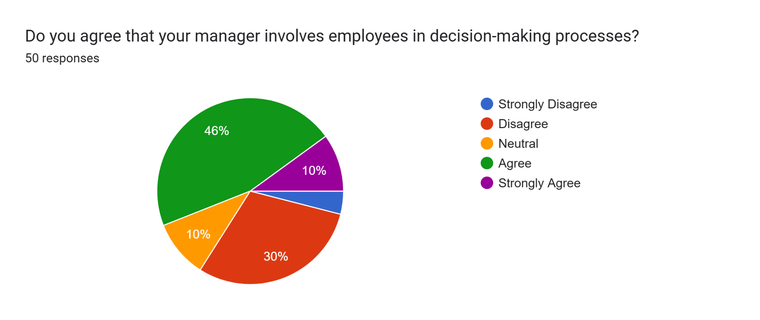
Fig 4 .2.1.5: Employee involvement in decision making
(Source: Google Form)
(f) Motivation to Perform the Job
Most employees felt motivated to perform their jobs. 46% agreed, and 14% strongly agreed with the statement. However, 30% disagreed, 10% remained neutral, and no respondents strongly disagreed. The findings indicate generally positive levels of employee motivation.
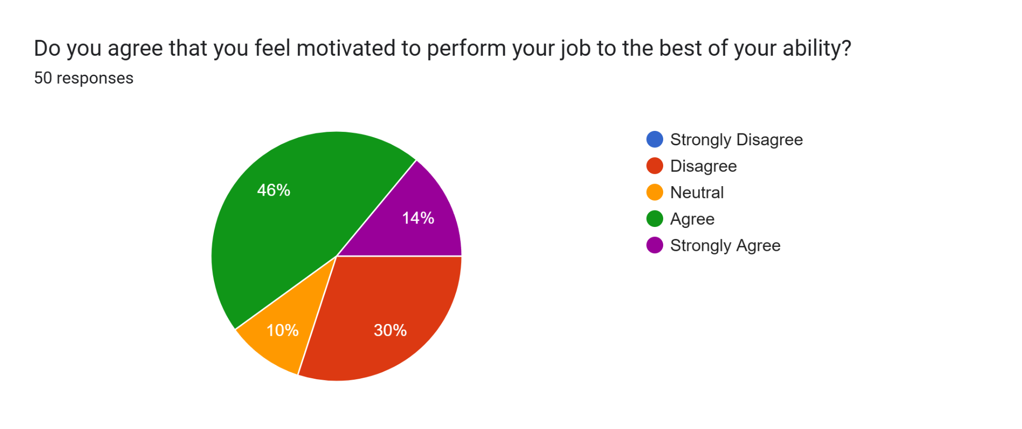
Fig 4 .2.1.6: Employee Motivation
(Source: Google Form)
(g) Recognition and Appreciation at Work
The majority of the participants were recognised and appreciated in their workspace in the beauty industry. 58% agreed, and 10% strongly agreed with the statement. But 22% disagreed, 6% were neutral, and 4% strongly disagreed. The results indicate that employee appreciation is generally implemented in beauty businesses.
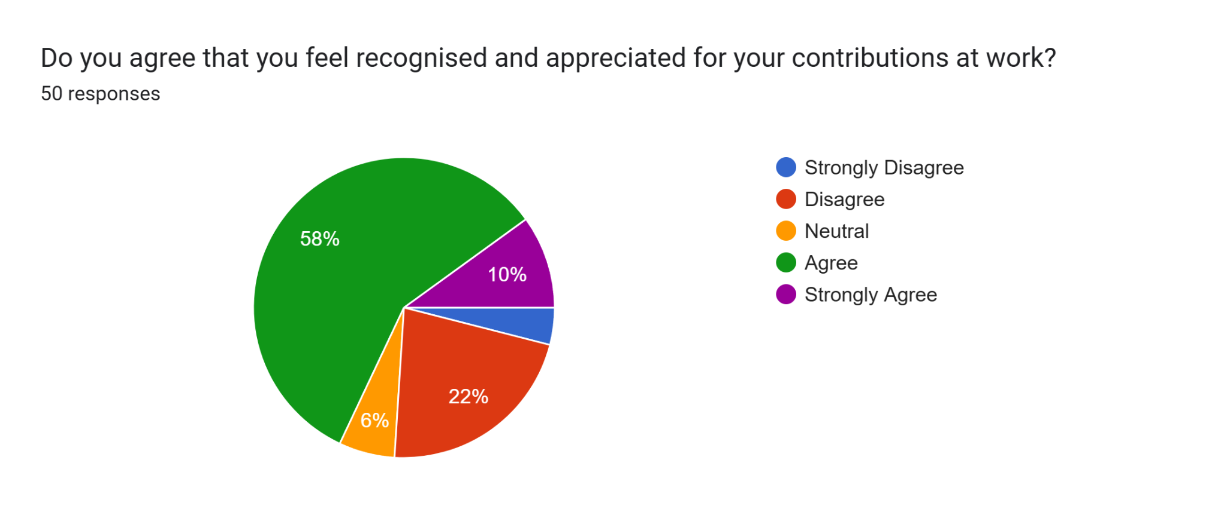

Fig 4 .2.1.7: Employee recognition and appreciation
(Source: Google Form)
(h) Completing Work Tasks Effectively
Most employees reported completing their work tasks effectively. 58% agreed, and 10% strongly agreed with the statement. But 18% disagreed, 8% were neutral, and 6% strongly disagreed. The results show that employees' performance in beauty businesses is generally high.
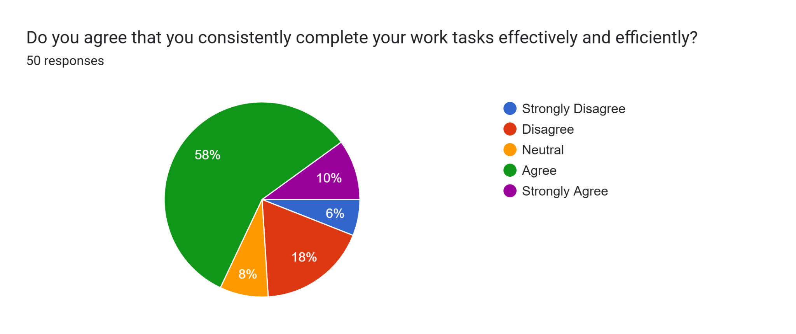
Fig 4 .2.1.8: Performing tasks consistently
(Source: Google Form)
(i) Providing High-Quality Customer Service
Customer service performance was positive. 58% agreed, and 14% strongly agreed that they provided high-quality customer service. Only 24% disagreed, while 4% remained neutral.
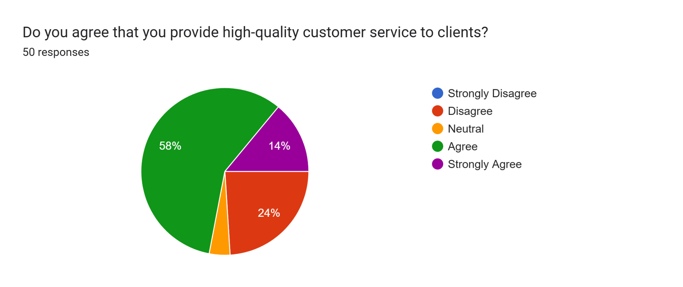
Fig 4 .2.1.9: Providing high-quality service to clients
(Source: Google Form)
(j) Workplace Satisfaction and Intention to Stay
Most employees expressed positive workplace commitment. 54% agreed, and 14% strongly agreed that they intended to remain with their organisation, while 26% reported neutral or negative responses.
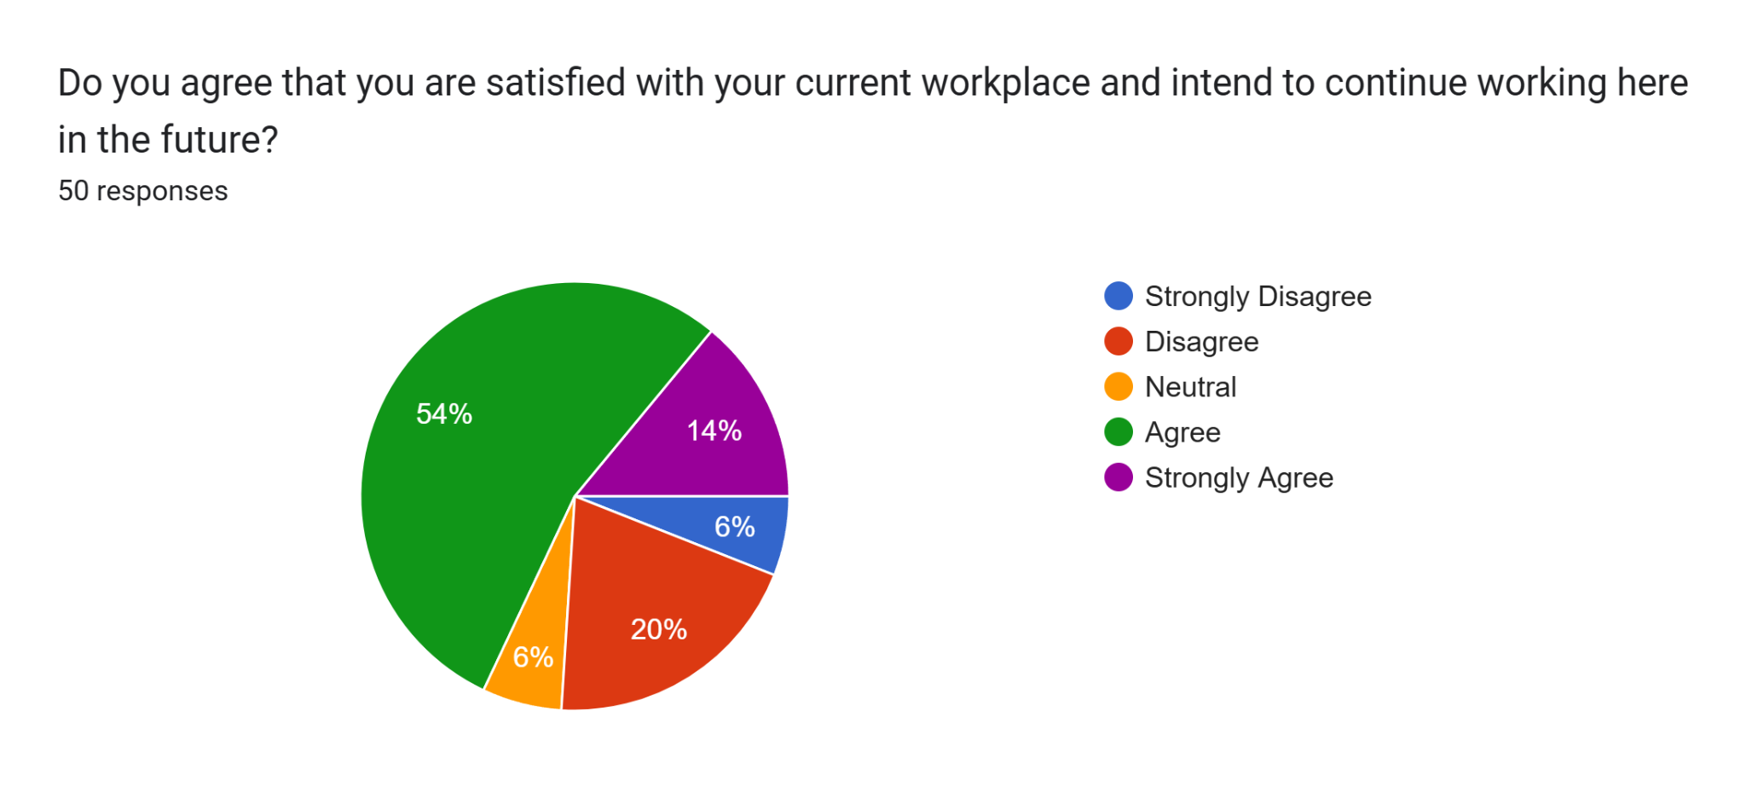
Fig 4 .2.1.10: Satisfaction with current workplace
(Source: Google Form)

4.2.2 Findings from Statistical Analysis
(a) Descriptive Statistics
The responses of the participants were analysed using descriptive statistics. The mean scores ranged from 3.28 to 3.62, indicating that the majority of respondents agreed with the questionnaire statements (Sreedharan et al. 2024). The highest mean score was for high-quality customer service (M = 3.62, SD = 1.008). This indicates that employees felt they provided satisfactory service to customers. The lowest mean was for employee involvement in decision making (M = 3.28, SD = 1.126). This indicates a lower level of employee engagement in decision-making processes at the beauty industry. The other variables had mean scores ranging from 3.40 to 3.54. The range of standard deviations for the responses was moderate, from 1.008 to 1.147. Overall, the descriptive statistics show a positive perception of leadership, motivation and performance among employees.
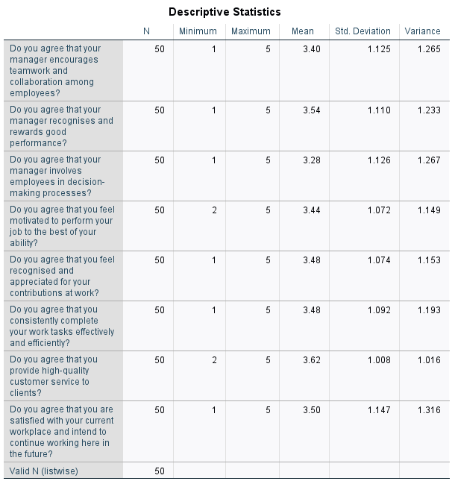

Fig: 4.2.2: Descriptive Statistics
(Source: IBM SPSS)
(b) Reliability Analysis (Cronbach's Alpha)
Reliability analysis was performed to check the internal consistency of the questionnaire. The Cronbach's Alpha value obtained was 0.866, which is higher than the recommended value of 0.70. This means that the questionnaire showed good reliability and the items were consistent in measuring the study variables. The corrected item-total correlation values ranged from 0.469 to 0.689, which is above the acceptable level of 0.30 (Li et al. 2026). This indicates that each item on the questionnaire had a significant contribution to the scale. Furthermore, the Cronbach's Alpha if Item Deleted values for the items ranged from 0.841 to 0.865. No values from these exceeded the overall alpha of 0.866. So, if an item is removed, the reliability will not improve. The eight items in the questionnaire were all kept for further statistical analysis.
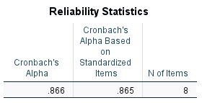
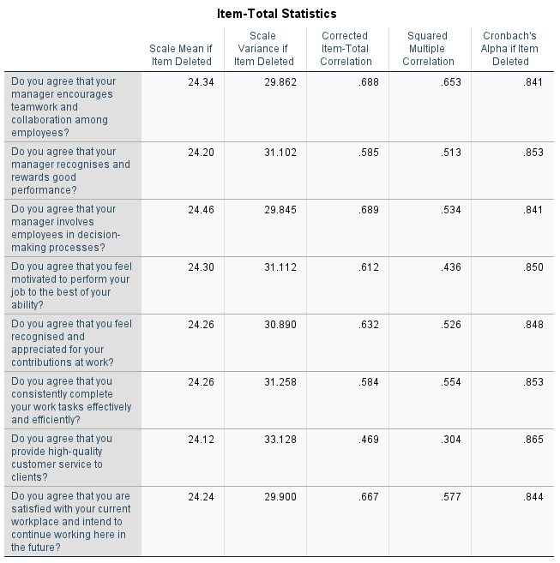
Fig: 4.2.3: Reliability Analysis
(Source: IBM SPSS)
(c) Pearson Correlation Analysis
Pearson correlation analysis was used to analyse the relationship between leadership style, employee motivation and employee performance. All the variables were found to be statistically significantly positively related (p < 0.001). There was a strong positive correlation between leadership style and employee motivation (r = 0.656). This indicates that those who felt that they had better leadership also had higher levels of motivation (Hoque and Raya, 2023). The employee performance was also moderately positively correlated with leadership style (r = 0.550). This means that good leadership leads to better employee performance, but other factors may also affect performance. Additionally, the employee motivation was positively correlated with employee performance (r = 0.614). In general, the results indicated that leadership style is one of the important aspects in enhancing employee motivation and employee performance in the beauty business.
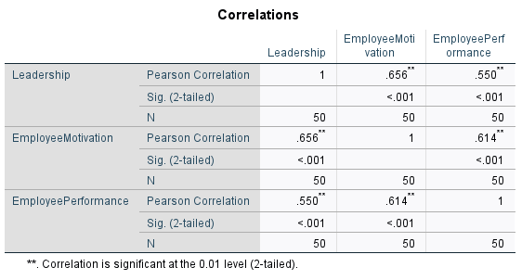

Fig 4.2.4: Correlation Analysis
(Source: IBM SPSS)
(d) Multiple Regression Analysis
To explore the relationship between leadership style and employee motivation and employee performance, multiple regression analysis was carried out. The results revealed that the leadership style was a significant predictor of employee motivation (R = 0.656, R² = 0.431, p < 0.001). This indicates that 43.1% of the variance in employee motivation can be attributed to leadership style. The leadership style also had a significant impact on employee performance (R = 0.550, R² = 0.303, p < 0.001). This means that 30.3% of the variance in employee performance could be attributed to the leadership style. In both models, the regression coefficients were positive, indicating that the better the leadership practices, the more motivated and productive the employees will be (Hajiali et al. 2022). The R² values also indicate that other workplace factors have an impact on these outcomes, and should be taken into account in future research.
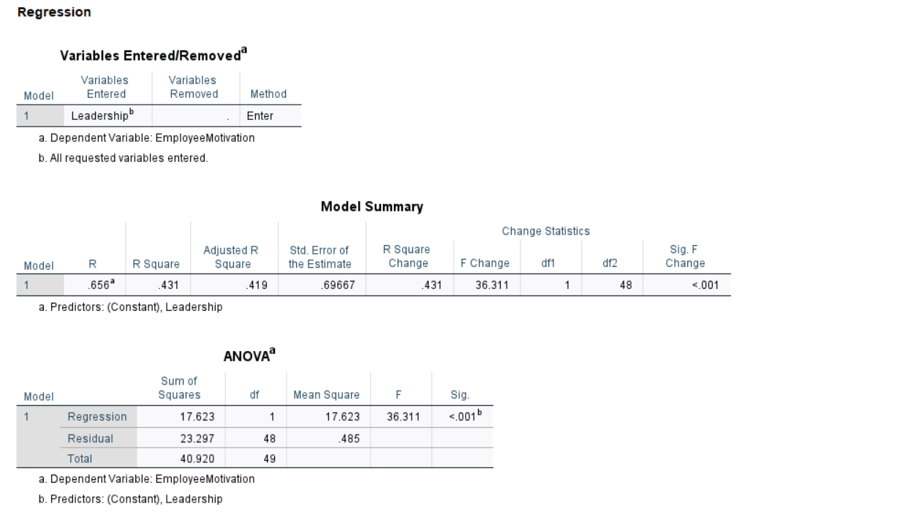
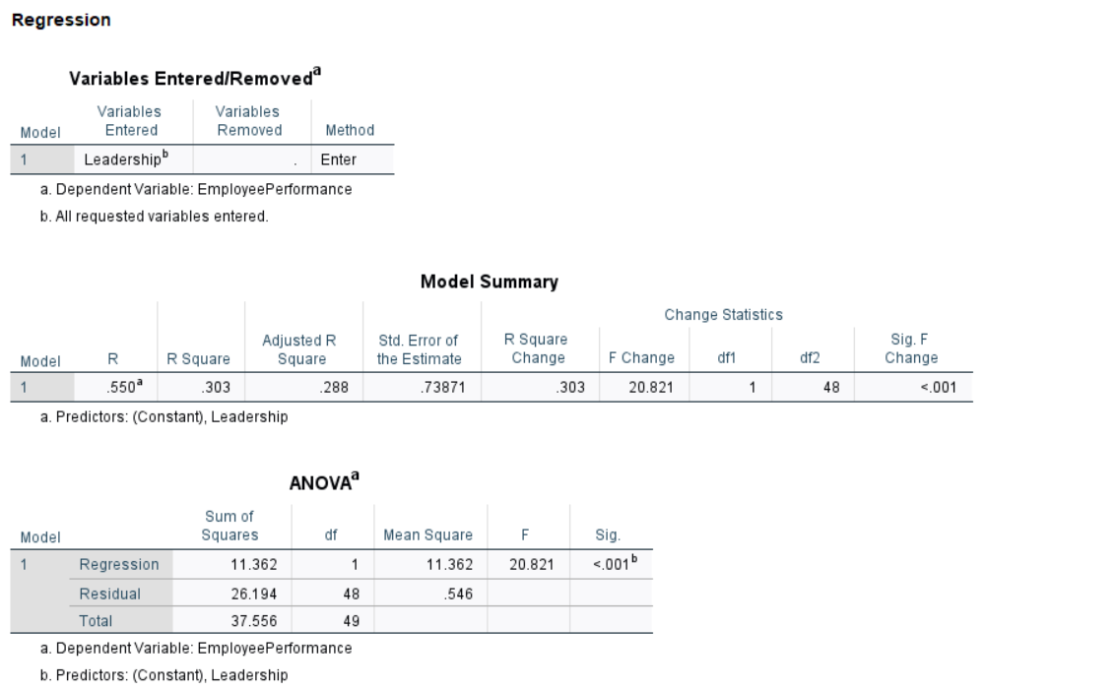

Fig 4.2.5: Multiple Regression Analysis
(Source: IBM SPSS)
4.3 Discussion

4.3.1 Leadership Styles Commonly Used in Beauty Businesses
The first objective was to identify the main leadership styles commonly used in beauty businesses. The survey results show that supportive leadership is the most common approach. 64% of respondents agreed or strongly agreed that managers encouraged teamwork. Similarly, 68% agreed or strongly agreed that managers recognised and rewarded good performance. But just 56% agreed or strongly agreed that managers engaged employees in decision-making. This was also the lowest-rated leadership practice (M = 3.28) (IBM SPSS). The results indicate that managers support and recognise employees, but do not engage them much in critical decisions. L'Oréal has also reported a 79% employee engagement rate via leadership and development programmes and spent €120 million on employee training in 2023 (L'Oréal, 2023). These are examples of how leadership support can enhance employee engagement and performance.

4.3.2 Leadership Styles and Employee Motivation
The second objective was to explore the correlation between leadership styles and employee motivation. The SPSS analysis revealed that there was a high positive correlation between leadership style and employee motivation (r = 0.656, p < 0.001). The regression analysis also found that leadership style explained 43.1% of the variation in employee motivation (R² = 0.431) (IBM SPSS). This indicates that supportive leadership positively impacts employee motivation. This is also reflected in the Google Forms results, which show that 60% of the respondents agreed or strongly agreed that they felt motivated to carry out their work. The same can be observed at Sephora, where leadership programmes, employee recognition and career development are implemented to boost employee engagement and motivation (‌Donaldson, 2025). This comparison helps to confirm that good leadership is a key factor in boosting employee motivation in the beauty sector.

4.3.3 Leadership Styles and Employee Performance
The third objective was to examine the effect of leadership styles on employee performance. The SPSS result indicated that there was a positive correlation between leadership style and employee performance (r = 0.550, p < 0.001). The regression analysis also revealed that the leadership style accounted for 30.3% of the variance in employee performance (R² = 0.303). Good leadership contributes to better employee performance in the workplace (Asif and Shaheen, 2022). The Google Forms results also indicated that 68% of the respondents agreed or strongly agreed that they were able to do their work effectively. Beauty stores like Ulta Beauty offer regular training and coaching to enhance employee skills and customer service (ULTA Beauty Careers, 2020). This aligns with the study results that employee performance can be enhanced through supportive leadership.

4.3.4 Most Effective Leadership Style and Managerial Implications
Finding | Discussion and Managerial Implication
Most effective leadership style | The findings show that supportive leadership was the most effective style. It was linked with teamwork, employee recognition and motivation (Reyaz, 2024).
Evidence from the study | 68% of respondents agreed that managers recognised good performance, while the SPSS results showed a strong relationship between leadership and motivation (r = 0.656) and a positive relationship with performance (r = 0.550).
Managerial implication | Beauty business managers should encourage teamwork, recognise employee achievements and involve employees more in decision-making (Suhartini and Sary, 2025). These practices can improve motivation, performance and long-term employee commitment.

4.4 Chapter Summary
This chapter presented the findings from the Google Forms survey and SPSS analysis. The results showed that supportive leadership positively influenced employee motivation and performance. The findings also confirmed significant relationships between the study variables. The next chapter discusses the conclusions, practical recommendations, study limitations and future research directions.

CHAPTER 5: CONCLUSION, LIMITATIONS, AND RECOMMENDATIONS

5.1 Conclusion
This study aimed to explore the effect of leadership styles on employee motivation and performance in the beauty industry. The main aim was to understand how different leadership practices influence employees' motivation and work performance. The study also looked at the leadership styles that are typically used in beauty businesses and what the employees felt was the most effective leadership style. The findings showed that the research aim was successfully achieved. Google Forms responses revealed that supportive leadership practices like encouraging teamwork and acknowledging employee accomplishments were prevalent among managers. However, employee involvement in decision-making received lower responses, showing that participative leadership was less common. This suggests that managers still have opportunities to involve employees more in workplace decisions.
These results were confirmed by SPSS analysis. Overall, the descriptive statistics revealed that the employees' perceptions of leadership, motivation and performance were generally positive. The Cronbach's Alpha value obtained in the reliability analysis was 0.866, indicating the reliability of the questionnaire. The Pearson correlation analysis revealed that there were significant positive relationships between leadership style, employee motivation and employee performance. Leadership style was the most significant factor related to employee motivation. The regression analysis also revealed that leadership style was a significant predictor of employee motivation and employee performance.
The research objectives and research questions were successfully addressed. Supportive leadership was the most frequently used and most effective leadership style among the beauty businesses studied. It also confirmed that effective leadership positively affects employee motivation and employee performance. The study is original in that it offers up-to-date data from beauty industry workers. It integrates survey results with statistical analysis to illustrate the link between leadership style, motivation and performance. The findings offer valuable information for beauty business managers who seek to enhance employee engagement, boost performance in the workplace, and ensure long-term organisational success by implementing effective leadership practices.

5.2 Recommendations

5.2.1 Strengthening Supportive Leadership Practices (Objective 1)
Beauty business managers should keep implementing supportive leadership practices. They should encourage teamwork, communicate openly and provide regular guidance to employees. Managers should also develop good working relationships with employees (Suknunan and Bhana, 2022). These practices can enhance trust and make it a better working environment. Effective leadership can keep employees engaged and do their jobs better.

5.2.2 Improving Employee Motivation Through Recognition (Objective 2)
Managers need to acknowledge employee accomplishments on a regular basis. According to Hansamali et al. (2024), rewards, recognition, performance bonuses and public recognition can boost employee motivation. On the other hand, feedback sessions should also be held regularly to inform employees of their strengths and weaknesses. These actions can enhance employee satisfaction and motivate them to do their job better.

5.2.3 Increasing Employee Performance Through Training (Objective 3)
Beauty businesses should provide regular training programmes to improve the technical and customer service skills of employees. Researchers like Rahimić et al. (2022), supported the fact by stating that managers need to coach and mentor newly recruited employees. Frequent performance evaluations can be used to identify skills deficits and facilitate ongoing growth. A better training programme can improve employee confidence, productivity and service quality.

5.2.4 Encouraging Employee Participation in Decision-Making (Objectives 4 and 5)
The results indicated that the lowest level of agreement was found for employee involvement in decision-making. Therefore, managers need to engage employees more in workplace discussions and decisions. Regular employee conferences, suggestion systems and feedback surveys should be implemented. According to Modise, (2023), increased participation can lead to better employee commitment, motivation, and organisational performance, and foster a more positive workplace culture.

5.3 Research Limitations
Limitation | Impact on the Study
Small sample size | The Google Form survey included only 50 respondents. This may not fully represent all employees working in the beauty industry.
Limited geographical coverage | Data were collected from beauty industry employees through an online survey without focusing on a specific country or region. Therefore, the findings may not represent all beauty businesses.
Self-reported responses | The study relied on employees' personal opinions and experiences. Some respondents may have provided socially desirable answers instead of their actual views.
Cross-sectional research design | Data were collected at one point in time only. Changes in leadership style, employee motivation and performance over a longer period were not examined.
Limited study variables | The research examined only leadership style, employee motivation and employee performance. Other factors, such as salary, organisational culture, job satisfaction and work environment, were not included but may also influence employee outcomes.

5.4 Future Directions
A larger sample size is recommended for further studies to enhance the reliability of the results. Research also needs to be conducted in specific countries or regions within the beauty industry to provide a better comparison. Other factors like organisational culture, job satisfaction, employee well-being and workplace environment can be studied in the future. A longitudinal study can be performed to study the relationship between leadership style and employee motivation and performance over a longer period. This would give a more complete picture of the effectiveness of leadership.

Reference List
Agwoje, O. (2023). Negative effects of leadership on organizational performance. International Journal of Scientific Research in Education, 16(4), pp.368–379.
Ahmad, S., Wong, W.-K., Riaz, S. and Iqbal, A. (2024). The role of employee motivation and its impact on productivity in modern workplaces while applying human resource management policies. Arabian Journal of Business and Management Review (AJBMR), 13(2), pp.7–12.
Ali, I.M. (2024). A Guide for Positivist Research Paradigm: from Philosophy to Methodology. Idealogy Journal, 9(2), pp.187–196.
Ardina, J.O., Llyod, J., Carl, J., Manguiat, G.I., Vanessa, M. and Mangarin, J.A. (2025). Setting Standard, Shaping Beauty: Top Operational Practices Inhealth And Beauty Industry.
Asif, M. and Shaheen, A., (2022). Creating a high-performance workplace by the determination of importance of job satisfaction, employee engagement, and leadership. Journal of Business Insight and Innovation, 1(2), pp.9-15.
Chib, S., Mehta, A.K., Selvakumar, P., Saravanan, A., Mishra, B.R. and Manjunath, T.C. (2025). Mental Health Challenges and Solutions in High-Pressure Work Environments. Innovative Approaches to Managing Conflict and Change in Diverse Work Environments, pp.247–272.
‌Donaldson, C. (2025). Sephora’s 5-stage strategy for improving the employee and customer experience. [online] Inside HR. Available at: https://www.insidehr.com.au/sephora-strategy-improving-employee-customer-experience/., [Accessed on: 4th July, 2026].
Fife, S.T. and Gossner, J.D. (2024). Deductive Qualitative Analysis: Evaluating, Expanding, and Refining Theory. International Journal of Qualitative Methods, 23(1), pp.1–12.
Firda, N. and Ferine, K.F. (2023). The Effect of Transactional Leadership and Punishment on Employee Performance with Motivation as an Intervening Variable for the Management Body Revenue Finance and Regional Assets of Binjai City. International Journal of Economics, Management and Accounting (IJEMA), 1(2), pp.71–82.
Gallup (2025). How to Improve Employee Engagement in the Workplace. [online] Gallup. Available at: https://www.gallup.com/workplace/285674/improve-employee-engagement-workplace.aspx.
Gamage, A.N.K.K. (2025). Research design, philosophy, and quantitative approaches in scientific research methodology. Scholars Journal of Engineering and Technology, 13(02), pp.91–103.
Garad, A., Haryono, S., Yaya, R., Pratolo, S. and Rahmawati, A. (2022). The Relationship Between Transformational Leadership, Improving Employee’s Performance and the Raising Efficiency of Organizations. Management and Production Engineering Review, [online] pp.15–3015–30.
Ghimire, B., Dahal, R.K., Karki, D. and Joshi, S.P. (2024). Motivators and Hygiene Factors Affecting Academics in Nepalese Higher Education Institutions: Applying Herzberg’s Two-Factor Theory. Journal of Business and Social Sciences Research, [online] 9(2), pp.1–16.
Golzar, J., Noor, S. and Tajik, O. (2022). Convenience Sampling. International Journal of Education & Language Studies, [online] 1(2), pp.72–77.
Hajiali, I., Fara Kessi, A.M., Budiandriani, B., Prihatin, E., Sufri, M.M. and Sudirman, A. (2022). Determination of Work Motivation, Leadership Style, Employee Competence on Job Satisfaction and Employee Performance. Golden Ratio of Human Resource Management, 2(1), pp.57–69.
Hajiali, I., Kessi, A.M.F., Budiandriani, B., Prihatin, E. and Sufri, M.M., (2022). Determination of work motivation, leadership style, employee competence on job satisfaction and employee performance. Golden Ratio of Human Resource Management, 2(1), pp.57-69.
Hansamali, H.G.C., Francis, S.J., Sirikumar, T. and Ganeshamoorthy, S., (2024). Impact of rewards system on employee performance.
Heerden, R.V. and Naicker, V. (2025). Revisiting Maslow’s hierarchy: the recognition and acknowledgment of greatness in others. EUREKA Social and Humanities, [online] (3), pp.11–17.
Hochwald, I.H., Green, G., Sela, Y., Radomyslsky, Z., Nissanholtz‐Gannot, R. and Hochwald, O. (2023). Converting qualitative data into quantitative values using a matched mixed‐methods design: A new methodological approach. 79(11).
Hoque, K.E. and Raya, Z.T., (2023). Relationship between principals’ leadership styles and teachers’ behavior. Behavioral Sciences, 13(2), p.111.
Imran, M., Li, J., Bano, S. and Rashid, W. (2025). Impact of democratic leadership on employee innovative behavior with mediating role of psychological safety and creative potential. Sustainability, [online] 17(5), p.1879.
Jian, Q., Wang, X., Al-Smadi, H.M., Waheed, A., Badulescu, A. and Samad, S. (2022). Proposing a Robust Model to Reduce Employees’ Turnover Intentions in an Ethical Leadership Framework: Empirical Evidence from the Healthcare Sector. International Journal of Environmental Research and Public Health, 19(15), p.8939.
Li, Y., Wang, R., Zhang, X., Hu, X., Liu, Z. and Zhang, J., (2026). Development and validation of the physical activity behavior scale for older adults based on the theory of planned behavior. BMC geriatrics.
Lindert, L., Zeike, S., Choi, K.-E. and Pfaff, H. (2022). Transformational Leadership and Employees’ Psychological Wellbeing: A Longitudinal Study. International Journal of Environmental Research and Public Health, [online] 20(1), p.676.
L'Oréal (2023). L’Oréal | annual report – culture and human relations. [online] L’Oréal Finance. Available at: https://www.loreal-finance.com/en/annual-report-2023/culture-and-human-relations/., [Accessed on: 4th July, 2026].
Manafe, L.A., Wahib, M., Zebua, M., Andriana, R. and Erawati, Y. (2024). IS EMPLOYEE PERFORMANCE INFLUENCED BY DISCIPLINE, MOTIVATION, AND COMPETENCE? A STUDY ON SALON AND BEAUTY EQUIPMENT BUSINESS. International Journal of Economics, Business and Accounting Research, 8(1).
McLeod, S. (2025). Maslow’s hierarchy of needs. [online] Simply Psychology. Available at: https://www.simplypsychology.org/maslow.html.
Modise, J.M., (2023). The impacts of employee workplace empowerment, effective commitment and performance: An organizational systematic review. International Journal of Innovative Science and Research Technology, 8(7), pp.3435-3457.
Mofu, Y.Y., Noch, M.Y. and Khotimah, K. (2024). The Influence of Motivation, Training, Work Environment and Compensation on Employee Performance. Advances Jurnal Ekonomi & Bisnis, 2(4), pp.113–126.
Mphaluwa, G., Hui, L., Marere, R.S. and Banda, L.O.L. (2025). How do leadership styles influence employee engagement and performance in SMEs? Humanities and Social Sciences Communications, [online] 12(1).
Ned, A.E. and Umesi, C.D. (2023). Effective Leadership and Employee Motivation for Sustainable Development. Journal of Education in Developing Areas, [online] 31(2), pp.310–321.
Pahi, M.H., Abdul-Majid, A.-H., Fahd, S., Gilal, A.R., Talpur, B.A., Waqas, A. and Anwar, T. (2022). Leadership style and employees’ commitment to service quality: An analysis of the mediation pathway via knowledge sharing. Frontiers in Psychology, 13, pp.1–12.
Permadi, I.K.O., Puspitawati, N.M.D. and Aristana, I.N. (2024). The Influence of Leadership on Employee Morale with Work Motivation as Mediation Effect. Jurnal Ecogen, [online] 7(1), pp.1–11.
Quaquebeke, N.V., Salem, M., van Dijke, M. and Wenzel, R. (2022). Conducting organizational survey and experimental research online: From convenient to ambitious in study designs, recruiting, and data quality. Organizational Psychology Review, 12(3), p.20.
‌Rahimić, Z., Čizmić, E., Šestić, M. and Hrnjić, A., (2022), May. Differences of the employee perception to the main job design parameters in the context of digitalization. In International Conference “New Technologies, Development and Applications” (pp. 1069-1075). Cham: Springer International Publishing.
Reyaz, S., (2024). The influence of leadership styles on employee motivation and job satisfaction. International Research Journal on Advanced Engineering and Management (IRJAEM), 2(3), pp.339-344.
Shin, E.J. and Kwon, K.H. (2022). The structural relationship between job satisfaction and organizational commitment of beauty industry employees. Journal of Cosmetic Dermatology.
Sordo, E. and Zattoni, A. (2024). The Role of Employee Ownership, Financial Participation, and Decision‐Making in Corporate Governance: A Multilevel Review and Research Agenda. Corporate Governance: An International Review.
Sreedharan, J.K., Karthika, M., Alqahtani, A., Albalawi, I., Alenazi, M., Alanazi, A.H., Almkayeel, G.M., Alahmari, M. and Daley, L., (2024). Psychometric properties and development of a structured questionnaire to assess the perception, attitude, and job satisfaction among respiratory therapists. Heliyon, 10(8).
Statista (2026). Cosmetics: Market value . [online] Statista. Available at: https://www.statista.com/statistics/289762/market-value-of-cosmetics-in-great-britain/.
Suhartini, H. and Sary, F.P. (2025). Empowering performance through engagement: the mediating role of employee engagement in the relationship between transformational leadership, self-directed learning, and employee performance in the cosmetics industry. International Journal of Business Innovation and Research, 37(7), pp.1–22.
Suhartini, H. and Sary, F.P., (2025). Empowering performance through engagement: the mediating role of employee engagement in the relationship between transformational leadership, self-directed learning, and employee performance in the cosmetics industry. International Journal of Business Innovation and Research, 37(7), pp.1-22.
Suknunan, S. and Bhana, A., (2022). Influence of employee-manager relationship on employee performance and productivity. Problems and Perspectives in Management, 20(3).
Suryadi, Y., Trisnawati, T. and Al-Amin, A.-A. (2024). The Impact Of Transformational Leadership On Organizational Performance And Employee Motivation. Transforma Jurnal Manajemen, 2(2), pp.65–76.
Taherdoost, H. (2022a). Designing a Questionnaire for a Research Paper: a Comprehensive Guide to Design and Develop an Effective Questionnaire. Asian Journal of Managerial Science, 11(1), pp.8–16.
Taherdoost, H. (2022b). How to Conduct an Effective Interview; A Guide to Interview Design in Research Study Authors. International Journal of Academic Research in Management (IJARM), 11(1), p.39.
Taufique, K.M.R., Sabbir, Md.M. and Rabbanee, F.K. (2026). A Guide to Key Decision Criteria for Likert‐Scale Use in Survey Research. Global Business and Organizational Excellence.
TUMIRAN, M.A. (2024). CONSTRUCTING A FRAMEWORK FROM QUANTITATIVE DATA ANALYSIS: ADVANTAGES, TYPES AND INNOVATIVE APPROACHES. Quantum Journal of Social Sciences and Humanities, 5(4), pp.198–212.
ULTA Beauty Careers. (2020). ULTA Beauty Careers. [online] Available at: https://careers.ulta.com/ [Accessed 4 Jul. 2026].

