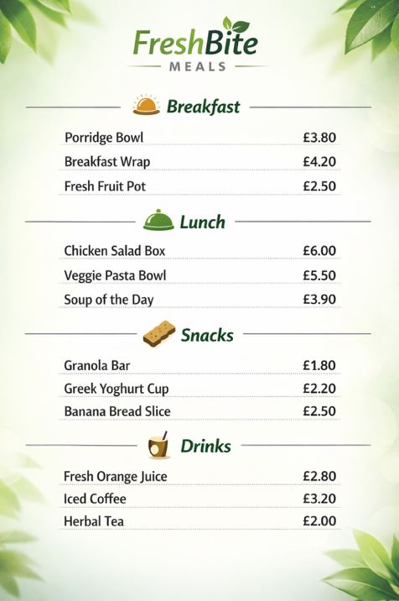
New Updated Menu For “Fresh Bite Meals”

Decision & Iteration Log
- Why I chose my tool
I chose Microsoft Word because this is the tool I am most familiar with and most comfortable using. It has allowed me to upload an image of the menu I have created for this business and explains the reasons behind it. I have also watched many videos on how to use Microsoft word properly and implemented this into my work. This has allowed me to use my skills to the highest of my potential therefore helping in my decision making to choose Microsoft word.
- What information I used
I used all the item names and the prices of each item from this scenario.
I also used the specific type of menu items and sectioned them into the correct category.
- How I created my artefact
- First, I created a “Canva” draft to allow me to create my menu
- I then added a sleek and professional design to suit the company’s aesthetic
- After that, I added the company name, categories, and menu items with prices.
- Second to last, I added small images to give the customers a visualisation and to match whichever category I was presenting.
- Lastly, I went over the menu and the prices again to make sure I had done everything correctly.

- What changes I made
- At first, my design of the menu was too dark and so I changed the colour to make it brighter and more appealing for the customers to read.
- I also changed the font of the writing as I did not feel it quite fit the aesthetic of the menu and surround colours.
- To begin with, the categories were coloured in black writing and so I changed this because I wanted the green colour looked more presentable.

- Feedback I used
My tutor said that the menu should be more centred on the page.
My classmates recommended that I increase the font size to make it easier to read.
I changed both things based on the feedback I received.
- Final explanation
This artefact helps the owner of “FreshBite Meals” present a more clear, professional, and more aesthetically pleasing menu which can help better increase the quality of service and increase in customer satisfaction.

