Title page:
Student name: Alda Costa
Student number:2133758
Module code:LCHS4004
Module title: Introduction to public health
Lecturer’s name: Laila Surani
Assignment title: Major health issue

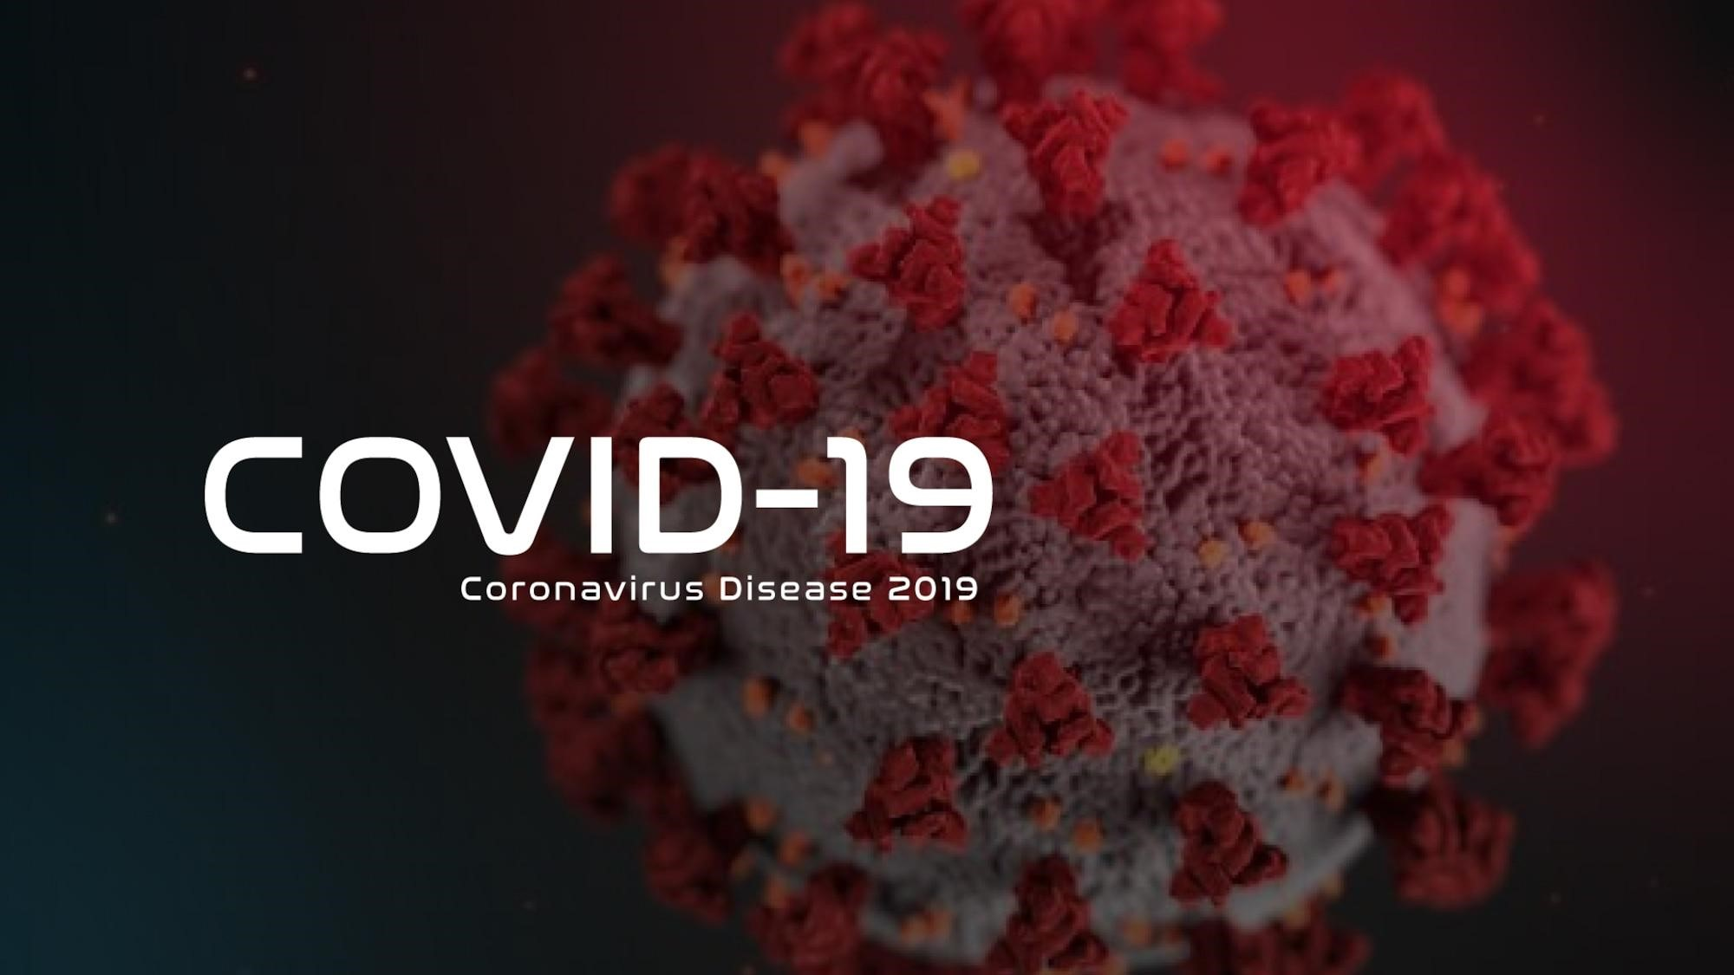
Introduction:
This report is about the disease known as Coronavirus, or for short, ‘COVID-19’. The disease got its name ‘COVID-19’ because CO stands for corona, VI for virus, D for disease, and 19 for 2019 as its first cases were reported in late December 2019.
Coronavirus is an infectious disease caused by SARS-CoV-2 virus. It is said that coronaviruses are found to circulate in mammals and birds, and scientists suggest that it originally came from bats.
UK statistics have shown that there have been 23.9 million cases of COVID from the 2nd of March 2020, up until 3rd of November 2022. From March 2022, there have been a total of 210 thousand deaths in the UK so far and it is said that it even rose as in the last 7 days 32,236 people have confirmed that they have tested positive. The severity of this disease in the UK states that the alert level has gone down from level 3 to level 2 (31 August 2022).
Worldwide statistics have shown that there have been 632 million total cases from the 23rd of
January 2020, up until 3rd of November 2022. From January 2020, there have been a total of 6.6 million deaths worldwide and it is still rising as there are reports that show cases are rising daily. Since October 2022, 815 people have died from COVID-19 on a daily basis. There are weekly new cases of 2 million and 7 thousand deaths. The estimated overall case of fatality is ~7%, with country-level estimates varying between 0.5 and 14%.
—-----------------------------------------------------------------------------------------------------------------------------
Main body:
The basic public health measures and guides to follow are:
Physical distancing
Wearing a mask
Keeping rooms well ventilated
Avoiding crowds
Cleaning your hands
Coughing into a bent elbow or tissue
There are also simple rules to follow when using a mask:
Cleaning your hands before and after you put on or take a mask off. As well as after touching it.
Making sure it covers both your nose, mouth and chin.
When taking it off, either store it in a clean plastic bag or wash it if it’s a fabric mask.
These public health measurements were put in place to limit the amount of people catching the disease and to also help limit the spread of bacteria or germs being passed around. They were also put in place to limit the disease being spread in more packed areas as it is way easier for viruses and illnesses to spread when there is more people around because there would be more movement and contact among everybody. It also boosts hygiene and can also be easier to get children to be more cautious as children are always messy and are not the best at keeping tidy. These health measurements are also not too complex or difficult to follow and it is just the bare minimum in order to keep yourself and those around you safe.
Some biological determinants of COVID-19 include CKD, C-reactive protein, diabetes, hypertension, obesity, cancer, COPD, dyspnea, asthma, and coronary heart disease. Health data has proven that most chronic conditions, like the ones above, decrease innate immune response in humans.
The risk factors of COVID-19 are close contact with someone who has the disease, especially those with symptoms, being coughed/sneezed on by someone who has been infected, and being near someone who has been infected in a closed space with poor air flow. These risk factors are the main ways of how the virus is spread and can be easily avoided by self-isolating, washing your hands or changing clothes as often as you can, keeping a distance and just following all orders put in place for the public. Also avoiding to go out into public places where a lot people may be and limit contact as much as you can.
(Short term consequences)
Short term consequences after having the disease of COVID-19 could be easily being able to catch the same disease several times and this can be very damaging to their immune system as it can make the person weak. Them being weak and ill at the same time is very serious and could cause hospitalization which can be time consuming and maybe even emotionally damaging towards people’s families. It is said that many people have had their symptoms for over 100 days and that can cause issues with isolation as the person may think it’s just a small after effect and won’t need to isolate whereas another family member may think it’s still COVID-19 and that they do need to isolate. Isolation can cause a feeling of loneliness and it may not be life damaging but it can cause an overwhelming feeling of sadness and some people may like being surrounded by others because it could make them feel safe and isolated alone in a room for over 100 days may not be the best. There are also common short term effects like tiredness, dizziness, shortness of breath and a fever. These symptoms with a weak immune system could be life threatening for some and may have to issue in being hospitalized where a person could catch COVID-19 from being in such an environment and this could increase to their symptoms being even more serious than they already are. After catching COVID you may feel down a lot more or even be sick a lot more as your immune system weakened and those who work busy schedules may be off work and that can cause them a lot of stress. Already being ill and also being stressed out on top of that can make being ill harder to deal with. For those who had a more serious case of COVID-19, their short term consequences can vary from breathing failure to confusion or kidney/heart problems due to lack of oxygen and blood clots formed. Breathing failure can obviously not be treated at home as it’s not a small issue that can be resolved which pharmacy medication and so you would need some real medical attention which could lead to you needing oxygen therapy or to have an oxygen mask put on and on serious occasions you might even need a tube. Heart issues are very serious and you would need to seek immediate medical attention if you’re experiencing any symptoms of heart issues. The heart is the main supplier in the body and it supplies you with blood around your body and if you’re heart is failing to do so it can lead to a high risk of death and since it’s an after effect of having COVID, the death would add to the COVID death rate. Now those are short term after effects of having COVID for an individual person but now let’s go onto short term COVID effects for families as a whole. Those who are dating may have had to end up having a long distance relationships which may have caused the connection between the two to break and this could damage the both emotionally. Another family effect may have been the social distancing and not being to go over to other family members homes and this could be upsetting, especially if you are wanting to see an elderly family member. The elderly were more at risk of catching the disease and if someone in your family who is elderly did catch it, you wouldn’t be able to go and comfort them and make sure their eating the right foods or getting the right amount of rest. It could cause an uneasy feeling and discomfort.
(Long term consequences)
Those who experienced the severe, deadly side of COVID might experience organ damage which can be very fatal. That includes organ damage to the heart, kidneys, skin and brain, and even problems with the immune system. It can never be clear how long this can last. There are many severe long-term health factors that can cause multiple issues in the human body. Whether if it’s mentally, emotionally or physically. Firstly, I’ll state the physical health issues that are long term consequences. Covid-19 affects several systems in the body; including the respiratory, cardiovascular, renal, nervous, musculoskeletal and metabolic systems. A long term health affect could be issues with the lungs and breathing. This could be very serious as it could limit the amount of every day activities being done, which can be a huge disruption in the lives of many whom have busy schedules. Issues with the lungs can take out a lot of time in everyday life with appointments, check-ups or even having to stay overnight in hospital for a few days if it gets to that level of severity. A mental or emotional long term after effect of having the disease of COVID-19 would be things like depression, post traumatic stress disorder (PTSD), anxiety and even paranoia. All these mental health problems are very severe and damaging to any human as it can effect you in your life and can even have a huge impact on those around you.
Paranoia is an instinct or thought process that is believed to be heavily influenced by anxiety or fear, often to the point of delusion and irrationality. COVID-19 being a serious disease that you have to be very cautious about may be even more difficult to handle with paranoia. The smallest signs/symptoms of the disease can cause a huge overwhelming feeling of anxiety and which might make it even more harder to be around people because you may still feel that you could catch it extremely easily when really and truly, you might not. Mental health overall is an extremely important issue that is under looked by a huge variety of people and more awareness must be spread among everyone in order to be able to look out for each other and so that everyone can feel a sense of ease and safety no matter what.

Conclusion:
In conclusion to this report and all things been said, COVID-19 is a very deadly disease that could easily be prevented by following protocol and the simple guides and rules that have been put in place to keep everyone safe but even with them being put in place, people are disobeying the laws and are breaking them. People breaking these rules have most definitely put people in danger and put multiple individuals lives at risk and that has been a reason why numbers and statistics have proved that the rates have increased but as of 2022, rates are decreasing but small deaths still continue to happen today. People may not think the disease is as serious as it was when it first came out but people are still dying around the world and so everyone must still wash their hands, wear masks in packed places and etc. The COVID-19 pandemic has shown many different aspects of life to several people, virtuality being one. People have learnt to work virtually and communicate better online and technology has become a big help during this pandemic. If it wasn’t for the pandemic many people would struggle to even use a zoom call or host a meeting online and would just resolute to doing everything in person. Technology has helped many and it definitely got teens and children to learn from home. The pandemic may have even helped students and adults concentrate more on work and studies due to being isolated in a quiet environment to where they could focus way better than in a classroom or workspace where it’s very busy and chaotic.
References:
COVID-19: Long-term effects - Mayo Clinic.
Impact of COVID-19 pandemic on healthcare workers - PMC
https://scholar.google.co.uk/scholar?q=key+determinants+of+covid+19&hl=en&as_sdt=0
&as_vis=1&oi=scholart
Coronavirus (COVID-19): guidance and support - GOV.UK
Country-level determinants of the severity of the first global wave of the COVID-19 pandemic: an ecological study | BMJ Open
Coronavirus Pandemic (COVID-19) - Our World in Data
Cases in the UK | Coronavirus in the UK

