Module: Organisational Consultancy
Module code: BMIH6005
Name and student number:
Assignment Title: A consultancy report on The Savoy Hotel in London

Name of the company: EliteEdge
Name of the client: The Savoy Hotel in London
Student Name:
Alexandra Beatrice Crisan
Student ID:
2208395

I acknowledge using Grammarly (https://www.grammarly.com/) on 18 October 2024 to check my work for grammar, readability, and syntax. I confirm that I have not presented any AI-generated text as my work. Additionally, I confirm that I have copies of my drafts, notes, and other resources used before and after the use of AI tools, which I may be asked to provide as evidence.

Table of Contents
Executive Summary 2
Introduction 5
Analysis 7
PESTEL Analysis 7
SWOT Analysis 9
TOWS Analysis 11
Recommendations and Change Management 13
Recommendations 13
Contactless Check-In and Digital Room Keys 13
Smart-Room Technology 15
Personalized Mobile Concierge Service 16
Change Management Strategies 17
Staff Training 18
Guest Communication 18
Pilot Program 19
Measuring Success 19
Guest Satisfaction 20
Operational Efficiency 20
Return on Investment (ROI) 20
Action Plan 20
Implementation Overview 21
Conclusion 23
References 25

Executive Summary
This consultancy report addresses the urgent need for The Savoy Hotel to modernize its technological infrastructure to maintain competitiveness in the luxury hospitality market. Despite its impressive background and highly recognizable brand image, The Savoy has several weaknesses. Those are mainly concerning the hotel’s ability to address the new demands of contemporary guests, such as a greater emphasis on the digital experience and individual attention. One of the key underlying problems identified is the slow pace of adopting innovative solutions, for example, contactless check-in and check-out, smart rooms, and mobile key concierge. These are prevalent in today’s competitive luxury hotel market.
The main concern here is that The Savoy has been slow to adapt from a service-based organization which does not align with the new age of technologically-savvy guests. The rivals have already leveraged digital inventions, providing guests with efficient and self-served services that increase comfort and individualization. On the contrary, the current work processes in The Savoy are far from efficient and even rude; the key areas such as check-in, main services, and limited opportunities to control the rooms significantly hinder the speed and efficiency of its work. This technological gap could reduce guest satisfaction, loyalty and the capacity to attract younger digitally inclined guests.
This analysis highlights several key findings. While competitors operating today have incorporated successful technological innovations that have made operations more efficient and guest experiences more memorable, The Savoy has not been left behind. Millennials and business people cherish convenience, technology-driven experiences, and no-contact services. The current services offered at the Savoy do not respond to these requirements, which is a problem for keeping its market share. Besides, costs of operation are high because of problems such high power consumption by outdated systems in rooms. There is also room for the hotel to enhance its sustainability in standard smart-room technologies which will also help in reducing energy consumption and costs.
Despite these challenges, The Savoy has several strengths that can support a successful digital transformation. They have a consistent brand image, and a large volume of repeat customers, and are situated right in London, which offers a perfect backdrop to introduce new age changes without losing out on tradition. This way, The Savoy can provide clients with the means for having a controlled interaction with technology while at the same time experiencing the type of luxury facilities that the hotel seeks to present to the competitive demanding hospitality market.
Based on these findings, the report provides three key recommendations. First, there is a need to establish contactless check-in technologies, whereby a guest can perform the check-in through an application on the smartphone and receive the digital key to his room. This will help make processes more efficient, minimize patients’ time spent waiting and create a more comfortable and secure environment as per the updated customer expectations. Second, smart-room technology needs to be implemented for the management of indoor climate, including lights, room temperature, etc, through the use of a smartphone application or a touch screen. This not only improves the feel of the guest, and the level of comfort but also helps the hotel to save energy due to sustainability. Lastly, The Savoy needs to implement an individual application for guests to order room service, book a spa or order a table at a restaurant through a smartphone. This will expand hotel guests’ expectations in terms of being able to have service delivery of their choice as well as prospects of offering them other services within the hotel.
Change management is therefore crucial for these changes to be implemented in the organization by having a structured change management plan. The Savoy should consider handling training for all employees as a way of making them familiar with such systems and how such technologies will enhance their responsibilities and customer relations. Moreover, communication with guests is going to be problematic especially if the guests are not familiar with the usage of digital services. To prevent interference with the normal flow of operations, the implementation process should follow a phased approach where the hotel first tests the software in a limited capacity.
Measuring the success of these initiatives will involve several key performance indicators, including guest satisfaction, operational efficiency, and return on investment (ROI). The analysis of guests’ surveys and the use and popularity of the applications will show the degree to which the new technologies supported the guests. Select parameters of ‘new’ operational efficiency might include check-in time and energy consumption while measurable benefits of ‘new’ financial performance might reveal revenue that comes with selling over and above the services and cost-cutting that comes with efficient management of energy.
In conclusion, the adoption of contactless check-ins, smart-room technology, and a personalized mobile concierge service will enable The Savoy Hotel to address its technological shortcomings and remain competitive in the luxury market. All these innovations will enhance customer satisfaction, organizational flow, and sustainable business advancement for the hotel. EliteEdge Consulting appreciates the opportunity to collaborate with The Savoy on this project and looks forward to supporting its continued growth in the future.

Introduction
The Savoy Hotel which was established in 1889 is located in London and has always provided guests with luxury and comfortable service. The luxurious Savoy Hotel is renowned for its historic and timeless looks offering 267 rooms and suites accompanied by cutting-edge facilities (Pavia, 2019). Being ideally located and with so many amenities as well as a world-class restaurant, the hotel has drawn both local and foreign clients, including businesspersons and celebrities. However, being a prestigious hotel, The Savoy has one particularly large problem of adjusting to the changing trend of technological innovations, especially for the guests’ services (Schmid, 2023).
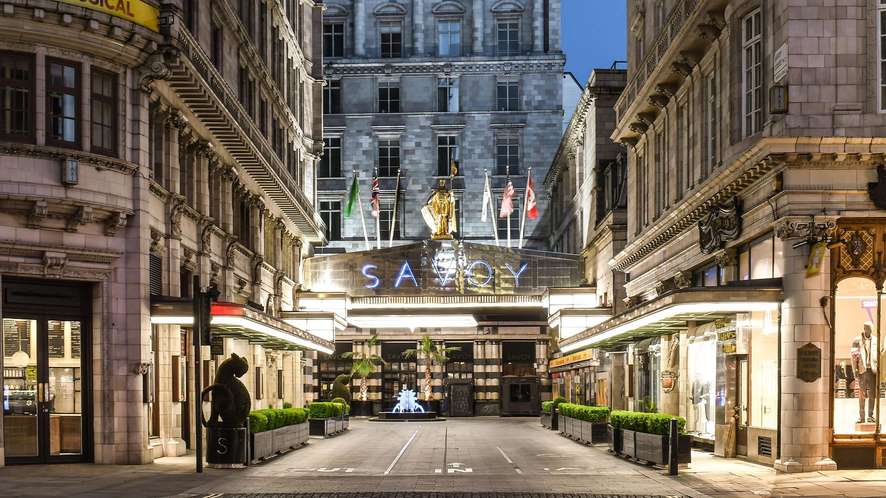
Figure 1: The Savoy Hotel in London
The core issue at The Savoy is the slow adoption of new technologies, such as contactless check-in, smart-room systems, and personalized digital services, which have become essential in the global luxury hotel market (Villa-Clarke, 2024). Most of The Savoy’s competitors have already implemented these innovations, which allow the creation of complete, technologically focused services that simultaneously increase guests’ comfort and individualization. On the other hand, The Savoy's overreliance on more conventional service delivery models makes it less competitive in the current climate, especially for the young generation of guests who have embraced the use of technology in hotel operations that grant them a seamless experience (Schmid, 2023). This gap that is current between customers’ perceived expectations and their perceptions of the services received is becoming unhealthy for a hotel in terms of competitiveness.
This challenge has been apparent, and EliteEdge Consulting, a consulting firm that focuses on digital transformation for luxury hotels, has partnered with The Savoy to work on it. EliteEdge’s strength is in supporting established hotels to transform themselves into modern technological hotels but does not detract from their historical significance or value. The vision is to create unique digital solutions to enhance existing processes, enhance the overall guest satisfaction and experience, and provide the operating environment that will enable The Savoy to thrive in the context of the contemporary and rapidly developing hospitality industry.
This consultancy report intends to present an evaluation of The Savoy’s current state and offer strategic recommendations for possible solutions that would help overcome the inn’s technological issues. The report will employ several analytical frameworks to structure the investigation. First, PESTEL analysis will be conducted on the external environment to ascertain various political, economic, social, technological, environmental and legal factors that affect the operation of the hotel and its efficiency in adopting new technologies. After that, a business assessment tool called SWOT analysis will be used to evaluate the internal environment for The Savoy as well as the opportunities and threats related to it in the external environment. Lastly, a TOWS analysis will assist in matching internal and external factors to come up with measurable recommendations that are actionable and sustainable.
These analytical tools will give the foundation to further dissect, how The Savoy can improve guest services in the hotel, by incorporating modern technologies while at the same time paying respect to Savoy’s traditions. As part of the conclusion of this report, an outline of the recommendations will be provided with details of how technological advancement can be embraced to support Savoy’s strategic vision without compromising its traditional luxury. This balance is important in ensuring that while The Savoy continues to adapt to future generations' customers’ demands, it also remains one of the world’s finest hotels.

Analysis
Even though the Savoy Hotel is prestigious, it cannot deal with some technological developments that are now considered to be crucial in the luxury hotel business. One of the strategic issues has been pinpointed at The Savoy concerning its relatively late implementation of various technologies such as contactless solutions and smart-room solutions that are pivotal to enhancing guests’ satisfaction and operational performance. This section offers a detailed evaluation of the aspects that facilitate or hinder the hotel’s capacity to apply and integrate these innovations by conducting analyses using the PESTEL, SWOT, and TOWS approaches.

PESTEL Analysis
The PESTEL forces consider the external environment for applying the digital transformation in The Savoy Hotel. These are Political, Economic, Social, Technological, Environmental and Legal factors that affect the technological advancement that hotels can adapt.
Factor | Impact on The Savoy’s Digital Transformation
Political | Currently, the UK government ensures that the use of digital transformation is supported by various guidelines for all industries, including the hospitality industry (Bilgihan and Ricci, 2024). Both short-term and long-term recovery plans demonstrate priorities for the preservation of safety and improvement of effectiveness in delivering services with such means as contactless technologies and digital solutions (Arbaiza, 2018). Potential policies to advance the service industry, particularly through automation can be perceived as openings for The Savoy to adopt new technologies in service provision without much interference from the government. Internationally, political stability in the UK and close links with important markets such as Europe and the Americas are beneficial for the hotel’s functioning as these upgrades can be implemented without being hampered by volatile geopolitics.
Economic | The economic climate, specifically within the luxury hospitality industry, affects The Savoy’s digitisation strategy. London centres as one of the key destinations preferred by high-end tourists and the demand for luxury tourist experiences continues to grow. Nevertheless, the general cost of implementing digital change, particularly acquiring the systems required and training the code, presents a financial issue. Furthermore, inflation or occasional economic downturn can affect consumers’ high-end spending (Bellini and Convert, 2016). However, the technical improvement would be incremental and would bring long-term organizational benefits such as shorter check-in time due to the implementation of smart-room technologies.
Social | Consumer behaviour has become an influential factor in hospitality (Guagno, 2017). The identified target market of The Savoy includes a classic upscale audience and tech-savvy, millennial guests. The millennial generation and business travellers prefer a digital touch point during their stay such as keyless entry, customized services and smart room services. This is dangerous because failure to meet such expectations can bring about deterioration in customer satisfaction hence loss in customer base (Abir and Khan, 2022). Also, due to the growing concern for the environment, guests are leaning towards hotels that use effective energy-saving measures and digital solutions (West and Cremata, 2016).
Technological | Technological innovation is now redefining competition in the luxury hotel market. The applications of smart technologies are already in place with competitors offering services such as check-in kiosks, digital key systems and smartphone application concierge services which establishes a high level of expectation of guests (Equenot, 2024). Currently, The Savoy Company has a relatively weak technological platform based on traditional methods of customer service, which puts it in a disadvantaged position in terms of offering convenience and comfort (Cohen-Portheim, 2021). Additionally, the use of mobile applications and artificial intelligence to provide guests with engaging personalization is still underdeveloped in The Savoy. This means that failure to adapt to these trends could have adverse effects on its position in the relevant market.
Environmental | Consumers are becoming more concerned about sustainability as well as regulators due to the effects of global warming and pollution. Hotels are expected to decrease their environmental impact through energy efficiency or better waste management practices. Digital transformation shows that The Savoy can meet these expectations given that; Digital menus instead of hard copy and check-in via mobile instead of paper, and Smart room technology to control the energy used in lighting and heating (Çeltek, 2024). Such initiatives are in line with the position of consumers who are sensitive to the environment and, at the same time, assist the hotel in minimizing costs in the long run, which makes it sustainable (Cobos et al., 2016).
Legal | Any organization that is adopting digital solutions should consider the GDPR guidelines and ensure that the organization meets the data protection regulations (Bardukova, 2023). The Savoy must be also correct about gathering the data of the guests by digital check-ins, smart-room controls, or mobile concierge apps, and save and process it in compliance with GDPR rules. The non-adherence to these regulations poses penalties such as fines and reputational loss as a major risk (Tyagi and Patvekar, 2019). Also, as most digital services involve gathering and storing personal details, the hotel needs to address cybersecurity to safeguard clients’ data from unauthorized access.

About these external factors, especially the technological and social surfaces, there is a clear need for the organization to embrace digital solutions that will improve guests’ satisfaction and organizational performance.

SWOT Analysis
SWOT analysis aims to identify The Savoy Hotel’s strengths and weaknesses as an organisation and also the opportunities and threats that exist in its environment for the hotel’s ability to deploy modern technologies.
Strengths:
Strong Brand Reputation | The Savoy has developed a high reputation in the 130 years of its operation and focuses on its target customers who appreciate the organization’s tradition, high-quality services, and location in the centre of London (Villa-Clarke, 2024).
Location and Accessibility | The Savoy is located in one of the best areas of London meaning that the hotel will always attract high-end clientele for business and travel purposes.
Established Clientele | The hotel enjoys repeat business from loyal clients who appreciate the unique blend of traditional luxury and personalized services (O’Mahoney, 2021).

Weaknesses:
Slow Technology Adoption | Lack of strategy in modern technologies has been evident in the hotel through poor or lack of amenities such as contactless check, digital keys and smart room controls among others. Thus, its applicability is rather limited to young, tech-savvy guests while overall operations are disrupted.
High Operating Costs | The service delivery in the traditional set-up of the hotel requires more manual effort, hence the hotel may incur high expenses in undertaking activities such as energy consumption and labour which could otherwise be enhanced through digital solutions (Williams, 2021).
Resistance to Change | The staff and management who are used to the traditional approaches to their services are likely to resist the new technologies thus slowing down the easy adoption of new technologies (The Savoy, 2024).

Opportunities:
Digital Transformation | The requirement for digital interactions in Luxury Hospitality is increasing, and some of the trends are contactless facilities, Smartphone applications for concierge, and smart rooms. The adoption of these technologies could improve guest satisfaction immensely besides increasing organizational efficiency (Singh et al., 2024).
Sustainability Initiatives | Using new technologies that are energy efficient (smart-room systems) in the hotel is consistent with the growing global concern for the environment. This could not only bring down the cost of operations but also target those tourists who are concerned with the environment (Warren et al., 2018).
Personalization Trends | Guests expect organisations and individuals to provide them with differentiated products or services. Through digital technologies, The Savoy has been able to suit guests according to their preferred choice through mobility applications that control rooms, order food and order other services (Nam et al., 2021).

Threats:
Competitive Pressure | The market of luxury hotels is already saturated and all the competitors have applied technological solutions to provide impeccable service, which may interest potential customers (Stylos et al., 2021).
Technological Obsolescence | Since technology is progressing at such a fast pace, it becomes increasingly dangerous for The Savoy to lag behind competitors without proper systems upgrades (Osei and Cheng, 2024).
Economic Uncertainty | Economic fluctuations, whether it is in terms of cyclical downturns or inflation, present a challenge to the firm’s reinvestment, particularly in the technological sphere (Mavridopoulou and O’Mahoney, 2020).

In this SWOT analysis, it becomes clear that The Savoy has significant brand and location advantages but technologically it needs to improve to take advantage of opportunities and stay ahead in the future.

TOWS Analysis
The TOWS analysis brings together both the Internal Issues arrived at from the SWOT analysis (Strengths, Weaknesses) and External Scopes (Opportunities, Threats) in order to construct navigations for improving The Savoy Hotel’s position in the market and adopt the new technologies.

Strengths (S) + Opportunities (O):
The Savoy has established itself as a prestigious hotel brand with many loyal patrons, these are key assets that can enable digital transformation efforts. This allows the hotel to incorporate new techniques such as the incorporation of contactless services and smart room technologies into the hotel without the perception of doing something that falls out of the traditional luxury feel experienced at the hotel (Zeebroeck, Kretschmer, and Bughin, 2021). For instance, The Savoy can explain that by using mobile devices for check-in and maintaining digital relations with customers the hotel will build upon the effective human branding and exceptional service for which the company is recognized across the globe. With this strategy, The Savoy will be in a position to meet the increasing demand of every modern customer for a digital offer, while not disrupting the tested and beloved aesthetics and settings of the hotel.
Weaknesses (W) + Opportunities (O):
The slow integration of technology and conventional service delivery methods is a strategic weakness of the hotel business. However, there is a need for a new qualitative change stimulated by the need for sustainability and personalized digital services. Savoy recommendation The Savoy should consider developing smart-room systems that lower operating expenses and contribute to environmental conservation efforts. Also, the hotel may develop applications for guests’ mobile devices that help them control various aspects of their stays, including their rooms or ordered services. They will improve customer satisfaction and attract clients seeking high technology as well as help minimize waste.
Strengths (S) + Threats (T):
The major strength of the Savoy is its favourable location and brand recognition; however, extensive use of modern technologies by rivals becomes a threat. Regarding this, The Savoy should strive to feature promotional messages about the hotel’s abilities to combine historical themes with all the conveniences of the modern world. The hotel can also position itself in a market by claiming that it has the technological advantages as well as the reputation of the classic old-world luxury feel that is not possible for new entrants to provide (Kim and Han, 2020). Thus, The Savoy can offer a unique competitive advantage in a highly saturated industry, focusing on the guest audience, which appreciates classical and modern solutions at the same time.
Weaknesses (W) + Threats (T):
The hotel’s resistance to change, combined with the threat of competitors' technological advancements, requires a strategic approach. To tackle this problem, The Savoy can introduce new technologies gradually, beginning with the least risky applications such as touchless registration and virtual room keys. To decrease internal resistance the training of employees and the use of new systems can gradually be integrated (Glazer, 2023). Thus, The Savoy can make constant minor modifications to stay competitive while not overwhelming the staff or upsetting the loyal clientele.
This TOWS analysis outlines strategic actions that leverage The Savoy’s strengths while addressing its weaknesses, positioning the hotel to capitalize on opportunities and mitigate potential threats.

Recommendations and Change Management
The Savoy Hotel has several threats in the area of IT, as the implementation of up-to-date technologies is crucial for increasing customer satisfaction and employee productivity as well as ensuring the hotel’s competitiveness in the luxury hotel industry (The Savoy, 2024). This section contains a plan for the implementation of several important technologies in The Savoy, as well as a comprehensive change management plan and a framework for assessing the success of these technologies.

Recommendations

Contactless Check-In and Digital Room Keys
The first recommendation for The Savoy Hotel is the complete delegation of the check-in process through a mobile application as an option for guests who do not wish to interact with other people and risk infection. Furthermore, digital room keys should be implemented to make it possible for the guest to use a smartphone to open the door to the room. It also matches the current trend of guests’ comfort-seeking and may negatively impact face-to-face interactions, especially after the COVID-19 crisis (Tian, 2024).
To facilitate this, there is a need for The Savoy to create a convenient and easy-to-use mobile application that would operate in synchronization with existing room lock solutions. Through the application, guests would be able to enter personal details, pay and receive the keys to their phones via application before they arrive at the hotel (Ivanov, 2019). Once checked in, visitors can go directly to their accommodation with no need to stand in a queue at reception. The app should also be able to contain features such as real-time status of available rooms in the hotel so that clients can organize themselves well and make their bookings (Yadav et al., 2024).
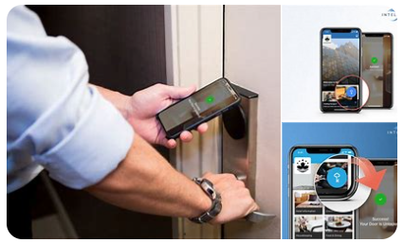
Figure 21: Contactless Check-In and Digital Room Keys Services in Hotel
The benefits of this system are twofold. Firstly, from the point of view of guests’ experience, it will minimize waiting time at check-in, which is an essential issue affecting a large number of luxurious customers. In the case of younger and more tech-savory guests, the use of their smartphones to perform check-in procedures improves such benefits as convenience and personal control over a stay (Lehmann et al., 2016). Secondly, operationally, the hotel will be freed of the excessive pressure on the front-desk employees and can serve the guests who require face-to-face services more effectively (Moser, 2022). However, some companies may develop this process manually, and the possibility of human mistakes is always present; but, the automation of this process can help in cutting such abilities.
To implement this technology, it is projected that £50,000 of initial cash will be required for both mobile application development and implementation of digital lock systems. But these costs will be recoverable by the longer run benefits of reduction in labour cost and overall operation cost as well as improvement in the guest satisfaction level.

Smart-Room Technology
Another significant recommendation is smart-room technology that enables a guest to manage the room and the equipment inside it, including lights, temperature, and entertainment systems, using a smartphone application or touchscreen. It not only serves to improve the comfort of guests but also helps the company achieve its green initiatives by regulating energy usage based on occupancy in each room (Alrawadieh, Alrawadieh, and Cetin, 2021).
Smart-room technology must become embedded into The Savoy’s current construction by having sensors and controllers put into the key systems for activities such as lighting and ventilation. Guests would be able to change the conditions of their rooms to their preference from the temperature to the lighting mood all through a mobile application (Milosh, 2023). In addition, it is recommended that every smart-room system should be set to change the settings of the room once the occupants vacate it, with a view to saving energy and cutting down expenses.
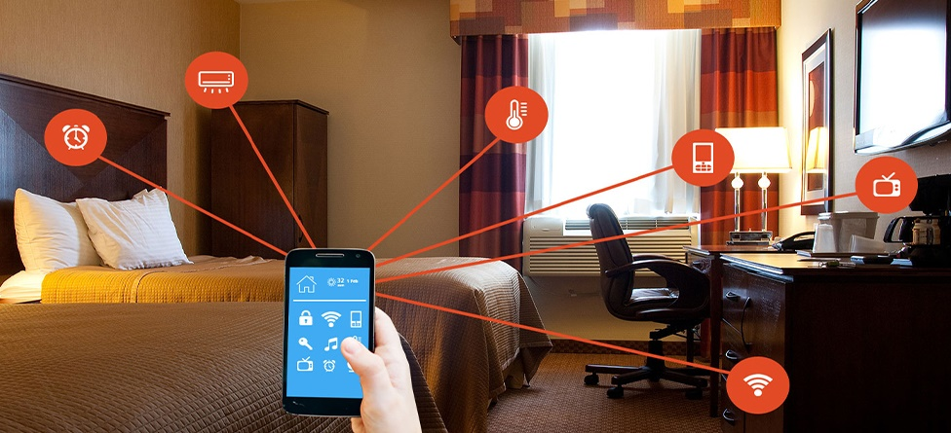
Figure 3: Smart-Room Technology in Hotel
Smart-room technology provides guests with improved comfort and convenience, which is the primary advantage of such a system (Shashwat and Rani, 2023). Today people, especially those traveling the luxury segment, seek individual approaches and it is nice to provide them with the tools that let them manage the environment around them. Furthermore, automated control of room settings can lead to large energy consumption differences and thus to the decrease of operating expenses and support The Savoy’s environmental goals. This will also make the hotel eco-friendly, a factor that will attract leisure and business travellers in equal measure (Ristova and Dimitrov, 2019).
It is expected that installing smart-room systems in the hotel may cost up to £75, 000 and £100, 000 based on the type of the system and the number of rooms to be fitted. This cost will be recovered through the savings accrued through efficient energy utilization and the qualitative improvement of the guest experience putting The Savoy in a relatively better position in the market.

Personalized Mobile Concierge Service
The last recommendation is to develop an individual mobile personal assistant where guests will be able to order different services of the hotel, including room service, booking options for a spa and different restaurant options within the hotel through an application. This service would also address a rising populism of customized, immediate services that are especially essential for luxury consumers (Nieves and Osorio, 2019).
The mobile concierge app should be designed to be a single application that works as part of the guest experience. It would enable them to order meals from the hotel restaurant book an appointment with a masseuse at the hotel or reserve a table at the hotel's famous restaurants from the palm of their hand (Shin, Perdue, and Kang, 2019). However, to create higher added value, the app can offer guest-specific service recommendations, for instance, to take a room service meal from the menu, or to have SPA treatment, based on his previous bookings. A virtual assistant or chatbot feature could also be installed to cater for simple requests like asking for directions or the type of services that the hotel has to offer among others (Wu, 2023).
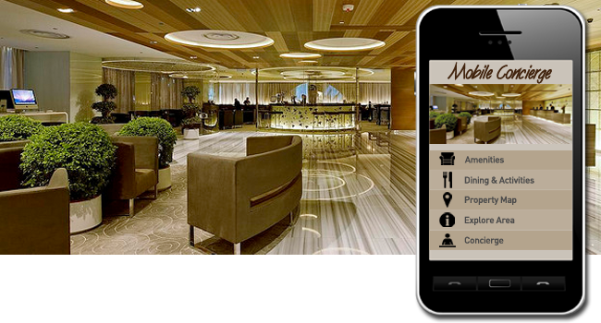
Figure 4: Personalized Mobile Concierge Service
The development of the personalized mobile concierge app would improve the guest experience as it is convenient and tailored. In this case, customers can freely communicate with the hotel regarding anything at the time most convenient for them (Jain et al., 2023). Furthermore, the application can also be used for the promotion of other services, including premium rooms, special offers, or luxurious restaurants, increasing the hotel’s income streams.
It would cost approximately £30,000 to £50,000 of investment to develop and launch a mobile concierge application where guests can order personalized services and pay for their rooms. However, return on investment (ROI) would be obtained through heightened guest interaction, increased spending on services, and better working mechanisms.

Change Management Strategies
The successful implementation of these technological recommendations requires a comprehensive change management strategy (Noordzife, 2014). The integration of new technology into a traditional business like The Savoy can be rather delicate, more so when the consumers and even some of the workers are likely to resist change due to presumptions of modernity and efficiency. Hence, there should be a systematic and gradual approach towards change management.

Staff Training
A key component of the change management strategy is staff training. Employers can also take comfort from the fact that many workers are bound to be anxious when presented with new technologies given the possibility of losing jobs or increased job tasks (Smuts, Lalitha, and Khan, 2017). To address these concerns, The Savoy needs to embark on extensive training sessions that not only explain the workings of the new systems to the employees but also illustrate how these systems will enhance the ways through which guest needs can be met.
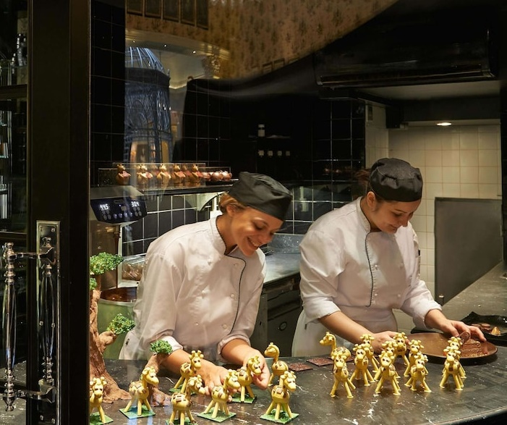
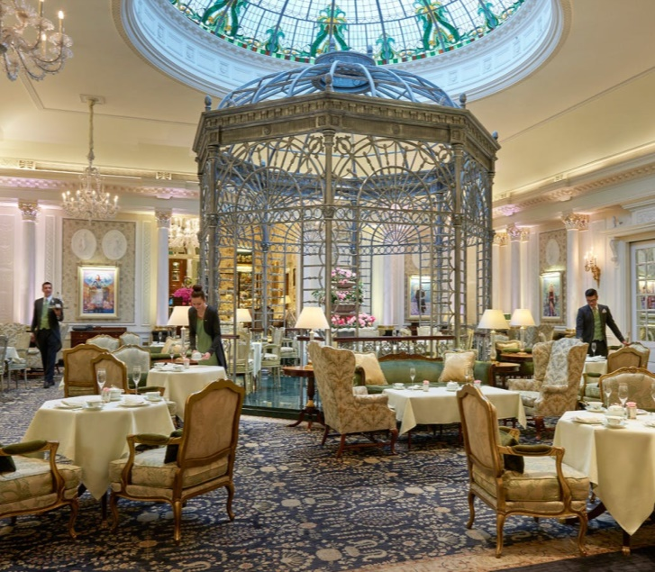
Figure 5: Staff Training Programs of The Savoy Hotel
When training front-desk staff, they should be taught how the contactless check-in system will work to their benefit, and save their time while extending time with clients (Lee et al., 2016). Cleaners should be trained to ask guests to participate in energy management; and to check the occupancy status of rooms through smart-room technology. Concierge personnel should also be trained on the new system to enable them to help their clients who may be finding it hard to navigate through the new mobile application (Pavia, 2017). Thus, The Savoy can provide the necessary training for the staff to adopt the new technology and address possible concerns of the employees.

Guest Communication
Effective communication with guests is equally important. Some guests, especially the elderly or those with limited literacy for new technologies, may experience a murkiness or overload when using new digital services offered (Dixit and Pol, 2024). Hence, The Savoy should establish straightforward lines of communication to explain the new technology to the guests.
Potential new services for guests should also be explained before one arrives, such as the non-contact check-in process and the technology behind controlling the room environment (Das, 2023). The customer can be informed about this through an email or through an email that confirms the booking made. In the same way, written and/or pictorial explanations to have in the bedroom to orientate guests with the novel systems should also be provided. Receptionists should also be ready to provide necessary support to the Guests if they later feel constrained when interacting with the offered digital tools (Bharwani and Mathews, 2021).

Pilot Program
To reduce the impact of the systems change and to improve the effectiveness of change implementation, The Savoy should adopt the use of pilot systems and use them in the hotel before expanding them to the entire hotel. The phased approach is particularly effective in allowing the various issues that may result from the full-scale implementation to be detected and solved in a staggered manner without necessarily paralyzing the hotel (Yang et al., 2021).
The pilot program should start with the contactless check-in system by featuring it to a limited number of guests. Such guests shall prove quite useful when it comes to improving the system and making sure that it effectively fulfils the needs of the guests (Whittington et al., 2020). The same progression technique should therefore be used on the smart-room technology and the mobile concierge app on smartphones covering a selection of rooms and then migrating to the remaining rooms of the hotel (Chatterjee, Vargas-Hernández, and Chakraborty, 2024). This strategic solution enables The Savoy to avoid service interruptions throughout the process while achieving the main goal of integrating new technology.

Measuring Success
To ensure that these initiatives achieve the desired results, The Savoy must establish clear metrics for measuring success. The three key areas to monitor are guest satisfaction, operational efficiency, and return on investment (ROI) (Bhatti and Alawad, 2023).

Guest Satisfaction
The level of satisfaction of the guests is considered to be the most important factor when evaluating the effectiveness of the new technologies. The Savoy should use post-stay questionnaires that would capture the guest interaction with the contactless check-in, smart room technologies and mobile concierge solutions. Furthermore, the usage rates of the app can also be measured by the hotel to know how much people engage with the digital services (Bowie, 2018). Increased levels of engagement will mean that guests can benefit from the technology as well as find it easy to use.

Operational Efficiency
Operational efficiency can be measured by tracking time savings and resource use. The hotel will have to monitor the average time check-in and compare them to what the process used to be when done in person for the contactless check-in system. Therefore, energy conservation from smart-room technology should be evaluated by comparing energy used before and after the system is used (Dumoulin and Giacomel, 2020). Staff productivity should also be measured, as the automation of guest services should decrease the amount of work staff has to do.

Return on Investment (ROI)
The financial benefits of the new systems can be used to measure ROI. The Savoy should be able to monitor how mobile concierge app revenue is growing in terms of upselling services like room upgrades, eating adventures, and spa reservations. Furthermore, energy cost savings due to the smart room system should be estimated to understand the overall financial effect (Roy and Pagaldiviti, 2023). Based on these financial metrics, a clear picture of the return on hotel investment in technology can be established.

Action Plan
Key issues, related solutions along with desired outcomes, time scales and estimated cost for each initiative have been identified to formulate an action plan for The Savoy Hotel. This structured plan gives the hotel clear instructions on how to incorporate technological improvements suggested, in the most efficient manner.

No. | Problem | Solution | Desired Outcome | Time Scale | Cost
1 | Slow check-in process and front-desk inefficiency | Implement contactless check-in and digital room keys (Wirtz, Holmqvist, and Fritze, 2020) | Streamlined check-in process, reduced guest wait times, and enhanced staff productivity | 3 months | £50,000
2 | Outdated room control systems and high energy consumption | Install smart-room technology (Cain et al., 2024) | Personalized guest experience, reduced energy consumption, and increased operational efficiency | 4-5 months | £75,000 - £100,000
3 | Limited personalized guest services | Develop a personalized mobile concierge app (Dimitrios et al., 2023) | Increased guest satisfaction through tailored services and enhanced upselling opportunities | 3-4 months | £30,000 - £50,000

Implementation Overview
- Contactless Check-In and Digital Room Keys: The proposed contactless check-in solution will enable the guest to bypass the front desk, and minimize the time spent on the formalities related to check-in while increasing the operational effectiveness of the hotel. The integration of a digital room key is also expected to improve the convenience of the guests (Buhalis et al., 2019).
- Smart-Room Technology: Through smart-room systems, guests of The Savoy will be able to manage lighting, temperature, curtains, and other aspects of the room’s environment; while the overall energy consumption will be minimized. This will be beneficial to the environment and eventually save the hotel money in the long run (Han et al., 2021).
- Mobile Concierge App: With the use of the personalized mobile app, the guests will be able to access various services at their convenience which includes room service and scheduling of spas thus improving customer satisfaction and possibly leading to increased revenue through upselling (Sestino, Santarelli, and Amatulli, 2022).
Based on the current estimates, it is projected to cost of implementation ranges from £155, 000 – to £200,000. Overall, each phase would take 3-5 months to be implemented, thus allowing the hotel to adopt these changes without interfering with its continual operations. This phased approach will also ensure that The Savoy gets to track performance and adapt where necessary for the best returns on the investment made.

Conclusion
The Savoy Hotel’s need to modernize its technological infrastructure is crucial for maintaining its competitive position in the luxury hospitality market. Technological requirements of the Savoy Hotel are imperative to the organization upgrading its hardware and software readily applicable in this luxury hospitality segment. In this report, specific areas have been highlighted that show how the hotel could improve the guest experience and workflow by implementing new technologies. Using and incorporating contactless check-in, digital room keys, smart-room technology, and a mobile concierge service that is tailored for the individual guest, The Savoy is capable of better-managing processes and at the same time, delivering the kind of personalized service that today’s guests demand from their accommodation. These solutions will not only enhance the quality of guests’ stay and satisfaction but will also help in supporting the company’s long-term sustainability by saving energy and introducing efficient organizational workflows.
The study showed that currently, The Savoy offers a service that is indeed familiar to those of the hotel’s clients who value classic British chic, however, the service is less effective than the services of new-generation competitors who actively use modern technologies. It has to simultaneously accommodate changing consumer preferences and increased demand for comfort and efficiency across all procedures connected to the guests’ stay, especially those linked to technology-savvy visitors. The recommendations given in this report are aimed at maintaining the unique character of The Savoy’s property and ensuring that novelties correspond to today’s tendencies in the sphere of hospitality.
Therefore, the strategies for changing management that might include staff training, guest communication, and the phased implementation of the new systems are critical in the implementation of the technologies. Taking such an approach will ensure that The Savoy does not experience significant levels of disruption in its operations while adopting and implementing new technologies, especially from the staff and guests who have never used the technologies before.
All these recommendations will help The Savoy Hotel to properly position itself as a hotel that aims to be at the forefront of the luxury hotel with integrated technology. These applied digital strategies will not only support the reinforcement of guest experience changes but also ensure that The Savoy continues to be one of the favourite luxurious and fashionable hotels in London in the ever-increasing competition.
On behalf of the entire team of EliteEdge Consulting, it is a great pleasure to work on this project with The Savoy Hotel. These recommendations will go a long way in changing the future prospects of the hotel and EliteEdge Consulting hopes that the information in this report will be useful in the process of further improvement. EliteEdge Consulting is thankful for this chance to bid and would like to receive this type of assignment in the future to help The Savoy remain prominent as a luxurious hotel.

References
- Abir, T. and Khan, M.Y.H., 2022. Importance of ICT advancement and culture of adaptation in the tourism and hospitality industry for developing countries. In ICT As innovator between tourism and culture, pp.30-41. IGI Global.
- Alrawadieh, Z., Alrawadieh, Z. and Cetin, G., 2021. Digital transformation and revenue management: Evidence from the hotel industry. Tourism Economics, 27(2), pp.328-345.
- Arbaiza, C.E.S., 2018, August. Critical variables for success in the technology adoption process in the framework of digital transformation. In Proceedings of the 1st International Conference on Information Management and Management Science, pp.109-113.
- Bardukova, L., 2023. Navigating the hospitality horizon: Current trends and strategies for customer attraction and retention in the hotel industry. Economics and Computer Science, 2, pp.88-103.
- Bellini, N. and Convert, L., 2016. The concierge. Tradition, obsolescence and innovation in tourism. Symphonya. Emerging Issues in Management, (2), pp.17-25.
- Bharwani, S. and Mathews, D., 2021. Techno-business strategies for enhancing guest experience in luxury hotels: A managerial perspective. Worldwide Hospitality and Tourism Themes, 13(2), pp.168-185.
- Bhatti, M.A. and Alawad, W.A., 2023. Technology adoption and customer loyalty in the hospitality sector: Mediating role of customer satisfaction and engagement. Przestrzeń Społeczna (Social Space), 23(3), pp.431-459.
- Bilgihan, A. and Ricci, P., 2024. The new era of hotel marketing: Integrating cutting-edge technologies with core marketing principles. Journal of Hospitality and Tourism Technology, 15(1), pp.123-137.
- Bowie, D., 2018. Innovation and 19th-century hotel industry evolution. Tourism Management, 64, pp.314-323.
- Buhalis, D., Harwood, T., Bogicevic, V., Viglia, G., Beldona, S. and Hofacker, C., 2019. Technological disruptions in services: Lessons from tourism and hospitality. Journal of Service Management, 30(4), pp.484-506.
- Cain, L.N., Mistry, T.G., Douglas, S., Rahman, I. and Moreo, A., 2024. Luxury hotel technology trends: A multigenerational analysis. International Journal of Contemporary Hospitality Management.
- Çeltek, E., 2024. Unmanned smart hotel: Applications and examples. Worldwide Hospitality and Tourism Themes, 16(5), pp.611-626.
- Chatterjee, P., Vargas-Hernández, J. and Chakraborty, N., 2024. Role of digitalization in the luxury hospitality industry. In Technology and Luxury Hospitality: AI, Blockchain and the Metaverse, p.252.
- Cobos, L.M., Mejia, C., Ozturk, A.B. and Wang, Y., 2016. A technology adoption and implementation process in an independent hotel chain. International Journal of Hospitality Management, 57, pp.93-105.
- Cohen-Portheim, P., 2021. The Spirit of London. Batsford Books.
- Das, M.P., 2023. Technology and guest experience: Innovations reshaping hotel management. International Journal for Multidimensional Research Perspectives, 1(3), pp.76-95.
- Dimitrios, B., Ioannis, R., Angelos, N. and Nikolaos, T., 2023. Digital marketing: The case of digital marketing strategies on luxurious hotels. Procedia Computer Science, 219, pp.688-696.
- Dixit, R. and Pol, R.S., 2024. To study the impact of implementing mobile check-ins in business hotels in Pune. ATITHYA: A Journal of Hospitality, 10(1).
- Dumoulin, R. and Giacomel, A., 2020. Disruption and the strategy of hotel groups. In Shapes of Tourism Employment: HRM in the Worlds of Hotels and Air Transport, 4, pp.9-21.
- Equenot, T., 2024. Change management dynamics applied to the fast-evolving luxury hotel industry (Master's thesis, T. Equenot).
- Glazer, F.S. ed., 2023. Blended learning: Across the disciplines, across the academy. Taylor & Francis.
- Guagno, S., 2017. Standardisation, customisation and digitalisation in the international hotel industry: A European perspective.
- Han, S.H., Lee, J., Edvardsson, B. and Verma, R., 2021. Mobile technology adoption among hotels: Managerial issues and opportunities. Tourism Management Perspectives, 38, p.100811.
- Ivanov, S., 2019. Ultimate transformation: How will automation technologies disrupt the travel, tourism and hospitality industries? Zeitschrift für Tourismuswissenschaft, 11(1), pp.25-43.
- Jain, V., Wirtz, J., Salunke, P., Nunkoo, R. and Sharma, A., 2023. Luxury hospitality: A systematic literature review and research agenda. International Journal of Hospitality Management, 115, p.103597.
- Kim, J.J. and Han, H., 2020. Hotel of the future: Exploring the attributes of a smart hotel adopting a mixed-methods approach. Journal of Travel & Tourism Marketing, 37(7), pp.804-822.
- Lee, P.C., Sun, S., Law, R. and Lee, A.H., 2016. Educational technology in hospitality management programs: Adoption and expectations. Journal of Teaching in Travel & Tourism, 16(2), pp.116-142.
- Lehmann, C.U., Unertl, K.M., Rioth, M.J. and Lorenzi, N.M., 2016. Change management for the successful adoption of clinical information systems. Clinical Informatics Study Guide: Text and Review, pp.435-456.
- Mavridopoulou, A. and O’Mahoney, J., 2020. Elitism in strategy consulting: How institutional prestige influences recruitment. Management Consulting Journal, 3(1), pp.12-22.
- Milosh, P., 2023. Evolving preferences: Understanding contemporary luxury hotel guests.
- Moser, J., 2022. Look but don’t touch: Contactless solutions to enhance the customer journey in hotels (Doctoral dissertation).
- Nam, K., Dutt, C.S., Chathoth, P., Daghfous, A. and Khan, M.S., 2021. The adoption of artificial intelligence and robotics in the hotel industry: prospects and challenges. Electronic Markets, 31, pp.553-574.
- Nieves, J. and Osorio, J., 2019. Using information technology to achieve management innovation. Academia Revista Latinoamericana de Administración, 32(1), pp.20-39.
- Noordzife, G., 2014. Project Management of Hotel Opening Processes: Exploring Better Ways to Manage New Hotel Openings. CreateSpace.
- O’Mahoney, J., 2021. How small consultancies grow: Challenging problem-based theorising. Management Consulting Journal, 4(1), pp.5–20.
- Osei, B.A. and Cheng, M., 2024. Preferences and challenges towards the adoption of the fourth industrial revolution technologies by hotels: A multilevel concurrent mixed approach. European Journal of Innovation Management, 27(6), pp.1912-1937.
- Pavia, L., 2019. London’s Savoy Hotel looks to the future with sustainability drive. Evening Standard, 29 Nov. Available at: https://www.standard.co.uk/lifestyle/living/the-savoy-hotel-looks-to-the-future-with-sustainability-drive-a4300576.html [Accessed 11 Nov. 2024].
- Pavia, T.F.N., 2017. Technology innovations as drivers of hotel attractiveness. Innovation Management, Entrepreneurship and Sustainability 2017, p.231.
- Ristova, C. and Dimitrov, N., 2019. Digitalisation in the hospitality industry - Trends that might shape the next stay of guests. International Journal of Information, Business and Management, 11(3), pp.144-154.
- Roy, B.K. and Pagaldiviti, S.R., 2023. Advancements in arena technology: Enhancing customer experience and employee adaptation in the tourism and hospitality industry. Smart Tourism, 4(1), p.2330.
- Schmid, S., 2023. Behind the scenes of a large hotel. In Temples of Luxury, pp.385-399. Routledge.
- Schmid, S., 2023. Dining out in London. In Temples of Luxury, pp.359-369. Routledge.
- Sestino, A., Santarelli, I. and Amatulli, C., 2022. Infusing new technologies and luxury: A literature review and current issues on luxury fashion, food, and tourism. In Handbook of Research on Digital Transformation Management and Tools, pp.474-488.
- Shashwat, K. and Rani, M., 2023. Technological transformation in the hospitality industry: An overview. In Sustainable Development Goal Advancement Through Digital Innovation in the Service Sector, pp.133-151.
- Shin, H., Perdue, R.R. and Kang, J., 2019. Front desk technology innovation in hotels: A managerial perspective. Tourism Management, 74, pp.310-318.
- Singh, R., Gehlot, A., Akram, S.V., Thakur, A.K., Gupta, L.R., Priyadarshi, N. and Twala, B., 2024. Integration of advanced digital technologies in the hospitality industry: A technological approach towards sustainability. Sustainable Engineering and Innovation, 6(1), pp.37-56.
- Smuts, R.G., Lalitha, V.M. and Khan, H.U., 2017. Change management guidelines that address barriers to technology adoption in an HEI context. In 2017 IEEE 7th International Advance Computing Conference (IACC), pp.754-758. IEEE.
- Stylos, N., Fotiadis, A.K., Shin, D.D. and Huan, T.C.T., 2021. Beyond smart systems adoption: Enabling diffusion and assimilation of smartness in hospitality. International Journal of Hospitality Management, 98, p.103042.
- The Savoy, 2024. The Savoy London. Available at: https://www.thesavoylondon.com/ [Accessed 11 Nov. 2024].
- Tian, J., 2024. Does technological innovation have an impact on employment in the hospitality industry? International Journal of Contemporary Hospitality Management, 36(4), pp.1025-1043.
- Tyagi, H. and Patvekar, A., 2019. The concept of smart room in hotels. International Journal of Trend in Scientific Research and Development, 3(3), pp.1314-1318.
- Van Zeebroeck, N., Kretschmer, T. and Bughin, J., 2021. Digital “is” strategy: The role of digital technology adoption in strategy renewal. IEEE Transactions on Engineering Management, 70(9), pp.3183-3197.
- Villa-Clarke, A., 2024. How new changes at the Savoy capture its timeless appeal. Forbes, 22 Oct. 2024. Available at: https://www.forbes.com/sites/angelinavillaclarke/2024/10/22/how-new-changes-at-the-savoy-capture-its-timeless-appeal/ [Accessed 11 Nov. 2024].
- Warren, C., Becken, S., Nguyen, K. and Stewart, R.A., 2018. Transitioning to smart sustainable tourist accommodation: Service innovation results. Journal of Cleaner Production, 201, pp.599-608.
- West, C. and Cremata, R., 2016. Bringing the outside in: Blending formal and informal through acts of hospitality. Journal of Research in Music Education, 64(1), pp.71-87.
- Whittington, R. et al., 2020. Exploring Strategy. Harlow: Pearson Education Limited.
- Williams, O., 2021. The Secret Life of the Savoy: Glamour and Intrigue at the World's Most Famous Hotel. Simon and Schuster.
- Wirtz, J., Holmqvist, J. and Fritze, M.P., 2020. Luxury services. Journal of Service Management, 31(4), pp.665-691.
- Wu, T., 2023. Analysis of the digital transformation of big data era. Highlights in Business, Economics and Management, 16, pp.288-293.
- Yadav, N., Shukla, A., Khunasathitchai, K. and Kaur, R., 2024. AI adaptations: Challenges and strategies for the hotel and tourism industry. In Hotel and Travel Management in the AI Era, pp.19-38. IGI Global.
- Yang, H., Song, H., Cheung, C. and Guan, J., 2021. How to enhance hotel guests’ acceptance and experience of smart hotel technology: An examination of visiting intentions. International Journal of Hospitality Management, 97, p.103000.

