Emily Caroline Miller

A critical analysis of social media and how it handles personal data: a Facebook case study

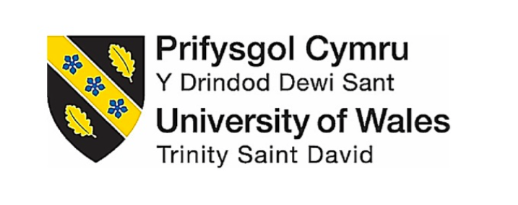

Dissertation submitted as part of the requirements for the award BA (HONS) Business Management

UWTSD SWANSEA
May 2020

Table of Contents

1 – Introduction 3
1.1 Facebook 3
1.2 Background and Literature Review 3
1.3 Rationale 5
1.4 Research Aims and Objectives 6
2. Research Design and Methodology 6
2.1 Paradigm 6
2.2 Data Analysis and Collection 8
2.2.1 Qualitative Analysis 8
2.2.2 Collection Method and Sample 8
2.4 Limitations 8
2.5 Ethical Risks 9
3. Resources and Planning 9
3.1 Resources 9
3.2 Timescale 9
3.2.1 Gantt Chart 10
4. References 13

Table of Figures

Figure 1: The Research Onion…………………………………………………………….6
Figure 2: Gantt Chart……………………………………………………………………...10

1 – Introduction

This dissertation aims to analyse how FaceBook handles user’s personal data (any information relating to an identified or identifiable natural person, (General Data Protection Regulation (GDPR), 2016)). There have been multiple studies looking at how social media as a whole affect’s consumer behaviour (Curran, Graham and Temple, 2011) and buying behaviour (Voramontri and Kleib, 2018), but very little exist that explores whether consumers care how data is being obtained and used. Only within the past two years, these questions have started to be asked largely due to the 2018 FaceBook-Cambridge Analytica Scandal which revealed over 50 million Facebook profiles were harvested for Cambridge Analytica in a major data breach, (Cadwalladr and Graham-Harrison, 2018).

1.1 Facebook

Founded in 2004, Facebook was created as a social networking website which allows users to connect using their profiles, send messages, post pictures and videos, share website links, etc. FaceBook’s mission statement states; “it gives people the power to build community and bring the world closer together. People can stay connected with friends and family, to discover what's going on in the world, and to share and express what matters to them” (Investor.fb.com, 2019). With “1.59 billion daily active users” (Newsroom.fb.com, 2019) Facebook has become a very useful marketing tool as it has created a pathway to connect with existing and new consumers, "Creating new possibilities and opportunities to increase consumer brand awareness" (Comscore Media, 2009)

1.2 Background and Literature Review

“The world’s most valuable resource is no longer oil, but data”
- (The Economist, 2017)
Facebook provides a free social networking platform for its users but still managed to make a revenue of 55.8 billion dollars in 2018, (Statista, 2019). This gives rise to the question; How is FaceBook making their money? FaceBook’s main source of income is digital advertising and in recent years has included the sale of user personal data to multinational companies such as Amazon so they can create better-targeted advertisements (Dance et Al, 2018). In 2014 FaceBook users were invited to take part in a personality type quiz. This quiz was developed by the University of Cambridge academic, Aleksandr Kogan to harvest the user's personal data including all the user’s friends who were not informed (Klienman, 2018). Another recent example where users data has been grossly mistreated is the Cambridge Analytica scandal where user’s data was unlawfully obtained to create better advertising campaigns (Common, 2018). In this case, over 87 million data profiles were harvested without the user’s consent, the data which was collected was used for political advertising to sway users to vote for a party, (Chadwick, 2018). As a result, the US Government ordered FaceBook to pay a penalty of $5 billion for “deceiving” users, which is the largest penalty ever given emphasising the scale of the breach. (Davies and Rushe, 2019). General Data Protection Regulation (GDPR) set by European law aims to provide protection and give control to persons within the EU over the use of their personal data, (General Data Protection Regulation (GDPR), 2016). Within Article 5 of the GDPR; Principles relating to the processing of personal data states that Personal data shall be; “Processed lawfully, fairly and in a transparent manner” (General Data Protection Regulation (GDPR), 2018). There is a clear lack of transparency and fairness for FaceBook users and this can be seen within their user’s agreement page regarding the use of their personal data. This agreement includes clauses and conditions that are very lengthy and overall very complex which makes it difficult for the average user to completely understand, (Esteve, 2017). Facebook is responsible for their user's data protection and as the number of FaceBook users rise so does the rise of privacy concerns, (Pitkänen and Tuunainen, 2012). Facebook has a corporate social responsibility (CSR) for all its users, this means that they have a responsibility to be mindful of the impact that they are having on society. There are two concepts of CSR; Broad and Narrow. Companies that take the broad approach believe that profits will only maximise when social responsibility is made priority whereas, narrow CSR approach main objective is to maximise profits without breaking the law and not go beyond (Anon, 2009). Milton Friedman an American economist supported this theory and argued that it was the government's responsibility to consider and provide money for social causes, not an organisation, (Freeman and Liedtka, 1991), this is the approach which it can be argued Facebook is currently taking. Business ethics right theory aims to protect stakeholders. It is a list of rights considered ethically correct by a large population, (Bartlett, 2003). In this case, the researcher would be looking at the right to personal privacy from the user’s perspective.

1.3 Rationale

As seen above there is a clear lack of safeguards when it comes to social media and protecting people’s data the introduction of GDPR in 2018 has sparked numerous questions on whether people’s data is secure from exploitation, (Privacy International, 2019). Although currently there are numerous researches on how people’s data can be used (Cherlin, 1991) (Hausmann et Al, 2018), there is limited research available on whether people are aware of how their data is being used and how this makes them feel. The Facebook/Cambridge Analytica scandal was an example of how Facebooks inability to regulate advertising has left a loophole allowing companies to exploit user’s personal data for unethical purposes without their acknowledgement. Using the rights ethical theory along with the narrow approach theory this dissertation will research how people who are regular FaceBook users feel about their personal data being unethically used without clear acknowledgement and whether it will affect their use of social media platforms in the future. This is important to research as companies such as Facebook need to look at the implications of having poor user satisfaction. By being associated with data being misused by third parties, this can have a devastating effect for social platforms as they rely on digital advertisement for revenue and if they have a declining number of user’s companies will no longer want to advertise on their platform. This will have a negative affect of the organisation overall.

1.4 Research Aims and Objectives

The purpose of this dissertation is to critically analyse how FaceBook handles its user’s personal data. The objectives are as follows;
1. To critically analyse previous FaceBook campaigns which have accessed user’s data and looking at the reactions to this.
2. To Analyse whether FaceBook’s policy for advertising, has left a loophole for external companies to exploit user’s personal data without their acknowledgement and how this affects Facebook's corporate social responsibility.
3. To conduct primary research in the form of online questionnaires and one to one interview to address how users feel about their personal data being used without their acknowledgement.
4. To synthesise existing literature and primary research to be able to recommend ways in which Facebook can better inform users of how their data is being used to improve their corporate social responsibility and overall user satisfaction.

2. Research Design and Methodology

2.1 Paradigm

Research is an investigation method which is carried out to determine facts, spot trends and to establish new conclusions, (Cooper et al, 2006). Understanding the numerous types of research methods available is key to be able to choose the most appropriate method which will provide the most informative results.
Saunders Research Onion demonstrates what stages must be included when developing research. The diagram starts with the outer layers which provide context then peeling away to the middle layers which provide building blocks for the research and then finally the centre, which is the data collection itself, (Sahay, 2016).
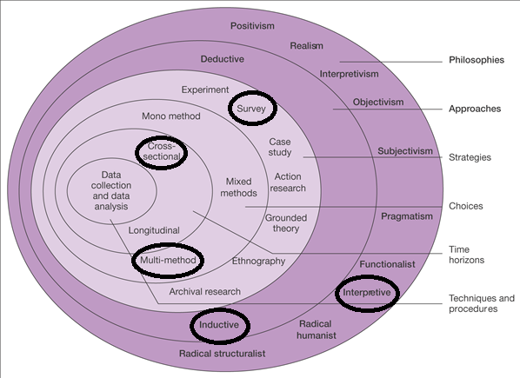
Figure 1. The Research Onion. Source: (Saunders, et al., 2009)

Above in Figure 1. The methods which the researcher will carry out are identified using black rings. This research will take an interpretive approach as the data collected will be qualitative (Putnam and Pacanowsky, 1983). Inductive reasoning will be used as data will be collected in the form of interviews and surveys (multimethod research, more than one research method used, useful for complex social research questions (Anguera et Al, 2019) ) which will form qualitative data. A cross-sectional study will be used as the research will be carried out over a short period to identify associations between risk factors and outcome of interest (Levin, 2006).

2.2 Data Analysis and Collection

2.2.1 Qualitative Analysis

Qualitative analysis is the collection of non-numerical data (Graue, 2015) this type of data is collected in interpretive approaches. This approach will be undertaken by the researcher through questionnaires and interviews. By having more than one collection method this will increase the credibility of this study.

2.2.2 Collection Method and Sample

The research will be carried out through an online questionnaire using the online survey platform Google forms as well as conducting one to one interviews. This questionnaire will be sent to a large group of people aged 18 to 24. This age group has been selected as from a global survey of FaceBook users done in 2017 it was found that this age group were the most active users, (Statista, 2019). Participants will not be specifically selected, and participation will be kept anonymous. The survey will be posted on FaceBook as these are the users which the research will be investigating. The interviews will be carried out with active FaceBook users within the targeted age range. Questions that will be used in the surveys and interviews will all be directly influenced by previous academic literature.

2.4 Limitations

The main limitation of this dissertation will be the time scale. Time will constrict the amount of previous literature that can be analysed to obtain a detailed understanding of the subject area and will also constrict the amount of primary research that can be carried and analysed. In section 3.2.1 a Gannt chart has been fashioned to aid in time management.

2.5 Ethical Risks

The ethical risks within this research are minimal; Participation will be voluntary and personal details will be kept anonymous. To participate the person must be over the age of 18 and no vulnerable population will be used.

3. Resources and Planning

3.1 Resources

Several resources will be used throughout the research process to gain a thorough understanding of the subject area. The resources which will be used include; Physical textbooks which are available within the UWTSD Library, the online Library service which UWTSD provides which gives access to multiple media resources including books, past case studies and peer-reviewed journals. The internet will also be used to gain information, however, the information gathered will come from credible sources such as google scholar which gives access to online journals and peer-reviewed journals and unreliable sites such as Wikipedia will be avoided.

3.2 Timescale

A Gantt chart is a timescale tool which will aid in meeting deadlines by clearly showing when tasks need to be completed. By having used this it will guarantee that this research project will be completed and submitted by the 11th of May 2020, (Kumar,2005).

3.2.1 Gantt Chart

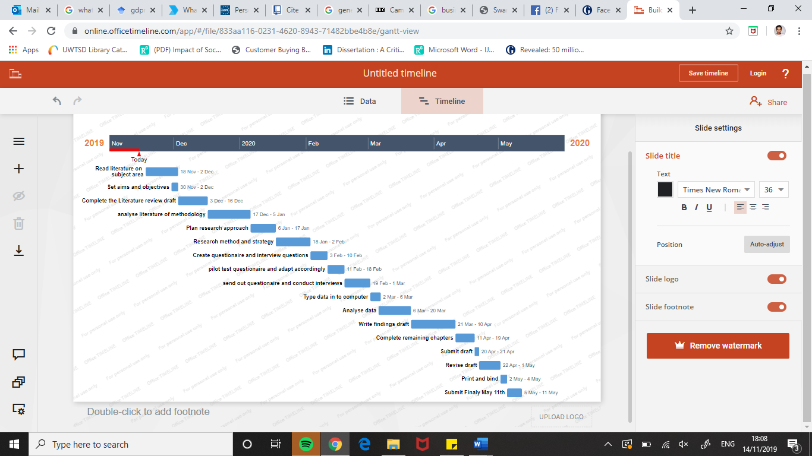
Figure 2: Gantt Chart 1 Source: (Saunders, Lewis, & Thornhill, 2009, p. 45)
4. References

Anguera, M.T., Blanco-Villaseñor, A., Losada, J.L., Sánchez-Algarra, P. and Onwuegbuzie, A.J., 2018. Revisiting the difference between mixed methods and multimethods: Is it all in the name?. Quality & Quantity, 52(6), pp.2757-2770.
Anon, 2009. Corporate Social Responsibility. , pp.165–173.
Bartlett, D., 2003. Management and business ethics: a critique and integration of ethical decision‐making models. British Journal of Management, 14(3), pp.223-235.
Cadwalladr, C. and Graham-Harrison, E. (2018). The Cambridge Analytica Files | The Guardian. [online] the Guardian. Available at: https://www.theguardian.com/news/series/cambridge-analytica-files [Accessed 23 Oct. 2019].
Chadwick, P. (2018). How many people had their data harvested by Cambridge Analytica? | Paul Chadwick. [online] the Guardian. Available at: https://www.theguardian.com/commentisfree/2018/apr/16/how-many-people-data-cambridge-analytica-facebook.
Cherlin, A., 1991. On analyzing other people's data. Developmental psychology, 27(6), p.946.
Common, M.F., 2018. Facebook and Cambridge Analytica: let this be the high-water mark for impunity. LSE Business Review.
Comscore Media, M. (2009). Total number of unique visitors to selected Social networking sites.
Cooper, D.R., Schindler, P.S. and Sun, J., 2006. Business research methods (Vol. 9). New York: McGraw-Hill Irwin.
Curran, K., Graham, S. and Temple, C. (2011). Advertising on Facebook. International Journal of E-Business Development (IJED), 1(1), pp.26 - 33.
Dance, G., Laforgia, M. and Confessore, N. (2018). As Facebook Raised a Privacy Wall, It Carved an Opening for Tech Giants. [online] Nytimes.com. Available at: https://www.nytimes.com/2018/12/18/technology/facebook-privacy.html [Accessed 17 Nov. 2019].
Davies, R. and Rushe, D. (2019). Facebook to pay $5bn fine as regulator settles Cambridge Analytica complaint. [online] the Guardian. Available at: https://www.theguardian.com/technology/2019/jul/24/facebook-to-pay-5bn-fine-as-regulator-files-cambridge-analytica-complaint [Accessed 14 Nov. 2019].
Esteve, A. (2017). The business of personal data: Google, Facebook, and privacy issues in the EU and the USA. International Data Privacy Law, 7(1), pp.36-47.
Freeman, R.E. and Liedtka, J., 1991. Corporate social responsibility: A critical approach. Business Horizons, 34(4), pp.92-99.
General Data Protection Regulation (GDPR). (2016). Art. 4 GDPR – Definitions | General Data Protection Regulation (GDPR). [online] Available at: https://gdpr-info.eu/art-4-gdpr/ [Accessed 14 Nov. 2019].
General Data Protection Regulation (GDPR). (2016). Art. 4 GDPR – Definitions | General Data Protection Regulation (GDPR). [online] Available at: https://gdpr-info.eu/art-4-gdpr/ [Accessed 14 Nov. 2019].
General Data Protection Regulation (GDPR). (2018). Art. 5 GDPR – Principles relating to processing of personal data | General Data Protection Regulation (GDPR). [online] Available at: https://gdpr-info.eu/art-5-gdpr/ [Accessed 14 Nov. 2019].
Graue, C. (2015). International Journal of Sales, Retailing & Marketing., 4(9), pp.5-14.
Hausmann, A., Toivonen, T., Slotow, R., Tenkanen, H., Moilanen, A., Heikinheimo, V. and Di Minin, E., 2018. Social media data can be used to understand tourists’ preferences for nature‐based experiences in protected areas. Conservation Letters, 11(1), p.e12343.
Investor.fb.com. (2019). Facebook - Resources. [online] Available at: https://investor.fb.com/resources/default.aspx.
Klienman, Z. (2018). Cambridge Analytica: The story so far. [online] BBC News. Available at: https://www.bbc.co.uk/news/technology-43465968 [Accessed 14 Nov. 2019].
Kumar, P.P., 2005. Effective use of Gantt chart for managing large scale projects. Cost engineering, 47(7), p.14.
Levin, K.A., 2006. Study design III: Cross-sectional studies. Evidence-based dentistry, 7(1), p.24.
Newsroom.fb.com. (2019). Company Info | Facebook Newsroom. [online] Available at: https://newsroom.fb.com/company-info/.
Pitkänen, O. and Tuunainen, V.K., 2012. Disclosing Personal Data Socially—An Empirical Study on Facebook Users' Privacy Awareness. Journal of Information Privacy and Security, 8(1), pp.3-29.
Privacy International. (2019). Cambridge Analytica, GDPR - 1 year on - a lot of words and some action. [online] Available at: https://privacyinternational.org/news-analysis/2857/cambridge-analytica-gdpr-1-year-lot-words-and-some-action [Accessed 14 Nov. 2019].
Putnam, L. and Pacanowsky, M.E., 1983. Communication and organizations, an interpretive approach (Vol. 65). Sage Publications, Inc.
Sahay, A., 2016. Peeling Saunders’s Research Onion.
Saunders, M. & Philip, L., 2012. Doing Research in Business & Management. 1st ed. Harlow: Pearson Education Limited.
Statista. (2019). Average age of social media users | Statista. [online] Available at: https://www.statista.com/statistics/274829/age-distribution-of-active-social-media-users-worldwide-by-platform/ [Accessed 15 Nov. 2019].
Statista. (2019). Facebook: annual revenue 2018 | Statista. [online] Available at: https://www.statista.com/statistics/268604/annual-revenue-of-facebook/ [Accessed 17 Nov. 2019].
The Economist. (2017). The world’s most valuable resource is no longer oil, but data. [online] Available at: https://www.economist.com/leaders/2017/05/06/the-worlds-most-valuable-resource-is-no-longer-oil-but-data [Accessed 17 Nov. 2019].
Voramontri, D. and Kleib, L. (2018). Impact of Social Media on Consumer Behaviour. International Journal of Information and Decision Sciences. Webster University.

