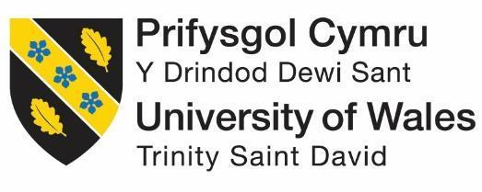

Title - International marketing strategies of Coca-cola
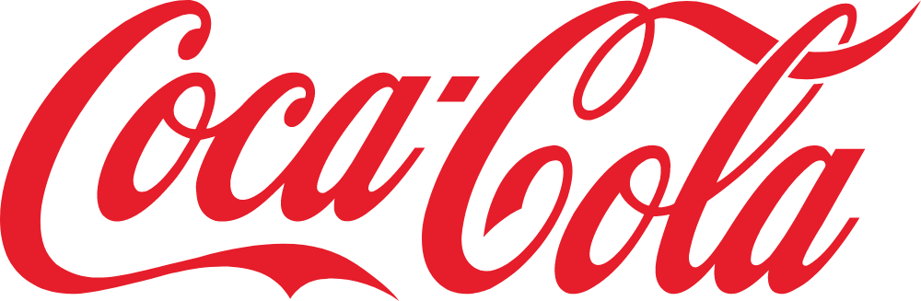

Student Name: Meetkumar Jayeshbhai Patel
Student Number: 2210109
Module: International Marketing (LCMB7006)
Lecturer: Tushara Balendran
Submission Date: 5th May, 2023

Executive Summary
The purpose of the report is to highlight the difference in the marketing strategies applied by the leading non-alcoholic brand Coca-Cola in the UK and in India. To radiate the finding, this report considered using various external as well as internal tools such as PESTLE to analyse the similarity and differences between the political environment and other socio-culture. Further, the Hofstede model was used to validate the differences and similarities in the market culture of the UK and India. Some contrasting differences and similarities have been observed during the report analysis, which had been used to recommend further strategy, and a TWO analysis was done considering the strength and weaknesses with threats and opportunities.
TABLE OF CONTENTS

1. Introduction 5
1.1 Company Overview 5
2. Analysis of Coca-Cola Macro-Environment 5
2.1 PESTLE 5
2.2 HOFSTEDE Module of the cultural dimension 9
2.3 Similarities and Differences in the Macro Analysis of Coca-Cola 12
3. Analysis of Industry Attractiveness for Coca-Cola in the UK and India Market 12
3.1 Porter’s Five Forces 12
3.1.1 Bargaining Power of Suppliers- Low 12
3.1.2 Bargaining Power of Buyers- Low in the UK, High in India 12
3.1.3 The Threat of New Entrants- Low 13
3.1.4 The Threat of Substitution-Moderate 13
3.1.5 Competitive Rivalry- Moderate 13
3.2 Similarities and Differences in the Market Forces Analysis 15
3.3 Benefits of Applying Porter’s Five Forces Situational Model 15
4. SWOT Analysis in Highlighting Coca-cola Strengths, Weakness, Opportunity and Threats in the UK and Indian Market 16
4.1 SWOT 16
4.2 Similarities and Differences in SWOT for Coca-cola in the UK and Indian Market 17
5. Coca-cola Marketing Mix Elements and Market Segmentation Strategies 18
5.1 Segmentation 18
5.2 Geographic 18
5.3 Demographic 19
5.4 Targeting and Positioning 19
5.5 Similarities and Differences in Both Markets 20
6. Marketing Mix 21
6.1 Product 21
6.2 Price 22
6.3 Place and Physical Evidence 22
6.4 Market Entry Method by Coca-cola 23
6.5 Advantages and Disadvantages of the Chosen Entry Methods 23
6.6 Promotion 23
6.7 people 23
6.8 Process 24
7. Directional Development Strategy 24
Market Penetration Strategy 25
Product Development Strategy 25
Market Development Strategy 25
Diversification Strategy 26
8. Recommendation 26
9. TOWS Matrix 27
10. Conclusion 28
References 29

1. Introduction
The primary aim of any company is to increase their market share by increasing its customer base; thus, these organisations are always analysing ways to achieve this competitive edge within their target markets and outside (Juanamasta et al., 2019 ). This has driven many organisations to develop effective strategies to venture into new territories and markets. Further, with the development of technologies, the business market is developing rapidly to engage itself with better customer services. However, there are certain challenges faced by these organisations while developing as a global market, and this includes; cultural differences, regional laws, and political factors which directly impact the growth of the organisation (Sadeghi et al., 2019).

This report will evaluate the challenges faced by Coca-Cola while expanding in the UK and India, and the similarities and differences they came across. Further, it will also discuss the different marketing strategies they have developed and how effective they were.

1.1 Company Overview
Coca-Cola is one of the world’s largest beverage companies, with its products sold in over 200 countries and territories (Zhang, 2022). They have been able to increase their revenue collection year-over-year, as in 2022, it was £ 43 billion, which was an 11% increase from £38.5 billion collected in 2021 (The Coca-Cola Company, 2023). This company is leading with 42% of the global soft drink market as per Euromonitor, manufacturing and selling beverages sparkling soft drinks, water and sports drinks (The Coca-Cola Company, 2023).

2. Analysis of Coca-Cola Macro-Environment

2.1 PESTLE
Political

UK
The political environment of the UK is favourable and stable; however, with Brexit as the free trading policy abolished, it will negatively affect the overall trading strategy of Coca-Cola as this shook the supply chain and distributor channels (Kordos, 2019). But tax policies such as low borrowing rates & FARLOGH are aiding to mitigate Brexit loss and help in sustaining international companies like Coca-Cola.

India
India offers overall political stability; however, there is an increased rate of corruption. However, the low labour costs and potential for growth in the Indian market attract potential international business companies. Coca-Cola invested £1.9 million in lobbying the government & invested £ 4.9 Million by 2020 (Gómez, 2023). Even though Coca-Cola can collect significant revenue from developed countries like the UK, they are still heavily investing in developing countries like India for its market size.

From this analysis, both countries offer Coca-Cola a stable political environment for business expansion and a proper risk management strategy making (Krizanova et al., 2019). However, the Indian government may launch policies against unhealthy consumption which will negatively impact the Coca-Cola brand’s development in India.

Economical
UK
With the increase in GDP, which is about +4.1%, and as per the forecast that energy prices would fall below the EPG level, which would cut household bill prices (Fry and Smith, 2023). This can positively impact the growth & sales of Coca-Cola as consumers will have disposal money with them.

India
India is still recovering from the global recession, and the rate of development is slow compared to developed countries (Ioan et al., 2020). As a result, it imposes a challenging situation for Coca-Cola because there are chances of profit reduction, as the increased price of Coca-Cola will shift consumer purchasing behaviour.

From the analysis, there are chances of economic development in the UK, which will aid in improving the sales growth of Coca-Cola in the UK. However, in India, it may be challenging, as the cost of living is increasing; most of the Coca-Cola products are optional for survival, so the consumption preferences may change.

Social
UK
With the increase of health-conscious consumers in the UK, Coca-Cola’s target market, which is the age group of 18-35, is looking for zero sugar-containing drinks (Vijaykumar, McNeill and Simpson, 2021). This negative impact on sales of Coca-Cola as the demand for their drinks is decreasing.

India
In India, similar health-conscious consumption was observed; teenagers & adults are involved in consuming less sugar, salt, and fat-containing products (Menon and Chavadi, 2022). This negatively impacted the sales rate of Coca-Cola in India as well.

Technological
UK
The advanced technology of the UK aids Coca-Cola in innovating strategies for best customer services, such as sip & scan, which unlock prizes by scanning the icons on Coke bottles (Weatherford, 2019). They also have a website, Coca-Cola Great Britain, to discover their latest news.

India
In India, Coca-Cola is heavily invested in R&D to improve its water management as it is their main raw resource for products. Further, they have acquired a 15% minority stake in Thrive, a food tech organisation (Business Insider, 2023). Thus, with the technology, Coca-Cola is improving its business.

From the analysis, it has been identified that Coca-Cola is benefiting from the developed technologies.

Legal
UK
The UK laws regarding sugar tax and labour protection law had an impact on Coca-Cola as they have been under fire for performing unfair labour practices (LeBaron, 2020). This negatively impacted the brand image of Coca-Cola.

India
A similar unfair business practice by Coca-Cola was observed in India, which was related to the lack of groundwater with the arrival of Coca-Cola in India. As a result, in 2005, the government of Kerala had to close the bottling plant forcefully, and recently in 2015, Tamil Nadu also had to close due to community protests (Rajesh, 2019). This negatively impacted the brand image of Coca-Cola in the Indian market. Overall, Coca-Cola’s business practices negatively impacted its brand image.

Environmental
UK
The UK has implemented strategies to reduce carbon emissions and proper water, waste, and energy management strategies. This influences the marketing strategy of Coca-Cola, as they had to improve their brand image, as they are responsible for 12% of litter in the UK (The Guardia, 2019). Coca-Cola is tackling this by aiming to collect recycled bottles or can make 100% use of them.

India
India also has their sets of environmental policies according to the National Green Tribunal Act, 2010, which the business company must follow. Coca-Cola in India aims to improve energy efficiency, reduce waste, and meet zero carbon emissions by 2050 (The Economic Times, 2023). This provides a growth opportunity for them. The environmental conditions and practices done by Coca-Cola are considered to be favourable.

2.2 HOFSTEDE Module of the cultural dimension

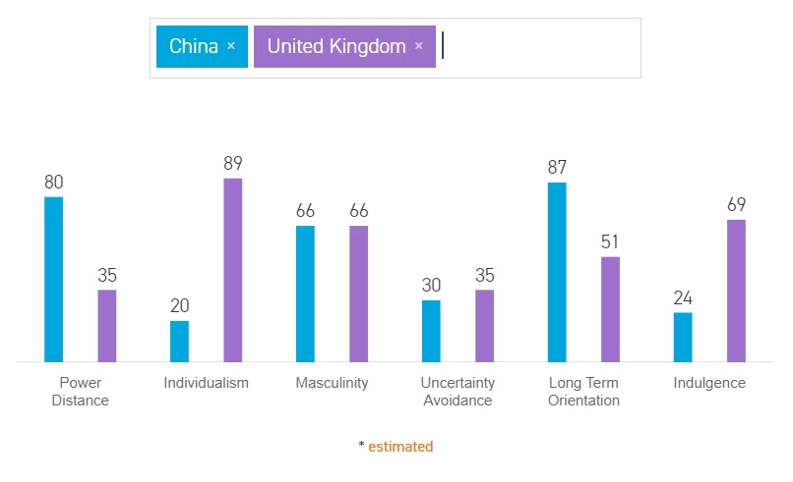
Fig1: Hofstede’s cultural dimensions of the UK
Source: (Minkov and Kaasa, 2021)

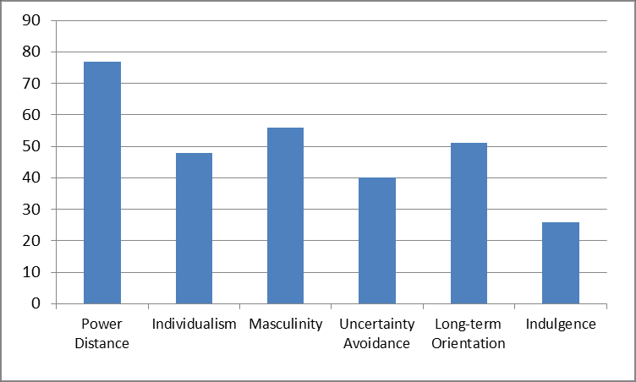
Fig 2: Hofstede’s cultural dimensions of India
Source: (Tiwari, 2023)

Power Distance (PDI)
Power Distance deals with the extent to which less influential members of an organisation or corporation acknowledge and expect power distribution to be done unequally. The UK soured 35%, which indicates that, as a society, they consider inequalities within the public must be minimised and emphasise equal & fair distribution of power. However, India scores the highest in PDI, 77%, indicating a high inequality level in power distribution (Tiwari, 2023). Thus, power is centralised to the company’s head, who makes the major decision, and employees are at the mid-management level.

Individualism (IDV)
This deals with the extent of l self-dependent in large communities instead of being interdependent. It indicates a great value in attaining personal goals; the person’s self-image is defined by “I”, and in collective mindset, which deals with goals achieving for the group's well-being, is defined by “We”. The UK scored highest in IDV, 89%, indicating it is a culture that values individual mindset culture in society; they are taught at an early age to be independent (Iulia-Cristina, 2021). Whereas India scours 48%, indicating they are more collective mindset and care more about the good of the wider community.

Masculinity (MAS)
It deals with the level of assertiveness and material reward success preferred by society. The MAS score of the UK is 66%, which indicates that they are success-oriented and have a high susses driving culture (Wenxin and Yue, 2022). They have an attitude of being ambitious with high-performance work skills. India also scores similarly to the UK, 56%, indicating they focus on success and achievement and value material gain (Tiwari, 2023). Thus, offers an assertive and ambitious work culture.

Uncertainty Avoidance (UAI)
It deals with the level of uncertainty about the future a particular culture can embrace. According to Hofstede, uncertainty can lead to anxiety; thus, all societies have their found coping methods to deal with it (Akanji et al., 2021). The UK soured 35% in the UAI, which indicates that they are quite comfortable with ambiguous and uncertain future situations, as they are good at accepting imperfection. Similarly, in India, they score 40%, which indicates that they also have a medium-to-low preference for uncertainty and acceptance imperfection.

Orientation (LTO)
This deals with the level of extent society can maintain the link with the past and adopt new challenges of the future with time (Kristjánsdóttir and Karlsdóttir, 2020). The UK score51%, which indicated that they value their past while coping with present and future challenges. However, it was an intermediate score, so the cultural dominance cannot be determined. Similarly, India soured 51% again; the culture cannot be determined.

Indulgence (IVR)
This deals with the level of extent to which an individual tries to hold on to their desires and impulsive behaviour based on where they were raised (Chudnovskaya and O’Hara, 2022). The UK soured 69%, indicating they are a culture that exhibits their willingness to realise their personal desires and impulses with life, whereas India soured the lowest 26%, meaning they are resistant to their willingness.

Hofstede Culture Model:
Advantages
- Aid in comparing differences between countries' cultures and practices.
- It may aid in analysing market segmentation, targeting and position strategy for effective marketing strategy.
- It may not consider the current cultural change that has influenced the market development in regard to a wider global level (Chun et al., 2021).

Disadvantages:
- It may not be relevant to the target market.
- It may contain misleading and outdated data
Through this analysis, it can be concluded that the culture of a society determines the value and the values drive the brands and the collaboration of these two leads to the success of the marketplace (Chun et al., 2021). Thus data collected from this model should be carefully considered while analysing the market, as it will aid in proving critical sociocultural analysis which can be utilised by multinational companies for market expansion globally.

2.3 Similarities and Differences in the Macro Analysis of Coca-Cola
The major similarities that were analysed from this Macro-level business environment from both the UK and Indian markets were the political factors. Governments from both countries are making policies to promote the development of international companies such as Coca-Cola and have a relatively stable political state (India Brand Equity Foundation, 2022). Further, economic policies are also considerable similarly, such as tax policies and other policies to mitigate loss due to covid.
However, the social factors differ widely, as observed by Hofstede's model. Indian culture is more community-driven, whereas UK culture is more individualistic. Also, self-control and overindulgence are not practised in India, but in the UK are excessive indulgences.

3. Analysis of Industry Attractiveness for Coca-Cola in the UK and India Market

3.1 Porter’s Five Forces

3.1.1 Bargaining Power of Suppliers- Low
In the UK, Coca-Cola has a strong foothold in the market; as a result, suppliers have low power over the company. Further, Coca-Cola engages itself with various raw material suppliers with their strong negotiating capability. Similarly, in India, they have a strong market hold, as this is the dominating soft drink in India (Minhas, 2023). Thus, it is easier for Coca-Cola to switch between suppliers, but it is difficult for suppliers to look for new customers.

3.1.2 Bargaining Power of Buyers- Low in the UK, High in India
It was observed that within the recent year, the bargaining power of consumers had increased because of the validity of various other soft drinks through social media. As a result, this lead to increased competition, as buyers can switch from one company to another for the same products. However, Coca-Cola is able to retain its UK-based customers with its innovative strategies and social engagement to ensure enhanced customer delivery. According to that statistic (2023), they have a total of 12.8 million consumers, indicating buyers do not have power over Coca-Cola (Statista, 2023). However, this is not the case in India, where the buyers have power over Coca-Cola, as Mazza is given the major competition for customers in India.

3.1.3 The Threat of New Entrants- Low
Considering the market of the UK, the threat of new entrants is low. The main reason behind this is the brand image of Coca-Cola; it is one of the leading companies along with Pepsi and covers almost 80% of the market. Thus, new entrants need to invest huge amounts of funds and time to compete with them directly. Similarly, in India, Coca-Cola is the leading company, followed by Sprite, as Coca-Cola has 60% of the Indian market share (Mishry, 2022). Thus, in both countries, the threat is low.

3.1.4 The Threat of Substitution-Moderate
It was observed that in the UK, the target market of Coca-Cola, which is the 18-35 age group, is getting more health-conscious when it comes to consumption. Thus, there is a moderate threat of being substituted for healthy drinks such as Smoothies and fresh fruit juices. Similarly, trends were also observed in India's health-conscious eating trends (Mare et al., 2022). However, Coca-Cola has already implemented strategies such as Coca-Cola Zero Sugar which is a no Calories Soft Drink, to retain its customers (Chua et al., 2020). Thus, the threat is moderate in both countries.

3.1.5 Competitive Rivalry- Moderate
The competition rate in both countries is high, considering the availability of similar products by other brands such as Pepsi, Fanta, Sprite, and Red Bull. however. It was noticed that Coca-Cola is extensively engaged in social media promotion, such as using Facebook and Twitter to spread awareness regarding their new launch and other campaigns, which makes them unique from others (Huse et al., 2022). Thus, Coca-Cola faces a moderate level of rivalry in both countries (Fig5).
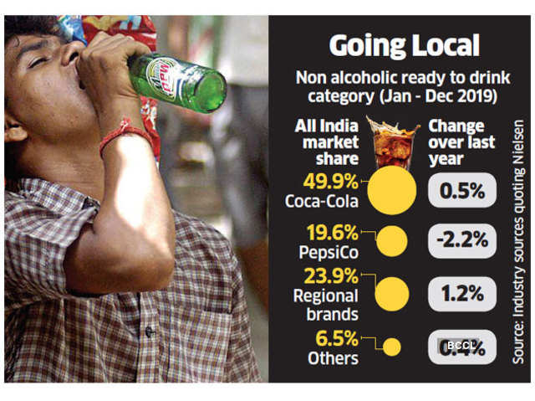
Fig 03: Market share of soft drinks in India
Source: (The Economic Times, 2023)
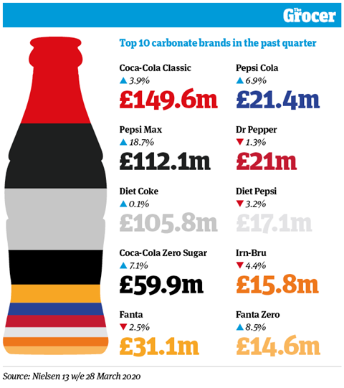
Fig 04: Market share of Soft drinks in the UK
Source: (Coca-cola, 2022)

3.2 Similarities and Differences in the Market Forces Analysis
The analysis of different external factors of the Market forced Coca-Cola in both the countries UK and India led to the identification of specific similarities and differences, which can be used by the company to improve their existing marketing strategies. The primary similarity between both countries regarding the brand was the low bargaining power of suppliers. The main reason behind this could be that they are vertically integrated; that is, they are involved in developing their own products, manufacturing them, distributing them, and taking care of the marketing trends with their product sales rate (Luco and Marshall, 2020). This improves the organisation’s commitment strategy regarding work towards sustainability and opportunity in the UK and India. Further, it was identified that Coca-cola in both countries has a low threat of new entrants. This was due to their strong brand image and proper brand promotion using social media (Chandpuri and Ahuja, 2020). The major difference between the UK and India regarding the Coca-Cola brand was the bargaining power of the buyer. In the UK, Coca-Cola is the most preferred soft drink brand, whereas in India, due to the availability of other potential brands such as Mazza, Thumbs Up, and Mazza, which is the largest soft-drink brand in India, Coca-Cola is the largest international brand in India (Minhas, 2023). This indicates that the customer has the power switch between both the brands, although it was observed that it is not price conscious but rather taste conscious, as Cola contains more sugar and is sweeter than the soft drinks sold by the Indian Market.

3.3 Benefits of Applying Porter’s Five Forces Situational Model
The model of Porter’s Five Forces can aid in developing the potential marketing strategy for global expansion if accurately applied. This model helps in identifying the market gaps and opportunities while highlighting the key differences between the market's driving forces regarding the target segment of the market (Goyal, 2020). And with this information, it may help in generating new strategies for market entry methods development.

However, the major drawback of this model is that it does not include the fast-changing factors that are occurring in the macro environment, and thus, the accuracy may vary.

4. SWOT Analysis in Highlighting Coca-cola Strengths, Weakness, Opportunity and Threats in the UK and Indian Market

4.1 SWOT
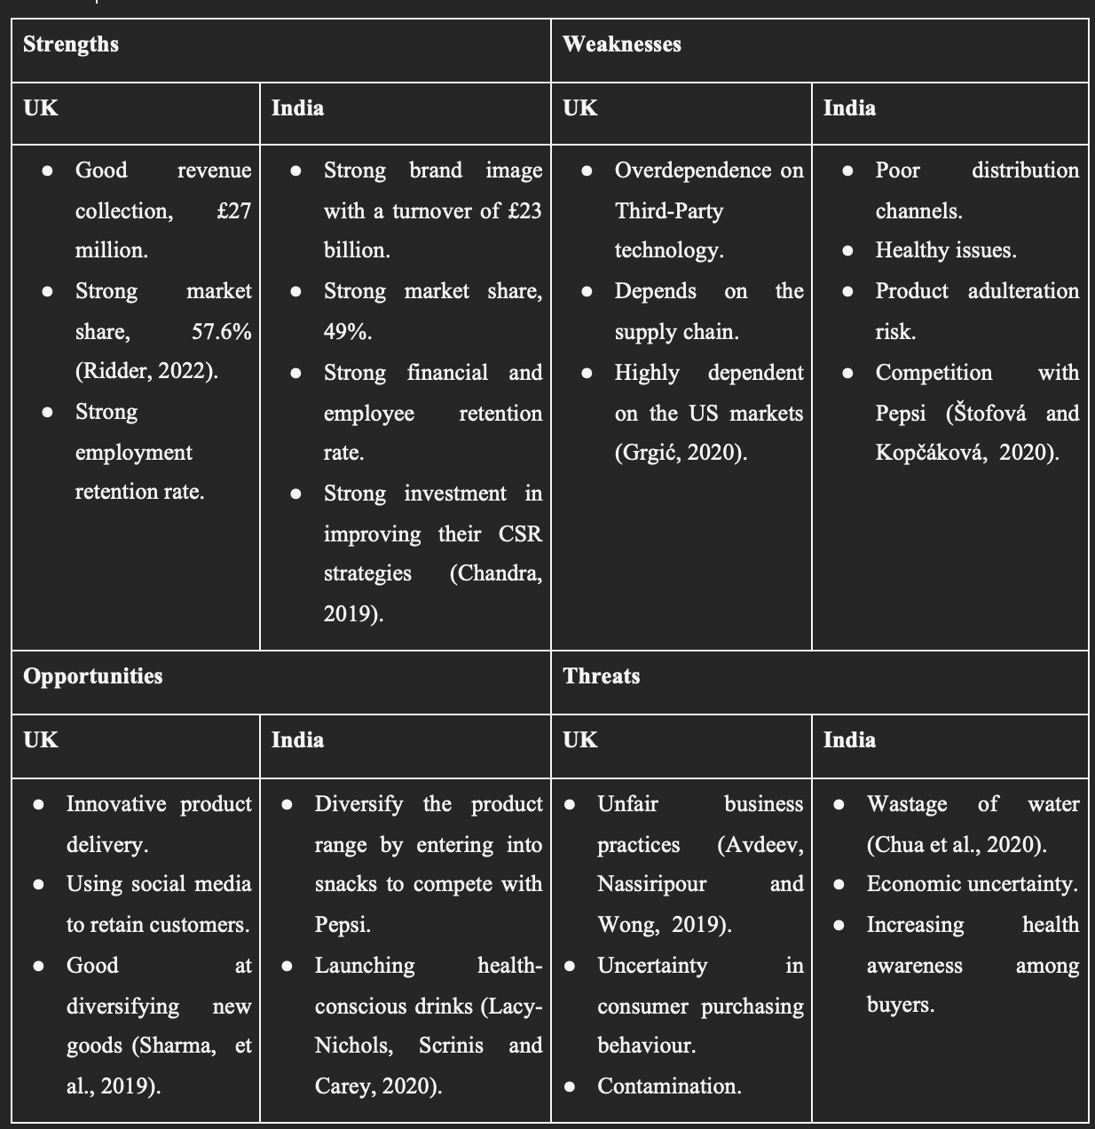

4.2 Similarities and Differences for Coca-cola in the UK and Indian Market
Coca-cola is one of the leading non-acholic brands in the beverage industry and had strong financial growth in both the countries of India and the UK; as they are leading with 49% and 56% of the total market share, respectively. This further indicates that they have strong financial growth from both countries, as from the UK, they generated £ 27 million in 2022, and from India, they generated £23 million in 2022. Another similarity that was observed in the marketing strategy of Coca-cola is that both in the UK and in India, they are heavily involved in implementing innovative strategies for increasing brand awareness regarding their new launch and other campaigns, and this aids them in retaining their customers because they are extensively engaging with the customers (Chu, 2020). And also, with the trend of health-conscious customer purchasing behaviours, Coca-Cola has launched in the UK as well as in India; their product range of zero sugar Coke has no calories, according to their advertisements.

However, there is a certain marketing strategy that is implemented by Coca-cola, which differs from the marketing strategy in the UK and India. That is due to the people's perception of the taste of the product. Otherwise, according to market research, Coca-Cola has the same marketing strategy. In the UK, they have more product diversification, such as Coca-cola life, Coca-Cola, Diet Coke, and Coca-Cola Zero, whereas in India, due to competition with local brands such as Mazza, Coca-Cola, and Coca-Cola Zero are the leading products, and they are more promoted by the brand (Chorazy, 2020). Also, it was observed that, in India, most of the bottling company of Coca-Cola was forcefully shut down due as they were involved in improper utilisation of groundwater, especially from the states of Kerala and Tamil Nadu, in the year 2015. Whereas in the UK, they were involved in unfair business practices, which led them to deal with lawsuits. Thus, in both countries, they have a hard time landing as a strong beverage brand.

Another marketing strategy that differs is due to economic uncertainty in India, whereas the UK has more or less stable economic conditions. As a result, Coca-cola had to modify its overall pricing strategy to balance the trading cost in both countries properly.

5. Coca-cola Marketing Mix Elements and Market Segmentation Strategies

5.1 Segmentation
There are some differences and similarities identified in the market segmentation strategies of Coca-Cola in India and the UK considering both the markets have different consumer preferences and behaviours. The market segmentation in India focuses on affordability and accessibility as the main target of Coca-Cola concentrates on rural areas with lower-priced products like ‘Thumbs Up’ and ‘Maaza’. In contrast to that, Coca-Cola in the UK put emphasis on health and wellness with its low-calorie options such as Diet Coke and Coca-Cola Zero Sugar. According to a report, the market share of Coca-Cola in India was around 42.5% in 2020, whereas, the soft drink and beverage company enjoyed a 22.4% market share in the UK in 2020 (Knežević, Koprivica and Kriste, 2019). The statistics show the importance of adapting to local market conditions that Coca-Cola has acquired according to the needs and requirements of respective markets. Coca-Cola's market segmentation strategies in India and UK are mostly similar to the target consumer base based on age, gender and income group. However, according to the perception and demand for soft drinks in both countries, launching drink beverages differ a bit. Marketing segmentation strategies of Coca-Cola, therefore, demonstrate the significance of tailoring market efforts to local preferences and needs.

5.2 Geographic
Based on the geographic location, the offerings of Coca-Cola change. When it comes to India, Coca-Cola tries to provide customers with what would cost people less money to purchase. The main target of Coca-Cola is to appeal to price-sensitive customers in rural areas of India. Launching a product design is often designated to appeal to local tastes and preferences which leads Coca-Cola to promote brands like ‘Thumbs Up’, ‘Limca’, and ‘Maaza’ more in India (Talukder, 2019). These products are sold out at a lower price to make more sense to the target consumer base in India. On the other hand in the UK, Coca-Cola's intention shifts toward providing low-calorie and sugar-free options as the consumer base in the UK is more health conscious rather than in India. This makes Coca-Cola design health-conscious diet offerings in expanding its product line to include non-carbonated drinks in the UK like ‘Innocent smoothies and juices.

5.3 Demographic
The demographic segmentation strategies of Coca-Cola can be compared and contrasted in the context of Indian and UK-based markets. Coca-Cola has the goal of targeting adults and teenagers with affordable and flavourful drinks in the Indian market. Coca-Cola's sole target in India concentrates on family-oriented consumers by providing products like ‘Minute Maid Pulpy Orange’ and ‘Maaza’, positioned as healthy alternatives to sugary drinks in India. When it comes to the UK market, Coca-Cola's primary target is health-conscious consumers, especially younger generations and adults concerned with sugar intake, by offering them low-calorie options (Sharma et al., 2019). Because of the younger population in India and the existence of a family-oriented culture, Coca-Cola tries to promote their services that would suit the Indian audience. While Coca-Cola targets the UK mostly for middle-aged or older customers, although they include young people also, but still, the core of their demographics limit to being within the tag of health-conscious.

5.4 Targeting and Positioning
In terms of targeting, a range of approaches are used by Coca-Cola in order to reach specific consumer segments in both markets. In India, the targeting approach of Coca-Cola consists of providing flavourful and unique tastes to young people aligning with local food preferences and cultural choices within an affordable range of prices. In the UK, the approach of Coca-Cola becomes more health-oriented.

In terms of market positioning strategy, reflecting on the target audience in each market helps Coca-Cola come up with better strategies. For instance, Coca-Cola positions itself as a youthful and fun-loving brand with the use of vibrant colours, music and celebrity endorsements in marketing strategies in India (Donahue, 2022). Coca-Cola runs marketing campaigns featuring Bollywood actors and local celebrities to put emphasis on appealing to the younger generation while at the same time maintaining the quality and flavour of the product, positioning Coca-Cola products as refreshing and enjoyable choices for the customers. In the UK, the quality and flavour of the products is a mandatory essence, still, the promotion heavily invests in letting customers know how Coca-Cola invests a lot in low-calorie and sugar-free options that come out as a better choice for customers in the UK for enjoying a fizzy drink without compromising their health.

5.5 Similarities and Differences in Both Markets
Analysing the marketing mix elements and market segmentation strategies implemented by Coca-Cola, it can be ascertained that most of the approaches taken by Coca-Cola in both markets are almost identical and similar. For instance, both markets target a similar youthful audience but also look for providing healthy drink options for people within a justifiable price rate. However, depending on the cultural difference and societal norms in India and UK, there is also a slight difference between Coca-Cola's marketing strategy.

Similarities
- Both in India and the UK market, Coca-Cola uses a mix of traditional and digital marketing channels in order to reach consumers.
- Coca-Cola focuses on health and wellness themes in its marketing that promotes different flavours of drinks with low-calorie and sugar-free options.
- Both markets in India and the UK use targeted promotions and sponsorships in order to reach specific demographic groups such as music festivals or sports events.

Differences
- Coca-Cola’s marketing focus is more on affordability and youthfulness, focusing on India's context of culture in believing in family-centric. In the UK, the brand focuses more on health-conscious consumers rather than concentrating on how to offer products at a cheaper rate.
- Coca-Cola has a strong presence in rural areas of India, whereas, in the UK, the drink and beverage company's market share is higher in urban areas.

Using the above information, the perceptual map for coca cola in two nations that are India and the UK is developed based on price and nutritional value as shown in the figure below:
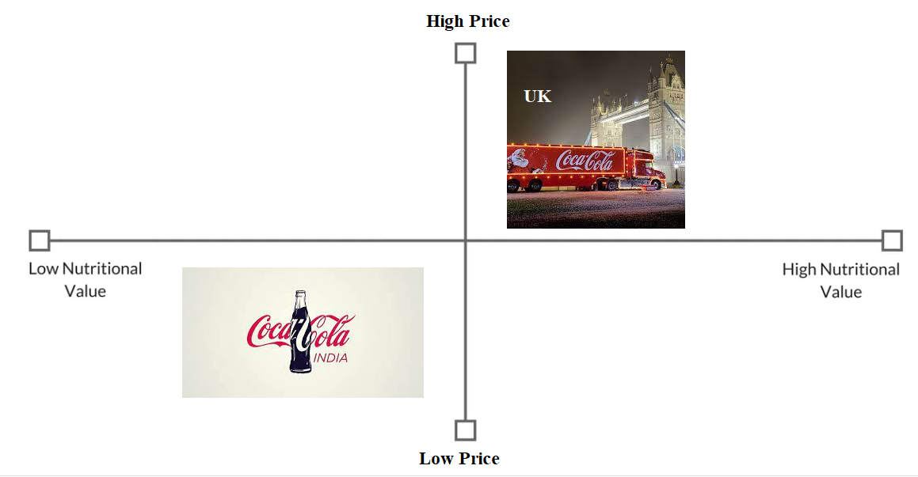

Fig 05: Perceptual Map of Coca-Cola in India and in the UK.

6. Marketing Mix

6.1 Product
In addition to traditional Coca-Cola products, Coca-Cola offers a range of fruit-based drinks such as ‘Maaza’, ‘Minute Maid Mango’, ‘Minute Maid Guava’ and ‘Minute Maid Pulpy Orange’ in India (Goyal et al., 2019). Coca-Cola introduced ‘Aquarius’, a beverage that aims at the energy drink market of India with a non-carbonated sports drink more targeted towards athletes (Jewel, Hasan and Kalam, 2020). Reduced sugar content in products of Coca-Cola complies with India's new sugar tax regulation.

In the UK, Coca-Cola offers more low-calorie and sugar-free options such as ‘Sprite Zero’ and ‘Fanta Zero’. Coca-Cola has expanded its offerings to include flavoured water and juice drinks in the UK such as Glaceau Smart Water Sparkling and vitamin water.

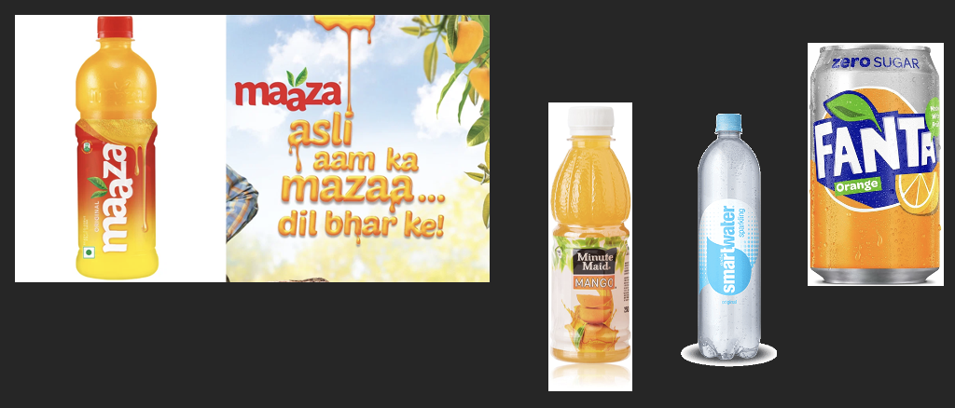
Figure 06 - Product lines in India and UK
Source - (Coca-cola, 2022)

6.2 Price
Coca-Cola offers reasonable pricing in both markets for products. However, Coca-Cola is extra careful to cater to the price-sensitive Indian market. Coca-Cola offers small sizes of Coca-Cola and other drinks such as in 200 ml and 300 ml bottles to make the products better accessible to consumers with lower budgets in India (Stürner, 2021). In the UK, Coca-Cola demonstrates different pricing strategies for different product lines considering value packs and promotional offers.

6.3 Place and Physical Evidence
Coca-Cola follows an extensive distribution network in India in order to reach the remotest areas. The company ties up with local retailers and vendors in India to make sure the availability of its product gets to reach even the smallest stores in rural areas of India. Coca-Cola products in the UK are made widely available in supermarkets, convenience stores and vending machines. The company usually target channels like sports and music events to reach more people in the UK to promote and distribute Coca-Cola products.

6.4 Market Entry Method by Coca-cola
Coca-Cola entered the Indian market in the ’70s but re-entered in 1993 with a joint venture partner program with an Indian company (Sugynanam and Shankar, 2019). The main marketing method by the company has always been to invest heavily in local production and sourcing of raw materials to support the business infrastructure in India and expand marketing opportunities as well. Coca-Cola has been present in the UK market for over 100 years. Years of strong marketing presence in the UK through acquisitions and partnerships with local bottlers and distributors make it easier for the company to sustain this long.

6.5 Advantages and Disadvantages of the Chosen Entry Methods
The main advantages of the joint venture allowed Coca-Cola to leverage local expertise and resources and get to know the local markets in India better. Facing challenges in navigating India's complex regulatory environmental and cultural difference also help Coca-Cola management to critically assess, evaluate and come up with better policies. In the UK, acquisitions and partnerships also help the brand quickly establish a strong market presence. However, the increasing favour to provide healthy drink options was challenging for Coca-Cola initially, had the management chosen to continue with the same entry market policy in the UK.

6.6 Promotion
In both markets, Coca-Cola employs a variety of marketing and advertising strategies mainly consisting of both traditional and digital approaches to promote its products. The inclusion of TV commercials, billboards and social media marketing with hiring influential celebrities such as actors or musicians help Coca-Cola better appeal to the audience.

6.7 people
In both countries, Coca-Cola appoints a diverse workforce to commit to a positive and inclusive corporate culture. Both countries come with unique diverse cultural components, therefore, letting local people take the main charge of leading ideas with market products and promotions helps Coca-Cola to make ‘relativity’ with the target audience.

6.8 Process
The production procedure is similar both in India and UK as Coca-Cola's manufacturing facilities in both countries are consistent in looking for providing product quality as expected by the loyal customer base.

7. Directional Development Strategy
To give perfect competition, Horizontal Expansion is the strategy and concept owned by the Coca-Cola Company to increase market share by expanding the number of outlets in the targeted market. The company can successfully implement the marketing strategies depending on how the company operates with their channelled partners. The company is currently operating in 200 countries (Dai and Dai., 2021). The product, price, customer preference, advertisement, and promotion guide a company or brand to improve its distribution system and help in retaining the retailers and converting non-retailers to Coca-Cola retailers in selling the products.

7.1 Ansoff Matrix.
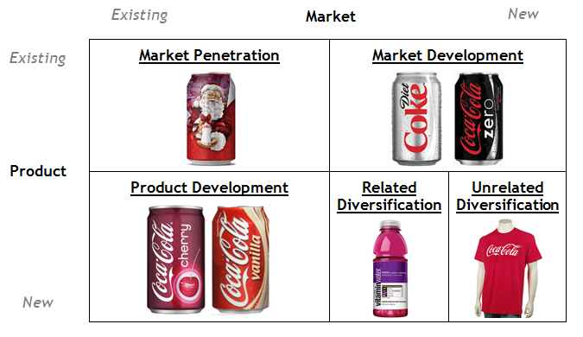
Figure 06. Coca-Cola market analysis through Ansoff Matrix Demonstration
Source:(Clarissia., 2020)

Market Penetration Strategy
The strategy involves increasing market share within the existing market in different countries, including the UK and India. Selling products through advertising and promotion is the marketing strategy of the company inventing Red-White clothed Santa for Christmas celebrations worldwide. Coca-Cola capitalises on the market as a strong Brand by associating with popular Holiday events. Coca-Cola is strongly equivalent to the celebration. Sports and Entertainment partnership is in the DNA of the Coca-Cola Company (Clarissia, 2020). People cannot watch any television program without the advertisement of Coca-Cola. Coca-Cola is everywhere from the billboards to the print media and on the Internet. Cock’s licensed logo is for sale through various accessories, such as mugs, Glasses and Fashionable accessories. Last year the total consumption rate in the UK was 12.08 million and 43 million in India.

Product Development Strategy
Development is the systematic process of improving materials, products, processes and services that can identify the customer need. Coca-Cola frequently launches new drinks and their variants as Diet Coke, Fanta, and Cola Zero with various fruits and soda flavours. As a marketing strategy with a new style of labelling and taste to attract love towards the brand at any age. But there are some limitations in the geographic regions (Tien et al., 2019). The company sells Diet Coke and Sprite more in the UK and India. But Fanta is the only variant that is sold in Pakistan as the highly consumed soft drink. The newly launched products are usually sold at lower prices to gain acceptance from the customer as flagship products.

Market Development Strategy
Entering into the new market by modifying the existing product and selling to the new group of customers. Coca-Cola changed its marketing strategy to just “one brand”. The company aims to encourage the British with its Coke variety by lowering the calorie in its products. In India, the company established a strong base by combining local and global brands such as Thumbs-Up, Limca and Mazaa. New packaging size and engaging celebrity and sports figures at the time of launching new products in the market. While promoting the brand to gain more customer loyalty. Clicking a selfie and posting it with the bottle helps the brand to make a better personal connection with the customer.

Diversification Strategy
The company has diversified with several offerings with sports drinks, energy drinks, juices, teas and vitamin waters. Aquafina is the purified mineral water sold by PepsiCo and has captured an 11% market share in India as the packaged drinking water (Tavares and Silitonga., 2023). Dr, Pepper and Glaceau smart water are highly sold in the UK as a diversified product as bottled water and as an energy brand by Coca-Cola. The UK expects the market share of these diversified products will gain 8% market share by the next 3 years. Diversified products also in terms of Fridge and Clothes. Outside the merchandising the horizontal diversification of the products by expanding the brand in various beverage industries to gain greater sales.

8. Recommendation
Despite Coca-Cola having a large market share in the UK and India, Company wants to emerge as a great brand by maintaining a disciplined approach to Innovation. The company is strategizing new relevant and diversified products for the market that drives through consumer-centric incremental growth. In 2022, the Company's intelligent experiments go beyond new flavours that add products, packages and processes. The company encourages the local market to taste the best ideas nurtured by the company experts. That helps the company to expand its geographic horizon. Through Digital strategies, it accelerated company sales, commercialisation and distribution through digital platforms online during the time of the pandemic. Combining cutting-edge digital tools can easily strengthen brand awareness.

Through Network Organisation, the company can change the way of doing business by maintaining the right balance between intimacy and scale. As global brand companies make a clear decision to modernize their approach towards marketing and innovation. The company has now established a platform where they can give services by analysing data, elevating and accelerating data and giving insights into the capabilities by reducing duplication. The networked organisation has potential resources and energy for growth. Great marketing strategies always start with accepting and acknowledging customer preferences. Customers are always passionate about tasting new products and sharing their own stories and emotions that are deeply attached to the brand. Operating structure and functions in various geographic locations that enable global solutions. The four elements that will help the brand in Brand -Building. The networked way of working, Human insights, superior products and Brand Bundle that engages the consumer journey. The global presence of the brand in end-to-end engagement between various new agency partners through traditional media. Additional new diversified products of the brand allow the brand to spread impactful to the clientele. Through these recommendations, the company will excel with informed decisions.

9. TOWS Matrix

Weakness & Threat | Strength & Threat
- The unhealthy products of Coca-Cola can become a threat to its competition. Red Bull and Tetra Pak in the UK and PepsiCo In India are the biggest competitors of Coca-Cola.  - The company can break its product price into various geographic locations to minimise its exchange rate. While operating in the domestic market and transacting in local currency (Susilo., 2021).  - Coca-Cola can use sustainability in their recycled packaging manner by not using fossil fuel. More recycled products help the brand in lowering carbon emission. The company produces 5.49 million tons of greenhouse gas. | - Coca-Cola needs to make healthier choices in their products to create a better image and meet the rising demand for healthier products.  - Companies should focus more on technological advancement that will help the company to focus more on research and development by reducing the use of fossil fuels and more sustainable packaging with recycling.  - Company is targeting to open new markets in the middle east. The growing population demands more varieties of products and the company through its diversified products can easily capture the market with the help of retailers.
Weakness & Opportunity | Strength & Opportunity
- Company has a large market share in the UK and India, so the company can increase its product price to tackle the market share. Overdependence on third-party technology is highly cost-effective for the company.  - But product diversification, lawsuits and aggressive competition to become a market leader in the beverage spoiled the brand image but Coca-Cola has a smart and better way of advertising strategies so the brand can easily compete and regain its market.  - Due to global presence and recognition the company can partner with different organisations and make partnerships to battle global warming.  - The company targeted to reduce carbon emissions and net zero by 2050. | - The growing population in India is the best destination for Coca-Cola to target the market. By arranging campaigns in schools, universities and colleges, the company is targeting young people from the age group of 10-35 to increase their market share.  - Through digital marketing, using recycled packaging and better advertisement campaigns will help the brand to gain customer loyalty and the company can spread its brand awareness.  - Nowadays customers are more focused on the brands that deliver healthier products, such as Diet Coke, Smart Water and Zero Sugar Coca-Cola can easily attract customers towards the Brand.

10. Conclusion
In conclusion, the following report pinpoints how to focus on the customer base on the basis of demographics, geographics and other aspects of measurements to better prepare with strategies in order to expect a competitive edge. The following report analyses the case study of Coca-Cola to look into how the organisation develops a global marketing strategy for approaching its products to the customer base considering factors of cultural differences, regional laws and political factors. The report considers India and the UK for the following assignment to look into how Coca-Cola approaches both markets. Both the opportunities and challenges associated with the company have also been emphasised thoroughly in the paper to generate better ideas on the company policies.

References
Akanji, B., Mordi, C., Ajonbadi, H. and Adekoya, O.D., 2021. Exploring cultural values in conflict management: A qualitative study of university heads of departments. Qualitative Research in Organizations and Management: An International Journal, 16(2), pp.350-369.

Avdeev, V., Nassiripour, S. and Wong, H., 2019. Case Study: Ethical Considerations of an Accounting Professional. Journal of Leadership, Accountability & Ethics, 16(2).

Brondoni, S.M., 2019. Shareowners, stakeholders & the global oversize economy. The Coca-Cola company case. Symphonya. Emerging Issues in Management, (1), pp.16-27.

Chandpuri, S.H. and Ahuja, V., 2020. Using social media for generating trust-A study of FMCG brands. NMIMS Journal of Economics and Public Policy, 4, pp.42-60.

Chandra, A. (2019) Coca Cola CSR activities in India and around the world: Avinash Chandra, avinashchandra.com. Available at: https://www.avinashchandra.com/coca-cola-csr-activities (Accessed: 1st May 2023).

Chorazy, E., 2020. 14 Coke and health. Decoding Coca-Cola: A Biography of a Global Brand, p.207.

Chu, B., 2020, November. Analysis on the Success of Coca-Cola Marketing Strategy. In 2020 2nd International Conference on Economic Management and Cultural Industry (ICEMCI 2020) (pp. 96-100). Atlantis Press.

Chua, J.Y., Kee, D.M.H., Alhamlan, H.A., Lim, P.Y., Lim, Q.Y., Lim, X.Y. and Singh, N., 2020. Challenges and solutions: A case study of Coca-Cola company. Journal of the Community Development in Asia (JCDA), 3(2), pp.43-54.

Chua, J.Y., Kee, D.M.H., Alhamlan, H.A., Lim, P.Y., Lim, Q.Y., Lim, X.Y. and Singh, N., 2020. Challenges and solutions: A case study of Coca-Cola company. Journal of the Community Development in Asia (JCDA), 3(2), pp.43-54.

Chudnovskaya, E. and O’Hara, L.L., 2022. Indulgence Versus Restraint: Exploration of A New Cultural Dimension in Context. Journal of Intercultural Communication, 22(2), pp.41-52.

Chun, D., Zhang, Z., Cohen, E., Florea, L. and Genc, O.F., 2021. Long-term orientation and the passage of time: Is it time to revisit Hofstede’s cultural dimensions?. International Journal of Cross Cultural Management, 21(2), pp.353-371.
Clarissia, S.M.S., 2020. A study on Ansoff Matrix Technique: As a growth strategy and an adaptive learning technique adopted in the leading brand of products. BIMS Journal of Management, p.18.

Coca-Cola India invests in foodtech platform thrive, which aims to change The way you order your meal online (2023) Business Insider. Available at: https://www.businessinsider.in/business/news/coca-cola-india-invests-in-foodtech-platform-thrive-which-aims-to-change-the-way-you-order-your-meal-online/articleshow/99589190.cms (Accessed: 1st May 2023).

Coca-Cola most common source of packaging pollution on UK beaches – study (2019) The Guardian. Guardian News and Media. Available at: https://www.theguardian.com/environment/2019/may/14/coca-cola-packaging-pollution-on-uk-beaches-surfers-against-sewage-study (Accessed: 1st May 2023).

Coca-Cola reports fourth quarter and full-year 2022 results: Press release (2023) The Coca-Cola Company. Available at: https://www.coca-colacompany.com/press-releases/fourth-quarter-full-year-2022-results#:~:text=For%20the%20full%20year%2C%20net,%2DGAAP)%20grew%2016%25 . (Accessed: 1st May 2023).

The Economic Times (2023). Available at: https://m.economictimes.com/industry/energy/power/coca-colas-ludhiana-bottling-plant-commission-100-kw-solar-powerplant/articleshow/58478688.cms (Accessed: 1st May 2023).

Dai, Y., 2021, March. Comparison of Emphasis Point Towards Marketing Strategies Between Pepsi & Coca-Cola. In 6th International Conference on Financial Innovation and Economic Development (ICFIED 2021) (pp. 79-83). Atlantis Press.

de Souza Tavares, W. and Silitonga, R.U., 2023. The Coca-Cola Company advertising history illustrated through phonecards. International Journal of Arts and Humanities, 4(1), pp.137-146.
Donahue, K., 2022. Marketing: An Introductory Text.

Foreign trade policy of India: Domestic &amp; International Import, Export Sector, exim policy of India: IBEF (2022) India Brand Equity Foundation. Available at: https://www.ibef.org/economy/trade-and-external-sector (Accessed: 1st May 2023).

Fry, E. and Smith, J. (2023) The only way is down • resolution foundation, Resolution Foundation. Available at: https://www.resolutionfoundation.org/publications/the-only-way-is-down/#:~:text=There%20is%20good%20news%20for,the%202023%2D24%20EPG). (Accessed: 1st May 2023).

Gómez, E.J., 2023. Junk Food Politics: How Beverage and Fast Food Industries Are Reshaping Emerging Economies. JHU Press.

Goyal, A., Nair, A., Kumar, B. and Bhardhwaj, S., 2019. Enhancing Consumer Preference towards healthy drinks. Great Lakes Herald, 13, pp.41-60.

Grgić, J., 2020. Coca-Cola internationalization strategies (Doctoral dissertation, University of Zagreb. Faculty of Economics and Business. Department of International Economics).

Huse, O., Reeve, E., Bell, C., Sacks, G., Baker, P., Wood, B. and Backholer, K., 2022. Strategies used by the soft drink industry to grow and sustain sales: a case-study of The Coca-Cola Company in East Asia. BMJ Global Health, 7(12), p.e010386.

Ioan, B., Malar Kumaran, R., Larissa, B., Anca, N., Lucian, G., Gheorghe, F., Horia, T., Ioan, B. and Mircea-Iosif, R., 2020. A panel data analysis on sustainable economic growth in India, Brazil, and Romania. Journal of Risk and Financial Management, 13(8), p.170.

Iulia-Cristina Uță Wednesday / January 20 / 2021, Uță, I.-C. and Uta, I.C. (2023) What is Hofstede's cultural dimensions theory? UK vs China, a comparison, BRAND MINDS. Available at: https://brandminds.com/what-is-hofstedes-cultural-dimensions-theory-uk-vs-china-a-comparison/ (Accessed: 1st May 2023).

Jewel, M., Hasan, M. and Kalam, K.K., 2020. The Importance and Level of Adaptation of STP Strategies for Growth in Foreign Markets: In the Case of Soft Drinks Company. Asian Journal of Economics, Business and Accounting, 19(2), pp.13-23.

Juanamasta, I.G., Wati, N.M.N., Hendrawati, E., Wahyuni, W., Pramudianti, M., Wisnujati, N.S., Setiawati, A.P., Susetyorini, S., Elan, U., Rusdiyanto, R. and Astanto, D., 2019. The role of customer service through customer relationship management (Crm) to increase customer loyalty and good image. International Journal of Scientific and Technology Research, 8(10), pp.2004-2007.

Knežević, A.G., Koprivica, I. and Kriste, L.M., 2019. The case study of the Coca-Cola company. company analysis, p.71.

Kristjánsdóttir, H. and Karlsdóttir, F.B., 2020. UK foreign direct investment in the OECD, culture and geography. Baltic Journal of Economic Studies, 6(5), pp.8-14.
Krizanova, A., Lăzăroiu, G., Gajanova, L., Kliestikova, J., Nadanyiova, M. and Moravcikova, D., 2019. The effectiveness of marketing communication and importance of its evaluation in an online environment. Sustainability, 11(24), p.7016.

Lacy-Nichols, J., Scrinis, G. and Carey, R., 2020. The evolution of Coca-Cola Australia’s soft drink reformulation strategy 2003–2017: A thematic analysis of corporate documents. Food Policy, 90, p.101793.

Le Mare, D., Thoebald, H., Lescop, O. and Bennett, E., 2020. Consumer understanding of health, nutrition and ingredient claims on sweet and savoury snacks: potential tool for encouraging healthier snacking choices. Proceedings of the Nutrition Society, 79(OCE2).

LeBaron, G., 2020. Combatting modern slavery: Why labour governance is failing and what we can do about it. John Wiley & Sons.

Luco, F. and Marshall, G., 2020. The competitive impact of vertical integration by multiproduct firms. American Economic Review, 110(7), pp.2041-64.

Menon, S.R. and Chavadi, C.A., 2022. A Research-based Approach to Identify the Health-conscious Consumers in India. Metamorphosis, 21(2), pp.118-128.

Minkov, M. and Kaasa, A., 2021. A test of Hofstede's model of culture following his own approach. Cross Cultural & Strategic Management, 28(2), pp.384-406.

Mishry, T. (2022) 10 best soft drink brands in India, Mishry. Available at: https://mishry.com/10-best-soft-drink-brands-in-india#:~:text=Coca%2DCola%20or%20Coke&amp;text=Coca%2Dcola%20is%20commonly%20known,captures%20around%2040%25%20market%20share (Accessed: 1st May 2023).

Statista Research Department (2023) Leading cola brands in the UK 2021, Statista. Available at: https://www.statista.com/statistics/308655/leading-brands-ofcolas-in-the-uk/#:~:text=Brands%20of%20colas%20in%20Great%20Britain%202021%2C%20by%20number%20of%20consumers&amp;text=This%20statistic%20shows%20a%20ranking,by%20its%20number%20of%20consumers (Accessed: 1st May 2023).

Statista Research Department, (2023) Coca-Cola: Leading Cola Brands in GB 2021, Statista. Available at: https://www.statista.com/statistics/312797/leading-cola-brands-of-coca-cola-in-the-uk-by-number-of-users/#:~:text=In%202021%2C%20an%20estimated%2012.08,people%20consumed%20original%20Coca%2DCola. (Accessed: 1st May 2023).

Rajesh, K.P., 2019. The Anti-Coca-Cola Movement in Plachimada, Kerala. Journal of Developing Societies, 35(4), pp.437-457.

Sadeghi, V.J., Nkongolo-Bakenda, J.M., Anderson, R.B. and Dana, L.P., 2019. An institution-based view of international entrepreneurship: A comparison of context-based and universal determinants in developing and economically advanced countries. International Business Review, 28(6), p.101588.

Sharma, A., Larkin, J., Fernandez, I. and Esteves, G., 2019. The Diversification of Coca-Cola: Globalization & Strategic Fit. Journal for Global Business and Community, 10(1).

Sharma, A., Larkin, J., Fernandez, I. and Esteves, G., 2019. The Diversification of Coca-Cola: Globalization & Strategic Fit. Journal for Global Business and Community, 10(1).

Štofová, L. and Kopčáková, J., 2020. The Competition Strategy between Coca-Cola vs. Pepsi Company. Calitatea, 21(179), pp.40-46.

Stürner, M.L., 2021. Equity Valuation: Coca-Cola Company (Doctoral dissertation, Universidade Catolica Portugesa (Portugal)).

Sugynanam, P.E. and Shankar, U., 2019. MARKETING STRATEGIES OF GLOBAL BRANDS IN INDIAN MARKET.

Susilo, D., 2021. Revealing How Coca Cola Successfully Broke into Indonesia Market with a Coke. Journal Economic and Business of Asia University Taiwan.

Talukder, O., 2019. Impact of Corporate Social Responsibilities on Revenue Generation: A case study of Coca-Cola (Doctoral dissertation, University of East London).

Tien, N.H., Vu, N.T. and Tien, N.V., 2019. The role of brand and brand management in creating business value case of Coca-Cola Vietnam. International Journal of Research in Marketing Management and Sales, 1(2), pp.57-62.

Tiwari, R. (2023) “Frugality in Indian context: What makes India a lead market for affordable excellence?,” India Studies in Business and Economics, pp. 37–61. DOI: https://doi.org/10.1007/978-3-319-46392-6_3.

Vijaykumar, S., McNeill, A. and Simpson, J., 2021. Associations between conflicting nutrition information, nutrition confusion and backlash among consumers in the UK. Public Health Nutrition, 24(5), pp.914-923.

Weatherford, A., 2019. Things Go Better with Nostalgia: How the Coca-Cola Company Uses Brand Storytelling to Influence Its Holiday Marketing Efforts (Doctoral dissertation, University Honors College Middle Tennessee State University).

Wenxin, Z. and Yue, W., 2022. An Analysis on Sino-UK Cultural Differences in Education from the Perspective of Hofstede’s Cultural Dimensions Theory (A Case Study of Are Our Kids Tough Enough?). Journal on Education, 4(2), pp.373-384.

Zhang, Z., 2022. Stocks Analysis in Consumer Staples Sector: Case of Johnson & Johnson, Procter & Gamble and Coca-Cola. Highlights in Business, Economics and Management, 4, pp.205-209.

