

The criminal exploitation of young people through county lines and the criminal justice response.

Name: Sara Elena Wells
Student number: 2124736@student.uwtsd.ac.uk
Degree title: Professional Policing Practice
Final word count – 6,392

Declaration
This work has not previously been accepted in substance for any degree and is not being concurrently submitted in candidature for any degree.
Signed: S E Wells
Date: 07-10-24

STATEMENT 1
This dissertation is being submitted in partial fulfilment of the requirements for the degree of BA.
Signed: S E Wells
Date: 07-10-24

STATEMENT 2
This dissertation is the result of my own independent work/investigation, except where otherwise stated.
Other sources are acknowledged by footnotes giving explicit references. A bibliography is appended.
Signed: S E Wells
Date: 07-10-24

STATEMENT 3
I hereby give consent for my dissertation, if accepted, to be available for photocopying and for interlibrary loan, and for the title and summary to be made available to outside organisations.
Signed: S E Wells
Date: 07-10-24

STATEMENT 4
I hereby give consent for my dissertation, if accepted, to be available on the university’s IT system to those who have consent to use the system.
Signed: S E Wells
Date: 07-10-24

Acknowledgment
I would like to thank my family and partner for their ongoing support throughout this course as well as the support throughout my current pregnancy. Being able to juggle policing as a career as well as the university work and at the time of writing, being 25 weeks pregnant has been a whirlwind !

List of abbreviations

UK- United Kingdom
TV- Television
UWTSD- University Of Wales Trinity Saint David
COVID- Coronavirus
MET- Metropolitan Police force
GMP- Greater Manchester Police
NPT-Neighbourhood Policing Team
PPU- Public Protection Unit
SWP-South Wales Police
CL-County Lines
OCT-Organised Crime Team
PPN-Public Protection Notice
CCTV- closed circuit television
ANPR-Automatic Number Plate Recognition

Abstract

This research project aims to establish the extent of criminal exploitation of young people through county lines drug dealing and the subsequent criminal justice response. Primarily, the breadth of county lines drug dealing is explored within the South Wales Police Force area, particularly focussing on Swansea. In addition to this, a further question is raised as to whether the portrayal and glamorisation of county lines drug dealing through the media is encouraging young persons to turn to a life of crime. Furthermore, the overall criminal justice response to this means of crime is explored, and whether this requires any recommendations or improvements. These objectives are achieved through a mixed-methods approach of questionnaires and one-to-one interviews with serving police officers who operate in the above area.

Table of Contents
The criminal exploitation of young people through county lines and the criminal justice response. 1
Abstract 3
Chapter 1 – Introduction 6
1.1 - Introduction 6
1.2 - Background and Objectives 6
Chapter 2 - Literature Review. 8
2.1 - Introduction 8
2.2 - County-Lines drug dealing 9
2.3 - The media portrayal of county lines 10
2.4 - The criminal justice response 10
2.5 - Conclusion 11
Chapter 3 - Research Methodology 12
3.1 – Introduction 12
3.2 - Qualitative data 13
3.3 - Quantitative data 13
3.4 - Ethics 14
Chapter 4 - Analysis of results 14
4.1 - Introduction 14
4.2 - How prolific is county lines drug dealing 15
4.3 - Does the media portrayal of county lines influence children 16
4.4 - How successful is the public protection response. 18
Chapter 5 - Findings and Conclusion 19
5.1 - Introduction 19
5.2 - How prolific and understood is county lines drug dealing and the exploitation of children in the Swansea area? 19
5.3 - How significant is the media portrayal of county lines e.g. trap music, top boy, in influencing children to adopting a life of crime? 20
5.4 - How successful are current methods of identifying and preventing the exploitation of children in the Swansea area? 20
5.5 Conclusion 20
5.6 Self-Reflection and recommendations. 21
6. - Reference List 22
7. – Appendix 24
7.1 Survey Responses 24

Chapter 1 – Introduction

1.1 - Introduction

In modern society, the illicit drug trade and subsequent child criminal exploitation in order to facilitate this criminal activity have become a more pressing and complex issue. It is a serious and dangerous social and cultural problem that has arisen due to a combination of social and cultural factors. Much of the existing literature surrounding child criminal exploitation tends to reference county lines drug dealing as a primary root of the exploitation. County lines drug dealing is a concerning form of criminal exploitation whereby urban gangs persuade, coerce, or force children and young adults to store drugs and money and/or transport them to suburban areas, market towns, and coastal towns (Home Office, 2018). This thesis will be directly focused on the child criminal exploitation in the coastal town of Swansea, which over the last few years has become a leading centre of education and tourism. In addition to this, Swansea has been targeted by county lines drug gangs due to its low affluence and high potential of drug users, which can be common amongst other coastal and rural towns. In 2018, data released by the Office for National Statistics showed that ‘coastal towns and resorts account for more than half of the hotspots for deaths from heroin and morphine misuse as crime gangs infiltrate coastal towns’ (Milmo, 2018), thus providing a potential outlet and customer base for the drug trade.

This research is important and will contribute significantly to the existing research as child criminal exploitation causes a lot of damage and physical harm, being initially diagnosed as a sudden shift in behaviour amongst children such as being more agitated, being expelled from school, and being in possession of bladed items (Dando et al., 022). The research shows that there is a clear risk to children in particular who are attracted to criminal activities. This research will allow us to further understand the mechanisms of county lines drug dealing and how particular children are recruited. Through the existing research, I have identified that children are not just being recruited directly but are influenced by third-party means such as music and television programs. Research shows that ‘’UK drill music is routinely accused of encouraging criminal behaviour among Britons from deprived areas of the capital.'' (Fatsis, L. 2019).

1.2 - Background and Objectives

In this research project, my objective is to answer the following research objectives;

1) How prolific and understood is county lines drug dealing and the exploitation of children in the Swansea area?

2) How significant is the media portrayal of county lines, e.g., trap music, top boy, in influencing children to adopt a life of crime?

3) How successful are current methods of identifying and preventing the exploitation of children in the Swansea area?

In order to answer the objectives, set out above, I intend to utilise a mixed method approach to conducting this research topic and gathering data. In order to fully understand the severity and prevalence of county lines drug dealing and the subsequent exploitation of young people in the Swansea area, my intention is to collect primary data through both quantitative and qualitative means. Through the use of surveys aimed at the target audience of serving police officers in the Swansea area, I will attempt to capture their personal experiences with county lines and child exploitation. Additionally, I intend to obtain qualitative data through interviews with Police officers working within child exploitation teams in order to gain an understanding of its prevalence and mechanisms. Furthermore, this data will also allow me to understand the significance of the media in influencing and glamorising a life of crime and whether the current safeguarding and preventative methods are effective in preventing the exploitation. This primary data will then be collated amongst secondary sources such as case studies and articles.

Chapter 2 - Literature Review.

2.1 - Introduction

This literature review will investigate and critically analyse criminal exploitation of young people through county lines and the criminal justice response. What is clear from evidence is the rise in county lines drug dealing as a form of exploitation and a means to commit crime. This vessel of crime primarily involves the exploitation of young and vulnerable children. While it is widely accepted as a means to commit crime, what is not yet fully understood is how prevalent this is throughout society.

In order to undertake a full investigation into this topic, the prevalence and wider impacts of county lines must be researched. A review into literature relating to the prevalence of county lines throughout the UK will be key in understanding the case studies undertaken previously along with any gaps in the existing research. The primary outcome of this literature review will be to gain an understanding of the issue as it presents itself within modern policing, in addition to how the media portrayal of county lines drug dealing can often glamorise the lifestyle. Lastly, it is vital to establish the success rates of the criminal justice response to county lines, in addition to which methods of engagement have been the most effective.

As stated above, in order to achieve the research objectives, set out in this study, the breadth of county lines for drug dealing must be established. Additionally, it’s prevalent in impoverished towns and city's across the UK. Through this research, my aim is to establish whether impoverished areas are being targeted by organised crime groups due to the ease with which these areas and the young people inhabiting them can be exploited. In order to conduct a literature review into the existing research, the “county-lines” mechanism must be defined and understood as a means of drug dealing and exploitation. The topic of county lines drug dealing is vast and expansive and will be explored as such throughout this review. Lastly, upon defining “county-lines drug dealing,” research must then be undertaken into the existing research that evidences county lines as a key contributor to the exploitation of young people through widespread drug dealing. In addition to this, the means by which county lines drug dealing is portrayed within the media, particularly social media, from a glance, it appears that county lines can often be glamourized through social media platforms such as YouTube, whereby a music genre centred upon modern grime music entitled “drill music” can often portray the drug dealing scene in a glamourous light. Furthermore, this can also be witnessed in more mainstream channels such as Netflix, whereby its hit show “Top Boy” will also proceed to depict drug dealing in a fashionable light, with its protagonists often driving expensive vehicles and wearing designer clothing and jewellery. Lastly, I will then consider my final research objective: the wider criminal justice response to county lines and exploitation of young people. A full review will be conducted into the existing research centred on the criminal justice response and its overall success and whether the existing safeguarding measures being implemented are having a desired effect.

I believe that the key limitation I will encounter whilst undertaking my literature review will be that county lines in themselves are a more modern mechanism of drug dealing and exploitation, and as such, the research is not likely to have caught up to its prevalence within society and the media. Its portrayal in the media and television, such as the television show “Top Boy,” is still relatively brand new, and its effects on young people are likely to be short-term at this stage. There is likely to be a shortfall in the existing research; therefore, this literature review is not likely to have an expansive and diversified breadth of studies to analyse. Additionally, due to the lack of research carried out on this topic previously, it will be difficult to establish the prominence of county lines from town to town rather than a country-wide viewpoint. In order to fully understand its mechanism and whether it’s targeted at more impoverished areas, research must have been conducted in both affluent and working-class areas. Furthermore, another limitation that is presented by this research topic is that county lines drug dealing is a mechanism of crime, and as such, its participants are going to be less identifiable and less likely to be willing to participate in research. The full prevalence of county lines drug will never be understood as its operatives are likely to proceed in a covert manner, as they are likely operating from within organised crime groups.

Due to the sensitive nature and the potential harm that could come to these individuals, their engagement with organisations such as the police and social services is likely to be limited and would be protected by data protection laws. Ultimately, county lines drug dealing is an infant in terms of mechanisms of organised crime and drug dealing, with any existing research likely to have analysed its short-term effects on exploitation and widespread criminality. Due to this, there will be an expected shortfall in existing research, coupled with the lack of participation from its operators due to its illicit nature.

2.2 - County-Lines drug dealing

County lines drug dealing is a mechanism of crime that is prevalent in modern society. According to the national crime agency, it is defined as a practice whereby illegal drugs are transported from one area to another across police and local authority borders. This activity is often carried out by children and other vulnerable individuals that are coerced by gangs (National Crime Agency, 2018). This form of coercion will often include physical and sexual violence, in addition to exploiting existing addiction issues through drugs (ibid.). Its prevalence within the UK as a means of exploitation and crime is vast, as according to the Home Office, since 2019, over 5,627 drug dealing lines have been closed down, 16,536 individuals arrested, and over 8,817 individuals referred to the police for relevant safeguarding (Home Office, 2023). In addition to its prevalence, a report by the Children's Society warns that whilst the main age bracket of exploitation within young children is often 14–17, this age is in fact getting younger (Children's Society, 2019 within Shaw, J. 2023). It is quite often the means by which county lines will exploit young people that causes the greatest concern, as it is now being described as a country-wide pandemic that is closing on the heels of the Rotherham child exploitation catastrophe (Shaw, J. 2023). A further problem explored by Shaw, J. 2023, is that quite often many will reject the label of “victim” and are quite often lured through money, social status, etc.; this further blurs the lines between victims and perpetrators of county lines. Due to its mechanism of moving and exploiting vulnerable persons, county lines drug dealing can now be recognised as a form of human trafficking under the UK modern slavery act (Windle et al., 2020). This literature clearly outlines the seriousness of the issue and its prevalence within the UK, as it can now be described as a nationwide pandemic that poses a significant risk to the vulnerable.

2.3 - The media portrayal of county lines

Whilst there is now a significant upsurge in the awareness of county lines drug dealing with its risks to young people and the vulnerable now being understood, there is still a sense that this vessel of crime is being portrayed as attractive in the media. Drill music is a sub-genre of grime music that often carries violent lyrics consisting of murder and gang violence (Beaumont-Thomas, B. 2018). It has also been stated in the above article that the gang-related ultra-violent lyrics can glamorise the culture of violence and crime, and it is within this culture that county lines is a pandemic. More recently, a gang of 16 members were arrested for their involvement in county lines; these gang members were prominent drill rappers uploading videos to YouTube consistently (Cole, W. 2019). The means by which the media glamourises county lines drug dealing has caused significant concerns to metropolitan police chief officers, as commander Paul Brogden has singled out the Bafta-winning TV show “Top Boy” (Evans, M. 2023). The TV series, which is set in a fictitious London estate, follows the activities of an organised crime group that exploits children into peddling heroin and cocaine. Throughout the series, its lead protagonists are often depicted as having access to large amounts of money and luxury cars (Ibid.). Commander Paul Broden, the national police chiefs’ council for county lines, has criticised this, stating that the lifestyle in itself is far from glamourous and that it is dangerous, violent, and exploitative. This TV series was released to widespread acclaim and attention and is likely to have inspired a whole new generation of young people towards the fictitious glamorisation of crime and county lines. It is quite clear that through the depictions of luxury goods and money, many who are being exploited will not label themselves as victims of exploitation, but rather living the life of crime. (Shaw, J. 2023). Ultimately, it is clear from existing research that the portrayal of county lines is often glamorous and attractive to young people at risk of exploitation, often from impoverished areas whereby the appeal of money and luxury cars is clearly a luring prospect.

2.4 - The criminal justice response

With the upsurge of county lines drug dealing spreading across the country, it is clear that this is a pandemic that is targeted towards the young and exploitable. There is a clear need for safeguarding and a criminal justice response in these instances, with over 15,402 individuals safeguarded to date; this figure also excludes individuals that have attended mass participation safeguarding sessions (Home Office, 2018). There are many organisations that have raised awareness of county lines drug dealing, outlining particular signs that may point towards exploitation, such as children going missing from school or home or acquiring clothes, money, and phones without being able to give a reasonable explanation as to the source of these goods (NSPCC, 2021). A difficulty faced by police forces dealing with county lines is the blurred lines between victims and perpetrators. It is often difficult to identify between them both, as with county lines being recognised as a form of human traffickers, perpetrators will often portray themselves as victims (Shaw, J. 2023). Existing research has identified that quite often children who are exploited by county lines are pushed by economic insecurity and/or chaotic home lives; these are key in forming a multi-agency response to the problem (Windle, J. Et al, 2020). The study conducted by Windle et al, states how police and youth offending team officers who have been spoken to over the last 7 years demonstrate an awareness of and empathy for young people's vulnerability and exploitation in relation to county lines; this is then further reflected in government policies such as the serious violence strategy (ibid.). Whilst it is vital when utilising a multi-agency response to incidents of county lines that victims’ vulnerabilities are considered, this can often be a double-edged sword in regards to safeguarding; as stated by Windle Et al 2020, “it can protect these young people from the excesses of the criminal justice system while simultaneously preventing them from engaging fully with rehabilitative agencies." As the luring nature of county lines can provide young people from impoverished areas places of shelter and food, victims can often view this as a means to their economic problems and may reject the efforts of multi-agency safeguarding.

2.5 - Conclusion

The above literature clearly evidences county-lines drug dealing as a nationwide pandemic, which is a poignant social and criminal issue. The literature that exists clearly evidences astronomical numbers of county lines exploitation throughout the UK; the figures evidenced by the Home Office will clearly support that argument, with over 16,536 individuals arrested and thousands of lines shut down. These lines would involve the exploitation of young people and the vulnerable, travelling across the country with the promise of money and luxury items. The Home Office statistics clearly present county lines as a crucial safeguarding problem, however, with approximately 9,000 individuals safeguarded from the exploitation, it is clear from the existing research that there is a solid multi-agency safeguarding approach in place. This safeguarding approach relies heavily on recognition and identifying the signs of exploitation, in addition to recognising the victims’ vulnerabilities and how they will often reject “victim” status due to the promise of money and shelter.

What is also clear from existing research, is the clear glamorisation of county lines in modern media. TV series such as “Top Boy” have been widely condemned by police chiefs, as a means of glamorising a lifestyle that is very clearly violent and exploitative. It is through the promise of money and luxury items that places young persons from poor economic backgrounds at significant risk. Additionally, coupled with “Top Boy,” the portrayal of drill music within these television programs and on YouTube is glamorising gang violence and culture, which is normalising the issue amongst young people. Ultimately, there are clear gaps within the current research, and with county-lines remaining in its infancy, there is limited research conducted. There is a lack of research into the exploitation of young people from certain areas, and whether the issue is more prominent in impoverished areas. This assumption can be made, however, due to the means by which the exploitation will target itself towards persons from poor backgrounds; there is no evidence at present pointing towards the link between environment and victims. It is clear that county lines is a major issue, presenting serious safeguarding risks towards young people and the vulnerable; however, the exploitation is clearly diagnosable in young people and, with the correct safeguarding approach, curable.

Chapter 3 - Research Methodology

3.1 – Introduction

In order to advance upon the previous chapter, I must clearly outline the method of data collation in which I intend to base this hypothesis. As identified in the previous chapter, there is a clear gap in the research concerning the prevalence of county lines drug dealing with the area of South Wales and, more broadly, rural-coastal towns. In addition to this, there is a clear absence in current research that concerns the influence of media on young persons and the current criminal justice response to this issue. This chapter will proceed to outline the proposed research methodology in which data will be collated, sanitised, and ultimately analysed. In order to achieve the best possible data from my sample group, I must have a clear philosophy and approach to obtaining and analysing data, which is in line with ethical principles and data protection law. The success of this hypothesis rests heavily on a well-structured and clear research methodology, as this is the process that will ultimately authenticate the case study (Bhattacharyya, D.K., 2006). In order to conduct the necessary research on the above topics, I intend to base my research upon the mixed-methods approach to data collation. The mixed methods approach seeks to combine both qualitative and quantitative data with the purpose of achieving a better understanding of the research problem by synthesising different types of data (Hecker and Kalpokas (n.d.)). The ultimate purpose of utilising a mixed-methods approach to this investigation will be to expand and strengthen the study’s conclusions and therefore contribute to the published literature. Ultimately, contributing to the gap in the existing research by collating and analysing data obtained from sample groups (Schoonenboom and Johnson (2017)).

3.2 - Qualitative data

Through utilising a mixed-methods approach to this hypothesis, the collation of data will be achieved through both qualitative and quantitative means. Qualitative data is a type of data that is collected and analysed in non-numerical form, such as words, images, or observations (Hassan, (2023). Through the use of non-numerical data, it is clear that qualitative data is useful in understanding the research hypothesis in a much deeper and broader capacity. Qualitative data is the key in obtaining and understanding more complex phenomena, such as raw human emotion, attitudes, and behaviour ibid.). As this is an emotive topic that bears heavily upon human emotion, in particular the criminal justice response to the issue, this type of data will contribute significantly to the overall research. In order to obtain qualitative research, I intend to conduct several interviews that are centred upon the research objectives in order to obtain and capture the attitudes and emotions towards the topic. My target audience for this study will be serving police officers that work within a public protection setting. My rationale for this is that this department, in particular officers that work within exploitation teams, are likely to have more experience with county lines drug dealing and the exploitation faced by the children involved. Qualitative data appears to be an attractive method of research, primarily due to the potential of developing the attitudes and emotions of subjects into a formal research strategy capable of yielding substantive and reliable contributions to knowledge (Parker, L. 2004).

3.3 - Quantitative data

As opposed to qualitative data, quantitative data is more one-dimensional in concept, however, also presents a significant contribution to the hypothesis. Quantitative data consists of information that can be quantified and given a numerical value (Stevens, E. 2023). Qualitative data will contribute significantly to this case study, as the numerical values of the information will allow for statistical analysis of the research objectives (ibid.). In order to successfully obtain quantitative data in this case, I intend to produce a 20-question survey that will be disseminated amongst serving police officers that work within the Swansea district of the South Wales Police. This will facilitate in answering the research objectives and contributing to the existing gaps in the research. The questions of this survey will be carefully formulated in order to approach the objectives of this hypothesis, with all answers remaining anonymous and being treated with the utmost confidentiality and ethical respect. In order to produce my survey and extend it to my target audience, I intend to disseminate through an online platform. This has many benefits, such as eliminating human error from the data entry stage of the survey (Schmidt, W.C. 1997). In addition to the above, an online survey will allow me to access a much wider target audience in a low-cost, time-saving manner. Ultimately, my key purpose in utilising quantitative data through the use of a survey is to achieve greater accuracy and a much wider target audience; it is with this that I believe that a survey will contribute to the overall hypothesis. Upon receipt of both types of data through the mixed methods approach, I will then intend to successfully analyse and present this data in a manner that contributes to this hypothesis. In order to structure this data analysis, I intend to utilise the triangulation method of data analysis, which is centred upon utilising data from two different sources. This method of research also eliminates bias and allows a thorough cross-check of evidence, in this case, qualitative and quantitative data streams (Bhandari, P., 2022).

3.4 – Ethics

When conducting such a sensitive research project, ethical considerations is important which is why an ethics form has been submitted to UWTSD and has received approval from an ethics board. Throughout this study, an adherence to the university guidelines will be followed, with the data and personal details of participants held and dealt with professionally and in line with legal requirements.

Chapter 4 - Analysis of results

4.1 – Introduction

This chapter will aim to compare and contrast the qualitative and quantitative data obtained through the mixed methods approach of collating information through the use of surveys and one-to-one interviews. In order to engage with the target audience, the survey was disseminated through the South Wales Police intranet, email, and via word of mouth. The survey gained (n = 28) responses, all of which are satisfactory in terms of quality engagement. Of the (n = 28) respondents, all of whom are serving police officers, In terms of age categories, (n = 5) were aged 18–25, (n = 11) were aged 25–35, (n = 9) were aged 35–45, and (n = 3) were aged 45+. Of the participants, (n=16) were male and (n=12) were female. All participants are white British. Overall, in terms of age and gender, the response was diverse and equal, which contributed well to the results of the survey. However, the ethnicity of participants was solely white British, which lacked diversification and failed to meet expectations of multi-racial engagement.

In terms of workplace roles, (n = 10) work within a response policing role, (n = 5) work within a neighbourhood policing role, (n = 10) work within a public protection role, and (n = 3) work within an intelligence-based role. This was a successful engagement, with a varied range of departments that may have encounters with exploitation and young persons. Most importantly, there is a large proportion of the survey stemming from the public protection department, which was the target of this study.

The overall aim of this survey is to establish the prevalence of county lines drug dealing within the Swansea area. As this survey has been targeted towards Police officers who work within Swansea, this is a very successful engagement. Additionally, a large proportion of participants work within a public protection environment. Additionally, the secondary goal of this study was to understand the influence of media on young people. In addition to public protection staff, the remaining participants operate within a front-line role and encounter county lines on a daily basis. It is my belief that the target audience has been successful, as it is a good mixture of experience, roles, and background. Lastly, the final objective of this research project is to evaluate the current success of identifying and preventing exploitation in the Swansea area. Qualitative data was obtained through an interview with a serving public protection officer, who encounters exploitation on a daily basis. This interview contributes to this study, as it offers an unbiased insight into the prevalence of county lines and in particular whether the public protection response has been successful. Despite this, one drawback is that only one interview could be conducted, which is relatively low when compared to the sample study.

This survey was conducted ethically by adhering to all university guidelines and policies. All participants were informed of confidentiality agreements and the manner in which the data will be held. This survey is entirely anonymous, with all participants advised of such prior to completing the survey. All data obtained is to be used for research purposes only and in line with the objectives of this study.

4.2 - How prolific is county lines drug dealing

As outlined in the pie chart above, of the (n = 28) participants, 26 encounter county lines and exploitation daily. The remaining (n = 2) participants describe this as “not often." This clearly outlines a disproportionately high number of Police officers experiencing county line exploitation on a daily basis. The generic theme from responses is that this exploitation happened far more often prior to COVID, which might be due to social restrictions put in place by the government. With 92% of participants experiencing county lines drug dealing and exploitation on a daily basis, there is no disputing its prevalence in current society. There is no doubt from the responses that this type of exploitation is extremely common and is a troubling issue facing Police and partner agencies. Of the ages of young people being exploited, the largest proportion (n = 59.3%) state this to be the 16–24-year age group. These are clearly young people who are bordering on adolescence, which often can result in forms of rebellion and disobedience. Of these numbers, 48.3% are between the 9- and 16-year-old age group. This exploitation is very clearly aimed towards young people, as due to their age and often circumstances they are vulnerable and open to persuasion. With all responses stemming from officers working within the Swansea area, county lines drug dealing is very much a significant issue facing modern day youths and policing.

4.3 - Does the media portrayal of county lines influence children

Of the (n = 28) participants, (n=20) stated that they do believe this to have an effect, with (n=8) stating not. This is a very interesting response, and clearly splits opinion. It is the opinion of some within the (n = 8) respondents that shows like Top Boy do depict the downfall and death of main characters, which may not make the show so attractive. It was also the belief of some, that shows like Top Boy do not directly influence the South Wales/Swansea community as much as other areas, with social issues such as adverse childhood experiences, social deprivation, and a lack of positive role models being more significant. This objective clearly divides opinion, with equal arguments pointing for and against. Of the (n = 20) respondents, they believed that through promoting and glamourizing the lifestyle, this will naturally attract young and vulnerable children to the lifestyle. This could be due to the lower socio-economic backgrounds of these children, resulting in them being drawn to the financial appeal of county lines drug dealing.

4.4 - How successful is the public protection response.

Of the (n = 28) participants, 50% believed that there was not enough knowledge or training in relation to county lines drug dealing; however, this is primarily due to South Wales having less exposure as compared to other forces such as the Met, GMP, etc. Following a one-to-one interview with a serving public protection officer, it was established that there is a significant shortcoming in identifying county lines and a general culture of criminalising and labelling the young persons involved. This is due to a lack of training and awareness, especially amongst front-line officers that do not encounter this on a daily basis. The general takeaway from this interview was the lack of communication and engagements between partner agencies, such as social services, to approach this form of exploitation at its earliest juncture.

Chapter 5 - Findings and Conclusion

5.1 – Introduction

This chapter of my thesis will proceed to discuss the findings of the research conducted in the previous chapter, while tying this in with the aims and objectives set out in the beginning of this study. This will determine the success of this study while highlighting key areas for improvement and recommendations. At the beginning of this research project, three key objectives and areas of investigation were identified. These consisted of;

1) How prolific and understood is county lines drug dealing and the exploitation of children in the Swansea area?
2) How significant is the media portrayal of county lines, e.g., trap music, top boy, in influencing children to adopt a life of crime?
3) How successful are current methods of identifying and preventing the exploitation of children in the Swansea area?

5.2 - How prolific and understood is county lines drug dealing and the exploitation of children in the Swansea area?

Overall, there appeared to be a disproportionately high number of police officers encountering county lines drug dealing on a daily basis. Of the n=28 participants, n=26 confirmed that they regularly encounter county lines exploitation, particularly amongst children and vulnerable persons. This clearly demonstrates the prevalence of county lines drug dealing, particularly within the Swansea area, which is a smaller sample pool. This presents a further question of how widespread county lines drug dealing is across the country and throughout more densely populated areas, particularly areas of lower socioeconomic status. It was identified that the age group at most risk of exploitation through county lines was 16-24 years, thus presenting county line exploitation as one of the greatest risks facing young people in modern society. With such young people being targeted, county lines drug dealing can at times be described as a pandemic that is causing significant harm and risk to the most vulnerable members of society. This can be attributed to a number of factors; however, it is quite often the case that youths seek acceptance and belonging in gangs, which is a means by which county lines drug dealing will target individuals. Additionally, this age group presents an often-rebellious period for teens, presenting them at even higher risk of exploitation.

5.3 - How significant is the media portrayal of county lines e.g. trap music, top boy, in influencing children to adopting a life of crime?

The belief that the media portrayal of county lines through trap music and popular TV programs influences young people into criminal exploitation was a more contested topic during the research. This generally split opinion, with the majority (n = 20) believing that this was the case. It was mentioned by respondents that while TV programs such as Top Boy glamorise the life of crime through the depiction of expensive cars, jewellery, and money, it also proceeds to depict the downfall of the show's main characters, who ultimately succumb to the life of crime. This is an interesting topic that generally leans towards the belief that media can influence young people into a life of crime, particularly if they’re from a lower socioeconomic background. It is the lack of sufficient income that can often lead young people into crime due to its quick returns of cash and other forms of revenue. Despite the majority believing this to be the case, there is an opinion from opposing respondents that the media portrayal of county lines drug dealing through “drill music” and television does not have a heavy influence within the South Wales communities. In particular, one respondent believed that social deprivation, adverse childhood experiences, and a lack of positive role models were much more influential factors in crime rates amongst young people. Whilst it can be agreed that there are various factors, such as adverse childhood experiences, that will play a significant role in a young person's adolescence and later adult years, it is these experiences that can often leave a young person vulnerable to the attraction and glamorisation of a life of crime, that which is so heavily depicted within the media portrayal of gang culture.

5.4 - How successful are current methods of identifying and preventing the exploitation of children in the Swansea area?

It was the general belief amongst participants that there is not enough training and education within the Police relating to identifying and responding to incidents of county lines and exploitation of young people. As a statistic, 51.9% of respondents answered “no” to the above question, with only 29.6% believing this was the case. The remaining 18.5% answered “Maybe” and elaborated on this answer. There are various responses to this question, with each answer providing a different perspective on the issue. It was the belief of one respondent that the South Wales Police as a Police force is not as exposed to county lines drug dealing, as would be witnessed in larger cities such as London, etc. Due to this lack of exposure, there is not an operational necessity to prioritise this as a force issue. On the other hand, it was the belief of another respondent that specialist officers within the force, such as public protection / exploitation teams, would receive adequate training in dealing with county line exploitation, whereas your regular uniformed response officer would not receive this level of training.

5.5 Conclusion

It is clear from these findings that county lines drug dealing is a vast and pressing issue facing modern Policing, particularly in the economically deprived areas of Swansea. There was a disproportionately high number of Police officers encountering county lines on a daily basis, particularly amongst young persons aged between 16 and 24. It can be agreed that there are multiple factors contributing to this number; however, it is clear from the research undertaken that the exposure to social media and television can also play a significant role. Young persons who grow up in economically deprived areas are more likely to experience adverse childhood experiences; however, it is clear that this leaves young persons more vulnerable to the entrapment of county lines and gang culture due to the materialistic portrayals of expensive cars and jewellery in television and music. There is a general agreement amongst Police officers that, whilst this is an issue within modern policing, there is not enough training or education provided to regular uniformed officers. On the other hand, officers in more specialist roles such as exploitation and public protection will receive much better training and development.

5.6 Self-Reflection and recommendations.

Overall, I am satisfied with the overall project and the methodology followed to achieve it. The responses received were wide and varied; however, the only issue was the lack of respondents to the survey, which overall was n = 28. If I were to undertake this study again, I would attempt to sample a much larger field of respondents and would do this through person to person engagement. It is my belief that the low numbers can be explained through the use of social media appeals only, which I believe has limited my responses. Despite the smaller sample size, I am pleased with the variety of responses obtained, which have all contributed effectively to this study. My expectations at the beginning of this project were to identify a positive trend between the prevalence of county lines drug dealing in the Swansea area and the effect of social media on young person’s being attracted to this lifestyle. I believe this was achieved effectively and presented in the research, in addition to identifying areas for improvement. From the research, it was established that there is a clear lack of training and development amongst uniformed response officers when dealing with county lines, and despite specialist roles having much more competence, this is counter-productive as regular uniformed officers will experience many more encounters. This has been identified as an area for improvement, in particular for the South Wales Police. This research clearly outlines county lines exploitation and a genuine and serious risk to the young people of Swansea, particularly those from an economically deprived background. There is a clear trend between young people originating from impoverished backgrounds being attracted to the riches and glamorisation of a life of crime, particularly that which is very well presented in TV series such as Top Boy. It is crucial that Police officers are able to identify cases of exploitation, rather than marginalising them as offenders. Usually in the case of county lines, there are many background factors leading to the exploitation that need to be identified; however, if there is a fundamental lack of training and understanding amongst response officers, then these cases are going to fly under the radar. Upon reflection, if I were to conduct this study again, I would attempt to gain a much larger sample size through person to person appeal rather than the sole use of social media. Despite the responses received benefiting greatly to the research objectives, overall, the low number of respondents has made it challenging to identify any trends amongst the data. In addition to this, I would extend the study across multiple forces to obtain a much larger data sample across the county and in particular the larger cities such as London, Liverpool, and Manchester. Despite this, I am pleased with the responses obtained and being able to achieve the research objectives, which I believe have highlighted county lines exploitation as a pandemic facing young persons in modern society.

6. - Reference List

- Bhandari, P. (2022). A beginner’s guide to triangulation in research. [online] Scribbr. Available at: https://www.scribbr.com/methodology/triangulation/.

- Bhandari, P. (2022). A beginner’s guide to triangulation in research. [online] Scribbr. Available at: https://www.scribbr.com/methodology/triangulation/.

- Bhattacharyya, D.K., 2006. Research methodology. Excel Books India

- Bhattacharyya, D.K., 2006. Research methodology. Excel Books India

- Criminal exploitation of children and vulnerable adults: county lines (accessible version) - GOV.UK (www.gov.uk)

- Dando, C.J., Ormerod, T.C. and Atkinson-Sheppard, S. (2022) Parental experiences of the impact of grooming and criminal exploitation of children for county lines drug trafficking, OUP Academic. Available at: https://academic.oup.com/jpubhealth/article/45/2/e346/6843552 (Accessed: 22 February 2024).

- Fatsis, L. (2019). Policing the beats: The criminalisation of UK drill and grime music by the London Metropolitan Police. The Sociological Review, 67(6), 1300-1316. https://doi.org/10.1177/0038026119842480

- Hassan, M. (2023). Qualitative Data - Types, Methods and Examples. [online] Research Method. Available at: https://researchmethod.net/qualitative-data/#:~:text=Qualitative%20data%20is%20a%20type%20of%20data%20that.

- Hassan, M. (2023). Qualitative Data - Types, Methods and Examples. [online] Research Method. Available at: https://researchmethod.net/qualitative-data/#:~:text=Qualitative%20data%20is%20a%20type%20of%20data%20that.

- Milmo, C. (5. 4. 2018). Deprivation and gangs turn seaside resorts into hotspots for drug deaths. The i, 5(4), 10.

- Schmidt, W.C. World-Wide Web survey research: Benefits, potential problems, and solutions. Behavior Research Methods, Instruments, & Computers 29, 274–279 (1997). https://doi.org/10.3758/BF03204826

- Schmidt, W.C. World-Wide Web survey research: Benefits, potential problems, and solutions. Behavior Research Methods, Instruments, & Computers 29, 274–279 (1997). https://doi.org/10.3758/BF03204826

- Schoonenboom, J. and Johnson, R.B. (2017). How to Construct A mixed Methods Research Design. KZfSS Kölner Zeitschrift Für Soziologie Und Sozialpsychologie, [online] 69(2), pp.107–131. doi:https://doi.org/10.1007/s11577-017-0454-1.

- Schoonenboom, J. and Johnson, R.B. (2017). How to Construct A mixed Methods Research Design. KZfSS Kölner Zeitschrift Für Soziologie Und Sozialpsychologie, [online] 69(2), pp.107–131. doi:https://doi.org/10.1007/s11577-017-0454-1.

- Stevens, E. (2023). What is Quantitative Data? [online] careerfoundry.com. Available at: https://careerfoundry.com/en/blog/data-analytics/what-is-quantitative-data/.

- Stevens, E. (2023). What is Quantitative Data? [online] careerfoundry.com. Available at: https://careerfoundry.com/en/blog/data-analytics/what-is-quantitative-data/.

7. – Appendix

7.1 Survey Responses

A survey was conducted whereby I received responses from serving officers within South Wales Police. Each answer is copied directly from the questionnaire response. P-person.

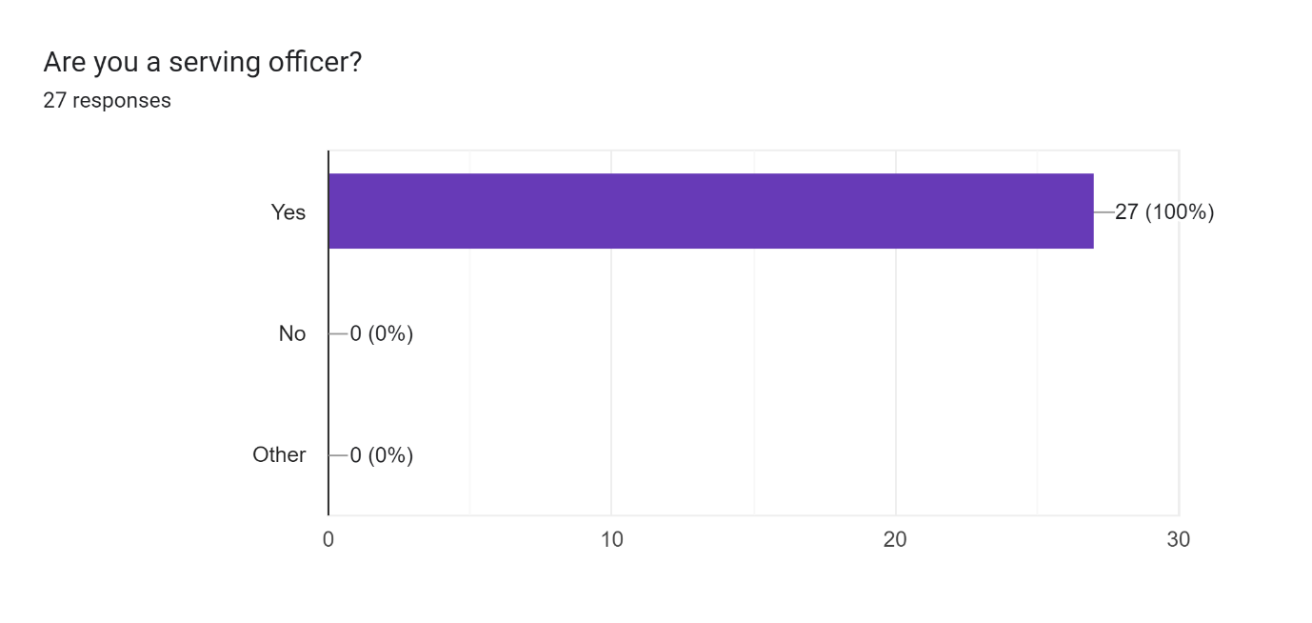

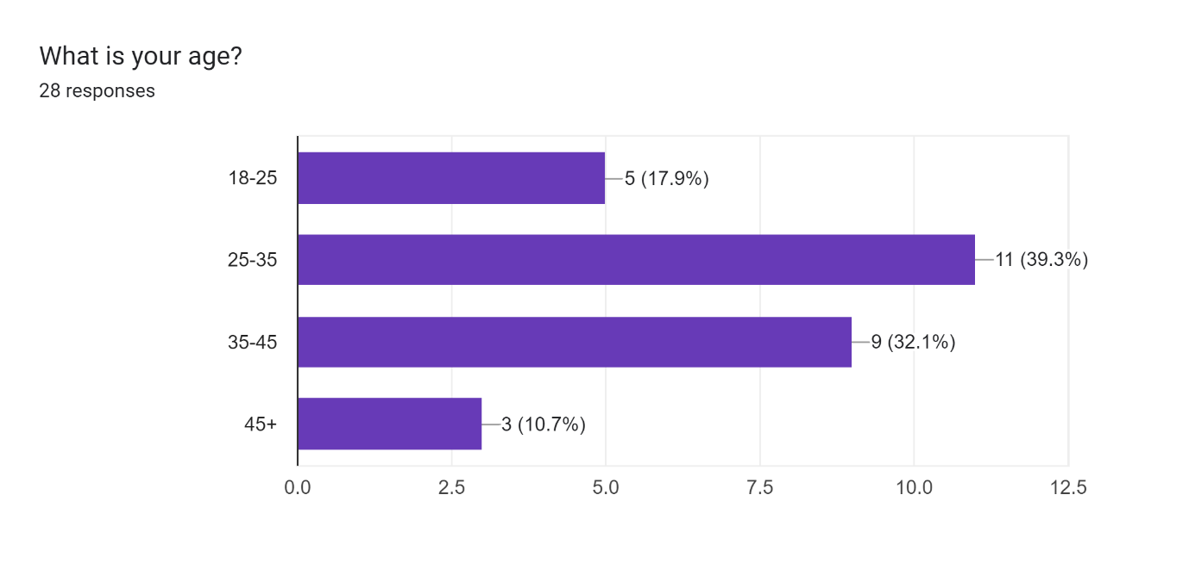
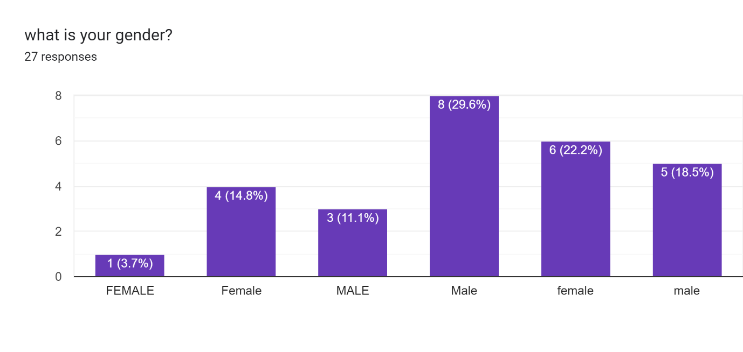
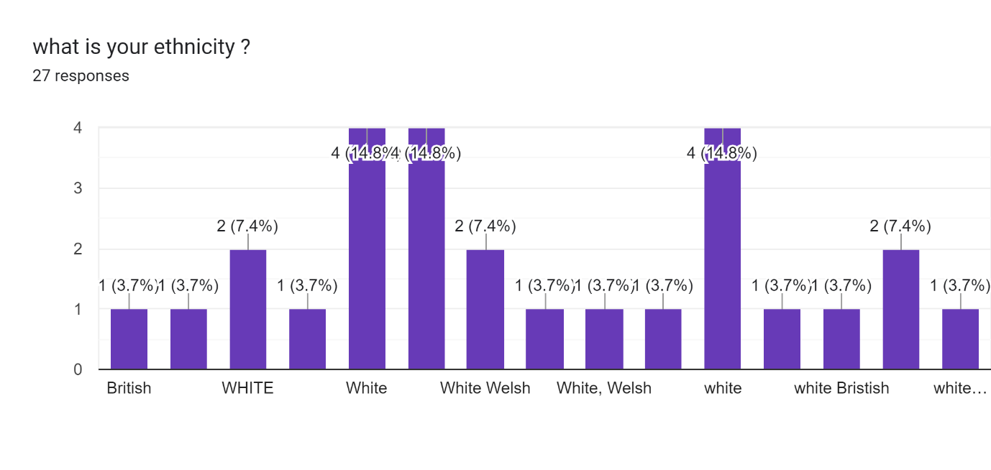
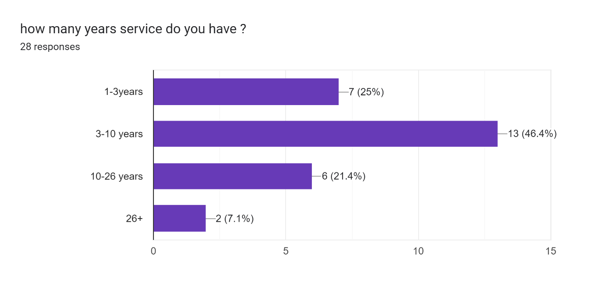
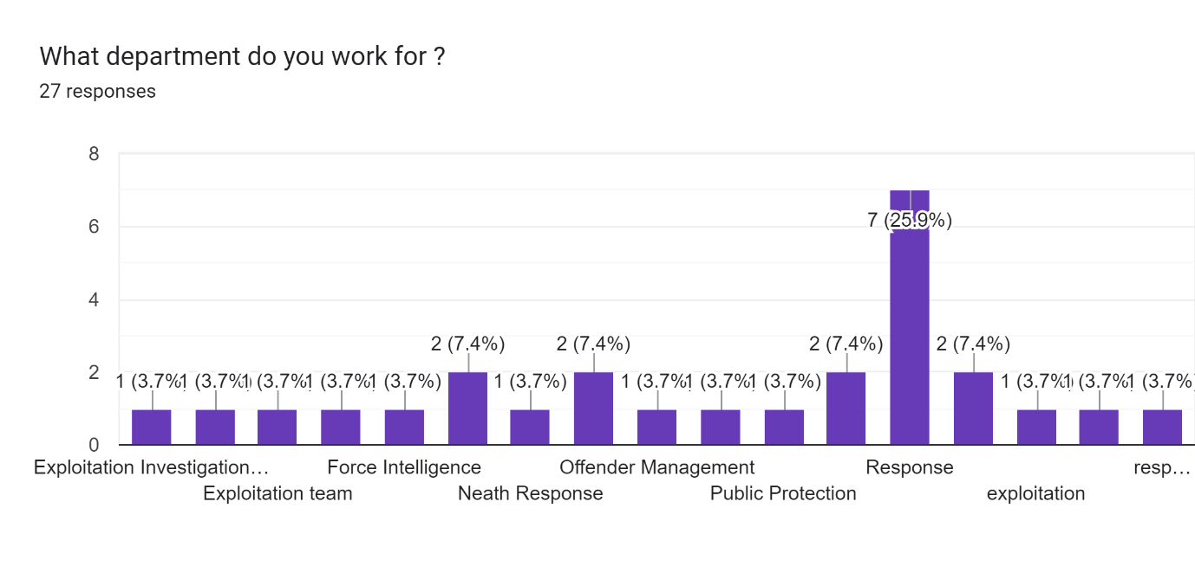
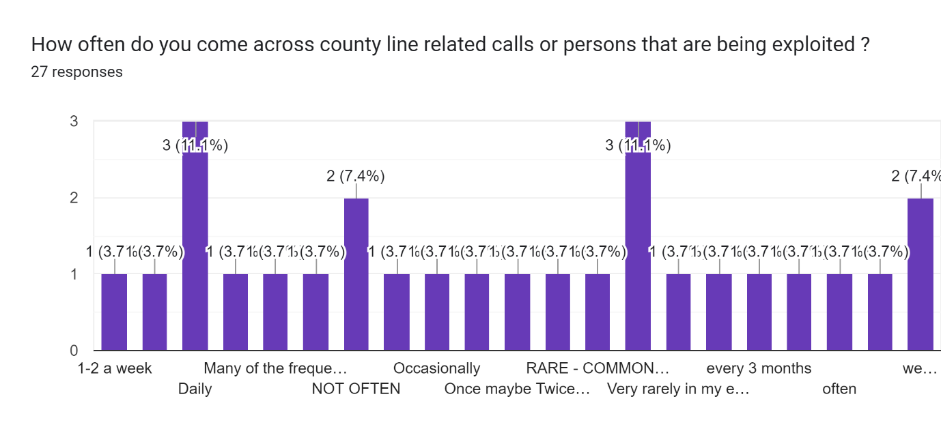
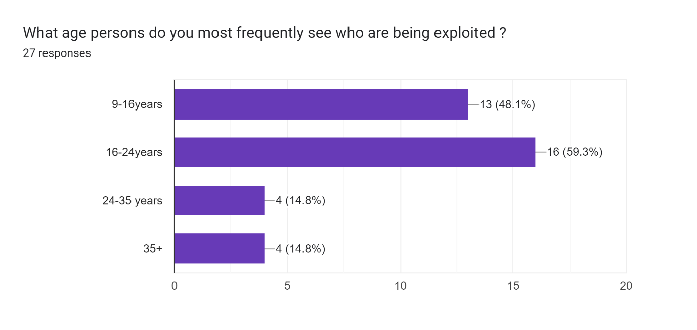

Q- Why do you think that younger children / young adults are easily exploited and how ?
A-
P1-These people are more susceptible to being sold the dream and not understanding the ramifications.
P2-Vulnerable
P3-Vulnerabilities and social media
P4-Children in the care system easily exploited as they can be exploited with some attention and afection that they do not get in the care settings
P5-YOUNG PEOPLE CRAVE ATTENTION, WANT TO BE PART OF A GROUP AND FEEL WANTED. SOCIAL MEDIA CREATES A FAKE REALITY FOR THEM
P6-YOUNGSTERS HAVE HAD A LOVELESS LONELY LIFE AND WANT TO FEEL LIKE THEY BELONG TO SOPMETHING AND FEEL WANTED. CRIMINALS EXPLOIT THIS
P7-Easily swayed by drugs, money and status
P8-Because they are more impressionable, vulnerable and they have a very different understanding of putting themselves at risk etc. I also have the opinion that when youre young you have no fear and dont understand or care about the life long implications drug dealing can land you in.
P9-Usually from less affluent backgrounds. The offer of money, a new bike or electric scooter or top brand clothing is too easy to resist
P10-Due to increased influenced within schools and young people thinking selling drugs is "cool".
P11-easier to manipulate
P12-Looking for friends/friendship group. Easily influenced. Many don't have strong family connections/good family background (Child Adverse Experience/wrong crowds etc).
P13-Usually this would be i believe would target those from that of a poor background, this then with the promise of money, drugs and other material.
P14-They are easily manipulated and coerced, often being groomed and "hooked" by some incentive e.g. drugs/ vapes. They are also often significantly threatened and thus very unlikely. reluctant to tell anyone what is happening to them. Sometimes they are chosen as they are less likely to be stopped by police but also if children are carrying/ dealing the drugs and/ or cash, this adds distance between the exploiters and the children (in terms of police action, etc).
P15-EMCOURAGABLE
P16-Yes as they are more vulnerable and easily influenced by others
P-17Lack of family support, money issues, addiction, lack of positive role models, not in education
P-18 Young people are seen as expendable with a reliance on the S45 defence as a 'get out of jail' card.
P-19Vulnerable given their age, easily led, not having sufficient support at home.
P20-Easily influenced by older persons who glamourize drugs/and material thing
P21-They are vulnerable due to their ages and very often drug addictions. They are also led by their peers. Very often their home life is not good with no adult supervision or support.
P22-generally the children that have been exploited, regardless of CCE CSE , it appears that the children are from broken homes, and or are from a deprived family. the subjects also target the more vulnerable that maybe mental / physical vulnerable, on certain situations they will befriend people who have been bullied providing them as sense of belonging.
P23-numerous reasons - ACEs, childhood expriences, trauma, friendship groups, lack of community resources such as clubs, activities, need for money and choice
P24-Promise of quick money, befriended by older persons when they may be loners
P25-Quick money whilst not truly outweighing the risks
P26-vulnerable due to low income families

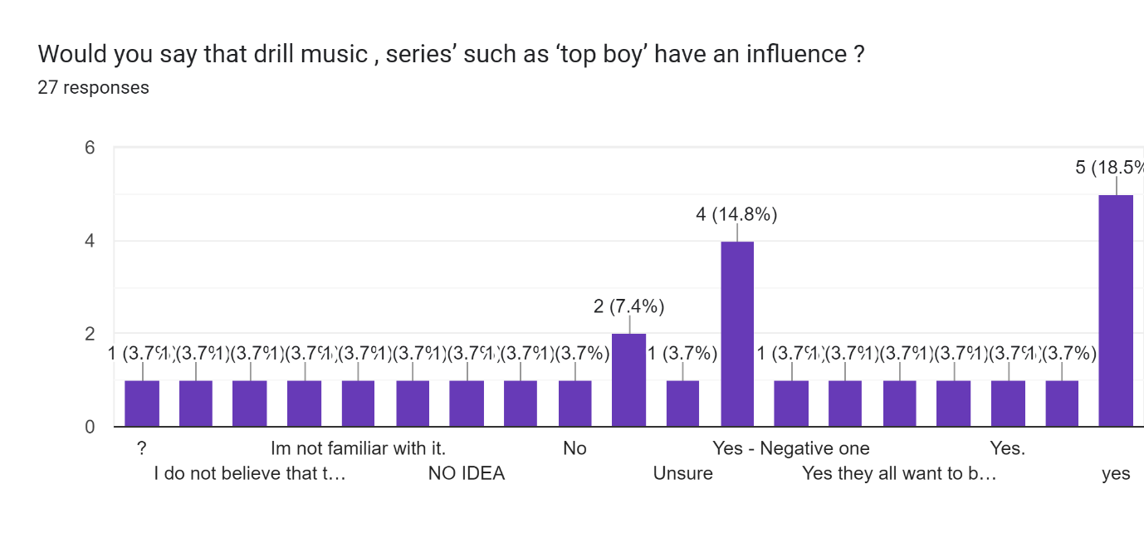

Q-Why would you say that drill music , series’ such as ‘top boy’ have an influence ?
A-
P1-N/A
P2-This sort of thing tries to paint a positive picture of a truly horrible issue.
P3-Unsure
P4-Children thinks it’s cool
P5-NO IDEA
P6-?
P7-yes - young people idolise these types of people and dont understand the successful people behind these music and tv shows are actually hard working tax payers (most)
P8-It sells Gang culture as a positive
P9-Glorifies the lifestyle of selling drugs and committing violent crime.
P10-No
P11-Never heard of this
P12-almost promotes and glamorises the life style
P13-yes, as young people rate this type of music and "gangster" representation highly.
P14-Unknown
P15-glamourizes it
P16-Encourages the behaviour, makes it look like you can be part of a group.
P17-The are a lot of people that are using the slang that was used in Top Boy aorund rugs etc.
P18-The drill music is very often associated with the gangster style drugs and gun culture.
P19-Youngster very often think this is exciting and cool as it can be glamourised, with the bling jewellery and fast high end cars in the music videos. However I think Top Boy portrayed the harsh reality of being involved in these gangs.
P20-the perception of of a affluent lifestyle
P21-yes
P22-Yes
P23-Making it look achievable
P24-Unknown

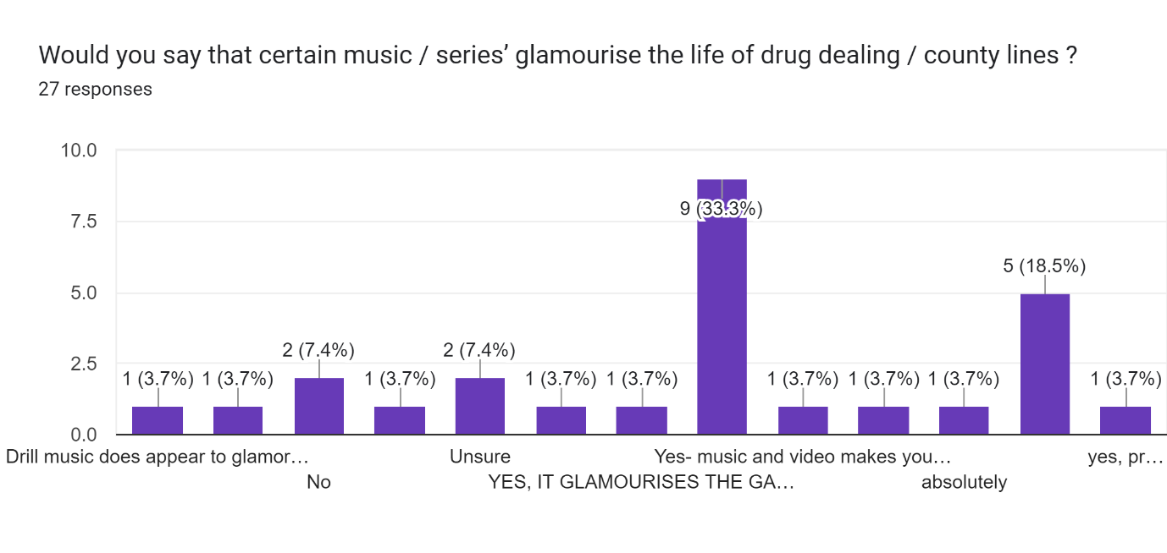

Q-Explain why you think that certain music / series’ glamourise the life of drug dealing / county lines?
A-
P1-They try to portray that this sort of behaviour will lead people to a life of riches.
P2-Children think it’s cool
P3-Shows the 'benefits' such as money and status
P4-PROMOTES A GANGSTER LIFESTYLE/ASPIRATION

P5-LYRICS ARE ABOUT 'GUNS, WHORES AND DRUGS'. LEAVING SCHOOL WITH NOTHING BUT ENDING WITH GIRLS AND GOLD JEWELRY ETC
P6-Because it is interesting to watch and stories of 'rags to riches' from the street.
P7-The whole point of the entertainment industry is to be entertaining and therefore is always going to glamorise things like this. These TV shows and Music videos wont show you the darkest and most disturbing side of county lines and drug dealing and even if they do it is never focused on.
P8-It tells the young person that there's money to be made from dealing. It tells them they can have all of the designer clothing they want and have the latest phones without working hard for it
P9-Young people think that drug dealing is cool and are easily influenced due to social media etc.
P10-Don;t know
P11-Make other think they look good. Listening to the music may give them good feelings (feel good music), something they enjoy.
P12-Because young people rate this type of music and "gangster" representation highly, and are impressionable, wishing to replicate.
P13-MAKES IT SEEM COOL AND WORTH DOING BUT NOT SUSTAINABLE
P14-Money, popularity, sense of belonging
P15-doesn't show reality, makes it look like you will get money, friends and status
P16-Drill music does appear to glamorise the lifestyle and advertise the potential gains.
P17-Don't watch the type of series so unknown.
P18-Youngster very often think this is exciting and cool as it can be glamourised, with the bling jewellery and fast high end cars in the music videos. They also get drawn into having extra money and cool friends.
P19-it is portrayed as being cool , and easy way of making lots of money
P20-the lifestyle
P21-Its the modern way for quick money and high status
P22-shows materialistic items funded by criminality

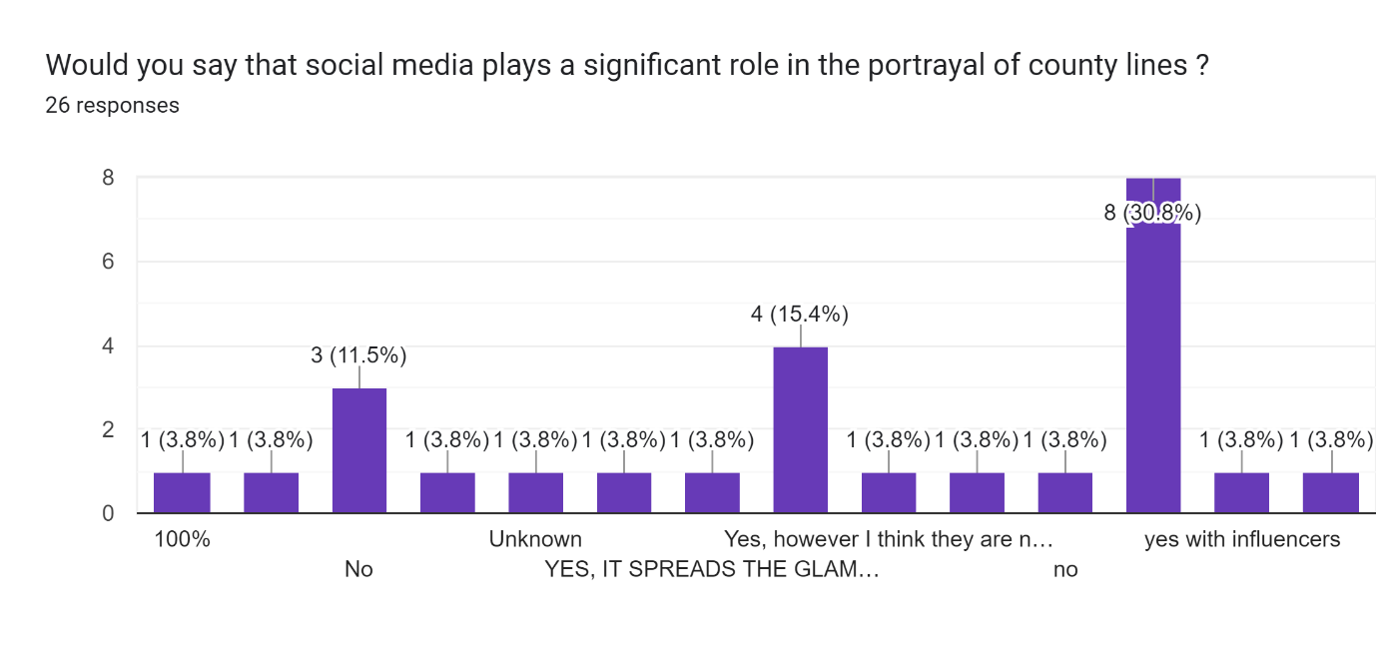
Q-Would you say that there is a rise in children/ young teens carrying knives , why do you think this ?
A-
P1-Yes
P2-Yes. I’m of the opinion that some youths consider it the norm and that’s it’s acceptable.
P3-Yes- trend
P4-More prevalent
P5-Yes, society deem it acceptable these days
P6-IT CREATES AN IMAGE THAT YOUR NOT TO BE MESSED WITH AND PEOPLE RESPECT YOU/SCARED OF YOU. COOL OR BAD REPUTATION
P7-STATUS AMONGST PEERS, INTIMIDATION AND SELF DEFENCE AS THEY THINK EVERYONE ELSE HAS KNIVES
P8-Yes. Because it is unknown what anyone is capable of
P9-Yes - statistics shows that there is a rise and in my experience I am now coming in to contact with youths with knives more often the longer I am on response
P10-Yes there is. They feel threatened by other young people who may be in a rival gang
P11-yes- rise in drug crimes= rise in young persons feeling the need to carry knives for "protection".
P12-Yes - for street credit
P13-Yes and No- Never witnessed this myself however its talked about on social media and the news so this heightens everyone's fears. As its spoken about people believe this to be the case, that it is happening when we don't know that to be the case. Exposure of these crimes on social media/ news increases the fear of crime- this all the effects the trust the public have in the police and young people.
P14-yes, for self-defence and a means to intimidate
P15-yes - partly relating to being exploited and the associated risks but also as a (misplaced and naive) way of keeping themselves safe/ protecting themselves safe.
P16-YES, BELIEVE THERE IS RISK/THREATS IF THEY DON'T
P17-Yes, due to drug culture, gangs
P18-yes - seen as norm
P19-Use of knives being seen in social media, seen a form of protection.
P20-Yes - To feel part of the gang. Sense of belonging and copying others.
P21-Wanting to be part of a gang culture and also for their own protection
P22-Yes there is definitely a rise in teens carrying knives. Gang culture has now increased within the SNPT area within the last few years. Possibly also the fact that we have more foreign persons (OCG), infiltrating the area with drugs. These persons who have come from a culture of carrying knives.
P23-persons are carrying more knives, as a result there are more knife crime
P24-yes - again down to social influences, friends, family, media
P25-Yes
P26-yes, easily influenced

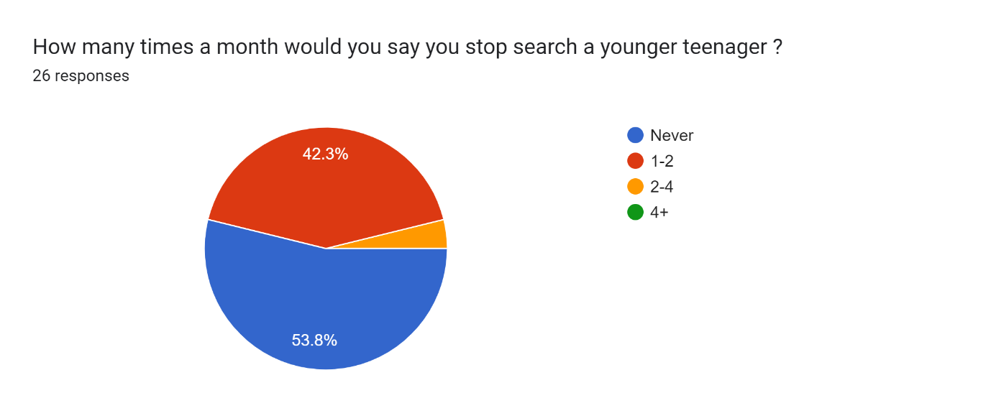

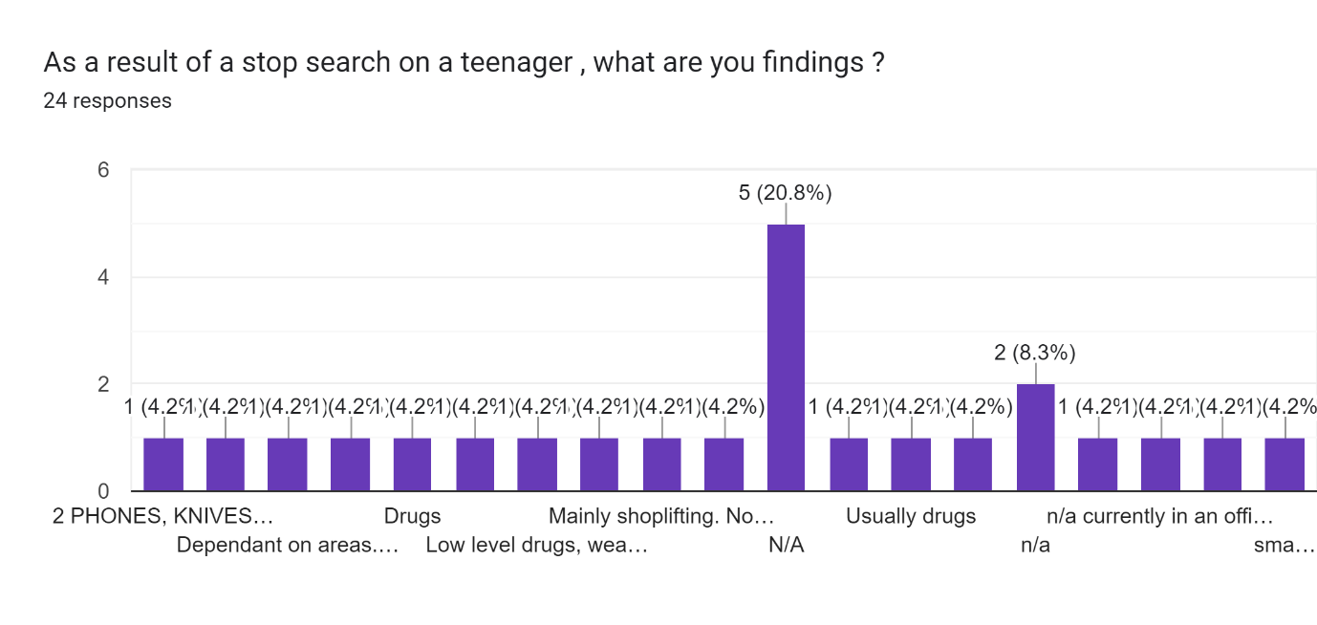
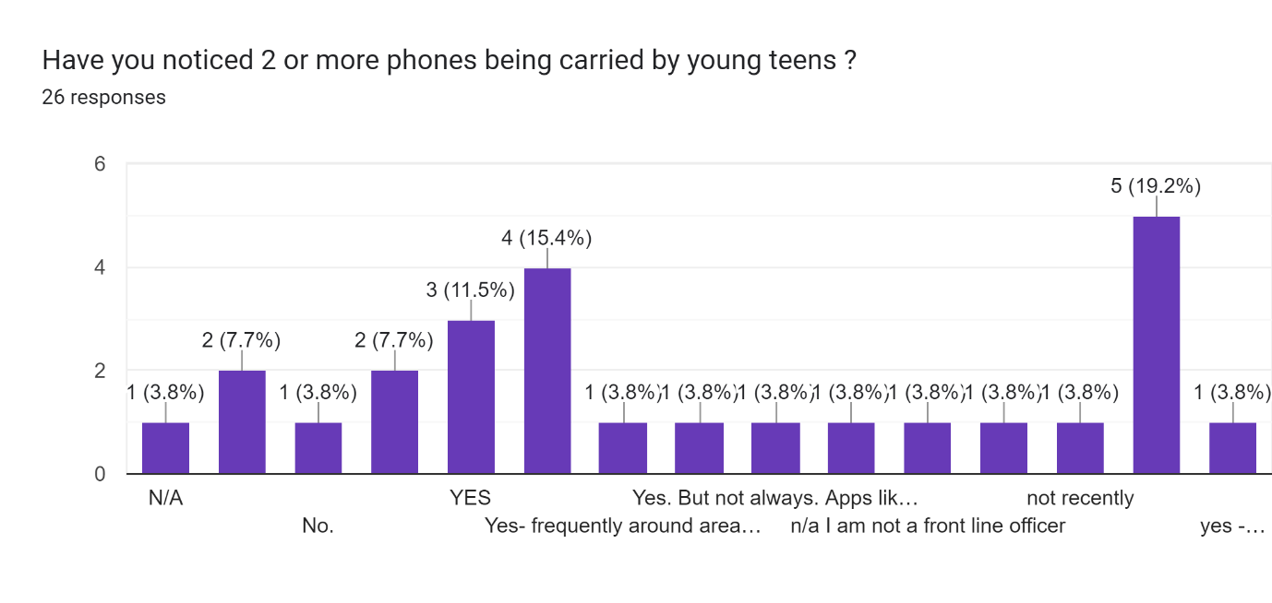
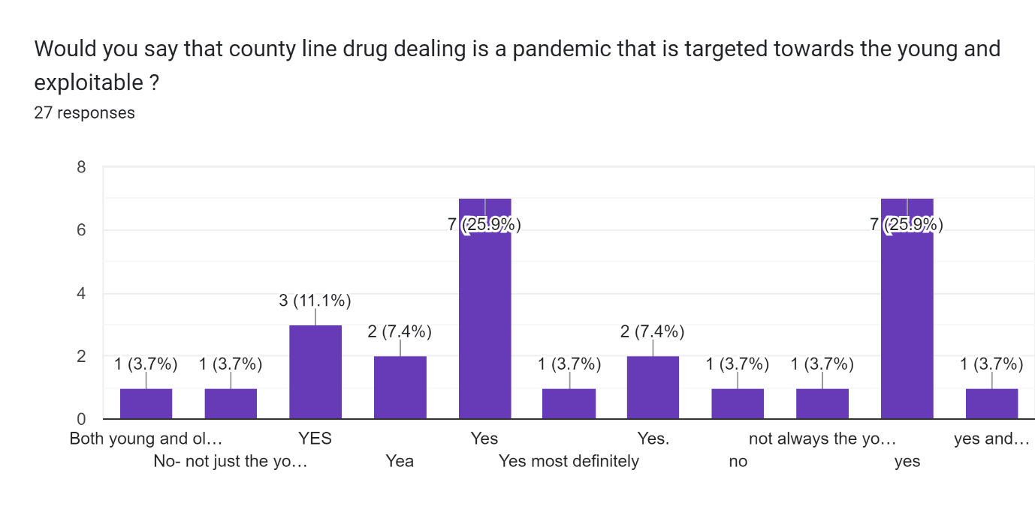
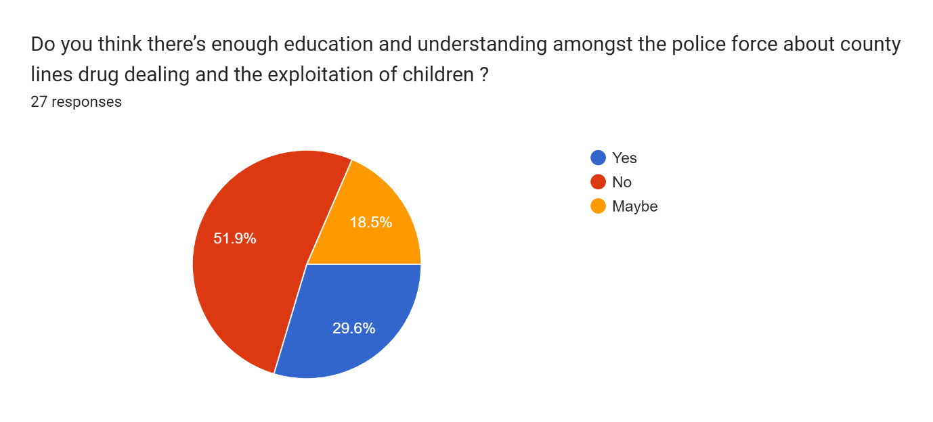

Q-Do you believe there is adequate training available ? If not - why ? What do you suggest needs to be taught ?
A-
P1-yes
P2-Yes
P3-No - children need to be advised on the dangers
P4-Training is very generic and should have more real life examples
P5-NPT TEAMS SHOULD BE MORE EDUCATED AS THEY ARE ON THE GROUND MORE.
P6-NPT - AS THEY SPEND MORE TIME ON THE GROUND. APPROPRIASTE FORMS/REFERALS
P7-Im not familiar with enough information about what to look out for.
P8-SWP arent the most exposed police force to County lines and therefore I dont think the issue is big enough to warrant the extent of training that is needed however there is a massive culture and rules surrounding county lines that SWP officers simply would not be aware of unless they have had experience with YP's that have been involved in CL's
P9-Yes. I believe there needs to be more of a focus teaching young children the actual risks involved.
P10-YES
P11-specialist officers are provided with adequate training but more front-facing officers dfo not appear to be so - which is where there should be better training as officers need to know the significance of what they are hearing and seeking whilst undertaking their roles, in order to identify concerns re exploitation at an earlier stage and signpost/ refer.
P12-NOT ADEQUATE
P13-This is improving but it is difficult to reach everyone and to deliver at an appropriate level for different departments.
P14-Yes
P15-Possibly more inputs around county lines with response and front line officers
P16-I think there should be regular in puts from specialist teams that are dealing with the drugs and exploitation on a daily basis - OCT and PPU
P17-no
P18- more recognition and knowledge of support
P19-No. What police should be looking for and what ways we have to dissuade someone rather than ppn’s
P20-Yes training is sufficient

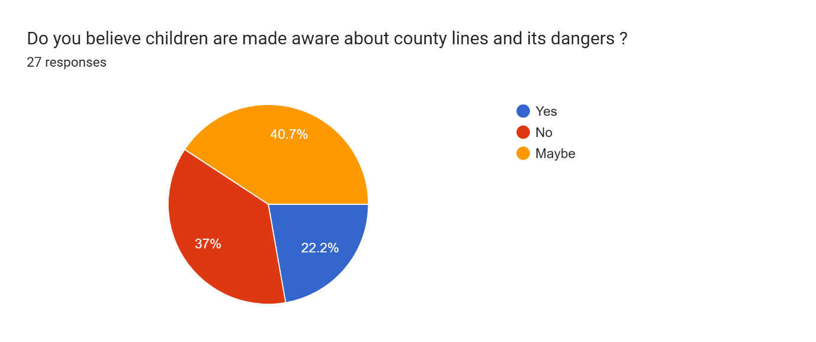

Q-As an officer ; how would you identify and prevent the exploitation of children ?
A-
P1-Proper education of both children and parents. More robust prosecution and imprisonment of those responsible.
P2-Warning signs like money etc, further learning in schools
P3-I am an experienced front line officer and know the signs such as money clothes electronics, P4-withdrawel from family, regular talks given to schools and care homes
P5-2 PHONES, HANGING AROUND WITH OLDER MALES
P6-PREVENTION AT A YOUNG AGE, BEFORE THEY ARE GROOMED
P7-Having items beyond their means of affording
P8-Identify - through the use of intell, stop search and targeted patrols Prevent - more talks in school from a multi agency approach
P9-Child from a less affluent background who has the latest phone or new electric scooter. Normally out late at night and hanging around in areas a distance away from home. The way to prevent is to challenge the child's behaviour with parents or to target the child if there is a belief that they are being used. By doing this Social Services and YOT get involved in Diversionary Tactics
P10-Community policing.
P11-Multiple phones, designer clothing on persons who would not typically be able to afford them
P12-Through a police report- visiting and speaking to parents/guardians/school teachers. All would have to work together to ensure the child is safeguarded and child is given appropriate information regarding the concerns/issues.
P13-At this time, there is no real way for response officers to identify exploitation of children. Unless they are a regular and notice that they are wearing brand new brands/clothing.
P14-being professionally curious and ask questions of any children and their parent/ guardian/ carers (as well as any professionals already involved) in order to build up a picture of any ongoing exploitation (or risk of). should any indicators of risk be apparent, share this information with relevant partners for multi-agency work to be undertaken to reduce the risks of/ prevent child exploitation.
P15-By engaging with them, being a visible presence in neighbourhoods
P16-signs to look out for - unexplained wealth, injuries, missing episodes
P17-Link in with partners, review intelligence
P18-Educate parents. To take more interest, take responsibility for their children.
P19-Referral into social services for work to be done
P20-Identify, could be through associations they are keeping, extra money, specific intelligence, engage with the child or their carers, make referrals for support and education
P21-money, new clothes, trainers, phones, associations, missing episodes
P22-from knowledge, information and talking to the person
P23-Children bank accounts, flash clothing. Where does it come from when they come from deprived areaa
P24-look for key signs and engage with the child adopting a multiagency approach

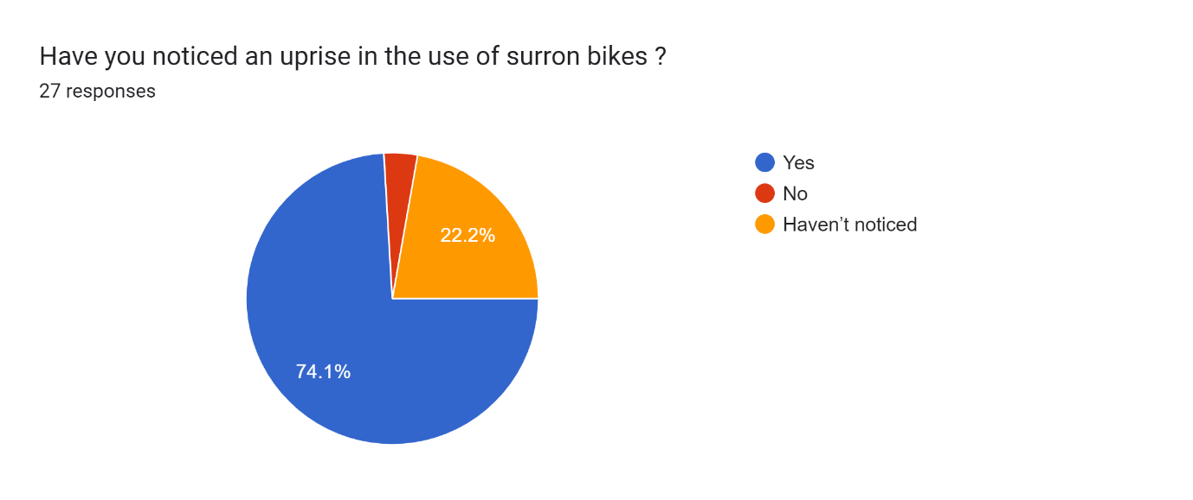

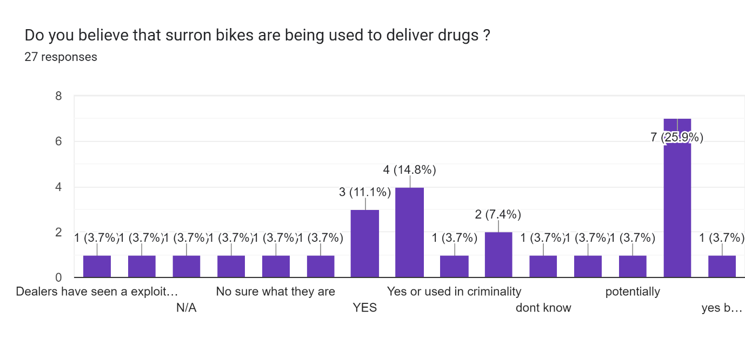
Q-Why do you believe that surron bikes are being used to deliver drugs ?
A-
P1-N/A
P2-Yes.
P3-Unsure
P4-Easy transport and cheap
P5-ALWAYS MAKING OFF UPON SEEING OFFICERS
P6-FAILING TO STOP FOR OFFICERS
P7-Because they are agile, quick and hard to catch
P8-Because they're fast, light, don't need refuelling at petrol stations so there is not trace/CCTV and the youths know that police can chase them
P9-speed and the fact we won't pursue if they have no helmets on. Surron riders normally use a balaclava only when riding
P10-Frequently seen riding Surrons and wearing balaclavas for ease of transportation and lack of consequences.
P11-dont know
P12-Never heard of this
P13-off-road capabilities so a means to avoid ANPR
P14-not familiar with the term Surron bike - bikes because they are a "normal mode of transport than may go unnoticed but also provide the riders with an easier and quicker "get away"
P15-FIRST HAND EXPERIENCE
P16-Because they are accessible, quick, can go on the road, or pavements, through parks etc...
P17-probably
P18-People are aware of the restrictions on polices ability to stop / intercept such bikes, and they are able to avoid being detained by making off at speed through lanes, bollards, etc
P19-Not sure what they are
P20-they are cheap, quick and able to evade officers.
P21-policy dictates we cannot pursue - public know this making it difficult to capture
Polices hands are tied after Ely and the backlash from this, no ability to safely stop
P22-See above
P23-Police are very limited in what they can do to stop this activity

Q-What do you think is needed in order to target the exploitation of young people ?
A-
P1-While those being exploited need to be supported. The only real way to truly protect them is to deal with the exploiters.
P2-Youth clubs - partnership with schools and parents
P3-Further education
P4-Education
P5-ADDRESS THE VULNERABILITIES, CONTANTLY GOING MISSING FROM CARE HOMES AND THEN UNSUPERVISED AND OPEN TO GROOMING
P6-HARD LINE
P7-Money community engagement
P8-Too much to name here, education is reflective practice is the only thing I can think of the summarise. Maybe trips to prison to meet with these CL/Gang children that they identify
P9-Tougher sentences and utilising the Modern Slavery Act in a better way to prosecute those using children to peddle their drugs
P10-Large scale operations dealing with anti social bike riding/ E-scooters etc around towns and cities. Education within schools at a younger age.
P11-more police
P12-More intervention on Social Media. Young children spend more time of their phones. Cyber Crime Department to identify any risk and early intervention.
P13-the creation of a specific unit that deals exclusively with the exploitation of young children and county line s
P14-Awareness amongst all professionals and parents/ carers of children of the signs to look out for, encouraging prompt referrals and information sharing. Also an increased awareness of P15-what to do with such information i.e. directly report to the police and/or social services and/or prevention support services. In addition to a greater recognition accross the general public of child exploitation.
P16-SUPPORT GUIDANCE AND HELP
P17-Greater community engagement
P18-don't understand the question
P19-More focus on those exploiting young people and ensuring that those responsible receive more significant sentencing and that these sentences are advertised as a deterrent. The risk has to be seen to outweigh the reward
P20-Better parenting.
P21-More input in schools
P22-more training, education and more officers and support for the young people.
P23-education, more collaborative work
P24-adequate sentences
P25-Allowing police officers to police and not fear immediate consequences from top officers
P26-education

Q-Do you believe the criminal justice response is proportionate? If not - why?
A-
P1-No. More robust ramifications are required.
P2-No - does not prosecute
P3-Should be harsher sentences for exploitation
P4-NO, TOO LENIENT, NO DETERENT
P5-NO, TOO LENIENT
P6-No, more often than not, the sentence is not proportionate to the crime.
P7-Not at all - certain offences shouldn't get the leniency that other offences get however this is my opinion. The most common example that I cant help but agree with is that things like Child sexual offences should not be getting lighter sentences that drug offences.
P8-Sentencing is weak
P9-Young persons are not treated with severe enough repercussions and are often dismissed as criminals, which is the reason they are exploited as they face no consequences.
P10-no - those involved do not get prosecuted correctly
P11-Unknown what response they have so unable to comment
P12-Unknown
P13-it is improving - in relevant cases, children are now identified as victims of exploitation as opposed to offenders.
P14-NO - DOESN'T SHOW THE DANGERS OF IT
P15-No, sentences are too lenient, not a deterrent enough. Lack of social care / support for young people
P16-yes
P17-Yes
P18-Yes.
P19-Yes as we are trying to deal with the persons as victims
P20-maybe
P21-sometimes
P22-no
P23-Yes. Too many chances are given again and again for violent and repeat young offenders
P24-no - too lenient

Q-Do you believe these teens need criminalising or safeguarding and why ?
A-
P1-If a person has capacity and has committed a crime, there is no excuse. They should be dealt with robustly.
P2-Safeguarding- vulnerable
P3-Criminalising as they think they can get away with it
P4-Safeguarding, they are children that have been exploited
P5-SAFEGUARDING TO AN EXTEND, THEN ONCE PASSED A POINT THEN PUNISHED CRIMINALLY
P6-SAFEGUARDING UNTIL IT IS APPARENT THEY HAVE BEEN TURNED TO THAT LIFESTYLE
P7-That all depends on circumstance and the individual
P8-Both - not all teens are the same and therefore should not be treated as such - it depends on their actions, intentions and harm caused to others.
P9-It depends on circumstances. Some young people are repeat offenders. Safeguarding has been tried and failed. If they repeatedly get involved, criminalising may be the only way to stop them
P10-Safeguarding and education should be a priority when dealing with young people. More so, early detection and prevention before they become immersed in to the life style.
P11-criminalising. In a lot of cases it is the only way to safeguard them
P12-Safeguarding/ early intervention and educated regarding the concerns/issues. Put a stop to their behaviour and prevent them going down the wrong road which could effect their futures.safeguarding, they are still in the early stage of life where they can turn things around given the right support
P13-Safeguarding as they are children who have been groomed, targeted, coerced, manipulated to commit crime and very often left with no choice. It is the adults linked to such exploitation who should be dealt with criminally.
P14-BOTH, CAN BE ENCOURAGED AND ADVISED TO DO BETTER
P15-Safeguarding, as they are easily influenced.
P16-safeguardiong if exploited
P17-I believe that there needs top be a criminal deterrent even if in the form community orders. But there needs to be a multi agency safeguarding response to prevent debt bondage and other issues linked to CL drugs supply.
P18-Depends on the circumstances. Firs time offence? Previous offending. Previous contact with police around similar incident. Age.
P19-No they should be safeguarded and more education is needed
P20-safeguarding will always come first, they must be given a chance to rectify their behaviour. However if they do not or choose not to use the help offered to them some form of formal rehabilitation needs to take place
P21-both depending on severity and how many times been in position
P22-both depending on circumstances
P23-Safeguarding first then criminalising them and forcing them to engage with services
P24-depending on the circumstances

Q-Do you think these young teens are being exploited or looking to commit crime for personal gain ? Please explain your reasons
A-
P1-Difficult to answer. However personally I’d be leaning towards believing the greater majority (especially of those I have dealt with) do so for personal gain and social standing.
P2-Quite possibly
P3-Yes and no
P4-EXPLOITED FOR THEIR VULNEARBILITY. NEED FOR BELONGING AND TO FEEL WANTED/NEEDED BY SOMEONE. USUALLY FROM THE CARE SYSTEM OF POOR PARENTING BACKGROUND, SO EASY PREY
P5-EXPLOITED AND TO BUILD THEIR REPUTATION AND FEEL POWERFUL
P6-Both, no job pays better than crime. There is no incentive for hard work on menial jobs
P7-Yes - The whole "designer" clothing culture now has gotten ridiculous and quite frankly pathetic. You have children walking around in clothing that costs more than their parents monthly mortgage payments and to make matters worse you have parents supporting this by buying them single items of clothing that cost over £1K each. This is only adding to the culture that young teens are idolising these brands of clothing not knowing the hard work that would have to go in to earning £1k and instead it is too easy to earn £1k from one night of drug dealing, becoming a drugs mule, running CL's or being exploited without them realising it as they are being gifted things like designer clothing, phones or adult commodities.
P8-Yes to an extent. Like every child they will want the latest phone and the latest fashion. If parents can't afford them, the child will look for a way to obtain what they want
Initially no, however I believe some young persons come to enjoy the lifestyle. Lavish goods, money etc.
P9-Both - some are exploitable while others see the opportunities to obtain nice things
P10-Not always. I don't believe they understand exactly what they are doing and have no understanding of the consequences of their actions. Criminally or their own personal safety.
P11-i believe it is due to the fact of boredom as alot of areas where these types of incidents ahappen there is not much in the way of afterschool clubs and entertainment
P12-Exploited - as above
P13-UNKNOWN
P14-Yes, for financial gain, peer support
P15-yes
P16-I think this will change on circumstances and both can be seen in South Wales communities
P17-Likely a majority are being exploited, however they are given numerous opportunities to engage with services and many don't. When this occurs they will need to be criminalised. Young people likely doing it for personal gain, but again this is likely because they are from deprived/uneducated background.
P18-Yes as the young persons are the ones who left to face the consequences and not the persons further up the chain.
P19-Both, I think they initially get involved for personal gain but once involved don't realise how quickly they become exploited by the gang leaders.
P20-yes
P21-yes, money/power and friendship groups they may not have
P22-Personal gain believe that they know more than the dealers
P23-Unknown
P24-yes, they are looking to achieve status

