Name: Morgan McGowan-Boswell
Student Number: 2203790
Module Number: ECGE4005Q
Title: The struggles & challenges men identifying as queer face in today’s society

This essay will define the struggles men who identify as queer face in today’s society, exploring examples of methods and government legislation used to tackle discrimination within a workplace environment. Men across the globe who identify with the LGBTQ community have/are facing discrimination in various structures within society, i.e. working environments. The general focus of this essay will target gay/bisexual men living and working in the United Kingdom. The Equality Act 2010 (Equality Act 2010, Part 2 and Chapter 1: Section 12) is a lawful deterrent against bias based on an individual’s protected characteristics. While the laws put in place do aim to control and minimise bias, it can also be argued that these same laws cannot govern how people think, feel and act about sexuality. The norms and values different groups across the United Kingdom live by greatly impact how we as a society view homosexuality and the labels we apply to individuals identifying within the queer community. The national statistics, government legislation & examples of individual personal experiences explored in this essay aim to highlight equality issues and the methods that could make this a prioritisable public issue. Research-influenced suggestions that could possibly impact how society can adapt to the pessimistic views behind homosexuality moving forward will also be argued.
Homosexuality is not just a name society has given to identify different sexualities within the LGBTQ community. To openly label yourself as ‘gay’ or demonstrate ‘gay acts’ is to provide the incentive and opportunity to determine your social status. The different groups and sub-groups within the LGBTQ community, such as lesbians, bisexuals, pansexuals, asexuals and transgender people, all face various forms of discrimination and a lack of acceptance. Stonewall (2018) surveyed 5,000 people across England, Scotland & Wales who identified with the LGBTQ community. The purpose of the survey was to gain insight into the lives/experiences of LGBTQ people in the UK. The results revealed that almost two in five (38 per cent) of the 3,213 employed respondents who identified as bisexual have not come out about their sexual orientation. Of that 38 per cent, 49 per cent were male, identifying as bisexual, and 7 per cent were male, identifying as gay. The survey also allowed respondents to provide details of their experience, one respondent detailing that ‘I hid my gender/sexual identity entirely, presenting myself fully in my assigned birth gender, knowing I could easily jeopardise my job prospects if I didn’t. While the results of this survey show that anxiety about one’s sexuality is common enough to make this a public issue, it can also be argued that the quantitative and qualitative data collected from this survey isn’t enough to understand the full depth of discrimination at a workplace environment based on one’s sexuality. There are over 60 million people in the UK, and a survey for 5,000 people with 3,213 respondents could lack a high enough number of respondents to conclude the experiences of men identifying as bi/gay face at work.
Aksoy et al. (2019) argue that the 2009-2014 integrated household survey data suggests that gay men are more likely to advance into managerial positions at work. However, with this advancement, it was also suggested that a ‘gay glass ceiling effect’ prohibits gay men from reaching high-level managerial positions. This essentially means that the climb up the managerial ladder ends at ‘low-level’ management positions for gay men. Further analysis of this article reveals the possibility of sub-discrimination, which is discrimination within itself, showing that gay men who were also classed as racial minorities were less likely to reach a low-level management position than their Caucasian colleagues. It could be argued that not only does the ‘gay glass ceiling effect’ exist, but the targeted group affected by this also faces a secondary glass ceiling, which affects those considered to be racial minorities. Though it wasn’t considered statistically significant, results also showed that bisexual men were less likely to reach any form of authority within the workplace. Considering that gay men already face a ‘gay glass ceiling effect’ with the additional argument that gay men of colour are affected, even more, it could be suggested that bisexual men of colour face the strongest struggles for managerial positions. The research on bisexual men and women was deemed not always statistically significant, restricting an accurate conclusion about bisexual men’s experience at work based on this article.
The national LGBT survey (2018) was created and endorsed by the ‘Government’s Equality Office’. The aim was to understand the LGBT experience in the UK. With 108,100 respondents, they made arguable conclusions on the experiences of many people identifying with the LGBT community. Results from the published data show that the average life satisfaction rate in the UK on a scale of 1-10 for LGBT members was 7.7, and gay men/lesbians, on average, had a 6.9 satisfaction rate. While the purpose of this survey was to gain insight into the experiences of LGBT people at work, at home and in education, it can be argued that the study lacks validity. For example, respondents were asked which part of the UK they lived in, with ten options to select from. Some respondents may not understand the wording of the options, i.e. not knowing your city’s geographical placement. The lack of specific options for city residency could also affect the authenticity of the results. The UK isn’t just divided by compass directions. Many cities share and don’t share the same norms and values. Even concepts such as ‘the great north-south divide (the divide between the North of England and the south) can impact generalised results. For results to be as fruitful as possible, a high and balanced amount of quantitative & qualitative data is needed. Having a survey that covers a variety of factors could prove to be more effective; factors such as class, race, religion, and age, with the addition of giving respondents the option to name their city rather than their cities placement, could also enlighten government officials of which parts of the UK specifically are affected and why. The survey also grouped respondents’ sexualities, condensing the National LGBT Survey (2018) summary report results.

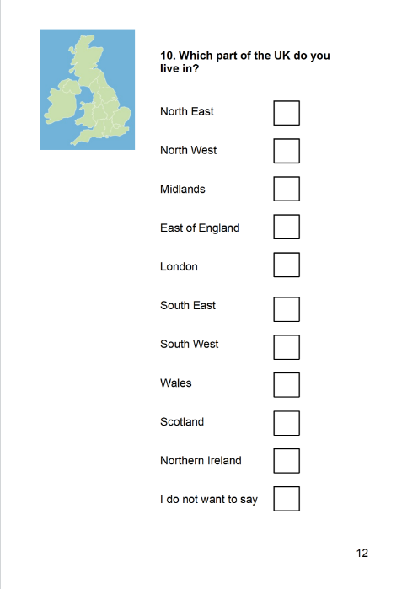

Image 2: How do you feel about being an LGBT person living in the UK?
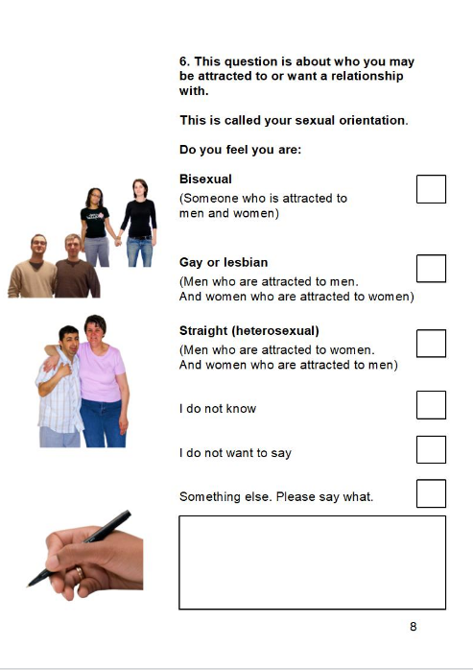

LGBT Survey (2018)

LGBT Survey (2018)

The equality act 2010 (Equality act 2010, Part 2 and chapter 1: section 12) was enforced to defend people with protected characteristics (Discrimination against an individual based on age, gender, sexual orientation, race, disability, religion, ethnicity and disability) from discrimination/bias. Since the act was enforced, many employers, fellow staff members even clients/customers have been deterred from discriminating against LGBTQ individuals for their sexual orientation. However, one could argue that even with an act of parliament designed to clamp down on discrimination, its usefulness may not be as effective as intended. An argument could be made that society is governed by norms and values just as much as the law with the addition of religion, primary & secondary socialisation etc. When looking at the impact of these and other factors, it is arguable that discrimination within the workplace cannot be fully controlled/stopped via one act of parliament.
An argument can also be made that to fully understand the struggles men of the LGBTQ community face at work, a deeper understanding of the struggles faced outside the workplace is essential. The national government LGBT survey details how transgender people were twice as likely to be offered conversion therapy (methods of reversing one’s sexuality to heterosexual) than their gay/bisexual counterparts. Since 2018 the media has reported the government’s U-turn’s on the matter of conversion therapy. The conservative party led by Theresa May 2018 had announced plans to ban conversion therapy, Boris Johnson 2020 reinforced plans to bring forth the ban. The queen also contributed to the idea that conversion therapy should and will be banned, but Liz trust (most former recent prime minister) was quoted stating the ban would only come into force with more views from the public and critical stakeholders. The variation, or rather the impact of the opinions of the former and previous prime ministers on the topics of the LGBTQ community, suggests that the government isn’t as serious about banning conversion therapy as it seems. Laws can be considered key factors in socialisation as they are essentially a guidebook to definite between right and wrong. When looking at working environments, socialisation plays a big part. An argument that we as a society are governed by what we think and feel just as much as the law can be made to suggest that government views on sexuality can impact any working environment. If the government cannot produce a legislation to ban conversion therapy that covers and protects all LGBT members, how are employers expected to do the same? BBC (2022)
The variety of views and national statistics give the opportunity to argue that the government needs reform on the topic of sexuality in particular gay and bisexual men. The article exploring ‘the gay glass ceiling effect’ provides enough substantial data to suggest gay/bisexual men face struggles across the country not only making this a public issue but an example of how labels applied to individuals based on their protected characteristics can affect employability but also the opportunity to advance up the managerial ladder in any working environment. The struggles gay/bisexual men face at work are not only considered to be linked to external struggles but also a demonstration that creative and effective change is required. A survey with respondents ranging from all ages, ethnicities and class backgrounds with the addition of multiple open questions handed out across the whole UK could possibly prove to be fruitful in both its qualitative and quantitative results. The variety of respondent’s characteristics would allow the government and public to personally gain an insight into the experience men who identify as gay/bisexual are facing in today’s society. Only when private issues become public issues that the plans for change are enforced. With the evidence within this essay, it is arguable to say that until the ideology behind the aspects of men’s sexuality has been altered then acceptance and change cannot be brought forth into modern-day society.

Reference List:
Aksoy C, Carpenter C, Frank J, Huffman M. (2019) ‘Journal of Economic Behaviour and Organization’, Gay Glass Ceilings: Sexual Orientation and Workplace Authority in the UK, 26(1), pp. 167-180
BBC (2022) Conversion Therapy. Available At: Conversion therapy: Ban to go ahead but not cover trans people - BBC News (Accessed: 06 November 2022)
National LGBT survey (2017) Easy Read Version. Available at: https://assets.publishing.service.gov.uk/government/uploads/system/uploads/attachment_data/file/646837/2017-09-19_-_LGBT_survey_easy_read.docx (Accessed: 18 October 2022)
National LGBT Survey (2018) Summary report. Available at: National LGBT Survey: Summary report (publishing.service.gov.uk) (Accessed: 18 October 2022).
National LGBT survey images: how do you feel about being an LGBT person in the UK? [online]. Available at: 2017-09-19_-_LGBT_survey_easy_read.docx (live.com) (Accessed 06 November 2022).
Stonewall (2018) LGBT In Britain: Work Report. Available at: lgbt_in_britain_work_report.pdf (stonewall.org.uk) (Accessed: 03 November 2022).
The Equality Act (2010). Available at: Equality Act 2010 (legislation.gov.uk) (Accessed: 18 October 2022)

