Marcus Thomas
Student No- 1905296
BMSK4003

Content Page
- Introduction
- Business Proposition
- My Competitors
- How my business will be operating
- Legal matters
- How I will reach my customers
- What needed to get your business up and running
- What is success for my business
- Coronavirus trading safe
10.Funding (Capital to start up business)
11. Cash Flow
12. Health and safety
13 Conclusion
14. References

Introduction

This essay is about me doing my own business plan. I have named my company T/Tronics ltd. I chose to use my hobby which I am repairing smartphone, PC tablet in my spare time. I have researched the market, finding premises, doing my cashflow stock, etc. I have identified my competitors in the industry and more. In next chapter I will explain more about my business plan.

Business Proposition:

My mission is to provide an easy to use, friendly service. I provide a high quality, rapid repair service for mobile phones, PCs, tablets and other electronic devices at low prices. I also offer refurbishment of electronic devices including changing keypads, housings (cases) and updating/upgrading software. I also sell a range of refurbished and new electronic products.
I offer all aspects of mobile phone, PC and tablet hardware repair including screens, casing, motherboards, camera’s and charging port replacement.
All repairs come with the option of choosing a different screen and housing color of your choice at a vastly discounted price.
Water damaged repair, battery replacement, faulty hardware replacement for example loudspeaker, camera, refurbishing your used mobile phones/PC tablets to new.
Payments will be taken using credit/debit cards, PayPal and postal orders. I will also offer 30-day invoice terms for sub-contracted work obtained.
I promise to:
A) Offer all customers low prices.
B) Deliver goods to our customers all over the UK with speed and precision.
E) Ensure the excellent quality of our products repair service is 100%
F) No fixed no fee on all repairs

My Competitor
Imend
Mobile/Pc tablets repairs

Quick mobile fix.com
refurbished stock, mobile phone repairs

Phone Matters
Good and Competitive prices for Quality repairs and accessories for mobile phones, Tablets and laptops

I will be competing with my competitor by targeting their Prices, quality of work, delivery service, time spent on repairing item and sending back to customers that's their strengths
What is your competitor doing right why customer keep going to them?
Fast friendly free service, Quick and efficient. 5 stars
Excellent in speed, quality of repair,
Good prices on refurbished stock.
polite friendly service. good prices, quality finished work.
What ideas do you have in place that would make your competitor customer come to you for their repair’s?
Low prices/, on repairs save each costumer £5-£10,
low prices on refurbished, next day
keeping low cost prices, on repairs and mobile phones, PC tablet repairs. quicker service. friendly helpful service
How do you plan on maintaining your strategies you have against your competitor?

Keep on top of every category mention above (1) Next day delivery
Keep Prices low
Keeping to booked times for repairs carried out at workplaces or homes,
Make sure every item is fully diagnosed and tested before dispatch on refurbished Goods. Giving the customer full confidence on buying are products
Friendly customer service
Checking all repairs
Dealing with complaints quick as possible not leaving customer waiting

How do you plan on maintaining your strategies you have against your competitor?

Keep on top of every category mention above (1) Next day delivery
Keep Prices low
Keeping to booked times for repairs carried out at workplaces or homes,
Make sure every item is fully diagnosed and tested before dispatch on refurbished Goods. Giving the customer full confidence on buying are products
Friendly customer service
Checking all repairs
Dealing with complaints quick as possible not leaving customer waiting
What would be the costs you would have to pay to maintain these activities? | LCD Display Touch Screen Digitizer Tester + PCB for iPhone 4 4s 5 5s 5c 6 6 plus iPhone 7 costing £300  I will Just keep on top of everything. Not rushing repairs causing items to break like new LCD screens which I am replacing or even damaging other parts of the item by rush fitting which will cost the business more money to replace. Making the job worth nothing making no money just losing money. Following health and safety, no drinks left around when repairing items keeping work area clean.  Make sure items are repaired same day and sent out for delivery

How my business will be operating and how my service will be carried out

I will be working from home in Birmingham. At home I have access to internet, telephone, same at my family members address in Wales, using spare room in loft.
That’s where I will be carrying out work, repairing etc., keeping my startup cost low to when I can generate a steady come to rent a unit. My stock will be delivered to PO. box address plus repairs from customers. My stock will be kept in storage with insurance etc. in Birmingham. I will carry stock to wales plus pick customer repairs from P.O. box with 24hrs accepts to storage site. In wales I will be working from family home. Same procedure. I will have a PO. box They have the option paying through PayPal where they can print off label sent to them by me through e-mail. The Post office will scan item get item delivered to me. costing costumer nothing.
I will be purchasing pallets of faulty mobile phones/PC tablets with minor damage from supplier. Each item will be fully diagnosed by supplier before dispatch, letting me know of faults. I then order the parts for repairs. Then fix items for sale. If item housing and screen has a lot of wear and tear like dents etc,I will refurbish to get max amount of money I can get. By making product new condition again.
Same process for broken mobile phone/PC tablet LCD screens. I will order all new fresh glass and replace broken front glass making it new again. My customer will be kept track of their delivery by e-mail or text message. Also kept informed about their repair what taking place. I will have no staff to start off with. Just me and my brother doing the repairing and paperwork. My brother will be trading Monday to Friday. I will be working helping weekends.
Complaint procedure. Will be made on website or through e-mail.
Post. I aim to respond within 7 working days. I then Investigating compliant keeping customer informed all threw process.

Legal Matters

What specific qualifications are needed to run a Mobile phone repair shop?

No qualifications just knowledge and experience in the industry.

My customers and how I will you reach them
Consumer profile | Groups  - Adults/students aged 18-64/  Jobs- nurse, Doctor, unemployed, Packers  Salaries start £3,000-£60,000 yearly. They shop at  New look, JD, Amazon, Argos, Primark, Local phone shops. Carphone warehouse  - family with kids from age 12-16]  Jobs-Mechanics, Bus drivers, shop keepers, £15600-£60,000 yearly. They shop at  Smith’s toy, Asda, Morrison, New look, Argos. Local phone shops. Carphone warehouse  - OFFICE DEPARTMENT  Jobs sales team, manager  Salary £18000 -£21000 Boots, New look, Argos, Biology, Tesco, Maplin’s, Curry’s, Apollo, Phone repair shops in town centre. Carphone warehouse
The reason I am targeting them | I believe the public can save money coming to me and receive quality repair, friendly customer service. Fast delivery service. Always putting customer first helping them with their demands
How I am you going to get consumers attention | by giving my customer more for their money by doing a good deal, than current store cheaper faster quality service.
How are you going to convince them to buy from you? | I am going to use discounts on items if you purchase between dates, I will be putting on leaflets, low prices good value for money, fast delivery service (next day delivery)
What action does this mean you need to do | - Leaflets Put in local shops, college canteen, etc  - business cards  - word of month  - Facebook  - radio as my brother DJ on radio every Friday, Gumtree,  - eBay,  - website  - Shpock  - Gumtree  - Calendars sent offices, schools, etc
Total cost related with these activities | Total cost for all activities £250. Me and my brother will create our own leaflets, calendars.

What needs to be done to get your business up and running?

Action  (Unit, shop, market store) | I be working from my brothers address and home plus Wales.  Po Box where items will be delivered to selling goods online.
Details  (lease agreement, pay deposit, etc) | No going to pay 6 months up front £349.98 for the Po. box
Why do customers go to from them? | There deals, low prices, sales, saving customer money and good quality items for value of money. Fast delivery, great customer service make customer feel comfortable.
Total Cost Associated getting your business up and running | £230 for Po.box for 12 months up front  £4242 stock/parts  £681 machinery  Website £500  Advertisement £309 - business cards, leaflets, calendars, radio (sent to schools, college canteens, office  £25 year activation to use box to unlock Samsung smartphones to any network  Insurance £280 pay off for year  Health and safety £150  £892.02 in bank in case of any good deal to come my way or anything to pop up. Instead of borrowing again getting company into debt  Packaging £360  LCD cleaner £20  Health and safety £117  Business cards £19  Car tax £67 for 6months  Coronavirus safety kit £50  First instalment unit (storage)- £58  Total £8000

What is success for your business?

My own business ruining successfully, me and my brother is going to attend a course mobile phone , PC Technician repair course level 2. Which will enable access to contract work for schools and colleges. This will also increase my offer to insurance companies, enabling more complex and on-site back log work.

T/Tronics ltd
Coronavirus Trading Safe Procedure
- One Way system
- Mask, Gloves worn always
- Pay on website for repairs
- Pick up from destination 2 metres distance
- Drop off 2 metre distance between customers
- Full PPE

Funding of capital to start up business

Business Start up Loans

- My Bank (Barclays)
- Nationwide finance
- Development bank of wales
- Grandparent’s

Business start up Grants
- Go Fund Me
- Business Wales

My option for business finance to start up my own business will be coming from my Grandparent’s. I have spoken to them and showed them my business plan and explained to them how much money I will need to start up my business and how much I can afford to pay them back monthly. Grandparents are happy to lend me the money.

CASH FLOW 2020

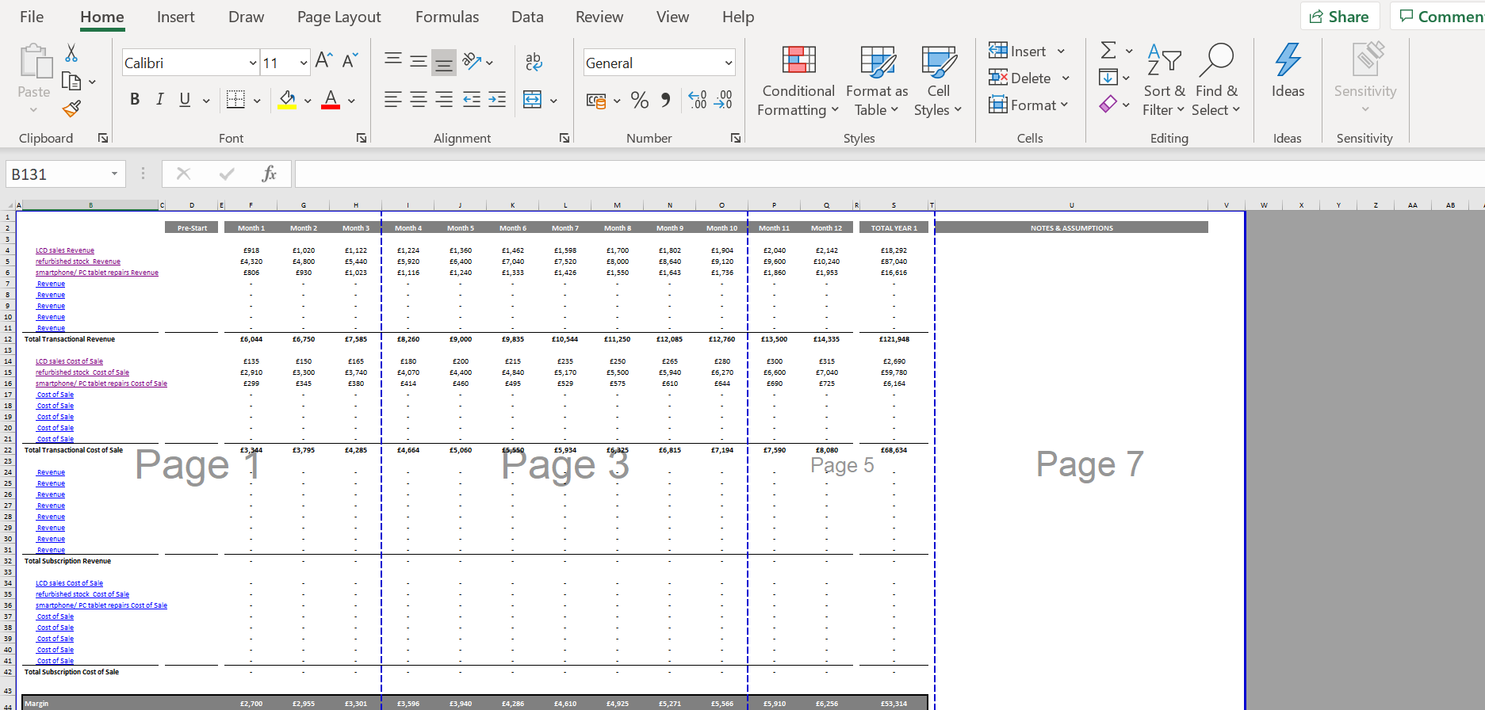

Business Expenses 2020

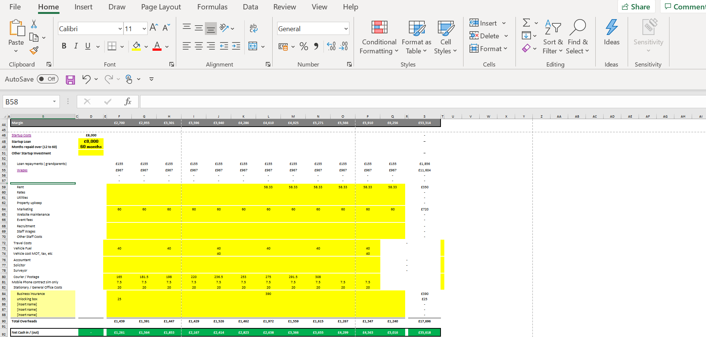

Cashflow for year 2020
Sales Revenue for 2020
LCD Sales Revenue - £18.292
Refurbish Stock revenue - £87.040
Smartphone/PC tablet repairs - £16.616
Total sales revenue- £121.948

Material Year Expenses
Freight- (Post item to customer)- £2.127
LCD cost of sale- £2690
Refurbished stock cost of sale -£59.780
Smartphone/ PC tablet repair cost of sale - £6.164
Total cost of sales -£70.761

Business year expenses
Unit (storage)- £700
PO box - £230
Fuel -£480
Marketing - £720
Mobile Phone contract (sim only) -£90
Stationary - £240
Wages- £11.604
Internet - £240
Grand Parents loan repayment £1.856
Total in business expenses = £16.160
Total Expenses for the year (Material, business expense) = £86.921
Total Profit for the year 2020 - £35.027

Cashflow for year 2021

Sales Revenue
LCD sale revenue - £18.292
Refurbish Stock - £96.000
Smartphone/Pc tablet repairs - £21.000
Total sales revenue £135.292
Material
LCD cost of sale - £3.000
Refurbished Stock cost of sale - £71.000
Smartphone repairs cost of sale - £6.000
Freight- (Post item to customer)- £2.127
Total cost of sales for the year -£82.127
Business Expenses
Unit (storage) -£700
PO. box - £230
Fuel - £480
Marketing- £720
Mobile Phone contract £90 (sim only)
Internet - £240
Stationary - £240
Wages - £11.604
Loan Repayment (Grand Parents) £1.860
Total business expenses year 2021- £16.164
Total Expenses for the year (Material, business expense) = £98.291
Total Profit for the year 2020 - £37.001
Health & Safety
I am going to have, Regular breaks on soldering to refocus my eyes.
to prevent backache, shoulders ache I will get an adjustable work bench table to reduce neck pain.
So, I am not constantly bending neck forward in awkward positions.
The Health and Safety (Display Screens Equipment) Regulations 1992 impose requirements concerning the use of computer equipment, workstations, seating and eye tests. The regulations are intended to minimise the risks of work-related upper limb disorders, bad backs, tendonitis and carpal tunnel syndrome, and of sight related health issues.

I will have in both place fire extinguisher for fires, first aid box for cuts burns. I will Buy labels to put on wall identifying each item

keep workplace tidy and clean avoid any spillages on work

When carrying out work duties. I will only work on my work bench. Never put item on carpet this creates more static

On my repair forms I will put on there the act Consumer Protection (Distance Selling) Regulations 2000. Which I will put information on regarding 7 days cool off period

I will post with every purchase or quotation my terms and conditions. My Terms and conditions will include provisions ensuring compliance with the Data Protection Act 1998 (DPA) in terms of
dealing with private data stored on customers' phones, policies preventing or dealing with accidental loss, damage or destruction of customers' private data, and any guarantees warranties offered by the service.
On my repair forms I will put on there the act Consumer Protection (Distance Selling) Regulations 2000. Which I will put information on regarding 7 days cool off period

I will post with every purchase or quotation my terms and conditions. My Terms and conditions will include provisions ensuring compliance with the Data Protection Act 1998 (DPA) in terms of
dealing with private data stored on customers' phones, policies preventing or dealing with accidental loss, damage or destruction of customers' private data, and any guarantees warranties offered by the service.

Mobile phones, PC tablets I cannot repair from customer, with their consent that do not want the phone. will be disposed for recycling at mobile bank or use for parts

No jewellery, rings, metal rings, watches and other conductive material to avoid damage, liable to be caught on or scrap against components
mobile phone batteries will be kept in cool place to avoid explosion

Data protection. Me as the data controller will not share anybody data. Less the person how owns mobile phone gives confirmation in writing signed and dated to me

Conclusion

After engaging in research in this essay I have acknowledged that my hobby if taken seriously on a business level I could have a successful business. Making me self-employed. I know now how to set up my own smartphone repair shop and what is need before you can trade to the public. When before I had no knowledge whatsoever. In the future after completely my 3 years course at ST David Trinity University of wales. I am going to starting up my own business.

References

https://www.squaretrade.co.uk/merchant/pdf/uk/revealed-britains-5-billion-mobile-program.pdf

https://www.finder.com/uk/mobile-internet-statistics
https://businesswales.gov.wales/businessfinance/types-finance-and-how-apply/grants#guides-tabs--1

https://www.cwmbrancentre.com/retailers/phone-matters/

https://www.mailboxcsbs.co.uk/
https://imendltd.co.uk/
https://www.quickmobilefix.com/

https://www.hse.gov.uk/coronavirus/working-safely/index.htm

https://www.prizminstitute.com/blog/cell-phone-repair-safety-and-precautions/

