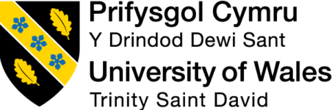

Master of Business Administration
Human Capital Management (LCMB7023)

Assessment component 1:
Individual report

The Influence of National and International Labour Markets on HRM and IHRM Strategies

Lecturer: Dr. Hoang Dang Nguyen

Student’s Name: Md Faysal Mia
Student’s ID: 2434754

Word Count: 2644
Date of Submission: 11th November 2025

Executive Summary
The report takes a critical analysis of the way technological innovation, demographic trends, and geopolitical instability are transforming the national and global labour markets. It also questions the reinventing of the HRM and the IHRM strategies that automation, artificial intelligence, and digital platforms have triggered and as such, the necessity to engage in lifelong reskilling and embrace data-driven decision-making processes. The paper predicts the potential challenges of ageing populations, migration, and a shortage of talent, all of which pose significant workforce planning and policymaking challenges to inclusion. The paper, in turn, suggests a set of strategic HR practices, such as corporate academies, cross-border hiring, and online learning collaborations, as ways of overcoming the systematic skills shortages. Finally, reflective self-evaluation based on the reflective cycle developed by Gibbs is used to understand whether the author is ready to lead in the global, digital, and adaptive HR environment or not.

Table of Contents
Executive Summary 2
1. Introduction 4
2. Technological Advancements and Labour Markets 4
2.1. Impact of Technology on Labour Market Structure 4
2.2. Implications for HRM and IHRM Strategies 5
2.3 Conclusion 5
3. Demographic and Geopolitical Factors in Employment Markets 5
3.1. Demographic Pressures 5
3.2. Geopolitical Shifts and Global Labour Mobility 6
3.3. Synthesis 6
4. Addressing Skills Gaps and Talent Shortages 7
4.1. Nature of Current Skills Gaps 7
4.2. Strategic HRM Responses 7
4.3. Organisational Examples and Evaluation 8
4.4 Conclusion 8
5. Reflective Analysis: Readiness for the Global and Digital Workplace (Using Gibbs’ Reflective Cycle) 9
6. Overall Conclusion 12
7. References 13

1. Introduction
The report explores how globalisation, technological innovation, and demographic change are transforming the national and international labour markets. The high pace of development of automation, artificial intelligence, and digital platforms has reshaped organisational processes in recruiting, training, and retaining employees (Pilbeam and Corbridge, 2019). At the same time, the greying populations, population movements, and the changing geopolitical forces have also worsened the competition for talented skills. The human resource management (HRM) and international human resource management (IHRM) need more strategic, data-driven, and globally responsive behaviours and practices that reflect changes in labour markets (Ulrich et al., 2017). In this paper, the effects of technology, demographic shift, and skills deficits on HR practices will be examined, and the paper will conclude with a reflective assessment of professional preparation to work in the global digital work environment.

2. Technological Advancements and Labour Markets

2.1. Impact of Technology on Labour Market Structure
Technology has transformed the modalities of work and the resultant characteristics of work. Robots and artificial intelligence (AI) are replacing manual tasks that are performed regularly, particularly in production, delivery, and customer service (Caligiuri et al., 2022). At the same time, such technologies introduce new jobs within the field of data analytics, analysis of systems and design. The shift polarises the labour force: workers with digital and analytical skills have new opportunities, and employees with low skills face the threat of increasing insecurity.
Uber, Upwork and Deliveroo, among other digital platforms, have expanded the gig economy, which has afforded workers a higher degree of autonomy at the cost of traditional job protection (Ererdi et al., 2022). Cloud-based tools and virtual communication have turned out to be commonplace in the national and international labour markets with flexible work arrangements. However, the shift has widened the gap between secure and precarious employees (Mayo, 2022). Telecommuting has made the recruitment processes more international, thus allowing companies to be more focused on skills and not location. Labour markets have thus become more competitive and open in the past than ever before. In this respect, flexibility and continuous education have become an essential requirement of being employable.

2.2. Implications for HRM and IHRM Strategies
The HRM needs to be changed to match these changes. Traditional HR models, which valued stability and control, can no longer work. HR practitioners need to repatriate the roles, integrate digital training and support lifelong learning. Reskilling has been the key to productivity and morale conservation (Ererdi et al., 2022). As an example, AI tools require that the HR departments teach employees to use automation instead of being afraid of it. Efficiency and ethics have to be resolved by HRM as well, with the algorithmic decision-making process managed and ensuring that the data of employees is not misused.
International HRM (IHRM) faces other issues in a global environment. The virtual cross-border team management requires cultural intelligence, inclusive leadership and fair digital monitoring systems. A regular communication policy is useful in maintaining fairness between the remote and local workforce (Chung and Sparrow, 2024). The systematic assessment of the effects of digital trends on labour laws and labour cultures becomes convenient under the application of the analytical frameworks like PESTLE, especially the technological dimension. On the same note, Ulrich’s HR Model accentuates the significance of managerial views by assuming that human resources are not an administrative department but a strategic ally (Patrick, Jha and Sharma, 2023). These analytical prisms, therefore, redefine technology as a tool of performance and inclusion, and not a bringer of job displacement.

2.3 Conclusion
Technological disruption continues to redefine HR strategy, demanding continuous learning, ethical AI use, and agile workforce planning to maintain competitiveness in global labour markets (Boudreau and Ramstad, 2021).

3. Demographic and Geopolitical Factors in Employment Markets

3.1. Demographic Pressures
The world labour markets are becoming more burdened with notable demographic changes. In developed countries like the United Kingdom, Germany and Japan, there is rapid ageing of the population (Patrick, Jha and Sharma, 2023). This tendency shrinks the cohort of labour-eligible individuals and increases dependency rates, thus making it more difficult to replace experienced employees. It, therefore, follows that employers will have to come up with adaptive retirement programmes, gradual departure systems and effective knowledge-transfer programmes.
Emerging countries, on the other hand, have a high youth bulge, in which a large percentage of the population is looking to work but lacks industry-specific skills (Bratton and Gold, 2017). This created misalignment, creating opportunities and instabilities that are experienced through excess supply of young labour in some areas and deficits in others.
Inclusion between diversity and gender has risen to become a determinant of the modern HR approach. Organisations are also being required to represent social equity and fairness along with productivity (Patrick, Jha and Sharma, 2023). Recruitment and career-development programmes are currently more focused on achieving a balance in the representation of gender, ethnicity, and age. The emergence of Generation Z, whose expectations are significantly different compared to the Baby Boomers, increases the challenge of multi-generational management even further (Laskowska and Laskowski, 2023). Competent HR reactions then require sympathetic, adaptable wage setups and mentoring systems that stimulate intergenerational working.

3.2. Geopolitical Shifts and Global Labour Mobility
There has been a reorganisation of the cross-border movement of labour and capital as a result of geopolitical tensions. The withdrawal of the United Kingdom from the European Union limited free movement between the United Kingdom and the EU member states, leading to shortages in vital areas (Mayo, 2022). It includes healthcare, agriculture, and construction. Also, the trade disputes between the key economies have upset international supply lines. It forces companies to revisit recruitment destinations and operational regions.
Migration laws have limited the movement of talent, but virtual international employment, with the emergence of remote working, has partially limited these measures.
These dynamics create complex challenges for International HRM practitioners. The global HR teams have to deal with different employment laws, tax systems, and social security systems (Serenko, 2024). The move towards pay equity between host and home jurisdictions has proved to be a painful undertaking with the change in the value of the exchange rate and the pressures of inflation (Stewart and Brown, 2019). In areas where the stability is poor, the well-being of employees and the safety of their jobs require crisis-management measures.

3.3. Synthesis
The geopolitical factors are closely interconnected with the demographic ones. In developed economies, the migrants needed are added to the demand for skilled workers, but the migration policies are restrictive (Mayo, 2022). The political choices, therefore, determine the balance between the labour shortages and surpluses. To that end, HRM and IHRM should embrace evidence-based, ethical and internationally inclusive approaches to the workforce to maintain fairness and robustness across borders.

4. Addressing Skills Gaps and Talent Shortages

4.1. Nature of Current Skills Gaps
Inadequacy of skills is a long-term issue in various industries. In the technology sector, there is always a shortage in the supply of cybersecurity analysts, data scientists, and artificial intelligence specialists compared to the demand (Vinícius et al., 2023). The modern educational systems have lagged in a rapid manner to provide the graduates with the necessary digital skills and forced most companies to engage in the training of the newly hired employees internally (Ererdi et al., 2022). The geriatric population has created acute nurse, physician, and care aide shortages in the healthcare sector, especially in the United Kingdom and the rest of Europe, and the COVID-19 pandemic aggravated these shortages. The hospitality sector is facing a challenge because of talent retention, since low wages and non-timely working schedules are lowering the stability of the workforce. Such inequalities reveal an institutional mismatch between university degrees and labour market demands (Caligiuri et al., 2022). Graduates often have theoretical skills but are not adequately equipped with transferable, applied and digital skills, which are integral to modern jobs. This kind of a fit disengagement hinders productivity and limits innovation in the existing and new labour markets.

4.2. Strategic HRM Responses
Strategic human resource management presupposes a significant role in eliminating these gaps. Workforce planning helps organisations to plan and match recruitment programmes with long-term goals. Analytical tools based on data allow predicting the changing skills requirements and which jobs can be automated, thus enabling HR departments to strike before they happen (Chung and Sparrow, 2024). Mutually beneficial relations between universities and employers are also unavoidable; the relations with industry help to incorporate practical modules that reflect the contemporary requirements of the workplace (Cappelli and Keller, 2020). In the business models, internal mobility and reskilling are becoming more and more popular. Instead of seeking outside recruitment, most companies resort to employee development to fill vacant and vital roles, which reflects the Ability-Motivation-Opportunity (AMO) Model, which is based on the notion that employees’ capabilities are improved by training them, motivation by means of recognition and the opportunity to use newly gained skills (Chung and Sparrow, 2024). Similarly, High Performance Work Systems (HPWS) focus on combining learning, engagement, and performance rewards. All these frameworks instil a culture of unremitting expansion and flexibility wherein HR is no longer viewed as a reactive entity but rather an active agent of talent development sustainability that will adapt in tandem with technological and market changes.

4.3. Organisational Examples and Evaluation
A good example of the issue and its solution is provided by the National Health Service (NHS) of the United Kingdom. With acute shortages of the nursing workforce, the NHS launched campaigns abroad in international recruitment and, at the same time, heavily subsidised domestic apprenticeships to ensure sufficient supply (Bratton and Gold, 2017). This two-level approach indicates the need to have global and local interventions.
Another example is given by the Digital Academy of Accenture, a company that provides training in the fields of artificial intelligence and data science and serves its offices across the globe. These programmes testify to the fact that the investment in learning pays off in terms of employee retention and innovation (Ererdi et al., 2022). However, in smaller companies, the introduction of similar systems is problematic; nevertheless, they can use governmental subsidies and reforms in education to resolve the issue of talent shortage in the long term..

4.4 Conclusion
To address such skill gaps, the build, buy, borrow and bind strategies should be integrated based on data analytics and partnerships with the focus on lifelong learning, which would protect long-term organisational resilience.

5. Reflective Analysis: Global Digital Workplace Readiness (Using Gibbs’ Reflective Cycle)
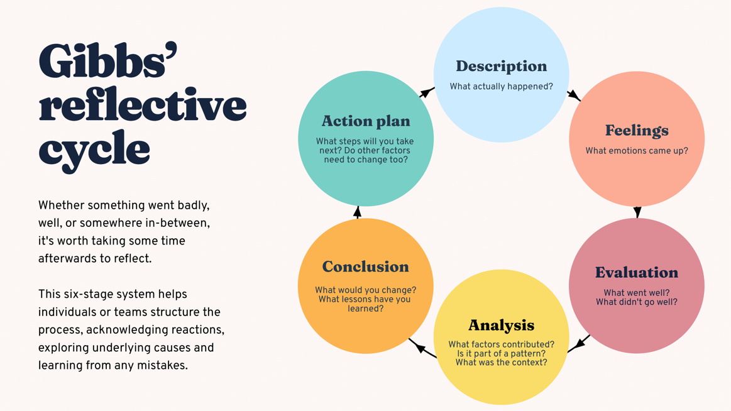
Figure 1: Gibbs’ Reflective Cycle
Source: (Ererdi et al., 2022)
Description: The tasks in the MBA module provided me with a chance to work on projects related to human resource management and digital transformation in a multicultural team. The collaborative tools were Microsoft Teams, Google Workspace, and ChatGPT, which were imitating the international virtual office dynamics. The projects required integrity, flexibility, and strict timetables (Ererdi et al., 2022). I was also involved in the discussion and generated written resources. It also consequently strengthened my self-confidence in working in a global team. However, there were also issues with delegation and trust in leadership; sometimes, delegating responsibilities to other people was a problem. These experiences instilled patience, respect and appreciation of the primacy of clarity of communication in a heterogeneous digital environment.
Feelings: First, I felt insecure about my ability to effectively work in a diverse, fully virtual cohort. In the course of the course, I grew more comfortable with cultural diversity and the use of digital tools. I also got the satisfaction of pride when my input helped the group to understand what theoretical models were and vice versa, and I experienced anxiety when the group was taking a long time to make a decision or when I noticed that my fellow group members were at loggerheads.

Evaluation: On the whole, it was a rather positive experience. It improved my communication and teamwork skills, especially in virtual teamwork. The application of digital tools reinforced my technical confidence, and feedback from peers reinforced my elasticity. However, I also traced salient weaknesses, namely, the lack of assertiveness in the leadership aspect and the lack of experience in using advanced HR analytics tools (Pilbeam & Corbridge, 2019). Such weaknesses diluted my ability to lead discussions in a decisive way as well as my ability to communicate data in a group assignment.

Analysis: Theories of leadership, such as emotional intelligence and cross-cultural competence, presuppose that to successfully collaborate internationally, a person needs to be empathetic, flexible, and communicative. The reflective model provided by Gibbs will help to understand the results of the activities, which are not only surface (Patrick, Jha & Sharma, 2023). The effectiveness of our collaboration was based on my effective interpersonal communication, and the reluctance to act as a leader was caused by fears of not recognising different opinions. Besides, modern HRM tendencies are more focused on digital literacy and data-driven management (as addressed in Q1 -Q3), which is why my area of HR analytics competency might limit professional readiness in a technology-based global environment (Boudreau and Ramstad, 2021).

Conclusion: This reflection confirms that I have a strong background in teamwork, flexibility, and being digitally literate. However, the lack of confidence in leadership, pressure decision-making, and skills in HR analytics tools, including Power BI or SPSS, still needs to be strengthened. Continuous self-education and systematic mentorship will be instrumental in helping me embrace an international HR-based career.
Action Plan
Objective | Action Steps | Timeline | Success Indicator
1. Build stronger leadership and decision-making confidence | Take the lead in the next group project, encourage open communication, and ask for honest peer feedback after completion (Chung and Sparrow, 2024). | Within 6 months | Positive peer feedback and smoother group coordination during future projects.
2. Improve digital HR analytics skills | Enrol in an online HR Analytics course on Coursera or CIPD and practice using tools like Power BI or SPSS in real coursework. | By March 2026 | Course completion certificate and practical use of analytics tools in assignments (Pilbeam & Corbridge, 2019).
3. Strengthen cross-cultural communication | Join an international student group or virtual exchange to interact with people from diverse backgrounds. | Within 4 months | Greater ease and confidence when collaborating across cultures (Pilbeam & Corbridge, 2019).
4. Develop reflective learning habits | Apply Gibbs’ Reflective Cycle after each major group task and record personal insights in a learning journal (Chung and Sparrow, 2024). | Continuous | Visible progress in self-awareness and problem-solving across future projects.
Table 1: Action Plan
Author: Self-Made

6. Overall Conclusion
Technology, demography, and geopolitics are collectively redefining the scope of HRM and IHRM. Automation and AI demand data-driven agility, while ageing populations and migration trends reshape workforce diversity and global mobility (Patrick, Jha, and Sharma, 2023). Strategic HRM must therefore prioritise continuous learning, ethical governance, and flexible talent systems to remain resilient. Bridging persistent skills gaps through digital learning and cross-sector collaboration will sustain competitiveness. (Caligiuri et al., 2022) Personally, this reflection strengthened my commitment to adaptability, analytics, and inclusive leadership—qualities essential for navigating an unpredictable global labour market and contributing to sustainable organisational growth in the digital age.

7. References
Boudreau, J. & Ramstad, P. (2021) Beyond HR: The New Science of Human Capital. Boston, MA: Harvard Business School Press.
Bratton, J. & Gold, J. (2017) Human Resource Management: Theory and Practice. 6th edn. London: Palgrave Macmillan.
Caligiuri, P. et al. (2022) ‘International HRM Insights for Navigating the COVID-19 Pandemic: Implications for Future Research and Practice’, JIBS special collections, pp. 417–454. Available at: https://doi.org/10.1007/978-3-030-80383-4_17.
Cappelli, P. & Keller, J. (2020) Managing the Future of Work: The New HR Imperative. Boston, MA: Harvard Business Review Press.
Chung, C. and Sparrow, P. (2024) ‘Exploring the Configuration of International HRM Strategies for Global Integration and Local Responsiveness in MNEs’, International Journal of Human Resource Management, 35(11), pp. 1943–1969. Available at: https://doi.org/10.1080/09585192.2024.2320768.
Ererdi, C. et al. (2022) ‘International HRM in the context of uncertainty and crisis: a systematic review of literature (2000–2018)’, The International Journal of Human Resource Management, 33(12), pp. 1–39. Available at: https://doi.org/10.1080/09585192.2020.1863247.
Laskowska, A. and Laskowski, J.F. (2023) ‘“Silver” Generation at Work—Implications for Sustainable Human Capital Management in the Industry 5.0 Era’, Sustainability, 15(1), p. 194. Available at: https://doi.org/10.3390/su15010194.
Mayo, A. (2022) Human Resources or Human Capital? Managing People as Assets. Boston, MA: Harvard Business Review Press.
Patrick, W.S., Jha, J.K. and Sharma, K.G. (2023) ‘Strategic International Human Resource Management (SIHRM) framework: an Integrated Review and Directions for Future Research’, Journal of Global Mobility: The Home of Expatriate Management Research, 11(2). Available at: https://doi.org/10.1108/jgm-08-2022-0039.
Pilbeam, S. & Corbridge, M. (2019) People Resourcing and Talent Planning. 6th edn. Harlow: Pearson.
Serenko, A. (2024) ‘The human capital management perspective on quiet quitting: recommendations for employees, managers, and national policymakers’, Journal of Knowledge Management, 28(1), pp. 27–43. Available at: https://doi.org/10.1108/jkm-10-2022-0792.
Stewart, G.L. & Brown, K.G. (2019) Human Resource Management. Hoboken, NJ: John Wiley & Sons.
Ulrich, D., Kryscynski, D., Ulrich, M. & Brockbank, W. (2017) HR from the Outside In: Six Competencies for the Future of Human Resources. New York: McGraw-Hill Education.
Vinícius, R. et al. (2023) ‘Editorial: Human capital, management and economics during and after the COVID-19 outbreak’, The Bottom Line, 36(2), pp. 101–111. Available at: https://doi.org/10.1108/bl-07-2023-139.

