Cameron Rees

ASsignment 2

Table of Contents
Introduction 2
Screenshots with Annotations 2
Methodology 4
Annotated code listing 5
Conclusion 9
Bibliography 9

Introduction
This assignment was about getting ajax and json API to work on a web app and designing a web app using CSS and this sit should be useable on a mobile device.

Screenshots with Annotations
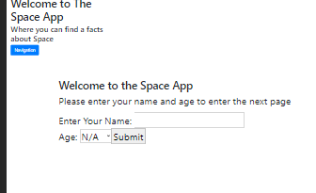
Here is the index page on the web application and we have the title a navigation button that turns into a dropdown and and you can type your name and age and submit it
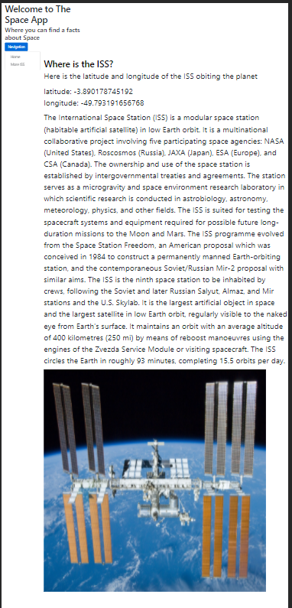
This is the first page and here you can see the latitude and longitude of where the ISS is orbiting the planet and some information about the ISS [1]
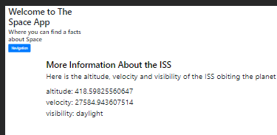
And on the second page we have some more information about the ISS and you can see what altitude, velocity and visibility of the ISS

Methodology
I will explain how I did the Json API first I got the link of where I was getting the information off the internet, then I created a function called getISS(_) and this is used at the end of the script and then I used the fetch function to retrieve the data from the API and then I converted it into json and then the data is broken down into sections to be shown on the screen and then I display the information and then its done. I did this for the first and second page.

Annotated code listing
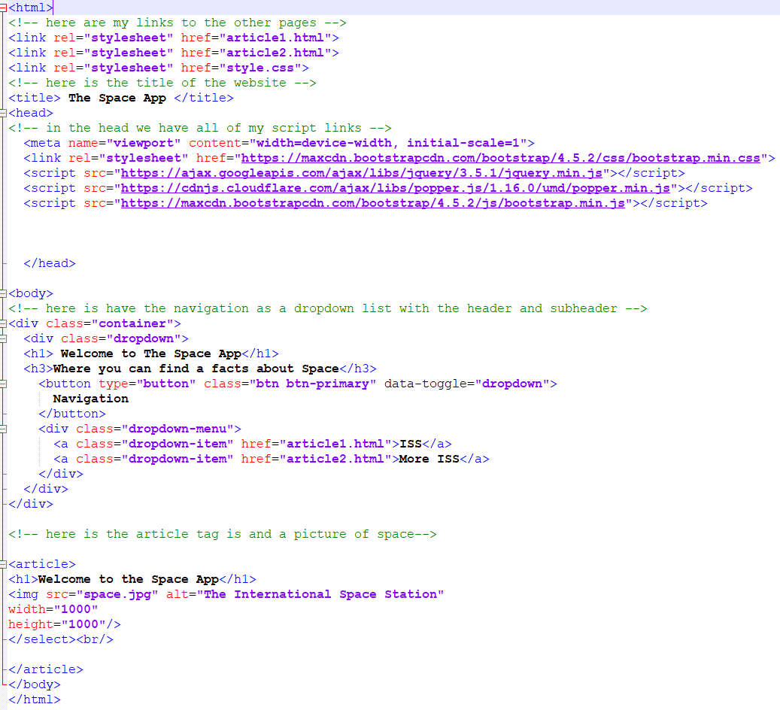
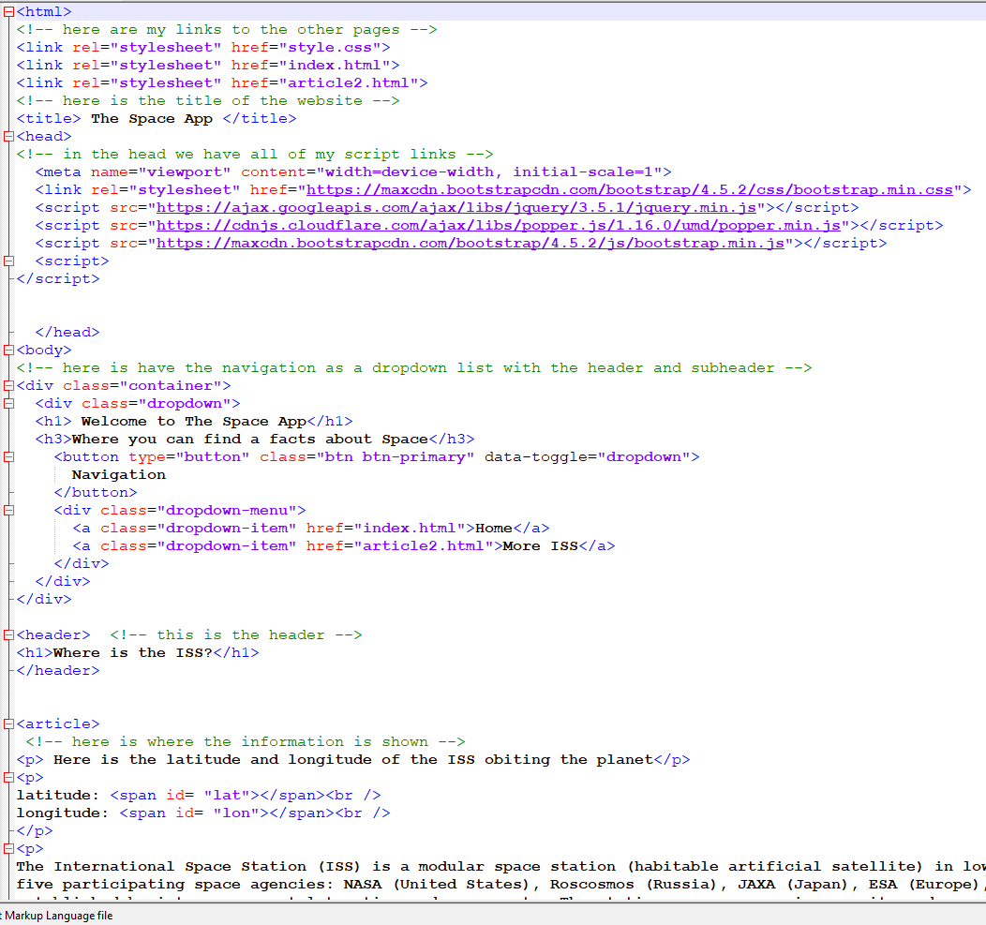
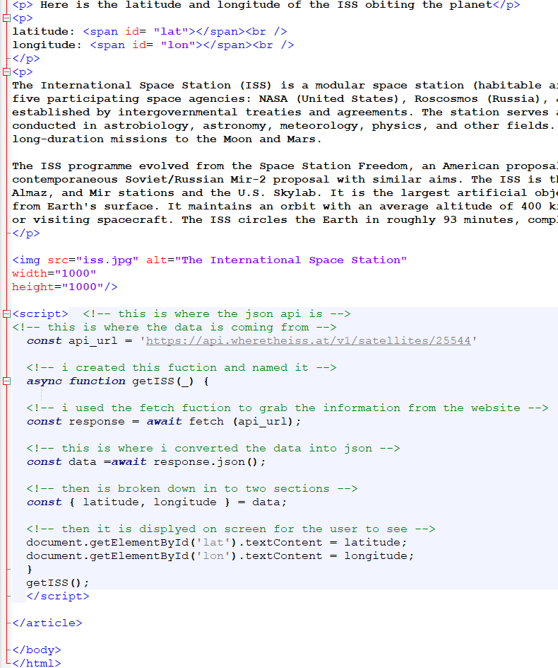
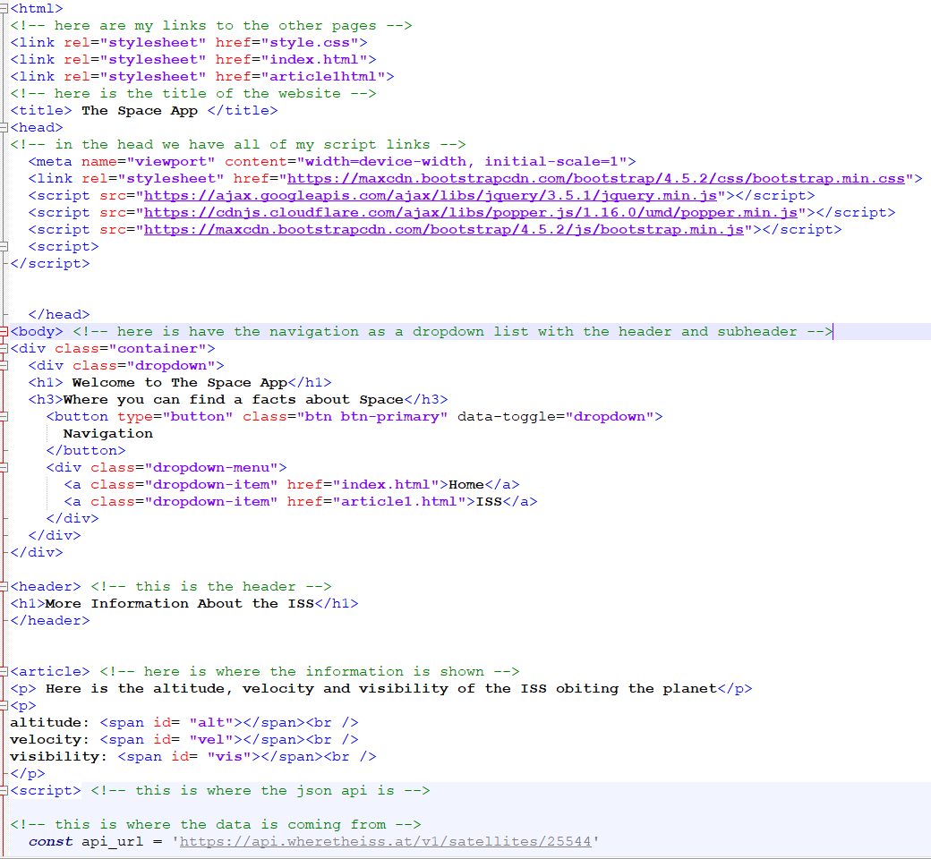
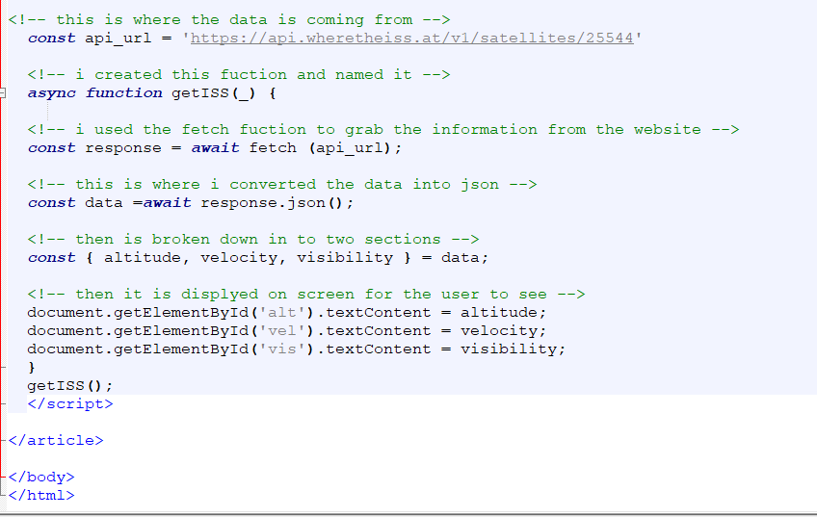
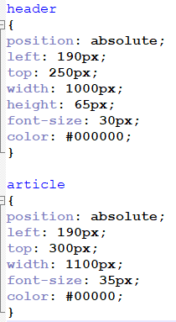

Conclusion
In conclusion I could have made a better web app as I could have done some more work for it but I did get a API working but overall I could have done much better on this assignment.

Bibliography

[1] | wikipedia, “International Space Station,” [Online]. Available: https://en.wikipedia.org/wiki/International_Space_Station.

