Student name: |  | Student ID number:
Programme: | Master of Business Administration
Module: | Human Capital Management
Module code: | LCMB7023 | Contribution to Overall Module Assessment (%): | 50%
Lecturer: | Gladius Kulothungan (London)  Eno Maycock (Birmingham) | Internal Verifier: | Vasilios Tavlaridis  Hoang Nguyen
Assignment Title: | Assessment component 1: Individual report | Word count (or equivalent): | 2,500
Submission deadline: | Friday 19th June 2026  by 2pm | Return date of provisional marks & written feedback: | 17th July 2026

Table of Contents
Contribution to Overall Module Assessment (%): 1
TASK A: Socialisation, Identity & Business Activism 3
1. Traditional Onboarding versus Strategic Organisational Socialisation 3
2. Strategic Socialisation Framework for Helios 4
3. Building Organisational Citizenship and Business Activism 6
TASK B: Job design 8
1. Proposal of an innovative job design strategy 8
1.1 Application of the job characteristic model (JCM) 8
1.2 Job crafting theory 9
1.3 Skills-based architecture and Internal talent marketplaces 10
2. Stimulating intrinsic motivation and supporting innovation through the design 11
2.1 Stimulating Intrinsic Motivation through Job Design 11
2.2 Supporting Innovation through Job Crafting and Skills-Based Architecture 11
2.3 Role of Goal Setting Theory and the Performance Management Cycle 12
TASK C: Reflective report 14
1. Using AI as a decision-support tool without eroding critical human judgment 14
2. Personal capability development plan 14
Reference list 16

TASK A: Socialisation, Identity & Business Activism

1. Traditional Onboarding versus Strategic Organisational Socialisation
Helios Urban Mobility (HUM) is facing a decline in employee engagement at 54%, with an average team-up period of 8 months, along with high attrition among potential talented graduate aspirants. This situation is indicative of the failing onboarding processes that focus on administrative integration instead of generating long-term employee commitment. Procedural compliance and strategic organisational socialisation remain the key targets of traditional onboarding processes while strategic practices enforce workforce productivity, psychological attachment and organisational identification (Lourenço and Rodrigues, 2025).
Dimension | Traditional Onboarding | Strategic Organisational Socialisation
Primary objective | Administrative focus and compliance for role familiarisation | Identity formation with organisational commitment supported by long-term cultural integration
HRM orientation | Hard HRM (Storey, 2007) is focused, and employees are considered operational efficiency-related resources. | Soft HRM (Storey, 2007) is focused on strategic commitment, which creates competitive advantage.
Employee experience | Short-term engagement and task-focused behaviour with transaction authority | Purpose-driven and developmental engagement with relational behaviour
Organisational outcome | Substantial disengagement and persistent attrition among graduate aspirants | Improved commitment and engagement with faster assimilation for enhanced retention of potential talent
Table 1: Comparison table of traditional onboarding and strategic organisational socialisation
(Source: Godinho et al., 2023)
Van Maanen and Schein's (1979) Socialisation Theory highlights six tactical factors for socialisation, which create role orientation for custodial and innovation strategies (Ricciardelli, 2022; Recruitment and Performance Management lecture). In the case of traditional onboarding, the random learning experiences and inconsistent role details are developed through informal and disjunctive functions. On the other hand, strategic functions use formal and collective strategies to create role clarity and accelerated learning (Jooss et al., 2024). Psychological contract theory and identity construction theory highlight the unspoken norms and identity formulation of employees in the organisational setting (Rogozińska-Pawełczyk and Gadomska-Lila, 2022). The traditional strategy creates a weak attachment and inconsistent performance, while strategic socialisation emphasises learning and career progression with an innovative identity. Hence, HUM can motivate induction into short-term administrative activity for a strategic capability-building process for higher retention.

2. Strategic Socialisation Framework for Helios
The prolonged ramp-up time of eight months in HUm has resulted in low employee engagement and high graduate attrition. Hence, socialisation can be a way out in this situation, where the strategic capability-building process can be reconceptualised by replacing one-off onboarding events. A strategic framework in Helios must comply with the principles of Goal-Setting theory, where the employee journey is created with specific, measurable and progressively challenging objectives (Bakhshandeh et al., 2024). Furthermore, the Concepts of Adjustment model and its stages will help to stabilise and predict the psychological transition based on anticipation while reducing the scope of uncertainty to develop commitment.

Stage | Objectives | Strategic initiatives | Justification and expected outcome
Stage 1: Preboarding  (Day 1 after accepting offer) | - To reduce uncertainty  - To disseminate realistic expectation-related information  - To strengthen psychological contract | - Digital portal to welcome and orient  - Buddy assignment  - Communication based on values and sustainability | It aligns with the anticipatory adjustment stage. Recruitment and socialisation risks are reduced with early communication. Role clarification and organisational culture association with communication expectations facilitate acceptance. Buddy support enhances social learning while value communication ensures organisational identification
Stage 2: First 90 days (integration phase) | - To accelerate operational integration  - To develop competence and confidence  - To establish a role with clarity | - Coaching sessions with manager  - Structured learning stage  - Rotations and cross-functional networking | It emphasises the management of uncertainty and early withdrawal based on culture shock and encounter stage details. Goal-setting theory factors demonstrate the need to implement SMART objectives with regular feedback for achieving developmental milestones. Self-efficacy is supported by structured coaching, while networking ensures social capital and organisational understanding.
Stage 3: Year 1 (Embedding phase) | - To develop commitment for long-term operations  - To guide career growth opportunities  - To promote strategic contribution | - Mentoring program for the executive level  - Hackathons and innovation projects  - Career conversations at quarterly performance appraisal | Adjustment and mastery stage are covered in this session, where mentoring and career conversations are used to maintain psychological contract along with organisational identity. Autonomy, visibility and long-term engagement are used for employee development.
Table 2: Strategic socialisation framework for HUM
(Source: Bakhshandeh et al., 2024)
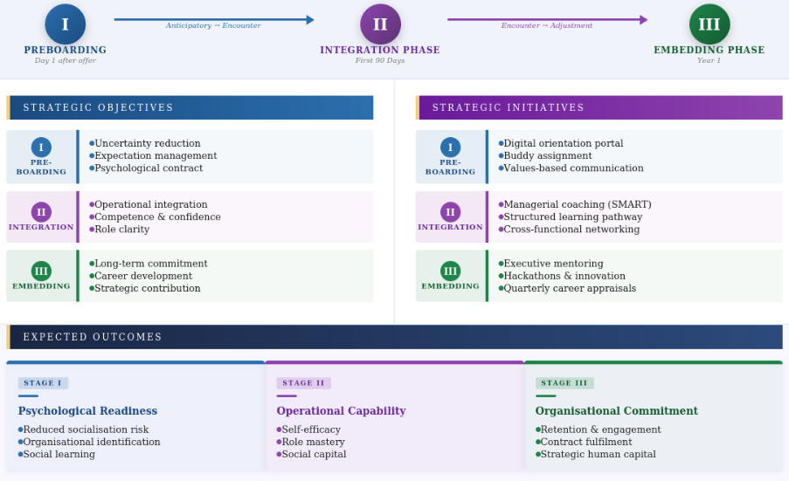
Figure 1: Diagrammatic representation of strategic socialisation framework for HUM
(Source: Self-developed)
Strategic justification
The framework is developed to address the human capital challenge of HUM and aims to integrate socialisation, employee development and performance management into the system comprehensively. As per the findings of Verhaelen et al. (2023), the staged learning objectives, along with continuous feedback, will help in reducing ramp-up period while accelerating role clarity and competitive acquisition. Additionally, the critical adjustment phase is supported with interventions and support mechanisms to reduce turnover and withdrawal from graduate employees at an early stage. Career planning and innovation participation are considered useful strategies in driving engagement. The framework sustains socialisation transformation through a strategic retention mechanism.

3. Building Organisational Citizenship and Business Activism
A Citizenship and Business Activism Framework is supposed to be more effective for HUM to retain graduated employees and develop commitment to the organisation. The systematic process will include identification, ethical professionalism and leadership behaviours with stakeholder involvement.
Strategic objective | Proposed mechanism | Theoretical foundation | Expected outcome
To develop organisational identification | Purpose-to-Practice Programme  Quarterly workshops to link sustainable urban mobility-related HUM’s mission with employee roles. Strategies include executive storytelling and employee access presentation | The Harvard Model of HRM establishes the role of ethical commitment in long-term stakeholder commitment. Aligning organisational values with personal values increases commitment | Improved organisational identification, employee belonging and employee retention
To substantiate ethical professionalism | Ethical Performance and Growth Framework  Transparent promotion and appraisal with a performance review is required. Training and development opportunities supported by fair audit and employee appeal systems are integrated. | Ethical management for performance evaluation principles highlights that increased employee commitment can be achieved with transparent and fair procedures. | Improved organisational citizenship and behaviour with increased trust based on the psychological contract
To create business activist mindset | Helios Change-Maker Programme  Sustainability-oriented cross-functional teamwork, along with smart-city innovation and AI ethics challenges, will create solutions for stakeholders and leadership. | Ulrich's HR Champion Model describes employees as strategic contributors and change agents of an organisation; stakeholder capitalism will promote responsibility for community and society. | Proactive problem-solving with improved innovation and participation affects strategic decision-making
Table 3: Proposed mechanism to cultivate
(Source: Week 1 HCM lecture, Week 1 HCM lecture session 12)

TASK B: Job design

1. Proposal of an innovative job design strategy

1.1 Application of the job characteristic model (JCM)
The “Job Characteristic Model” mostly influences the employee motivation and performance through 5 core job dimensions such as skill variety, task identity, task significance, autonomy, and feedback (Zhao et al., 2024).
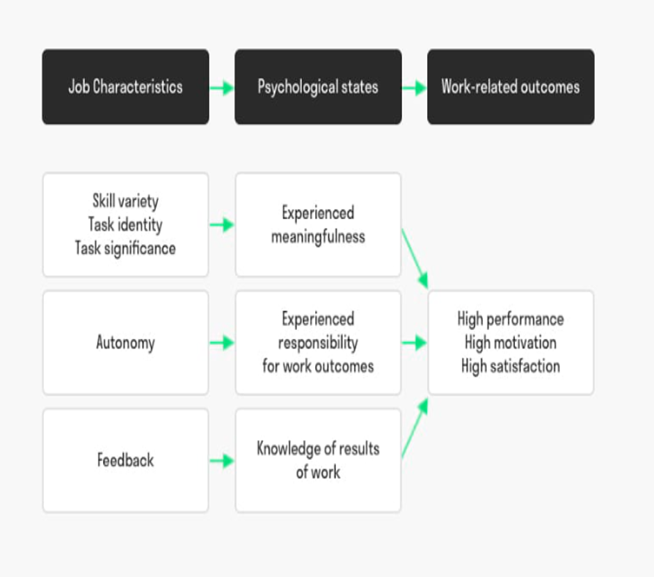
Figure 2: Job Characteristics Model
(Source: Lecture slides, slide 8)
At Helios, software developers, AI engineers, and analysts of the smart mobility must be organised into the cross-functional innovation squads rather than narrow departments. This type of structure would enhance the skill variety by exposing the workers or employees to software development, adequate client engagement, data analytics, and sustainability projects. Task identity can be boosted by allowing the workers to actively participate in the entire project lifecycle, such as from designing the “AI-enabled mobility solutions” to deployment, as well as evaluation. Moreover, task significance can be emphasized by showcasing how employee contributions effectively improve the transportation system, reduce the excessive congestion of traffics and enhance environmental sustainability (Zhao et al., 2024).
Autonomy can be increased by the firm through the agile working practices, employee-led decisions, and innovation sprints. Lastly, the continuous feedback has to be delivered through performance dashboards, customer reviews, and review meetings. This approach is quite relevant as it has been found out that low engagement is a global challenge, as it declined by 20% for a second year to its lowest level since 2020 (figure below). This indicates that organizations have to create more empowering work environments.
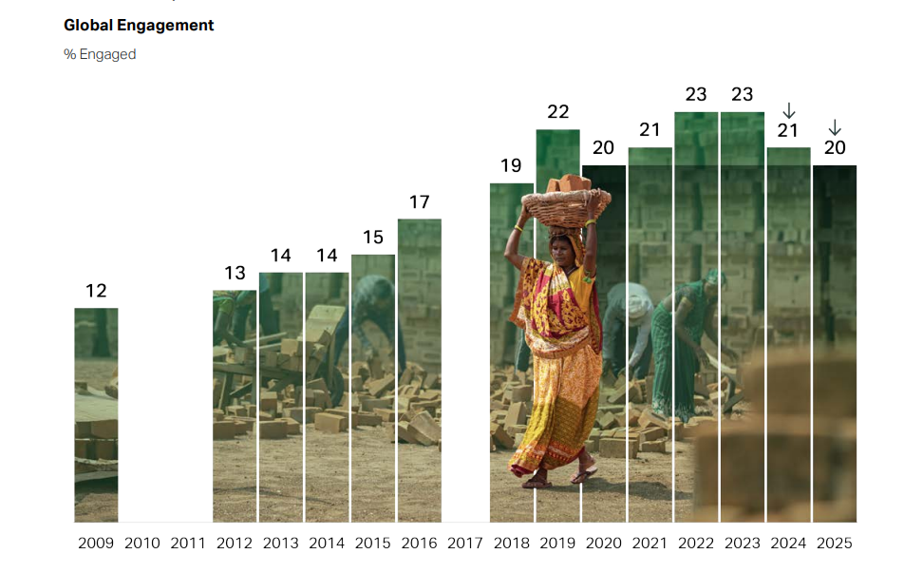
Figure 3: Engagement slump continues globally
(Source: Gallup, 2026)

1.2 Job crafting theory
Job crafting theory considers employees as active participants who are able to shape their own work experiences (Dhanpat, 2025). In this case, employees at Helios must be encouraged for active engagement in tasks, relational as well as cognitive crafting. For instance, software engineers of the firm can voluntarily contribute towards sustainability initiatives beyond their formal roles, and data scientists can make collaborations with the city government stakeholders for solving the existing challenges in the urban mobility (Dhanpat, 2025). This type of flexibility can enable the workers to align their business roles with their personal interests and career aspirations.

1.3 Skills-based architecture and Internal talent marketplaces
In order to complement the JCM and Job crafting, Helios must transit from the traditional “job-based structure” to the “skills-based architecture” (Zhao et al., 2024). Rather than recognizing employees by their job titles, the firm must identify and manage talent based on skills, abilities, and future potential. In terms of individuals' skills, the profiles must include certain competencies like AI, ML, data analytics, and smart-city consulting.
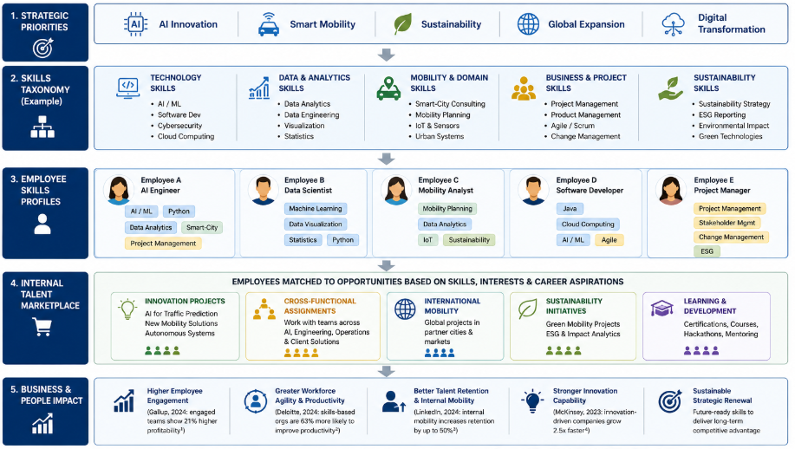
Figure 4: Skills based architecture
(Source: Inspired by Lecture slides, slide 8)
It is also essential to establish an internal marketplace where employees can apply for the short-term projects, such as innovative assignments, international mobility opportunities, and cross-functional programs. This approach will broaden the career opportunities, and individuals can develop new competencies as well.

2. Stimulating intrinsic motivation and supporting innovation through the design

2.1 Stimulating Intrinsic Motivation through Job Design
The proposed job design strategy can facilitate intrinsic motivation at the Helios by creating such meaningful and autonomous work experiences. Referring to JCM, intrinsic motivation develops when the workers experience responsibility and knowledge of results through their work procedures (Zhao et al., 2024). Employees who are in the cross-functional innovation teams are exposed to a diverse range of activities, such as AI development, and so on. Moreover, assigning responsibilities to the workers for projects from start to implementation strengthens the task identity along with ownership. Task significance seems to be reinforced as well by highlighting how the mobility solutions help to reduce traffic congestion, improve the urban sustainability, and enhance the quality of life for citizens. It has been found out that highly engaged employees are more productive, and they contribute positively to the organisational performance, such as engaged employees deliver 14%-18% higher performance in output and sales (Bowen, 2025).

2.2 Supporting Innovation through Job Crafting and Skills-Based Architecture
Job crafting enables the workers for modifying tasks proactively along with relationships and perceptions of work to align their strengths & interest levels properly (Dhanpat, 2025). For example, voluntary participation of the software engineers within sustainability initiatives can develop such innovative mobility solutions. Apart from that, the implementation of a skill-based architecture as well as an internal talent marketplace develops an environment where the workers can move across projects based on their capabilities. Employees can also access the existing opportunities related to AI innovation, international mobility projects, and so on, which ultimately facilitate the sharing of cross-functional knowledge and development of capabilities. As of 2025, 52% employees stated that it is a good time to find a job, although it was still below the 2019 peak (Gallup, 2026) Hence, Helios has to retain its employee base or talent pool through the skill-based architecture to get the best possible outcomes.
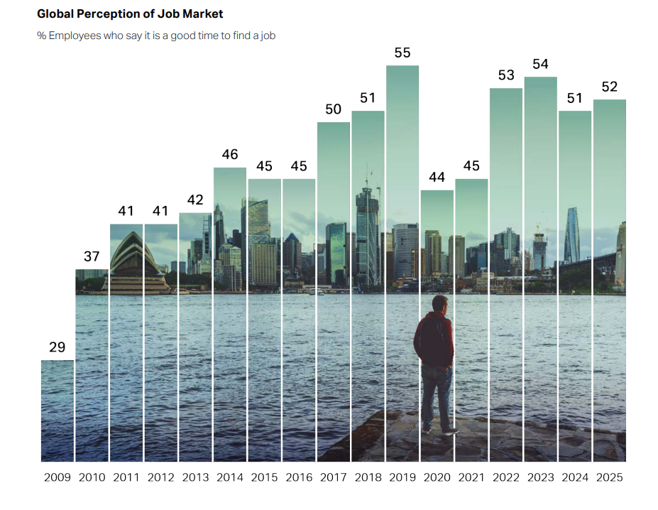
Figure 5: Global perceptions of the job market
(Source: Gallup, 2026)

2.3 Role of Goal Setting Theory and the Performance Management Cycle
The effectiveness of the proposed design can be more clearly evaluated through the “Goal-setting theory” and “Performance management cycle”. As per the “Goal setting theory”, specific and challenging goals capture direct attention, stimulate the effort level, encourage the skill utilisation, and increase the persistence throughout (Locke and Latham, 1190).
At Helios, the workers must be assigned with the innovation-focused objectives, such as the development of the new functionalities of AI, improvement of the system efficiency, and contribution towards sustainability projects. These goals encourage the workers for applying their knowledge as required and pursue the continuous improvements.
Considering the “Performance Management Cycle”, it has been observed that it delivers a structured mechanism to sustain motivation as well as innovation. At the “performance planning stage”, innovation goals along with development objectives must be established jointly between the employees and the managers of Helios.
In the “performance management stage”, coaching on a continuous basis, receiving feedback, and mentoring can help the workers to overcome existing obstacles and improve the innovative ideas (Van Dooren et al., 2025).

TASK C: Reflective report

1. Using AI as a decision-support tool without eroding critical human judgment
The reflection has been drafted with Driscoll's (2007) What? – So what? – Now What? Model to determine the future use of artificial intelligence (AI) and its role in strategic human resource management (HRM).
What?
Workforce strategies are affected by AI-driven H technologies, typically the planning, recruitment, performance management and talent analytics. During this module, AI is recognised as an important tool to support decision-support systems for analysing large datasets and identifying workforce trends. Additionally, I also perceived AI as a system to develop biased recommendations without analysing contextual factors and creating dependence on algorithmic outputs.
So what?
From this module work, the importance of balancing human judgement and technological capacity is highlighted. Strategic HR decisions are essential on ethical consideration, employee wellbeing, organisational culture and stakeholder management, while AI is used for improved analytical accuracy and efficiency (Rodgers et al., 2023). I consider that AI augmentation in the ethical and stakeholder-focused organisational operations will ensure improved outcomes without replacing managerial judgement. Therefore, human-oriented decision-making can be achieved through the evaluation of standard assumptions while challenging AI-generated recommendations regarding overall organisational consequences.
Now what?
Considering future practice, I consider the need to use AI selectively for data analysis and scenario modelling to support decisions while maintaining judgemental accountability and decision-making. Critical evaluation of AI outputs will support standard verification of drawn conclusions along with organisational evidence (Parycek et al., 2024). Consideration of ethical implications is also essential here. Therefore, this approach is effective in ensuring AI-enabled insight integration with professional responsibility against mechanical decision-making.

2. Personal capability development plan
Personal capability for strategic decision-making is essential to support organisational outcomes. The module learning has highlighted capabilities regarding the growing use of digitised HR environments globally. Henceforth, I have also identified the opportunities to improve analytical, technological and leadership capabilities.
Capability area | Current developmental needs | Planned developmental activities | Timeline | Expected outcome
Data literacy | Interpretation skills regarding workforce analytics and HR metrics | - Certification of HR analytics and Power BI  - Case study mediated decision-making practices | 6-12 months | Improved capabilities in workforce trend analysis and evidence-based HR decision-making
AI augmentation in HR | AI application and HR-related ethical risk analysis | - AI-in-HR course enrolment  - Applying HR analytics tools  - Following emerging AI governance frameworks | 6-12 months | Responsible use of AI and strategic decision-making
Strategic skills to influence | Confident approach to influence senior stakeholders and support institutional change | - Presentation and group activity participation  - Leadership workshop and consultancy-based project participation | 12 months | Improved capabilities in communication, stakeholder management and negotiation
Awareness of global mobility | Limited knowledge in international and expatriate HR challenges | - Operational involvement in international HR practices  - Cross-cultural training  - Management studies on the global workforce control | 12-18 months | International workforce mobility knowledge and improved capability in managing a diverse workforce
Table 4: Personal capability development plan
(Source: Influenced by Jia and Tu, 2024; writing your reflective log PPT)
The reflection highlighted the skills and capabilities required for future employability with technological competence. Critical judgment, strategic thinking and ethical reasoning are part of it. Hence, operational success can be achieved with the obtained skills, considering the complex global business environment.

Reference
Bakhshandeh, B., Rothwell, W.J. and Zaballero, A.G., (2024). The Inclusive, Empathetic, and Relational Supervisor: Managing Diverse Employees Through Interpersonal Relationships. Productivity Press.
Bowen, L., (2025). ‘Employee Productivity Statistics You Need to Know in 2025’. Available at: https://www.yomly.com/employee-productivity-statistics/ (Accessed: 26 May 2026)
Dhanpat, N., (2025). ‘Job crafting agility: a conceptual proposition for rethinking behaviour in organizations.’ International Journal of Organization Theory & Behavior, 28(1), pp.18-33. Available at: https://doi.org/10.1108/IJOTB-03-2023-0062
Gallup, (2026). ‘State of the Global Workplace 2026’. Available at: https://www.gallup.com/workplace/349484/state-of-the-global-workplace.aspx (Accessed: 20 May 2026)
Godinho, T., Reis, I.P., Carvalho, R. and Martinho, F., (2023). ‘Onboarding handbook: An indispensable tool for onboarding processes’. Administrative sciences, 13(3), p.79. Available at: https://doi.org/10.3390/admsci13030079
Jia, X.H. and Tu, J.C., (2024). ‘Towards a new conceptual model of AI-enhanced learning for college students: The roles of artificial intelligence capabilities, general self-efficacy, learning motivation, and critical thinking awareness’. Systems, 12(3), p.74. Available at: https://doi.org/10.3390/systems12030074
Jooss, S., Collings, D.G., McMackin, J. and Dickmann, M., (2024). ‘A skills‐matching perspective on talent management: Developing strategic agility’. Human Resource Management, 63(1), pp.141-157. Available at: https://doi.org/10.1002/hrm.22192
Locke, E. A., and Latham, G. P. (1990). ‘A theory of goal setting and task performance’. Upper Saddle River, NJ: Prentice Hall.
Lourenço, B. and Rodrigues, R., (2025). ‘Organisational onboarding and talent retention: The mediating role of workplace attachment and supervisor support’. Social Sciences & Humanities Open, 12, p.101909. Available at: https://doi.org/10.1016/j.ssaho.2025.101909
Parycek, P., Schmid, V. and Novak, A.S., (2024). ‘Artificial Intelligence (AI) and automation in administrative procedures: Potentials, limitations, and framework conditions’. Journal of the Knowledge Economy, 15(2), pp.8390-8415. Available at: https://doi.org/10.1007/s13132-023-01433-3
Ricciardelli, R., (2022). ‘Socialization Across the Three Stages of the Correctional Services of Canada's Correctional Officer Training Program: An Ethnographic Study’. Qualitative Criminology (QC), 11(1), p.3. Available at: https://doi.org/10.21428/88de04a1.2cb79f6d
Rodgers, W., Murray, J.M., Stefanidis, A., Degbey, W.Y. and Tarba, S.Y., (2023). ‘An artificial intelligence algorithmic approach to ethical decision-making in human resource management processes’. Human resource management review, 33(1), p.100925. Available at: https://doi.org/10.1016/j.hrmr.2022.100925
Rogozińska-Pawełczyk, A. and Gadomska-Lila, K., (2022). ‘The mediating role of organisational identification between psychological contract and work results: an individual level investigation’. International Journal of Environmental Research and Public Health, 19(9), p.5404. Available at: https://doi.org/10.3390/ijerph19095404
Van Dooren, W., Bouckaert, G. and Halligan, J., (2025). ‘Performance management in the public sector.’ Routledge.
Verhaelen, B., Martin, M., Peukert, S. and Lanza, G., (2023). ‘Practice-oriented methodology for increasing production ramp-up efficiency in global production networks of SME’. Production Engineering, 17(1), pp.145-177. Available at: https://doi.org/10.1007/s11740-022-01154-7
Zhao, S., Ping, J., Zhu, H., Ji, W., Wang, Y. and Wang, Y., (2024). ‘Job characteristics model-based study of the intrinsic motivations for primary care practitioners.’ Chinese General Practice Journal, 1(1), pp.3-10. Available at: https://doi.org/10.1016/j.cgpj.2024.03.004

