Name of the Team: BCRD
Team Members
Student Name | Student ID
Benjamin | 2003557
charlie wilkinson | 2104032
rhys davies | 2104756
dylan jones | 2106499

Team Evaluation (Self Evaluate your Team) (1 – Worst, 5 – Best)
 | 1 | 2 |  | 3 |  | 4 |  | 5
Benjamin |  |  |  |  | x
Charlie |  |  | x
Rhys |  |  |  |  |  |  |  |  | x
Dylan |  |  |  |  | x
N/A
Rate your Teams Contribution with a scale of 1 to 5 (1 No Contribution and 5 Excellent Contribution)
Add your comments on Team Evaluation: (Justify your evaluation)
N/A:
Rhys: will contribute with the screenshots and writing
Dylan: will help with the screenshots
Charlie: will contribute to the work and help out
Benjamin: highly motivated and will get his work done

Table of Contents
Abstract 4
Introduction 4
Task 1 4
Task 2 11
Task 3 15
Enhancing Security on a SOHO Network 15
Failover Clustering for High Availability Systems/Services 16
Draft Network Policy: 17
References 19

Figure 1 This screenshot shows the windows computer accessing the local drive 5
Figure 2 This screenshot shows the folder being created in the local drive 5
Figure 3 This image shows the confidential file having its permissions changed 6
Figure 4 This image shows the full list of permissions and what permissions each user has for that specific file 6
Figure 5 This screenshot shows the user having their permissions changed 7
Figure 6 This screenshot shows the inside of the text document 7
Figure 7 This screenshot shows a user setting up a server in server manager 8
Figure 8 This screenshot shows the group policy management application being used to manage different policies for each user so they don’t access stuff they are not supposed to 8
Figure 9 This image proves that the main user cannot access the control panel after having their permissions revoked 9
Figure 10 This image shows the user adding a new organisational unit to the folder in the group policy managment program 9
Figure 11 This shows that the PC is the domain controller 10
Figure 12 This image shows the folder for the active directory and computer program being created 10
Figure 13 This shows the folder being moved 11
Figure 14 This image proves that the main PC cannot install programs onto the computer itself becuase there were restrictions put in place 11
Figure 15 This image shows the network cards information 12
Figure 16 This image shows the route the network traffic will take 12
Figure 17 This image shows an additional server being created 13
Figure 18 This image shows the computer management software on server 2 13
Figure 19 This image shows the internet information services manager options 14
Figure 20 This shows a successful ping has been completed 14

Introduction

Task 1
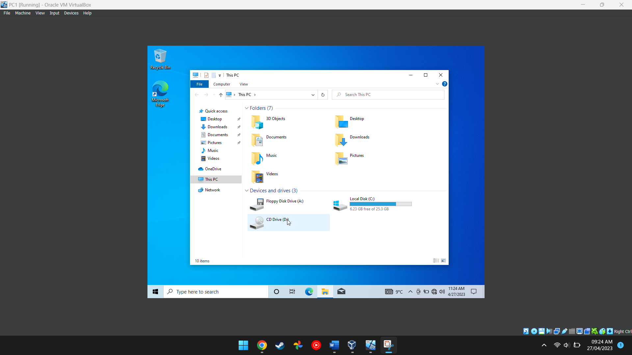
Figure 1 This screenshot shows the windows computer accessing the local drive
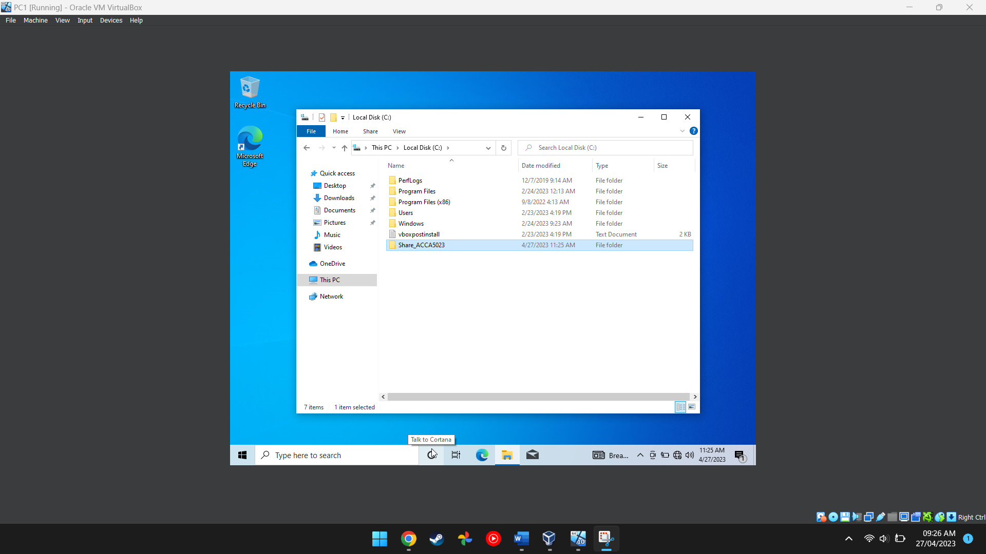
Figure 2 This screenshot shows the folder being created in the local drive
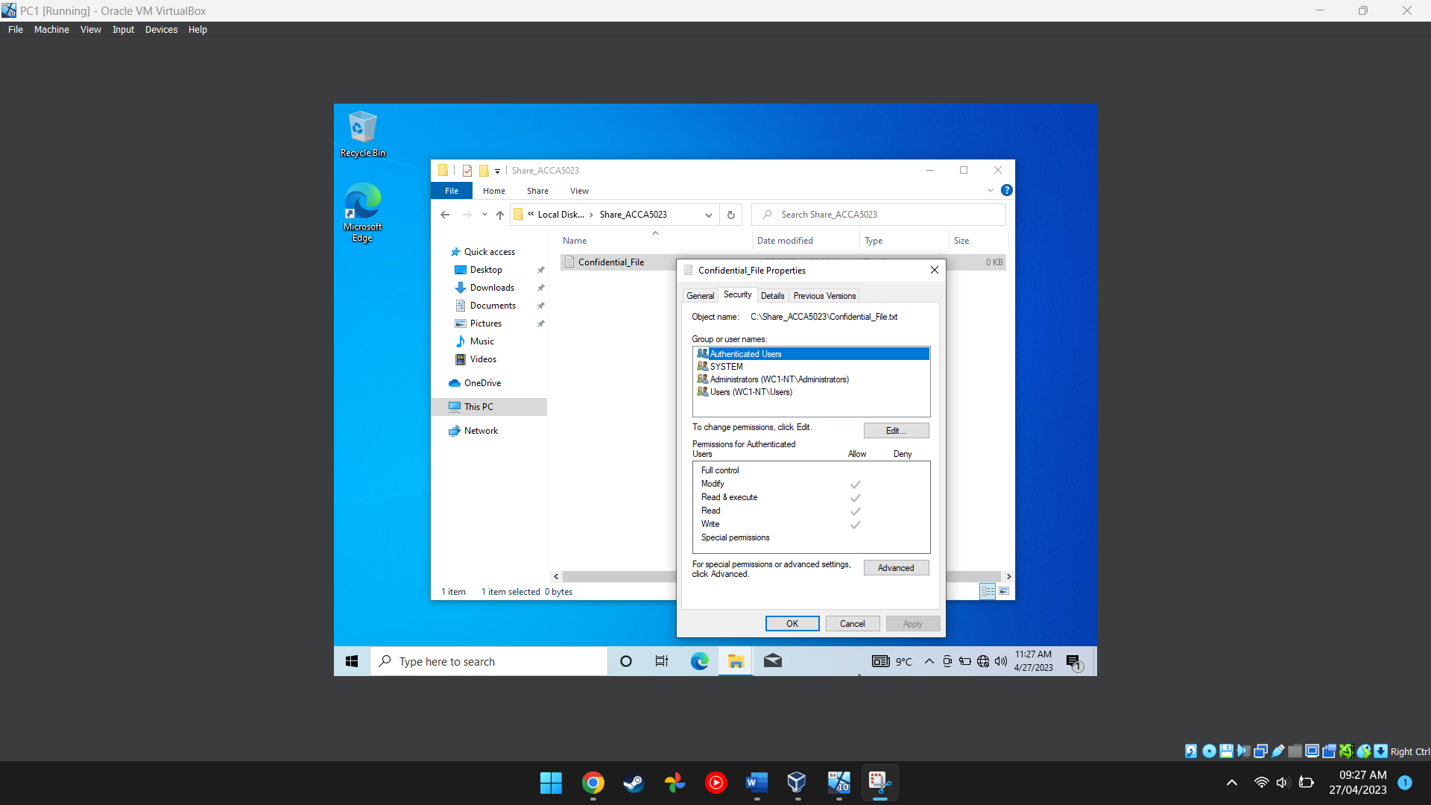
Figure 3 This image shows the confidential file having its permissions changed
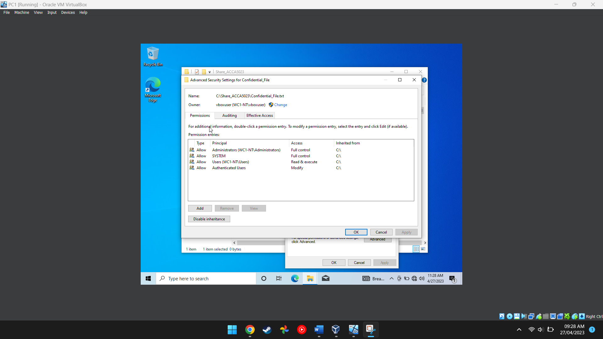
Figure 4 This image shows the full list of permissions and what permissions each user has for that specific file
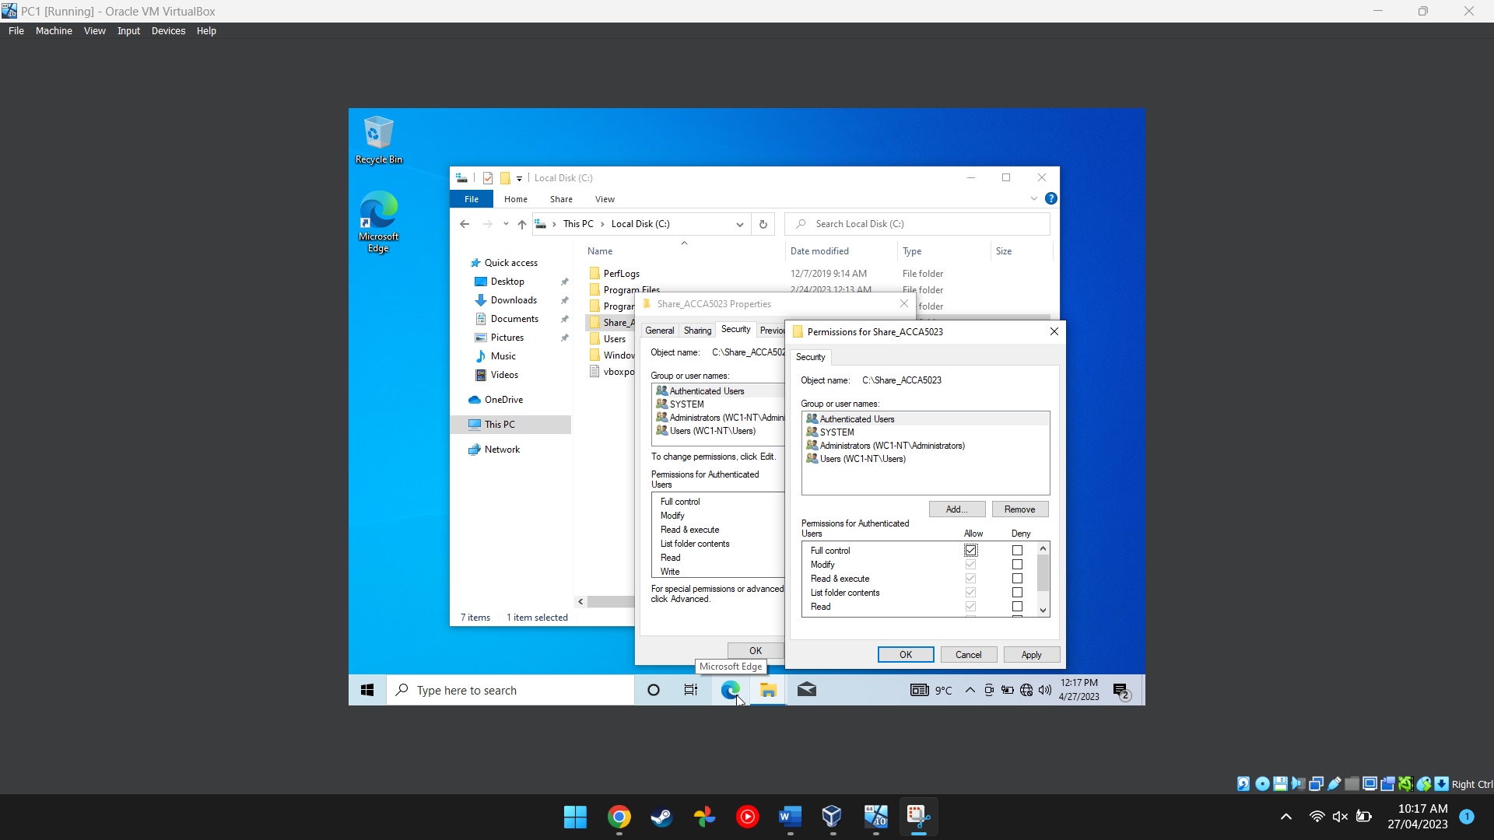
Figure 5 This screenshot shows the user having their permissions changed
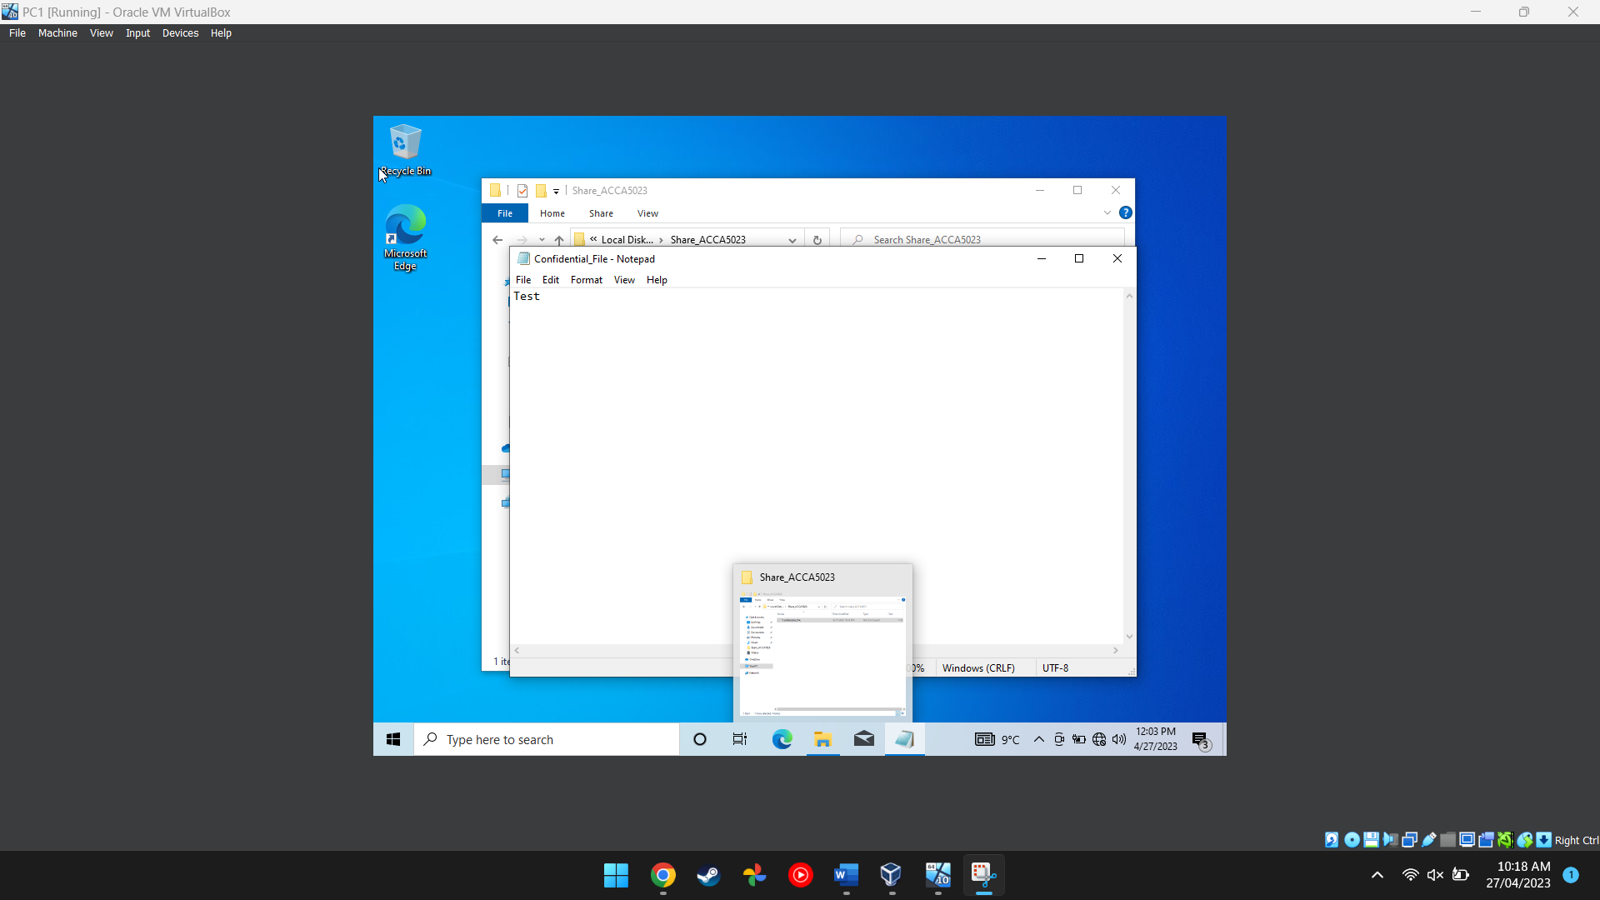
Figure 6 This screenshot shows the inside of the text document
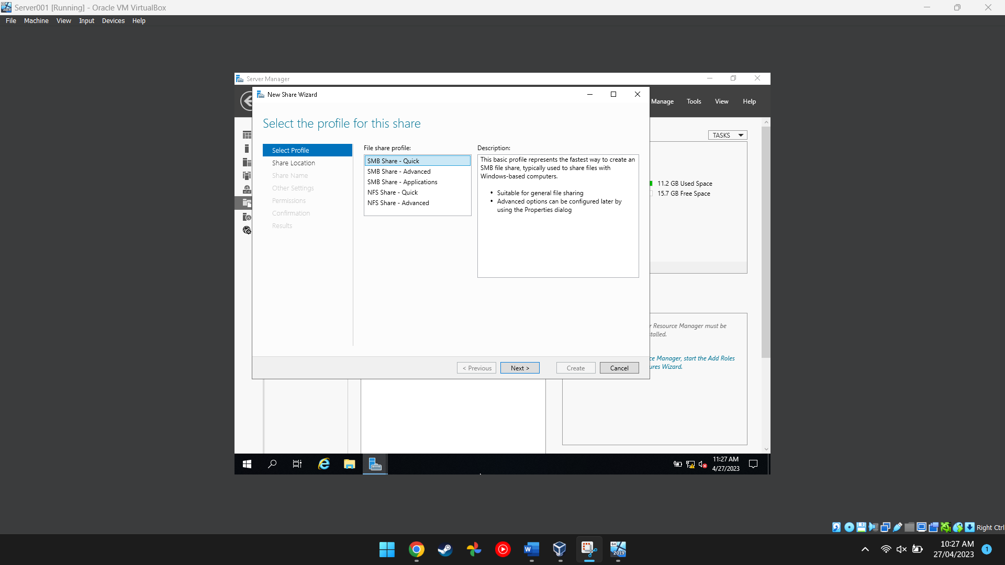
Figure 7 This screenshot shows a user setting up a server in server manager
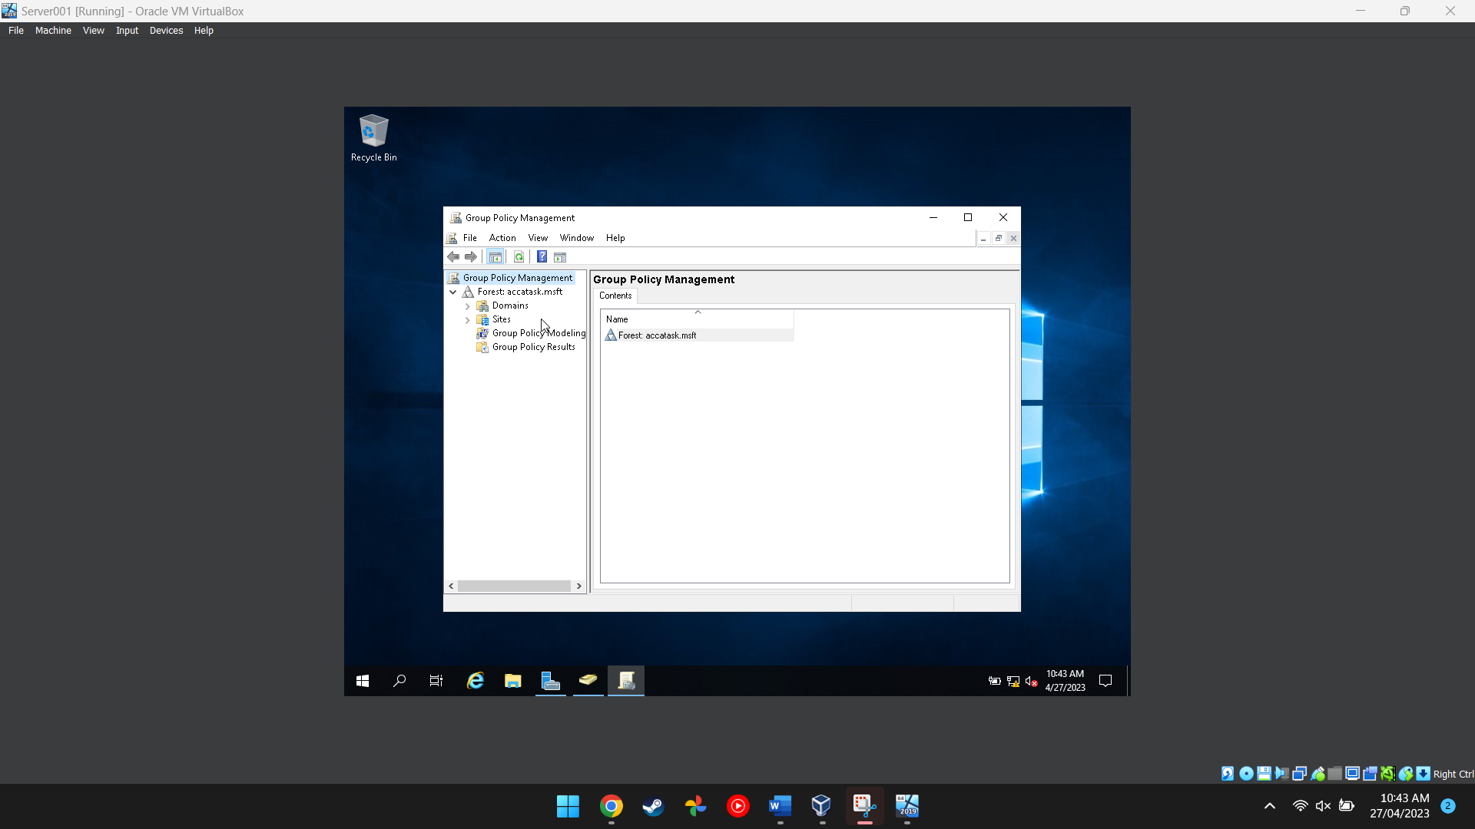
Figure 8 This screenshot shows the group policy management application being used to manage different policies for each user so they don’t access stuff they are not supposed to

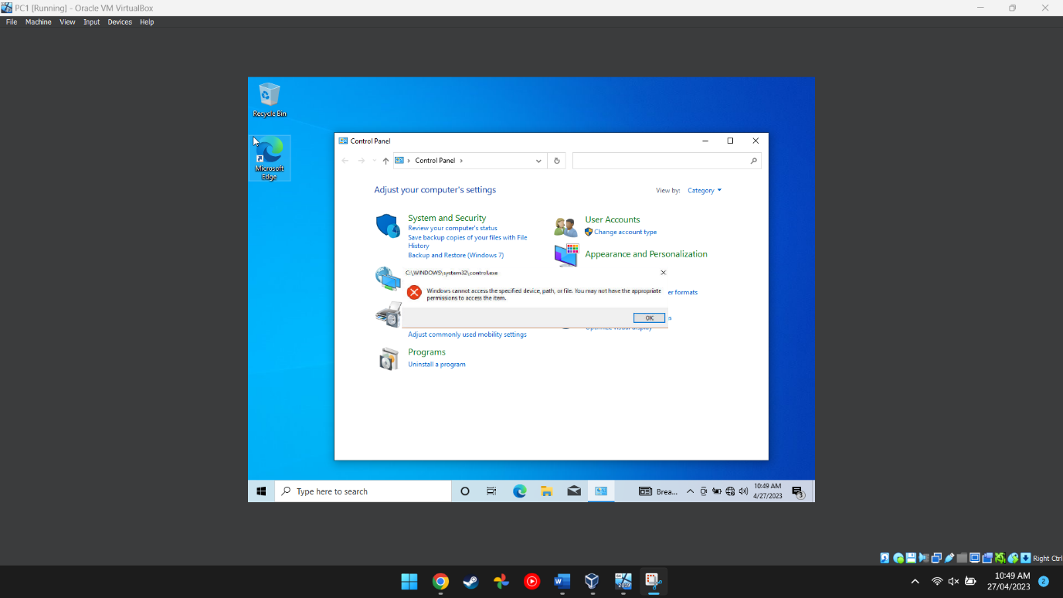
Figure 9 This image proves that the main user cannot access the control panel after having their permissions revoked

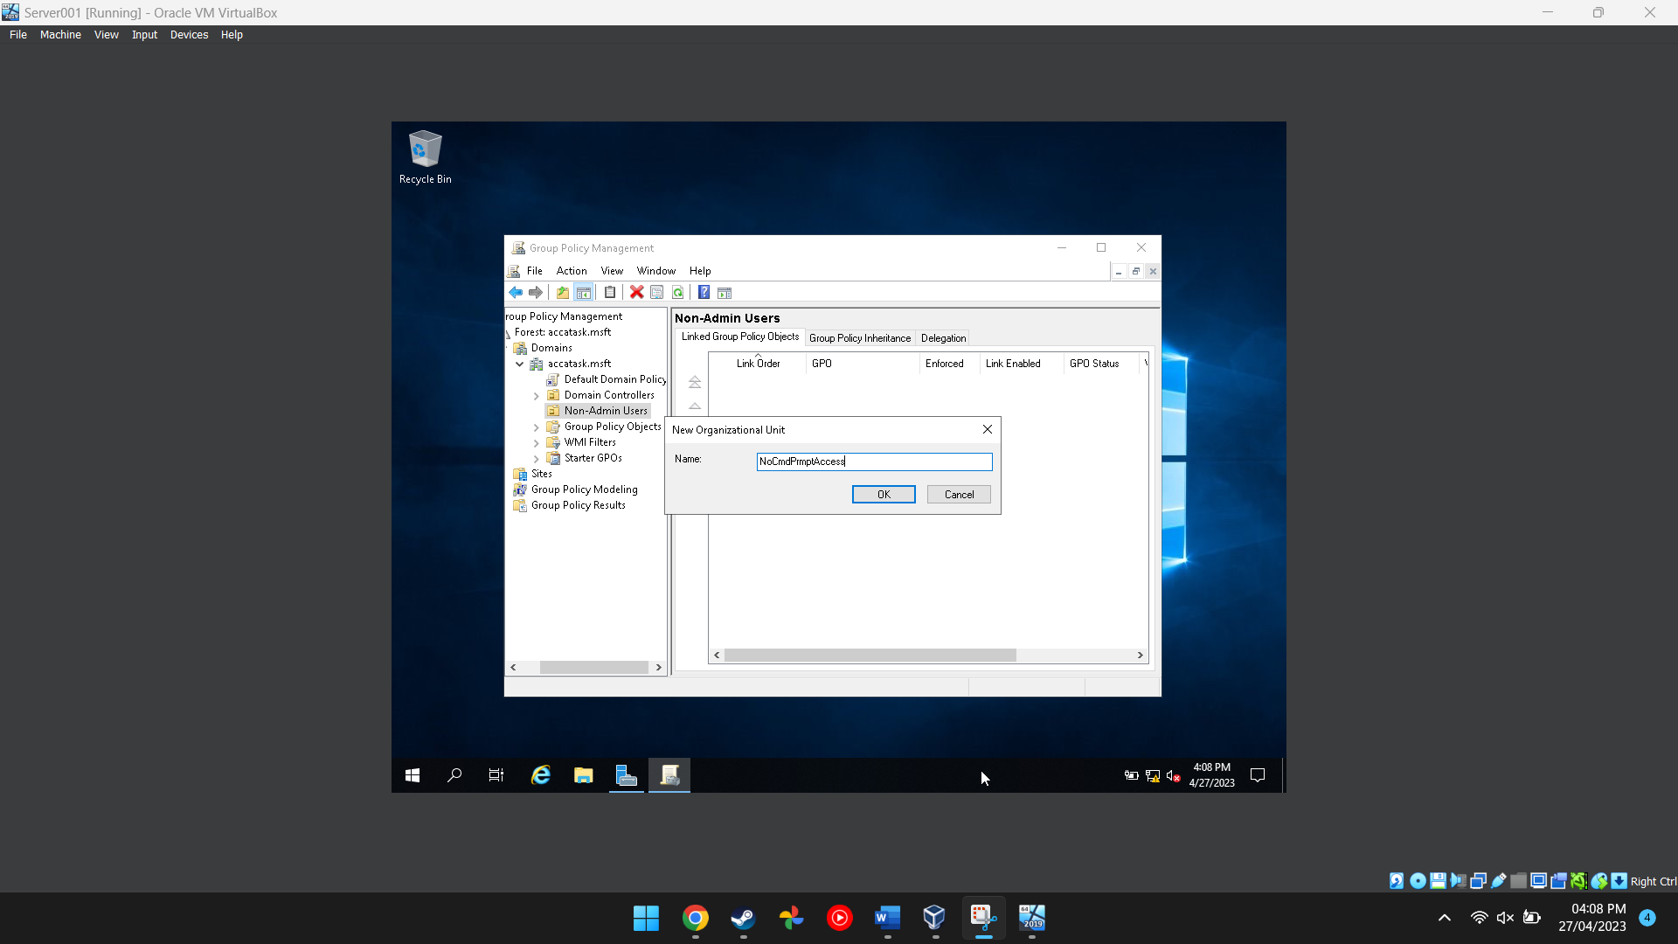
Figure 10 This image shows the user adding a new organisational unit to the folder in the group policy managment program
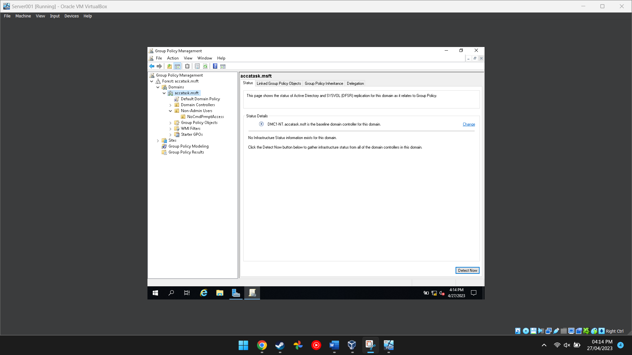
Figure 11 This shows that the PC is the domain controller

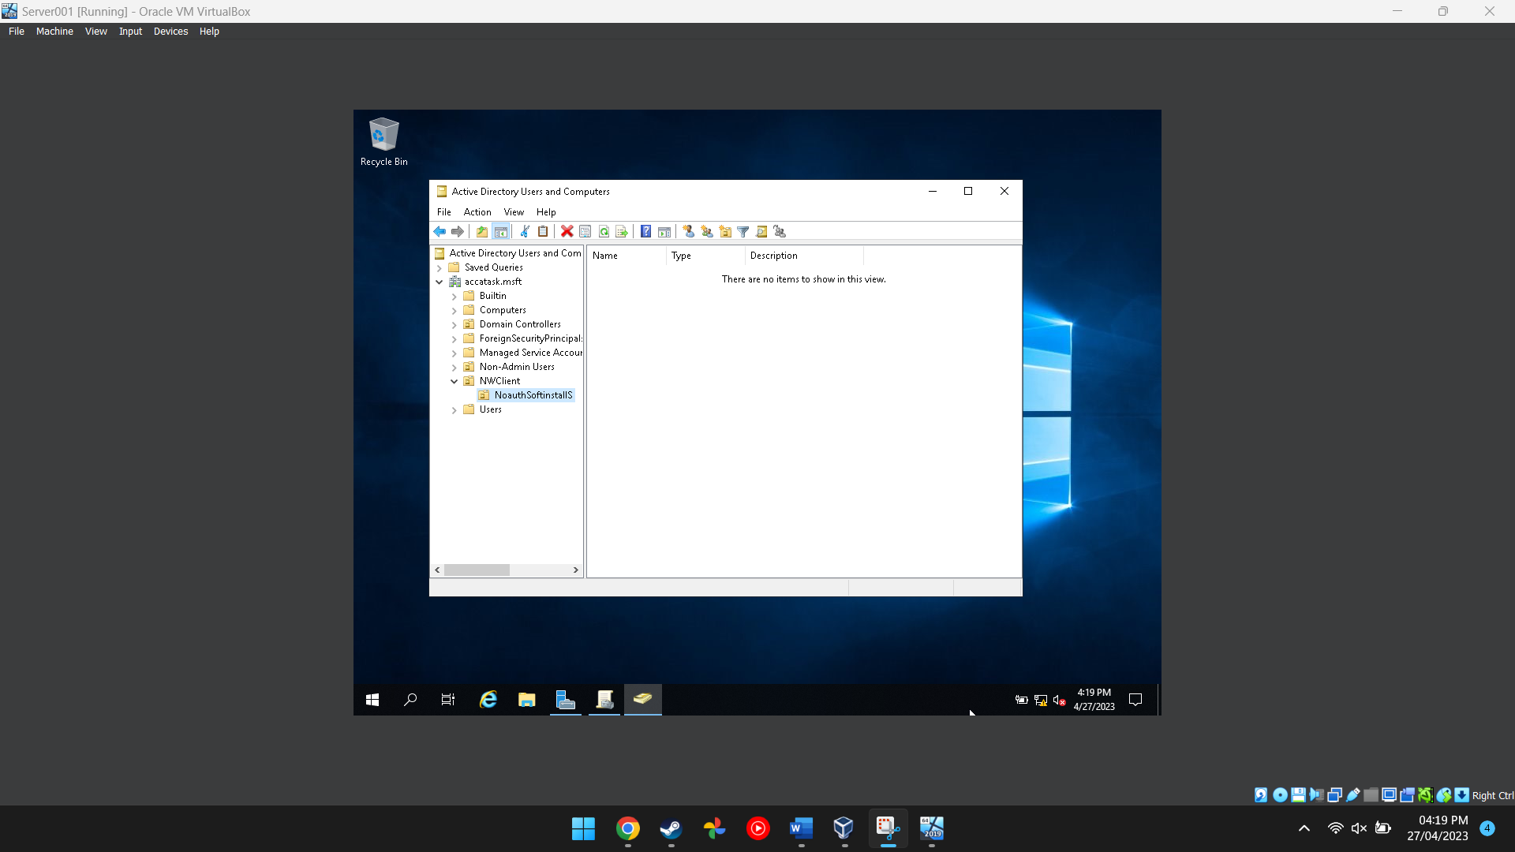
Figure 12 This image shows the folder for the active directory and computer program being created

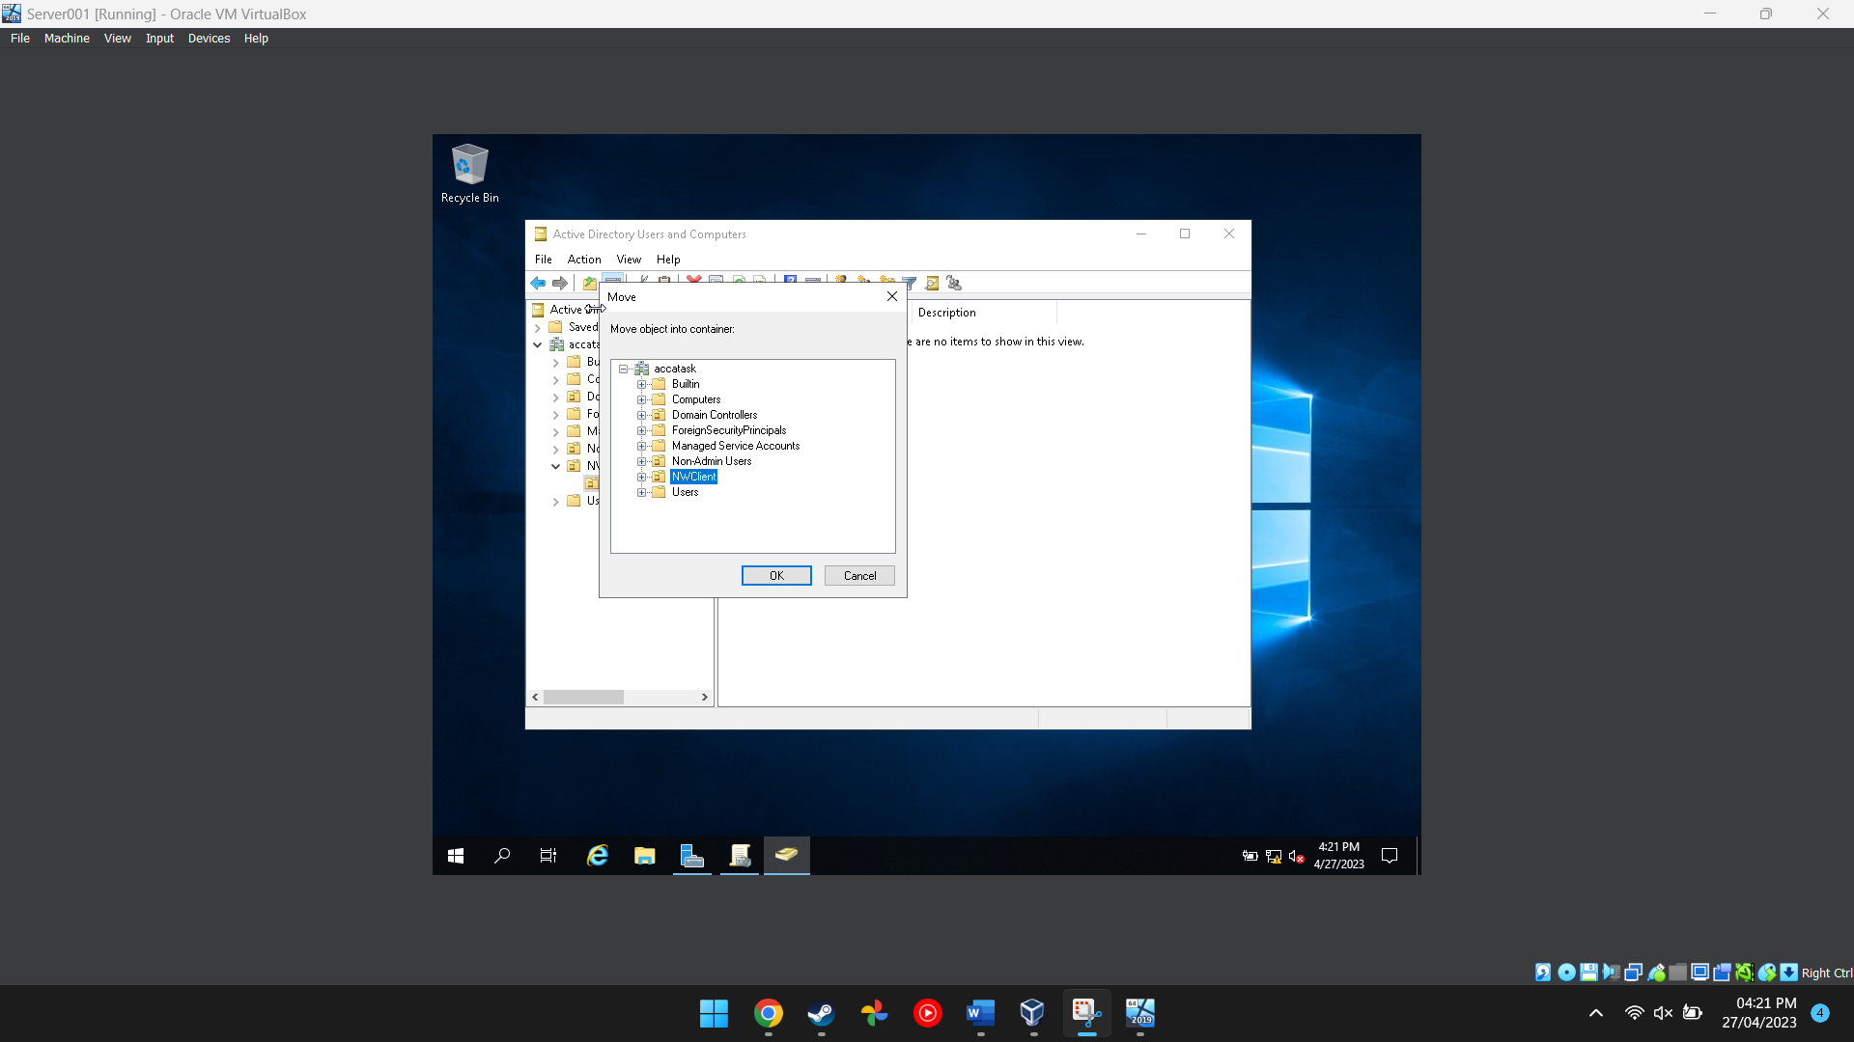
Figure 13 This shows the folder being moved

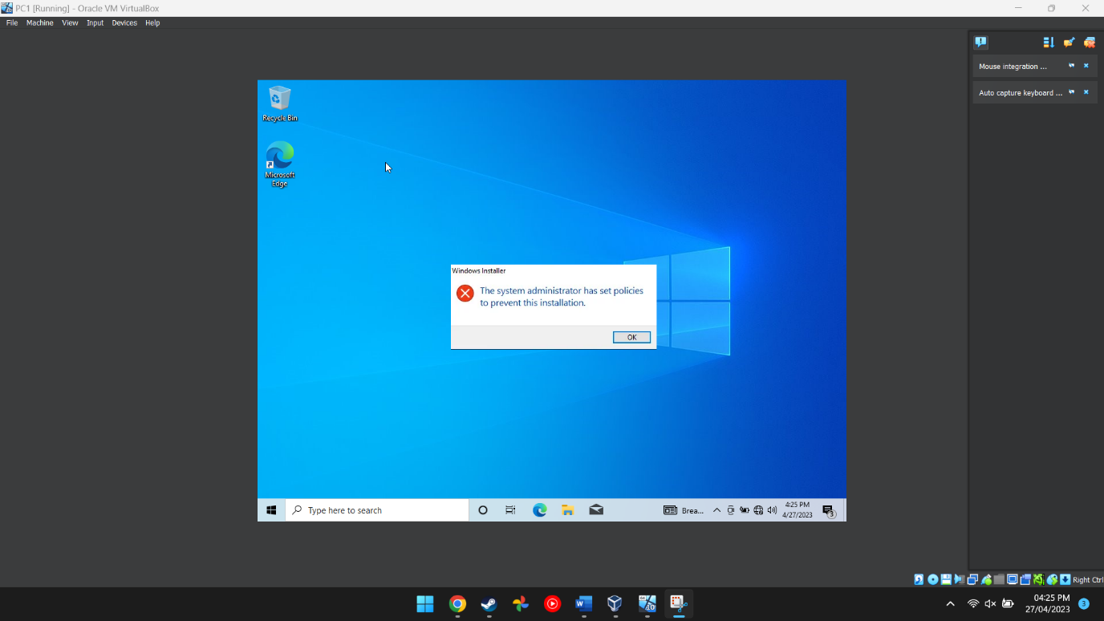
Figure 14 This image proves that the main PC cannot install programs onto the computer itself becuase there were restrictions put in place

Task 2
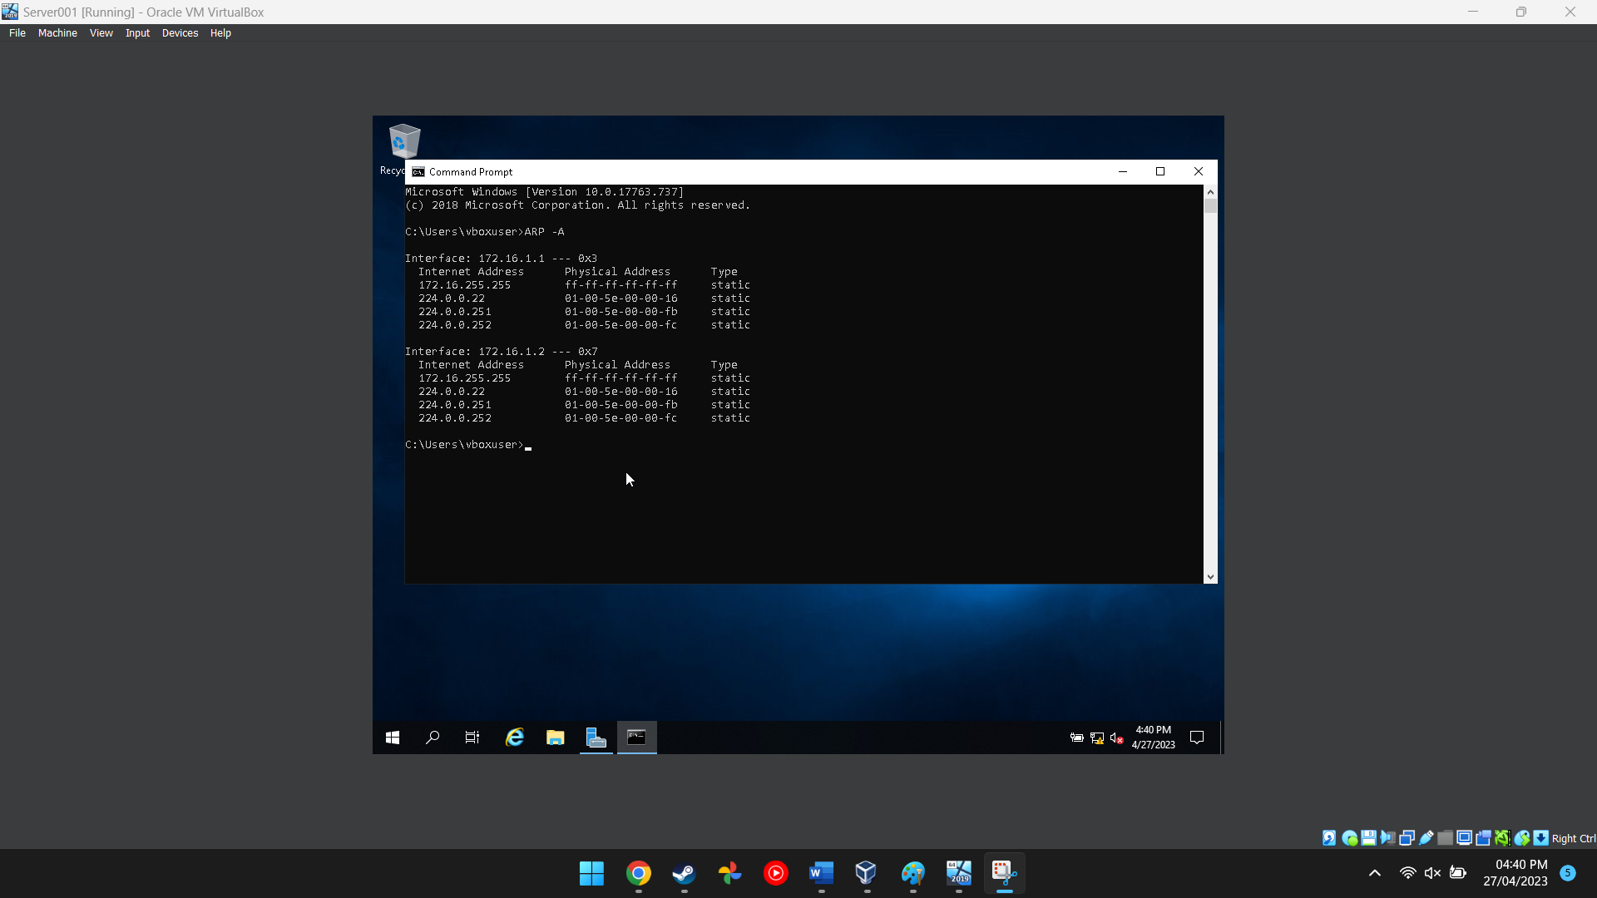
Figure 15 This image shows the network cards information
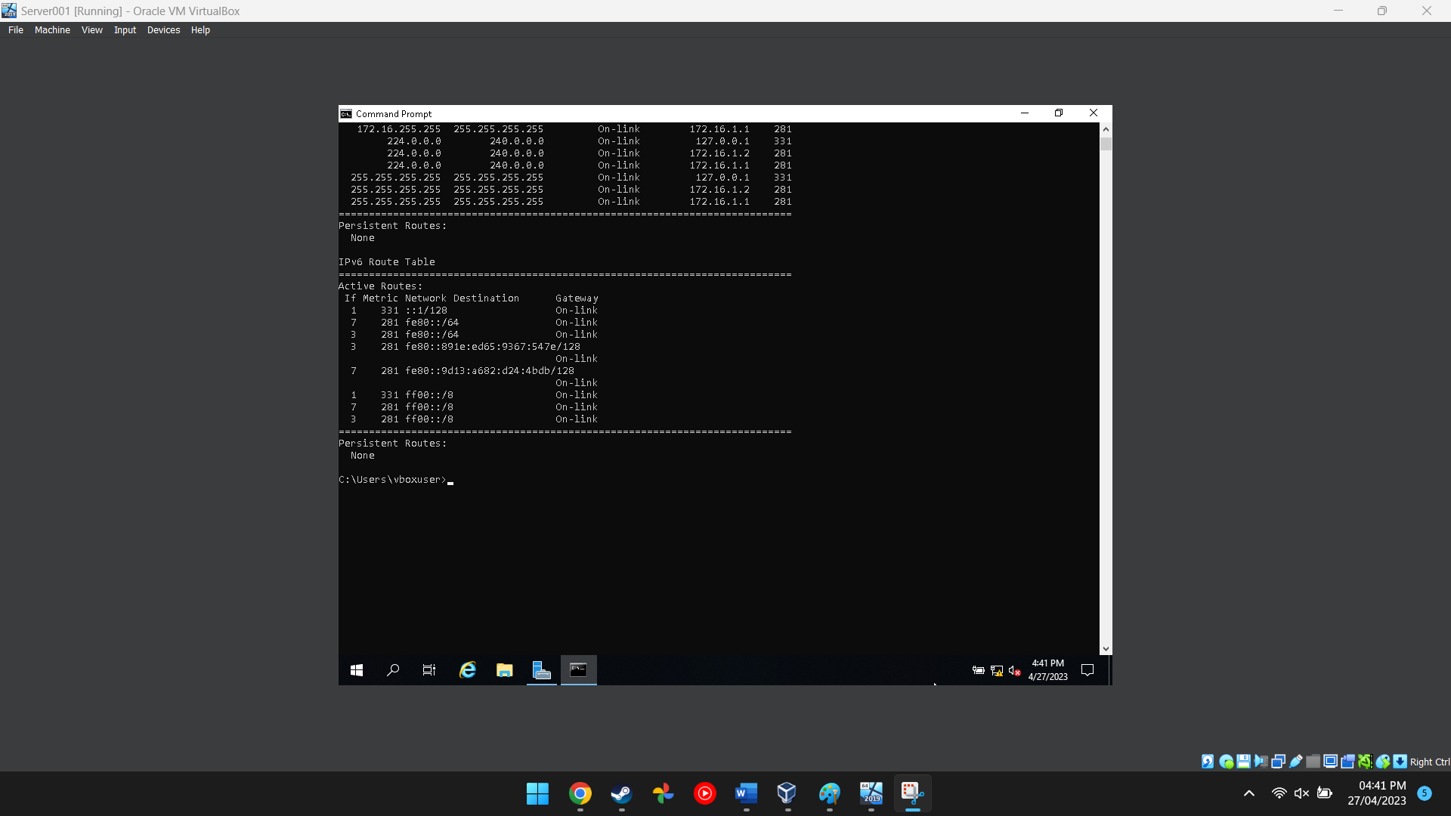
Figure 16 This image shows the route the network traffic will take
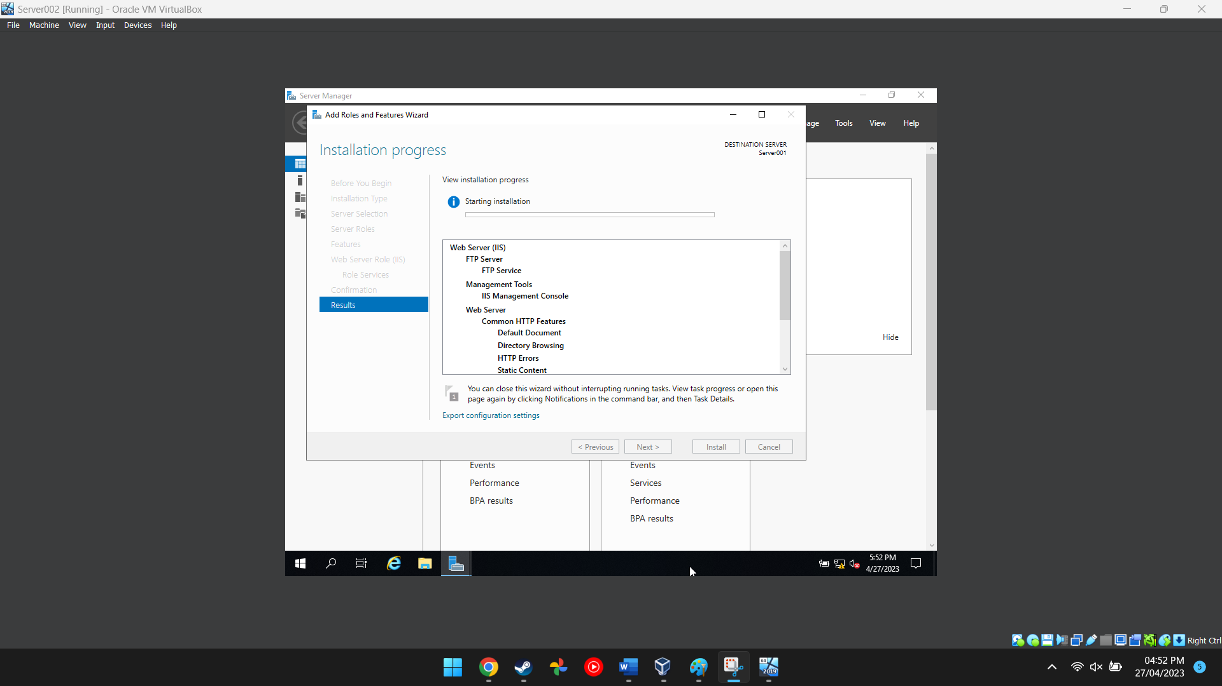
Figure 17 This image shows an additional server being created
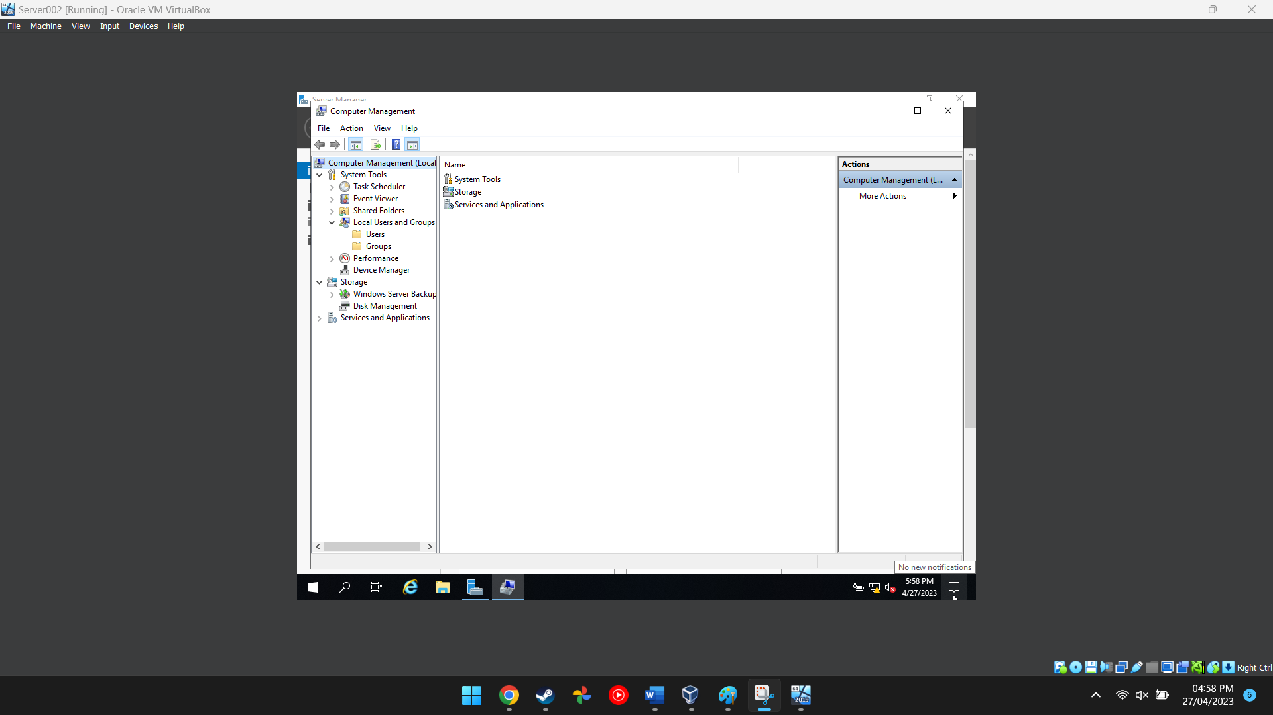
Figure 18 This image shows the computer management software on server 2
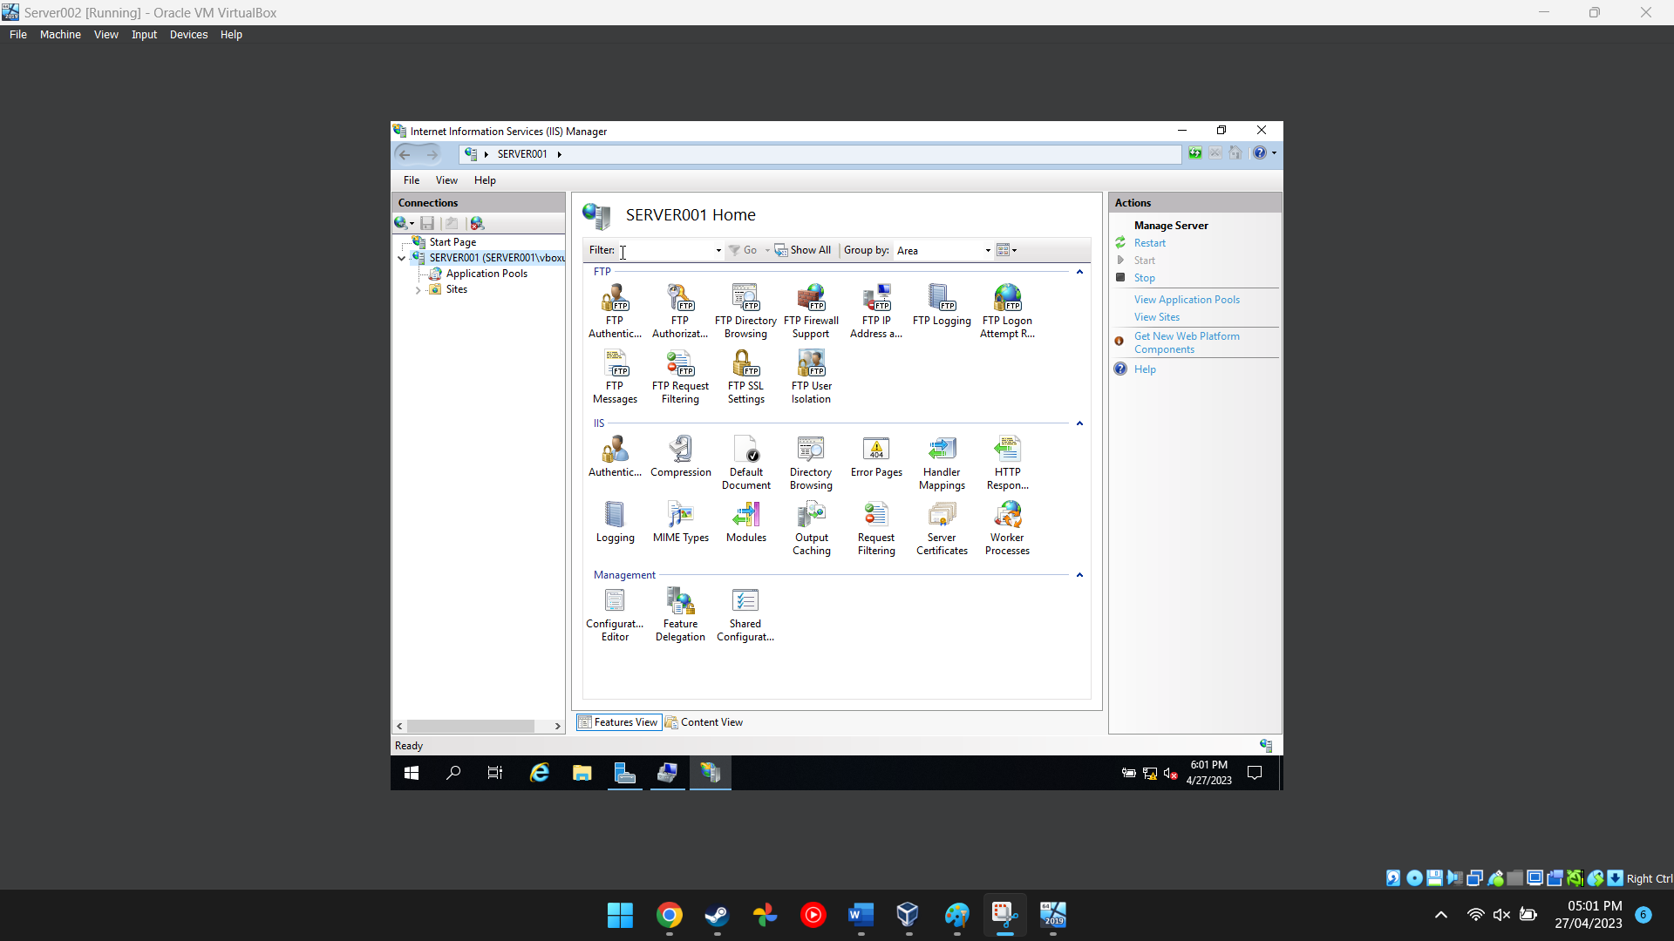
Figure 19 This image shows the internet information services manager options
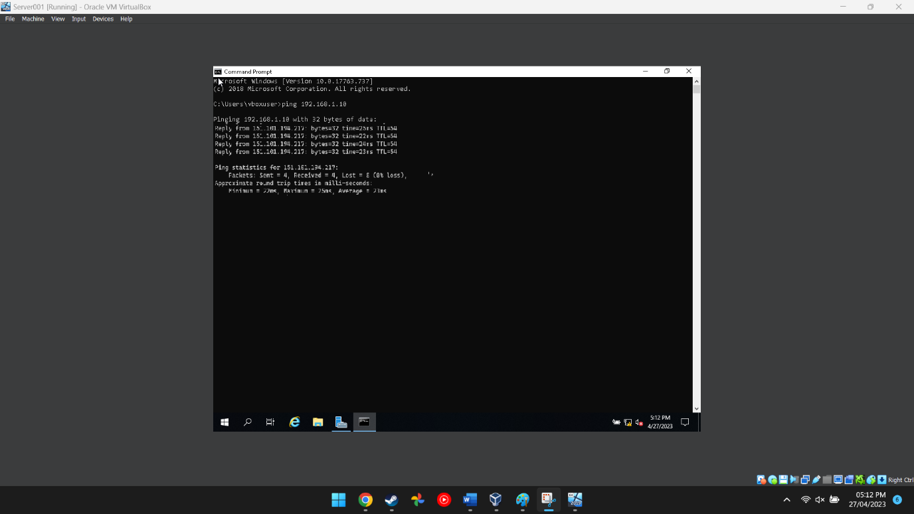
Figure 20 This shows a successful ping has been completed

Task 3

Enhancing Security on a SOHO Network
Usually used in homes or small offices, a Small Office/Home Office (SOHO) network is a type of computer network. There are various steps that can be performed to make sure a SOHO network is secure when contemplating boosting security.
Changing the default password on routers, switches, and other networking equipment is one of the first things that may be done [1]. This will make it less likely that the network and devices will be accessed improperly. Enabling network encryption, such as WPA2, is another option for preventing unauthorised users from intercepting wireless transmissions [2]
All network-connected devices, including computers, mobile phones, and tablets, should also have antivirus and anti-malware software installed and updated on a regular basis. This will assist in defending against viruses, malware, and other harmful software that might jeopardise the network's security [3].
Other measures include creating distinct network segments for various types of devices, limiting physical access to the network, and locking up or securing network equipment (e.g., IoT devices on a separate segment from computers and smartphones) [4].
Regularly updating all network devices' software and firmware is a crucial step in boosting security on a SOHO network [5]. This entails upgrading the firmware on the router as well as any software or operating systems on the PCs and other network-connected devices. Keeping all software updated might assist to prevent security breaches since software vulnerabilities are a regular target for hackers.
Using strong passwords for all user accounts and network-connected devices is another technique to increase security on a SOHO network [1]. Long passwords with a variety of capital and lowercase characters, digits, and symbols are recommended. Passwords must also be updated often to avoid unwanted access.
Finally, it's critical to inform all network users about the best practises for online security. To achieve this, one must refrain from opening files from dubious sources or clicking on strange links. One should also be aware of frequent phishing schemes and other internet dangers. With a combination of strong security measures and user education, a SOHO network can be made much more secure and less vulnerable to attacks.

Failover Clustering for High Availability Systems/Services
Failover clusters are a set of physical or virtual computer servers that enable numerous applications and services to function in a High Availability (HA) or Continuous Availability (CA) environment [6]. Hardware and software selection is a critical consideration when implementing a failover cluster to avoid single points of failure. Dependable and redundant hardware components with multiple power sources, network interfaces, and storage devices are necessary, as are software components that can quickly and efficiently manage failover and recovery operations and are compatible with the cluster's hardware and other software components [6]. Failover Clustering capability is one possible function within the Windows Server OS environment that can meet these requirements, providing automated failover for virtual machines and other services running on a cluster of servers [6].
The setup of the cluster is another crucial consideration, which includes configuring networking, storage, and other settings, as well as building virtual machines or other resources that will be hosted on the cluster. Administrators can use the Failover Cluster Manager tool in Windows Server to establish and manage failover clusters [7].
Before configuring the failover cluster, the administrator must install the Failover Clustering feature on each server that will be part of the cluster. This can be done using the Add Roles and Features Wizard in Server Manager [8]. Once the functionality has been implemented, the administrator can use the Failover Cluster Manager tool to create a new cluster, add servers to the cluster, and define the parameters for virtual machines and other resources that will be hosted [7].

Draft Network Policy:
Assumptions: This corporate network utilizes both wired and wireless network infrastructure in multiple locations, consisting of servers, access points, firewalls, routers, and switches. Critical business applications such as finance, inventory management, sales, and customer relationship management systems are in use.
Architecture/Topology/Design/Layout: The hierarchical structure of this corporate network will consist of the core, distribution, and access layers, with redundant links between the core and distribution levels and between the distribution and access layers to ensure high availability. The network will also incorporate virtual local area networks (VLANs) to segment network traffic and enhance security.
Network Access: Access to the network will require usernames, passwords, and digital certificates to approve and authenticate network access. Network access will be provided based on the user's position within the business and the necessity to access particular resources. To maintain network security, network access policies will be frequently reviewed and revised as necessary [9].
Security Team: A dedicated security staff will handle the execution and enforcement of security policies, analysing security threats and finding potential network vulnerabilities. The security team will work closely with the network team to enforce security rules and respond to security events [10].
Enforcement of Security Policies: Compliance with security policies is mandatory for all network users, and failure to comply may result in disciplinary action, including termination of employment. Security policies will be regularly reviewed and updated to ensure maximum security [11].
Scope of Security Changes: Any alterations to network architecture or security rules will be carefully considered and executed in stages. All network infrastructure modifications will undergo lab testing before being implemented in the real-world setting [12].
Monitoring the Security Operations: The security team will continuously monitor the network for security breaches and respond quickly to any incidents. To identify potential security events, log data will be gathered and analysed. Network users must report any security incidents to the security staff [13].
Mitigations in the Event of Violations: In the event of security violations, the security team will take appropriate actions to mitigate the effects of the violation and prevent future violations. These actions may include disabling network access, blocking network traffic, and conducting a thorough investigation of the incident [14].
In summary, this business network policy ensures the network's security and high availability. The policy will be frequently reviewed and revised to maintain the highest level of security.

During the completion of our group project, it was evident that not all members contributed equally. While one member, namely person one, had a significant role in the project's completion, another member, person two, contributed very little to the project. Regrettably, person two spent the majority of their time playing video games or watching videos on YouTube, leaving the project's ultimate responsibility on person one and me.
Despite my efforts to involve person two in the project, they were not interested in contributing, and their active participation was minimal. Person one, on the other hand, was a remarkable team player who actively contributed to the project's success. Their collaborative efforts and expertise helped me to comprehend complex concepts, and we effectively divided our work to avoid confusion and ensure efficiency in the project's completion.
However, given the project's scope, it is essential that all group members dedicate themselves to the project equally. Unfortunately, person three failed to attend any lectures, causing the project's weight to fall on the rest of us.
Overall, the project's successful completion offered an opportunity to demonstrate the importance of hard work and effective teamwork within a group project. It also highlighted the importance of active participation and engagement from all members to achieve the intended objectives.

References

[1] | National Cyber Security Alliance, “Securing Your Home Network,” 20 December 2022. [Online]. Available: https://staysafeonline.org/resource/securing-your-home-network/. [Accessed 05 May 2023].
[2] | J. K. Kurose and K. W. Ross, Computer Networking: A Top-Down Approach, Pearson, 2017.
[3] | Federal Trade Commission. , “Cybersecurity for Small Business,” n.d.. [Online]. Available: https://www.ftc.gov/tips-advice/business-center/small-businesses/cybersecurity. [Accessed 5 May 2023].
[4] | CSO Online, “10 tips for securing your small business network,” n.d.. [Online]. Available: https://www.csoonline.com/article/3294477/10-tips-for-securing-your-small-business-network.html. [Accessed 05 May 2023].
[5] | D. Lowe, Networking All-in-One For Dummies, John Wiley & Sons, 2021.
[6] | J. Gerend, J. Cobb and L. Poggemeyer, “Failover Clustering in Windows Server and Azure Stack HCI,” Microsoft, 02 November 2022. [Online]. Available: https://learn.microsoft.com/en-us/windows-server/failover-clustering/failover-clustering-overview. [Accessed 05 May 2023].
[7] | J. Cobb, J. Gerend and E. Ross, “Create a failover cluster,” Github, 16 March 2023. [Online]. Available: https://learn.microsoft.com/en-us/windows-server/failover-clustering/create-failover-cluster. [Accessed 05 May 2023].
[8] | A. S. Tanenbaum and M. V. Steen, Distributed systems: Principles and paradigms, Pearson, 2017.
[9] | Cisco, “Secure network access.,” 2022. [Online]. Available: https://www.cisco.com/c/en/us/solutions/enterprise-networks/secure-access.html. [Accessed 05 May 2023].
[10] | Microsoft, “Network security best practices,” n.d.. [Online]. Available: https://docs.microsoft.com/en-us/azure/security/fundamentals/network-security-best-practices. [Accessed 05 May 2023].
[11] | US-CERT, “Developing a security plan,” 2021. [Online]. Available: https://us-cert.cisa.gov/bsi/articles/best-practices/developing-security-plan. [Accessed 05 May 2023].
[12] | IBM, “Best practices for network security.,” 2017. [Online]. Available: https://www.ibm.com/topics/network-security-best-practices. [Accessed 05 May 2023].
[13] | VMware, “Network security monitoring,” n.d.. [Online]. Available: https://www.vmware.com/topics/glossary/content/network-security-monitoring. [Accessed 05 May 2023].
[14] | NIST, “Computer security incident handling guide.,” 2020. [Online]. Available: https://nvlpubs.nist.gov/nistpubs/SpecialPublications/NIST.SP.800-61r2.pdf. [Accessed 05 May 2023].

