User Interaction with Virtual Reality Environment Study
Research Proposal
Jordan Griffiths
Nik Whitehead
01/10/2022

Contents
Table of Figures 3
Table of Tables 3
1. Introduction 4
2. Aims and Objectives 4
3. Background to the Proposed Research 5
4. Project Design 6
4.1 Outline of Project Process 6
4.2 Data Collection 6
4.3 Data Evaluation 7
4.4 Risks & Limitations 7
4.5 Ethical Issues 7
5. Resources & Planning (200 Words) 7
5.1 Resources Required 7
5.1.1 Hardware Resources 7
5.1.2 Software Resources 7
5.1.3 Other Resources 7
5.2 Planning table 8
6. Reference List 9
References 9

Table of Figures
Figure 1 5

Table of Tables
Table 1 9

1. Introduction
In this project proposal, I will be detailing my project idea, the problem the project will solve, why this project is worth doing, what needs to be done to complete the project and the objectives that will be used to reach that point.
I will also be going into the literature based around the technologies that will allow me to develop my project, how I will design the project, what data I will be collecting and why, as well as diagram of my planning of the project.
At the end of the proposal, I will also be discussing the tools that will be used to plan and develop the project until completion.

2. Aims and Objectives
The aims and objectives of this project is to create and study how users interact with a VR environment, compared to their interaction in real life. The reasoning this project is worth doing to me as it would be interesting to critically analyse how users interact with the virtual environment, they find themselves in. The completion of this project could then be beneficial to all fields of study and current technologies. It could very well improve how users learn from virtual environments.
In my research I have discovered that it will be important consider the S.M.A.R.T technique for project planning [1] [2] [3].
My overall aim of the project is conducting an experiment of the differences and performance one would encounter interacting with a VR environment, compared to interacting with the real-world environment.
This could be done by creating a set of small tasks in VR then replicate them in real life. I would then study and critically analyse their responses using questionnaires. I would measure how difficult they found the tasks to be, which interaction the users would’ve done first and which option they would prefer to do the tasks. To create the environment, game engines such as Unreal Engine 5 or Unity can be used.
To complete this project, arrangement of 4 objectives is needed that will lead to a conclusion. This conclusion will then render the study successful. To achieve that success:-
- My first objective will be to research and identify the methods of creating a virtual environment, as well as tasks that can be performed in VR and real life.
- The second objective will need to be to plan out a timeline of the overall project.
- The third objective will be to create the virtual environment, fully compatible with a VR headset. This will the also include creating tasks that could be performed in VR and real life.
- The fourth and final objective will be to conduct testing on users to evaluate how they interact with the virtual environment, as well as how they interact in real life. Afterwards I will then analyse the data and implement them in the final report.
The final deliverable of the project is a statistical analysis of user performance of virtual reality and real life physical and cognitive tasks.

3. Background to the Proposed Research
In this section I will go into the literature that resembles and relates my proposed project.
I have found many study that loosely relates to my project. In that they resemble the study of user interaction with a VR environment and even how effective it can be. One such study [4] a ‘Alexana Calado’ examines the research and elements of virtual reality and applies them to virtual environments constructed by professionals.
One other researcher, ‘Silvia Rossi’ [5] conducted a study on how similar do users behave in VR systems, using headsets, laptops, and tablets. They collected data of users by analysing the way they view omnidirectional videos.
To analyse further interaction, one researcher, ‘Daniel Zielasko’[6], conducted an online survey how users prefer to interact with a VR headset. What they analysed was whether users sit or stand/walk. They used this and studied how this affected posture. They also considered the accessibility, user comfort, safety and motion perception. They also studied the cyber sickness the users felt between standing or sitting.
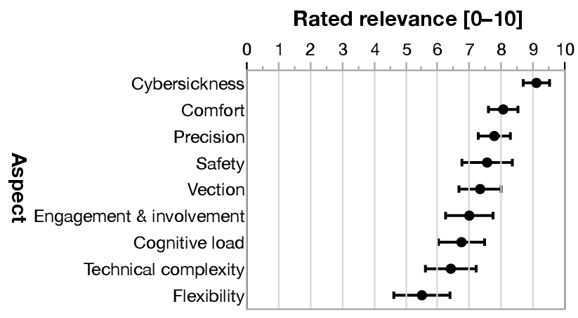
Figure 1
Like source [5], a researcher named’ Chongsan Kwon’ studied how verifiable and effective it is to learn using immersive VR technologies [7]. The researcher concluded that learning effect was “enhanced” due to the highly interactive environment available to the users, through “locomotive tactile interaction”.
One important element of VR technologies is the “VR sickness” that users report. A evaluation study conducted by ‘Andrej Somrak’ [8] showed that there was a negative correlation of user experience and user VR sickness. They conducted this through user experience questionaries(UEQ) and through measurement on the speech, spatial and qualities scale(SSQ).
To analyse driver awareness, researcher ‘Jacob M. Read’ [9] analysed the difference in “situation awareness” and “task performance” by 15 users testing parking situations. They deemed that there was no significant difference in driver situation awareness between reality and virtual reality.
Alternatively, another similar study, researcher ‘Isamu Endo‘ [10] attempted to create a new HMD(Head Mounted Display) labelled “ ModularHMD”. This would then allow the user to interact with the real-world environment by viewing it through the display headset using various modules installed on the HMD. They conducted a user study, which then concluded that the ModularHMD was an effective solution to virtual reality and, when needed, peripheral interactions.
Finally, one piece of literature found, researcher ’Pulkit Budhiraja’ and their research group [11] conducted testing on incorporating real life tasks into the virtual reality environment. This real world incorporating came in the form of drinking a beverage. They conducted user testing and concluded that real life objects could be incorporated into virtual environments.

4. Project Design
In this section there will be a critically review of the overall project design, the data that will collected in the project and how I will evaluate the data. I then will include the various risks and limitations that will be involved in the project, as well as the ethical issues the proposed project could encounter.

4.1 Outline of Project Process
The process of the project will be as follows:-
1.Research and identify similar approaches to user study of VR and real life.
1.1 Research and identify VR approaches to creating an environment.
2. Plan out the timeframe of the project.
3.Create and design the VR environment, as well as implementing the tasks within said environment.
3.1 Identify tasks in real life that resemble those within the VR environment.
3.2 Conduct testing on participants to compare the performance of task in real life vs VR environment.
3.3 Critically analyse the data collected from test results.
4. Implement the findings within the final report.

4.2 Data Collection
The data will be collected using qualitative and quantitative research [12] [13]. This will involve them testing the tasks in a VR environment, then testing in a real-life environment. Measurement of their performance will then take place through questionnaires, asking what tasks they found challenging, and which approach they prefer. Observations will then be performed upon the participants and their performance. This will then minimise any risks.
This is an appropriate form of data collection as this will allow the user interaction, physical and cognitive tasks within VR and real life test environments be measurable and able to be analysed.

4.3 Data Evaluation
I will evaluate the validity of the data collected by using special analysis tools such as Tableau and Excel. I deem these appropriate as you can conduct analysis methods within the software to validate the data imported.

4.4 Risks & Limitations
The limitation to the project includes a brief time allowed to conduct the objectives, this mixed with the time available to the participants, may risk some testing not being complete. Risks to the project may include harm or injuries that myself or the participants can receive in testing the VR environment tasks or real-life tasks.

4.5 Ethical Issues
The ethical issues that may arise in the study could be the information collected from the testing. Other ethical issues that may arise are the failure of any GDPR rules. Potential ethical issues include any information collected could be used to identify participants. These could include name, age , hair colour, health status, etc.
Other ethical issues that could be encountered in a project is the morality of the project, and or how lawful the project is.

5. Resources & Planning
In this section there will be a discussion on the resources that I will plan to use for the project. It will also contain the plan and timings for all the objectives needed to complete the project.

5.1 Resources Required
In this section there contains, the various resources needed for this project to be completed. They will involve the hardware, software and additional resources needed to complete the project.

5.1.1 Hardware Resources
The resources required for this project will need computer access at home and on campus, access to computer hardware capable of running Unreal engine software(This could include suitable CPU and GPU hardware), access to VR equipment, VR controllers , mobile phone access.

5.1.2 Software Resources
The software that will be needed in the project will need to be Microsoft Office 365, Computers running Windows 10, software used to develop planning charts, Unreal Engine 5/Unity, Microsoft Excel, Tableau, personal messaging applications(Messenger, Outlook, Gmail) , Discord.

5.1.3 Other Resources
The other resources that the project will need is the human factor. This will include myself(the primary researcher), the project supervisor, participants in testing, any technical support staff both in university or any company responsible for any hardware or software issues.

5.2 Planning table
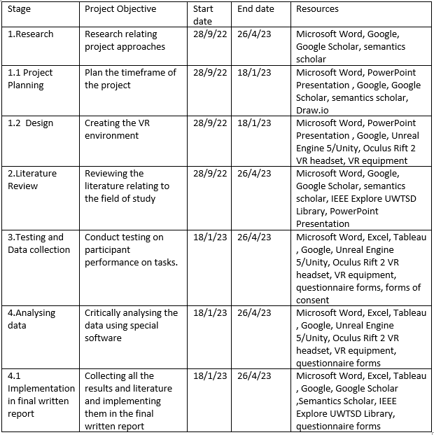
Table 1

6. Reference List

References

[1] | M. J. H. K.Blaine Lawlor, “Smart Goals: How The Application of smart goals can contribute to achievement of student learning outcomes,” Developments in Business Simulation and Experiential Learning, pp. 1-9, 2012.
[2] | L. F. Poe, N. G. Brooks, M. Korzaan, A. R. Hulshult and D. M. Woods, “Promoting Positive Student Outcomes: The Use of Reflection and Planning Activities with a Growth-Mindset Focus and SMART Goals,” Information Systems Education Journal, vol. 19, no. 4, pp. 13-19, 2021.
[3] | J. O. Anne Conzemius, The Power of SMART Goals: Using Goals to Improve Student Learning, Bloomington: Solution Tree Press, 2009.
[4] | M. M. S. F. C. &. W. C. Alexana Vilar Soares Calado, “Virtual Reality Applied to the Study of the Interaction between the User and the Built Space: A Literature Review,” in International Conference of Design, User Experience, and Usability, Berlin, 2013.
[5] | S. R. a. C. O. a. A. S. a. L. Toni, “Do Users Behave Similarly in VR? Investigation of the User Influence on the System Design,” ACM Transactions on Multimedia Computing, Communications, and Applications, vol. 16, pp. 1 - 26, 2020.
[6] | D. Z. a. B. E. Riecke, “To Sit or Not to Sit in VR: Analyzing Influences and (Dis)Advantages of Posture and Embodied Interaction,” Computers 2021, vol. 10, p. 73, 2021.
[7] | C. Kwon, “Verification of the possibility and effectiveness of experiential learning using HMD-based immersive VR technologies,” Virtual Reality, vol. 23, pp. 101-118, 2018.
[8] | I. H. M. S. H. M. F. A. M. A. H. a. J. G. Andrej Somrak, “Estimating VR Sickness and user experience using different HMD technologies: An evaluation study,” Future Generatiion Computer Systems, vol. 94, pp. 304-316, 2019.
[9] | J. M. &. S. J. J. Read, “Task Performance and Situation Awareness with a Virtual Reality Head-Mounted Display,” Proceedings of the Human Factors and Ergonomics Society Annual Meeting, vol. 61, no. 1, pp. 2105-2109, 2017.
[10] | I. a. T. K. a. I. M. a. F. K. a. K. K. a. K. Y. Endo, “ModularHMD: A Reconfigurable Mobile Head-Mounted Display Enabling Ad-hoc Peripheral Interactions with the Real World,” in The 34th Annual ACM Symposium on User Interface Software and Technology, New York, 2021.
[11] | P. B. a. R. S. a. B. R. J. a. K. K. a. B. P. B. a. D. A. Forsyth, “Where's My Drink? Enabling Peripheral Real World Interactions While Using HMDs,” ArXiv, vol. abs/1502.04744, pp. 1-5, 2015.

