

Graduate Diploma in Professional Police Practice

LEVEL 6 - 40 Credits

Workbook title: Competency Based Workbook 1 (DHEP)

(SOUTH WALES POLICE, GWENT POLICE AND UWTSD)

Learner name: PC MIA PITMAN 8249

Learner’s University Registration Number: 2131760

FACULTY OF BUSINESS AND MANAGEMENT
PUBLIC SERVICE PROGRAMME

Module title: Policing in the Workplace 3 (DHEP)
Workbook Guidance

Please read these notes carefully; they provide essential information.

What is the workbook for?

The purpose of this workbook is to enable learners to demonstrate and provide evidence of how they meet the learning outcomes set by the College of Policing, for the Graduate Diploma programme. Essentially, you are being asked to outline your experiential learning based upon your theoretical understanding in a range of operational situations.

Area of Professional Practice covered, (called elements in your module descriptor):

- Wellbeing and Resilience
- Communication Skills
- Managing Conflict
- Valuing Difference and Inclusion
- Criminal Justice
- Decision making, discretion
- Conducting Investigations
- Criminal Justice (Managing offenders)
- Problem Solving
- Evidence Based Policing
- Maintaining Professional Standards
- Public Protection.

You may wish to use the same incidents as you’ve outlined in the Occupational Competence Portfolio.

How should the workbook be presented?

Blank electronic copies can be found on Moodle of this workbook. You must submit this document electronically therefore it is important that you save your work regularly and upload the final typed version through Turnitin on Moodle.

Word count policy can be found in chapter 7 of the Academic Quality under section 7.7 (this applies to presenting work above and under the specified word count).
(https://www.uwtsd.ac.uk/media/uwtsd-website/content-assets/documents/academic-office/aqh-chapters/chapters---en/Chapter_07_Assessment_Taught_Programmes_Pages_72-79-UPDATED-05-11-2019.pdf)

Reflective practice is a core aspect for your workbooks and although there is a variety of useful resources on Moodle, there is one particular book, that is specifically based on reflective practice in policing, here is a link to one chapter from Selina Copley’s Reflective Practice for Policing Students:
https://moodle.uwtsd.ac.uk/pluginfile.php/298870/mod_resource/content/1/Reflective%20Practice%20for%20Policing%20Students%20-%20Selina%20Copley%20Chapter5.pdf

How is the workbook assessed?

Advice and support about the completion of this workbook will be provided by university staff as part of your initial training day. Your tutor constable and in-force training staff will not be involved in assessing or marking your workbook after it has been submitted.

Dates of workbook submission will be made available during the initial training day and posted on Moodle.

Once submitted your workbook will be assessed and marked independently.

Confidentiality

It is important that no individual can be identified either directly or indirectly from the information in the workbook. Therefore, you must:

- adhere to guidance in the Student Handbook about unfair practice and plagiarism;
- not identify individuals including witnesses, victims or offenders by name;
- not write information that enables any individual to be identified indirectly through the description you provide. This includes references to names, colleagues, places (including hospitals, schools, town, villages, streets) specific incidents which were high profile and could be identified due to past publicity, other professionals or any other personal information including medical or other conditions.
- take personal responsibility for adhering to confidentiality rules.
- not include any dates of any incidents or anything that specifically identifies an actual incident.

The content of this workbook should be your own work. Do not allow anyone else to see your work or use your work for their own submissions.

Please be aware that any content that is deemed to be inappropriate, disrespectful, or abusive will not be tolerated. Following review of any content of this nature the information will be shared with the employer of the student responsible.

Should any health and wellbeing concerns be raised because of disclosures made by the student within this workbook, the employer of the student will be informed.

NOTE

Your workbook will be submitted electronically via Turnitin on Moodle. Guidance on this is in the Student Handbook.

Remember that the workbook is YOUR responsibility you must not rely on the assessor or anyone else to pick up any confidentiality breaches as this is your work and you must accept full responsibility for confidentiality. Meeting all the confidentiality requirements is very important.

Dyslexia and other special circumstances

If you have any condition that you feel may affect your ability to deal with any part of the programme, please see the Student Handbook for further guidance. The University has a Student Services Unit that may be able to help but it is the learner’s individual responsibility to contact them.

Guidance:

- Your workbook must contain the items specified in the table below (clearly identified and in the order given);
- You should use this document to insert your text / answer within each section of this workbook;
- You should upload your completed document as a saved pdf file of this workbook; if this is not possible then a Worddoc file is acceptable. Do not send a scanned file from a photocopier, an apple.dot file or a Microsoft publisher file as Turnitin will not be able to assess them, despite you being able to upload them.

Contents

Workbook | Area of Professional Practice | Word count
Task 1 | Wellbeing and Resilience | 1000
Task 2 | Communication Skills, Managing Conflict, Valuing Difference and Inclusion | 2000
Task 3 | Criminal Justice, Valuing difference and inclusion | 2000
Task 4 | Decision making and discretion, Conducting Investigations and Criminal Justice (managing offenders) | 2000
 | Bibliography
Task 5 | Development Plan | Equivalent 1000 words
Confirmation of Confidentiality and Plagiarism
Confirmed by submission through `Turnitin

Task 1

Relevant areas of the National Policing Curriculum:
Understanding the roll of a constable

Guidance:

Focussing on your initial 6 months of learning and since being attested as a Police Constable, discuss and compare the coping strategies you have applied to develop resilience and minimise stress.

1000 words (+/- 10%: include your actual word count at the end of each section)

ANSWER:

Starting a new career can be extremely daunting on any individual and can create many internal and external challenges. In a forever changing society policing has changed, public demand and expectations has increased, therefore it is vital that officers develop resilience and learn how to manage stress early on in their career through using coping strategies. In this Assignment I will be discussing coping strategies, stress and resilience and the way in which I used several coping strategies to develop resilience and deal with stress.
According to (Skinner & Zimmer-Gembeck, 2007) coping strategies are processes used to manage stress, they help to control your thoughts, feelings and actions before, during and after challenging situations. There is extensive research identifying coping strategies and multiple classifications (Skinner & Zimmer-Gembeck, 2007). Skinner & Zimmer-Gembeck 2007 analysis of 44 studied found coping strategies fit under 12 mutually exclusive coping families as seen below;
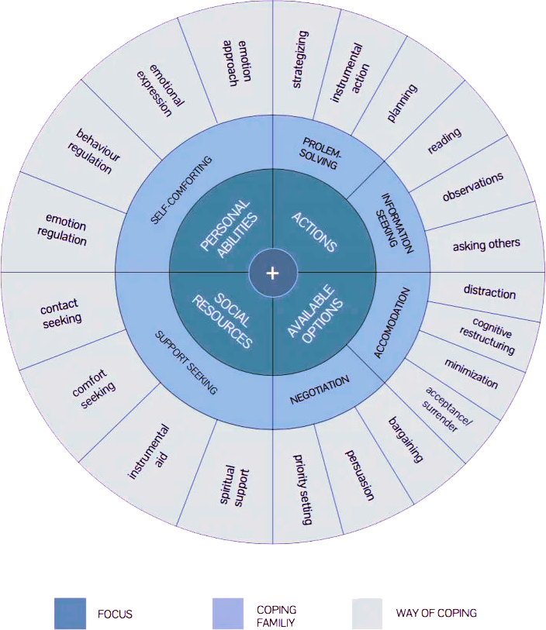
Figure 1- coping strategy wheel
coping strategies are ways we use to deal with, alleviate and manage stress, they can be emotional, cognitive and behavioural or a combination of all three. The terms resilience and stress are defined differently depending on the circumstances in which it is being discussed. Richardson 2021 defines stress as a state of physical or emotional tension, usually as a reaction to an impending challenge or threat (Richardson, 2021). Resilience and stress come hand in hand it is a characteristic that people use in the face of tress, Navsaria 2020 defines resilience as “The ability to process and cope in times of stress and change and is a skill that can be developed and learnt with experience” (Navsaria, 2020).

Recognise the stress
The first coping strategy that I found beneficial which then leads on to other coping strategies is the ability to recognize and counter signs of stress. It was vital to recognise stress throughout the training period to analyse how I was feeling and then adopt the coping strategies best fitting to help manage this kind of stress. Personally, I recognize I am stressed through how I feel physically and mentally, such as feeling unwell, run down, over-eating or having a low mood. According to McEwen 2011 states the brain regulates body processes though the nervous system, metabolic system, and immune system this is called the Nonlinear system that affects many organs throughout the body. (Mcewen, 2011). McEwen 2007 work explains how the as the key organ of stress and adaption the brain perceives threats and determines a behavioural response as well as directing Health damaging behaviours, these behaviours can include a change in eating and sleeping habits, Drinking, smoking and other change of habits. In order to counter-act these health-damaging behaviours it is vital that the body recognizes the problem and removes the health damaging behaviours before long term problems such as anxiety and depression develop (Mcewen, 2007). Throughout the training period I was highly aware of how I was feeling physically and mentally, I would recognize where the problem has stemmed from and then tackle that problem by using other coping strategies.

Physical activity and take time for self
A second coping strategy crucial to my training period was finding time for myself and trying out new routines, this includes time to exercise. At the beginning of the six months, I found myself adapting to the working hours, and revision schedule and therefore taking time for myself and exercising were not a priority, I found my mood declined significantly and had overwhelming feelings of guilt and stress. Once I had settled, I began making small changes to my routine to prioritize myself along with my responsibilities by working in time to exercise and participate in activities I find relaxing and enjoy which led to shifting my attention on to the positives rather than negatives. A study conducted on 64 students carried out by the Penstate article found evidence to suggest that regular physical activity improves sleep quality, well-being, and more positive and less negative thoughts, this has been named the stress buffering effect. Cohen and Wills 1985 state the stress buffering hypothesis populates that physical activity acts as a moderator of the stress by reducing its detrimental effects on physical and mental health and therefore buffers the effects on our health (Cohen & Wills, 1985). Scientifically the reason physical activity acts as a stress-buffer are because it reduces levels of stress hormones such as adrenaline and cortisol, stimulating the production of endorphins and chemicals in the brain that act as the body’s painkiller and mood elevator (Havard health , 2020). Despite this physical activity and taking time to relax has the possibility to have adverse effects on coping with stress, an individual who regularly takes part in exercise or relaxing as a coping strategy may become increasingly stressed and guilty when not having the time or the energy to do. Personally, I have found that I need to remain active in order to manage stress and develop the resilience needed, if I do not remain active, I have guilt on my conscience which contributes to being stressed.

Following the first exam I was not happy with my result. In order to evaluate this, reflect and improve for the future I adopted the Gibbs cycle. The Gibbs reflective cycle was developed in 1988 by Graham Gibbs provides six stages to deal with experiences including experience, description, feelings, evaluation, analysis, conclusion and action plan (The Edinbugh University , 2020). I analysed my results, and how I felt upon receiving, I evaluated my efforts towards revision, the time I put in and whether that correlated with the result I had Upon analysis I found that I did not put in the time needed to achieve a higher grade and the time I allowed myself I was not focused enough. I created a revision plan and ensured I was aware of the revision methods best suited to me. I found that this method of evaluation was extremely useful as it ensured I covered my experience in detail and focus on parts I would not usually consider when evaluating work.
Throughout my time in training, I have found different ways of coping with stress and developing resilience, the coping strategies included within this assignment are the strategies I found most beneficial to myself and will use in my future career as a police officer. I found that maintaining regular exercise and ensuring I find time to myself to prevent getting overwhelmed with the workload. I found the Gibbs cycle especially useful to evaluate my experiences and coping strategies used to maintain stress.

WORD COUNT- 1,096

Task 2

Relevant areas of the National Policing Curriculum:
Communication Skills, Managing Conflict, Valuing Difference and Inclusion

You must choose a policing incident involving conflict in which you played a significant role with an offender/service user/victim and reflect on what happened.

Critically assess the incident including social and legislative contexts and any relevant cultural, ethnicity and language issues.

Consider the use of effective communication skills that you used within the incident.

Reflecting upon your incident, critically evaluate any theories or models underpinning the causes of conflict within policing interventions. (Examples would include, Betaris Box, The Drama Triangle).

2000 words (+/- 10%: include your actual word count at the end of each section)

ANSWER:

The police regularly must respond and deal with conflict situations involving violent and aggressive individuals. Conflict can come in various forms, it can be a in the form of physical, verbal or emotional conflict. The incidents police encounter is never the same, the people involved could be going through one of the worst days of their lives and conflict could arise where you least expect it. Police officers’ actions when responding to such incidents are vital and can have an impact on confidence and trust in police. This assignment will be critically assessing an incident in which I was the attending officer and victim. I will be critically assessing and reflecting my performance and communication skills used throughout the incident using the GIBBS model of reflection which I will explain further in the assignment. I will then discuss the use of force used, and the processes used to determine whether the amount and kind of use of force used was suitable for the incident. Further into the assignment I will discuss the use of Policing models; betaris box, the national decision model and the best practice used during this incident such as the use of JPLANE, and the code of ethics.

I will begin by describing the occurrence however certain details will be kept out. At around 23.30 officers received a call from a male stating his mother was intoxicated and behaving aggressively towards him, the male did not want his mother arrested or removed he merely wanted officers to calm her down. On arrival shouting could be heard coming from within the address, the son (the reported person) was outside of the property, he had locked his mother and stepfather inside the address to prevent his mother drink driving. From the get-go of police entry into the property the female and her partner were acting in an aggressive manner and did not like that officer entered without knocking first. It was clear to see that the female was extremely intoxicated, slurring her words, and stumbling. Her partner also slurring his words. Within the property it was evident that the couple had been drinking heavily. Officers attempted to follow usual domestic violence procedure set out by the college of policing and split parties involved to establish what had happened however the female and male refused and became increasingly irate (policing, 2022). The female and male cornered my colleague into a corner in which officers have reacted by separating the female from the situation with force following several attempts and tactical communication methods, in response the female began kicking out at myself in which I have used the approved techniques taught in officer safety training to restrain the female, the female stood up and pushed me and my colleague with force. My colleague arrested the female for Section 89 assault police, Police act 1996 (Legislation.gov.uk, n.d.). The male became irate and assaulted another colleague in which an assistance shout was deployed, and the male was detained and arrested for Section 89, assault police, Police act 1996. Following the arrests, I spoke with the female’s son regards to what had happened, he disclosed his mother assaulted him by pushing and hitting him and confirmed he wanted to make a complaint in which the female was further arrested for Section 39 common assault criminal justice act 1988 (CPS, 2022).

This assault on police and assault on son was heavily influenced by alcohol. It was clear to see that the female drinks a large amount of alcohol on a regular basis which results in her becoming aggressive and psychotic. The world health organisation estimated that roughly 55% of domestic abuse perpetrators were drinking prior to the assault (WHO, 2022), there are multiple studies that support this information, The institute of alcohol studies state research typically suggests that between 25% and 50% of those who perpetrate domestic abuse have been drinking at the time of the assault with some studies showing as high as 73% (Foster, 2018). The Institute of alcohol have also found the most shocking discovery as a result of the survey was the widespread physical, sexual and verbal abuse on emergency workers and staff with three quarter of police respondents and half of ambulance respondents being injured in alcohol related incidents. A second survey carried out 5,000 emergency workers have found that up to half police, paramedic and emergency consultants and fire services time is spent dealing with alcohol related incidents with 76% of police reported being injured while dealing with drunken members of the public (Brown, 2016). In order to reduce alcohol related incidents Australia have implemented progressive closing times for pubs and bars pursued by the New South Wales Government which has led to a significant decline in alcohol related incidents, these are measures which if proposed in the UK would have full support of emergency services and could be a common sense solution to a problem that is costing police and other emergency services (Brown, 2016). It is evident from current research surrounding this topic that alcohol is an aggravating factor towards assault especially assault on police, I have witnessed this first hand throughout my short career as a police officer in which an individuals have acted aggressively towards officers however once sober the individual shows remorse and are ashamed of their actions and behaviour towards officers.

The elements for an assault in this situation were clear. The Mens Rea of common assault is that the defendant either intentionally or recklessly causes the victim to fear some degree of contact or violence, this force can be intentional, or the subject can be reckless as to whether their actions will apply force (Gray & CO solicitors, 2012). In this case the male informed officers on arrival that his mother pushed him with force on several occasions prior to police arrival. Following interview, it was clear that the female did not intend on injuring or harming her son however due to the amount of alcohol she had consumed she was merely reckless as to whether he would get injured in the process. The initial report made to police stated that the male needed officers help to calm his mother down however following the events that followed afterwards the male informed officers that he now wanted to make a complaint regarding his mother pushing him around. Section 89 of the police act 1996 is defined as “Any person who assaults a constable in the execution of his duty, or a person assisting a constable in the execution of his duty, shall be guilty of an offence” (Legislation.GOV, 2020). When officers attempted to control the female, she assaulted my us by kicking my arm with force and pushing us with excessive force. The female and her partner in this incident would not comply and resist officers arrest, section 89 of the police act 1996 subsection 2 states any person who resists or wilfully obstructs a constable in the execution of his duty is a criminal offence.

The body worn video evidence recorded of this incident captures the fact due to their intoxicated state the female and the male were unable to process the situation and reason for police presence, they were not willing to listen to officers and became increasingly violent and aggressive, reacting by recklessly assaulting officers in the process. On top of the assault on officers and younger male the couple’s language was abusive and insulting to officers. According to The National Institute of alcoholism Alcohol disrupts the communication pathways affecting the way your brain works, Alcohol makes it hard for the areas that control balance, memory, speech and judgement resulting in a person being unable to process information, communicate and physically act, leading on to a higher likelihood of miscommunication, misjudgement, injuries and other negative outcomes (NIH, 2022)

Police officers implement tactical communication methods into policing to resolve conflict and de-escalate situations. Key skills officers should develop, and use are advanced communication skills to be able to establish trust, build a rapport and encourage individuals to be open and honest, these skills enable officers to develop a better understanding of the incident, gather information and identify any risks (policing, 2022). This incident required extensive communication skills. Myself and my colleagues attempted to calm the individuals down, speak to them one on one and build a rapport to establish what had happened however the couple were in such an intoxicated state they were unable to co-operate with officers. Once the female had been arrested, I attempted to speak with her during the transport to custody and once in custody however the female continued to shout abusive words at me. Once in custody the female slowly began to sober up and state, she did not understand the reason for her being in custody in which I explained several times.

Conflict was an area in which I felt most in-experienced and found the possibility of being amongst conflict daunting. During this incident I was able to assess the situation and establish what I needed to do. Another colleague and I managed to successfully detain the female, arrest her and handcuff her for assault police, my contribution to this occurrence was substantial, I had the most contact with the female. I dealt with this situation as effectively as possible and managed to protect myself and colleagues successfully. Once in custody I managed to keep the female calm, process her despite her being difficult. This incident has taught me that conflict may arise at any point. I have learnt a result of this incident how quick an incident can change. It has taught me to never let my guard down and to always be aware of my surroundings. The only thing I would do differently in this scenario is have more authority and more control when trying to calm an individual down and using different language when communicating.

In order to make decisions and use force as a police officer the primary decision-making tool must be used, The National Decision-Making Model (NDM). The NDM was developed by the College of policing (COP) for decision makers to structure a rationale of what they did during an incident and why. The NDM can be used for spontaneous incidents or planned operations and by a team of people or an individual (college of policng, 2022). The NDM should be used for every decision made by officers no matter how big or small. The NDM has six key elements:
- Code of ethics
- Gathering information and intelligence
- Assess threat and risk and developing working strategy
- Consider powers and policy
- Identify options and contingencies
- Actions taken and review what happened. (college of policng, 2022)

Another tool developed by the college of Policing is the code of ethics (COE). COE was created in 2014 to set and define the standards of behaviour for police officers (COP, 2022). The aim of the COE is to encourage personal responsibility and exercise professional judgement and empower those in policing to ensure they are doing the right thing (COP, 2022). Officers will use force for their own protection and colleagues protection, aside from this the main reason for using force is the impact factors that contribute, Officers are taught to use force if the individuals are under the influence of drugs or alcohol and resisting arrest, when the individual is of greater size or strength or when they are in possession of a weapon (AAAPPP, 2020). On top of making decisions using the correct tools it is important for officers to be able to justify these decisions and their use of force and to do this officers use the pneumonic JPLANE to ensure their actions were:
- Justifiable
- Proportionate
- Legal, accountable
- Necessary
- Ethical.

The betaris Box is described as the “Cycle of conflict”, It models how the attitude and behaviour of one person during an interaction affects the other person they interact with in a cyclical way (Wall, 2019). The natural outcome of this model is that if there is negative attitudes or behaviour then they will continue to escalate until there is conflict, if there is positive attitudes at an incident the likelihood of conflict is significantly decreased, this theory is attempting to say if we change our attitude towards individuals this could break the cycle of conflict (Wall, 2019).

Throughout this assignment I have used the GIBBS reflective cycle in order to reflect on this incident. The Gibbs reflective cycle was developed in 1988 to give structure to learning from experiences, it is a framework that is used for examining experiences, allowing individuals to learn and plan from incidents that did or did not go well (UoE, 2020).

I am satisfied that I have dealt with this conflict incident correctly and effectively. I have learnt that how quickly things can change. I am confident that in the future I will be able to reflect on this incident and what I have learnt and use it for the next.

WORD COUNT- 2,170

Task 3

Relevant areas of the National Policing Curriculum:
Criminal Justice, Valuing difference and inclusion

You must choose a policing incident in which you played a significant role with an offender/ service user/victim and reflect on what happened

Critically explore a policing incident that you have attended and examine how you dealt with competing issues such as legalisation, social issues, culture and language.

Consider the victims code of practice and how it was used to support your victim/witness through the criminal justice system.

Your reflection must illustrate your understanding and application of core principles of ethics, equality, diversity and human rights, as well as any relevant Code of Practice considerations.

2000 words (+/- 10%: include your actual word count at the end of each section)

ANSWER:

Every year one in five people in England and Wales will become a victim of crime, and each one is affected differently (GOV.UK, 2022). Policing is a victim led institute; Police are the start of an individual’s journey as a victim in the Criminal justice system. Over recent years there has been a major shift towards prioritising victim’s needs. Since 2013 the government and the criminal justice system have been determined to improve the service and support that victims receive (GOV.UK, 2022). In 2018 the government released the “victim strategy” to ensure the criminal justice system support victims and encourages them to speak up by providing a better understanding, protection and support (MoJ, 2018). The strategy set out several recommendations which include improving and strengthening the victims code, improve support for victims of all crime, and increasing spending to improve pathways (MoJ, 2018). As a result of the victim’s strategy a new victims code was released in 2021 bringing to life the recommendations set out by the Ministry of justice (MoJ, 2021). Throughout this assignment I will be describing, reflecting and critically assessing an incident in which I was the officer in case working closely with the victim.

I will begin by describing the occurrence however certain details will be kept out or made ambiguous in order to comply with policing data protection rules. We received a report from a male who is a regular caller stating his landlord called him a “Gay c***” outside of the property. The male state he has had to move out of the address as he has received continuous verbal abuse and threats from his landlord who also resides at the address. The report was made several hours after the incident once the victim had arrived at his new address, due to there being no immediate danger to the victim the call was downgraded. The following day myself and my colleague attended the address, after several attempts at the address the landlord answered and informed officers the victim had moved back to his hometown. I called the victim on his mobile, I immediately established that the male was going through a mental health crisis and had severe learning difficulties. I spoke to the male for some time attempting to establish what had happened however it was extremely difficult to understand what he was talking about as he was mixing this incident up with several other unrelated incidents. The victim state to officers he has been living at the address for a number of weeks following his release on bail from a mental health hospital, throughout that time his landlord made continuous homophobic comments and comments judging his mental health and he genuinely feared his landlord would eventually harm him which is the reason he has moved back to his home town, the victim state as he was leaving the address on this particular day with his belongings the landlord called him a “Gay C***” and that he had a video of the whole incident. Throughout the phone call the victim continued to go off topic and talk about traumatic events that has happened in his past and mixing them up with current events, despite this I explained to the victim that this is a hate crime, and it will be dealt with in a serious matter in which the victim was thankful. After gathering all the relevant information and evidence needed, I arrested the landlord under section 4 public order act 1986, the landlord understood the caution and was compliant throughout the process.

Hate crime is defined by the police and criminal prosecution service as;

“Any criminal offence which is perceived by the victim or any other person to be motivated by hostility or prejudice based on a person’s disability or perceived disability; race or perceived race; or religion or perceived religion; or sexual orientation or perceived sexual orientation or transgender identity or perceived transgender identity." (CPS, 2022).

Since 2012 hate the number of hate crimes reported have increased each year, GOV.UK found that in the year ending March 2022 there were 155,841 hate crimes recorded by the police in England and Wales, a 26% increase compared to the previous year as shown below;

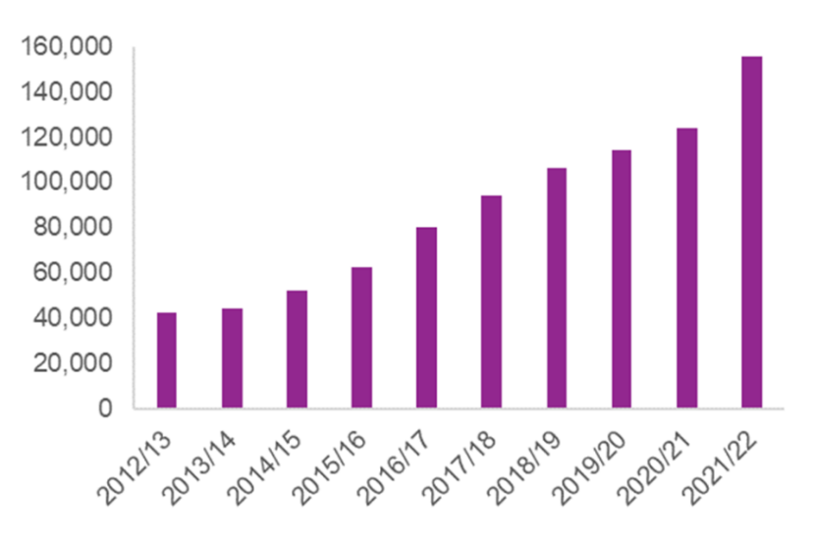 (GOV.UK, 2022)
Acceptance and freedom of LGBTQI+ community has improved over the years however hate incidents and crimes towards this community continuously rise, GOV.UK hate crime statistics state between March 2021 and March 2022 a total of 26,152 sexual orientated hate crimes were reported to the police, this is a 41% increase from the previous year (GOV.UK, 2022). Despite this increase LGBTQI+ hate crimes are highly under reported and there are thousands of victims who do not come forward (Stophateuk, 2021). Many believe the increase in reports is due to an increase in public confidence, others would argue that the reason Hate crime is under-reported is due to the fact victims normalise the abuse they receive, they believe change cannot occur and instead they must put up with these crimes (Navarro, 2022).

The Landlord who commits this offence was arrested under section 4 of the public order act 1986 which states

“A person is guilty of an offence if he uses towards another person threatening, abusive or insulting words or behaviour, or distributes or displays to another person any writing, sign or other visible representation which is threatening, abusive or insulting with intent to cause that person to believe immediate unlawful violence will be used against them” (Legislation.com, 2006).

This offence can be committed in a public or private place, this offence falls under section 4 as it was committed on the stairs outside of the dwelling.

This incident had no language barriers however it was extremely difficult to understand the male due to his mental health. This was my first incident which involved a victim with severe mental health issues and needs, it was difficult to understand the male however by building a rapport and getting familiar with the way he communicates I was able to establish a timeline of the incident. I explained to the victim that he should seek more support and if his state worsened to call the crisis team as soon as possible. I ensured this information was included in the public protection form.

The new victims code came into force in April 2021, the code consists of 12 rights and sets out the services and minimum standards that must be provided to victims of crime by police (CoP, 2021). I will not be talking about each code in depth however I will be talking about the victims’ codes most applicable to the victim of this hate crime.

A victims code directly applicable to the victim is the right to enhanced victim services due to his mental health, learning difficulties, and being a victim of hate crime. I informed the victim of the Victim personal statement (VPS). A VPS is optional, it can be an important part of an investigation as it gives the victims a voice in the CJS process and helps others understand how the crime has affected them (MoJ & Green MP, 2013). Hate crime falls under the category of a serious offence therefore the victim is entitled to support from victim focus. Victim focus was founded in 2017 to treat victims of trauma, abuse and violence with the respect and support they need, this is carried out following a referral from the officer in the case. In this incident the victim was referred in order to provide him with some level of support ensuring him that as a force we take his needs seriously (Victimfocus, 2017). A third enhanced service victims are entitled to is a Hate crime support officer (HCSO), following every hate crime incident a HCSO is linked to the occurrence, to ensure the victims needs are being met and a tailored level of support is provided (CoP, 2022).

Another right directly applicable to the victim in this case is the right to receive support by the courts regarding the court process. Special measures are a series of provisions that help vulnerable and intimidated witnesses to give their best evidence in court and minimise stress (CPS, 2021). Special measures are provided to victims, witnesses and defendants, the provisions provided include the use of screens, video live link, evidence given in private, removal of wigs and gowns, and visual recorded interviews (CPS, 2021). In this case a pre-recorded interview and live link for cross examination would be most fitting to avoid confusion in court as the victim finds it difficult to remain focused on one topic jumping back and forth to past incidents.

Lastly the victim has the right to be updated regularly about the investigation process. Every victim has the right to be told by the police when key decisions are made where applicable and within a set timescale of the suspect being: arrested, interviewed under caution, released without charge, released on bail or under investigation or police bail conditions (CoP, 2021). In this case the victim is a regular police caller, in order to avoid further calls regarding this incident it is vital that the victim is updated regularly, and processes are explained in simple terms to avoid confusion.

Since the beginning of my tutorship on response I have been widely praised for care I have for victims, I always ensure I am going above and beyond to update victims and provide them with the best possible outcome. In this case due to the circumstances surrounding the incident and the current state of the victim’s mental health I prioritised the incident and ensured it was dealt with as soon as possible to avoid further harm on the victim. In order ensure best values in policing the code of ethics was produced by the college of policing in 2014 to set and define the standards of behaviour expected by those who work in policing which go hand in hand with the nine principles of policing (CoP, 2014) Those most applicable to this case are;

Honesty and openness, I used these values throughout the case by firstly explaining to the victim following initial report that it would be difficult to take the case further as the account we received was inconsistent, in which the victim then provided officers with further evidence. I have also been open with the victim regarding predictions of how the investigation could turn out. Due to his mental health struggles and history of complaints against other officers in the past it was important to ensure openness to avoid giving high expectations.

Duties and responsibilities, it is important to be diligent in the exercise of duties and responsibilities (CoP, 2014). Crimes are usually overseen by the Sergeants however the case of Hate crimes the local inspector oversees the case and as officer in the case it was vital that I took full accountability of all actions, ensuring that all actions were done in a timely manner and complete to a high standard. On top of this I had to ensure that third party mental health support had been informed of the victim’s current state to ensure he received immediate support. I prioritised this case above my outstanding workload and complete all actions necessary ready for arrest in one tour of duty due to its seriousness.

Equality and diversity, upon receiving the first report I initially believed this call would not be as reported due to the victim’s history of reporting; however, it was important not to pre-judge the individual on his past and treat this incident separately. The victim belongs to the LGBTQI+ community, I believe I have done all I can to ensure the Victim feels supported by the police.

Policing is a profession full of mixed emotions, the demand for police is increasing and making it extremely difficult to manage a workload on top of being a response officer. Overall, I am happy with how I have dealt with this incident, from the initial report right through to the result I remained in contact with the victim, I built a rapport with him and got to know his way of communicating. This individual is an extremely vulnerable person and as a result of his continuous reporting and mental health I believe he is often overlooked, however in this instance I believe I have done the best to my ability to ensure the victim received the outcome he wished for.

WORD COUNT- 2,064

Task 4

Relevant areas of the National Policing Curriculum:
Decision making and discretion, Conducting Investigations and Criminal Justice (Managing offenders)

You must choose a policing incident in which you played a significant role with an offender/service user/victim and reflect on what happened.

Critically assess a policing incident that you have attended, where you played a significant role with an offender/victim and reflect upon what happened.

Reflect upon your use of the National Decision-Making Model and the Code of Ethics and review this impacted upon your decision making and use of discretion within the incident.

Critically review your responsibilities regarding the provision of CPIA when conducting this investigation.

2000 words (+/- 10%: include your actual word count at the end of each section)

ANSWER:

Policing is a demanding profession, no day is the same for officers and every incident an officer attends is different, Police officers need to have the ability to make justifiable decisions. In order to make these decisions, several decision-making tools have been developed to educate officers and provide guidance on how to make justifiable decisions. The decision-making model widely used in everyday policing and used heavily by south Wales police is the national decision model (NDM). In this assignment I will be critically assessing my decision making and actions relating them to the NDM in an incident in which I was Officer in case (OIC) and investigating. I will then go on to explain the criminal procedure and investigations act 1996 (CPIA) and the aim of the CPIA act and how it relates to this incident.

I will begin by describing the occurrence however certain details including names will be changed to comply with policing data protection rules. We received a report that an adult female and two youths had been fighting in the street. The area in which this happened is an area which is anti-police and do not like police presence. On arrival to the area there were several people stood in the road, a female approached me and pointed at the individuals involved. I could immediately see that the adult female Nadine had injuries to her face, knees and elbows, she was extremely upset and distraught. The two youths had not sustained injuries and displayed an arrogant demeanour towards officers. My colleague spoke with the two youths in which it was established they were brother and sister, Kayleigh aged 15 and Joseph ages 17. Due to the atmosphere in the street becoming irate my colleague took the youths details and advised them to leave the area and not return. Myself and my colleague then entered Nadine’s address to establish what had happened. Nadine state her son and his friend were home, she was putting her three month old baby to bed when she heard loud banging on her door and could see Kayleigh and joseph outside who she did not know prior to this event, she state her son opened the door stated something which she was unaware of and shut the door, shortly after the pair began banging the door again, that is when Nadine answered the door and told the pair to keep it down and leave her property as she had a baby upstairs. Nadine state Kayleigh reacted to this by dragging her out of the house by her hair and across the floor on her knees and then punched her to the face, Joseph had a metal bat and placed it on Nadine’s cheekbone with force and threatened her stating “That’s my sister”. Nadine state her son and her neighbour came outside and pulled the female off her in which the pair left and walked down the street. My colleague spoke with the youths on the phone in which they stated they attended the address to find Kayleigh’s boyfriend which is the friend of Nadine’s son, and it was Nadine who started the fight.

NADINE is the victim in this, she was assaulted by Kayleigh and threatened by Joseph, Nadine, her son and neighbours in the street state that NADINE is the victim and was merely acting in self-defence. NADINE had suffered several superficial and small injuries and was visibly distressed and upset- the subject in this offence had commit an assault under section 39 criminal justice act 1988 –

“S.39 criminal justice act 1988- An assault is any act by which a person intentionally or recklessly causes another to suffer or apprehend immediate unlawful violence” (CPS, 2022)

Using threatening words or a raising a fist is enough for the crime to be committed provided that the victim perceives they will be attacked (Sentencing council, 2022). Assault covers a range of actions from using threatening words, to a severe physical attack, an offence of assault falls under the offenses against a person act 1961, the criminal justice act 1988 and the crime and disorder act 1998 (Sentencing council, 2022). Currently majority of crime statistics covering common assault and violence against a person are dated and do not corelate to modern society (Stripe, 2020). The youth justice board found in 2021 that as a result of covid-19 the number of children sentenced, cautioned or arrested had reached an all-time low (YJB, 2022). Despite the decrease in youth crime, violence against a person remains the most commit offence by youths as shown below:

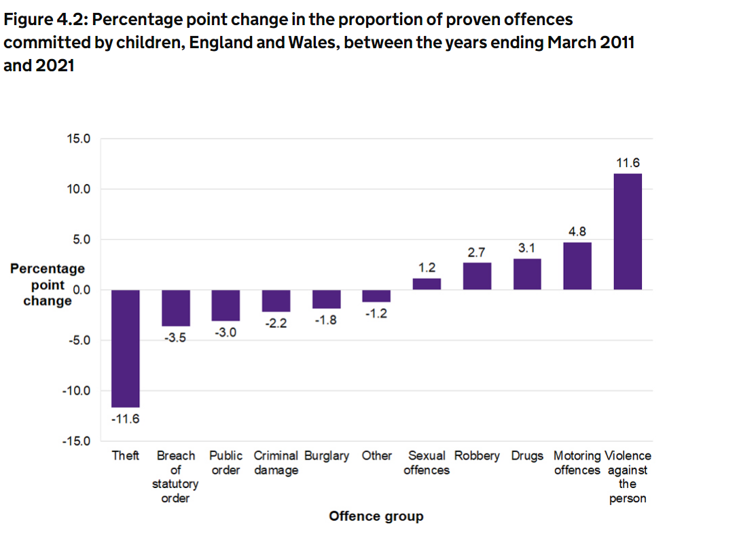
Figure 1- (YJB, 2022)
The national decision model (NDM) is a decision-making model used throughout policing, it is designed to help and assist operational officers, planners, advisers and commanders to manage their response and decisions to a situation in a reasonable, proportionate and justifiable way (empac, 2017). The Model consists of 5 key elements as shown in Figure 2 with the Code of ethics in the middle, the code of ethics is at the heart of all decision making.

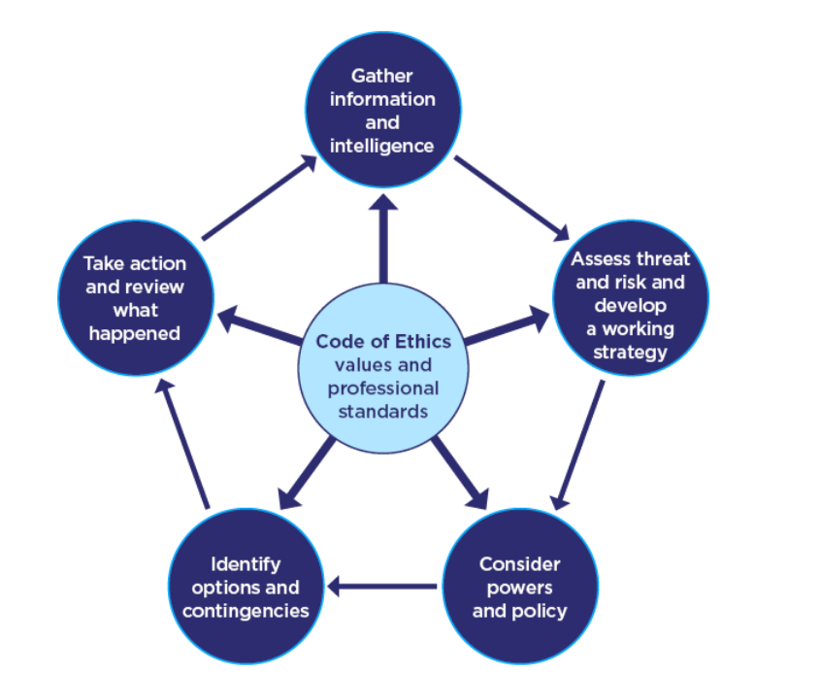
Figure 2- (CoP, 2015)

The first stage of the NDM is gathering information and intelligence where the decision maker defines the situation and clarifies matters relating to any information and intelligence (CoP, 2015). This stage begins as soon as the report is put through the radio. Prior to attending the address, I carried out PNC and NICHE checks on the address in which we established NADINE has been well known to police in the past, at this point we were unaware of who the subjects were. The NICHE checks also confirmed that the street in which the address is located are anti-police, they do not appreciate the presence of police and have a cold and intimidating attitude towards officers. Both parties in this incident provided conflicting versions of events and therefore it was vital for me to not favour a side until all information had been gathered. In order to establish what had happened my colleague and myself listened to both sides, we conducted house to house and established that the subjects Kayleigh and Joseph had initiated the incident as shown in the circumstances above.

Myself and my colleague attended the incident alone and due to the street being anti-police, and the group of youths continuing to aggravate the situation on top of the fact Nadine was extremely distressed and upset with injuries myself and my colleague by assessing the threat and risk to all those involved made the decision to collect the youths details conduct the procedural checks on NICHE, explain to them that they will be spoken to at some point and sent them on their way. The initial working strategy was to diffuse the tension and atmosphere on the street, split up both parties ensuring they are both safeguarded for myself and my colleague to decide what way this incident is going and consider all options before going forwards and making decisions.

The third stage of the NDM is powers and policies which then leads on to options and contingencies. The powers and policies available to officer then determine the options and contingencies available. In this incident initially it was difficult to establish what had happened, despite this by using the previous stages of the NDM we established that we had powers to arrest the two subjects however myself and my colleague were not satisfied that arresting the two teenagers at this stage was necessary due to the initial information we received, the age of the subjects and the amount of people present in the area. I believe if we arrested the subjects there and then we would not have been able to prioritise the victim and ensure her safety. She was a vulnerable female, she was clearly distressed and upset with injuries, she was a single mother with young children at her address and therefor it was vital to ensure her wellbeing and safety over arresting the subjects. In situations where the subjects are not arrested on scene and incidents involving children/youths the process of using voluntary attendance (VA) is useful. Voluntary attendance is a police station interview where a subject voluntarily attends to assist police with the investigation and they are not under arrest, If the subject does not attend a VA interview, they run the risk of being arrested (Levins, 2017).

In policing the term “Discretion” is widely used. Discretion means the power and ability to make decisions, in a policing context it refers to the freedom of police officers to make decisions as they perform their official duties (Treebold, 2018). Discretion is a necessary part of a police officers ability to do their job, we often have to make quick decisions and cannot always wait for specific laws to be consulted, this does not give officers the right to make unlawful decisions instead they must use their knowledge to the best ability to establish what is lawful and reasonable and what is unlawful and unreasonable to make decisions (klening, 1996). Following protocol is not always the right thing to do and can be impractical it is recognised that officers must make their own judgement and make decisions in difficult situations where protocol does not fit the situation. In this incident I used my discretion to not arrest the subjects and advise them to leave the area and focus my attention on the distressed victim which was a decision that was supported a due to the circumstances and aggravating factors.

The criminal procedure and investigations act 1996(CPIA) is a piece of legislation aimed to regulates the investigation process and regulates the recording and retention of material that is found or is generated during an investigation (MoJ, 2015). The act applies to all those working in the criminal justice system and police officers are those who are at the beginning of the investigation journey. The code specifies several different roles within the investigation, with different duties attaching to different roles, these roles include investigation, officer in charge of investigation, disclosure officer and prosecutor (HSE, 2020). There is a subset of policing information and records that relates to evidential material The CPIA 1996 categorises information into three categories; the first being evidential material, this includes statements, exhibits, and digital exhibits. The second is unused material which is any material from the investigation which will not be used and the third being non relevant information, this is information officers have collected however it is not relevant in the case (CoP, 2022). The CPIA 1996 sets the guidelines for the disclosure process, disclosure happens in all criminal cases and the police who investigate crimes and gather evidence have an obligation to disclose to the defence any material they have that they think is relevant to the case (RASASC, 2021). Disclosure helps ensure a fair trial, the defendant has the right to be provided with any material that could be used to defend themselves, they have the right to an open and honest prosecution which notify them of any weaknesses in the case that could be used against them (CPS, 2022). Every investigation has a disclosure officer the disclosure officer is responsible for this area of an investigation, the CPS and the disclosure officer have a duty to keep disclosure under review throughout the life of a case (CPS, 2022).

The policing values guiding police officers is based on the code of ethics and nine policing values. Throughout this incident and its investigation, I believe I used several policing values. Firstly, duties and responsibility- officers have responsibility over victims, investigations and to be diligent in the exercise of their duties (CoP, 2014). This is the first incident I have been officer in the case (OIC) right through to the court process, this incident is currently still under investigation however I have been preparing the documents ready for court. Secondly, I engaged in authority, respect and courtesy- this case involved two subjects under the age of 18 it was important when engaging with them I was simple, relatable and listened to them in order to build a rapport which made more of an impact when explaining them that their actions were out of order and engaging in trouble like this is leading them the wrong way. Thirdly I ensured I treat both the victim and the subjects with fairness and honesty- I informed the victim of every step and update ensuring her needs were met, I allowed the subjects to speak to me when needed and openly allowing them to talk about anything they needed.

Referring back to the NDMs last stage of reviewing what happened I am happy with the outcome of this incident. Initially myself, my sergeant and the victim were happy to use the restorative justice process as the victim did not want this incident to affect the youths further down the line however both Kayleigh and Joseph had previously been involved in a similar incident less than 12 months ago in which the restorative justice route was used which meant they needed to be charged with this offence and taken to court. I am satisfied with how I have dealt with the innocent and the decisions I have made. I will go on to use the NDM throughout my career.

WORD COUNT- 2200

Task 5
Personal Development Plan (PDP)

As part of your reflective process, please use this table to aid you in identifying the next steps for development.

This is equivalent to 1000 words towards the overall wordcount, please note this is not the actual number of words used in completing the table, the count reflects the thought and research behind it.

Area of Development | How it will be achieved | Who can provide support | Timeline
In person communication skills with public, and mobile phone communication skills. | I will achieve within this area by gaining experience and watching how colleagues communicate with people in different ways and take these skills on board. I will also take on any advice provided by colleagues. Mobile phone communication will be achieved by getting used to using my work phone and being confident with using it. | My colleagues have state to me I can use my phone and I know what to do however I always double check and second guess myself if what I am doing is correct, my sergeant along with my colleague’s state I just need more confidence in myself, and this will come over time. | This is an area that will develop quickly as I use the phone every day. I aim to be completely confident and able to use my phone and its forms ein a quickly and effective way without double checking or clarifying with every chance I get.
Gain control and authority. | Throughout my tutorship this is an area I found particularly challenging. This is a problem that again roots from a lack in self-confidence. My confidence is slowly building every day, I can control suspects if needed however it is not a skill, I have found easy to develop. I aim to achieve this goal by taking control of more situations and getting stuck in rather than evaluating the situation for a short while prior to getting involved. | Despite being signed off my team and sergeant continuously provide me with feedback. I am open to all the feedback I can get as it allows me to develop in areas I lack and acknowledge the areas where I am improving which is also a confidence builder. | I aim to improve in this area over the first three months of being independent, I have set my self a target.
Interviewing | I enjoy the interviewing process however I find it very daunting. I need to gain confidence in this area and engage with the suspects in a more confident and comfortable manner. I believe my hub attachment will be extremely beneficial to improve my skills and confidence in this area. | My team and sergeant recognise that this is an area that I need to improve and are more than happy to assist and sit in on interviews I conduct to ensure I am improving and being there for support if needed. | I believe this is an area which will continue to improve throughout my probation, the more interviews I conduct the more confident I will become in conducting interviews.

Bibliography
The bibliography should only include sources referenced within the workbook using the Harvard referencing system. Informati
on about referencing in written assignments and how to avoid plagiarism can be found on Moodle. It is important that you are aware of the importance of ensuring that the work submitted is your original work.

TASK 1

References
Cohen, S. & Wills, T., 1985. Stress, social support ans the buffering hypothesis. psychol bul, Issue 93, pp. 310-357.
Havard health , 2020. exercising. [Online]
Available at: https://www.health.harvard.edu/staying-healthy/exercising-to-relax#:~:text=The%20mental%20benefits%20of%20aerobic%20exercise%20have%20a,are%20the%20body%27s%20natural%20painkillers%20and%20mood%20elevators.
[Accessed 3rd November 2022].
Mcewen, B., 2007. Physiology and neurobiology of stress and adaption: Central role of the brain. PHYSIOL, Volume 87, pp. 873-904.
Mcewen, B., 2011. Effects of stress on developing brain. [Online]
Available at: https://dana.org/article/effects-of-stress-on-the-developing-brain/#:~:text=The%20brain%20is%20the%20central%20organ%20of%20stress,too%20much%2C%20smoking%20or%20drinking%2C%20and%20sleeping%20poorly.
[Accessed 3rd November 2022].
Navsaria, N., 2020. Developing Healthy coping skills for resillience. Washington University in St.Louis- Human resources.
Richardson, B., 2021. Development Academy- Resilience: The relationship between resilience and stress. [Online]
Available at: https://development-academy.co.uk/news-tips/resilience-the-relationship-between-resilience-stress/
[Accessed 3rd November 2022].
Skinner, E. A. & Zimmer-Gembeck, M. J., 2007. The development of coping. Department of psychology, pp. 119-140.
The Edinbugh University , 2020. Gibbs reflective cycle. Reflecting on experience.

Task 2

References
AAAPPP, 2020. Reasons for the use of force tactics and the impact facotrs that leads to the same. AAAPPP for better policing.
Brown, K., 2016. Alcohols impact on frontline emergency service workers. DRINKTANK, 26th February.
Code of Ethics, 2022. Code of Ethics. [Online]
Available at: https://www.college.police.uk/ethics/code-of-ethics
[Accessed 19th December 2022].
college of policng, 2022. National Decision making Model. [Online]
Available at: https://www.college.police.uk/app/national-decision-model/national-decision-model
[Accessed 19th December 2022].
COP, 2022. Code of eithics. [Online]
Available at: https://www.college.police.uk/ethics/code-of-ethics
[Accessed 19th December 2022].
CPS, 2022. Crown prosecution service - Offences against the person. [Online]
Available at: https://www.cps.gov.uk/legal-guidance/offences-against-person-incorporating-charging-standard
[Accessed 2022 December 2022].
Foster, J., 2018. Alcohol, domestic abuse and sexual assault. Institute of alcohol studies.
Gray & CO solicitors, 2012. Section 39- Common assault. [Online]
Available at: https://www.grayandcosolicitors.co.uk/section-39-common-assault/
[Accessed 20th December 2022].
Legislation.gov.uk, n.d. Legislation.GOV.UK. [Online]
Available at: https://www.legislation.gov.uk/ukpga/1996/16/section/89
[Accessed 09 December 2022].
Legislation.GOV, 2020. Police act 1996. [Online]
Available at: https://www.legislation.gov.uk/ukpga/1996/16/section/89
[Accessed 19th December 2022].
NIH, 2022. Alcohol and the brain: An overview. National institute on alcohol abuse and alcoholism.
policing, C. o., 2022. comunication. [Online]
Available at: https://www.college.police.uk/guidance/vulnerability-related-risks/communication
[Accessed 19th December 2022].
policing, c. o., 2022. Domestic Abuse authorised proffessional practice. [Online]
Available at: https://www.college.police.uk/app/major-investigation-and-public-protection/domestic-abuse
[Accessed 9 December 2022].
UoE, 2020. Reflection toolkit- Gibbs reflective cycle. The university of Edinburgh.
Wall, D. I. r., 2019. Policing atmospheres, crowds and atmotechnichnics. WARWICK.
WHO, 2022. World health organisation. ALCOHOL, 9th May.

TASK 3

References
CoP, 2014. Code of eithics - what is the code of eithics. College of policing.
CoP, 2021. College of policing- Victims code for policing. [Online]
Available at: https://www.college.police.uk/guidance/victims-code/victims-rights-policing
[Accessed December 2022].
CoP, 2022. Authorised professional practice- Victim and witness care and support. [Online]
Available at: https://www.college.police.uk/app/major-investigation-and-public-protection/hate-crime/victim-and-witness-care-and-support
[Accessed 23rd December 2022].
CPS, 2021. Special measures. Criminal prosecution service.
CPS, 2022. Hate crime. [Online]
Available at: https://www.cps.gov.uk/crime-info/hate-crime
[Accessed 23rd December 2022].
GOV.UK, 2022. Delivering justice for victims: A consultation on improving victimd experiences of the criminal justice system. GOV.UK- Ministry of Justice.
GOV.UK, 2022. Hate crime, England and wales 2021-2022, s.l.: GOV.UK.
Legislation.com, 2006. Public order act 1986. [Online]
Available at: https://www.legislation.gov.uk/ukpga/1986/64/section/4
[Accessed 20th Deceember 2022].
MoJ, 2018. Victims Strategy, s.l.: Ministry of Justice.
MoJ, 2021. New victims code comes into force. GOV.UK press release Victim codes of practice.
MoJ & Green MP, H. D., 2013. Victim personal Statement. GOV.UK.
Navarro, C., 2022. Hate crime reporting barriers: why are victims reluctent to report?. Tackling hate.
Stophateuk, 2021. Sexual orientation and transgender identity. [Online]
Available at: https://www.stophateuk.org/about-hate-crime/sexual-orientation-and-transgender-identity/
[Accessed 20th December 2022].
Victimfocus, 2017. About victim focus. [Online]
Available at: https://www.victimfocus.org.uk/about-us#:~:text=Founded%20in%202017%20by%20Dr%20Jessica%20Taylor%2C%20VictimFocus,this%20work%20through%20high%20levels%20of%20public%20
[Accessed 23rd December 2022].

Task 4

References
CoP, 2014. College of policing - The code of eithics. [Online]
Available at: https://assets.college.police.uk/s3fs-public/2021-02/code_of_ethics.pdf
[Accessed 29th December 2022].
CoP, 2015. College of policing- the national decision model. [Online]
Available at: https://www.college.police.uk/app/national-decision-model/national-decision-model
[Accessed 27th December 2022].
CoP, 2022. College of policing- Retention, review and disposal. [Online]
Available at: https://www.college.police.uk/app/information-management/management-police-information/retention-review-and-disposal
[Accessed 28th December 2022].
CPS, 2022. Crown prosecution service- Disclosure. [Online]
Available at: https://www.cps.gov.uk/about-cps/disclosure
[Accessed 28th December 2022].
CPS, 2022. Offences agaisnt a person, incorporating the charging standard. Criminal presecution service- violent crime.
empac, 2017. Interproperability of the National decision model. EMPAC.
HSE, 2020. Key requirments of the CPIA, s.l.: Health and safety executive.
klening, J., 1996. Police discretion. In: The ethics of policing. s.l.:Cambridgecore, pp. pp81-95.
Levins, G., 2017. Voluntary attendence police interviews. [Online]
Available at: https://www.levinslaw.co.uk/voluntary-attendance-police-interviews-i-really-need-solicitor/#:~:text=A%20voluntary%20attendance%20is%20a%20police%20station%20interview,any%20time%20unless%20and%20until%20they%20are%20arrested.
[Accessed 27th December 2022].
MoJ, 2015. Criminal procedure and investigations act 1996 code of practice, s.l.: Ministry of justice.
RASASC, 2021. Closer look at what "disclosure" in the criminal justice system actually means. [Online]
Available at: https://www.rasasc.org.uk/a-closer-look-at-what-disclosure-in-the-criminal-justice-system-actually-means/#:~:text=This%20sharing%20of%20information%20is%20called%20disclosure%3B%20material,that%20they%20think%20is%20%E2%80%98relevant%E2%80%99%20to%20the%2
[Accessed 28th December 2022].
Sentencing council, 2022. Sentencing council- assault. [Online]
Available at: https://www.sentencingcouncil.org.uk/outlines/assault/
[Accessed 26th December 2022].
Stripe, N., 2020. Office of national statistics. [Online]
Available at: https://www.ons.gov.uk/peoplepopulationandcommunity/crimeandjustice/bulletins/coronavirusandcrimeinenglandandwales/august2020
[Accessed 26th December 2022].
Treebold, J., 2018. Police discretion. [Online]
Available at: https://www.encyclopedia.com/articles/police-discretion-definition/#:~:text=Discretion%20means%20the%20power%20and%20ability%20to%20make,choices%20that%20impact%20the%20people%20they%20are%20policing.
[Accessed 27th December 2022].
YJB, 2022. Youth justice statistics; 2020-2021. Youth justice board.

CONFIDENTIALITY and PLAGIARISM – confirmed by submission through Turnitin

Please sign to confirm the work submitted is your own work and has not been copied from another.

Signed: M.L.PITMAN

Date: 03/01/2023

