Management and Organisational Behaviour
(BMIH5004)

Audit report for IHG hotel group

Written by

Tahmina Islam
(2124414)

Lecturer’s name: Charlotte Joyner

Executive summary:
This audit report is for Intercontinental Hotels Group. It is one of the organisation have 18 hotel brands. Whereas IHG® One Rewards is one of the industry’s largest loyalty programs. It has over 5,000 hotels in over 100 countries. The purpose of 'True Hospitality for Good' is endeavoring variation to guests, colleagues, and communities. The organisation endorses a proficient approach with employees. The assortment is supported and variations are valued at IHG. An influence prospects are presented by such useful diversity. This Group’s example illustrated the significance of refining a specialized organisational culture to continue flourishing within expanded background.
In this report, I will share the IHG's structure, culture, goals, recent change initiative and its effects and strategy on the process of carry on to outline the conscientious journey in future.
The organisations culture is further internally driven. The top administration honestly correspond the significance of implement the moral approach in spite of ensure a swift reaction to the shifting needs of customers, whilst act in response towards market requirements. The shares of company can sturdy assurance to implant reliability and ethics hooked on running business. The internally driven organisational culture has facilitated to get a sturdy spirited circumference over rivals. The whole analysis implies that the entity cultural proportions as well interrelate among each other. However IHG's goal orientation or orientation and allocate a nearer partiality in the direction of mean orientation towards the internally determined measurement.
IHG follows decentralised structure to make the vision into reality. For making long run relationship, accessible service with profitable facility to increase the demand. Most of the hotels in this group are running with the help of third party whereas liability is less than the profit that makes IHG industry leading company and be on truck of competition.
IHG touches the lives of thousands of people day by day as culture shapes the behavior. By delivering the function of 'True Hospitality for Good' is to caring the guests by working all together, taking care of environment for the communities. In this report, I will discuss about Hendy's culture model. However IHG follows Hendy's role model. Whereas the procedures are formed by an ethnicity of well-built policies and ambitious assurances embark in the trip with a tough competition with the rivals.
The goals of IHG hotel group is 'True Hospitality for Good'. As IHG has addresses on value-creation by creating ideal brands, carry out an advanced vendor proposition, escalation the loyalty program, reduce the carbon emissions and the power uses with technology with the renovation to a minimum waste and save water and facilitate to protected water at greatest risk areas.
In this report, I am discussing about the SWOT analysis of the IHG to discuss about the strength, weakness, opportunity and the threats of the organisation. It includes a summary of IHG’s conscientious business policy, social, environmental, and ESG routine that spotlight mostly on the actions of the activities across the earth. Whereas it has access the value chains data to find out the changes in possibility. In this report, it has obtained third-party declaration on chosen data revealed.
Additionally to the information about the impact of the recent changes has been discussed in this report. Whereas the IHG has supports their staffs with new skills to developing the customer care. Also IHG partnership with other organisation to helps the communities. Moreover they were working on reducing their carbon, waste and water impacts in support of financial disclosers.
To pioneer the goals IHG is taking lots of program such as 'Lean in circle' programme, the female employee supports each other to be ambitious. IHG examine the performance and introduce corporate plan to broad vision to their rival can do as it is necessity to fulfil the objectives that support the intention of present the 'True Hospitality for Good'.
This report shows position on different branches of IHG by revenue stream and segmentation through the Boston Group Matrix. However IHG has following the strategy to make their income stream more predictable to meet the goals. The ever changing business climate makes the corporate world more compelling. The future strategic direction of the business will be drive demand.

Table of Contents
Understand the purpose: 1
Introduction: 1
Investigate the Intercontinental Hotels Group: 1
Structure of IHG hotel group: 1
The culture of IHG hotel group: 2
The goals of IHG hotel group: 3
Recent change initiatives: 3
Strength: 3
Weakness: 3
Opportunities: 4
Threats: 4
The impact of recent change initiatives: 4
How well the recent change initiatives managed: 5
Conclusion: 5
Recommendation: 5
Appendices: 6
References: 7

Understand the purpose:
This report shows the IHG hotel group's goals, culture and structure. Also I am discussing the current change initiatives, its impact and the process of management. So, the main purpose of this report is to figure out the IHG's strategic direction and current business performance with some reference to relevant theories, audit, analyze and critically evaluate of IHG hotel group at both corporate and individual unit levels.

Introduction:
IHG or InterContinental Hotels Group, a hospitality business that own, manage, and franchise more than 5,400 hotels, resorts, and vacation places throughout hundred countries. It is one of the foremost hotel groups in the globe along with its varieties include Holiday Inn, Kimpton Hotels & Resorts etc (IHG, 2024a). The objective of this report is to audit the strategic direction and current business performance by researching about the IHG hotel groups' structures, culture, goals and recent change initiative with the help of SWOT analysis. Furthermore, the impact of this change and the management process of this change to make direct and relevant comparisons with competitors within the market and include recommendations.

Investigate the Intercontinental Hotels Group:
The group strictly appreciate the importance of its employees & consequently prioritise the motivation and satisfaction. The organisation taking care of employees concerns and keeps away from compel them that can be direct the employees headed for exhausted while employees are allocating by the demanding goals. As the hotel group follow McGregor's Y theories by taking care of their employees ambition, love their work, taking responsibility etc with positive mindset (Organizational Communication, 2016). They maintain stability among the assignment and employee direction is achieved by taking the challenging goals and offering rewards to maximise the work performance, providing necessary coaching in 5 courses, advice and supervision to accomplish the consign goals (IHG, 2023a)

Structure of IHG hotel group:
IHG has professional provincial improvement teams' work strongly with the vendors to twirl a vision into actuality. Creating long-standing relationships by giving the support, possessions and in-market acquaintance that allow a project to thrive. IHG followed decentralised structure that means teams are running exceedingly approachable and delivered accessible service – couture brand standards, profitable actions and act enrichment toward the market in support of making extensive investments in brands, attractive loyalty policy and escalating the technology as well as revenue management that helps to constantly create, alter and preserve the hotels' demand (IHG, 2024b).
IHG has running their business in 3 ways (figure- 5) - Franchise, own or leased and the managed model. Mainly a franchise business accounting 71% open rooms as they do not owned or not taking any direct responsibility for the colleagues but they are still part with IHG members as IHG takes up to 3% hotel revenue and a share of a profit through third party. Next, own or leased hotel represent 1% room globally and are responsible for colleagues and assets as they were taking all of their revenue directly. At last the managed model, whereas hotel has responsible for day to day performances and responsible for general manager as IHG took up to 3% rooms food and beverages, conference and other hotel revenues. However, the strategy of IHG is to drive profit growth comes from Growth Revenue per available rooms' income and royalty rate. That helps IHG to move fast, think return, solution focussed and build one team for moving forward to industry leading company (IHG plc, 2024a).

The culture of IHG hotel group:
Organisational culture is often coined at “the way we do things around here” (CIPD, 2023). Customs shapes the behaviour. It can influence our attitude towards the things like friendly or destructive, positive or reflexive, apprehensive or not concerned, team-work or individual (Worthy et al., 2020). Workers culture can boost the power of administration because of worker categorize with the establishment, they increase the organisation’s values; have motivation to attain companies values (Albrecht, 2012; pp.840-853). Hendy's model shows 4 form of culture in 1986. They are person, role, power and task. Whereas, the person is the individuals who have the centre of organisations, next; power exude out from the middle similar to a spider’s web. It can establish in small industrial organisations, family conquered business. Then role is originated in administration. The foremost importance is on fulfilment the regulations and conventions. The last is task; highlighting on finishing the career or development that involve flexibility, solidarity and swiftness for example- events agencies (Tutor2u, 2018). IHG follows Hendy's Role cultures that have obvious procedures, hierarchies and personality known whereas it sits within that structure. As an personage workings their technique up the profession ladder, a well-built pledge toward sustainability and community accountability that are entrenched the companies culture by being responsible, doing the right thing, respecting for people, being Innovative and delivering performance to reveal the way that the workers work and communicate together, treat the guests, move toward work through a centre on quality of ethics, the shared goals and principles that helps the employees diversity, accountability, quality, integrity collaboration, passion and leadership (IHG, 2023). The administrations appreciate the significance of correspond the interior standards in order that everyone could admit and alter the behaviour consequently (IHG, 2024c). Companies that spotlight on culture create a positive work environment and setting themselves up for enduring fiscal success (Khan, 2022). The overall culture rate of Marriott is 4% and Hyatt's 13% higher than IHG (Comparably, 2024).

The goals of IHG hotel group:
The goals of IHG hotel group is 'True Hospitality for Good'. The fast-growing brands from industry leaders are renowned and sundry portfolio has five collections: Luxury & Lifestyle, Essentials, Premium, Exclusive and Suites Partners. These collections are assurance en route for True Hospitality for Good in the hotels and champion a sundry culture that everyone can progress the lives and thrive for 31 million people on the area around the planet (IHG plc, 2024b). IHG has addresses on value-creation by creating ideal brands, carry out an advanced vendor proposition, escalation the loyalty program, using sustainability program to reduce carbon emission, pioneer plan to preserve water, reduce waste and assist to protected water entrance in those areas at major risk and produce revenue throughout the low-cost express channel (IHG plc, 2022).

Recent change initiatives:
The InterContinental Hotels Group PLC is one of the top organisations that maintain its outstanding place in marketplace by cautiously reviewing and analyzing. The SWOT analysis among internal and external factors that impact the performance of an organisation by optimizing performance, manage competition, get the most out of resources employed, searching for new opportunities and minimization of different business and policy creating threat. The details of SWOT analysis are given below:

Strength:
IHG operates more than 100 countries with strong brand portfolio for a wide range of travellers. Lock (2021) said that, ' around $2.08 billion revenue was reported of InterContinental Hotels Group in 2019'. Moreover, the franchise model has allowed the expansion of the brand by maintain brand standard and consistency. However, IHG certify the utmost moral principles of authority are preserved to maintain the valus, culture and commitment to performing business dutifully. In 2021, IHG launched sustainability program named as 'Journey to Tomorrow' that was following the UN's Sustainable Development Goals had 5 ambitions to make changes in people, planet and communities within 10 years (Otley, 2021).

Weakness:
The franchise model of IHG helps to expand rapidly. But the company has less control over the quality and consistency of its properties that impact the customer satisfaction and overall brand portfolio as it wedged in many controversies beforehand. As in 2013 at Tibet, a global prohibits campaign beside it intended for the pronouncement to open a lavishness hotel. As it was blamed of poor hygiene standards and price fixing etc had impacted the brand image badly. Moreover 1,200 hotels be accused by guest information such as cardholder number, name, internal verification code etc. & credit-card stealing malware were stolen (Kastrenakes, 2017).

Opportunities:
This group earned 15% in 2020 from non-room services of gross revenue and from food and beverage got 13% (IHG, 2021a). To escalating the loyalty program, IHG had introduced 'IHG One Rewards'. That loyalty program work with a scheme named as' Guest How You Guest' had 5 tiers that will decide on the number of days stays in IHG hotels (Jefferson, 2022). Chase launches IHG Business credit card to faster points earning with flexible options (Luthi, 2022). They also offer a big bonus to the IHG customer with everyday expenses that helps to redeem the points of their stays at hotels (Southam, 2023). However, IHG supporting charities for the long-standing dedication to reliably operate the actions taking in towards local areas provide support to those in need such as- war in Ukraine and natural disasters. As they want to positive change and grow their business all over the world through Journey by Tomorrow (IHG, 2023b).

Threats:
There are lots of competitors all over the world. The world's economic crisis and lockdown affect the group extremely poorly. In 2020, it proclaimed a big loss in the few months (IHG, 2021b). On top of that, rising raw materials and pay scale can direct to severe stress on productivity.

The impact of recent change initiatives:
The mission of IHG is to development of 30 million people throughout improving food security, stay there of natural disaster when necessary and skills training. Guests are supporting the opportunity and almost 70 million points are redeemed by IHG One Reward Members and contributed in the charitable partners around the world in 2022 (IHG, 2024d). Currently IHG offer the customer 3 co-branded credit card by Chase through Chase's5/24 rule (Southam and King, 2024). To robust plans and actions IHG building inclusive culture and making effort to enhanced biodiversity in 2022 to mitigate risks towards squad and introduced a variety of implements and metrics to maintain in dropping carbon, water and waste impacts in supporting the economic discloser with suppliers' code of conduct if necessary (IHG plc, 2024c). Porter Five Forces on IHG helps sustainable competitive advantage, develop a strategic position and explore profitable opportunities in loading industry (figure, 2).

How well the recent change initiatives managed:
The brands of IHG group are superior of their culture in place that shows the reason of offer 'True Hospitality for Good' is vital towards represent, process of work and the tactics to grow the business at IHG. The key Journeys to Tomorrow commitments are to winner at varied culture that each can thrive. Companies' passion and commitment to DE&I are the foundation of the culture at IHG. It is not only essential for business but also the feelings and the freedom of employees at IHG. Under the 'Lean in circle' programme, the female employee supports each other to be ambitious towards their career (IHG, 2024e). According to Boston Consulting Group matrix analysis (figure-1) for IHG includes Holiday Inn Express shows good market share with midscale segment demonstrated 'The cash cows quadrant' (figure-6) and Hualuxe hotels and resorts and Candlewood suites has struggle to gain strong market share with slow- growing market segment that demonstrates 'The Dogs quadrant' matrix (figure-7). The Kimpton Hotels & restaurant & InterContinental Hotel & Resorts are the BCG Stars for IHG with extensive market share and consistent growth .The Evan hotel and Voco are the BCG 'Question Marks' with prospective growth among low market share (figure-8).

Conclusion:
This report has discussed the changes and strategic direction of IHG hotel group. It related to its market growth, structure, culture etc. IHG hotel group has a goal to create grand hotels with the intention of the guest affection. To achieve their goal IHG has sustain tactically to be most proficient and efficient to using their international status. IHG has following the strategy to make their revenue more conventional with a well-built cash invention to prolong on escalation by third party investment. It influenced by customer needs, experiences and loyalty. There are not any specific agreements regarding the nature or the flexibility of culture. However supervisors formulate options derived from their own position and apparent selections. Managers can find hard to consent within attain compliance from others or themselves devoid of well-built or suitable cultures. The future strategic direction of the business will be drive demand, increase revenues, great brand image to stay on competition and success in future.

Recommendation:
There are few recommendations for IHG's from analyses and workings with some strategy with a deeper understanding are given below:
- Build a strong step to control and manages the expenses and cash flows with attractive offer up-to-date amenities and new eco-friendly initiatives.
- A well-built management might transform the revenue growth with analytical skills and growth of technology in hotel industry (AltexSoft, 2020). Marriott has invested over $50 million on ROS (Revenue Optimizing System) incorporate the data sources to boost demand through real time analysis (Alumni, 2022).

Appendices:
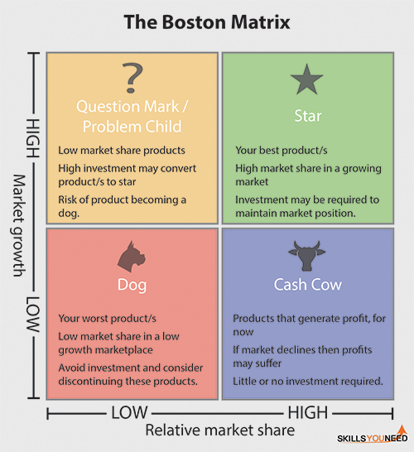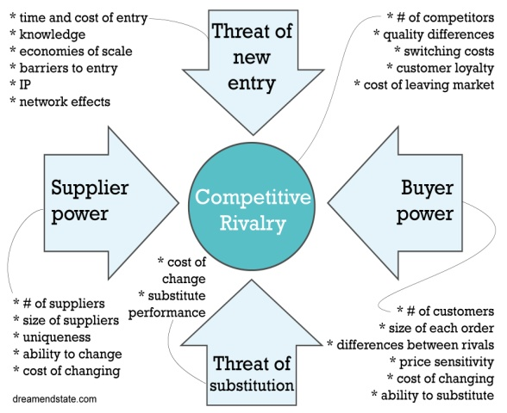
Figure: 1 (Skills You Need, 2023) Figure: 2 (Dream End State, 2021)
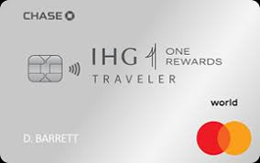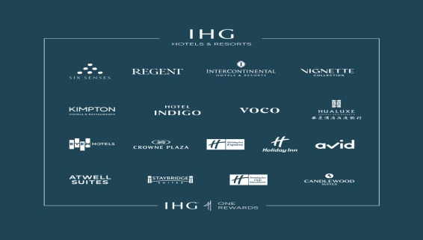
Figure: 3 (IHG Rewards card, 2024) Figure: 4(Intercontinental hotel group, 2024)
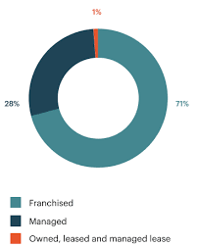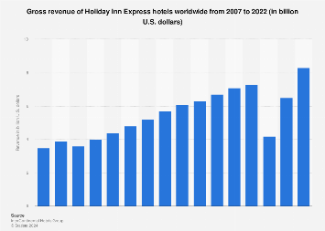
Figure: 5(Intercontinental Hotel group, 2021) Figure: 6 (Statista, 2023)
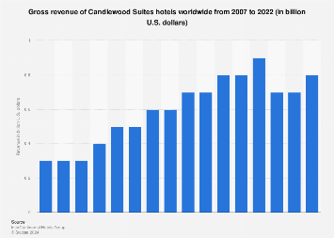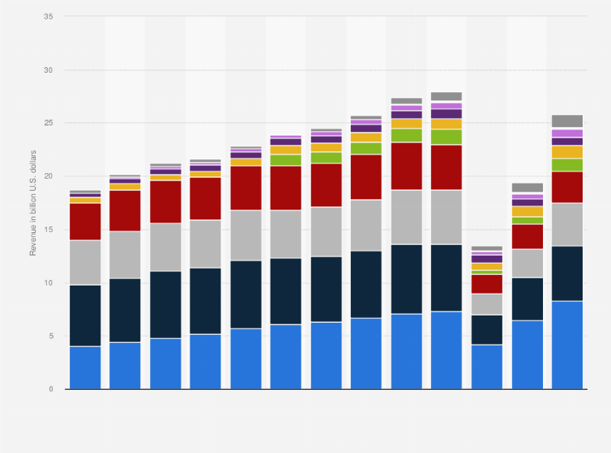
Figure: 7(Statista, 2022) Figure: 8 (Statista, 2022a)

References:
- Albrecht, S.L. (2012)."The influence of job, team and organizational level resources on employee well-being, engagement, commitment and extra-role performance". International Journal of Manpower, vol. 33, no. 7, pp. 840-853. (Accessed on: 12 February 2024).
- AltexSoft (2020). Revenue Management- the science of ultimate hotel success. [YouTube]. Available at: https://youtu.be/Ohx6Y3QOr50?si=yr0zZEphL7hkpdS- (Accessed on: 18th February 2024).
- Ben Luthi (2022). 'Chase Launches IHG Business Credit Card, Enhances IHG Consumer Credit Cards'. Investopedia. Available at: https://www.investopedia.com/chase-adds-to-ihg-credit-card-line-5223759 (accessed on: 11 February 2024).
- Cabrera, Á. Cabrera, E. F., & Barajas, S. (2001). 'The key role of organizational culture in a multi-system view of technology-driven change'. International Journal of Information Management, 21(3), 245-261. Accessed on: 10 February 2024.
- CIPD (2023). 'Organisational culture'. Available at: https://www.cipd.org/uk/views-and-insights/cipd-viewpoint/organisational-culture/ (accessed on: 13 February 2024).
- Comparably (2024). 'IHG Competitors'. Available at: https://www.comparably.com/companies/342644/competitors (accessed on: 8th February 2024).
- Christiansen, B., & Chandan, H. C. (Eds.) (2017). 'Handbook of research on organizational culture and diversity in the modern workforce'. IGI Global. (Accessed on: 10 February 2024).
- Dream End State (2021). 'Porter’s 5 Forces: Who has the upper hand, and why?' Available at: https://www.dreamendstate.com/wp-content/uploads/2021/01/Porters5forces-1.jpg (accessed on: 19 February 2024).
- IHG (2021a). 'Annual report'. Available at: https://www.ihgplc.com/investors/annual-report (accessed on: 14 February 2024).
- IHG (2021b). 'Preliminary Results for the year to 31 December 2020'. Available at: https://www.ihgplc.com/en/news-and-media/news-releases/2021/preliminary-results-for-the-year-to-31-december-2020 (accessed on: 14 February 2024).
- IHG (2023). 'Diversity, Equity and Inclusion'. Available at: (accessed on: 8 February 2024).
- IHG (2023a). 'Skills Academy'. Available at: https://careers.ihg.com/en/skills-academy/ (accessed on: 18 February 2024).
- IHG (2023b). 'Supporting Our Communities Policy'. Available at: https://www.ihgplc.com/~/media/Files/I/Ihg-Plc/responsible-business/policy-documents/english/supporting-our-community-policy-september-final-2023.pdf (accessed on: 11 February 2024).
- IHG (2024a). 'Our Brands'. Available at: https://www.ihgplc.com/our-brands ( accessed on: 6 February 2024)
- IHG (2024b). 'IHG culture'. Comparably. Available at: https://www.comparably.com/companies/342644 (accessed on: 8 February 2024).
- IHG (2024c). 'Communities'. Available at: https://www.ihgplc.com/responsible-business/communities#:~:text=The%20Community%20Champions%20are%20volunteers,join%20our%20community%20initiatives%20and (accessed on: 11 February 2024).
- IHG (2024d). 'Diversity, Equity and Inclusion'. Available at: https://careers.ihg.com/en/life-at-ihg/diversity-equity-and-inclusion/ (accessed on: 14 February 2024).
- IHG plc (2022). 'Our Strategy'. Available at: https://www.ihgplc.com/~/media/Files/I/Ihg-Plc/investors/annual-report/our-strategy-2022.pdf (accessed on: 11 February 2024).
- IHG plc (2024a). 'How our business works'. IHG Hotels and resorts. Available at: https://www.ihgplc.com/about-us/how-our-business-works#:~:text=We%20operate%20hotels%20in%20three,meet%20guests'%20needs%20and%20occasions. (Accessed on: 6th February 2024).
- IHG plc (2024b). 'What we stand for'. Available at: https://www.ihgplc.com/en/about-us/what-we-stand-for (accessed on: 8 February 2024).
- IHG plc (2024c). 'Responsible Business'. Available at: https://www.ihgplc.com/en/responsible-business (accessed on: 11 February 2024).
- IHG Rewards card (2024).'IHG one rewards traveller credit card'. [PHOTO]. Available at: https://www.google.com/url?sa=i&url=https%3A%2F%2Fcreditcards.chase.com%2Ftravel-credit-cards%2Fihg-rewards-club%2Ftraveler&psig=AOvVaw2JDKxex1F9v6qTLU_z3phG&ust=1708685603658000&source=images&cd=vfe&opi=89978449&ved=2ahUKEwiD7-OE5L6EAxVZVaQEHeYMAnEQr4kDegUIARD2AQ (accessed on: 22 February 2024).
- Intercontinental Hotel Group (2021). [Photo]. Available at: https://www.ihgplc.com/~/media/Images/I/Ihg-Plc/images/investor/annual-report-2021/businessmodel1.png?h=456&iar=0&w=365 (accessed on: 22 February 2024).
- Intercontinental Hotel Group (2024). [Photo]. Available at: https://www.google.com/url?sa=i&url=https%3A%2F%2Fwww.concur.com%2Fapp-center%2Flistings%2F550353cc99066b13221bce14&psig=AOvVaw141aE0kaQqyqunZLsf64s6&ust=1708686312130000&source=images&cd=vfe&opi=89978449&ved=0CBMQjRxqFwoTCMion9fmvoQDFQAAAAAdAAAAABAJ (accessed on: 22 February 2024).
- Jiwon Woo Alumni (2022). Digital Innovation and Transformation. Marriott: Data-driven Customer Experience for Decades at Scale. Available at: https://d3.harvard.edu/platform-digit/submission/marriott-data-driven-customer-experience-for-decades-at-scale%EF%BF%BC/ (Accessed on: 18 February 2024).
- Kastrenakes, J. (2017). '1,200 InterContinental hotels were breached by credit card stealing malwar'. The verge. Available at: https://www.theverge.com/2017/4/19/15363800/ihg-credit-card-breach-details-lookup-tool (accessed on: 14 February 2024).
- Lock, S. (2021) 'Revenue of the InterContinental Hotels Group (IHG) from 2007 to 2019'. Statista. Available at: https://www.statista.com/statistics/273254/revenue-of-the-intercontinental-hotels-group/ (accessed on: 14 February 2024).
- Michaela Jefferson (2022). 'IHG Hotels & Resorts heroes ‘revamped’ loyalty scheme with biggest campaign in a decade'. MarketingWeek. Available at: https://www.marketingweek.com/ihg-hotels-revamped-loyalty-biggest-campaign/ (accessed on: 11 February 2024).
- Organizational Communication (2016). 'Douglas McGregor's Theory X and Theory Y'. [YouTube]. Available at: https://youtu.be/CXAzZRnJo2o?si=FbiorcdDgV8ANuSf (accessed on 23 January 2024).
- Statista (2022). 'Candlewood suite hotels gross revenue'. [Photo]. Available at: https://www.google.com/url?sa=i&url=https%3A%2F%2Fwww.statista.com%2Fstatistics%2F223350%2Fcandlewood-suites-hotels-revenue%2F&psig=AOvVaw1kVeOMnFBpMQWDqwwjdj-m&ust=1708691097257000&source=images&cd=vfe&opi=89978449&ved=0CBMQjRxqFwoTCMCt2sD4voQDFQAAAAAdAAAAABAE (accessed on: 22 February 2024).
- Statista (2022). 'IHG Gross Revenue worldwide'. [Photo]. Available at: https://cdn.statcdn.com/Statistic/295000/298806-blank-754.png (accessed on: 22 February 2024).
- Statista (2023). 'Holiday Inn hotels gross revenue 2022'. [Photo]. Available at: https://cdn.statcdn.com/Statistic/220000/223347-blank-355.png (accessed on: 22 February 2024).
- Skills You Need (2023). Available at: https://www.skillsyouneed.com/images/lead/boston-matrix.png (19 February 2024).
- Tom Otley (2021). 'IHG Hotels and Resorts launches sustainability programme'. Business Traveller. Available at: https://www.businesstraveller.com/business-travel/2021/02/16/ihg-hotels-and-resorts-launches-sustainability-programme/( accessed on: 11 February 2024)
- Toni Perkins-Southam (2023). 'Chase Launches Best-ever Offer on IHG Rewards Premier Credit Card, Elevates Offers on Premier Business and Rewards Traveller Cards'. Forbes Advisor .Available at: https://www.forbes.com/advisor/credit-cards/chase-launches-best-ever-offer-on-ihg-rewards-premier-credit-card-elevates-offers-on-premier-business-and-rewards-traveler-cards/ (accessed on: 11 February 2024).
- Toni Perkins-Southam and Barbara King (2024). 'IHG One Rewards: The Complete Guide'. Forbes Advisor. Available at: https://www.forbes.com/advisor/credit-cards/travel-rewards/ihg-one-rewards-the-complete-guide/ (accessed on: 11 February 2024).
- Tutor2u (2018). 'Handy's model of organisational culture- explained'. [YouTube]. Available at: https://youtu.be/kRIc0W48qYY?si=-JEMQw8ydRbniS3t (accessed on: 11 February 2024).
- Worthy, L. D., Lavigne, T., & Romero, F. (2020). Stereotypes and Gender Roles. Maricopa. Available at: https://open.maricopa.edu/culturepsychology/chapter/stereotypes-and-gender-roles/ (accessed on: 15 February 2024).

