Brief Ransomware report (CryptoWall Trojan Focused)

Introduction:

In this report the author will look to inform managers and leaders of small to medium businesses of what ransomware is, and in what ways it can affect their businesses. The Report will start by defining ransomware in general, and then expand on the specific dangers of CryptoWall in the business world. The author will expand on definition of CryptoWall Trojans, along with its specific workings and the outcome of an infection of CryptoWall Trojan. Some information on prevention and backup plans (best practises) will be details by the author.

Table of Contents

- Introduction to Ransomware
  - Brief Introduction to Ransomware
  - Brief examples of types

- CryptoWall Trojan
  - Introduction – What is CryptoWall
  - What does it target
  - Examples of Crypto-Malware incidents + outcomes

- Strategies to reduce susceptibility CryptoWall
  - Basic outline of strategies & Specific Examples
  - Advice from industry

- Conclusion
  - Overall conclusion of CryptoWall / Ransomware
  - Reflection on how it affects your own setup

- Referencing

- Introduction in to Ransomware

  - Ransomware is a type of malware (sometimes referred to as virus), that attempts to extort the victim of such attacks for monetary gain to the person or persons inciting the attack. As stated by Timothy Gallo & [1] Ransomware dates to a piece of malicious code know as AIDS, written in 1989 by Joseph Popp. Its basic purpose was after a number of device reboots the code would then hide and encrypt directories on the device infected.

  - Types of ransomware include: Crypto-malware, Locker, Doxware, Scareware and Popcorn Time ransomware, as referenced [2] each type has a specific outcome in mind. Varying from Crypto-malware which is one of the most common types, which aims to only encrypt certain file types and demand payment for decryption keys. To Ransomware such as Locker which aims to lock the user(s) out of their devices completely.

Example of Ransom Payment request screen of various “Crypto-Malware” [3]

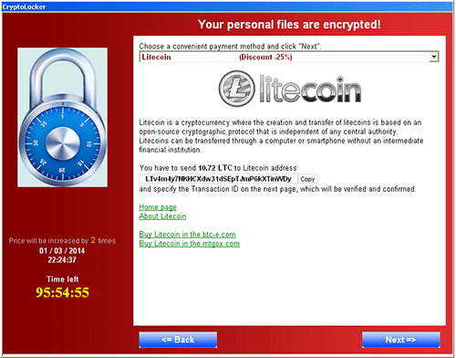

- CryptoWall Trojan

  - CryptoWall and its many variants have become one of the more common malware attacks in recent times as referenced by Jeff Petters [4] a 2018 Verizon Data Breach Investigation report concluded that around 40% of all reported malware incidents was now some form of Crypto-Malware, It was also reported that its estimated that the financial damage caused by CryptoWall 3.0 itself now runs over $325 million since its arrival. The reason for such wide spread damage and infection is down to its ease of use and deployment

  - CryptoWall Trojan is a specific type of Crypto-Malware that looks to not only encrypt local files and hold them to ransom, but to also go further and delete basic backup processes such as “Volume Shadow Copy” which essentially creates a roll back copy of file on a local device, making it far less easy for the average user to restore encrypted data. It also looks to detect local Bitcoin Wallets and attempts to gain access to these wallets to facilitate Bitcoin transfers [4]. CryptoWall Trojan targets specific document types [5] As shown in the screenshot below:

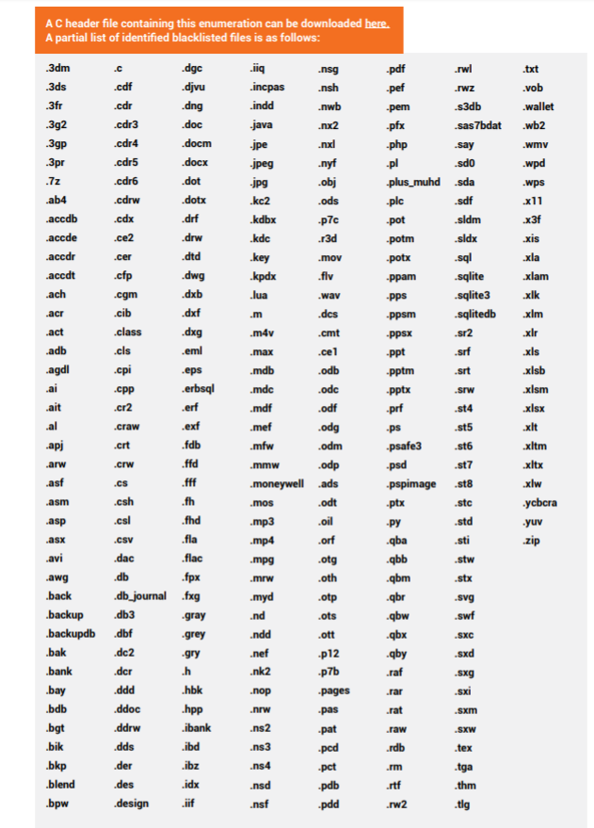

  - An example of Crypto-Malware that has caused large scale disruption and gained media attention would be the “WannaCry”. As referenced [6] According to a National Audit Office report 81 out of 236 English NHS trusts were affected either directly or indirectly, and 603 other primary care trusts such as GP surgeries. As well as devices such as desktop pc’s or laptops being affected and having important files encrypted, important medical devices such as MRI Scanners and Blood analysing equipment were also prevented from working. It is reported that around 19,494 appointments were cancelled due to such disruption.

- Strategies to reduce susceptibility CryptoWall

  - Basic Steps to aid in the prevention of Crypto-ware infections such as CryptoWall are:
- Avoid opening or executing any unknown files from unknown senders.
- Make sure a reputable Anti-Virus and/or Malware product is installed and kept up to date with the latest definition files (Updates).
- Have a backup of important files, preferably on an external drive or cloud based backup.

  - Some best practise methods according to industry experts to reduce the risk of CryptoWall infections and other types of Crypto-Malware are as follows:
- Make sure all software and operating systems are up to date and patched to latest available security patches
- Prevent transfer & opening of certain file types (Blacklist & Whitelist). This can be set in Group Policy object settings or use 3rd party software products to manage this.
- Educating users on the dangers of accessing/running unknown files from known & unknown sources (preach caution)
- Look to implement scanning/filtering software on your email servers to prevent spread to client devices.

The above information is referenced [7] and [8] Along with some further detailed advice.

- Conclusion

  - CryptoWall and its various other Crypt-ware/Ransomware variants have continued to become big business in recent years. Its simplicity and effectiveness to deploy, along with its ability to spread rapidly are a low cost and efficient way for criminals to gain financially from victims of such crimes. But with what is clear is that with some basic steps from business and individuals, is that the prevention of Crypto-ware type Trojans can be limited if not prevented. Business’s need to make sure they are utilizing up to date software and antivirus/malware products along with a good offline (cold) backup plan. These two key actions would (a) Limit the chances of being infected and (b) in the instances where infection still occurs, limit the fallout from such occurrences.

  - In the authors on reflection of the steps needed to prevent/reduce the chances of such infections, It is clear that there needs to be a clarification on how linked in cloud backup processes are in relation to synchronised backups. In other words to make sure that any Crypto-ware infection is not spread from the offline synchronization of cloud storage and then spread upon synchronising. This is where “cold” or offline backups are key and something that will be investigated further to seek clarity in the author’s own backup routines.

For further reading on the definition and further explanation of cold backups. Please refer to the article referenced [9]

References

[1] | T. Gallo and A. Liska, “O'Reilly - Chapter 1. Introduction to Ransomeware,” [Online]. Available: https://www.oreilly.com/library/view/ransomware/9781491967874/ch01.html. [Accessed 21st November 2018].
[2] | Thilak, “Comodo AntiVirus,” 22nd February 2018. [Online]. Available: https://antivirus.comodo.com/blog/comodo-news/ransomware-types-and-prevention/. [Accessed 21st November 2018].
[3] | Dell SecureWorks Counter Threat Unit Threat Inteligence, “Secureworks,” 27th August 2014. [Online]. Available: https://www.secureworks.com/research/cryptowall-ransomware. [Accessed 24th November 2018].
[4] | J. Petters, “Varonis Blog - The State of CryptoWall in 2018,” Varonis, 6th January 2018. [Online]. Available: https://www.varonis.com/blog/cryptowall/. [Accessed 21st November 2018].
[5] | Cyber Threat Alliance, “Lucrative Ransomeware Attacks: Analysis of the CryptoWall Version 3 Threat,” Cyber Threat Alliance, 2015.
[6] | O. Hughes, “Digital Health News,” 27th October 2017. [Online]. Available: https://www.digitalhealth.net/2017/10/wannacry-impact-on-nhs-considerably-larger-than-previously-suggested/. [Accessed 21st November 2018].
[7] | SonicWall, “SonicWall Knowledge Base,” 5th November 2018. [Online]. Available: https://www.sonicwall.com/en-us/support/knowledge-base/170505805544043. [Accessed 5th November 2018].
[8] | Norton / Symantec, “7 tips to prevent ransomware,” 2018. [Online]. Available: https://us.norton.com/internetsecurity-malware-7-tips-to-prevent-ransomware.html. [Accessed 26th November 2018].
[9] | M. Rouse, E. Hannan and Douglas Malcolm, “cold backup (offline backup),” Techtarget, November 2016. [Online]. Available: https://searchdatabackup.techtarget.com/definition/cold-backup. [Accessed 25th November 2018].

