

Public Health Assignment 2

Student Name: Zawadi Nibigira
Student ID:

Table of Contents
Introduction 4
Main Body 5
1. Implications of Heart Disease in Communities 5
2. Factors Influencing Health and Wellbeing 7
3. Inter-Professional Collaboration for Better Outcomes 9
Conclusion 11
References 12

Berlo (1960) Model of Communication
- In 1960, David Berlo came up with the Sender-Message-Channel-Receiver (SMCR) model of communication which was adapted from Shannon Weaver's Model of Communication (1949).
- Berlo (1960) described factors affecting the individual components in the communication process, making the communication more efficient.
- Berlo's model (1960) has mainly, four components to describe the communication process.
They are sender, message, channel and receiver. Each of the component is affected by many factors.

Trawsnewid Addysg; Trawsnewid Bywydau
Transforming Education; Transforming Lives

Introduction
This report focuses on the heart disease, major non-infectious condition that damage the structure and function of the heart & blood vessels. The WHO or World Health Organisation (2023) defines the heart disease as the group of disorders of the heart & blood vessels, that include the coronary heart disease, cerebrovascular disease, rheumatic heart disease & also related conditions. As the most prevalent chronic illnesses across the world, heart disease contributes significantly to the global morbidity & premature mortality, as also placing the extensive pressure on individuals, families & health and social care systems. In the UK, over 7.6 million people live with heart/circulatory diseases, that result in more than 160,000 deaths of each year according to the British Heart Foundation, 2023. On the global scale, heart disease is responsible for almost 17.9 million deaths per year, accounting for 32% of all the global deaths according to the World Health Organisation, 2023. Though being largely preventable, heart disease disproportionately affects the socioeconomically disadvantaged communities. This will explore the impact on the communities, examine factors that influence the health and wellbeing & thus evaluate how health and social care professionals can conspire to enhance the outcomes for the affected.
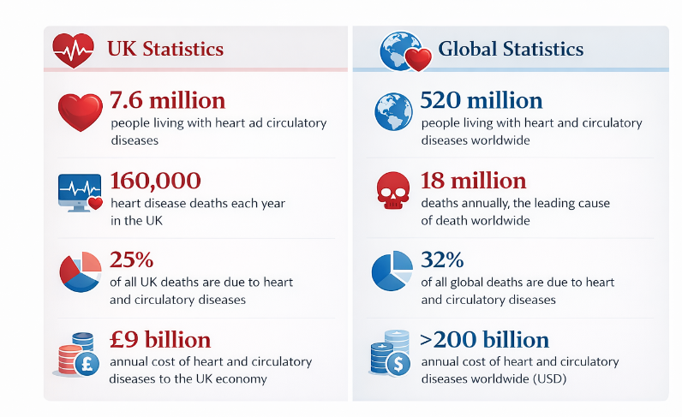
Figure 1: The Global & UK Burden of Heart Disease

Main Body

1. Implications of Heart Disease in Communities
The term of Heart disease has wide-ranging implications for different communities, that affect the social wellbeing, economic stability and overall healthcare services. The individuals living with the heart diseases often experience the reduced quality of life due to the symptoms for instance, fatigue, breathlessness and also chest pain (Cleveland Clinic, 2022). These symptoms can restrict the daily activities, reduce their mobility and that may lead to loss of their independence. As a result, many of the individuals’ experience social isolation, especially the older adults or those who are living alone, that can negatively affect the mental health and their emotional wellbeing.
The economic impact of the heart disease is crucial for their families & communities. Individuals may require to reduce the working hours or leave the employment due to their poor health, that may lead to loss of their incomes and financial strains. Families often face the additional costs related to their long-term medications, transport to the medical appointments and also lifestyle adjustments. Informal care provided by their family members is a common phenomenon, placing their emotional and physical strain on their carers and disrupting the family routines and also employment opportunities (Connolly, 2016).
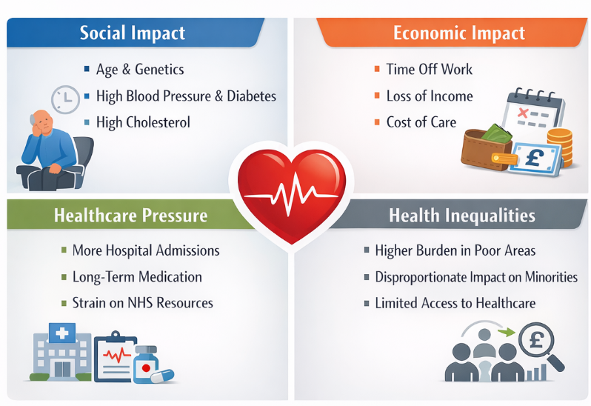
Figure 2: Community Implications of Heart Diseases
Heart disease also places the considerable strains on the healthcare systems. It is considered as one of the leading causes of the hospital admissions in the UK, that need the ongoing medical treatments, regular monitoring systems and access to the specialist services like, cardiac rehabilitations. Long-term treatment needs increase demand for NHS resources, contributing to longer waiting times and pressures on emergency & outpatient services (David, 2025).
Health inequalities also intensify the community impacts of their heart diseases. People from the low-income backgrounds & the certain ethnic minority groups experience the higher rates of heart disease due to the increased exposures to these risk factors such as smoking, poor diet routines, limited access to the healthcare and also their chronic stresses. The clear example can be seen in the Blackpool, where the hospital admissions for the heart-related conditions are nearly double the national averages. The high smoking rates, their unhealthy diets and the economic hardships have resulted in the overstretched of the NHS services, longer waiting times for the cardiac appointments and also the increased pressures on the emergency care units (De and Torbjørn Omland, 2017).
The intergenerational effects are also crucial, with the family members often acting as the unpaid carers. This can lead to the emotional stresses, reduced wellbeing and also long-term impacts on their family stability & community health.

2. Factors Influencing Health and Wellbeing
The range of the interconnected factors influence the health & wellbeing of individuals affected by the heart disease and those around them. Biological factors play a crucial role, that include the age, genetic predisposition, and pre-existing conditions like, the high blood pressures, diabetes, and high cholesterol (Frayn, Stanner and Coe, 2019). The risk of the heart diseases increases with age, especially when these are combined with the other chronic conditions.
The lifestyle factors are among the most influential contributors to the heart diseases. Poor diet, especially the high consumption of the saturated fats, salt and the processed foods, increases the cardiovascular risks (Maleszewski, Burke and Veinot, 2023). Smoking damages blood vessels and remains one of the leading preventable causes of the heart diseases. Excessive alcohol consumptions and the lack of the physical activity further contribute to their obesity, high blood pressures and the reduced heart functions.
Environmental factors also shape the health results. Individuals living in the deprived areas may have limited access to the affordable healthy food, safe neighborhoods, or the green spaces for different physical activity. Exposures to air pollutions has been linked to the increased cardiovascular risks, especially in the urban areas with high traffic/industrial activities.
Psychosocial influences crucially affect overall wellbeing. Stress, loneliness and the mental health conditions for instance, anxiety & depression are common to the heart disease diagnosis or the cardiac event (Ndejjo and Hassen, 2021). These can reduce overall motivation to adopt the healthy behaviours and negatively affect their recovery.
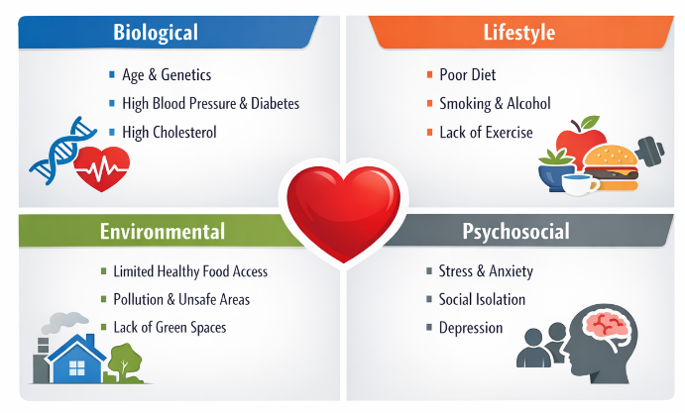
Figure 3: Factors Influencing Heart Health & Wellbeing
Education & health literacy is also significant. Individuals with the limited understanding of the heart disease’s symptoms may delay the seeking of medical helps, that increase the risk of severe results. The cultural attitudes, that include the stigma surrounding the illness, gender norms and also distrust in the medical systems within the certain communities, may also discourage engagements with the preventative services & long-term cares.
The support systems & the social networks further influence the overall outcomes for the individuals with the heart diseases. Strong family supports, community engagements and peer encouragements can improve the adherence to treatment plans & overall lifestyle modifications. On the other hand, social isolations may worsen the stresses & hinder recoveries. Access to the quality healthcare services, timely intervention and continuity of these care are critical in managing the heart conditions as effectively as possible (Utley, Mathena and Gunaldo, 2020). The public health initiatives, awareness campaigns and the targeted interventions can also help to reduce the risk factors, promote the early detections and support the long-term management, that will ultimately improve both physical & psychological well-being for the patients & those who are around them.

3. Inter-Professional Collaboration for Better Outcomes
The effective inter-professional collaboration is crucial for enhancing the wellbeing of the individuals living with the heart diseases. Healthcare & social care professionals, that include the general practitioners, nurses, cardiologists, physiotherapists, dietitians and the social workers, work together to ensure holistic & coordinated care (World Health Organization, 2022). This approach ensures that both the medical & social needs are being addressed.
The joined-up care pathway for the heart diseases typically starts with the hospital-based treatment & continues into community. Following the discharge, patients can be supported by the cardiac rehabilitation programmes that involve the GPs, physiotherapists, community nurses and the social care services (World Health Organization, 2025). This coordinated support improves overall recovery, encourages the lifestyle changes and also reduces the hospital readmissions.
Health promotion plays a crucial role in the collaborative care. Community nurses & health educators support the individuals in managing their diet, increasing the physical activities, stopping smoking and adhering to their medication. Social care professionals help with housing, financial supports and access to the community resources, that address the wider determinants of health.
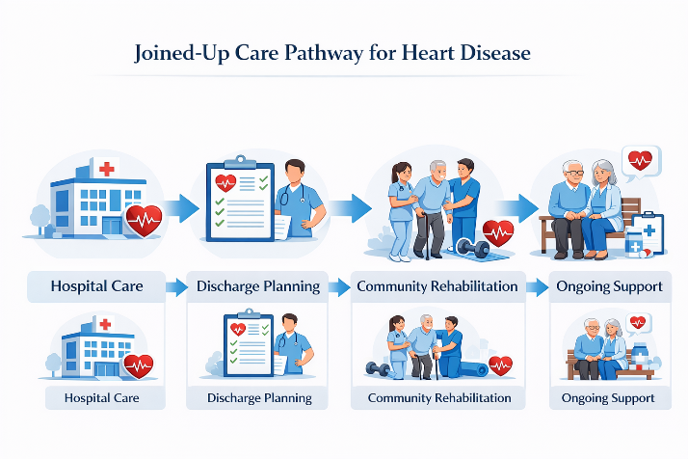
Figure 4: Joined-Up Care Pathway for Heart Disease
The effective communication & information sharing between their services are crucial to avoid fragmented care. Shared electronic health records & care plans enable the professionals to monitor their progress & respond quickly to changes in the condition of patient. Technology like the remote monitoring & virtual consultations also supports the ongoing care, especially for the individuals with the mobility limitations (World Heart Federation, 2023).
NHS Long Term Plan (2019) ensures the Cardiac Rehabilitation Pathways, where the patients recovering from the heart attacks gain the coordinated care between hospitals, GPs, community rehabilitation teams and the local health & wellbeing services. This approach is shown to reduce the hospital readmissions & improve their long-term recovery. Also, involving the patients & their families in care planning strengthens their engagement & adherence to treatment. Shared decision-making enables the individuals to realise their conditions, set different realistic goals and also actively participate in the lifestyle modifications (Youngwha Kee, Seung Jong Lee and Phillips, 2016). The psychological support is also crucial; the clinical psychologists or the counsellors can help the patients manage anxiety, depression and stress, that are common following the cardiac events. The inter-professional education & regular team meetings enhance the coordination by ensuring that all the professionals are aware of the evolving needs & any potential risks of the patients. The community-based initiatives, like the support groups & the exercise programmes, complement the formal healthcare by promoting social interactions & motivation for the healthy behaviours. The continuous evaluation of the care pathways & feedback from the patients help to refine services, that ensure the care remains patient-based & evidence-based. Finally, the collaborative, holistic approach both improves the clinical outcomes also enhances the quality of life, independence and overall the well-being for the individuals who are living with heart disease.

Conclusion
Heart disease pursue to be the major non-infectious condition with the serious implications for public health in both the UK & global-level. Its result extends beyond the individual, that affect the families, communities and health & social care services emotionally, financially & also practically. The range of the factors influence the wellbeing of those who are affected, that include the socioeconomic status, lifestyle behaviours, environmental conditions & access to timely supports. Effective collaborations between the healthcare & social care professionals, like the structured discharge planning, shared electronic records and the community rehabilitation services, can crucially improve the outcomes. Moving forward, tackling the heart diseases need a coordinated, person-based approach that supports the preventions, early interventions and long-term cares. The holistic model of care plays a crucial role in reducing the health inequalities & enhancing the overall quality of life for the individuals who are living with heart disease.

References
Cleveland Clinic (2022). Cardiovascular Disease: Symptoms, Types, Causes, Management & Prevention. [online] Cleveland Clinic. Available at: https://my.clevelandclinic.org/health/diseases/21493-cardiovascular-disease.
Connolly, S. (2016). The World Health Organisation. London: Franklin Watts.
David (2025). Global, Regional, and National Burden of Cardiovascular Diseases and Risk Factors in 204 Countries and Territories, 1990-2023. JACC. doi:https://doi.org/10.1016/j.jacc.2025.08.015.
De, J.A. and Torbjørn Omland (2017). Chronic coronary artery disease : a companion to Braunwald’s heart disease. Philadelphia, Pa: Elsevier.
Frayn, K.N., Stanner, S. and Coe, S. (2019). Cardiovascular disease : diet, nutrition and emerging risk factors. Chichester: Wiley Blackwell.
Maleszewski, J., Burke, A.P. and Veinot, J.P. (2023). Disorders of the Heart and Blood Vessels.
Ndejjo, R. and Hassen, H.Y. (2021). Community-Based Interventions for Cardiovascular Disease Prevention in Low-and Middle-Income Countries: A Systematic Review. Public Health Reviews, 42(1604018). doi:https://doi.org/10.3389/phrs.2021.1604018.
Utley, J., Mathena, C. and Gunaldo, T. (2020). Interprofessional Education and Collaboration. Human Kinetics.
World Health Organization (2022). Cardiovascular Diseases. [online] www.who.int. Available at: https://www.who.int/health-topics/cardiovascular-diseases.
World Health Organization (2025). Cardiovascular diseases (CVDs). [online] World Health Organization . Available at: https://www.who.int/news-room/fact-sheets/detail/cardiovascular-diseases-(cvds).
World Heart Federation (2023). World heart report 2023. [online] World Heart Federation. Available at: https://world-heart-federation.org/wp-content/uploads/World-Heart-Report-2023.pdf.
Youngwha Kee, Seung Jong Lee and Phillips, R. (2016). Social Factors and Community Well-Being. Cham Springer International Publishing.

