Problem Solving and Decision Making

STUDENT NAME: FAZLEE ZAHID
STUDENT ID: 2012168
MODULE TITLE: PROBLEM SOLVING AND DECISION MAKING
MODULE CODE: BMSW4004
ASSIGNMENT TITLE: PROBLEM SOLVING AND DECISION MAKING
LECTURER: SUNETH FERNANDO

Contents
Problem Solving and Decision Making 1
Introduction: 1
1. Organization, type of business and the problem: 2
2. Evaluation of the current situation and identify and define alternative solutions 4
3. Apply decision-making tools to finding the best solution for the problem 6
Develop a plan for implementing the solution 7
4. Review your implementation process 8
Conclusion 9
References 10

Introduction:
In this Pandemic situation, the company faces different types of problems. The multinational company faces this problem hardly. The company is shut down its physical activities due to the covid-19 pandemic situation. Although some companies are operating their business activities it is difficult for them to maintain a completely physical distance. Therefore, it is a very big problem. The company business revenues decrease for this pandemic situation. In this condition, the company does not meet operation expenses because it faces a very big loss. Products production and sales are completely falling. The company cannot give full salary to its employees. Some companies are laying off their workers due to reducing companies expenses. As result, many employees accept unemployment. This part of this report is going to discuss different problems in current conduction for a company. This report also explains tools and techniques to identify problems as well as assess the present situation and identify an alternative solution.

1. Organization, type of business and the problem:
I. Provide a brief introduction about the organization
Marks and Spencer is one of the renowned companies in retail. It is the oldest brand working in the fashion retail industry. Marks and Spencer were founded by Michael and Tom Spencer. The company started its commercial business journey in 1884. Now, the company is employing over 60,000 individuals in 450 stores. The company operates business in more than 30 countries in the world. At first, it started its business with the selling of buttons, threat, socks, and biscuits with the help of its penny Bazaars. The company is highly committed to selling great value, outstanding food and fashion products. This company collects its necessary raw materials from over 2000 suppliers. It believes that maintaining effective relationships with customers, suppliers and society are very significant and assists in creating good value for its shareholders and stakeholders (Abd. Ghani., 2018). It is the largest fashion industry. For this reason, the company is highly affected by the preference and choices of large numbers of customers. The company also faces several issues in distributing and developing services in the target marketplace. The vision statement of the company indicates that all products provided and service provided by it is measured against a predetermined standard. The mission statement of the company reflects that the company is involved in making quality that can easily be evaluated by all. The company considers marketing strategy to include innovation, trust and quality.
II. What type of business they are doing (selling products or services – specify)
Marks and Spencer is one of the renowned companies in retail. At first, it started its business with the selling of buttons, threat, socks, and biscuits with the help of its penny Bazaars. The company is highly committed to selling great value, outstanding food and fashion products. The company also offers its customers home products, selling clothing and foods products. Now, the company is trying to increase its product range in the world market (Shapira, 2017).
III. Identify the departments of the company
This company has many departments. Marketing, human resource (HR), selling, R&D, customers relationship and accounts are notable departments names of the company. The marketing department is liable to current market research includes current market situation, current competitors position, current market problems, opportunities etc. The HR department is liable to fulfil employees of different departments. This department collects information about different department workforce demands and provides according to their demands. R&D department increases employees skills. This department also increases employees innovative powers. The customer's relationship management department is liable to build up a strong relationship with customers and inform them about products and services. The selling department is liable to sell products to its customers.
IV. Identify the department where the problem occurred
In this Pandemic situation, all departments face different types of problems. For example, the HR department cannot motivate its employees because this department gives huge pressure on its employees but do not pay any incentive. The HR department also faces a lot of problems. This department is laid off a large number of employees of the company due to decrease company expenses (Berry and Bartholomew., 2012). The HR manager needs to find out ingenious solutions for ensuring the continuity of the company and assist its employees to adapt to this extraordinary crisis. The marketing department does not conduct marketing research. As a result, the company does not get actual market information. For this reason, the company does not take effective business decisions. The customer's relationship management department does not conduct their customers for this Covid-19 pandemic condition.
V. Identify the stakeholders and how they are impacted by the problem.
Identification of stakeholders is very effective for the company in identifying conflicts and gaps between different stakeholders. In this pandemic situation, stakeholders face a lot of problems. Customers, employees, suppliers, investors are very important stakeholders of any company. They do not take effective and useful business decisions due to the Covid-19 pandemic situation because they do not judge the current market condition.
Tools and techniques used to identify and define the problem
The employment procedures are completely changed due to the Covid-19 pandemic situation. In this condition, the company can select effective tools for solving this problem (Linstone, 2016). By considering the Covid-19 pandemic situation, the online platform is a very effective technique for employing new employees in the company. The HR managers can give circulars on online platforms and recruit new employees for the company.

2. Evaluation of the current situation and identify and define alternative solutions
SWOT analysis of the company:
Well experienced:- M&S has well experienced more than 136 years. This company is now passing a very critical situation due to Covid-19 Pandemic. However, the company has good experience to handle many critical situations.
Strong funds: This Company has strong funds. For this reason, this company can manage all operating expenses and give employees salaries in this lockdown situation. It is possible for its healthy funds.
Various products: The Company offer variety of products to its customers. It also offers necessary goods such as grocery products to its customers. In the covid-19 situation, the company earns a huge revenue lot of revenue from grocery products that help to meet company demands.
Weakness:
Declining sales:
The fashion sector of this company is completely shut down because people are interested to purchase fashionable products in this Covid-19 pandemic situation. The company is declining sales by end of 2020 because the company needs to shut down its offline stall maximum time this year due to the Covid-19 pandemic situation.
Minimize training program: For reducing company expenses and maintain social distance, the company reduce its training program. As result, the employees are demotivated because they do not increase their skills due to sufficient training (Marmol, Feys and Probert, 2015).
Opportunity:
Develop online platform: In this pandemic situation, the company has a very big opportunity to develop its online platform. Today, most people order products on the online platform. In this situation, the company can redesign its online platform to attract new customers and retain existing customers.
Threats:
Coronavirus Covid-19: Now, it is a very threat name for every company. If the world will be going to in this condition, each company ruins for this reason. The company sales will decrease because the income level of people has already decreased due to Covid-19.
Pestle analysis in Covid-19 Pandemic situation:
Political: After the Covid-19 pandemic situation, telehealth expands covering during this time. Political stability, instability, government policy, foreign trade policy, trade restriction are considered political factors. With significant uncertainty sounding Covid-19 and Brexit M&S is quite struggling at this moment. Covid-19 is completely affecting the margins and sales volumes of the company.
Economic: Economic growth, inflation, interest rate, disposable income of people and exchange rate are considered as economic factors. In the Covid-19 Pandemic situation, the income levels of people are decreasing day by day. Many people are unemployed due to Covid-19. As result, the company sales volume decreases in this pandemic condition.
Technology: In this pandemic situation, the use of high technology is increase but the company profit decrease. As a result, the company operational expense decreases but it cannot generate its profit due to the Covid-19 pandemic situation.
Social: In the Covid-19 pandemic situation, the company does not meet its desirable business profit but the operational expense does not reduce. In this situation, the company decides to lay off many employees for reducing operational expenses. As a result, many people will be unemployed and social crime will increase (Groznik, Krapež and Škerlavaj, 2011).
In this situation, the company can Fishbone diagram for solving problems.
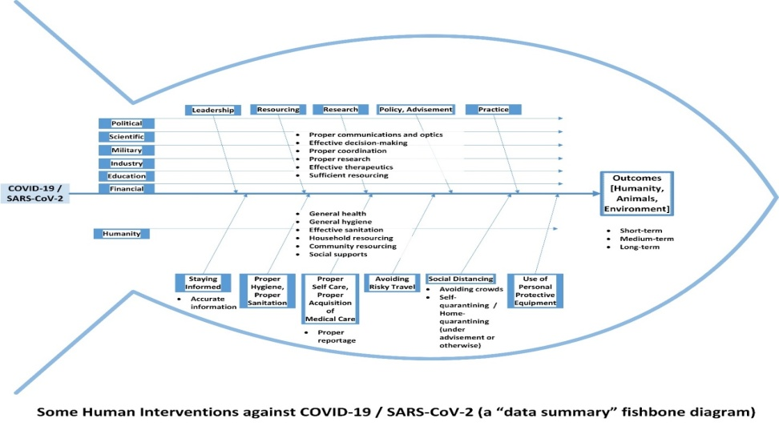
Figure :Fishbone diagram
Source: : (Groznik, Krapež and Škerlavaj, 2011)

Define alternative solution:
Solution-1
Now, M&S is employing over 60,000 individuals in 450 stores. For reducing operational expenses, the company can minimize the number of stores.
Solution-2
Now, M&S is employing over 60,000 individuals in 450 stores. . For reducing operational expenses, the company can lay off some employees
Solution: 3:
The company can improve its online platform so that it can get products orders from customers.

3. Apply decision-making tools to finding the best solution for the problem
PMI analysis:
PMI stands for plus, minus and Interesting. It is the tool for barnstorming and for thinning critically. This analysis motivates the examination of ideas and experience. Dr Edward de Bono is the developer of this PMI.
PMI CHART of the company:
Plus: All employees can play a very effective role in the decision-making process. For this reason, the company should allow resolving problems. A co-relation with all employees is very important to overcome this Pandemic condition (Abd. Ghani., 2018). Online services is developed by the company at a reasonable amount so that each customer can enjoy purchase products from the company.
Minus: Ineffective and weak procedures, policies and strategies, as the operation and activities of the company are not being properly instructed effectively. In the Covid-19 pandemic condition, the company should improve employees performance levels. Funding is a very important issue in this pandemic situation. However, the company has good quality products and a good image to customers.
Interesting: The Company should apply creative ways and a rational approach in order to find out effective solutions to the problems of the employees. The company to develop the appropriate decision in this pandemic condition can use the above stated innovative and effective techniques. Interesting skill development programs and campaigns should conduct in the company to overcome the coming of this pandemic situation(Shapira, 2017)..

Develop a plan for implementing the solution
Problem | Solution | Objective | Time duration (months)
Funding Issue:- It is a very big issue in covid-19 pandemic condition because the government of the UK does not provide any financial support in this critical situation. | The solution for these problems is that M&S can raise the funds from another source. The company can reduce operational expenses for managing funds. | The key objective is to solve the financial problem of the company. | 3 months
Declining sales volume: The fashion sector of this company is completely shut down because people are interested to purchase fashionable products in this Covid-19 pandemic situation (Fitzgerald, 2012).The company is declining sales by end of 2020 because the company needs to shut down its offline stall maximum time in this year due to the Covid-19 pandemic situation | The solution for the company is to decrease products price so that the customers can attract. The company can take the step for a good marketing campaign in this pandemic situation. | The key objective is to solve this problem and increase sales. | 4 months
Poor quality of services: In this pandemic situation condition, the company are facing poor quality of products problem. | The company can develop a new business strategy and increase employees’ performance to solve this problem (Richardson, 2012). | The key purpose is to solve the poor quality of service problem that increase the goodwill and brand image of the company. | 4 months

4. Review your implementation process
Identify the problem: At first, the company of the company must identify what the problem is. The employee may think he knows but the employee needs to check it out. The employee can use a rational approach to determine what the problem is.
Search for the alternative: After identifying the problem, the company should search for an alternative. It is a very significant step to search for alternative options to solve the problem. Brainstorming is a very useful tool to address possible alternatives (Abd. Ghani., 2018).
Weight the alternative: In this step, the company should select an effective alternative problem-solving tool so that problem can easily solve.
Make choice: In this step, the company needs to eliminate the number of problem-solving options and select the best option for problem-solving.
Implement the choice: In implementing step, the company need to apply his choice option in order to solve complex problems.
Evaluate the outcome: In this step, the company considers the result of the option. It means that the employee does judge the alternative option will work effectively or not (Berry and Bartholomew., 2012).

Conclusion
In this Pandemic situation, the company faces different types of problems. The multinational company faces this problem hardly. The company is shut down its physical activities due to the covid-19 pandemic situation. Although some companies are operating their business activities it is difficult for them to maintain completely physical distance. Therefore, it is a very big problem. The company business revenues decrease for this pandemic situation. In this condition, the company does not meet operation expenses because it faces a very big loss. Products production and sales are completely falling. The company cannot give full salary to its employees.

References
Abd. Ghani., A., 2018. Problem solving & decision making management. 4th ed. Shah Alam: Pusat Penerbitan Universiti, Universiti Teknologi MARA, pp.55-90.
Berry, J. and Bartholomew., 2012. Every kid's guide to decision making and problem solving. 4th ed. Chicago: Childrens Press, pp.66-90.
Fitzgerald, S., 2012. Decision making. 11th ed. Oxford, U.K.: Capstone Pub., pp.89-108.
Groznik, A., Krapež, J. and Škerlavaj, M., 2011. National innovation system study. 9th ed. [S. l.]: FORSEE Partnership, pp.67-90.
Linstone, H., 2016. Decision making for technology executives. 8th ed. Boston: Artech House, pp.77-90.
Marmol, T., Feys, B. and Probert, C., 2015. PESTLE analysis. 6th ed. [Lieu de publication non identifié]: 50Minutes, pp.66-78.
Richardson, L., 2012. Creative problem solving. 5th ed. Delhi: Global Media, pp.77-98.
Shapira, Z., 2017. Organizational decision making. 8th ed. Cambridge: Cambridge University Press, pp.43-77.

