Natasha Louise Ellis 2309153
Module BMHP6029_BIRM – Psychological Classifications and Provisions

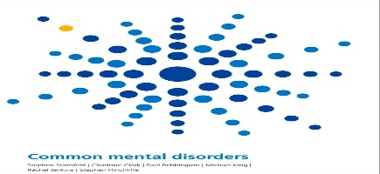
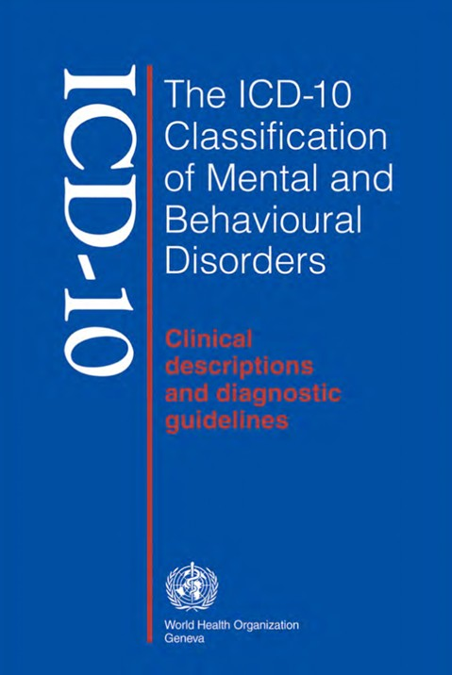
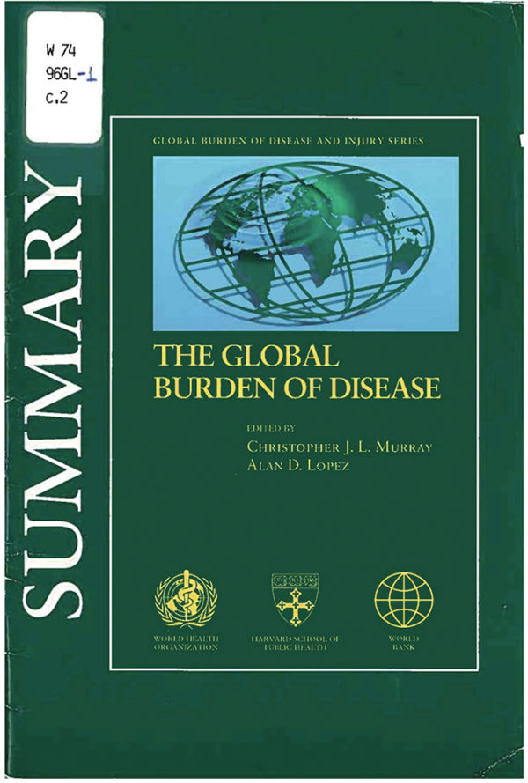
Report Title: Component Two, Report

ICD-11- Obsessive Compulsive Disorder

Date of submission: 24 November 2025, 2 pm

Contents
1. Introduction 3
2. Classification and Diagnosis 6
3. Treatment Approaches 9
4. Rehabilitation & Long‑Term Management 12
5 Debates Over Language Use 14
References 15
Appendix A: Diagnostic Classification of OCD 18
Appendix B: UK Policy Frameworks 21
Appendix C: Prevalence Data 24

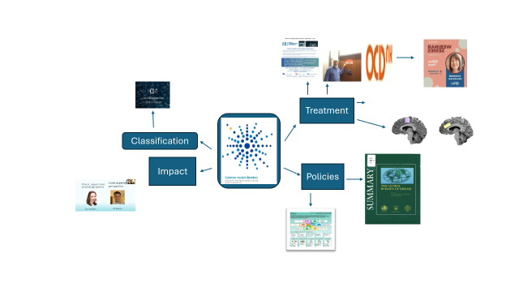
- Introduction
Image 1: Report Structure Diagram (Adapted from Natasha Ellis in PowerPoint)

  - 1.1 What is obsessive-compulsive disorder (OCD)
Obsessive-Compulsive Disorder (OCD) is a chronic and severe mental health condition that affects daily functioning and well-being. It is characterised by two central features (World Health Organisation, 2024).

- (obsessions) Unwanted, intrusive, and distressing thoughts, images, or urges that repeatedly enter the mind. The individual recognises these as excessive or unrealistic, yet they provoke marked anxiety (World Health Organisation, 2024).

- (compulsions) Repetitive behaviours (such as checking, washing, or ordering) or mental acts (such as counting or praying) performed in response to obsessions. These actions are intended to reduce distress or prevent feared outcomes, but they are often excessive and not realistically connected to the feared event (World Health Organisation, 2024).

  - 1.2 significant
OCD causes significant impairment in education, employment, relationships, and well-being, making OCD one of the most disabling of the common mental disorders (World Health Organisation, 2024).

  - 1.3 Impact and Importance of the Study
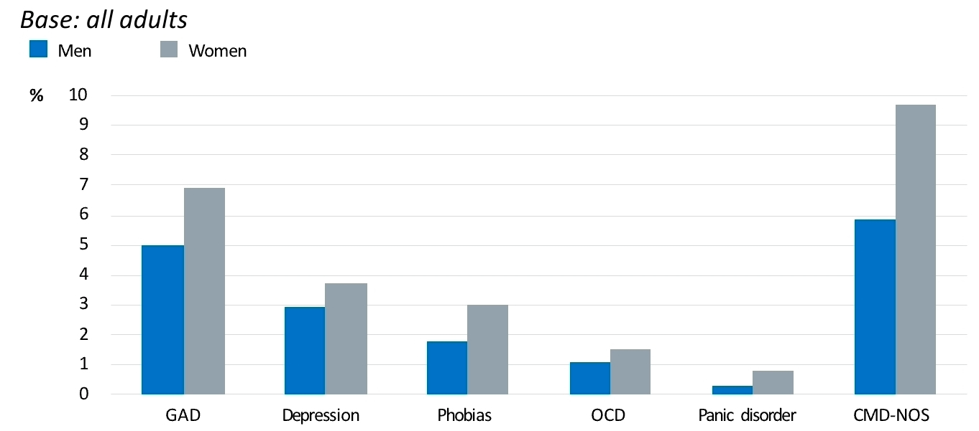
In the UK, the Adult Psychiatric Morbidity Survey reported that one in six adults (17%) in England met criteria for a Common Mental Disorder (CDM), with OCD contributing to this burden (NHS Digital, 2016). Image 2 illustrates the prevalence of CMDs by sex, showing a higher rate among women, a trend reflected in OCD service-user data, where approximately 75% of contacts are female (OCD‑UK, 2025).
Image 2: Prevalence of common mental disorders (CMDs) by sex (APMS 2014)

Current estimates suggest that approximately 750,000 people live with OCD in the UK, affecting around 12 in every 1,000 individuals (OCD‑UK, 2025). Internationally, lifetime prevalence is estimated at 2–3%, with onset often occurring in childhood or adolescence (Office for National Statistics, 2021). These figures highlight the importance of early recognition, targeted intervention, and gender-sensitive service design in both clinical and policy contexts.

  - 1.4 Policy frameworks highlight their significance:
Policy frameworks highlight the importance of accurate diagnosis and timely intervention in managing OCD. The NICE Clinical Guideline CG31 (National Institute for Health and Care Excellence2005; updated 2024) recommends Cognitive Behavioural Therapy with Exposure and Response Prevention (ERP) and pharmacological treatment with Selective Serotonin Reuptake Inhibitors (SSRIs) as evidence‑based approaches. The NHS Long‑Term Plan (NHS England, 2019) and the Major Conditions Strategy (Department of Health and Social Care, 2023) further prioritise early recognition, integrated care, and reducing waiting times for mental health services.
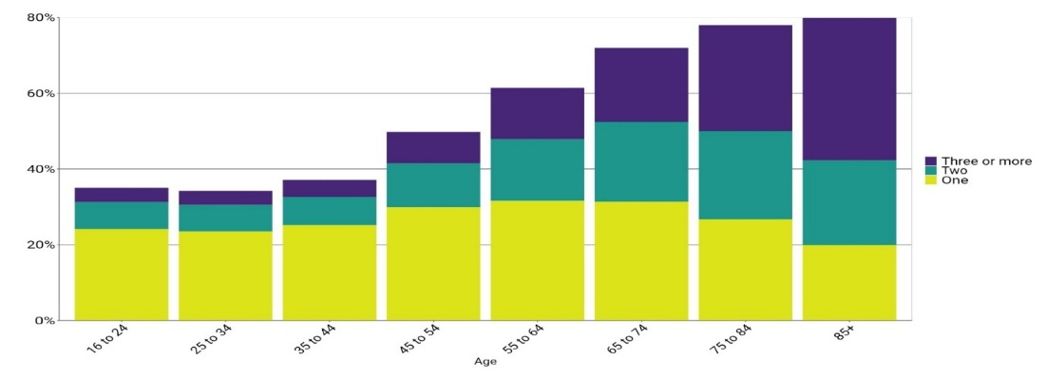
However, demographic change and the changing burden of disease are reshaping society and the health and care system. Image 3 demonstrates that the likelihood of having a long-term condition rises significantly for older age groups

Image 3: proportion of age cohorts living with long-term conditions (Adapted from the Department of Health and Social Care’s Major Conditions Strategy 2023)

  - 1.5 Report structure:
This report will examine OCD through the lens of ICD‑11 classification, exploring diagnostic criteria, international and UK diagnostic processes, debates over terminology, NHS guidelines, relevant UK health policies, and diagnostic challenges such as service delays.

- Classification and Diagnosis

Framing for OCD has evolved significantly over time. In ICD‑10 (World Health Organisation, 1992), OCD was grouped with anxiety disorders, reflecting an emphasis on anxiety as the central feature. By contrast, ICD‑11 (World Health Organisation, 2018; 2024) and DSM‑5 (American Psychiatric Association, 2013) reposition OCD into its own category, highlighting compulsivity, intrusive thoughts, and related disorders such as hoarding and Body Dysmorphic Disorder (BDD). The NICE Clinical Guideline CG31 (National Institute for Health and Care Excellence, 2005; updated 2024) operationalises these classifications into stepped‑care pathways, focusing on functional impairment, family involvement, and early intervention (NICE, 2024).

Image 4: ICD-11 Classification (Adapted from World Health Organisation, 2018; 2024)

The colour‑coded table in Appendix A demonstrates these historical shifts, conceptual differences, and practical applications. It is not simply a list of codes and systems; it tells the story of how OCD moved from being seen as an anxiety disorder to being recognised as a distinct condition with its own diagnostic category and treatment pathways.

  - 2.1 Classification in ICD-11 under OCD (2018-2025)
Obsessive-Compulsive Disorder (OCD) is classified in ICD‑11 under Obsessive-Compulsive and Related Disorders (OCRDs) (code 6B20), within the chapter Mental, behavioural or neurodevelopmental disorders (World Health Organisation, 2024). This marks a significant shift from ICD‑10, where OCD was grouped under anxiety disorders. The reclassification acknowledges OCD’s unique phenomenology and its overlap with related compulsive conditions (Krzanowska and Kuleta, 2017).

  - 2.2 ICD‑11 outlines four key diagnostic criteria
- Obsessions: Persistent, intrusive, and unwanted thoughts, images, or urges that cause marked distress (World Health Organisation, 2024).
- Compulsions: Repetitive behaviours (e.g., washing, checking) or mental acts (e.g., counting, praying) performed to reduce distress or prevent feared events, recognised as excessive or unrealistic (World Health Organisation, 2024).
- Impairment: Symptoms must cause clinically significant distress or impairment in social, occupational, or academic functioning (World Health Organisation, 2024).
- Exclusions: Symptoms should not be better explained by other OCRDs (e.g., Body Dysmorphic Disorder, Hoarding Disorder), substance use, medical conditions, or culturally sanctioned practices (World Health Organisation, 2024).

  - 2.3 International Diagnostic Processes and UK Application
Internationally, diagnostic processes differ in their approach. DSM‑5 employs prescriptive operational criteria, often requiring exact symptom counts, while ICD‑11 uses prototype‑based descriptions, allowing greater flexibility across cultural contexts (Krzanowska and Kuleta, 2017).
In the UK, services primarily operationalise ICD‑11 through NICE guidance. Assessment typically combines structured measures such as the Yale‑Brown Obsessive Compulsive Scale (Y‑BOCS), clinical interview, and functional assessment to determine severity and guide stepped‑care pathways (National Institute for Health and Care Excellence,2024).

  - 2.4 Debates Over Language Use
Debates over terminology highlight tensions between clinical precision and stigma reduction. The term “disorder” ensures diagnostic specificity for coding and commissioning, while “condition” is often preferred in public‑facing materials to reduce stigma (OCD‑UK, 2025).

  - 2.5 UK Health Policies and Diagnostic Challenges
Despite robust frameworks, diagnostic challenges persist in the UK. Long waiting times for specialist assessment and treatment remain a significant barrier, particularly for moderate to severe cases. Regional variation in service provision and limited availability of ERP‑trained clinicians exacerbate delays. High rates of comorbidity with depression, anxiety, and neurodevelopmental disorders further complicate diagnosis (Sharma et al., 2021; Jain, 2025). These challenges highlight the gap between policy ambition and clinical reality, underscoring the need for investment in workforce capacity and equitable access.

Terminology remains contested. Public‑facing NHS and charity materials often use “condition” to reduce stigma, while clinical guidelines retain “disorder” for diagnostic precision and coding consistency. Charities such as OCD‑UK (2025) highlight the risks of trivialisation when OCD is misused colloquially (“a bit OCD”), reinforcing the need for accurate language to support help‑seeking.

  - 2.6 NHS Guidelines Compared with ICD‑11
NICE Clinical Guideline CG31 (National Institute for Health and Care Excellence, 2005; updated 2024) operationalises ICD‑11 criteria into UK pathways. It recommends CBT with ERP and SSRIs as first‑line treatments, delivered in a stepped‑care model. NICE emphasises recognition, assessment, and family involvement for children and young people, aligning closely with ICD‑11’s emphasis on impairment and diagnostic exclusions.
Broader UK policy frameworks, including the NHS Long‑Term Plan (NHS England, 2019) and the Major Conditions Strategy (Department of Health and Social Care, 2023), prioritise early recognition, integrated care, and reduced waiting times. Together, these policies demonstrate how international classification systems are adapted into national service structures, ensuring diagnostic consistency while addressing workforce and access challenges.

- Treatment Approaches

  - 3.1 Psychological Treatments
The most effective psychological intervention for OCD is Cognitive Behavioural Therapy (CBT) with Exposure and Response Prevention (ERP). ERP involves gradual exposure to feared stimuli while preventing the associated compulsive response, thereby reducing anxiety and breaking the cycle of reinforcement. NICE Clinical Guideline CG31 (National Institute for Health and Care Excellence, 2005; updated 2024) recommends CBT with ERP as the first‑line treatment for both adults and children. Evidence shows ERP is effective in reducing symptom severity and improving functioning, though dropout rates can be high due to the distressing nature of exposure tasks. Limitations include variable access to trained therapists and long waiting times within NHS Talking Therapies services (NHS England, 2019). These barriers highlight the need for investment in workforce capacity and equitable service provision to ensure timely access to evidence‑based care.
  - 3.2 Pharmacological Treatments
Pharmacological treatment typically involves Selective Serotonin Reuptake Inhibitors (SSRIs) such as fluoxetine, sertraline, or fluvoxamine. NICE Clinical Guideline CG31 (National Institute for Health and Care Excellence, 2005; updated 2024) recommends SSRIs as either first‑line treatment (when CBT is not available or declined) or in combination with CBT for moderate to severe OCD. SSRIs are effective for many patients, but side effects (e.g., gastrointestinal upset, sexual dysfunction) and partial response rates limit their utility.
Emerging research highlights the role of glutamate and GABA imbalances in the forebrain as biological underpinnings of compulsive behaviour. A University of Cambridge study (2022) used magnetic resonance spectroscopy to demonstrate raised glutamate and reduced GABA levels in OCD patients. This finding supports biological explanations of OCD and has led to the exploration of drugs targeting presynaptic glutamate receptors. severe cases sometimes require invasive options such as deep-brain stimulation (DBS) or neurosurgery targeting the anterior cingulate cortex (University of Cambridge, 2022).

  - 3.3 UK Healthcare System and Accessibility
Both OCD and depression are managed through stepped‑care models, escalating interventions according to severity. OCD pathways (NICE Clinical Guideline CG31) emphasise CBT with ERP and SSRIs, tailored to obsessions and compulsions (National Institute for Health and Care Excellence, 2005; updated 2024).
By contrast, depression pathways (NICE Clinical Guideline CG91) include broader biological treatments such as Electroconvulsive Therapy (ECT) and access to crisis services or treatment-resistant cases (National Institute for Health and Care Excellence, 2009; updated 2024).
  - 3.4 Comparative Stepped-Care Models: OCD vs Depression
Step | OCD – NICE CG31 (2005; updated 2024) | Depression – NICE CG91 (2009; updated 2024)
Step 1 | Recognition, assessment, psychoeducation, and active monitoring. GP referral for suspected OCD (NICE, 2024). | Assessment, support, psychoeducation, active monitoring, and referral for further assessment/intervention (NICE, 2024).
Step 2 | Low-intensity psychological interventions (guided self-help, group CBT). Focus on mild OCD (NICE, 2024). | Low-intensity psychosocial interventions, psychological interventions, medication, and referral for further assessment/intervention (NICE, 2024).
Step 3 | High-intensity CBT with ERP and/or SSRIs for moderate to severe OCD. Combined treatments if partial response (NICE, 2024). | Medication, high-intensity psychological interventions, combined treatments, collaborative care, and referral for further assessment/intervention (NICE, 2024).
Step 4 | Specialist services for severe/complex OCD (combined treatments, multidisciplinary care, inpatient referral if risk) (NICE, 2024). | Severe and complex depression: medication, high-intensity psychological interventions, electroconvulsive therapy (ECT), crisis services, multiprofessional and inpatient care (NICE, 2024).

Table 1: Comparative Stepped-Care Models: OCD vs Depression (Adapted from NICE, 2024).

The comparison shows NICE’s consistent principle: start with low‑intensity support, escalate to specialist care as severity increases. This demonstrates how NICE operationalises ICD‑11 diagnostic criteria into practical NHS pathways across different disorders (WHO, 2024; Krzanowska and Kuleta, 2017).

  - 3.5 Effectiveness, Limitations, and Alternatives
- Effectiveness: CBT with ERP and SSRIs are evidence‑based and effective for many patients (University of Cambridge, 2022).
- Limitations: High dropout rates in ERP, partial response to SSRIs, and long NHS waiting times (University of Cambridge, 2022).
- Alternatives: Augmentation strategies (e.g., combining SSRIs with antipsychotics), neuromodulation techniques (transcranial magnetic stimulation), and experimental glutamate‑modulating drugs. Cambridge research suggests non‑invasive brain stimulation may offer future promise (University of Cambridge, 2022).

  - 3.6UK Prescribing Policies
UK prescribing policies Selective Serotonin Reuptake Inhibitors (SSRIs) as first‑line pharmacological treatment, with monitoring for side effects and adherence (NICE,2022). Nice guidance requires regular review and stepped escalation if symptoms persist. Access to newer or experimental medications is limited within NHS practice, reflecting cost‑effectiveness thresholds set by NICE. This can restrict the availability of innovative treatments, though research findings such as those from Cambridge may inform future policy shifts (University of Cambridge, 2022).

4. Rehabilitation & Long‑Term Management

  - 4.1 ICD‑11 Strategies
Rehabilitation in ICD‑11 emphasises sustained management, relapse prevention, and functional recovery. The framework recognises that OCD is often chronic, requiring long‑term strategies beyond acute treatment. Key goals include maintaining symptom reduction, supporting daily functioning, and preventing relapse through ongoing psychological support, medication review, and community integration (World Health Organisation, 2024).

  - 4.2 UK Implementation
In the UK, rehabilitation is embedded within NICE pathways and the NHS Long Term Plan (2019). NICE guidance highlights the importance of stepped‑care approaches, ensuring that patients move between low‑intensity and specialist services depending on severity and response. The NHS Long Term Plan prioritises early recognition, integrated care, and workforce expansion to reduce waiting times and improve access to evidence‑based interventions (NHS England, 2019). Together, these frameworks demonstrate how national policy and clinical guidance align to deliver recovery‑focused, accessible mental health care.

  - 4.3 Social Reintegration Challenges
Despite these frameworks, individuals with OCD face significant reintegration challenges. Stigma remains a major barrier, with OCD often trivialised in public discourse (“a bit OCD”), undermining help‑seeking and social acceptance (OCD‑UK, 2025). Employment barriers are common, as intrusive symptoms can impair productivity and workplace relationships. Relationship difficulties also arise, with compulsions and avoidance behaviours straining family and social networks. These challenges highlight the need for holistic rehabilitation that addresses both clinical and social dimensions.

  - 4.4 Community Interventions
Charities play a vital role in bridging gaps in statutory provision. Mind offers advocacy and peer support, Rethink Mental Illness provides community programmes and policy lobbying, and Samaritans deliver crisis helplines that support individuals experiencing distress. These organisations complement NHS services by offering accessible, non‑clinical support that promotes reintegration and resilience.

  - 4.5 Legal Framework
The Mental Health Act (1983; amended 2007) establishes statutory safeguards for compulsory treatment, ensuring that interventions balance patient rights with public safety. Compulsory admission may be necessary in severe cases, but the Act requires proportionality, the use of least restrictive options, and the preservation of patient dignity (UK Government, 2007). Rehabilitation planning under the Act is guided by the Code of Practice, which emphasises recovery‑oriented approaches and structured pathways for community reintegration (Department of Health, 2007). These provisions align with contemporary NHS guidance, which highlights person‑centred care and long‑term wellbeing as central to effective rehabilitation (NHS England, 2023; Department of Health and Social Care, 2024).

  - 4.6 Government Initiatives
Recent initiatives such as the Major Conditions Strategy (Department of Health and Social Care, 2023), reinforce the importance of long‑term management. The strategy highlights demographic change and the rising burden of chronic mental health conditions. These policies aim to integrate mental health into broader health system reforms, ensuring parity of esteem with physical health.

  - 4.7 Lived Experience

The Body Dysmorphic Disorder Foundation (BDDF) Webinar Series provides expert‑led discussions and lived experience insights into OCD and related conditions, including Body Dysmorphic Disorder (BDD). Recent events, such as the December 2025 webinar on “BDD by Proxy”, feature leading clinicians, including Dr Katharine Phillips and offer accessible education for both professionals and the public (BDDF, 2025). These webinars complement clinical frameworks by embedding patient narratives, enhancing practitioner understanding, and promoting stigma reduction.
Image 5: Promotional flyer for BDDF Webinar Series featuring Katharine Phillips, M.D. — expert-led discussion on BDD by Proxy (BDDF, 2025).

- Debates Over Language Use
Terminology remains contested. Public‑facing NHS and charity materials often use “condition” to reduce stigma, while clinical guidelines retain “disorder” for diagnostic precision and coding consistency. Charities such as OCD‑UK highlight the risks of trivialisation when OCD is misused colloquially (“a bit OCD”), reinforcing the need for accurate language to support help‑seeking (OCD‑UK, 2025).

References

American Psychiatric Association (2013) Diagnostic and statistical manual of mental disorders.DSM‑5. 5th edn. Washington, DC: American Psychiatric Publishing. Available at: https://www.psychiatry.org/psychiatrists/practice/dsm (Accessed: 23 November 2025).
Body Dysmorphic Disorder Foundation (BDDF) (2025) Stories. BDDF. Available at: https://bddfoundation.org/stories-3/ (Accessed: 17 November 2025).
Department of Health (2007) Mental Health Act 1983: Code of Practice. London: TSO. Available at: https://assets.publishing.service.gov.uk/media/5a80a774e5274a2e87dbb0f0/MHACodeofPractice.PDF (Accessed: 21November 2025).
Department of Health and Social Care (2023) Major conditions strategy: case for change and our strategic framework. GOV.UK. Available at: https://www.gov.uk/government/publications/major-conditions-strategy-case-for-change-and-our-strategic-framework/major-conditions-strategy-case-for-change-and-our-strategic-framework--2 (Accessed 16 November 2025).
Department of Health and Social Care (2024) Discharge from mental health inpatient settings: statutory guidance. GOV.UK. Available at: https://www.gov.uk/government/publications/discharge-from-mental-health-inpatient-settings/discharge-from-mental-health-inpatient-settings (Accessed: 21 November 2025).
Jain, S.M. (2025) ‘The Relationship Between Obsessive-Compulsive Disorder (OCD) and anxiety disorders,’ International Journal of Social Science and Economic Research, 10(5), pp. 1842. Available at: https://doi.org/10.46609/IJSSER.2025.v10i05.028 (Accessed: 7 November 2025).
Krzanowska, E. and Kuleta, M. (2017) ‘From anxiety to compulsivity - a review of changes to OCD classification in DSM‑5 and ICD‑11’, Archives of Psychiatry and Psychotherapy, 19(3), pp. 7–15. Doi: 10.12740/APP/76150. Available at: https://www.archivespp.pl/From-anxiety-to-compulsivity-a-review-of-changes-to-OCD-classification-in-DSM-5-and,76150,0,2.html (Accessed: 18 November 2025).

Mataix‑Cols, D. and Fernández de la Cruz, L. (2025) Hoarding disorder in adults: Epidemiology, clinical features, assessment, and diagnosis. UpToDate. Available at:
https://www.uptodate.com/contents/hoarding-disorder-in-adults-epidemiology-clinical-features-assessment-and-diagnosis/print (Accessed: 17 November 2025).

Mental Health Matters (2023) Stepped care – FAQs. Mental Health Matters. Available at: https://www.mhm.org.uk/pages/faqs/category/stepped-care- (Accessed: 22 November 2025).
National Institute for Health and Care Excellence (NICE) (2005, updated 2024) Obsessive-compulsive disorder and body dysmorphic disorder: treatment (CG31). NICE. Available at: https://www.nice.org.uk/guidance/cg31 (Accessed: 16 November 2025).
National Institute for Health and Care Excellence (NICE) (2009, updated 2024) Depression in adults with a chronic physical health problem: recognition and management (CG91). London: NICE. Available at: https://share.google/lTLZLh7SmTVbfR2XD (Accessed: 23 November 2025).
NHS Digital (2016) Adult Psychiatric Morbidity Survey: Survey of Mental Health and Wellbeing, England, 2014. NHS Digital. Available at: https://digital.nhs.uk/data-and-information/publications/statistical/adult-psychiatric-morbidity-survey/adult-psychiatric-morbidity-survey-survey-of-mental-health-and-wellbeing-england-2014 (Accessed: 16 November 2025).
NHS England (2019) The NHS Long Term Plan. London: NHS England. Available at: https://www.longtermplan.nhs.uk (Accessed: 23 November 2025).
OCD‑UK (2025) About OCD. OCD‑UK. Available at: https://www.ocduk.org/ocd/ (Accessed: 7 November 2025).
Office for National Statistics (2025) Mental health statistics. ONS. Available at: https://www.ons.gov.uk/peoplepopulationandcommunity/healthandsocialcare/mentalhealth (Accessed: 16 November 2025).

Sharma et al. (2021) ‘Comorbidities in Obsessive-Compulsive Disorder Across the Lifespan: A Systematic Review and Meta-Analysis’, Frontiers in Psychiatry, 12, Article 703701. Available at: https://www.frontiersin.org/journals/psychiatry/articles/10.3389/fpsyt.2021.703701/full (Accessed 7 November 2026).
University of Cambridge (2022) Chemical imbalance in the forebrain underpins compulsive behaviour and OCD, study finds. Available at: https://www.cam.ac.uk/research/news/chemical-imbalance-in-the-forebrain-underpins-compulsive-behaviour-and-ocd-study-finds (Accessed: 8 November 2025).
UK Government (1983) Mental Health Act 1983. London: HMSO. Available at: https://www.legislation.gov.uk/ukpga/1983/20 (Accessed: 21 November 2025).

UK Government (2007) Mental Health Act 2007. London: HMSO. Available at: https://www.legislation.gov.uk/ukpga/2007/12/contents (Accessed: 21 November 2025).

World Health Organization (1992) The ICD‑10 classification of mental and behavioural disorders: clinical descriptions and diagnostic guidelines. Geneva: World Health Organization. Available at: https://www.who.int/publications/i/item/9241544228 (Accessed: November 2025).
World Health Organisation (2024) ICD-11 for Mortality and Morbidity Statistics: Obsessive-Compulsive Disorder (6B20). Available at: https://icd.who.int/browse/2024-01/mms/en#1321276661 (Accessed: 7 November 2025).

Appendix A: Diagnostic Classification of OCD

Aspect |  |  |  | 
 | ICD-10 | ICD-11 | DSM-5 | NICE CG31
UWTSD, Harvard Reference | World Health Organization, (1992) | World Health Organization, (2018; 2024) | Krzanowska, E. And Kuleta, M. (2017) | National Institute for Health and Care Excellence (NICE) (2005)
System | International Classification of Diseases (10th Revision) | International Classification of Diseases (11th Revision) | Diagnostic and Statistical Manual of Mental Disorders (5th Edition) | National Institute for Health and Care Excellence Clinical Guidelines
Chapter/Section | Chapter V: Mental and behavioural disorders | Chapter 06: Mental, behavioural or neurodevelopmental disorders | Section II: Obsessive-Compulsive and Related Disorders | Mental health and wellbeing; OCD and BDD
Code for OCD | F42 (within F40–F48)- Neurotic, stress-related and somatoform disorders | 6B20 | 300.3 | Not coded; operationalises ICD-11 criteria
Grouping | OCD grouped with anxiety disorders (World Health Organization, 1992, pp. 142-173). | OCD placed in its own category | OCD placed in its own category | OCD treated as distinct condition with stepped-care pathways
Conceptual Focus | Emphasis on anxiety | Emphasis on compulsivity and neurobiological underpinnings | Emphasis on compulsivity and intrusive thoughts | Emphasis on functional impairment, family involvement, and early intervention
Related Disorders | Not separately classified | Includes related disorders (e.g., hoarding, BDD) | Includes related disorders (e.g., hoarding, BDD) | Includes BDD; refers to related OCRDs in stepped care
Classification Approach | Fixed categories | Ontology-based, allows post-coordination | Categorical with dimensional specifiers | Clinical pathways based on severity and age group
Digital Tools | Paper-based or static digital references | Online browser, coding tool, multilingual support | Digital formats for clinical and research use | NICE website, interactive flowcharts, downloadable tools
Table: Summary- Framing for OCD has evolved (Adapted from World Health Organization, 1992; World Health Organisation 2024; Krzanowska, E. And Kuleta, M. 2017; National Institute for Health and Care Excellence NICE 2024
This colour coded table illustrates the progression in how OCD has been classified. ICD‑10 grouped OCD with anxiety disorders, but ICD‑11 and DSM‑5 recognised it as distinct, reflecting advances in understanding compulsivity and related disorders. NICE guidelines go further by operationalising these classifications into stepped‑care pathways, emphasising functional impairment and early intervention. The shift from fixed categories to ontology‑based and dimensional approaches shows how
ICD-10 | ICD-11 | DSM-5 | NICE CG31
World Health Organization, (1992) | World Health Organization, (2018; 2024) | Krzanowska, E. And Kuleta, M. (2017) | National Institute for Health and Care Excellence (NICE) (2005)

ICD 10 1992

- Code: F42 (within F40–F48: Neurotic, stress‑related and somatoform disorders). Grouping:
- OCD was placed alongside phobias, panic disorder, and generalised anxiety disorder (World Health Organization, 1992, pp. 142–173).
- Focus: Emphasis on anxiety symptoms and avoidance behaviours.
- Limitation: Related disorders (e.g., hoarding, BDD) not separately classified.
World Health Organization (1992) The ICD‑10 classification of mental and behavioural disorders: clinical descriptions and diagnostic guidelines. Geneva: World Health Organization. Available at: https://www.who.int/publications/i/item/9241544228 (Accessed: November 2025).

ICD-11(2018; WHO, 2024 update)
- Code: 6B20.
- Grouping: OCD reclassified under Obsessive‑Compulsive and Related Disorders (OCRDs).
- Focus: Emphasis on compulsivity, neurobiological underpinnings, and cultural flexibility.
- Advancement: Related disorders (hoarding, BDD) explicitly recognised.
World Health Organisation (2024) ICD-11 for Mortality and Morbidity Statistics: Obsessive-Compulsive Disorder (6B20). Available at: https://icd.who.int/browse/2024-01/mms/en#1321276661 (Accessed: 7 November 2025).PublicationD-10 Version 2019
DSM-5 (2013)
- Code: 300.3.
- Grouping: OCD placed in its own category, Obsessive‑Compulsive and Related Disorders.
- Focus: Intrusive thoughts and compulsive behaviours, with dimensional specifiers (e.g., insight levels).
- Style: Prescriptive symptom counts compared to ICD‑11’s prototype approach.
American Psychiatric Association (2013) Diagnostic and statistical manual of mental disorders: DSM‑5. 5th edn. Washington, DC: American Psychiatric Publishing. Available at: https://www.psychiatry.org/psychiatrists/practice/dsm (Accessed: 23 November 2025).
NICE CG31 (2005; updated 2024)
- System: UK clinical guideline.
- Grouping: OCD treated as a distinct condition with stepped‑care pathways.
- Focus: Functional impairment, family involvement, and early intervention.
- Application: Operationalises ICD criteria into practice, recommending CBT with ERP and SSRIs
National Institute for Health and Care Excellence (NICE) (2024) Obsessive-compulsive disorder and body dysmorphic disorder: treatment (CG31). NICE. Available at: https://www.nice.org.uk/guidance/cg31 (Accessed: 16 November 2025).

Appendix B: UK Policy Frameworks

- Major Conditions Strategy (2023):
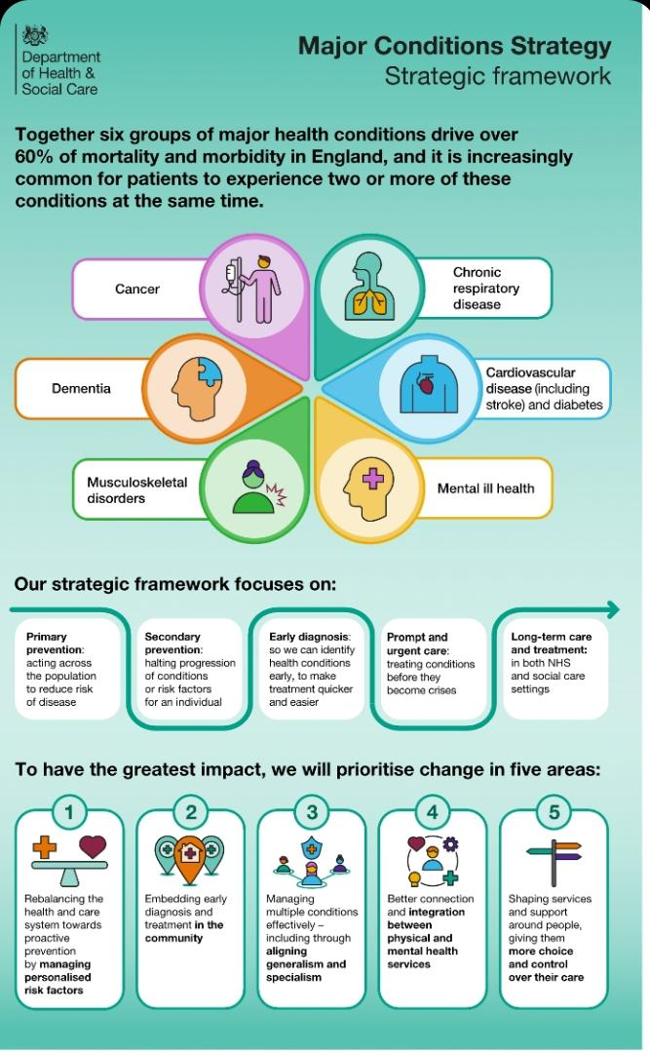
Image 1 major condition’s strategy framework Adapted from Department of Health and Social Care (2023)

UK policy framework, Major Conditions Strategy (2023), identifies Individuals, in England suffer with at least one of 6 major health conditions representing the cause of over 60% of years lost to early death or lived in ill health and timely intervention Department of Health and Social Care’s Major Conditions Strategy (2023),

- NICE guideline CG31 (2005; updated 2024): Evidence‑based treatment recommendations (CBT with ERP, SSRIs).

Focus of the intervention | Nature of the intervention
STEP 1: All known and suspected presentations of depression | Assessment, support, psychoeducation, active monitoring and referral for further assessment and intervention
STEP 2: Persistent subthreshold depressive symptoms; mild to moderate depression | Low-intensity psychosocial interventions, psychological interventions, medication and referral for further assessment and intervention
STEP 3: Persistent subthreshold depressive symptoms or mild to moderate depression with inadequate response to initial interventions; moderate and severe depression | Medication, high-intensity psychological interventions, combined treatments, collaborative care and referral for further assessment and intervention
STEP 4: Severe and complex depression; risk to life; severe self-neglect | Medication, high-intensity psychological interventions, electroconvulsive therapy, crisis service, combined treatments, multiprofessional and inpatient car
Table 1: Stepped care model (Adapted From NICE guideline CG31 (2005; updated 2024)
NICE also provides a stepped‑care model for depression, which is relevant to comorbid presentations and informs broader mental health pathways. This framework ensures that interventions are proportionate to severity, ranging from psychoeducation and monitoring to intensive therapies and inpatient care (NICE 2009).


- NHS Long‑Term Plan (2019):

Prioritises early recognition, integrated care, and reduced waiting times.
- From hospital to community
- From analogue to digital
- From sickness to prevention

NHS England (2019) The NHS Long Term Plan. London: NHS England. Available at: https://www.longtermplan.nhs.uk (Accessed: 23 November 2025).

Appendix C: prevalence Data
- APMS 2014: 1 in 6 adults (17%) in England met criteria for a common mental disorder, with OCD contributing to this burden (NHS Digital, 2016).
- UK estimates: Around 750,000 people live with OCD, affecting 12 in every 1,000 people (OCD‑UK, 2025).
- Gender differences: OCD slightly more prevalent in women; service‑user data show ~75% female contact ratio (OCD‑UK, 2025).
- International prevalence: Lifetime prevalence estimated at 2–3%, often beginning in childhood or adolescence (ONS, 2021).
NHS Digital (2016) Adult Psychiatric Morbidity Survey: Survey of Mental Health and Wellbeing, England, 2014. NHS Digital. Available at: https://digital.nhs.uk/data-and-information/publications/statistical/adult-psychiatric-morbidity-survey/adult-psychiatric-morbidity-survey-survey-of-mental-health-and-wellbeing-england-2014 (Accessed: 16 November 2025).

