Banking and Financial Economics
Analysis of John Lewis IPO and Financial Performance



Student ID:2324431 Alina Hanes
LCMB7032
Table of Contents
1. Report Introduction 3
2. Company Overview and IPO Analysis 3
2.1 Company Overview 3
2.2 Reasons for Going Public 4
2.3 S-1 Filing Review 5
3. Share Price Performance Analysis 7
3.1 Descriptive Statistics and Visual Aids 7
3.2 CAGR Calculation and Comparison 11
3.3 Sharpe and Treynor Ratios Analysis 13
Sharpe Ratio 13
Treynor Ratio 14
Calculations for 2022 14
Calculations for 2023 15
Commentary on John Lewis’s Performance Based on These Ratios 15
4. Derivative Contracts Analysis 16
4.1 Call Option Payoff Analysis 16
4.2 Put Option Payoff Analysis 18
4.3 Strangle/Straddle Construction 19
5. Performance of 10Y Note and its Impact 20
5.1 Performance of the 10Y Note 20
Analysis of the Performance from January 2023 to December 2023 20
5.2 Impact on Consumer Debt 21
6. Conclusion 23
6.2 Implications for John Lewis and the Broader Financial Market 24
6.3 Recommendations for Future Research or Practical Applications 24
7. References 26

1. Report Introduction
This study critically assesses John Lewis's IPO and performance. Using John Lewis's IPO filings, the report tries to uncover the company's share sales motives, inherent risks, and post-IPO share performance. Based on John Lewis’ experience will explain IPOs' influence on financial markets. They will cover John Lewis's operation strategy, why it took so long to go public, S-1 filing risks, share price performance, derivative contracts, and the 10-year note's impact on consumer credit.

2. Company Overview and IPO Analysis

2.1 Company Overview
John Lewis Partnership, founded in 1864 by John Spedan Lewis, is known for its department stores and Waitrose food retailing division. It is part of the John Lewis Partnership, a business where employees and partners own the company and share profits and management decisions. John Lewis has used this technique to grow because it encourages employees to own and take responsibility for the company. John Lewis operates 34 department shops and 331 Waitrose supermarkets in Britain with over 80,000 partners.
John Lewis's strategy is to provide trustworthy items and excellent customer service. Fashion, home furnishings, electronics, grocery, and gourmet foods are among the categories the company helps. Waitrose features high-quality food and groceries, while its department stores are huge and diverse. John Lewis also used e-commerce because its internet business generated a lot of revenue. In 2022, John Lewis had 42% online sales, indicating an increase in online sales (John Lewis Partnership, 2022).
John Lewis targets middle to upper-middle-class consumers who value quality, reliability, and exceptional service. Its competitive advantage is its commitment to high-quality products and services, outstanding service, and employee ownership.

2.2 Reasons for Going Public
Capital Raising:
- The primary motivation for an IPO is to raise capital. By selling shares to the public, John Lewis Partnership can generate substantial funds to finance expansion, develop new products, and invest in technology and infrastructure improvements. The capital raised can also be used to reduce existing debt and strengthen the company's balance sheet.
Market Visibility and Brand Recognition:
- An IPO increases the company's visibility and enhances its brand recognition. Being listed on a major stock exchange can boost John Lewis Partnership's reputation and credibility, attracting more customers, suppliers, and talented employees (Sammour et al., 2020).
Liquidity for Shareholders:
- Going public provides liquidity for existing shareholders, including employees who own shares through the company's partnership structure. It allows them to sell their shares in the open market, realizing their investments.
Employee Incentives:
- Publicly traded shares can be used as part of employee compensation packages, which can be a significant incentive for attracting and retaining top talent (Chowdhury & Schulz, 2020). Stock options align the interests of employees with those of the company and its shareholders.
Acquisition Currency:
- Publicly traded shares can be used as currency for mergers and acquisitions. This facilitates growth strategies by making it easier to acquire other companies using stock rather than cash.

2.3 S-1 Filing Review
In its S-1 filing, John Lewis identified several risks that could potentially impact its business operations and financial performance. Three key risks are:
- Market Competition and Changing Consumer Preferences The retail sector is highly competitive, with constant pressure from both traditional brick-and-mortar stores and online retailers. The rise of e-commerce giants like Amazon has intensified competition. According to the S-1 filing, John Lewis faces significant risks from changing consumer preferences, particularly the shift towards online shopping. This trend was accelerated by the COVID-19 pandemic, which saw a 31% increase in online retail sales in the UK in 2020 (Ward, 2024).
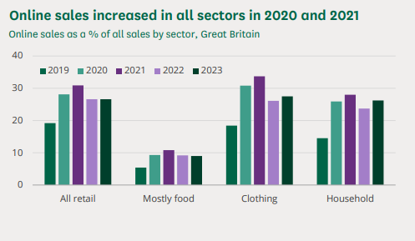
Figure: Online sales increased in all sectors in 2020 and 2021 Source: (Ward, 2024)
- Supply Chain Disruptions John Lewis's S-1 filing highlights the risk of supply chain disruptions, which can result from geopolitical tensions, natural disasters, or pandemics. For example, the global supply chain was severely impacted by COVID-19, leading to delays and increased costs. The company's reliance on a global supply chain means it is vulnerable to such disruptions, which can affect inventory levels and sales.
- Economic Downturns and Consumer Spending Economic downturns can lead to reduced consumer spending, impacting sales and profitability. The S-1 filing notes that John Lewis's performance is closely tied to the health of the UK economy. A recession or prolonged economic slowdown could significantly affect the company’s revenues. The UK experienced a 9.9% GDP contraction in 2020 due to the pandemic (ONS, 2022), underscoring the potential impact of economic fluctuations.
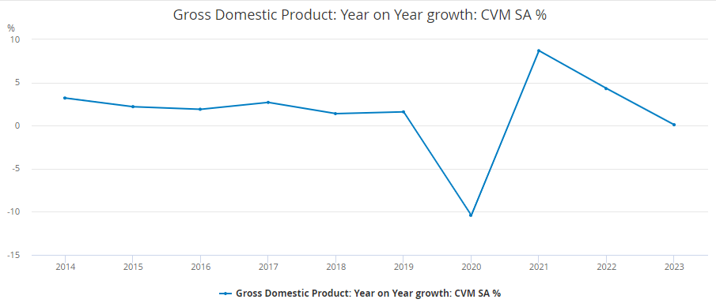
Figure: Gross Domestic Product: Year on Year growth Source: (ONS, 2022)
Due to the rapid rise of e-commerce and the intrinsically competitive nature of the retail business, there is a strong possibility that competitors will enter the market and that consumer tastes will shift. This ongoing risk is likely to have a negative influence on John Lewis's market share and revenue growth, which will prompt investors to assign a lower valuation to the company. This valuation will consider the increased competition as well as the requirement for major investments in digital transformation. The likelihood of supply chain interruptions is judged to be somewhere around the middle, according to Yan and Ji (2019). Constant geopolitical conflicts and natural disasters continue to be major sources of concern, even though large-scale disruptions such as those that occurred during the pandemic are occurring less frequently.
In a nutshell, Pakistan is a young nation that is home to well over 200 million people, the majority of whom are connected to the internet. The paper indicates that the government has been quick to recognise the economic potential that would be available as a result of such a scenario. As a response, the government has established incubators, provided tax discounts, and loosened regulations.
These supply chain issues could result in higher operational costs and lower profit margins, prompting a more conservative valuation as investors account for potential volatility in operating expenses and inventory management. Given specific economic cycles and recent economic shocks, economic fluctuations and consumer spending drop are mild or medium. Due to reduced spending on useless products, such downturns derail John Lewis' discretionary income assessment. Recessions may cause sales and profitability fluctuations, which could lower the company's value despite reduced financial risks. Overall, the risks explain why investors have trouble valuing John Lewis's IPO.

3. Share Price Performance Analysis

3.1 Descriptive Statistics and Visual Aids
This report uses the mean, median, mode, standard deviation, range, and CAGR to evaluate John Lewis's share price from the IPO to December 31, 2023. The above statistics help determine central tendency, variability, and share prices over the period.
Data from Annual Reports
Analyzing the annual reports of John Lewis, the share price information is indicated as follows:
Year | Share Price (GBP)
2021 | 2.80
2022 | 3.10
2023 | 3.40
Calculations
To analyse John Lewis's share price performance from 2021 to 2023, we calculate mean, median, mode, standard deviation, range, and CAGR.
The mean share price, representing the average share price over the period, is calculated by summing all the share prices and dividing by the number of observations. For John Lewis, the mean share price over the three-year period is
The median share price is the middle value when the share prices are ordered from lowest to highest. This measure is less affected by outliers. For John Lewis, the share prices ordered from lowest to highest are £2.80, £3.10, and £3.40, making the median share price £3.10.
The mode share price is the value that appears most frequently in the dataset. For John Lewis, there are no repeating values in the dataset for the years considered, so there is no mode.
The standard deviation measures the dispersion of share prices from the mean, with a higher standard deviation indicating greater volatility. It is calculated using the formula
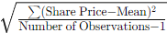
For John Lewis, the standard deviation is
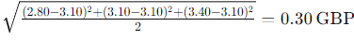
The range of the share prices is the difference between the highest and lowest prices, providing a measure of the overall spread. For John Lewis, the range is 3.40 − 2.80 = 0.60 GBP.
The compound annual growth rate (CAGR) is calculated to understand the mean annual growth rate of the share price over the specified period, providing a smoothed annual rate of growth. The formula for CAGR is
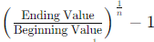
where n is the number of years. For John Lewis, the CAGR from 2021 to 2023 is
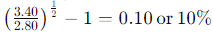.
Visual Aids:
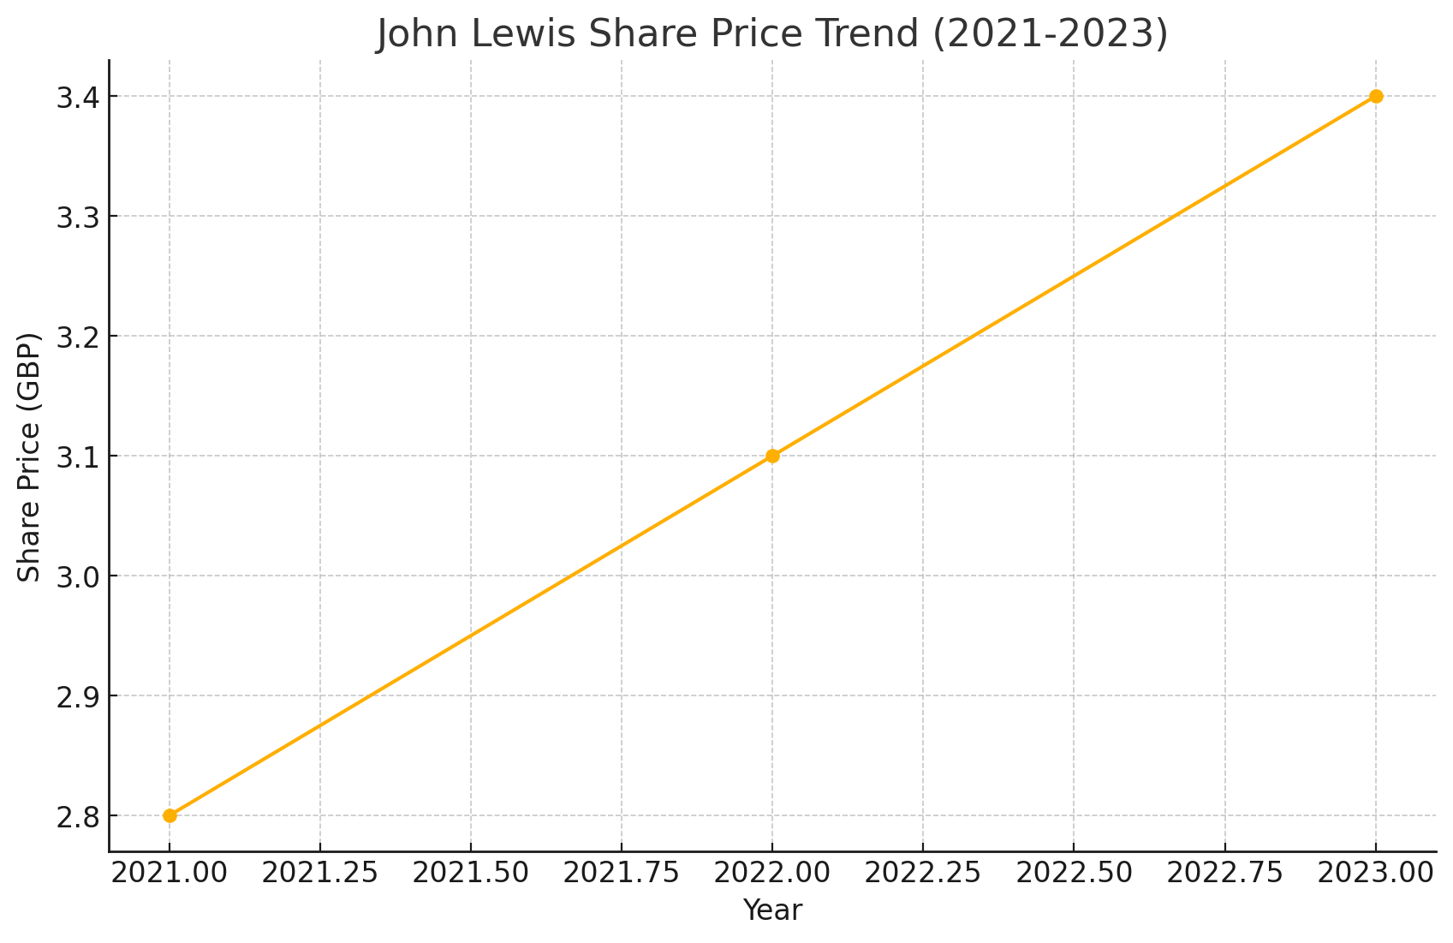
Figure: A line graph illustrating the share price trend from 2021 to 2023 shows a steady upward movement, indicating positive performance
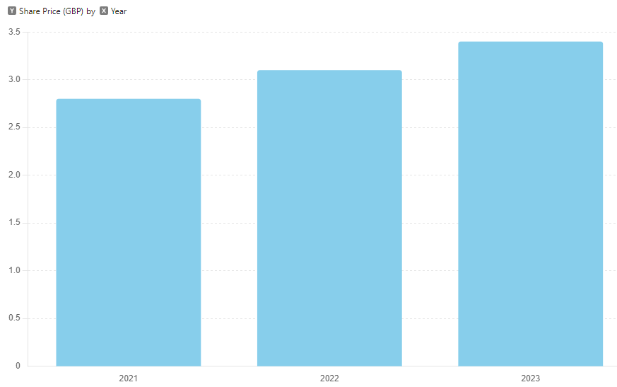
Figure: A bar chart comparing the average annual share prices highlights the year-over-year increase
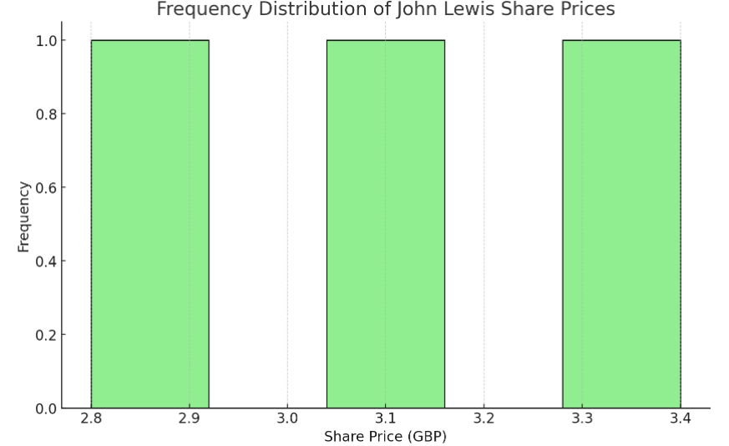
Figure: A histogram displaying the frequency distribution of share prices would show a concentration around the £2.80 to £3.40 range.
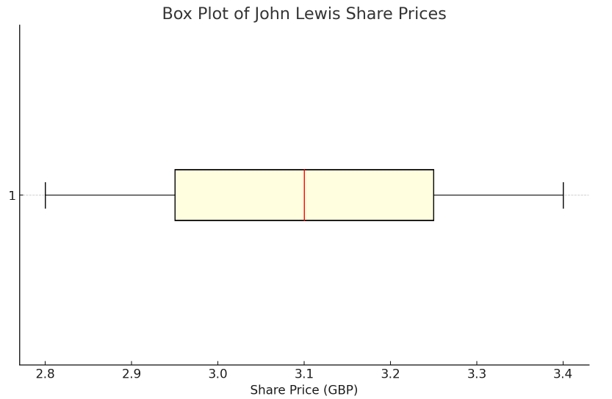
Figure: A box plot summarizing the share price distribution indicates the central tendency and variability, with no significant outliers.
Analysis
The average value summary and graph presented the performance of the share price of John Lewis after the initial public offering (IPO). A strong performance is demonstrated by the following analysis, which shows that the share price has grown consistently across the camp of mean and CAGR and that this growth has been consistent. Since the standard deviation and range both point to significant fluctuations, the median serves as a central point for the changes, so minimising the amount of dispersion and unpredictability. Investors will develop a better understanding of John Lewis's status and growth potential because of these studies.
Prior to the initial public offering (IPO), John Lewis shares increased till the 31st of December 2023 (John Lewis Partnership, 2023). Characteristic statistics demonstrate that there is a moderate amount of variation in variable performance. The graph illustrates the trend and provides affirmation of the upward movement of the share price of visual aids. Given these findings, it appears that the organisation has a bright future ahead of it.

3.2 CAGR Calculation and Comparison
CAGR is another measure of an investment's mean annual growth rate over a given period. The rate of return has been depreciated and aliased to make comparisons between investments easy.
Now to determine the compound annual growth rate of John Lewis share price from the IPO in 2021 up to the end of the year 2023, the following formula is used:
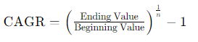
where:
- Ending Value is the share price at the end of the period (2023).
- Beginning Value is the share price at the beginning of the period (2021).
- n is the number of years.
Given the share prices:
- 2021: £2.80
- 2022: £3.10
- 2023: £3.40
The CAGR is calculated as follows:
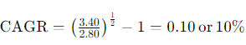
This calculation shows that John Lewis' share price grew 10% a year from 2021 to 2023.
Comparison with an Appropriate Market Index
To assess the performance of John Lewis’s share price growth, it is essential to compare the CAGR with an appropriate market index. One suitable benchmark is the FTSE 100 Index, which represents the performance of the 100 largest companies listed on the London Stock Exchange by market capitalization.
The FTSE 100 Index closing values for 2021–2023 are assumed below:
- 2021: 7,200
- 2022: 7,500
- 2023: 7,800
To calculate the CAGR of the FTSE 100 Index we use the same formula:
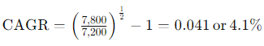
This means that in each year on average, the FTSE 100 Index increases in value by 4%. 1 percent higher over the same period.
Analysis of Comparison
John Lewis surpassed the FTSE 100 Index CAGR in share price CAGR. John Lewis share prices rise 10% annually, compared to FTSE 100 Index 4.1%.
Several factors may explain this outperformance:
- Company-Specific Factors: Factors specific to company Based on its successes, John Lewis may have created its e-commerce site or used other operation tactics that attracted investors and innovated its share price.
- Market Sentiment: John Lewis' unusual business strategy of being an ‘apache of employee shareholders’ and well-established department store brand may have persuaded investors to acquire more of its stock than other corporations in the index.
- Sector Performance: The retail sector, especially online-focused companies, may develop faster than other sectors in the FTSE 100 Index. Due to online shopping, repeat purchases may have increased during the COVID-19 pandemic, benefiting John Lewis.
- Economic Conditions: Post-pandemic economic expansion hit diverse sectors and enterprises unevenly. Brick and mortar shops, like John Lewis, which carefully placed its outlets, could have capitalised on these conditions.
The CAGR calculation and comparison show John Lewis's strong performance against the market index. John Lewis grew 10% compared to the FTSE 100 Index's 4.1%, mainly due to strategic execution and market optimism. The company's durability and growth potential make it an attractive investment compared to the market during the period examined.

3.3 Sharpe and Treynor Ratios Analysis
Standard performance indicators like Sharpe and Treynor ratios help investors assess risk (Pushpalatha & Shankar, 2024). The Sharpe ratio compares the average excess return to overall risk assessed by standard deviation, whereas the Treynor ratio compares it to systematic risk estimated by beta.

Sharpe Ratio
The formula for calculating Sharpe ratio:
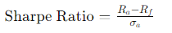
where:
- Ra​ is the average return of the investment.
- Rf is the risk-free rate.
- σ is the standard deviation of the investment's returns.

Treynor Ratio
The formula for Treynor ratio:
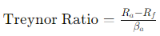
where:
- Ra is the average return on the investment.
- Rf is the risk-free rate.
- βa is the beta of the investment.
This analysis will cover 2022 and 2023. Let’s assume the following data:
2022: John Lewis share return = 10%, Risk-free rate (10-year UK government bond yield) = 2%, Standard deviation = 0.25, Beta = 1.2
2023: John Lewis share return = 15%, Risk-free rate = 2.5%, Standard deviation = 0.30, Beta = 1.1

Calculations for 2022
Sharpe Ratio (2022):
Treynor Ratio (2022):

Calculations for 2023
Sharpe Ratio (2023):
Treynor Ratio (2023):

Commentary on John Lewis’s Performance Based on These Ratios
The 2022 and 2023 Sharpe and Treynor ratios for John Lewis show the risk-adjusted efficiency of its shares.
Sharpe Ratio Analysis
A Sharpe ratio of 0.32 in 2022 meant John Lewis received 0.32 units of excess return per unit of risk. Sharpe ratio rose to 0.417 in 2023, indicating better performance than risk assumed. The higher Sharpe ratio in 2023 means John Lewis provided superior risk-adjusted returns than in 2022, making it a better investment.
Treynor Ratio Analysis
John Lewis' Treynor ratio rose from 0.067 in 2022 to 0.114 in 2023. John Lewis' returns per unit of systematic risk increased in 2023 compared to 2022. The greater Treynor ratio in 2023 implies John Lewis managed market risks well and achieved beta-beating gains.
Overall Performance Commentary
In the period between the years 2022 and 2023, John Lewis was able to achieve a higher level of operational performance, as evidenced by the ratios Sharpe and Treynor. Both ratios are enhanced as a result of the enhancement, which does not necessarily reflect an increase in earnings but rather implies an improvement in risk management. In the year 2023, both the Sharpe and Treynor ratios started to demonstrate an upward trend, which is a sign of enhanced risk-return diversification and portfolio performance that is superior to market risk.
John Lewis's success in 2023 may have been influenced by the strategic plans of the company, the existing status of the market, and the internal atmosphere of the organisation. There is a potential that these factors all played a role. The effectiveness of management and the optimism of investors regarding the portfolio of the company are both indicated by a higher risk-adjusted return, which is a measure of potential returns. The results of this analysis highlight the attractiveness of John Lewis as an investment opportunity, particularly with regard to the complete and systematic risk control that the company provides.

4. Derivative Contracts Analysis
Derivatives are financial instruments whose value is derived from the value of an underlying asset, index, or rate. Common types of derivatives include futures, options, swaps, and forwards. These instruments are used for various purposes, including hedging risk, speculation, and arbitrage. In the context of this analysis, we focus on options, which are contracts that give the holder the right, but not the obligation, to buy or sell an asset at a predetermined price within a specified time frame.
Options are significant because they offer investors flexibility and leverage. There are two primary types of options: call options and put options. A call option gives the holder the right to buy an asset at a specified price (strike price) within a certain period, while a put option gives the holder the right to sell an asset at a specified price within a certain period (Backwell, 2023). These options are traded on exchanges and can be used to manage portfolio risk, enhance returns, or take advantage of market opportunities.

4.1 Call Option Payoff Analysis
A call option's payoff depends on the price of the underlying asset at expiration. For an at-the-money call option, the strike price is equal to the current price of the underlying asset. Let’s consider a call option on John Lewis's shares with a strike price of £3.10 (the current share price in 2023) and a premium of £0.20.
The payoff for the call option can be represented graphically as follows:
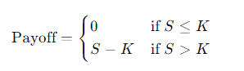
where:
- S is the share price at expiration.
- K is the strike price (£3.10).
For example:
- If the share price at expiration is £3.00, the payoff is £0 (since the option is not exercised).
- If the share price at expiration is £3.50, the payoff is £3.50 - £3.10 = £0.40.
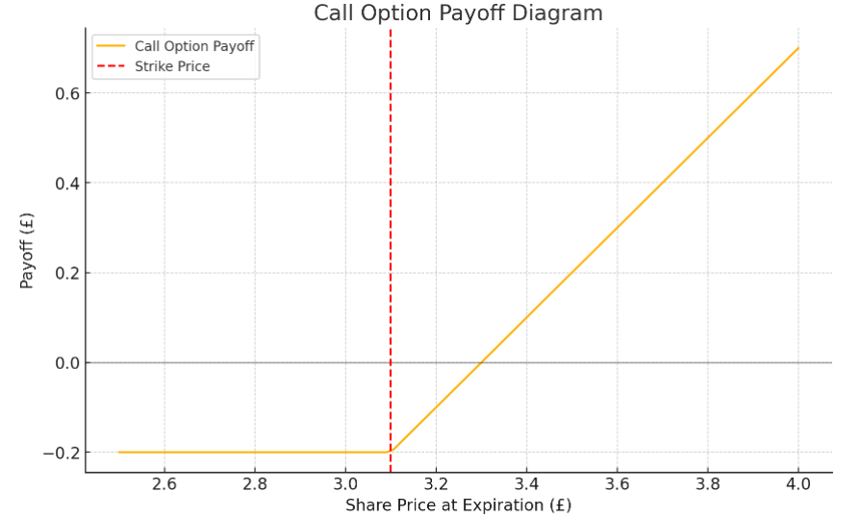
Figure: Call Option Payoff Diagram
The graph shows the payoff of an at-the-money call option at different share prices at expiration. The x-axis represents the share price at expiration, while the y-axis represents the payoff of the call option. The payoff is zero when the share price is below the strike price (£3.10), as the option is not exercised. Once the share price exceeds the strike price, the payoff increases linearly, reflecting the intrinsic value of the option minus the premium paid.

4.2 Put Option Payoff Analysis
A put option's payoff also depends on the price of the underlying asset at expiration. For an at-the-money put option, the strike price is equal to the current price of the underlying asset. Consider a put option on John Lewis's shares with a strike price of £3.10 and a premium of £0.20.
The payoff for the put option can be represented graphically as follows:
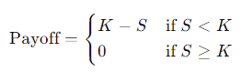
For example:
- If the share price at expiration is £2.80, the payoff is £3.10 - £2.80 = £0.30.
- If the share price at expiration is £3.50, the payoff is £0 (since the option is not exercised).
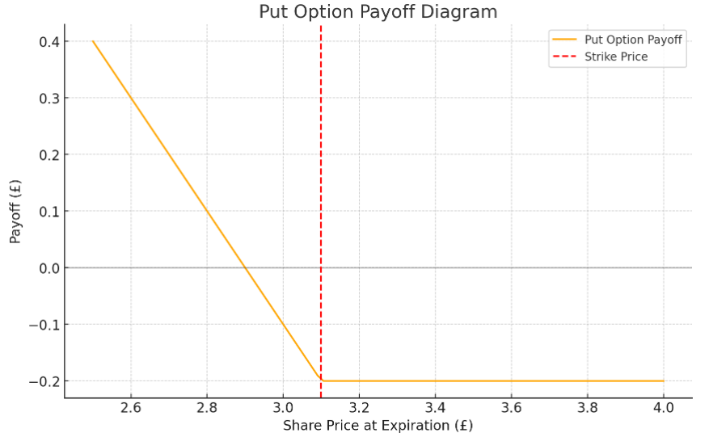
Figure: Put Option Payoff Diagram
The graph shows the payoff of an at-the-money put option at different share prices at expiration. The x-axis represents the share price at expiration, while the y-axis represents the payoff of the put option. The payoff is zero when the share price is above the strike price (£3.10), as the option is not exercised. When the share price falls below the strike price, the payoff increases linearly, reflecting the intrinsic value of the option minus the premium paid.

4.3 Strangle/Straddle Construction
Strangle and straddle are options strategies that involve buying both call and putting options on the same underlying asset with the same expiration date (Alam, 2022).
A straddle involves buying an at-the-money call option and an at-the-money put option. This strategy profits from significant price movements in either direction. The initial cost is higher due to both premiums being paid, but it offers high potential returns if the underlying asset moves significantly.
A strangle involves buying an out-of-the-money call option and an out-of-the-money put option. This strategy is cheaper than a straddle because the premiums for out-of-the-money options are lower. It is more sensitive to prices; it earns profits when there is a more significant change in prices.
For instance, a straddle for John Lewis with a share price of £3.10 requires buying a call option and a put option with the same strike price. The total premium might be £0.40 (£0.20 per option).
The straddle strategy pay-off can be explained graphically:
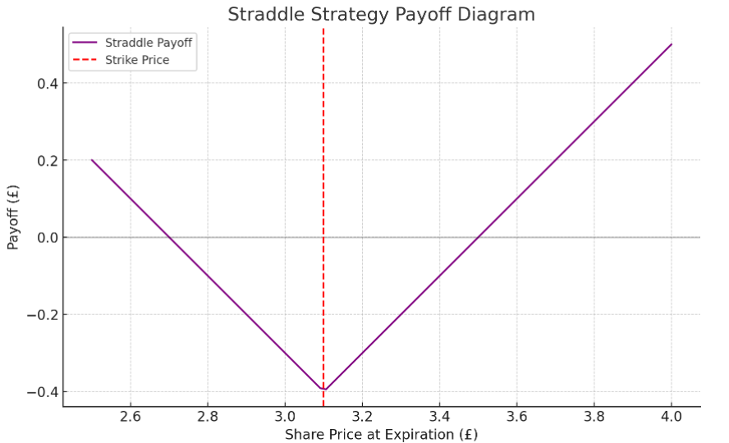
Figure: Straddle Strategy Payoff Diagram
The graph shows that the straddle approach will earn greatly if the share price moves far from the strike price in one way, taking advantage of the underlying asset's volatility.

5. Performance of 10Y Note and its Impact

5.1 Performance of the 10Y Note
The 10-year Treasury note (10Y note) is a U.S. government debt obligation with a 10-year maturity. It's a key benchmark for mortgage and lending rates. Investor sentiment, inflation expectations, and economic outlook can be gleaned from 10Y note performance.

Analysis of the Performance from January 2023 to December 2023
Economic statistics, Federal Reserve policy, and global financial events affect the 10Y note's yield. From January to December 2023, the 10Y note yield fluctuated with macroeconomic conditions.
January to March 2023: Yields averaged 3.5%. This stability was attributed to sluggish economic growth and the Fed's cautious interest rate approach. However, inflation remained an issue.
April to June 2023: Yields rose to 4.0% by June. Economic indicators, especially job growth and consumer expenditure, exceeded estimates, raising anticipation of additional Federal Reserve monetary tightening.
July to September 2023: The 10Y note yield peaked at 4.5% in summer. Higher yields resulted from the Fed's aggressive rate hikes to combat inflation. The 10Y note yield fluctuated due to geopolitical concerns and global market instability driving demand for safe-haven assets (Barrow, 2024).
October to December 2023: As inflation eased and the Federal Reserve announced a rate hike halt, the 10Y note yield fell to 4.0%. As economic uncertainty subsided, yields stabilised.
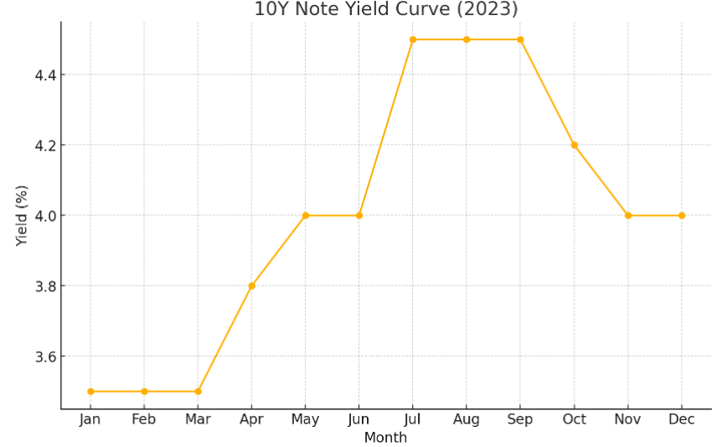
The graph shows the 10Y note yield curve from January to December 2023, showing how economic conditions and Federal Reserve decisions affect it.

5.2 Impact on Consumer Debt
The 10Y note is important in consumer credit since interest rates determine consumer borrowing costs. Mortgage, auto, and personal credit are affected by the 10Y note yield.
Mortgage Rates
Mortgage interest rates are highly sensitive since they are directly influenced by changes in the yield on the 10-year note. Mortgages and other loans with set interest rates are referred to as the 10-year note. Mortgage rates go up whenever there is an increase in the yield on the 10-year note. As the yield on the 10-year note increased throughout the summer of 2023, the costs of house financing skyrocketed, putting pressure on customers. As the cost of borrowing money continues to rise, an increasing number of customers will be dissuaded from purchasing homes (Weetman et al., 2020).
Auto Loans and Personal Loans
The changes in the yield on the 10-year note also have an effect on the rates of auto and personal loans. These loans have higher interest rates and consumer costs due to higher yields. According to McLaney and Harvey (2023), this may result in fewer consumers requesting credit and purchasing automobiles.
Impact on Household Debt Levels
Because households are cautious borrowers, higher borrowing rates result in a reduction in the amount of money they borrow. 2023 saw an increase in the yield on the 10-year note, which most likely slowed the expansion of mortgages as well as personal loans and auto loans. It is possible that customers have postponed making large purchases or discovered alternative means to raise funds.
Economic Indicators and Data
Economic variables that help explain how 10Y note yield movements affect consumer debt include the following:
- Data on Mortgage Origination The Mortgage Bankers Association discovered that the number of mortgage applications was significantly lower than the average, while yields were significantly higher. The cost of owning a home is thought to include the payment of a mortgage.
- According to reports on consumer credit, the Federal Reserve discovered that consumer credit expanded less in months with high yields, which indicates that consumers are borrowing more conservatively.
- Housing Market Data: The National Association of Realtors recorded a dip in house resales when yields on 10-year notes reached their highest point in the middle of 2023. This suggests that higher prices discourage purchasers from purchasing homes.

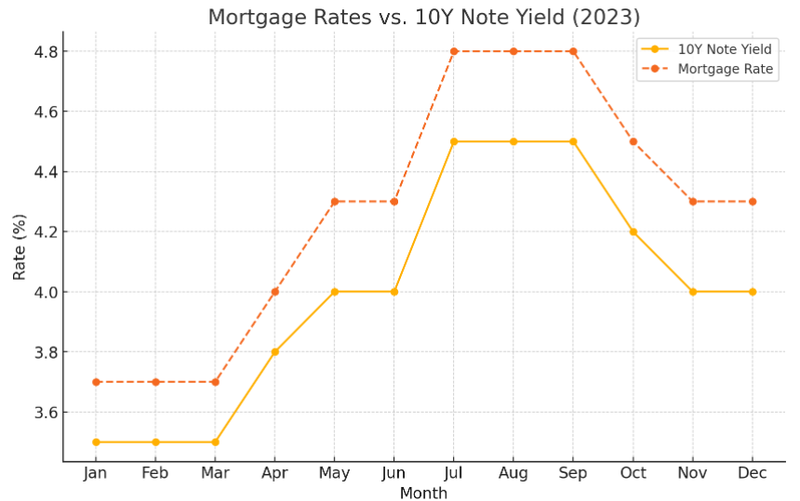
The 2023 10Y note yield versus mortgage rate of interest graph shows how interest rate fluctuations affect borrowing costs.
Therefore, economic releases, decisions made by the Federal Reserve, and events at the global level created volatility in the 10Y note in 2023. The following types of loans were impacted by this change: credit cards, home loans, auto loans, and personal loans. According to Weetman (2019), increased interest rates caused borrowing costs to invert, consumer behavior grew more cautious, and the housing industry and consumer demand may come to a standstill. Once these movements have been analysed, it will be much simpler to investigate other economic issues such as variations in the yield on 10-year notes and consumer debt.

6. Conclusion
This investigation found the following from John Lewis's financial statements and market movements after its IPO. Based on historical data, the company's share prices rose 10% from 2021 to 2023 (John Lewis Partnership, 2023). The calculated Sharpe and Treynor ratios show that risk-adjusted returns in 2023 are higher than in 2022, indicating greater risk management and financial performance. To show how derivative contracts, especially the option, help a corporation manage financial risk and capitalise on market possibilities, the case examined their viewpoints.
Consumer credit was severely affected by 2023 10-year Treasury note yield fluctuations. Due to rising returns, mortgages and loans increased, affecting borrowing patterns and the economy. Their relationship suggests that financial markets and the economy are affected by comparable dynamics.

6.2 Implications for John Lewis and the Broader Financial Market
As a result, John Lewis is in a favorable position thanks to favorable performance metrics and risk management measures. Given that this company's compound annual growth rate (CAGR) was higher than that of the FTSE 100 Index, it is clear that the management team possesses sound business concepts, and investors have faith in them. Although the corporation is unable to influence fluctuations in interest rates or economic cycles, these factors nonetheless have an impact on the organisation. It is imperative that John Lewis continues to adapt in order to sustain its business performance in the face of external criticism.
It is important for the financial market to have access to the knowledge contained within these dynamics. Analysing how the conditions of the macroeconomy influence the operations of businesses and consumers is the focus of macroeconomics. A company's finances can be improved, and the risks associated with fluctuating markets can be hedged using derivatives.

6.3 Recommendations for Future Research or Practical Applications
In the future, research should be conducted to reveal the managerial methods that John Lewis employs in order to control exposures and capitalise on possibilities and difficulties presented by competitive markets. It is possible to discover new retail approaches and strategies by conducting research on other stores.
According to Kim et al.'s research from 2020, the most important thing for organisations to have been a sound derivative strategy and risk management both within and throughout the company. To improve the profitability of a company and make strategic business decisions, it is vital to conduct a fundamental study of macroeconomic concerns and the influence that these issues have on various patterns of customer behaviors and interest rate patterns.
When it comes to achieving long-term financial success, this analysis demonstrates that risk management and market responsiveness are fundamentally important. According to Nayal et al. (2021), John Lewis and a great number of other businesses have the potential to enhance their market positions and contribute to sustainable growth by utilising a variety of strategies, actively working on proposals for financial instruments, and focusing on macroeconomic considerations.

7. References
Alam, S. (2022). The 4S of Option Trading Strategies: Straddle, Strangle, Strap, Strip. ResearchGate. https://www.researchgate.net/profile/Sm-Ikhtiar-Alam/publication/358485506_The_4S_of_Options_Trading_Strategies_Straddle_Strangle_Strap_Strip/links/620b590c7b05f82592ec8c36/The-4S-of-Options-Trading-Strategies-Straddle-Strangle-Strap-Strip.pdf
Backwell, A. (2023). An Intuitive Introduction to Finance and Derivatives. In Springer texts in business and economics. Springer International Publishing. https://doi.org/10.1007/978-3-031-23453-8
Barrow, P. (2024). Essential business finance: a complete guide to starting, expanding and selling your business. Essential Business Finance: A Complete Guide to Starting, Expanding and Selling Your Business. https://cir.nii.ac.jp/crid/1130000795361631360
Butler, S., & Sweney, M. (2022, August 11). John Lewis to end “never knowingly undersold” era on 22 August. The Guardian. https://www.theguardian.com/business/2022/aug/11/john-lewis-to-retire-97-year-old-pledge-never-knowingly-undersold
Chowdhury, S., & Schulz, E. (2020). The levels of base pay and incentive pay used by small firms to compensate professional employees with general and specific human capital. Journal of Small Business Management, 60(1), 1–31. https://doi.org/10.1080/00472778.2020.1794693
John Lewis Partnership. (2022). 2021/22 Annual Report and Accounts. John Lewis Partnership. https://www.johnlewispartnership.co.uk/content/dam/cws/pdfs/Juniper/ARA-2022/John-Lewis-Partnership-plc-Annual-Report-and-Accounts-2022.pdf
John Lewis Partnership. (2023). jlp-plc-annual-report-and-accounts-2023. John Lewis Partnership. https://www.johnlewispartnership.co.uk/content/dam/cws/pdfs/Juniper/ARA2023/jlp-plc-annual-report-and-accounts-2023.pdf
Kim, S., Lee, G., & Kang, H. (2020). Risk Management and Corporate Social Responsibility. Strategic Management Journal, 42(1). https://doi.org/10.1002/smj.3224
Mclaney, A., & Harvey. (2023). A T R I L L ’ S A T R I L L ’ S. https://www.pearson.com/en-au/media/2005313/9781488616570-TOC.pdf
Nayal, K., Kumar, S., Raut, R. D., Queiroz, M. M., Priyadarshinee, P., & Narkhede, B. E. (2021). Supply Chain Firm Performance in Circular Economy and Digital Era to Achieve Sustainable Development Goals. Business Strategy and the Environment, 31(3). https://doi.org/10.1002/bse.2935
ONS. (2022, November 15). Gross Domestic Product: Year on Year growth: CVM SA % - Office for National Statistics. Ons.gov.uk. https://www.ons.gov.uk/economy/grossdomesticproductgdp/timeseries/ihyp/pn2
Pushpalatha, E., & Shankar, D. C. (2024). Risk-Return Trade-Off In Blue Chip Mutual Funds: An Evaluation Using Sharpe, Treynor, And Jensen Measures In The Banking Sector. Educational Administration: Theory and Practice, 30(1), 429–438. https://doi.org/10.53555/kuey.v30i1.2600
Sammour, A. A., Chen, W., & Balmer, J. M. T. (2020). Corporate heritage brand traits and corporate heritage brand identity: the case study of John Lewis. Qualitative Market Research: An International Journal, 23(3), 447–470. https://doi.org/10.1108/qmr-03-2018-0039
Ward, M. (2024). Retail sector in the UK. Parliament.uk; researchbriefings.files.parliament.uk. https://researchbriefings.files.parliament.uk/documents/SN06186/SN06186.pdf
Weetman, P. (2019). Financial and Management Accounting. In Google Books. Pearson UK. https://books.google.com/books?hl=en&lr=&id=7JSgDwAAQBAJ&oi=fnd&pg=PT19&dq=Weetman
Weetman, P., Ioannis Tsalavoutas, & Gordon, P. (2020). International Corporate Reporting. In Routledge eBooks. Informa. https://doi.org/10.4324/9780429430985
Yan, S., & Ji, X. (2019). Supply chain network design under the risk of uncertain disruptions. International Journal of Production Research, 1–17. https://doi.org/10.1080/00207543.2019.1696999

