Audit of the External and Internal Environments of the Burger King Corporation
Word count: 2,689

Executive summary
Coming out of the covid-19 pandemic, the global fast food industry faces an unprecedented rise in inflation, which has seen a sharp spike in the cost of fast food ingredients and labour. This has led to operators recording significant declines in their margins. Against this background, this report undertakes a detailed audit of the current and future external and internal environments of Burger King. Burger King is based in Florida and is one of the largest fast food chains globally. Its products include fries, burgers and shakes. PESTEL framework, Porter’s five forces framework, Porter’s generic value chain analysis and the SWOT analysis are used. The analysis has surfaced five main issues. These include: low operational flexibility due to its modified production line approach, low speed of service arising from the operations aspect of Burger King’s value chain analysis, relatively weak market position compared to incumbents such as McDonalds and Yum Brands, potential reduction in the demand for Burger King’s fast foods due to the growing health consciousness trend, and the potential threat of higher costs and reduced margins due to the unfavourable economic conditions. To address these issues, the audit provides three key recommendations for the company. These include: expanding its menu of healthy food items, automation of its modified line flow production method, and enhancing brand differentiation (through a focus on better service, greater customisation, new product introductions and aggressive advertising).

Table of contents
1.0 Introduction 1
2.0 Burger King’s External Environment Analysis 1
2.1 Economic Forces 2
2.2 Sociocultural Forces 3
3.0 Porter’s 5 Forces 4
3.1 Industry rivalry 5
3.2 Buyer Power 6
4.0 Porter’s Generic Value Chain 6
5.0 SWOT Analysis 8
6.0 Recommendations 9
7.0 Conclusions 10
8.0 Reference List 11

1.0 Introduction
The global fast food industry continues to be beset by some challenges. Coming out of the covid-19 pandemic, the industry faces an unprecedented rise in inflation, which has seen a sharp spike in the cost of fast food ingredients and labour, with some fast food chains reporting increased inflation costs of up to 20% on their inputs. This has led to operators recording significant declines in their margins (Levin, 2023).
Against this background, this report undertakes a detailed audit of the current and future external and internal environments of the global fast foods industry. The audit has is in pursuance of a request made by the marketing manager of Burger King Corporation. Burger King is based in Florida and is one of the largest fast food chains globally. Its products include fries, burgers and shakes (Bloomberg, 2023).
The first section of the audit utilizes the PESTEL framework to assess Burger King’s external environment. The second section of the audit makes use of Porter’s five forces framework to assess the fast food chain’s competitive environment. Section 3 of the audit examines Burger King’s micro environment using Porter’s generic value chain analysis, after which the SWOT analysis, analysis of key issues, and conclusions and recommendations are given.

2.0 Burger King’s External Environment Analysis
The PESTEL framework is a strategic management tool which is used to evaluate the external (macro) environment in which the firm operates. The framework conceptualises the firm’s macro environment as consisting of political, economic, sociocultural, technological, legal and ecological forces (Fahy & Jobber, 2015). In addition to its simplicity, the PESTEL framework is able to facilitate external and strategic thinking, better grasp of the macro environment, the ability to anticipate future threats, and the ability to identity future opportunities (Dibb et al, 2016). For these reasons, the framework was applied in auditing Burger King’s macro environment. Accordingly, Burger King’s PESTEL analysis is depicted in figure 1 below.

BK’s MACRO ENVIRONMENT
Political: junk food tax, high political stability
Economic: high interest & inflation rates, high energy prices, & recession.
Sociocultural: busy lifestyles, rising health awareness trend
Legal: food safety, employment, anti-trust, & IP laws
Environmental: rising awareness on need to protect environment
Technological: online food ordering, AI, social media analytics, food kiosks

Figure 1: Burger King’s PESTEL framework
Source: Author.
Even though the PESTEL framework identifies five forces, the analysis considers the economic and sociocultural forces as being most impactful in the specific case of Burger King. Therefore, particular focus and more detailed analysis is on the economic and sociocultural forces.

2.1 Economic Forces
Some of the key variables within the economic environment include: interest, inflation, exchange, and unemployment rates, the business cycle, and disposable incomes (Jobber & Ellis-Chadwick, 2016). Global GDP growth rate is expected to decline from 3.4% recorded in 2022 to 2.9% in 2023. This is due to the Russia-Ukraine conflict and the cost of living crisis (high energy and food prices). However, global GDP growth rate is expected to recover and to expand by 3.1% in 2024 (OECD, 2023; IMF, 2023).
Even though the global rate of inflation (8.8% in 2022) is substantially above the pandemic level of 3.5%, the IMF (2023) projects continued decline in global inflation rate to 6.6% in 2023 and 4.3% in 2024. To fight the global rise in inflation, central banks around the world have raised the central bank rates, resulting into high rates of interest globally (Adrian and Natalucci, 2022).
The high energy and food prices and high inflation rate is likely to result into higher labour and fast food ingredient prices. Burger King may react by passing on the additional costs to consumers (which may dampen demand for its products), absorbing the costs (which may shrink its margins), or maintaining current prices while reducing food portions (Krietzberg, 2022). The high rates of interest imply high costs of borrowing and therefore reduced spend (low demand for Burger King’s products). Likewise, falling GDP growth rate implies reduction in aggregate demand for fast food items (Mankiw, 2016).
Nevertheless, this impact is likely to be short term in nature. As global GDP growth rate expands in 2024 accompanied by a sustained decline in inflation rates and the on-going fall in energy and costs (IMF, 2023; OECD, 2023); consumer spend is likely to pick up resulting into growing demand for Burger King’s products in the future.

2.2 Sociocultural Forces
Some of the key sociocultural trends include: Population demographics (younger/older populations), income distribution, and taste and lifestyle changes, attitudes to work and leisure, and levels of education (Dibb et al., 2016). In many countries around the world, consumer lifestyles have become busier and more hectic. These demanding lifestyles mean that consumers no longer observe the traditional meal times, but only take meals when they are hungry (Sims, 2016). As a result, fast foods have become more popular due to their convenience, and this continues to boost the demand for Burger King’s products.
While traditional gender roles across many countries have traditionally confined women to household chores, more women are currently being absorbed into the workforce. This means that most of their time is spent working or commuting. As a result, they have less time to prepare food for their families, so that many families are now forced to turn to fast foods. This is more pronounced in instances where both couples are employed, a situation that has been on the rise in the world (Westholm and Ostwald, 2020). As a result of these lifestyle trends, Burger King is likely to record increased demand for its products.
At the same time, there is a growing health consciousness trend among consumers, and this is likely to persist in the future (Konar et al., 2022). This is likely to hurt the demand for Burger King’s unhealthy fast food options (e.g. those high in salt, sugar and fat) going into the future, and this may require Burger King to respond by expanding the number of healthy food items on its menu (e.g. introduce organic, plant-based, and free range menus) (Globe Newswire, 2023).

3.0 Porter’s 5 Forces
Porter’s five forces framework assumes that the competitive environment is influenced by the following five forces: industry rivalry, buyer power, supplier power, threat of new entrants, and threat of substitutes (Porter, 1998). The framework is regarded as suitable for the analysis because it facilitates a static analysis of the fast food industry, thereby providing support for entry and exit, strategic competitive, capacity, and profitability decisions. The model also provides a dynamic framework that is useful in the identification of future change drivers, on the basis of which action towards specific outcomes may be coalesced (Morris, 2013). Accordingly, Burger King’s five forces analysis is summarised in figure 2 below.
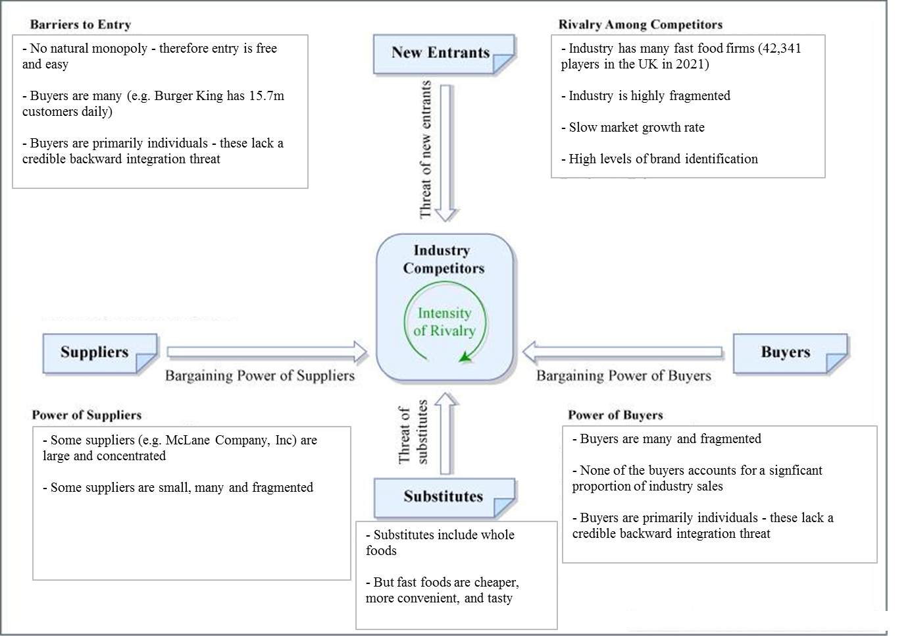
Figure 2: Five forces analysis for Burger King
Source: Author, based on Porter (1998)
Even though all five forces of the framework are relevant for Burger King and the fast food industry, more detailed focus in this analysis will be on industry rivalry and buyer power.

3.1 Industry rivalry
The global fast food industry has 541,642 companies currently. This represents an increase of 0.2% compared to 2022 (IBIS, 2023). The size of the global market was estimated to be $593.3 billion in 2021, and is expected to expand to $813.9bn by 2028. This translates into a CAGR of 4.6% between 2021 and 2028 (Grand View Research, 2021).
The global fast foods industry is highly concentrated, with six of the top brands being dominant in the market. These include: McDonalds (market leaders with 43.8% of the share), Yum Brands (30.9%), Restaurant Brands International (which owns Burger King, at 10.8%), Domino’s Pizza (8.2%), Wendy’s (2.8%), and Papa John’s (3.4%) (Khaveen Investments, 2022).
This large number of firms implies a high intensity of competition and industry rivalry. However, the degree of competitive intensity and rivalry appears to be constrained by the high level of concentration in the industry, the high rate of growth of the market, as well as the high levels of brand identification (Porter, 1998). Overall, the industry rivalry appears moderate to weak. This position is likely to be sustained going into the future, considering the projected CAGR growth rate, and the expected continued dominance of the ‘Big Six’ (Grand View Research, 2021).
The moderate to weak competitive rivalry implies that Burger King has the opportunity to charge higher prices for its fast food products and to negotiate better terms from suppliers. Nevertheless, Burger King appears to be in a relatively weak competitive position compared to McDonalds and YUM Brands (Khaveen Investments, 2022). Considering this weak market follower position, Burger King may jockey for top position against McDonalds and YUM Brands through: building switching costs through enhancing brand differentiation, improving service quality, aggressive advertising, new product introductions, and price competition (Porter, 1998). These moves may be carried out proactively or in response to similar moves by the other firms, considering the interdependent nature of the industry.

3.2 Buyer Power
Fast food buyers predominantly consist of individuals. These are many and fragmented, with each individual buyer accounting for a very small share of the fast food chain’s sales (for example, Burger King serves more than 11m customers daily) (The Sun, 2022). Due to their individual nature, these buyers do not possess a credible backward integration threat. Therefore, buyer power is regarded as weak. Since Burger King has millions of independent customers who are individually unable to negotiate for lower prices, Burger King has the opportunity to charge higher prices for its products (Porter, 1998).

4.0 Porter’s Generic Value Chain
The value chain refers to the set of activities or processes through which the firm adds value to a product or service. According to Porter’s (1985) value chain analysis, these activities may be categorized into primary activities and secondary activities. The primary activities include (firm infrastructure, human resource management, technology development and procurement. The secondary activities include inbound logistics, operations, outbound logistics, marketing and sales, and service (Lynch, 2015).
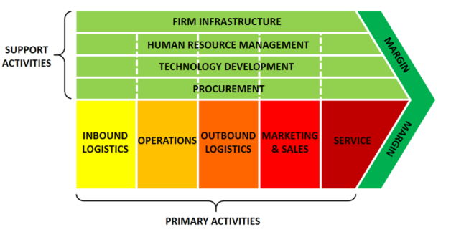
Figure 3: Value chain analysis
Source: Lynch (2015)
Of these value chain activities, this analysis focuses on Burger King’s operations activity. Burger King utilizes the production line approach to food service. This is based on the principles of: task simplification, division of labour, automation of the production process, and little decision making discretion for the employees. By using this approach, Burger King is able to enjoy extremely fast, low cost, high volume and efficient production of food items. The production line approach also ensures that the food products are of consistently high quality (Hill, Jones, ‎and Schilling, 2014).
However, the use of the production line approach to food service promotes standardization and restricts Burger King’s ability to offer customized products as required by its ‘Have It your Way’ motto. Whatever customization Burger King currently offers is limited to the choice of dressing for its burgers (lettuce and pickles) rather than on a large menu choice (Murguia, 2018). Nevertheless, this limited degree of customization has resulted into Burger King having longer waiting plus service time (363 seconds) compared to competitors such as KFC (303 seconds) and Taco Bell (318 seconds) (Pomranz, 2022).
Thus, Burger King’s production depicts the use of a modified line process. Even though the production process helps meet the cost and quality objectives, it does not appear to meet the flexibility and speed objectives. Adoption of the job production method in place of the line flow method may enable Burger King to achieve high levels of customisation, but is likely to compromise service times even further and to erode mass production. Therefore, Burger King may consider retaining its current production method, but instead automate it in order to facilitate greater variation in production to accommodate specific customer preferences while also achieving speed of service (Murguia, 2018).

5.0 SWOT Analysis
Based on the PESTEL analysis, Porter’s five forces analysis, and Porter’s generic value chain analysis, the SWOT analysis for Burger King is presented below.
Table 1 SWOT analysis
Strengths  - Strong bargaining position over buyers  - Low cost advantages arising from the production line approach to food service  - High consistent quality arising from the production line approach to food service  - Better customer satisfaction due to some customer choice facilitated by the ‘Have It your Way’ philosophy | Weaknesses  - Low operational flexibility due to the production line approach  - Low speed of service arising from the operations aspect of the value chain analysis  - Relatively weak market position compared to incumbents such as McDonalds and Yum Brands
Opportunities  - Opportunity to maximise sales due to the increasingly busier and hectic lifestyles  - Opportunity to charge higher prices due to low industry rivalry and higher bargaining power over buyers | Threats  - Threat of reduction in demand for fast foods due to the growing health consciousness trend and weak economic conditions  - Potentially higher costs and reduced margins due to high interest rate (high borrowing costs), high inflation rate, high energy and food prices. These are likely to erode consumer discretionary income and spending power, thereby leading to restricted demand for Burger King’s products
Source: Summarised by the research
Considering the analysis provided therefore, this analysis identifies the following as the five key issues which affect Burger King: low operational flexibility due to its modified production line approach, low speed of service arising from the operations aspect of Burger King’s value chain analysis, relatively weak market position compared to incumbents such as McDonalds and Yum Brands, potential reduction in the demand for Burger King’s fast foods due to the growing health consciousness trend, and the potential threat of higher costs and reduced margins due to the unfavourable economic conditions.

6.0 Recommendations
Based on the strength of the analysis carried out, Burger King should consider adopting the following three recommendations:
- To address the growing health consciousness trend; Burger King should consider introducing a healthy alternative menu. This will comprise of healthy food items, smaller portion of current fast food items, and fast food items that contain lower salt, sugar, and fat content. Healthy menus may be targeted at a different segment and offered at a higher price point compared to the low price point offered for fast food. Reduction of the portion sizes and of ingredients such as fat and salt may not only help address health concerns, but will also reduce some costs, and therefore help to mitigate some of the effects of the high inflation affecting the fast food industry.
- To address the weaknesses associated with the ‘operations’ aspect of Burger King’s value chain analysis (its modified line flow process); Burger King should automate and integrate robotic technology to its current production line method. This will result into a production method that facilitates the mass production of fast foods, while also enabling the programming of the production line to accommodate all the variations which customers may desire. In this way, the firm will be able to simultaneously achieve fast speed and mass customisation (high flexibility).
- To enhance its position in the global fast foods market, Burger King should avoid cutting product prices since this may trigger a price war with its (much larger) rivals such as McDonalds and Yum Brands. Instead, it should focus on building switching costs through enhancing brand differentiation. This may be achieved through: improving service quality, aggressive advertising, and new product introductions.

7.0 Conclusions
This report has presented an audit of the external environment in which Burger King operates. The analysis has surfaced five main issues which the fast food chain faces and must address for continued success. These include: low operational flexibility due to its modified production line approach, low speed of service arising from the operations aspect of Burger King’s value chain analysis, relatively weak market position compared to incumbents such as McDonalds and Yum Brands, potential reduction in the demand for Burger King’s fast foods due to the growing health consciousness trend, and the potential threat of higher costs and reduced margins due to the unfavourable economic conditions.
To address the five, the audit provides three key recommendations for the company. These include: expanding its menu of healthy food items, automation of its modified line flow production method, and enhancing brand differentiation (through a focus on better service, greater customisation, new product introductions and aggressive advertising).

8.0 Reference List
Adrian, T. and Natalucci, F. (2022) Central Banks Hike Interest Rates in Sync to Tame Inflation Pressures [online]. Available at: https://www.imf.org/en/Blogs/Articles/2022/08/10/central-banks-hike-interest-rates-in-sync-to-tame-inflation-pressures (Accessed 17 Mar 2023).
Bloomberg. (2023) Burger King Holdings Inc [online]. Available at: https://www.bloomberg.com/profile/company/1619058D:US#xj4y7vzkg (Accessed 13 Mar 2023).
Dibb, S., Simkin, L., Pride, W.M., & Ferrell, O.C. (2016) Marketing: Concepts and Strategies 7th ed. Boston, MA: Houghton Mifflin.
Fahy, J. & Jobber, D. (2015) Foundations of Marketing, 5th ed. London: McGraw-Hill.
Globe Newswire. (2023) Global Fast Food Restaurants Market Research Report 2022 [online]. Available at: https://www.globenewswire.com/en/news-release/2023/02/03/2601452/28124/en/Global-Fast-Food-Restaurants-Market-Research-Report-2022.html (Accessed 15 Mar 2023).
Grand View Research. (2021) Market Analysis Report: Fast Food Market [online]. Available at: https://www.grandviewresearch.com/industry-analysis/fast-food-market (Accessed 15 Mar 2023).
Hill, C.W., Jones, ‎G.R. and Schilling, M.A. (2014) Strategic Management: Theory: An Integrated Approach. Mason, OH: Cengage.
IBIS. (2023) Global Fast Food Restaurants - Number of Businesses [online]. Available at: https://www.ibisworld.com/global/number-of-businesses/global-fast-food-restaurants/1480/ (Accessed 16 Mar 2023).
IMF. (2023) Inflation Peaking amid Low Growth [online]. Available at:https://www.imf.org/en/Publications/WEO/Issues/2023/01/31/world-economic-outlook-update-january-2023#:~:text=Global%20inflation%20is%20expected%20to,since%20the%20October%202022%20WEO (Accessed 15 Mar 2023).
Jobber, D. & Ellis-Chadwick, F. (2016) Principles and Practice of Marketing 7th revised ed. Berkshire: McGraw-Hill.
Khaveen Investments. (2022) McDonald's: King of Fast Food Is Here to stay [online]. Available at: https://seekingalpha.com/article/4499843-mcdonalds-king-of-fast-food-is-here-to-stay (Accessed 16 Mar 2023).
Konar, N., Gunes, R., Palabiyik, I. and Toker, O.S. (2022) ‘Health conscious consumers and sugar confectionery: Present aspects and projections’, Trends in Food Science & Technology, 123, pp. 57-68.
Krietzberg, I. (2022) Higher prices, skimpier portions and apps — how fast-food chains are changing value deals [online]. Available at: https://www.cnbc.com/2022/08/06/higher-prices-skimpier-portions-apps-fast-food-deals-are-changing.html (Accessed 16 Mar 2023).
Levin, M. (2023) How fast-food chains are buffeted and buoyed by inflation [online]. Available at: https://www.marketplace.org/2023/02/02/how-fast-food-chains-are-buffeted-and-buoyed-by-inflation/ (Accessed 17 Mar 2023).
Lynch, R. (2015) Strategic Marketing 7th ed. Harlow: Pearson.
Mankiw, G.N. (2016) Principles of Economics. Mason, OH: Cengage Learning.
Morris, M. (2013) Strategic Business Diagnostic Tools - Theory and Practice. Scotts Valley, CA: CreateSpace Independent Publishing Platform.
Murguia, S.J. (2018) Epic Fails: The Edsel, the Mullet, and Other Icons of Unpopular Culture. Lanham: Rowman & Littlefield.
OECD. (2023) A Fragile Recovery [online]. Available at: https://www.oecd.org/economic-outlook/march-2023/(Accessed 19 Mar 2023).
Pomranz, M. (2022) Which Drive-Thru Restaurants Are the Fastest (and the Slowest) in 2022? [online]. Available at: https://www.foodandwine.com/news/fastest-slowest-drive-thru-restaurant-2022 (Accessed 18 Mar 2023).
Porter M.E. (1985) Competitive Advantage: Creating and Sustaining Superior Performance. New York, NY: Free Press.
Porter, M. (1998) Competitive Strategy. New York: Free Press.
Sims, L.S. (2016) The Politics of Fat: People, Power and Food and Nutrition Policy. Oxfordshire: Taylor & Francis.
The Sun. (2022) BUNCREDIBLE I work in Burger King – the secrets customers never spot like how we lure you in & how to make the best Whopper [online]. Available at: https://www.thesun.co.uk/fabulous/food/18671195/work-burger-king-secrets-customers-spot-lure-eat-whopper/ (Accessed 19 Mar 2023).
Westholm, L. and Ostwald, M. (2020) ‘Food production and gender relations in multifunctional landscapes: a literature review’, Agroforest Syst, 94, pp. 359–374.

