Professional Career Development in Health and Social Care (LCHS 4009)

ASSIGNMENT 2

Name of Student: Terhas Sultan

I.D. Number: 2442420

Name of Tutor: Christopher Mafuva

Acknowledgement of AI use: I confirm that I have not used AI to complete my work.

Table of Contents
Job Advert 2
My Curriculum Vitae 4
Personal Statement 6
SWOT Analysis 8
Personal Development Plan (PDP) 9
Gibbs Reflection 9
Reference List 10

Job Advert
https://uk.indeed.com/viewjob?jk=c4c282a3824b1b10&from=shareddesktop_copy
Figure 1JobAdvert
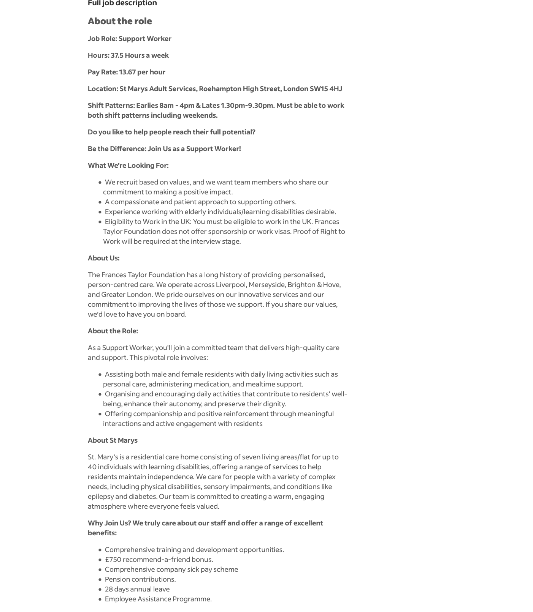
Figure 2 JobAdvert

My Curriculum Vitae
TERHAS SULTAN
39 Prince Avenue, Bedford Crescent, EN3 6UJ
075 38274260 | terhassultan123@gmail.com
Professional Profile
Compassionate and dependable care worker with experience in health and social care, customer service, and person-centred support. Experienced in assisting adults with daily living activities, promoting dignity and independence, and building positive relationships with service users, families, and colleagues. Currently studying Level 4 Health and Social Care and committed to developing a long-term career as a Support Worker. Brings patience, empathy, strong communication skills, and a genuine commitment to helping adults with learning disabilities and complex needs live safely, comfortably, and with respect.
Key Skills
• Person-centred care and support for adults with diverse needs
• Personal care assistance with dignity, respect, and compassion
• Mealtime support and encouraging independence in daily living
• Medication awareness and following care procedures safely
• Strong communication and interpersonal skills
• Empathy, patience, and active listening
• Ability to build trust with residents, families, and colleagues
• Teamwork and collaboration with health and social care professionals
• Observation, reporting, and attention to changes in wellbeing
• Good organisation, time management, and reliability
• Ability to work flexible shifts, including weekends
• Commitment to safeguarding, dignity, equality, and inclusion
Employment History
Care Worker - Hartwig Care Ltd - 2012 – 2014
• Supported clients with daily living activities, including personal hygiene, meal preparation, mobility support, and medication management, helping them remain safe and comfortable in their environment.
• Built positive and trusting relationships with clients and their families through respectful communication, compassion, and consistent support.
• Worked with healthcare professionals and colleagues to help deliver personalised care based on individual needs and preferences.
• Monitored clients’ wellbeing and reported changes in health, behaviour, or care needs promptly and professionally to supervisors.
• Promoted dignity, independence, and emotional wellbeing by encouraging service users to participate in everyday tasks wherever possible.
Optician Support / Optical Assistant - Raj Opticians - 2025
• Supported customers with appointments, enquiries, and orders in a professional and patient manner while maintaining high standards of service.
• Worked closely with the optometrist to respond to patient needs, solve problems efficiently, and provide reassurance where needed.
• Maintained accurate handling of customer information and ensured work was completed in a timely and organised way.
• Developed strong attention to detail, communication skills, and professionalism, which are highly transferable to a support worker role.
Barista - Costa -2022 – Present
• Delivered high-quality customer service in a busy environment, demonstrating patience, communication, and the ability to remain calm under pressure.
• Built rapport with customers from a wide range of backgrounds and created a welcoming, respectful atmosphere.
• Managed tasks efficiently, including teamwork, cleanliness, organisation, and training new team members on procedures and service standards.
• Strengthened reliability, timekeeping, and the ability to work effectively as part of a team during busy shifts.
Education
Level 4 Health and Social Care -St David University Trinity 2025 – Present
Level 2 Childcare in London - Westminster Kingsway College -2015
Level 2 Pre-Access to Nursing - Kings Cross College - 2012
Additional Information
• Interested in building a long-term career in health and social care, especially in roles that support adults with learning disabilities and complex needs.
• Able to work rotating shifts, including early shifts, late shifts, and weekends, in line with the vacancy requirements.
• Understands the importance of compassion, patience, dignity, safeguarding, and promoting independence in residential care environments.
• Enjoys helping people reach their full potential and making a positive difference through practical and emotional support.
Interests
• Health and social care learning and professional development
• Community support and helping others maintain independence
• Team-based work and communication-focused roles
References
References available on request.

Personal Statement
I am an energetic and caring individual with a great desire to work in health and social care, specifically with individuals who have learning difficulties and complicated needs. I am now pursuing Level 4 Health and Social Care at the University of Wales Trinity Saint David, which is allowing me to get a better understanding of person-centred care, communication, safeguarding, and the value of supporting dignity and independence. I am eager to advance my career in a Support Worker capacity, where I can make a positive influence on people's everyday lives.
My former position as a Care Worker at Hartwig Care Ltd provided me with important hands-on experience in assisting patients with personal care, meal preparation, mobility, and medication regimens. This position taught me the value of respecting everyone’s decisions, treating them with decency, and promoting independence. I also worked directly with families and professionals, which taught me the importance of collaboration, clear communication, and providing care that is suited to individual requirements.
In addition to my care experience, my present position as a Barista at Costa has helped me improve my communication, collaboration, and time management abilities. Working in a busy atmosphere has taught me how to remain cool under pressure, be organised, and give polite and respectful service to individuals from all backgrounds. I've also learned patience, dependability, and the capacity to adjust rapidly to changing circumstances. These abilities are particularly transferable to a Support Worker position, where compassion, consistency, and flexibility are essential.
I also worked as an Optical Assistant at Raj Opticians, where I helped customers in a professional and patient manner. This experience helped me enhance my attention to detail, listening skills, and confidence when interacting with persons who may require reassurance or further support. Throughout my job career, I have demonstrated the ability to create trust, collaborate well with others, and respond calmly and appropriately to people's requests.
I feel I would be a great part of your team since I am dedicated to delivering high-quality care and constantly prioritise the needs of others. I appreciate the significance of safeguarding, equality, and fostering a secure and inviting atmosphere in which individuals feel valued and supported. I'm especially interested in a position where I can assist individuals keep their freedom, enhance their well-being, and live with dignity. I am willing to work variable schedules, including nights, weekends, and rotational patterns, which aligns with the requirements of the position. I am also keen to continue learning and honing my skills via training and practical experience. I would appreciate the opportunity to contribute my caring attitude, transferable talents, and commitment to person-centred assistance to your organization.

SWOT Analysis
Strengths | Weaknesses | Opportunities | Threats
I have previous experience working in care, which shows that I understand the responsibilities involved in supporting people in a professional and respectful way. | I may need to build more confidence when dealing with complex needs or challenging situations, especially in busy care settings. | This role gives me the opportunity to develop my skills further through training and hands-on experience. | Working shifts, including weekends and late hours, may be physically and emotionally demanding at times.
I am currently studying Level 4 Health and Social Care, which shows that I am committed to learning and improving my professional knowledge. | I may need to improve my knowledge of some specialist areas, such as supporting people with epilepsy, sensory impairments, or complex learning disabilities. | I can gain more experience working with adults with learning disabilities and complex needs. | Other applicants may have more direct or recent experience in similar support worker roles.
I have strong communication, teamwork, patience, and empathy skills from both care and customer service roles. | Sometimes I may take on too much because I care deeply about helping others, so I need to make sure I manage my own boundaries well. | This job can help me build a long-term career in health and social care. | Stress, fatigue, or a poor work-life balance could affect my performance if I do not manage them well.
I understand the importance of dignity, safeguarding, independence, and person-centred care, which are essential in this role. | I may need to continue developing my confidence in making quick decisions in high-pressure situations. | I can use this role to improve my confidence, safeguarding knowledge, and practical care skills. | Staffing pressures or changes in the workplace could make the job more challenging at times.

Personal Development Plan (PDP)
Goal | Action plan | How I will measure progress | Timeframe
I will improve my confidence in supporting adults with learning disabilities and complex needs. | I will learn from experienced colleagues, observe good practice, and reflect after shifts. | I will need less guidance and feel more confident at work. | 12 months
I will strengthen my knowledge of safeguarding and person-centred care. | I will complete training, read course materials, and practise what I learn. | I will apply safeguarding procedures correctly and understand care values better. | 6 to 12 months
I will improve my communication skills in care settings. | I will practise active listening, clear communication, and calm responses in different situations. | I will get positive feedback from staff and residents. | 1 to 2 years

Gibbs Reflection
Using Gibbs' reflective cycle, I may reflect on my presentation assessment in a disciplined manner and find areas for improvement in future work. Gibbs' approach helps me think about what happened, how I felt, what went well, what didn't, and what I should do next (Gibbs, 1988). It is useful because it converts experience into knowledge and promotes personal growth.
The presentation exam first made me worried since I wanted to speak effectively and create a good impression. I also felt pressure since I knew my instructor would provide criticism on my performance. However, after I started preparing properly, I felt more assured. I practised my slides, reviewed my notes, and attempted to arrange my ideas in a logical way. This allowed me to feel more in control and less nervous.
Overall, I believe my presentation had some positive elements. I spoke about the issue with a clear aim and attempted to keep my explanation short and easy to understand. I also showed dedication by planning ahead of time and working hard to complete the assignment correctly. One excellent aspect of my presentation was that I remained focused and attempted to utilise language suited to the audience. On the other side, I believe I can enhance my confidence, tempo, and eye contact. At times, I may have leaned too heavily on my notes, making me appear less genuine.
After reflecting on the evaluation, I realised that my greatest strength was preparation, while my main shortcoming was delivery. Good reflective practice involves not just detecting mistakes but also understanding why they occurred and how to avoid them in the future. Reflection is especially useful in healthcare and professional education because it helps transform experience into action and progress (Gibbs, 1988).
Finally, this exam helped me identify both my strengths and opportunities for improvement. I discovered that preparing boosts my confidence, but I still need to improve my speaking style and self-assurance. In the future, I plan to use feedback more actively and practise more frequently so that I may do better in presentations and professional scenarios. Gibbs' reflective cycle has helped me perceive the assessment not merely as a duty, but also as a learning opportunity that will benefit my personal and professional development.

Reference List
Ashcroft, J. (2018) ‘How do I prepare a personal development plan?’, The BMJ, 363, k4725. Available at: https://doi.org/10.1136/bmj.k4725
Gibbs, G. (1988) Learning by doing: a guide to teaching and learning methods. Oxford: Further Education Unit, Oxford Polytechnic.
Jasper, M. (2013). Beginning reflective practice. 2nd edn. Andover: Cengage Learning.
McAllister, M. and Madsen, W. (2011). Reflective practice in health and social care. London: SAGE.
Williams, N. (2023) ‘Writing a personal development plan’, Occupational Medicine, 73(6), p. 381. Available at: https://doi.org/10.1093/occmed/kqad037
Yates, B.T. (2024). Reflective practice in healthcare settings. In: Introduction to healthcare knowledge and library services. Cambridge: Cambridge University Press.

