

Name: Iryna Didushok
Student ID: 2436149
Module Code: LCHS4009
Module: Professional Development within Health and Social Care
Lecturer: Amitave Banik

Table of Contents

- Introduction 3
2. Task 1 - CV 3
3. Task 2 - Personal Statesman 6
4. Task 3 - SWOT Analysis and Personal Development Plan 6
3a. SWOT Analysis 6
3b. Personal Development Plan 7
5. Reflective Account Using Gibbs’ Reflective Cycle 8
6. Counclusion 9
7. References 10

- Introduction

This portfolio is focused on my preparation for a role in the health and social care sector, specifically as an Aesthetic Therapist. It presents my current skills, experience, and areas for development in relation to this role.
The document includes a CV, a personal statement, a SWOT analysis, a Personal Development Plan (PDP), and a reflection based on my presentation. Each section is designed to show my understanding of the job requirements and my ability to develop professionally.
This portfolio also demonstrates my ability to reflect on my performance and identify clear steps for improvement in the future.

2. Task 1 - CV

Curriculum Vitae
Name: Iryna Didushok
Phone: 07425710146
Email: irynadidushok23@gmail.com

Personal Profile
I am a qualified Aesthetic Therapist with a background in nursing and practical experience in aesthetic treatments. I have worked in different clinics where I performed laser hair removal, skin treatments, and assisted doctors. I am confident working with clients and always follow hygiene and safety standards. I am motivated to continue developing my skills in the aesthetic field.

Education
Secondary School Education — Ukraine (2005–2015)
Completed 11 years of general secondary education (equivalent to GCSEs and A-Levels in the UK).
Medical College, Ukraine (2015 – 2019)
Diploma in Nursing.

Private Medical School — Ukraine (2016–2018)
Diploma in Medical Aesthetics and Cosmetology.

London Aesthetic Academy — UK (2023–2024)
QUALIFI Level 4 Certificate in Laser Hair Removal.

Moda Donna Academy — London, UK (2024)
VTCT Level 2 & Level 3 in Beauty Therapy
CPD Masterclasses in Aesthetic Treatments Phlebotomy Training

University of Wales Trinity Saint Davide— London, UK (2025 - 2026)
Health and Social Care

Work Experience

Aesthetic Therapist
Innoderm Clinic 2025 – Present
Perform laser hair removal treatments.
Assist with pigmentation and vascular procedures.
Provide consultations and skin analysis.
Maintain hygiene and safety standards.

Aesthetic Therapist
Victoria Aesthetic Clinic 2024 – 2025
Performed facials, chemical peels, and skin treatments.
Assisted doctors during procedures.
Gave aftercare advice to clients.

Aesthetic Therapist
Moda Donna Clinic, London 2023 – 2024
Carried out treatments and consultations.
Built good relationships with clients.
Kept accurate client records.

Key Skills

Clinical support: basic patient care, vital signs monitoring, assisting physicians, maintaining medical records
Aesthetic procedures: laser treatments, skin rejuvenation, non-invasive cosmetic techniques, post-treatment care
Injections experience: phlebotomy, mesotherapy, PRP (preparation and assistance)
Patient communication: clear explanations of procedures, consultations, building trust with patients, emotional support
Organisation: time management, attention to detail, infection control, maintaining a safe clinical environment
Teamwork: ability to work in multidisciplinary teams and adapt quickly to new clinical settings

Languages
Ukrainian – Native
English – B2
Italian – Intermediate
Polish – Intermediate

Interests
Skincare and aesthetic treatments, maintaining a healthy lifestyle, fitness, and continuous professional development within the beauty and healthcare industry.

References
References are available upon request

3. Task 2 - Personal Statesman

I am applying for the position of Aesthetic Therapist because I want to continue developing my career in the health and social care sector. I am especially interested in aesthetic treatments, as this field combines medical knowledge with practical skills and communication with clients.
I have a diploma in nursing, which I completed in Ukraine. During my studies, I learned about anatomy, hygiene, and patient care. This helped me to understand how to work safely and professionally. After that, I moved into aesthetic therapy and gained practical experience in different clinics.
I have worked in clinics in London where I performed laser hair removal, facial treatments, and assisted with more advanced procedures. I also worked with clients directly, providing consultations and explaining treatments. This helped me develop strong communication skills and confidence when working with people.
One of my strengths is that I can build good relationships with clients. I understand that clients need to feel comfortable and safe during treatments. I always try to explain procedures clearly and give correct aftercare advice. I also follow hygiene rules carefully, which is very important in this type of work.
I am also organised and able to work in busy environments. In clinics, I often needed to manage time well and work with different clients during the day. I can stay focused and complete my tasks professionally.
At the same time, I understand that I still need to improve some areas. English is not my first language, so sometimes I find it difficult to explain complex ideas in detail. However, I am working on this and improving my communication every day through practice.
I believe I can be a valuable employee because I have both medical knowledge and practical experience. I am responsible, motivated, and willing to learn. My goal is to continue improving my skills, learn new treatments, and provide high-quality service to clients.

4. Task 3 - SWOT Analysis and Personal Development Plan

3a. SWOT Analysis

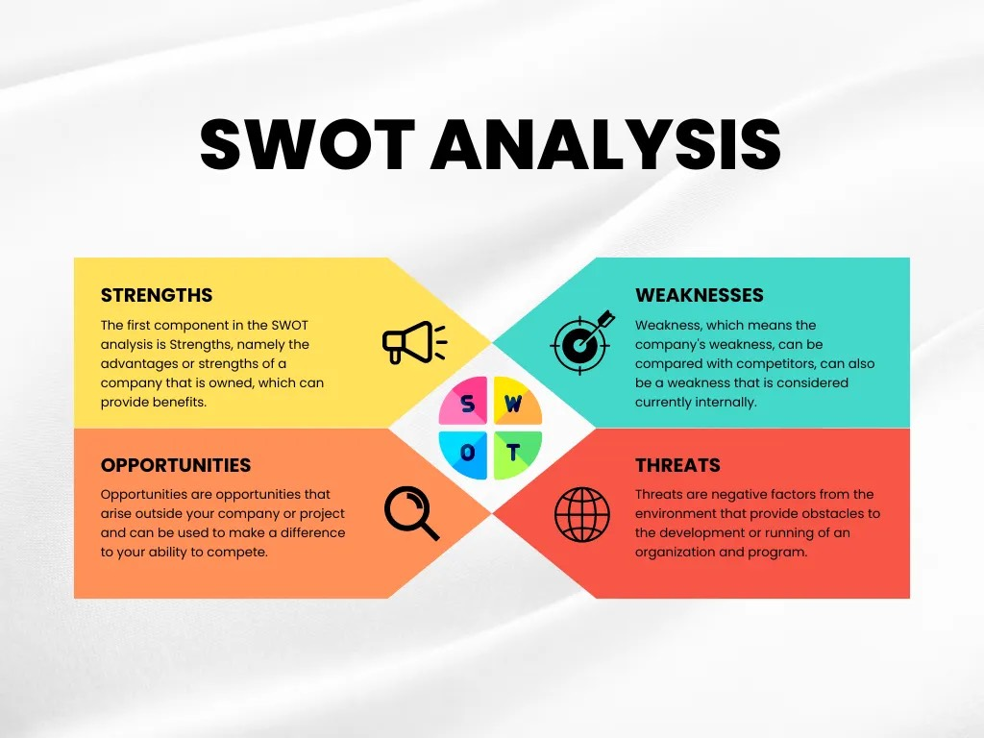
Picture: Samsulliwan (2022)

My strengths include practical experience in aesthetic treatments and a nursing background, which support my understanding of clinical practice and patient care (Skills for Health, 2021). I also have good communication skills with clients and a solid understanding of hygiene and safety standards, which are essential in a clinical environment (Health and Care Professions Council, 2023).
My main weakness is the English language barrier, which sometimes limits how clearly I can express more complex ideas. I also feel less confident when speaking in formal or assessed situations, especially when I need to explain detailed information (NHS, 2022). There are several opportunities for my development. The aesthetic industry continues to grow, which increases demand for skilled professionals. I also have the opportunity to take additional courses and training to improve my knowledge and support my career progression in clinics (Indeed, 2024).
However, there are also threats that may affect my development. The industry is highly competitive, and employers often expect strong clinical and communication skills. In addition, a higher level of English is required in many workplaces, which means I need to continue improving my language ability (NHS, 2022; Skills for Health, 2021).

3b. Personal Development Plan

My first goal is to improve my English communication skills. I will achieve this by practising speaking every day and attending English classes regularly. This is a long-term goal that I plan to develop over the next 1–2 years. Improving communication in healthcare settings is essential for safe and effective patient care (NHS, 2022). I will monitor my progress by noticing increased confidence when communicating with clients and colleagues, as well as improved fluency in professional situations.
My second goal is to improve my confidence in presentations. To develop this skill, I will practise delivering presentations more often and try to speak in front of others whenever possible. I plan to work on this over the next 6–12 months. Reflective practice can support the development of communication and presentation skills through continuous self-evaluation (Bolton, 2018). I will evaluate my progress through feedback from teachers and by reflecting on my own performance after each presentation.
My third goal is to develop new skills in aesthetic treatments. I will do this by attending professional courses and training sessions to expand my practical knowledge. Continuous professional development is an important part of maintaining safe and effective practice in healthcare-related roles (Skills for Health, 2021). This is a goal for the next 1–2 years. I will measure my progress by completing certifications and gaining the ability to confidently perform new procedures in a clinical environment

5. Reflective Account Using Gibbs’ Reflective Cycle

The presentation was part of my assessed academic work on the topic of critical thinking in health and social care, where I was required to prepare a topic, design supporting slides, and deliver a structured oral presentation within a limited time. In addition to presenting, I also had to respond to questions from the lecturer, which required a clear understanding of the subject and the ability to communicate effectively under pressure (Bolton, 2018).
Before the presentation, I felt nervous, although this nervousness was less intense compared to my previous speaking experiences. I had already prepared my materials and understood the topic well, which helped reduce anxiety. Once I started speaking, I gradually became more focused on the content rather than my stress. As the presentation continued, I felt more confident because I was able to follow my structure and explain the key ideas clearly. Overall, I felt that I managed to communicate my points at a good level, even though there was still some internal pressure.
In general, I consider my presentation to have been successful. I demonstrated a clear understanding of critical thinking in health and social care and was able to explain the main points in a structured way. I also did not rely heavily on reading from the slides, which made my delivery more natural and helped me maintain better engagement. This was an improvement compared to my earlier presentations, where I was more dependent on written notes. However, I also identified several challenges during the task. The most significant difficulty was the language barrier, which limited my ability to fully express more complex ideas in English. Although I understood the content well, I was not always able to explain everything in detail within the time available. The time limit itself also added pressure, as it required me to focus on completing the presentation rather than expanding my explanations (NHS, 2022). Another challenge occurred during the question-and-answer part of the presentation. When the lecturer asked me a question, I did not understand it immediately, which caused a brief moment of confusion and reduced my confidence. After the question was repeated and clarified, I was able to understand it properly and provide a correct answer. This situation showed that my knowledge of critical thinking in health and social care was sufficient, but my listening comprehension in academic English still needs improvement, especially in real-time situations.
Reflecting on this experience, I recognise that my performance was influenced mainly by language processing and time management. Because English is not my first language, I often need extra time to form sentences and organise my thoughts before speaking. This affects how detailed and fluent my explanations can be. In addition, working within a strict time limit made it more difficult to fully develop my ideas, even though I had the necessary knowledge (Skills for Health, 2021). Despite these challenges, I am satisfied with my overall performance. I believe I showed progress in confidence, organisation, and understanding of the topic. This presentation was an improvement compared to my previous experiences, particularly in terms of reduced anxiety and better structure in my speech. At the same time, it clearly highlighted areas that require further development, especially in academic English communication, spontaneous speaking, and responding to questions more confidently.
In future presentations, I will focus on improving my spoken English through regular practice in professional contexts. I also plan to rehearse presentations more thoroughly to improve structure, timing, and clarity. Additionally, I will work on developing my listening skills and ability to respond more naturally to unexpected questions. These steps will help me become more confident and effective in academic and professional communication settings (Gibbs, 1988).

6. Counclusion

This portfolio shows my current skills, experience, and areas for development in relation to the role of an Aesthetic Therapist. It includes a CV, personal statement, SWOT analysis, PDP, and a reflection on my presentation.
Overall, I have demonstrated relevant clinical knowledge and practical experience, supported by my nursing background. The work also shows that I am developing my communication skills and professional confidence.
At the same time, I identified key areas for improvement, especially in academic English, speaking confidence, and presentation skills. I have set clear goals to support my future development in these areas.
In general, this portfolio reflects my progress and my commitment to improving within the health and social care field.

7. References

Bolton, G. (2018) Reflective Practice: Writing and Professional Development. 5th edn. London: Sage.
Gibbs, G. (1988) Learning by Doing: A Guide to Teaching and Learning Methods. Oxford: Oxford Polytechnic.
Health and Care Professions Council (HCPC) (2023) Standards of Conduct, Performance and Ethics. Available at: https://www.hcpc-uk.org (Accessed: 14 April 2026).
NHS (2022) Working in Health and Social Care. Available at: https://www.nhs.uk (Accessed: 10 April 2026).
Indeed (2024) Aesthetic Therapist Job Description. Available at: https://www.indeed.com (Accessed: 7 April 2026).
Samsulliwan, M. (2022) SWOT Analysis: Definition, Benefits, and Effective Implementation for Business Products and Brands. Medium. Available at: https://medium.com (Accessed: 14 April 2026).

Skills for Health (2021) Core Skills Framework. Available at: https://www.skillsforhealth.org.uk (Accessed: 14 April 2026).

