PROJECT MANAGEMENT.

STUDENT: MBONGO MBIMBA.

STUDENT NUMBER: 1602985.

LECTRURER: MOLLY.

Table of Contents

INTRODUCTION 3
SCOPE OF THE PROJECT 3
GOALS OF THE PROJECT 3
OBJECTIVES OF THE PROJECT 3
REQUIREMENTS OF THE PROJECT 4
DELIVERABLES OF THE PROJECT 4
WORK BREAKDOWN STRUCTURE 5
RISK FACTORS 5
PROJECT ORGANIZATIONAL STRUCTURE 6
STAKEHOLDER ANALYSIS 7
PROJECT SCHEDULE 8
PROJECT CONTROL MECHANISMS 8
PROJECT PLANNING 8
BUDGET ASSUMPTIONS 8
REFERENCES 8

INTRODUCTION

The term project management can be defined as achieving goals of a project within an appropriate time, articulated scope, quality management and budget (Meredith and Mantel, 2011). It also involves analyzing the risks that might be encountered during carrying out the operations of the project. Project management enable an individual to effectively sort out the factors that might affect the operations of the project and analyze the consequences accordingly. This report is based on the initiation of the project of “Dancing Competition” that would take place in University of Wales TSD.
This report outlines and discusses the project plan of the dancing competition, the objective and schedule of the programme. The event is planned in order to bring entertainment for the University students which would help in releasing the stress that is caused by the continuous assessments. In this event, about 25 individuals can participate either in groups or individually from which only 3 winners would be announced.

SCOPE OF THE PROJECT

According to Cleland and Ireland, (2006) project scope allows an individual to create the objectives and goals of the project and motivate the team members to be goal-oriented in order to attain completion and success of the project on time.

GOALS OF THE PROJECT

The core purpose of this project plan is the organizing and scheduling the TSD dancing competition which would enable the students to entertain themselves either by participating or as audience. The event would also allow some relief in the atmosphere of university which is often in distress due to the continuous study and assessments.

OBJECTIVES OF THE PROJECT

The formulation of the objectives allow the project managers to clarify the purposes of the project to the team members and stakeholders and enables to have a better insight to the activities of the project. The project objectives are designed using the SMART technique. Following are the objectives which are required to be fulfilled within the given time of the project. These objectives would be carried out only after the approval of the project from the principal.
- The first and foremost objectives is to get the participants register for the competition which would be done by distributing flyers and making announcements. This would be done within the scheduled time for this objective.

- Second objective is viewing the registrations and announcing the auditioning dates and carrying out the auditions.

- Third objective is to finalize which participants would perform in the show.

- Fourth objective is preparation for the event which includes the preparation and designing of stage, gathering the required equipment, arranging and testing of sound systems.

- Fourth objective is to judge the participants and carrying out their performances within the scheduled time.

- Fifth and last objective of the project is announcement of winners by proper judgment. Also, celebrating the success of the project.

REQUIREMENTS OF THE PROJECT

It is important for the manager of the project to make list of all possible requirements and backup systems (Wysocki, 2011). The requirements of the project are given as under:
- Flyers for event promotion
- Sound system for the event
- Microphones for hosts and judges
- Stage equipment for stage decoration
- Arrangement for sitting area
- Arrangement of spotlights
- Photographer

DELIVERABLES OF THE PROJECT

According to Gido et al., (2014) the deliverables of the project are the results that are obtained by the whole project, they determine the success of the project. The deliverables of the dance competition at TSD includes the experience of project management, event management, control and command on team members, effective leadership and means of entertainment.

HUMAN RESOURCES
The people who create the workforce of an organization and tend to work for the benefit of the organization. The HR are dealt by the managers of the organization who make several efforts to effectively and strategically manage the workforce, analyze the performances of the employees by various means, work for the employee benefit, recruitment process and talent management of employees. The project managers are also responsible for dealing the information management in the human resources. By the management of HR, the focus of the workforce sharpens and becomes oriented towards the goals and motives of the organization.
In case of this project, the project manager has a tendency to select the group members accordingly to assign different responsibilities of project to them. Also, then the project manager would observe the performance of the team members to make sure they are carrying out their responsibilities up to the required standard or not. If any performance issues occur, the manager himself is responsible to address those issues and dismiss the team member on the basis of performance. Human resource practices are vital for the manager to implicate into the project as it would organize and arrange the working in the easiest and goal-oriented as possible.

WORK BREAKDOWN STRUCTURE
According to Shields and Rangarajan, (2013) the work breakdown structure is enunciated by the project manager which helps the members of the team to develop understanding of those operations which are assigned to them and also having insight of the objectives so that they can be goal-oriented. The tasks are divided according to the capability of the team members who has best set of skills to carry out those tasks. It doesn’t only develop team building but also aids in effective communication by sharing knowledge throughout the project. In the work breakdown structure the tasks and objectives are sub divided that a way which would lead in completion of all the tasks in the given time. Following is the WBS of the dance competition:
- First and foremost task for the project manager is to get approval of the project idea and take permission from the principal of the University (1 day)

- Gathering participants and promoting the events by distribution of flyers (15 days)

- Preparing the budget and collecting it from University (2 days)

- Gathering the required equipment for the event (10 days)

- Preparation of the stage (2 days)

- Sitting arrangement for judges, audience and participants (2 days)

- Arranging photographer for the event (2 days)

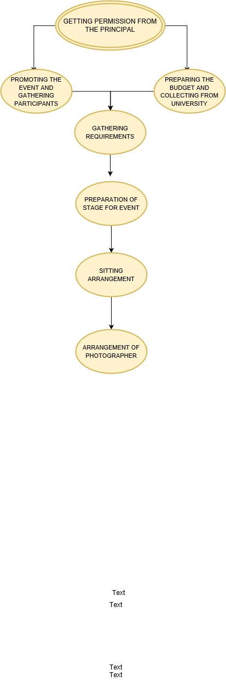

RISK FACTORS

Fuller et al., (2010) states that while carrying out a project, there are possibilities that unintentional incidents might occur and that’s the reason risk analysis is carried out. It is the responsibility of the project manager to analyze the project operations from different dimensions in order to analyze all the risks in a proper manner. The analysis of risk factors helps in taking necessary measures that are possible to perform the risk management. If the risks are not managed properly, it can cause a lot of issues for the project managers and the team members such as delay in the project completion and no achievement of goals and objectives (Rose, 2013).Further are the risks identified of this project which would be attempted to manage accordingly in order to deliver the project objectives accordingly.

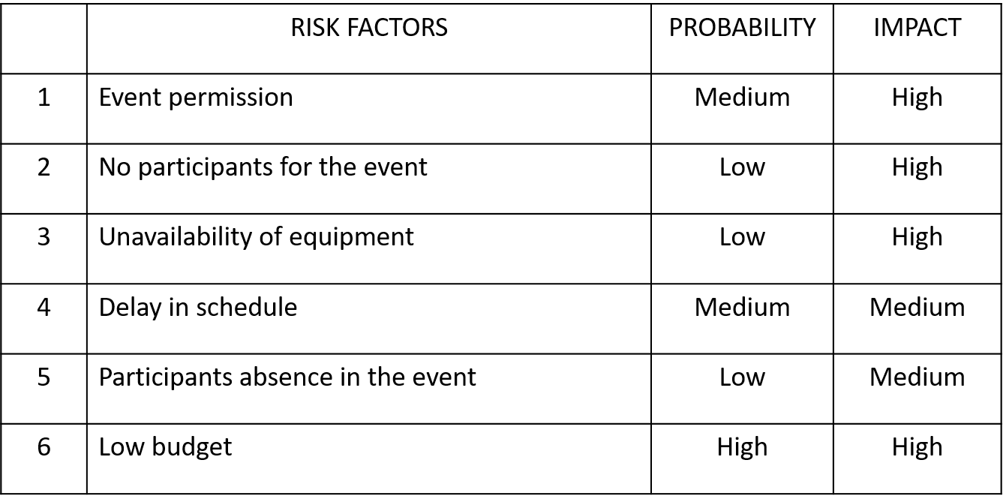
Risk analysis for Dancing Competition
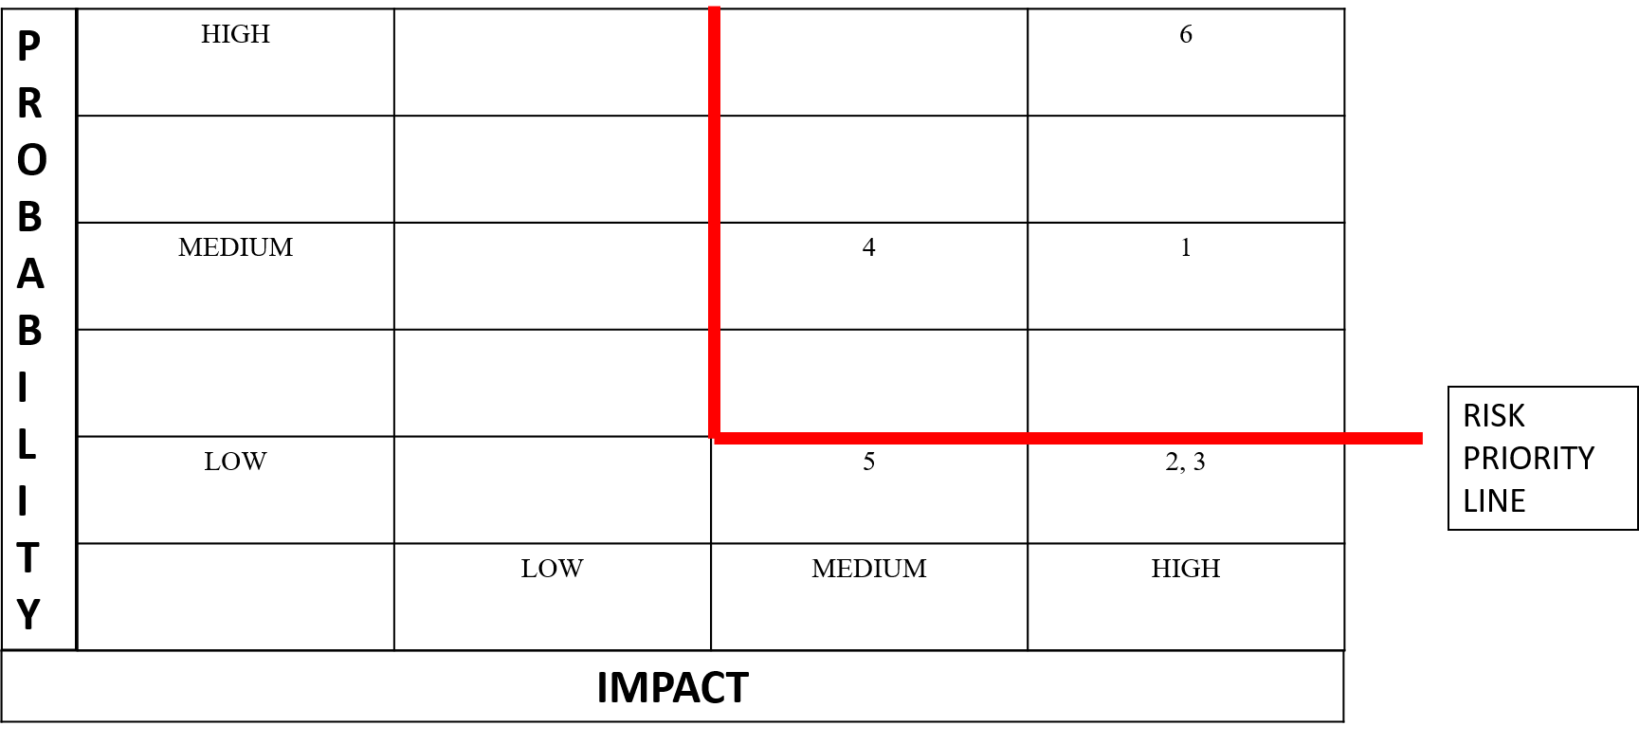
Risk priority graph for the dancing competition
For those risks which have high rates of affecting the operations of the project, the contingency plan has been prepared by the team managers in order to evaluate these risks:
For risk no. 1: The event permission is necessary before beginning the project, in case the permission is declined by the principal the idea would be modified and the benefits of this project would be presented to acquire permission.
For risk no.8: As the budget would be assumed before the beginning of the project but in case of any issues, a meeting with the team members would be carried out time to time in order to make sure there would be no issues created related to the cost.

PROJECT ORGANIZATIONAL STRUCTURE

The project is extremely affected by the organizational structure that is designed (Rose, 2013). It is necessary to prepare the organizational structure as it would allow the presentation of line of authority and would determine who is in command (Conforto and Amaral, 2010). The manager of the project is the main leader who maintains and manages all decisions that are made as well as the tasks that are to be carried out.
First the organizational flow of this project begins with the main corporate i.e. the principal on whom this project approval depends and then the process, procedure and planning of the project is presented to the executive and other stakeholders. The project manager can also modify and make changes in the project with approval and has also much authority to change the team members by the judgment of their performances. The representation of the line of authority helps in reducing the conflicts which are possible to be created at the time of decision making. As decision making is a critical process, the project manager is the one who decides what happens in the project and what changes and modifications should be made. Effective management requires the project manager to gather the ideas of the team members by the help of effective communication which can lead to better results of the project and also create enthusiasm in the project members. Thus, the project organizational holds extreme value towards the process of project management and its completion. Following is the organizational structure for the project of dance competition TSD.
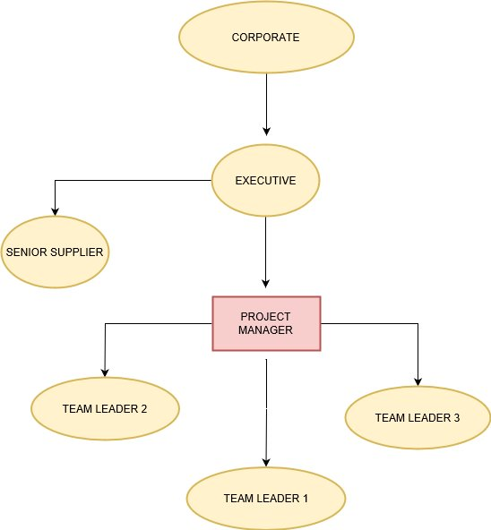
ORGANIZATIONAL STRUCTURE FOR DANCING COMPETITION

STAKEHOLDER ANALYSIS

According to (Conforto and Amaral, 2010) stakeholders are those people who show interest towards the project or are involved or have influence on the project operations. Rose, (2013) describes stakeholders of the project as those people who are effected in any way by the failure or success of the project. The stakeholders of this project may include participants, judges, suppliers, team members and managers of the project. Also, stakeholder analysis enables the project manager to identify which stakeholder has high, medium or low intensity of power and interest. This analysis also allows to effectively manage the stakeholders according to their level of power or interest. A project or organization cannot process without the stakeholders as if there would be no stakeholders of the project, there would be no benefit to the organization. Regarding this project, as the venue of the dance competition is the University which enhances the power and interest of the principle because it completely depends upon the decisions of the principle regarding the project. Moreover, other stakeholders of this project includes the judges of the event that are requested and invited to the university event in order to observe and judge the participants. If the judges are not present during the event, that can be highly effective for the dance competition as the performances of the participants wouldn’t be judged and the other stakeholders i.e. the audience would start losing its interest in the event.
Thus, the stakeholders are analyzed in a thorough way and their power as well as interest is noted towards the project. According to the table presented below, each stakeholder would be dealt according to their gravity of power and depth of interest in the project.
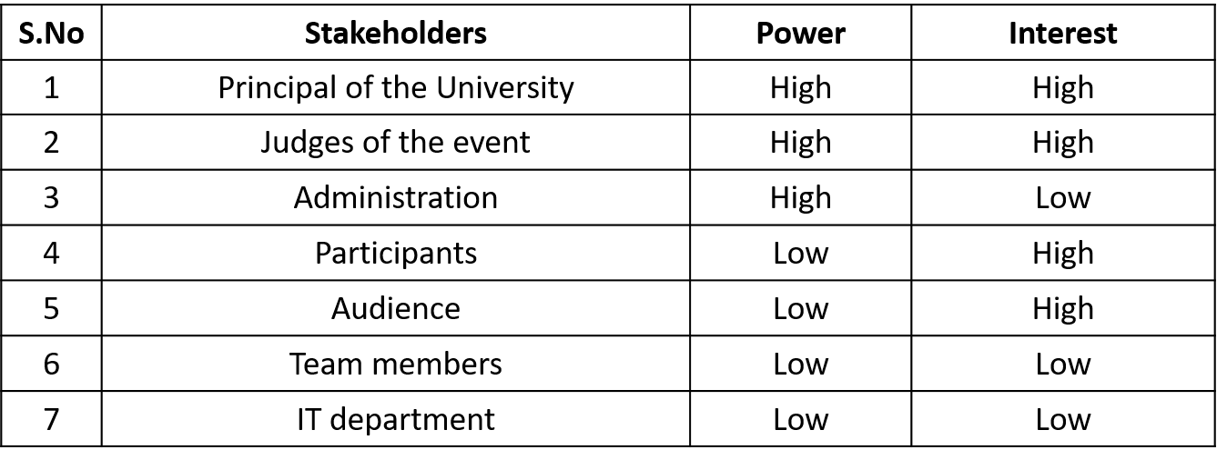

Table showing interest and power of Stakeholders
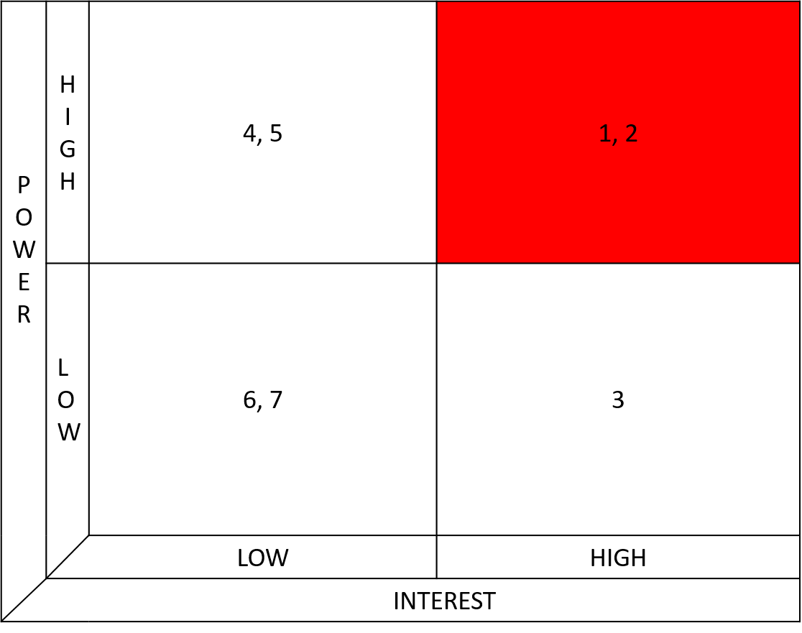

REPORTING FRAMEWORK

To ensure the stakeholders that the project is going smoothly or according to the schedule, reporting is highly essential. Reporting framework of stakeholders allows the project manager to be attentive of the level of attention required by each stakeholder. It doesn’t only enhances the stability of the project but also aids towards the better performance of the project. When the stakeholders are being informed time to time regarding all the activities, updates and challenges being faced in the project, it helps them in developing understanding towards the objectives of the project and clears the perception of the project in their minds. Also, by creating a reporting framework, project manager can have an organized way of dealing with all the stakeholders within the given duration of time leading towards the achievement of objectives of the project.
In this project, the stakeholder’s importance that is measured by the power interest graph is utilized as an important tool in order to handle each of the stakeholder according to their requirement. There would be a time frame designed for each stakeholder by which it would be known to the project manager what, when and how to report to each stakeholder.
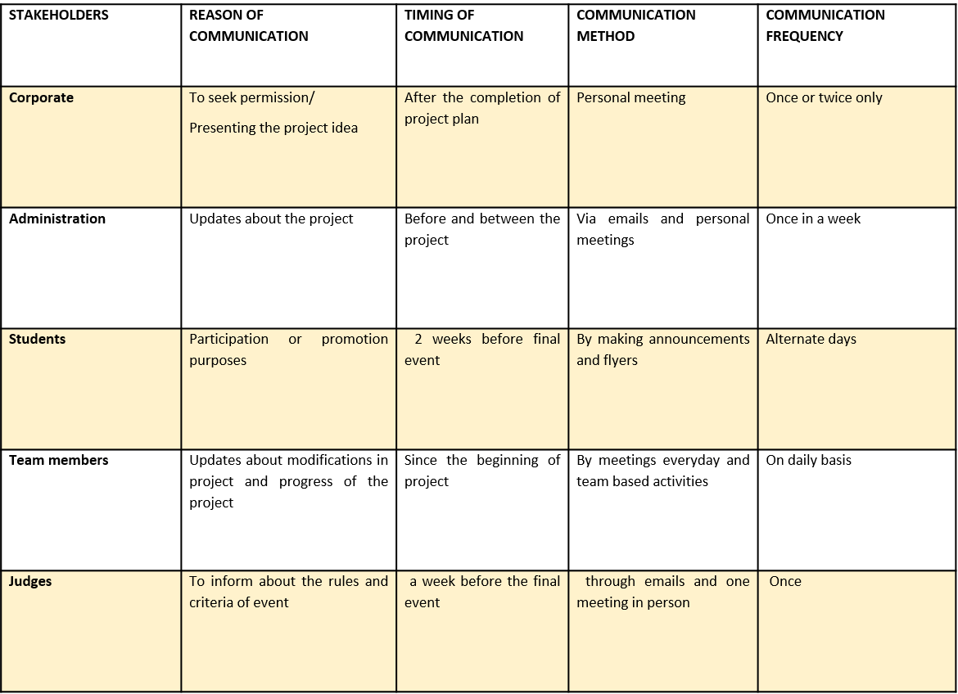

PROJECT SCHEDULE

According to Steyn et al., (2016) the project is said to be highly successful when there are no delays in the schedule and each tasks is performed in the provided duration of time. Completion of the project on the given time is not only beneficial for the project operatives but also for all the stakeholders. In project management, preparing a structured schedule aids in making list of the activities, milestones and the deliverables which have both the initiation and completion dates provided. Also, Gantt chart has been used in order to represent the schedule of the project.
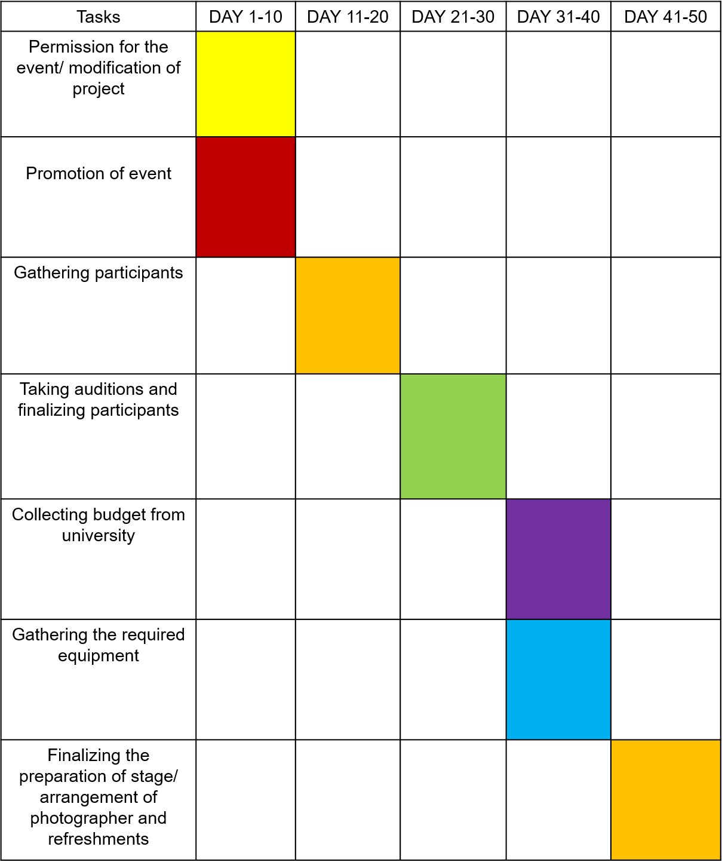
Gantt chart for the dance competition

PROJECT CONTROL MECHANISMS

The project control mechanisms are the fundamental tools which helps the project manager to reduce the gap that is present between the planning of the project and its execution. It is designed in order to achieve the aims and objectives of an organization in a proper way including the management of time, cost and the content. Project control mechanisms tend to handle the most important aspects of the project management. Each category that can affect the performance of the project are dealt separately according to their degree of effectiveness over the project.
In this project, each category is maintained in an organized manner such as maintenance of supplies, equipment, participants, judges and schedule. Several project control tools are being used in this project for measuring and maintaining the mechanisms. Furthermore, appropriate planning process leads towards the efficient performance in the project. If the key areas of the project aren’t identified, they might cause failure in the project management.

COST ASSUMPTIONS

Cost assumptions are made in order to make assumptions of the budget that would be utilized within the project. By making these assumptions project manager gets enabled to prevent the over budgeting in the project and the project cost is managed effectively.

 | COST | AMOUNT
1 | Supplies for event | £250
2 | Prizes and awards | £200
3 | Event promotion | £100
4 | Refreshments and decoration | £150
 | Total assumed cost | £700

cRITICAL PATH

Critical path management (CPM) is primarily used in order to lead the projects towards completion on the provided schedule. A path is created which helps interrelating those tasks that depend upon each other and that a way a fastest way to deliver the project operations is created. Also, by the help of the critical path analysis the chances to attain goals of the organization on the schedule maximizes.
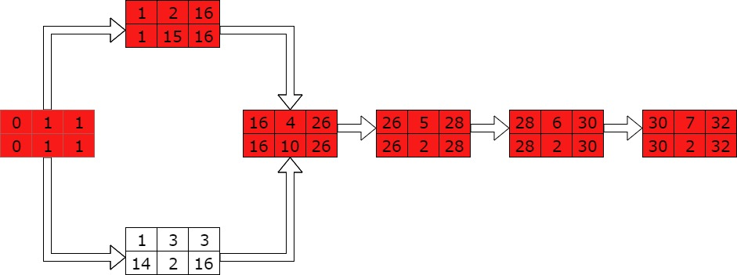

This diagram identifies the critical path which is derived by showing the forward and backward passes in the project timeline. It shows what path can be the longest for project duration.

REFERENCES

- Cleland, D.L. and Ireland, L.R., 2006. Project management. McGraw-Hill Professional.
- Conforto, E.C. and Amaral, D.C., 2010. Evaluating an agile method for planning and controlling innovative projects. Project Management Journal, 41(2), pp.73-80.
- Fleming, Q.W. and Koppelman, J.M., 2016, December. Earned value project management. Project Management Institute.
- Fuller, M., Valacich, J. and George, J., 2010. Information systems project management: A process and team approach. Prentice Hall Press.
- Gido, J., Clements, J. and Clements, J., 2014. Successful project management. Nelson Education.
- Meredith, J.R. and Mantel Jr, S.J., 2011. Project management: a managerial approach. John Wiley & Sons.
- Rose, K.H., 2013. A Guide to the Project Management Body of Knowledge (PMBOK® Guide)—Fifth Edition. Project management journal, 44(3).
- Shields, P.M. and Rangarajan, N., 2013. A playbook for research methods: Integrating conceptual frameworks and project management. New Forums Press.
- Steyn, H., Dekker, A.H., Kuschke, B., Van Eck, B.P.S. and Visser, K., 2016. Project management: A multi-disciplinary approach. FPM Publishing.
- Wysocki, R.K., 2011. Effective project management: traditional, agile, extreme. John Wiley & Sons.

