Party Hard

INTENDED PLATFORMS | PC (Steam), Playstation4, Xbox One, Nintendo Switch, Mobile (IOS, Android)

TARGET AGE / DEMOGRAPHIC OF PLAYERS
Demographic: Male and female gamers aged 16-35.
Age Rating: ESRB Mature 17+ / PEGI 16 (Due to violence, gore and alcohol / drugs misuse).
Psychographic: Designed for fans of tactical stealth games (Hitman), fast paced action (Hotline Miami) and dark humour qnd players who like puzzle solving and pixel art aesthetics.

INTENDED PEGI / ESRB RATING
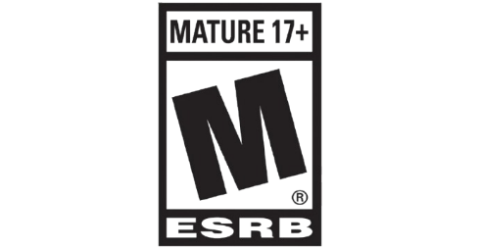
Content is generally suitable for ages 17 and up. May contain intense violence, blood and gore, sexual content and/or strong language.


This rating is applied once the depiction of violence (or sexual activity) reaches a stage that looks the same as would be expected in real life. The use of bad language in games with a PEGI 16 rating can be more extreme, while the use of tobacco, alcohol or illegal drugs can also be present.

CONTRIBUTING TEAM MEMBER: | Olcay Sivas

SECTION 2: GAME OUTLINE

GAME STORY SUMMARY
The story of the game follows a man named Darius who only wants to get to sleep at 3 am. Unlike a hero, he instantly snaps and decides to kill everyone in the very loud party next door. This action triggers something in him and it spreads countrywide just like a virus. He starts to travel across the country and join other disturbing parties (e.g. roof parties, casino parties, yacht parties etc.) to silence everybody in there. The plot is framed by Detective John Vest years later recounting the Party Hard Killer’s crimes.

GAME FLOW
Party Hard follows a linear and a level-based progression. Interrogation style short cutscenes sets the context and the player spawns in a semi procedural map which leads to traps in the map which changes location every time player spawns. The gameplay loop is followed by identifying the targets, then either setting traps to attract them into it or stabbing them quietly and then hiding/disposing bodies and evading the police. The win condition of the game is killing all the NPC’s in the map without getting caught by the police and the progression goes by score table which encourages player to make combos and unlock new characters and levels.

CONTRIBUTING TEAM MEMBER: | Olcay Sivas

SECTION 3: MAIN CHARACTER(S)
& PLAYER CONTROLS

CHARACTER APPEARANCE
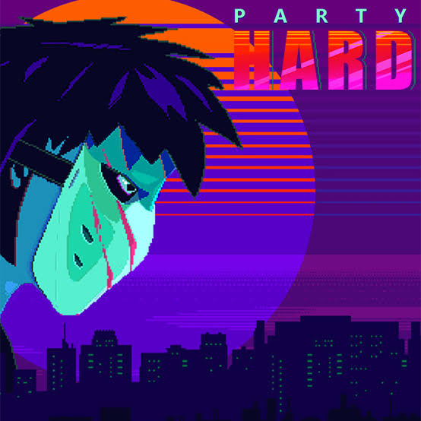
Darius The Party Hard Killer’s design seems to be inspired by “Slasher Villain” archetype of 1980’s horror cinema.
He wears a blue boiler suit which resembles a janitor’s uniform to imply a working-class background to the character. His face is completely covered by a hockey mask which inspired by “Jason Voorhes” and shows the player that he doesn’t show any emotions while slashing party anticipators, he is dehumanized and he has lack of sympathy. The character’s sprite is compact and unassuming which helps him to get in crowds unrecognized and stay between them until he does what he came for. Due to show the player his anti-social sociopath personality, his animations are designed as awkward and stiff.

CHARACTER DOSSIER / DETAILS (Add/adjust categories as appropriate)
NAME: | Darius (The Party Hard Killer)
GENDER: | Male
SPECIES: | Human
AGE: | Estimated Mid 30’s
FACTION: | Independent
KNOWN ASSOCIATES: | None (Solo Serial Killer)
PSYCHOLOGICAL PROFILE: | Hypersensitivity to noise and suffers from severe insomnia. Extreme violent outburst caused by lack of sleep.
CRIMINAL STATUS: | Wanted for mass homicide across the country
MOTIVATION: | Obtain peace and quiet no matter what costs.
SIGNATURE WEAPON: | Short Blade Combat Knife

CHARACTER’S BACKSTORY
The story begins at 3am in the middle of the morning in USA. Darius is a very tired man and most probably back from work again and has to deal with loud neighbours having a party. Walking through between reality and hallucination due to lack of sleep Darius snaps. Instead of getting help from authorities he decides to end this nightmare all around the country by himself.
This backstory has direct effect on gameplay loop. Darius is not a well-trained soldier or high skilled ninja. He is just a normal person but has anger issues. That explains why he doesn’t want to fight police and try to evade them all the time, so he kills his victims by relying on stealth, traps and his knife instead of a noisy gun. His motivation is silencing the party, and it feeds the win condition which is that the level only ends when noise stops (everybody dies). The narrative is shaped trough a retrospective examination of a detective (John Vest) adding a “True Crime” documentary feeling to the events.

CHARACTER CONTROLS / PLAYER CONTROLS
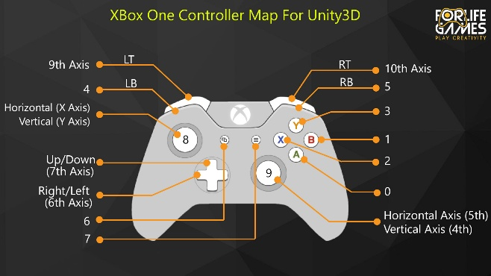
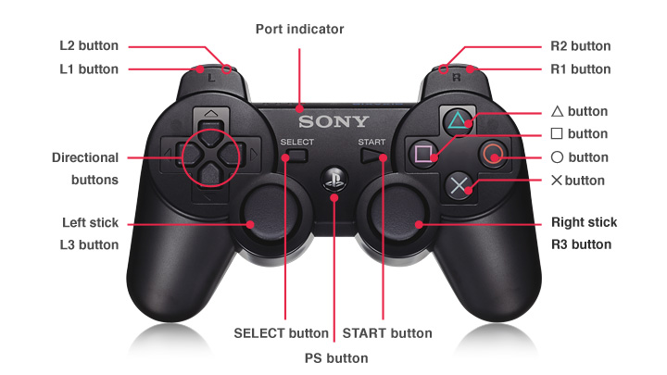
Left Stick: Move Character
A (Xbox) / X (PS): Use trap / Interact (Sabotage objects)
X (Xbox) / Square (PS): Stab / Kill
B (Xbox) / Circle (PS): Pick up / Drop body
Y (Xbox) / Triangle (PS): Dance (Blend in ability)
LT (Xbox) / L2 (PS): Sprint
RT (Xbox) / R2 (PS): Listen Mode (Highlights interactable objects)
Start (Xbox) / Options (PS): Pause Menu

CONTRIBUTING TEAM MEMBER: | Olcay Sivas

SECTION 4: GAMEPLAY

SEQUENCE OF PLAY
1: Camera / Perspective:
The camera type is 2d and top down with isometric hybrid. And the camera is mostly static, and frames mostly shows the house and the party on a single screen. This perspective gives player multiple choices and sections which are the player can see the victim in the kitchen and cop at the door and the traps in the living room at the same time so player can render multiple choices in their mind.

2. Core Gameplay Mechanics:
Stealth: NPCs has limited field of view which is when player kill a victim in their view they get in panic mode and try to run and call police.

The Suspicion Meter: When a player kills someone and if an NPC sees that they gain suspicion which raises the suspicion meter and when suspicion meter is full the police chase begins until the player get arrested.

Body Disposal: The player can pick up dead bodies of partygoers which slows the character down and hide them in specific containers picked up bythe game randomly. Hiding a body lowers thechance of police caught.

Dancing: Pressing the dance button will put character in a dancing mode which allows character to blend in at a party with the party goers and basically hides the character from being seen by police. While dancing near other partygoers the suspicion level decreases.

Stamina: The player can sprint to escape police but sprinting decreases the stamina bar and when the stamina bar is empty the player extremely slows down and that makes arrest almost guaranteed.

3. Gameplay System (AI):
NPC Behaviour: NPCs walk randomly in random directions and if they witness a murder they start to run to the telephone to let the police know about it.

Police Behaviour: When get called police arrives and put body bag to the dead body. If the police sees the player while player is suspect a chase begins. Police runs faster then player which forces player to run trough shortcuts which can be broken windows or passages.

UNIQUE SELLING POINTS (USPs)
Twitch / Kick Integration: Party Hard comes with unique feature called chat integration which allows chatters in livestream vote for random events to happen while a streamer plays the game such as spawning a bear or calling SWAT team. This gives more excitement to both chatters and streamers because there will be more random events and they feel like they all playing together.

Semi Procedural Replayability: The game map is static but the placement of the traps and NPC routes changes on every restart which allows the player to make more complicated and fun trap plans and tactics instead of just trying to memorize the perfect path for the map.

Mass Stealth Gameplay: Most of the similar games focus on the eliminating one important target and escape from the map but Party Hard comes with a feature called mass stealth which is trying to kill a group without being seen by anyone and don’t stop until everyone dies. This requires crowd control and social stealth mechanics which makes game different then the similar games.

Dynamic AI Events: The random events happens in the game which changes the game flow such as pizza deliveries, drug deals and robbers entering the party. This mechanic makes the game more fun and makes player feel like every other run is different and unique.

PLATFORM-SPECIFIC FEATURES
PC (Steam):
Twitch / Kick Integration: Full API support for chat voting and interaction.
Controls: Mouse allows to use mechanic called point and click which activates to trap.
Xbox One / PlayStation 4:
Haptic Feedback: The controller vibrates while suspicion is rise or during a police chase to make player feel the tension.
Achievements / Trophies: There are various achievements and trophies that add challenges to the game and make it more fun such as kill 10 party anticipators in a row without being seen and upon obtaining them all there is a unique trophy called platinum.

Nintendo Switch:
Portable Play: For a handheld device like Switch, pick up and play feature suits perfectly for small and quick levels.
HD Rumble: Vibration feedback for trap activations.

CONTRIBUTING TEAM MEMBER: | OLCAY SIVAS

SECTION 5: GAME WORLD

GAME WORLD
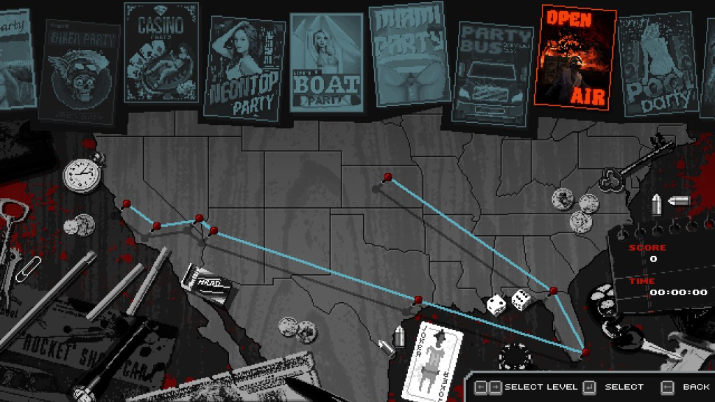

The world map of the game is presented as a road trip across all USA. The character travels in camper van and crashes at the parties across all America.
Most of the levels are designed as single screen environments which shows the player to all map and a few larger levels designed as slightly scrolling to see everything. Despite the open world games, Party Hard is more of a puzzle box game which is levels filled with crowded NPCs, hiding spots and interactive traps. The environment designed as 1980’s slasher type of movie style and pixel art.

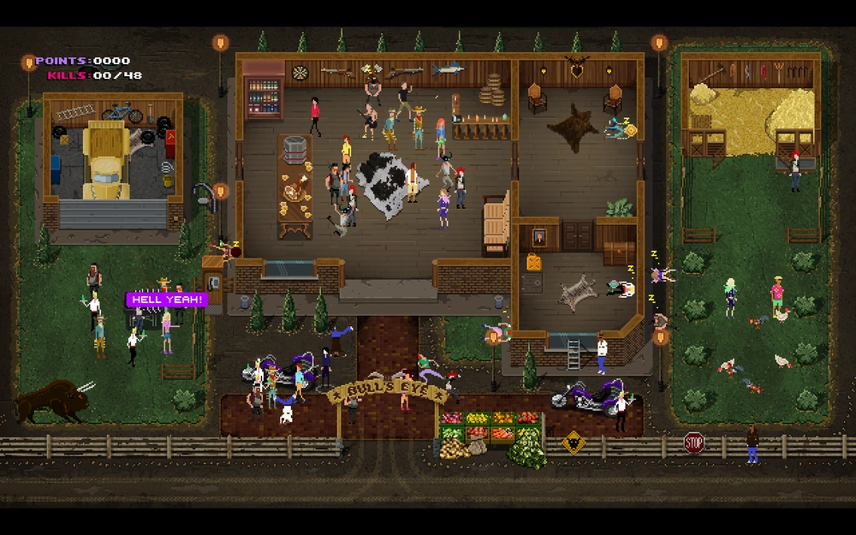

LOCATION DETAILS
NAME: | The Biker Party
WHAT DOES IT LOOK LIKE? | A dusty industrial warehouse and a bar area. Outside of the map there are motorbikes and a dumpster. Inside of the map is bit dark and comes within a bar, a pool table and a backroom. The colour palette is dark grey tones compare to other neon tone parties it gives negative and cold vibes.
WHAT MOOD IS BEING INVOKED IN THIS LOCATION? | Hostile and Dusty: The atmosphere is rougher than a normal house party and party goers are bikers who are more dangerous and rougher which gives the player a higher threat level. When the player get caught there is more danger than a normal house party.
WHAT KIND OF MUSIC WILL BE USED FOR THIS LOCATION? | An aggressive synth rock which comes with heavy bass. The tempo of the music matches the aggression of the bikers, and the audio includes the sounds of brawling.
HOW ARE THE LOCATIONS CONNECTED IN THE GAME WORLD? | The game has linear design which is when player clears the map, then will be able to unlock next map and travel there with the camper van.

(NOTE: Copy-paste the table in this section as necessary for each location you wish to feature.)

GAME FLOW
TITLE SCREEN
OPTIONS - (Audio / Video)
CREDITS
CHARACTER SELECT - (Darius, Ninja, etc.)
CUTSCENE / BRIEFING
MAIN MENU
LEVEL SELECT / CAMPAIGN
GAME OVER
THE GAMPLAY - CORE
THE GAMPLAY - PARTY
PAUSE MENU
SCORE SCREEN
NEXT LEVEL

CONTRIBUTING TEAM MEMBER: | Olcay Sivas

SECTION 6: GAME EXPERIENCE

GAME EXPERIENCE
The game comes with a dark humour and retro slasher mood. It mixes the mass murder theme with a light-hearted absurd tone.

HOW IS THIS FEELING GOING TO BE PRESENTED TO THE PLAYER?
The player feels like a predator and observes the victims from above which creates a sense of power and tactical planning. When a trap fails or dead body found by others it puts player in panic and forces to player to hide or blending in. Because of the ongoing dance music, the gameplay feels rhythmic and energetic rather than scary.

ARE THERE ANY SPECIAL MODES OR INTERFACES FOR GAMEPLAY?
Modes:
There is Twitch / Kick integration which viewers can vote and change streamers game to make it more fun and local Co-Op mode which is two players can play simultaneously on same screen to clear the party.

Interfaces:
There is suspicion meter which is a dynamic icon stays on top of character’s head and has two functions which are eye icon and handcuffs icon. Eye icon means that when an NPC see the player but isn’t sure about suspect or not and handcuff icon means that police been called for player and player is the main suspect.
Then there is object highlighting which is when the player holds the listen / scan button, the objects that the player can interact with will glow.
And lastly there is stamina bar which is shows the current stamina of the character. Player can sprint and run faster but it consumes stamina.

WHAT DOES THE PLAYER FIRST SEE WHEN THEY START THE GAME?
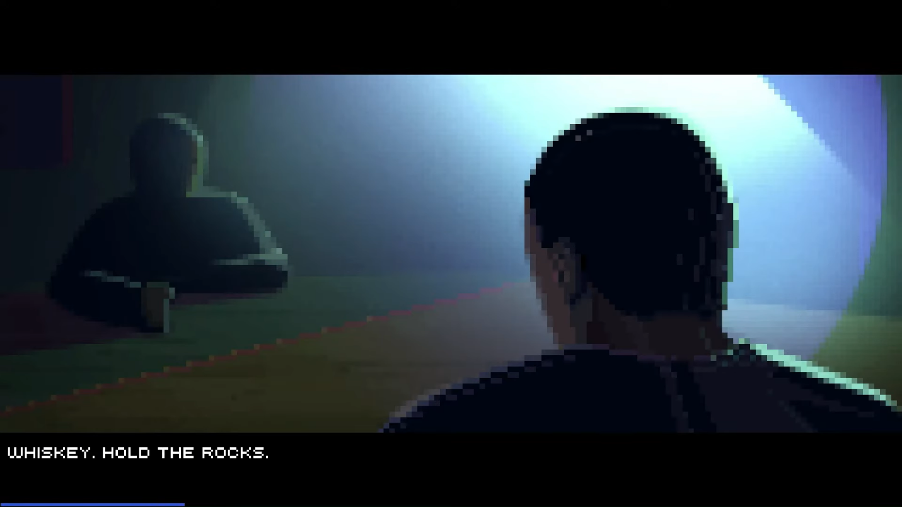
The game starts with a pixel art scene inside a police interrogation room instead of just throwing the character into a party. Rain falls against the window in the background. Player sees the detective John West sitting at table while smoking a cigarette. He is being interviewed about party hard killer while a slow background music goes on. As he starts to tell the story by saying “He just wanted some sleep” the player sees a white flashing on the screen and transitions into the first level.

WHAT EMOTIONS ARE MEANT TO BE INVOKED BY THE GAME?
The core theme of the game is sadistic / dark humour. When the player triggers a trap and watches the chaos player feel amused rather than scared.
When a body is discovered or the police arrive the mode of the game changes immediately. It turns into a panic from a dance party.
The game is a strategic puzzle game, so when player clears the room perfectly without being noticed, the player feels powerful and smart. This gives the vibe of invisible predator.

HOW ARE MUSIC AND SOUND GOING TO BE USED?
The core gameplay music is a rhythmic trance type of music. This music is designed to induce a flow state which makes player feel like dancing while killing the partygoers. Then there is a music speaker mechanic which is when player walks in the level there are speakers and while walking next to them player hears the sound more like diagonal. If speakers get destroyed music stops. Then there is a panic sound which is when player be seen by the crime scene the police comes with an annoying signal sound and makes the player feel like player is the victim from now on. And lastly there is cartoonish sfx sounds which are trap and NPC sounds. The reason of them being cartoonish is the real sounds would make it more serious than dark humour.

HOW DOES THE PLAYER NAVIGATE THE SHELL MENUS/ SCREENS OF THE GAME?
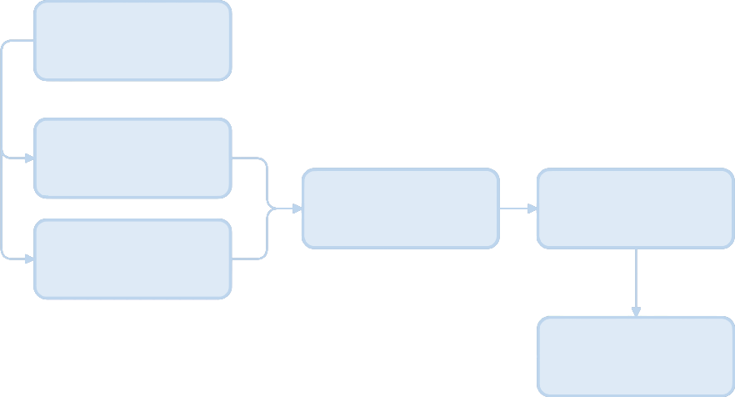
Main Menu

Level Select

Score Screen
Gameplay

Character Select

Unlock Reward

CONTRIBUTING TEAM MEMBER: | Olcay Sivas

SECTION 7: GAMEPLAY MECHANICS

GAMEPLAY MECHANICS
MECHANIC: Body Disposal, Sabotage, Dancing, Shortcuts.

HAZARD: Moving cars, Fire, Electrocution Puddles.

POWER-UP: Smoke Bombs, Poison Vials, Stun Bombs, Running Shoes.

COLLECTIBLE: Briefcases, Evidence.

MECHANIC DETAILS
NAME: | Sabotage
WHAT DOES IT LOOK LIKE? | The objects that player can interact are highlighted with a small gear icon or glows when the player uses listening mode
EFFECT ON PLAYER: | It creates chaos without showing the player’s location to the others. They can e interacted and starts a timer then after timer runs off, they deploy.
WHEN WILL IT FEATURE IN THE GAME? | It’s a constant feature and is on every level

HAZARD DETAILS
NAME: | Moving Cars
WHAT DOES IT LOOK LIKE? | Cars that run on traffic outside of the party house.
EFFECT ON PLAYER: | If the player or an NPC touches the car it causes them to instant death.
WHEN WILL IT FEATURE IN THE GAME? | Some specific levels like street party or casino.

POWER-UP DETAILS
NAME: | Smoke Bomb
WHAT DOES IT LOOK LIKE? | A grey single bomb sprite found in random container.
EFFECT ON PLAYER: | It’s a stealth tool which is when thrown it causes smoke explosion and hides the player’s location. It allows player to kill in crowd without being seen.
WHEN WILL IT FEATURE IN THE GAME? | Randomly because its randomly found in containers.

COLLECTIBLE ITEMS
The main collectibles of the game are briefcases and evidence. Briefcases randomly appear during gameplay and have random collectible items in it. Evidences are in specific levels and provide large score bonuses.

COLLECTIBLE DETAILS
NAME: | The briefcase
WHAT DOES IT LOOK LIKE? | A standard brown leather briefcase.
BENEFIT FOR PLAYER: | This collectible gives the player a brief advantage that allows player a temporary advantage.
WHEN WILL IT FEATURE IN THE GAME? | Randomized in every level.
CAN IT BE USED AS CURRENCY? | No, it’s a consumable container.
WILL IT EARN PLAYERS AN ACHIEVEMENT? | Yes, it provides the collector achievement.

GAME ECONOMY
The economy is based on points rather than the coins and currency. The points can be earned by kills, sabotage traps, hiding bodies and speed. The points can be used to unlock new characters and the levels. There is no shop in the game, instead the scores can be used between levels.

CONTRIBUTING TEAM MEMBER: | OLCAY SIVAS

SECTION 8: ENEMIES

LIST OF ENEMIES
The enemies in the game are security personal and law enforcements. They don’t attack unless the player is suspicious or kill someone in front of them. There are police officers which arrive when called, the bouncer which blocks the pathway and if player kill so many people in short time there is Special Forces like SWAT Team or FBI.

ENEMY DETAILS
NAME: | Police Officer
WHAT DOES IT LOOK LIKE? | Wears a standard blue police uniform with police hat. While chasing the player a red “!” symbol appears on his head.
ATTACKS: | The bust. If touches the player game over screen appears.
WHEN WILL IT FEATURE IN THE GAME? | All levels through entire game. Whenever an NPC calls the police they arrive.
HOW DOES THE PLAYER DEFEAT IT? | Player can’t kill him. Only can run away from him using the shortcuts.
WHAT DOES THE PLAYER EARN FOR DEFEATING THEM? | Player earns escape point bonuses.

LIST OF BOSS CHARACTERS
In party hard there is no end game bosses like other games. Instead there is a special SWAT Team which appears when player kills so many people in a row within short time.

BOSS CHARACTER DETAILS
NAME: | SWAT TEAM
WHAT DOES IT LOOK LIKE? | A big squad of heavily armoured special agent forces.
ATTACKS: | They run much faster than normal police and block the path of player.
WHEN WILL IT FEATURE IN THE GAME? | If player kills so many people in a row in short time.
HOW DOES THE PLAYER DEFEAT IT? | Player only can hide from them and wait for them to clear the room.
WHAT DOES THE PLAYER EARN FOR DEFEATING THEM? | Player can only earn survival and continue the game by hiding from them.

CONTRIBUTING TEAM MEMBER: | OLCAY SIVAS

SECTION 9: CUTSCENES

CUTSCENES
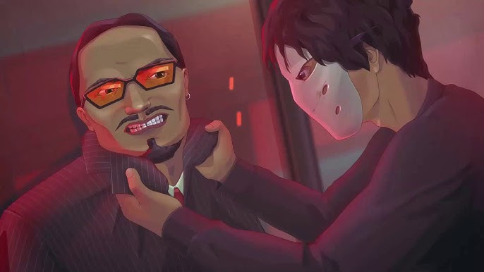

Party Hard doesn’t come with 3d cinematics. Instead, it uses pixel art static scenes with subtitle to give player the story.

CUTSCENE DETAILS
VISUAL STYLE: | (Pixel Noir, High Contrast 2D static pixel art cutscenes. Environmental sound affects instead of character sounds.
BRIEF DESCRIPTION OF SCENE: | The Interrogation
WHEN WILL IT FEATURE IN THE GAME? | Starting scene of the game.
PURPOSE: | This scene used to provide player the details about what’s going to happen and the reason of it in the future.

CONTRIBUTING TEAM MEMBER: | OLCAY SIVAS

SECTION 10: BONUS MATERIALS

BONUS MATERIALS
The unlockable content in party hard is the new characters which player can get with the points or achievements player earned during the gameplay. Each character has a unique gameplay and forces player to go back the old levels to make new strategies. For example, ninja can be unlocked by clearing a level without being seen. He has a smoke bomb and moves faster than other characters. Another example is The Cop. Can be unlocked by clearing all levels and he can move bodies without raising suspicion meter. And another example is The Butcher. Can be unlocked by killing 20 people in a row and he starts with chainsaw which is a strong weapon, but he has less stamina than other characters.

REPLAY VALUE
Semi Procedural Gameplay: While the map layout stays same, the interactable objects and traps and the movement of the NPC’s changes for every playthrough which gives player replayability feeling.

Score and Ranking System: The game grades the player performance from F to A. This marking system pushes player to get more score and make combos which gives player replayability feeling.

CONTRIBUTING TEAM MEMBER: | OLCAY SIVAS

