Student Name: Laura Mary Wade
P Number: 2104041
University: Swansea College of Art, UWTSD
Programme of Study: BA (Hons) Graphic Design
Module: ADAD5003 – Research in Context
Tutor’s Name: Donna Williams

Tasks in the order I received them:
Task One (Question 2): Can Graphic Design really save your life? Explore the association of wellbeing and personal growth in Design in your discussion.

Total word count: 2,567

Table of Contents:
- Introduction……………………………………………………………………………………………3
- Thesis Statement…………………………………………………………………………..................3
- Chapter 1 – “Automated External Defibrillators” ………………………………………...........3
Figure.1………………………………………………………………………………….........4
Figure.2………………………………………………………………………………….........4
Figure.3………………………………………………………………………………….........4
Figure.4………………………………………………………………………………………..5
Figure.5………………………………………………………………………………………..5
- Chapter 2 – “A Better A&E”……………………………………………………………………...…6
Figure.6………………………………………………………………………………...……...6
Figure.7…………………………………………………………………………...………….. 6
Figure.8…………………………………………………………………………...…………...7
Figure.9…………………………………………………………………………..……………7
Figure.10………………………………………………………………………………………8
- Chapter 3 – “One Mindful Mind”…………………………………………………………………...9
Figure.11………………………………………………………………………………………9
Figure.12……………………………………………………………………………………..10
Figure.13……………………………………………………………………………………..10
Figure.14……………………………………………………………………………………..10
Figure.15……………………………………………………………………………………..11
Figure.16……………………………………………………………………………………..11
- Conclusion………………………………………………………………………………………...…12
- Bibliography…………………………………………………………………………………………...13

Task One (Question 2): Can Graphic Design really save your life? Explore the association of wellbeing and personal growth in Design in your discussion.

Introduction
Can our health really benefit from graphic design? Sixty five percent of the population are visual learners and ninety percent of information transmitted to the brain is visual. Visual communication therefore has a huge responsibility in matters of life-or-death. Persuasion, information and education are at the forefront of medical graphic design to engage the general public. From being seen in hospitals to being placed on medical devices it is seen almost everywhere, design impacts on our understanding, what we notice and the action we choose to take as human beings. Most people will have their own view on this subject matter, in my opinion as a graphic designer the relationship of visual communication and medical healthcare is closely linked. I believe that without design solutions, less lives would be saved on a daily basis. Through critical evaluation I am going to further discuss the role that graphic design plays throughout the medical sector today.

Thesis Statement
Many different factors of visual communication lead to a better medical sector, builds trust, patient engagement and improves behaviour - effectively saving lives.

Chapter 1 - “Automated External Defibrillators”
Automated External Defibrillators (AEDs) are lifesaving pieces of medical equipment. This is unnegotiable. If used within the first minute of cardiac arrest the survival rate is as high as ninety percent, in contrast to the use in the first three to five minutes the rate drops drastically to sixteen percent. (E. Hammett, 2022) Acting fast and efficiently is at the forefront of the functionality of the equipment, during this time of uncertainty the human body is consumed by adrenaline and pressure. Under these immense circumstances the mind can struggle to undergo simple tasks, hands begin to shake, the brain clouds, you need to potentially save someone's life. How?

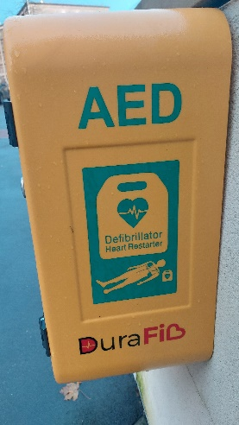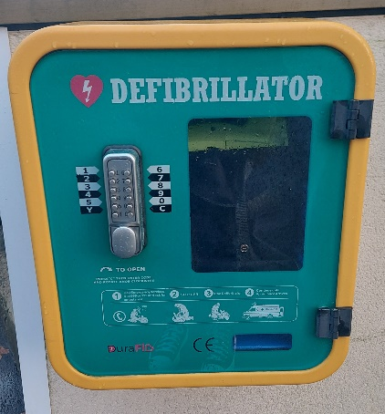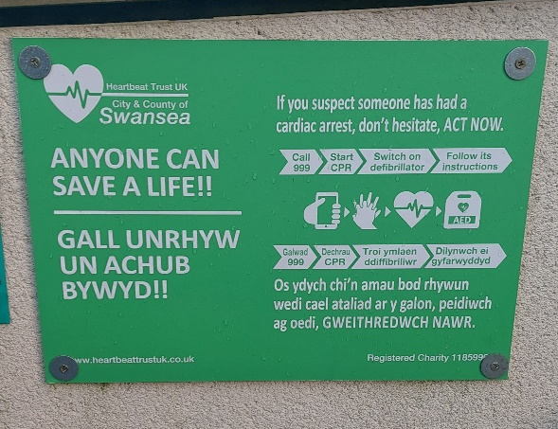
Figure.1, Figure. 2, Figure. 3: Automated External Defibrillator, outside Swansea College of Art, UWTSD Dynevor Campus.

The importance of rapid communication is vital, being able to understand information through successful visual communication on the device allows the user to carry out the procedure quickly. The vast majority of graphic design seen on defibrillators consists of icons and pictograms this allows instructions to be conveyed in an efficient manner. The brain of the user instantly interprets the pictogram because society has taught us all to associate certain icons with their tasks. For instance, a phone icon is shown on the front of the device which reminds the user to call the emergency services, in a high-pressure environment self-explanatory steps like this can easily be missed. Essentially this could be lifesaving. A high percentage of the population walk past a defibrillator every single day; hoping never to use one but if that day does come the machine needs to be approachable and provide clarification. Often, it is the general public that is required to operate an AED; with no medical training this immediately is a test. However, through design solutions this can be helped. Numerous amounts of the devices contain the colour green, a clever design choice to help provide encouragement and clarification to the user. The association of the colour with positivity and ‘Go’ instantly provides reassurance, meaning they are more likely to complete the procedure correctly. Hesitation whilst providing care for a cardiac arrest patient could be dangerous, due to the advancement in technology in 2004 AEDs became automated (The Community HeartBeat Trust, 2021) allowing the device function to be a single button. Providing only two options to the user straight away allows them to feel more at ease; the binary choice calms the mind due to thinking there is less pressure on their decision. Ultimately pushing the button to save a life. In contrast, this meant the user can be clouded with fear during a time where every second counts, but the button was a bright orange colour which immediately shows danger, this could have been the problem. Contrasting arguments question the colour use, could the positive colour green be further placed on the button to provide that last minute reassurance.

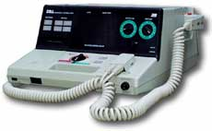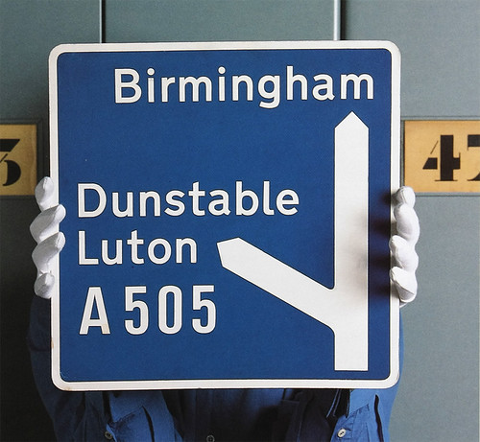
Figure.4: PD 1200 Defibrillator Model (ZOLL,1990)
Figure.5: Third advance direction sign sited at the start of the deceleration lane (M.Calvert, J.Kinneir, 1964).

Instructions that are seen on the device frontage use a sans serif font with a mix of capital and lower-case characters; this finer detail may seem less obvious to the public but to us as designers this indicates the message is needed to be communicated quickly. When you consider Jock Kinneir and Margaret Calvert’s commissioned project to readapt all UK road signs, it proves that when quick responses at fast pace are required it is essential to combine clear icons, text and colour. “What do I want to know, trying to read a sign at high speed?” (J.Kinneir, 1965) A sans serif type with a combination of cases allows the brain to read and process the words at a faster pace due to our brains associating the shapes created by the words to their meaning. Using capital letters means words are recognised slower, this methodology proves that during uncertain and fast paced situations the importance of visual communication. However, this methodology was not used in earlier models of the defibrillator. The PD 1200 Defibrillator Model (ZOLL, 1990) consisted of a very medical and sterile feel with multiple buttons and instructions. Development in medical science has meant this defibrillator is now retired, this can also show an advancement in design due to graphic designers condensing instructions to assist in the operation of the current devices we see today.

Defibrillators are lifesaving pieces of medical equipment but without clever design solutions would they be able to save as many lives as they do? In my opinion no. If you had to read a ten-page instruction manual before using the device the cardiac arrest patient wouldn’t be alive. However, graphic designers innovatively convert the manual into visual communication. Assisted by colour theory, typography and pictograms information is communicated within seconds which in conclusion could potentially save lives.

Chapter 2 – “A Better A&E”
In a similar fast paced environment design solutions were implemented in an attempt to ease frustration and effectively save lives. Throughout hospitals in the United Kingdom, it is estimated that every year violence and aggression towards hospital staff in the National Health Service (NHS) costs approximately £70million - staff absences, litigation costs and reduced productivity all included. (Department of Health, 2017) Design studio Pearson Lloyd were commissioned to try and help the rising issue, in my own opinion this was a brilliant project which put patient feelings at the forefront to overall improve behaviour, this really does summarise graphic design saving lives in my view.

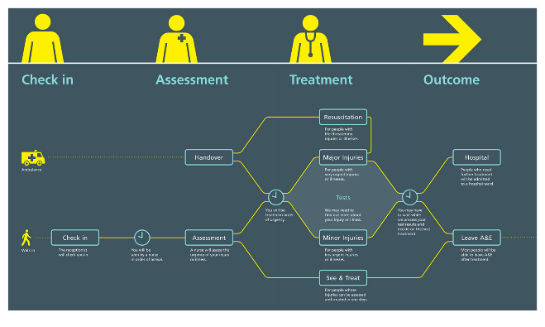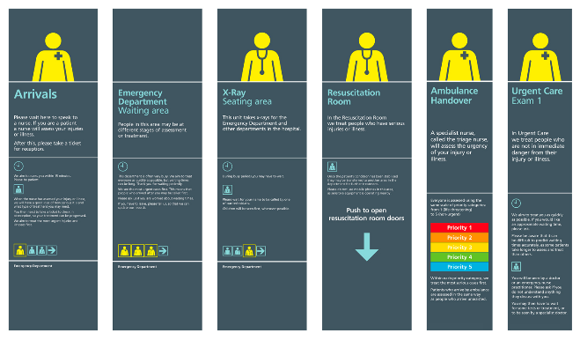Figure.6: Process Map illustrating patient journey, displayed in waiting room. (A Better A&E, 2012).
Figure.7: Panels installed throughout the department, guide patients through each stage of their care. (A Better A&E, 2012).

Generally, we do not wake up and expect to find ourselves in Accident and Emergency (A&E), it means we are injured, hurt or unwell. Therefore, our emotions, anxiety and nerves are all raised, we are in the unknown. Through creative curiosity the project designed a set of steps that can be implemented in hospitals – firstly, by showing guidance through a map diagram on entrance immediately puts patients and their family members at ease. Instead of hitting them with posters stating ‘Do not do this’ and ‘You will be prosecuted if you do this’ the free-flowing map of the journey through the department allows patients to immediately feel valued. The transparency of information on waiting times; a common reason for outburst in behaviour, meant that patients received clarity and eases false hope. This is assisted by visual animations seen on television screens throughout the department, showing a live moving scale of the current wait times. The graphic design communicates through colour theory and association of red communicating negativity and therefore a longer wait time. In essence, this improves staff productivity as they are not being required to constantly answer questions on the times so can focus on their medical professional job whilst less likely to make mistakes as they are more focused. In every part of the project simplicity of design is used, not over complicating anything means it is easier to communicate with the large target audience, this is assisted by simple use of language. In turn the vast majority of patients can take on board the information given. An extremely good example of the importance of icons in design history. It is quick, easy, and effective visual communication that patients are willing to look at as they have not got to sit and read a large amount of text on a boring white sheet of A4 paper.

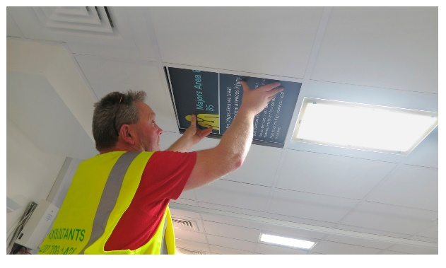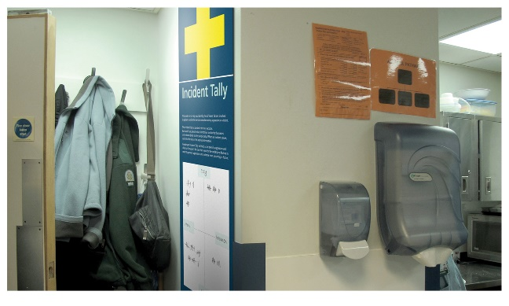
Figure.8: Ceiling panels installed about patient hospital beds. (A Better A&E, 2012).
Figure.9: Incident Tally panel installed in staff room. (A Better A&E, 2012).

Graphic design delves deeper than choosing colours and fancy fonts; an often misconception, innovative placement of design in this project considers every move that patients have on their hospital journey whilst also considering medical illnesses. Through observation of how patients use the facility, graphic designers placed designs on the ceiling tiles above patients’ beds this explained to them their stage of their journey. Innovation of the ceiling tiles allows them to read without leaving bed or having to look around the room, clever. The sterile environment with the constant ringing of high-pitched noises off machines is unnatural for most, but by the designs using curved edges, smooth icons, and a clear sans serif typeface it adds a sense of the normal world outside of the four walls, overall making Accident and Emergency a more comfortable place. Pearson Lloyd went further into providing support for NHS staff, intervention and toolkits were put into place to help staff morale including an ‘Incident Tally Chart'.
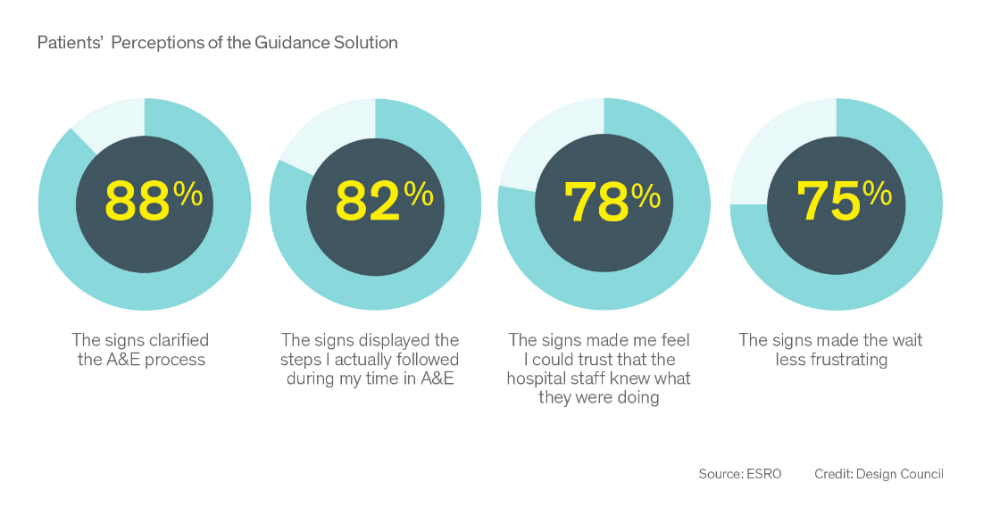
Figure.10: Impact of Design Solutions on Hostility and Non-physical Aggression. (ESRO; Frontier Economic Analysis, 2012).

Since 2012, this project has been implemented into sixteen hospitals across the country with dramatic results. 88% of patients felt that the guidance solution clarified the A&E process whilst 50% of threatening body language and aggressive behaviour fell post implementation. (A Better A&E, PearsonLloyd, 2017) The figures show that this has had a significant impact on this rising issue in the National Health Service across the UK, and in my own opinion I believe this should be implemented across all hospitals. Lives can be saved by medical professionals being more focused, patient care is improved and, we all value our NHS much more.

Chapter 3 – “One Mindful Mind”
A similar approach to behaviour and attempting to provide clarity was taken in India regarding mental health in the younger generation. Putting education rather than rehabilitation as the top priority. The World Health Organisation estimates that one in four children the age of thirteen to fifteen years old in India suffer from anxiety, depression, mood and conduct disorders. (World Health Organisation, 2017) This is not just prevalent in the Asian culture it is becoming a vital issue across the United Kingdom and whole of the globe. Fifty percent of mental health problems are established by age fourteen and seventy five percent by age twenty-four in the United Kingdom. (Mental Health Foundation, 2020) These figures prove that it is a rising issue, this project is universal, so therefore should it be readily available in every country? I am going to further discuss reasonings why I believe so.
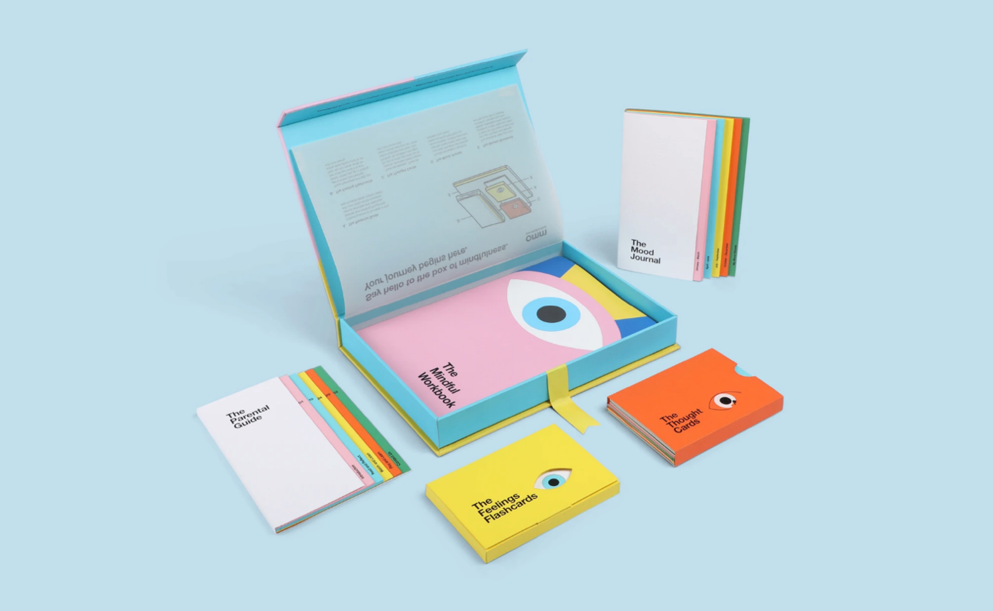

Figure.11: One Mindful Mind full toolkit. (R.Jain, 2018).

The majority of us will not get through our entire life on planet earth without experiencing some kind of mental health, therefore this subject is required to be spoken about. In most countries the academic curriculum does not accommodate mental health, there is no doubt that children should be educated on the taboo subject area. NeuroGen created the ‘One Mindful Mind’ which target audience is seven- to fifteen-year-olds, the project aims to help parents become counsellors for their children whilst educating children on the importance of mental health and how we feel. A high percentage of parents don’t know how to deal with children’s mental health and therefore feel helpless but by the help of this project parents and the younger generation unite to combat the rising problem. A five-step approach was undertaken which included a mood journal, feeling flashcards, mindful workbook, thought cards and the parental guide. All items can be seen below.

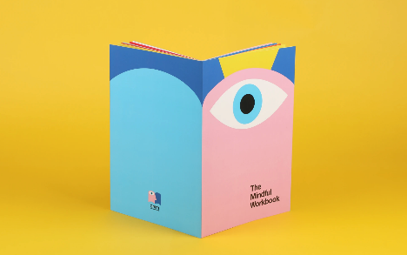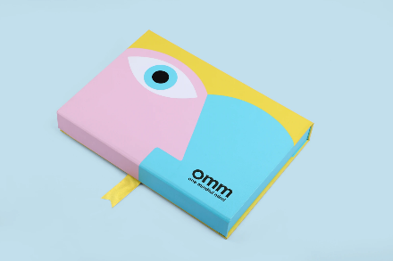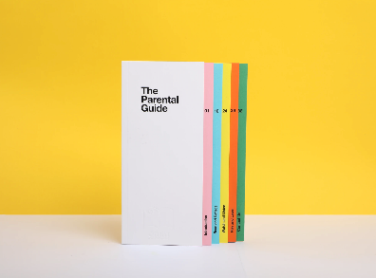
Figure.12: One Mindful Mind toolkit, The Mindful Workbook. (R.Jain, 2018).
Figure.13: One Mindful Mind toolkit, Box packaging (R.Jain, 2018).
Figure.14: One Mindful Mind toolkit, The Parental Guide (R.Jain, 2018).

Firstly, the immediate visual design is attractive by the light-hearted illustrations, making it extremely child friendly and inviting to the target audience. Allowing younger children’s brains to be stimulated in a visual manner whilst still being educational and helping them understand their individual emotions. A large majority of mental health during the educational period of adolescent's lives can be caused by academic stress, therefore education is often perceived in a negative light. Designing illustrations with soft lines, rounded edges and bright colours attempts to shine a positive light back on education. Visual learning is a common way in which many of us learn; including myself, illustrations mean children can relate their feelings to an art form visually, this sometimes can be more reassuring and better their understanding. As discussed previously, colour is vital, and this project showcases this immaculately. Softer toned colours whilst still being bright adds a pop of colour into a dark world that a young person is experiencing. A clear positive message in psychology.

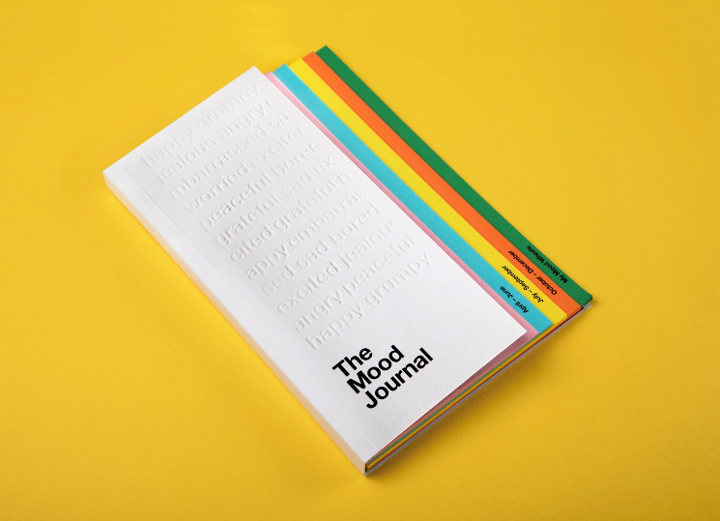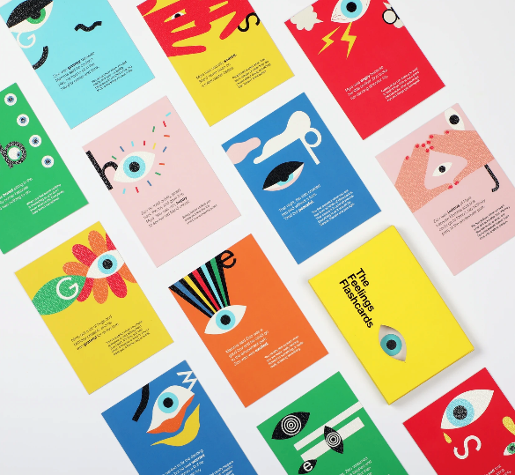
Figure.15: One Mindful Mind toolkit, The Mood Journal. (R.Jain, 2018).
Figure.16: One Mindful Mind toolkit, The Feelings Flashcards. (R.Jain, 2018).

The award-winning designs help parents build crucial relationships with their children, talking can be a huge help when suffering with mental health. Imbedding the importance of communication into the younger generation's lives could save multiple lives from mental health sufferers. Interestingly this point raised indirectly proves the importance of graphic design when saving lives because of it being a form of visual communication. The Mindful Workbook is fully interactive and encompasses many different activities, the brain is immediately stimulated but sometimes can include topics that could trigger or be difficult to discuss but by the friendly nature of design the children feel encouraged. Clever use or language is noticeable in the Feeling Flashcards, by writing a section in third person adds a sense of comfort that the child isn’t the only one struggling. Clearly communicating that it is okay not to be okay, there is many others struggling to.

Many behavioural disorders; for example, Obsessive Compulsive Disorder (OCD) are triggered by objects being out of place similarly to perfectionism. To help make the product inclusive to every individual, the packaging design allows all product elements to precisely fit into the box. This may be unnoticed by many but a clever design choice which could lead to more users. Potentially saving lives indirectly. In conclusion, the project light-heartedly addresses a rising mental health issue around the world, by educating the younger generation hopefully less lives will sadly be lost to the taboo subject matter.

Conclusion
Our health really can benefit from graphic design. By communicating information quickly and effectively through design solutions our feelings of emotion, adrenaline and pressure are suppressed. Our medical sector today benefits from successful graphic design to help engage patients, build trust and support medical knowledge, indirectly saving lives. AED’s are able to be placed in public spaces for the non-medical professionals to operate due to the ease of instructions, designed by graphic designers. Accident and Emergency has become more comfortable for patients and medical staff are able to provide a greater level of care, as a result of successful visual communication. The rising issue of children’s mental health across the world is being supported by designers to educate the younger generation. If we were to remove graphic design from these examples would less lives be saved?

Bibliography:

Books:

Bayley,S. 2017. ‘Design: Can Graphic Design Save Your Life?’ The Spectator; London.

Burki, T. 2017. Can Graphic Design Save Your Life? The Lancet Respiratory Medicine. Volume 5, Issue 11, p854-855, 01 November 2017.

Conway.A. 2012. Lady with the diagram Florence Nightingale on Crimean War mortality, 1858. The Eye Magazine. Winter 2012 no.82 vol.20 2012.

Schrauwen.S, Wright. R, Roberts.L. 2017. Can Graphic Design Save Your Life? A Graphic Design & Health title.

Podcasts:

Hendren, S and Moreau, L. (2022) The Futures Archive S2E4: The Defibrillator [Podcast]. 28 April.
Available at: https://designobserver.com/feature/the-futures-archive-s2e4-the-defibrillator/40536 (Accessed: 10 November 2022).

Hendren, S and Moreau, L. (2022) The Futures Archive S2E9: The Insulin Pump [Podcast]. 7 July.
Available at: https://designobserver.com/feature/the-futures-archive-s2e9-the-insulin-pump/40552 (Accessed: 10 November 2022).

Websites / Articles:

A Better A&E, A Project led by PearsonLloyd (no date), Design solutions, created by PearsonLloyd, deliver a better A&E to staff and patients. These are proven to be both cost effective and impactful. Available at: http://www.abetteraande.co.uk/#homepage (Accessed: 11 November 2022).

ArchiPanic (2017), Can Graphic Design Save Your Life? Available at: https://www.archipanic.com/portfolio/can-graphic-design-save-life/ (Accessed: 30 October 2022).

BBC Future (2017), There’s art hidden all around us, on ambulances, pill packets, and in hospitals, that can mean the difference between life and death. Available at: https://www.bbc.com/future/article/20170927-the-graphic-design-that-can-help-save-lives (Accessed: 25 October 2022).

BBC News (2006), Timeline: 25 years of HIV / Aids. Available at: http://news.bbc.co.uk/1/hi/health/5033810.stm (Accessed: 23 October 2022).

Campaign Brief Asia (2019), Seen + Noted: TBWA/ India Launches ‘One Mindful Mind’ Interactive Tool Kit That Helps Every Parent Turn Into A Counsellor For Their Child. Available at: https://campaignbriefasia.com/2019/06/18/seennoted-tbwaindia-launches-one-mindful-mind-interactive-tool-kit-that-helps-every-parent-turn-into-a-counsellor-for-their-child/ (Accessed: 22 November 2022)

Design Museum (2015), British Road Signs. Available at: https://designmuseum.org/discover-design/all-stories/british-road-signs (Accessed: 30 November 2022).

Design Museum (2015), Profile Jock Kinneir and Margaret Calvert. Available at: https://designmuseum.org/designers/jock-kinneir-and-margaret-calvert# (Accessed: 30 November 2022).

DesignObserver (2022), Health Design Thinking. Available at: https://designobserver.com/feature/health-design-thinking/40520 (Accessed: 11 November 2022).

Design Observer (2020), Information Design for Healthcare. Available at: https://designobserver.com/feature/information-design-for-healthcare/40286 (Accessed: 10 November 2022).

Dezeen (2011), Help Remedies by Pearlfisher. Available at: https://www.dezeen.com/2011/10/26/help-remedies-by-pearlfisher/ (Accessed: 21 October 2022).

Eye Magazine (1999), A design (to sign roads by). Available at: https://www.eyemagazine.com/feature/article/a-design-to-sign-roads-by (Accessed: 30 November 2022).

Elephant.Art (2021), Stay Home, Save Lives: The Design Secrets of Covid-19 Health Campaigns. Available at: https://elephant.art/stay-home-save-lives-what-the-graphic-design-of-public-health-warnings-reveal-18032021/ (Accessed: 25 October 2022).

First Aid For Life by E.Hammett (2022). All about defibrillators – what they are and how to use them. Available at: https://firstaidforlife.org.uk/all-about-defibrillators-aeds-what-they-are-and-how-to-use-them/ (Accessed: 30 November 2022).

Fuselab Creative (No Date). The Role Of Graphic Designers In The Healthcare Industry. Available at: https://fuselabcreative.com/the-role-of-graphic-designers-in-the-healthcare-industry/ (Accessed: 22 November 2022).

It’s Nice That (2017), Can Graphic Design Save Your Life? Explores “widespread and subliminal” impact of design on health. Available at: https://www.itsnicethat.com/news/can-graphic-design-save-your-life-wellcome-trust-exhibition-lucienne-roberts-rebecca-wright-050917 (Accessed: 21 October 2022).

Lakeside Group (2022), Blog – A Buyer’s Guide to Battenburg Livery Markings. Available at: https://www.lakesidegroup.co.uk/blog-a-buyers-guide-to-battenburg-livery-markings/ (Accessed: 10 November 2022).

Maharam (No Date), Florence Nightingale's “Rose” Diagram. Available at: https://www.maharam.com/stories/sherlock_florence-nightingales-rose-diagram (Accessed: 23 October 2022).

Medical Design Solutions (2022).Healthcare Graphic Branding, Making First Impressions Last. Available at: https://mds.healthcare/our-medical-digital-marketing-services/medical-graphic-design/
(Accessed: 22 November 2022).

Medium (2017), Can Graphic Design Save Your Life? By Craig Berry. Available at: https://craigberry93.medium.com/can-graphic-design-save-your-life-65d7d99e2dfd (Accessed: 20 October 2022).

Medium (2019), Florence Nightingale is a Design Hero. Available at: https://medium.com/nightingale/florence-nightingale-is-a-design-hero-8bf6e5f2147 (Accessed: 23 October 2022).

Mental Health Foundation (2020), Children and Young People: Statistics. Available at: https://www.mentalhealth.org.uk/explore-mental-health/statistics/children-young-people-statistics (Accessed: 25 November 2022).

National Health Service, NHS (No Date). NHS emergency ambulance. Available at: https://www.england.nhs.uk/nhsidentity/examples/nhs-emergency-ambulance/ (Accessed: 11 November 2022).

NC State University (2019), Kissing Doesn’t Kill. Available at: https://go.distance.ncsu.edu/gd203/?p=28219 (Accessed: 25 October 2022).
Rajlaxmi Jain, (2018). One Mindful Mind – Positive psychology toolkit for children. Available at: https://www.rajlaxmijain.com/onemindfulmind (Accessed: 22 November 2022).

Sh!FT (No Date).Studies Confirm the Power of visuals to Engage your Audience in eLearning. Available at: https://www.shiftelearning.com/blog/bid/350326/studies-confirm-the-power-of-visuals-in-elearning (Accessed: 22 November 2022).

Studio Dumbar / Dept. (No Date), Alzheimer Nederland – Communication design with integrity. Available at: https://studiodumbar.com/work/28-alzheimer-nederland (Accessed: 4 November 2022).

The Community HeartBeat Trust (No Date), Defibrillators A Brief History, The external defibrillator as known today was invented by Electrical Engineer William Kouwenhoven. Available at: https://www.communityheartbeat.org.uk/defibrillators-brief-history (Accessed: 4 November 2022).

The Community HeartBeat Trust (No Date), Cardiac Arrest, The Electrical Problem. Available at: https://www.communityheartbeat.org.uk/cardiac-arrest (Accessed: 4 November 2022).

The Health Foundation (No Date), AIDS: Don’t Die of Ignorance’ campaign. Available at: https://navigator.health.org.uk/theme/aids-dont-die-ignorance-campaign (Accessed: 21 October 2022).

The National Archives (1987), Central Ofifice of Information for Department of Health. Public Information Files: AIDs Monolith. Available at: https://www.nationalarchives.gov.uk/films/1979to2006/filmpage_aids.htm (Accessed: 23 October 2022).

Union (2009), Life & Death Scottish Government Kill Jill. Available at: https://www.union.co.uk/campaign/organ-donation/ (Accessed: 25 October 2022).

University of Bristol, Brigstow Institute (2022), ‘Designing in’ defibrillators: combining art and urban planning to increase the visibility of public access defibrillators in civic spaces. Available at: https://brigstowinstitute.blogs.bristol.ac.uk/project/designing-in-defibrillators/ (Accessed: 10 November 2022).

Widewalls (2017). The Curious Relationship Between Graphic Design and Health. Available at: https://www.widewalls.ch/magazine/graphic-design-health-wellcome-collection (Accessed: 22 November 2022).

ZOLL an Asahi Kasei Company (2022).Other Defibrillator Models. Available at: https://www.zoll.com/uk/medical-products/defibrillators/earlier-models (Accessed: 30 November 2022).

