MANAGING PEOPLE

LCBB5004

Assignment Title: Assessment 1 - Individual Presentation
Speaker Notes

Name:Desislava Radeva
Student ID: 2030540
Slide 1: Cover

Slide 2: Content
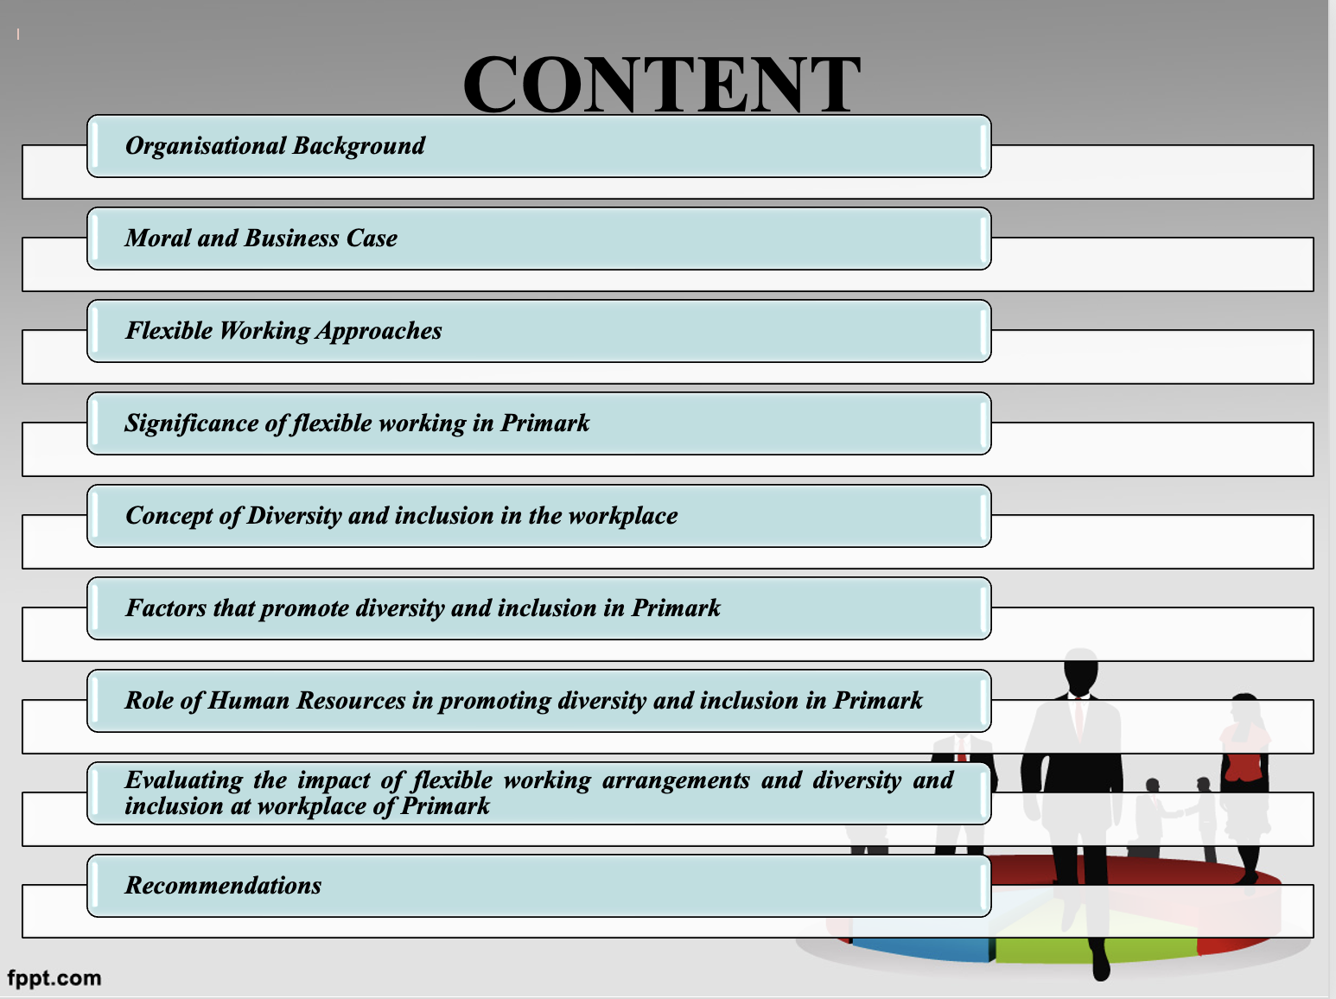
Slide 4: Organisational Background
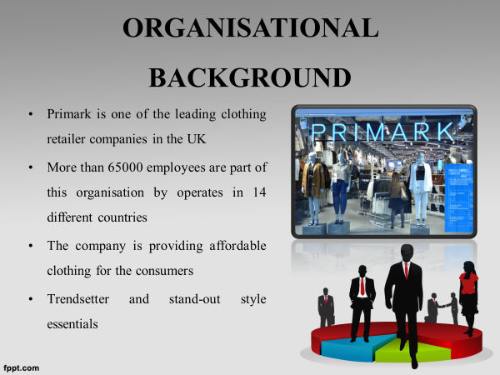
Primark is one of the leading brands in the retail fashion industry of the UK which operates with more than 65,000 employees across 14 locations worldwide (Primark, 2022). The company has gained a reputation currently due to its suitability of brands and affordable range of clothing materials.

Slide 5: Moral and Business Case
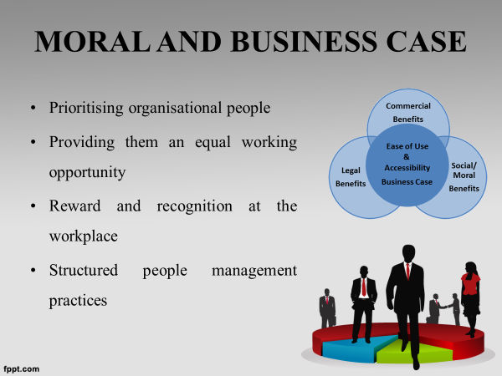
Prioritising organisational people is one of the most required moral traits for business organisations. It requires each employee to provide each employee an equal working opportunity by conducting equal distribution of work. Moreover, providing recognition and reward are necessary in order to motivate the morale boost of employees (Ng and Sears, 2020). Structured people management practice needs to be implemented in order to guide the employees in the proper direction.

Slide 6: Flexible Working Approaches
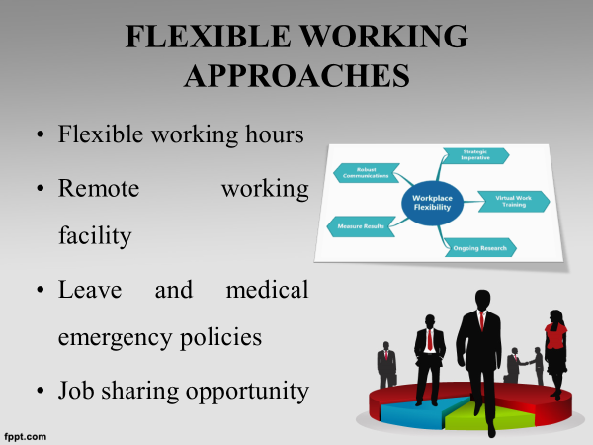
Primark has implemented a few approaches for flexible working such as modifications of flexible working hours, execution of remote working facilities, execution of leave and medical facilities and development of job-sharing opportunities for employees. This flexibility of working hours has helped in achieving successful management (Groen et al., 2018).

Slide 7: Significance of flexible working in Primark
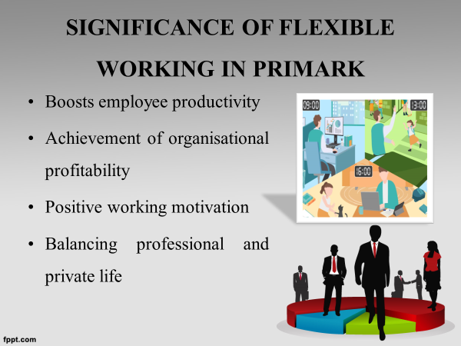
This achievement of flexible working processes within organisations has helped the company in boosting employees' productivity by influencing their working capacity and workplace motivation. Moreover, it helps the company in acquiring higher margins of profit and gaining positive working motivation (Davidescu et al., 2020).

Slide 8: Concept of Diversity and inclusion in the workplace
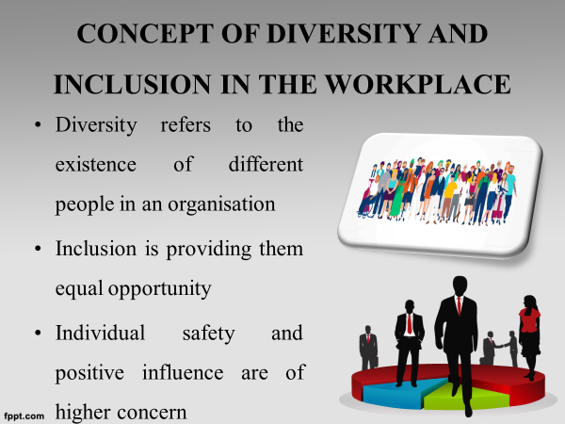
Diversity within the workplace is the process of engaging different people from different cultural backgrounds. Diversity requires inclusion by providing different cultural backgrounds and people an equal opportunity within the workplace irrespective of their cultural priorities, preferences, gender, caste and sexual orientation (Grissom, 2018).

Slide 9: Factors that promote diversity and inclusion in Primark
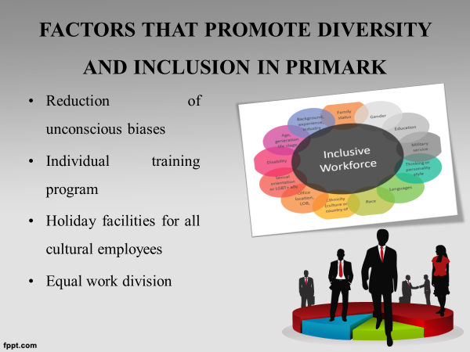
Important factors which promote diversity and inclusion at the workplace of Primark are the reduction of unconscious bias. It helps in providing equal working opportunities for the employees with equal division of work. Moreover, an individual training program is required to make the employees effective and skilled in their working process (Goldberg et al., 2019).

Slide 10: Role of human resources in promoting diversity and inclusion in Primark
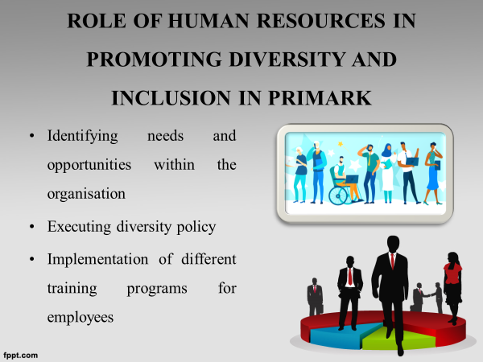
Human Resources of Primark is aiming to promote diversity and inclusion in the workplace. Initially, HR is aiming to identify all needs and opportunities for employees in order to execute strategic implementation. Besides, HR has implemented diversity policies to improve employee management in a systematic way (Jimenez et al., 2019).

Slide 11: Continued
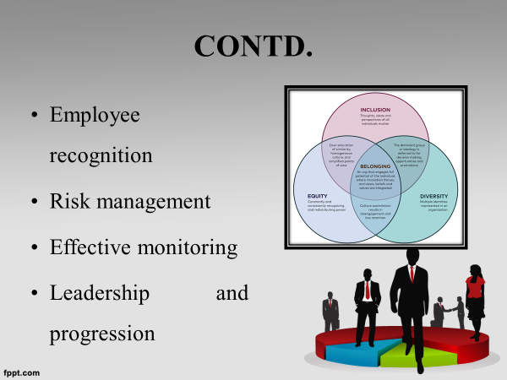
HR of Primark plays a key role in providing employee recognition according to their labour. It helps in boosting employee morale. HR is also prioritises risk management strategies to identify the risks and negative traits of employee motivation (Podgorodnichenko et al., 2020). By reducing such negative traits HR is capable of conducting effective monitoring of employees and improving leadership.

Slide 12: Evaluating the impact of flexible working arrangements and diversity and inclusion at workplace of Primark
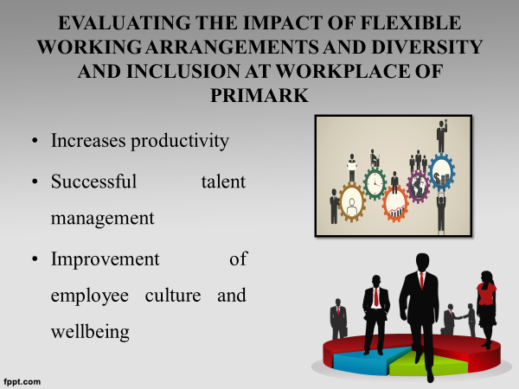
Flexible working arrangements and execution of inclusion and diversity at the workplace have helped in increasing production rate and conducting successful talent management by identifying the core talent of employees. (Chung and Van der Lippe, 2020). Diversity of the workplace has helped in improving employee well-being and culture within Primark.

Slide 13: Continued
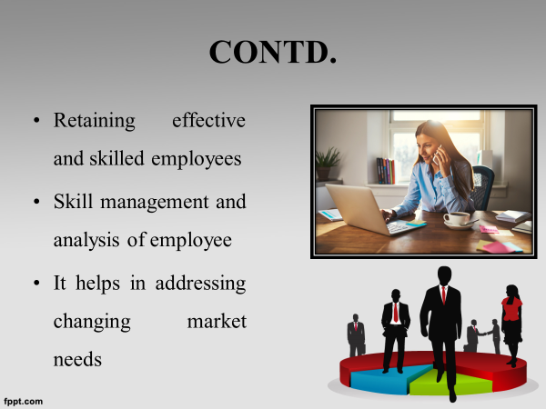
Flexible working approaches and implementation of diversity and inclusion in the workplace of Primark has also helped in retaining effective and skilled employees with the management of talent and analysis of their performance. Through the effective skill assessment of employees, the company has successfully formed a skilled employee group (Chung et al., 2021).

Slide 14: Continued
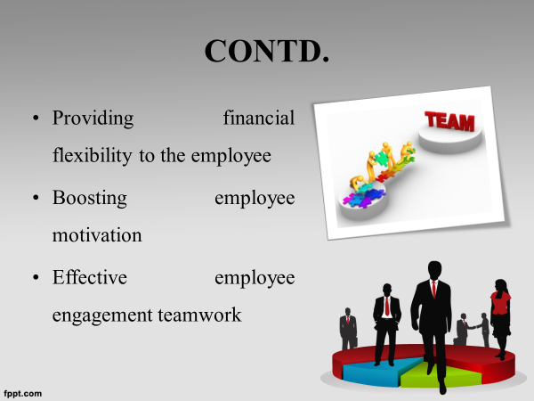
Similarly, with the formation of a stable and flexible organisational culture with the inclusion of diversity and an inclusive working atmosphere, Primark has achieved a higher rate of profitability with the development of production rate. It has helped the company in providing financial security for its employees (Yu et al., 2019).

Slide 15: Recommendations
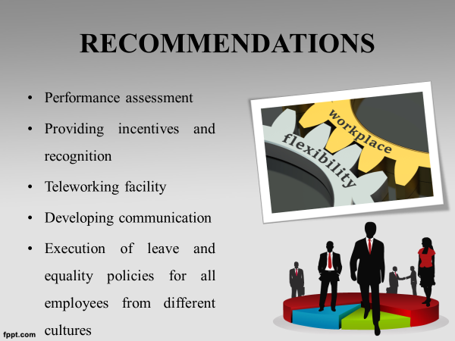
Human Resources of Primark needs to provide a performance assessment process through which HR can identify the problems and issues of employee performance systematically (Lehdonvirta, 2018). Moreover, the company will be needed to provide required incentives and recognition for employees through which they can motivate their employees systematically by providing financial security and appropriate working motivation (Belzunegui-Eraso and Erro-Garcés, 2020). In addition, the company will need to implement proper communication strategies to influence the employees in collaborating and effective teamwork with the influence of leadership strategies.

Slide 17: Reference List


