Educational project
AI as an Educational Assistant: Improving Assessment Feedback and Student Well-Being

There is no doubt that Artificial Intelligence (AI) has become an entrenched part of human activity; acting as a platform that we can almost not live without. As AI becomes an intrinsic part of society it is therefore essential that we understand the algorithms to proceed forward ethically and morally. AI in Education (AIEd) can promote transformative potential, benefiting stakeholders by enhancing cognitive engagement, improving assessments, and promoting digital literacy. Additionally, AI aids policy development, addresses ethical concerns, and boosts efficiency and accessibility. However, as stated in the abstract a study by Mohammed, Velander and Milrad (2024) rapid technological advancements can create uncertainty, even for experts. Additionally, an example cited by Cioara (2024) raises the idea that humanist values need to be considered as there can be a risk of students not developing their critical thinking skills, social skills can decline leading to central humanistic values being negatively affected. Therefore, it is vital to consider the ethical issues surrounding the use of AI in education. Interestingly an observation by Ali et al. cited by Mohammed, Velander and Milrad (2024)Transformations in AI have allowed for teaching in many settings to be revolutionised through innovation mixed with original methods used in education. An interesting point is raised by Chellappa(2022, p.30) ; here lies the moral issue of how far we can go with AI and how do we ensure it aids our experience in life rather than replaces it.
An article by Guskey (2005, p.1)Formative assessment is closely linked to several education theorists, the most influential being Benjamin Bloom. His emphasis on mastery learning emphasises the use of formative assessment as a guide to help students and guide enabling them to have a better understanding of knowledge. Bloom deduced that with a higher level of variation in teacher led to a less variation in outcomes and learning. An example by Guskey (2005, p.2-5) states that Bloom believed that to reduce the variation teachers needed to assess students at the end of a classroom assessment; to use this as a tool to provide feedback and suggest correction to improve outcomes which can lead to independent problem – solving. Further work by Bennett (2011, p.2) emphasises that formative assessment or assessment for learning is a tool used by teachers to understand how much the students have learnt and whether teaching of certain area needs to be repeated. Additionally, feedback is used by teachers and peers to allow students to understand how to improve their outcomes. Additionally some argue, notably Black (2015, p1), that formative assessment can increase students’ capabilities of increasing independence and agency, therefore it is critical to keep this in mind when considering the role of AI in formative assessment – that students need to keep their independence.
As mentioned by Houston and Thompson in the abstract, (2017, p.1) ,summative assessment or assessment of learning is a form of assessment used by educators and governments to measure against a benchmark of results. Its assessment of learning is used to allocate grades to students to measure what they have learned after a period. Additionally, echoed by Svensater and Rohlin (2023, p.1)It is used from primary school aged children through to higher education as a structure for passing courses.
In my view AI has become integral to human activity, necessitating ethical and moral considerations in its use. However, rapid advancements create uncertainties, and concerns persist regarding the erosion of humanistic values, such as critical thinking and social skills. AI has revolutionized teaching by blending innovation with traditional methods, raising ethical questions about its role in education and the extent to which it should augment rather than replace human experience. It can be argued, while AI-driven formative assessments provide personalized feedback and improve student progress tracking, they do not offer deep insights into students' personal lives. AI’s influence on educational assessments continues to grow, presenting both opportunities and challenges and recent advances in deep learning have contributed to AI’s expanding role across academia and industry. Educators and policymakers must critically engage with AI’s potential through tools like AI tutors, collaborative learning partners, and policy development frameworks. AI’s presence in education is undeniable, requiring thoughtful integration to maximize its benefits while safeguarding ethical considerations. I will therefore explore the opportunities that AI can offer for educators in terms of formative and summative assessment while considering how educators and policymakers must take a nuanced approach to utilising its benefits.

Theme 1 Formative assessment feedback
An insight into formative assessment given by Hattie and Gan (cited in Goldin et al, 2017, p2)2011) states that part of teachers’ insights into student progression, formative assessment can inform student progress, being regarded as one of the most influential tools in improving learning. The idea developed by Evans (cited in Zhai, X and Nehm, R.H, 2023, p.7)states this could be because formative assessment has become one of the most useful tools in developing motivation and self-efficacy and enabling them to self -regulate. Moreover, formative assessment supports students in building motivation skills, cognition skills, and metacognition, helping them develop self-regulation abilities throughout the learning process, as stated by Chen and Bonner (2020, cited in Zhai, X. and Nehm, R’H, 2023, p.7).
Current research highlights that AI driven feedback can allow for personalised learning, the authors Goldin et.al(2017, p.1) states that formative assessment improves student engagement and performance just as traditional feedback has done in the past before the arrival of AI. Additionally, research by Zhai and Nehm (2023,p.2) asserts that AI is already bound into the education system across many contexts and is now outpacing the research sector. Zhai (cited in Zhai and Nehm, 2023, p.2) mentioning Familiar platforms such as Grammarly and ChatGPT are already being used by students and professionals across the world, with teachers using ChatGPT to create useful formative assessment prompts in the classroom . The paper makes considered arguments for the use of AI, not that the discussion should be whether AI should be used or not, but as maintained by Zhai and Nehm (2023,p.3), more to discover its potential while minimising any negative effects. Zhai and Nehm (2023,p.5) argue against critics who maintain that AI- based formative assessment might create unfairness because AI struggles to interpret students’ unexpected ways of thinking. The authors agree that students’ unique ideas are important but believe that fairness in assessment depends on the overall practices used, not just AI generated scores. To simplify they argue that inequity is more about how assessments are designed and used rather than AI itself. For example, a non – English speaking student answering English language questions using incorrect grammar and spelling could have lower scores even though the analysis is logically sound. Therefore, it would be beneficial for teachers to use the AI scores as a starting point and to be critical in its provision of grading to ensure a fair assessment process.
Further studies indicate an argument against the use of AI for formative assessment purposes; Wang et al (2023,cited in Wang et al, 2024,p.2) arguing that while AI has its purpose it needs to be driven more by the AI’s effective use in personalised learning rather than utilising it solely for its technological capabilities. For example, understanding the pupil as a unique learner with the need for individual specific instructions or needs could not yet be completed by AI. Additionally, the authors note that there are issues with the use of AI due to its limited time within the field of education. Firstly, as Wang (2024, p.2) proclaims there is a gap in understanding how generative AI helps create personalised learning specifically enhancing cognitive skills. It can tell you where you need to correct grammar, spelling etc but it could not teach you how to be critical. Moreover, Fonkam, Cela and Potluri (2024, p.2) agree with this statement that the literature is highlighting a growing commonality around cognitive skills, the suggestion being that AI is hindering critical thinking skills. This is because AI provided quick answers, which could reduce pupil engagement with the literature limiting their development of analytical thinking.
Furthermore, this study undertaken by Fonkam, Cela and Potluri, (2024,p5-6) in Albania (a country undergoing educational reforms) use the example of writing a rationale (for use in higher education) whereby critical thinking skills are necessary for understanding complex ideas. The authors note that the use of AI tools for summarising and checking grammar and spelling etc can be used as a time saving tool. Therefore, it is important to understand that AI albeit a useful and advantageous tool, will require usage guidance. This idea raises the question expressed by Lee in the preface (2020): what is intelligence and how important is it to separate human intelligence from artificial intelligence? Lee (2020, p19) continues by asserting that definitions of intelligence range from the ability to decipher difficult challenges and problems, and others define it as the ability to accomplish aims. These definitions are problematic as there are too many levels of intelligence to enable us to understand the idea of intelligence. In the scenario of combatting climate change and creating new solutions to create more sustainable affordable energy then intelligence would need to be unique and profound, something which AI is not capable of. Therefore, AI when used (in its current state) would need to be utilised to save time, correct errors and ultimately as a tool and not a replacement.
New technology within the realm is allowing educators to assess student responses, provide automated feedback and therefore improving formative assessment. An example of this new technology is identified by Liao et al. (2024, p.4) which is called Natural Language Programming (NLP). NLP is advanced AI technology that can help computers understand human language and generate improved versions of that language. It is split into two parts: one is natural language understanding which reads text, and natural language generation, which creates new text from the original. An example can be seen in Grammarly which is a piece of software that can assess a student’s written work by detecting any grammatical errors, evaluating sentence structures and offer suggestions for improvement. Below is an image which demonstrates how Grammarly can be used without any help from the teacher:
Figure 1
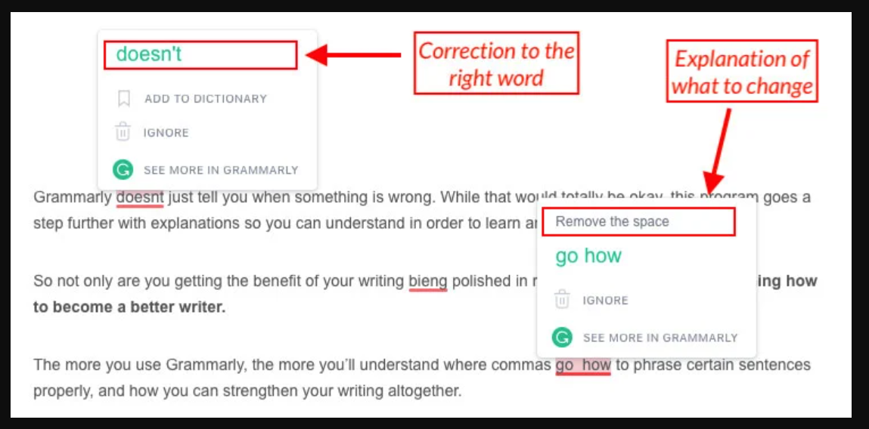
https://self-publishingschool.com/wp-content/uploads/2019/03/grammarly-example.jpg
Figure 1 demonstrates the usefulness of AI in the classroom for pupils who are second language English, pupils who have dyslexia and other additional learning needs. With these corrections being made in real time for pupils the saving of time and extra work for teachers is significant.
Liao et al (2024, p.4) acknowledge that bias that can occur with AI, however there is significant positives for the diversification that AI can offer; that it may boost motivation. Arnold and Pistilli’s findings (cited in Liao et al, 2024, p.6) in the study also acknowledge the positive aspects of using visual colour codes to indicate level of progress and highlight areas of strengths and weaknesses. This could be beneficial for students who face language barriers using visual models as they do not have to rely on a textual explanation. (see Figure 1).
However, it is imperative to remind ourselves that AI, while an informant of data does not provide a deep understanding of a student’s personal lives. Luckin’s findings (2018, p.81) imply that AI is increasingly affecting assessment practices in education, and can unlock opportunities and challenges for formative and summative assessment. Moreover, Luckin (2018, p.81) continues by expressing that AI - driven tools can improve by providing personalised feedback allowing for more differentiated teaching and tracking of progress more effectively. With this in mind it is important to undertake a further review of current literature around the topic of AI enhancing assessment strategies alongside teacher aid.
As mentioned earlier, AI can have a significant impact on students learning where they have a language barrier. The abstract highlights that the impact AI technologies can have with regards to creating programmed and personalised language assessments. This means that they are automated within seconds (Chen, A. et al.2025). However, Chen (2025,p.3) also states that educators must understand students' needs and adjust AI assessment tools accordingly for better educational outcomes. The review continues to emphasise that AI assessment tools had the most impact on language learning through narrative feedback. This is because the narrative feedback is similar to teacher input. However, Chen (2025, p.14)asserts that the role of the teacher in an AI based classroom needs to be as a facilitator, and students may need support in understanding the AI content of the feedback. The study highlights the need for further understanding of how teacher aid can work alongside AI and that AI cannot replace human – led formative assessment.
Findings:
The abstract describes a convincing study using a quasi -experimental design to study the cause and effects of the integration of AI enabled visual reports with a pre -existing group in their natural setting. These groups consisted of 125 high school biology students. Their research using a quasi – experimental design explores an intervention of AI driven feedback to analyse the statistics. The study was to compare groups with the intervention and without the AI intervention (using oral teacher feedback); to test if AI can improve achievement and self – regulated learning while highlighting test anxiety as a problem. With further analysis of this study Liao et al (2024, p.16) highlights the negative effects that AI driven feedback can have psychologically on students. The authors of the study use Jacob Cohen’s metric, described by Becker (2000, p.2) to determine the magnitude of an observed effect in experimental research. This revealed that test anxiety (d=0.203) had a slight increase, due to AI driven feedback; albeit this effect is small as declared by Liao et al (2024, p.16). In comparison to the self – efficacy (d=1.793) AI driven feedback had a strong positive effects on student’s confidence. This suggests that the positive effects of the AI driven feedback significantly outweighs the negative effects.
The study by Liao et al (2024, p.1268 -70) assumes that AI generated feedback boosts self – efficacy which aligns with findings that align with findings that visual feedback strengthens motivations. However, the study underestimates the risk of heightened anxiety – students may feel overwhelmed by detailed visual feedback exposing their weaknesses. The study contributes to the growing discourse on AI – assisted education by offering empirical evidence on the effectiveness and limitations of AI -driven formative assessment tools. However, the study on the NLP was in the context of one school and one subject with no knowledge of the class ability of both groups. This hinders the understanding and can create bias in the study as it limits the broader understanding to other educational contexts.

Key findings from this review of the use of AI in formative assessment highlights many positive aspects. Firstly, there is evidence from Liao et al (2024, p.17) that shows it can have a positive impact on motivation, student progress and self-efficacy, which is critical for long term success as expressed by These psychological effects of AI – driven feedback are reinforced in this study; however, it does echo concerns raised by Rakoczy (2019, p.9) regarding student engagement and motivation. Other issues raised by Liao et al (2024, p.4) study are mirrored in studies of similar themes where assessing AI’s impact across different disciplines would be beneficial as asserted by McCallum and Milner (2020, p.15). Furthermore, providing personalised support similar to traditional methods enables individual feedback without increasing workload, which would make this AI method particularly useful for large class sizes. Particularly the use of platforms such as Grammarly to incorporate automated corrections of spelling and grammar can be effective when time constraints, language barriers and large class sizes are an issue.
In the abstract of another study the authors describe state that the (Wang et al,2024)study has a focus on personalised learning using a quantitative analysis of 48 students. The learning achievement of the students was analysed using statistical methods to compare the treatment group (receiving AI visual reports) and the control group (receiving traditional teacher feedback). Wang et al.(2024, p.14) describes that before comparing the learning improvements, researchers used a non-parametric test to check if the two groups had similar initial learning outcomes. This avoids bias as it ensures that any observed differences after the intervention are due to the AI enabled reports rather than the pre-existing differences between the students.
Another key finding in Liao et al’s study (2024, p.14) relates to the overall learning achievement trends observed across the assessment. The learning achievement trends in the study show that both groups improved across three tests, but the treatment group (with AI) showed a greater size affect. This means that both the students who received AI enabled visual reports and those who received teacher driven feedback improved over time. However, the AI group showed a greater improvement in their learning compared to the control group. The effect size (np2) indicates how much impact the intervention had – as 0.754 is larger than 0.586. Therefore, the AI driven feedback had a stronger influence on learning progress. While this study offers practical applications of AI – driven formative assessment and use of effect size comparisons the study only focuses on short term gains.
Additionally, the Wang et al’s(2024, p.15) study recognises that AI personalised feedback can lead to performance confidence and this contrasts with the study by Liao et.al (2024). According to Wang et al.(2024, See Appendix A for questionnaire details) the impact highlights through a qualitative study, that AI can serve as an aid for students who suffer from social anxiety. For one student their answer to the question ‘Do you think generative AI can motivate and interest you in learning? If so, how does generative AI achieve this in motivating and interesting you?’ the answer was, ‘Yes. For those with social anxiety, AI can be like a teacher. If you don't understand something, you can ask it, and problems are solved more promptly, preventing them from being forgotten. Moreover, when asking a teacher, sometimes you don't understand and are too embarrassed to say so.’ While this result is bias in that it only represents one person it does highlight the need for further research on the benefits of AI for students suffering from social anxiety.
Another study systematically examines the design, implementation, and effectiveness of AI enabled assessment tools in language learning, highlighting their impact on student outcomes, fundamental design models and emerging pedagogical implications, as highlighted in the abstract (Chen, et al, 2025). The Chen et al, (2025, p.5) conducted a systematic review and meta – analysis to evaluate the design, implementation and effectiveness of AI enabled assessment tools in language learning. The methodology followed a PRISMA (Preferred Reporting Items for Systematic Reviews and Meta -Analyses) framework for data collection, ensuring transparency and accuracy in the research process. This was sourced from six major academic resource databases to ensure validity.
Additionally, Chen et al’s (2025, p.4) study was based on an inclusion and exclusion criteria. The inclusion criteria means that only studies between 2012 and 2014 were included in the research. Studies were to include primary and secondary students only. The exclusion criteria means that the study used only data driven or experimental literature reviews and the topics were focused on language subjects. This was to ensure all findings were applicable to educational contexts.
These three studies provide an insight in AI – driven feedback, with Chen et al (2024) providing a broad theoretical insight, Wang et al. (2024) focuses on personalized AI learning outcomes, and Liao (2024) offers practical classroom applications of AI driven formative assessment. To conclude Chen et al (2024) offers a strong meta-analysis with accurate results but does not offer intervention insights in class. Wang et al (2024) provides excellent insights into learning impact comparison but lacks psychological comparison. Liao et al’s (2024) study is effective in examining student well – being but lacks control of selection bias and no long term effects are studied.

Theme 2 : Summative and anxiety
Critiques, notably Harlen and Deakin-Crick, (cited in den Boer, A.w., Verkoeijjen, P.P and Heijltjes, A.E, 2021, p.1) state in the abstract argue that summative assessment can cause pupils anxiety and decreased confidence with the focus being on passing a test reducing significant learning goals. Therefore other proposals by Harlen and James (1997, cited in den Boer, A.W., Verkoeijen, P.P. and Heijltjes, A.E., 2021,p.1,)have been made to utilise summative assessment for classification and qualifications for pupils; which suggests it should be kept to a minimum. It is therefore perhaps critical to be aware of this when considering AI’s contribution to the two methods of assessment and to take into account the humanist contribution to formative assessment as vital for student wellbeing, progression and self -esteem. Additionally, issues raised by Foa et al (1992, cited in Lee, R. and Thompson, S., p. 2,2024) emphasise that it is important to understand the anxiety that summative assessment can cause among students, with research highlighting the negative impact it can have on exam outcomes.
Significantly, AI while being a useful tool for generating summative assessments, it is perhaps more important to consider the role that AI can play in reducing exam stress. Further studies by Murtaza et al (2022, cited in Milicević, V., Lazarova, L.K. and Pavlović, M.J.2024, p.2) highlights that current AI technology is being used to tailor study plans for students. Personalised learning uses AI to analyse a student’s understanding, learning style, and preferences to provide tailored support. AI can identify the needs of the students and adapt materials for each student, helping them to learn in the most effective way. These study plans can be utilised effectively for students who are experiencing exam stress; one technology platform called Reinforced Learning stands out for its ability to take account of individual characteristics of students. Other notable research by Barone ( 2024, p.ii) highlights that Machine Learning (ML) is a part of AI that helps software learn and improve over time. ML has three types: supervised learning, (which uses labelled data from experts); unsupervised learning, (which finds patterns in data without guidance); and reinforcement learning, (where AI learns by trying different actions and receiving rewards). In education, reinforcement learning helps AI tutors adjust lessons based on a student’s progress to keep them engaged and progressing. Additional findings by Robert (cited in Barone, M. et all, p.III, 2024) within this paper offers an insight into more specific and beneficial ways AI can aid pupils for exam study. The AI tutor can offer personalised learning through algorithms that assess strength, weaknesses and learning style. Through analysis of data from quizzes, assessments and interactions with AI it can adjust the content to match each student’s progress and improve learning outcomes.
However, in my view it is also important to consider that there are negatives to overuse of AI. While some research shows that it can be an effective tool it is important to consider the over reliance on technology over human interaction. AI plays an increasing role in assessment, offering personalized feedback that enhances formative assessment by tracking student progress more effectively. However, while AI can support learning, it does not provide deep insight into students’ personal lives, and over-reliance on AI risks diminishing human interaction. Research highlights AI’s ability to reduce exam stress through personalized study plans and reinforcement learning, but concerns remain about its impact on student confidence and the anxiety associated with summative assessments.
Interesting research by Rothkrantz (2024) highlighted in the abstract, describes the use of AI tutoring systems in the realm of mathematics to demonstrate how AI can generate realistic exam simulations, helping students to familiarise themselves with the content and timing. This recent study highlights how the use of educational games in an educational setting can increase understanding and motivation in students, not just in secondary school but also higher educational settings. The results from Rothkrantz’s study (2024, p.221) infer that the students after using an AI piece of software known as the ‘logical trainer’ benefit in a positive manner. This software was implemented to educate students through games. The following graph depicts the results from the study:

Graph 1
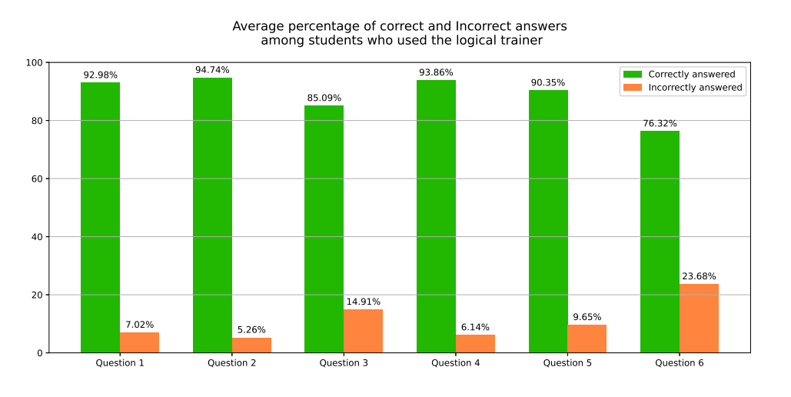 (Rothkrantz, C. et al.,2024, p,221)
This bar chart presents the average percentage of correct and incorrects answersamong students whoused the logical trainer. The key points to make are that there was a high accuracy across most of the questions. However, there is a notable difficulty in question 6 which indicates that the question was more challenging or the logical trainer was less effective for this question. Further research could offer an insight into whether the logical trainer could be adjusted to improve outcomes for such a question. Overall, the results indicate that there was a consistent approach across all questions.
The following graph displays the results for the pupils not using the logical trainer:
Graph 2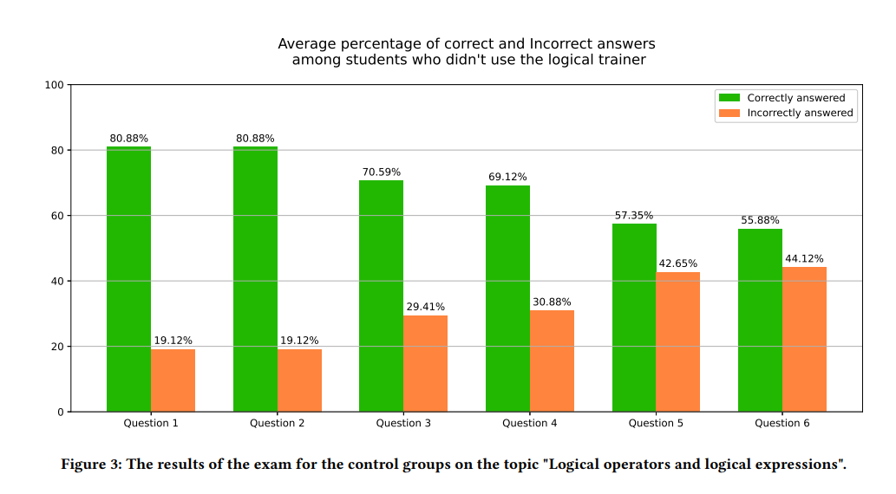

(Rothkrantz, C. et al.,2024, p,221)
Graph 2 indicates that the pupils not using the logical trainer had significant lower scores. The lowest score in Graph 1 was 76.32 % while the same question on Graph 2, the lowest score was 55.88 %. While the highest score among logical trainer uses was 94.74 %, the highest score for the non-logical trainer users was 80.88%. This suggests the trainer users had a more consistent performance across the questions suggesting better understanding and retention.
The results suggest a convincing indication that the use of the logical trainer is beneficial for students in preparation for exams. The 20% gap in accuracy between logical trainer users and non-logical trainer users implies that the platform can enhance outcomes for students. However, in my view, further research on alternative instructions for complex questions would perhaps enable a more robust AI system. There are also no indicators for the level of ability for each set of students which can create a bias for the results.
Findings and critical analysis
The key findings when examining summative and anxiety suggest that summative assessment can increase anxiety and reduce confidence, as suggested by Harlen and Deakin-Crick (2002) and should be limited to using for classification and qualifications as previously noted by Harlen & James, (1997). This is highlighted by negative exam outcomes which highlights the need for alternative methods as stated by Foa et al., (1992), whether it is AI or not. Additionally, over reliance on AI risks diminishing human interaction and therefore may struggle to understand personal contexts and individual reasoning. Therefore, in my view, teacher intervention would still be necessary for fair assessments. On the other hand, the finding in the study suggest that AI could perhaps reduce exam stress through personalised learning and improving student engagement as highlighted by Murtaza et al.(2022). For example, the logical trainer demonstrates how AI can improve problem solving skills and retention. (Rothkrantz et al., 2024).
Moreover, AI can create a bias as the studies do not reveal the student’s ability, and it does not account for diverse learning backgrounds. Further research would need to be carried out to understand this. Additionally, current research focuses heavily on STEM field; broader applications need further exploration.
Additional studies by Xie, Hwang and Wong (2021) in the abstract focus on how deep learning structures have transformed AI, contributing to more revolutionary innovation in both academic and industrial efforts. Due to the ongoing evolution of AI, it urges educators and stakeholders within education to consider its potential. Examples of this include AI tutors, collaborative learning partners and implementing AI to form education policies and systems.

The study by Rothcrantz et al. (2024, p.1-2)) presents a massive open online course (MOOC) that has been designed to support secondary school students in preparing for their mathematics exams using an AI based intelligent Tutoring System (ITS) . The development of this MOOC was developed to offer free, accessible exam training particularly for students who can’t afford private tutoring. Comparing this approach to Liao et al. (2024) , Chen et al. (2024) and Wang et al. (2024) several methodological strengths and weaknesses emerge. While Chen at al (2024) provides a meta analytical view of AI based assessments, Liao et al (2024) examines direct AI intervention in classrooms , and Wang et al (2024) focuses on personalised AI learning outcomes, Rothcrantz et.al (2024) emphasises practical AI driven tutoring but lacks rigorous experimental design and accuracy as this study is not tested against a control group. This makes it difficult to determine the effectiveness when compared to a teacher led group.
Therefore, future research should focus on validating AI’s effectiveness in relation to classrooms, enhancing personalisation, and improving collaboration between AI and teachers. Also, expanding studies across more language-based lessons and a move away from STEM subjects to more broader educational contexts to gain a better understanding of AI’s role in transforming education.

Reference List
Barone, M. et al. (2024) ‘Reinforcement Learning based Intelligent System for Personalized Exam Schedule’, in 2024 19th Conference on Computer Science and Intelligence Systems (FedCSIS). Polish Information Processing Society, pp. 549–553. Available at: https://doi.org/10.15439/2024F302.

Becker, L.A., 2000. Effect size (ES).

Bennett, R.E. (2011) ‘Formative assessment: a critical review’, Assessment in education : principles, policy & practice, 18(1), pp. 5–25. Available at: https://doi.org/10.1080/0969594X.2010.513678.

Black, P. (2015) ‘Formative assessment - an optimistic but incomplete vision’, Assessment in education : principles, policy & practice, 22(1), pp. 161–177. Available at: https://doi.org/10.1080/0969594X.2014.999643.

Black, P. and Wiliam, D., 1998. Assessment and classroom learning. Assessment in Education: principles, policy & practice, 5(1), pp.7-74.

den Boer, A.W., Verkoeijen, P.P. and Heijltjes, A.E. (2021) ‘Comparing Formative and Summative Cumulative Assessment: Two Field Experiments in an Applied University Engineering Course’, Psychology learning and teaching, 20(1), pp. 128–143. Available at: https://doi.org/10.1177/1475725720971946.

Chen, A. et al. (2025) ‘A systematic review and meta‐analysis of AI‐enabled assessment in language learning: Design, implementation, and effectiveness’, Journal of computer assisted learning, 41(1). Available at: https://doi.org/10.1111/jcal.13064.

Cioară, I. (2024) ‘AN OUTLINE OF A HUMANIST CRITIQUE ON THE RELATIONSHIP BETWEEN EDUCATION AND TECHNOLOGY’, Romanian Journal of School Psychology, 17(33/34), pp. 83–96.

Chellappa, R. (2022) Can We Trust AI? Johns Hopkins University Press. Available at: https://doi.org/10.1353/book.100180.

Fonkam, M.M., Çela, E. and Potluri, R.M. (2024) ‘Risks of AI-Assisted Learning on Student Critical Thinking: A Case Study of Albania’, International journal of risk and contingency management, 12(1), pp. 1–19. Available at: https://doi.org/10

GOLDIN, I., NARCISS, S., FOLTZ, P. and BAUER, M., 2017. New Directions in Formative Feedback in Interactive Learning Environments. International Journal of Artificial Intelligence in Education, 27(3), pp. 385-392.

Guskey, T.R., 2005. Formative Classroom Assessment and Benjamin S. Bloom: Theory, Research, and Implications. Online submission.

Hopfenbeck, T.N. et al. (2023) ‘Challenges and opportunities for classroom-based formative assessment and AI: a perspective article’, Frontiers in education (Lausanne), 8. Available at: https://doi.org/10.3389/feduc.2023.1270700.

Houston, D. and Thompson, J. (2017) ‘Blending Formative and Summative Assessment in a Capstone Subject : “It’s not your tools, it’s how you use them”’, Journal of university teaching & learning practice, 14(3), pp. 1–15. Available at: https://doi.org/10.53761/1.14.3.2.

Lee, D. (2020) Birth of Intelligence: From RNA to Artificial Intelligence. 1st edn. New York: Oxford University Press. Available at: https://doi.org/10.1093/oso/9780190908324.001.0001.

LEE, R. and THOMPSON, S., 2024. Exam Anxiety: A Review including Assessment Alternatives to Summative Exams. The e - Journal of Business Education & Scholarship of Teaching, 18(1), pp. 21-28.

Liao, X., Zhang, X., Wang, Z., & Luo, H. (2024). Design and implementation of an AI-enabled visual report tool as formative assessment to promote learning achievement and self-regulated learning: An experimental study. British Journal of Educational Technology, 55, 1253–1276. https://doi.org/10.1111/bjet.13424

Luckin, R., 2018. Machine Learning and Human Intelligence. The future of education for the 21st century. UCL institute of education press.

Manprisio, R. et al. (2024) ‘Redefining Learning Paradigms: Integrating Artificial Intelligence into Modern Classrooms’, Ubiquitous learning, 17(2), pp. 157–177. Available at: https://doi.org/10.18848/1835-9795/CGP/v17i02/157-177.

McCallum, S. and Milner, M. M. (2020) ‘The effectiveness of formative assessment: student views and staff reflections’, Assessment & Evaluation in Higher Education, 46(1), pp. 1–16. doi: 10.1080/02602938.2020.1754761.

Milicević, V., Lazarova, L.K. and Pavlović, M.J. (2024) ‘The Application of Artificial Intelligence in Education - The Current State and Trends’, International Journal of Cognitive Research in Science, Engineering & Education (IJCRSEE), 12(2), pp. 259–272. doi:10.23947/2334-8496-2024-12-2-259-272.

Mohammed, A.T., Velander, J. and Milrad, M. (2024) ‘A Retrospective Analysis of Artificial Intelligence in Education (AIEd) Studies: Perspectives, Learning Theories, Challenges, and Emerging Opportunities’, in Radical Solutions for Artificial Intelligence and Digital Transformation in Education, pp. 127-. Available at: https://doi.org/10.1007/978-981-97-8638-1_9.

Rakoczy, K., Pinger, P., Hochweber, J., Klieme, E., Schütze, B. and Besser, M., 2019. Formative assessment in mathematics: Mediated by feedback's perceived usefulness and students' self-efficacy. Learning and instruction, 60, pp.154-165.

Rothkrantz, C. et al. (2024) ‘A MOOC for exam training mathematics using intelligent tutoring’, in Proceedings of the International Conference on Computer Systems and Technologies 2024. New York, NY, USA: ACM, pp. 221–226. Available at: https://doi.org/10.1145/3674912.3674928.

Svensäter, G. and Rohlin, M. (2023) ‘Assessment model blending formative and summative assessments using the SOLO taxonomy’, European journal of dental education, 27(1), pp. 149–157. Available at: https://doi.org/10.1111/eje.12787.

Wang, X. et al. (2024) ‘Exploring the impact of artificial intelligence application in personalized learning environments: thematic analysis of undergraduates’ perceptions in China’, Humanities & social sciences communications, 11(1), pp. 1644–10. Available at: https://doi.org/10.1057/s41599-024-04168-x.

Xie, H., Hwang, G.-J. and Wong, T.-L. (2021) ‘Editorial Note: From Conventional AI to Modern AI in Education: Re-examining AI and Analytic Techniques for Teaching and Learning’, Educational Technology ＆ Society, 24(3), pp. 85–88. Available at: https://doi.org/10.30191/ETS.202107_24(3).0006.

Zhai, X. and Nehm, R.H. (2023) ‘AI and formative assessment: The train has left the station’, Journal of Research in Science Teaching, 60(6), pp. 1390–1398. doi:10.1002/tea.21885.

Appendix A
The Impact of Generative AI on Personalized Learning Environments
- A Student Perspective Questionnaire

4.Do you think generative AI can motivate and interest you in learning? If so, how does generative AI achieve this in motivating and interesting you?
(S1) Generative AI indeed has the potential to inspire motivation and interest in learning. This technology can create unprecedented content and scenarios, allowing me to explore unknown areas and thus ignite a passion for learning. Generative AI can stimulate my learning motivation and interest by providing engaging and intriguing information and stories. It can generate personalized learning content according to my needs and interests, helping me better understand and master knowledge. Additionally, generative AI can arouse my curiosity through interactive dialogue and problem-solving capabilities, prompting me to explore more knowledge and information. Through interaction with generative AI, I can continuously learn new things, maintaining motivation and enthusiasm for learning.
(S2) It can better stimulate my motivation to learn, making me wonder why it polishes or modifies something in a certain way.
(S3) Generative AI can stimulate our learning motivation and interest because it can provide interesting and engaging learning materials, helping us better understand and master knowledge while also offering more learning opportunities and feedback. AI stimulates our motivation and interest in learning by generating engaging, interactive, and personalized learning materials and providing timely and useful feedback and suggestions.
(S4) Yes. This is reflected not only in daily conversations but also in the ability to tell it about small issues in life in detail, making it my encyclopedia.
(S5) Yes, it can. When I encounter difficulties, AI can use its knowledge base to provide suggestions, helping me complete seemingly trivial tasks, allowing me to devote more time and energy to learning.
(S6) Of course. In the process of using GPT, I have gained a deeper understanding of knowledge and a more comprehensive grasp of content that interests me, which can enhance my thirst for knowledge.
(S7) Using AI tools can greatly improve my learning efficiency. Learning materials that I need to master over a long period can be quickly accessed and transformed into my own knowledge. I have not encountered any difficulties using these generative AI tools.
(S8) I believe AI can stimulate my interest in learning. Not only because it helps handle trivial tasks, but also because it provides new, unexplored perspectives, enhancing the comprehensiveness of my viewpoints. Additionally, when facing difficulties, AI serves as a good teacher, offering comprehensive and user-friendly explanations without showing impatience.
(S9) I don't think it can for now. Personally, I believe that learning motivation and interest still come from oneself. As university students, only when we want to learn will we invest in it.
(S10) Yes. For those with social anxiety, AI can be like a teacher. If you don't understand something, you can ask it, and problems are solved more promptly, preventing them from being forgotten. Moreover, when asking a teacher, sometimes you don't understand and are too embarrassed to say so.

