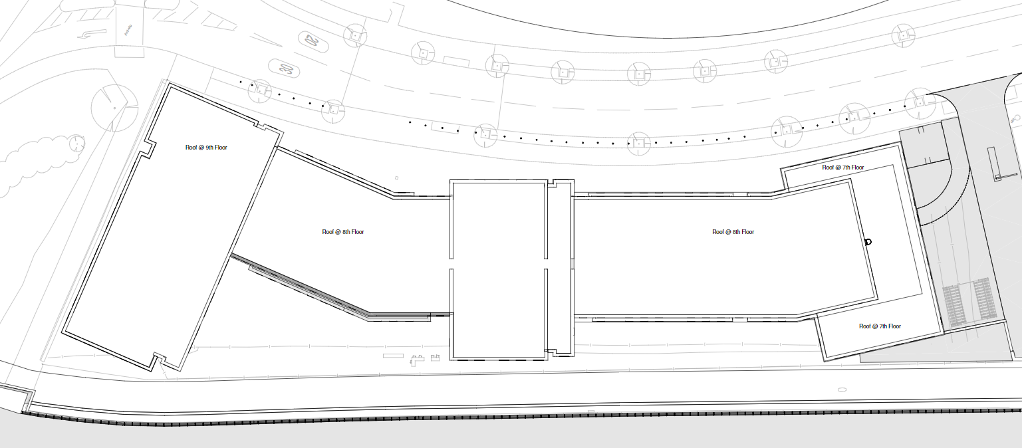  Programme control | Abstract  Report included Time, Cost and Resources for planning of a new SA1 student accommodation building, Plot A1.  Jonathan Andrew Triggs (1807834)  Construction Management

Original Gantt chart with Baseline

Contents
Time 2
Programme Overview 2
Critical Path 2
Work Hours 3
Cost 3
Overview 3
Breakdown 3
Progress Versus Cost 4
Resource 4
Resource Sheet 4
Resource Hours 5
Delay Scenario 6
Critical Path with Delay 6
Delay With Baseline 6
Contractual Implications 7
Productivity and Incentivisation 7
Client Specific Scenario 7
References 8

Time

Programme Overview
Below shows an overview of how long the project will take from start to finish. The project is divided up into category’s which shows how the work can progress as the building is erected. These categories can be opened to show the specific tasks that make up each category.
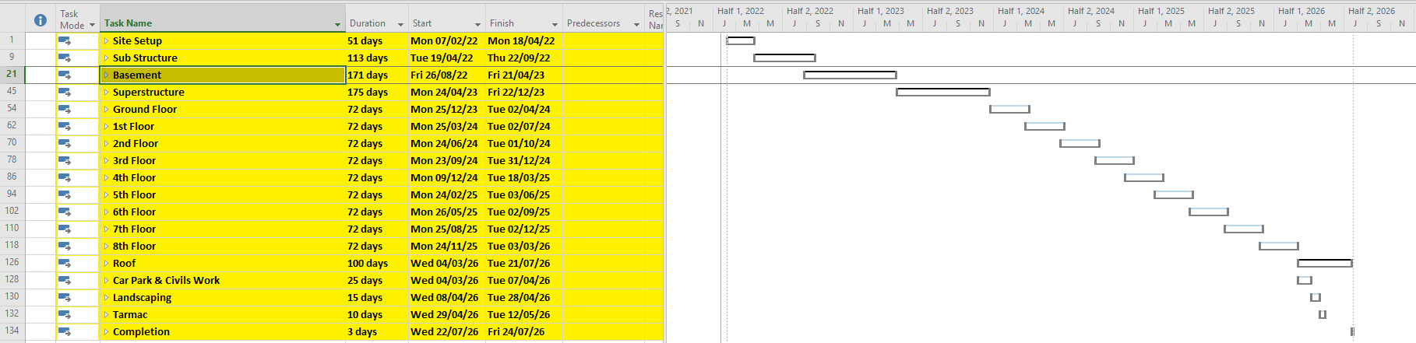
Figure 1 Project Gannt Chart Overview

Critical Path
This Image shows the critical path of the of the Gannt chart specifically the basement. The critical path is highlighted in red. This means that any tasks that are highlighted in red (part of the critical path) if delayed will then have a knock-on effect to the finishing date of the whole project. The tasks that are highlighted blue and are not part have the critical path and have float. This means that it has a date it must be completed by and is not restricted exactly to a start time.
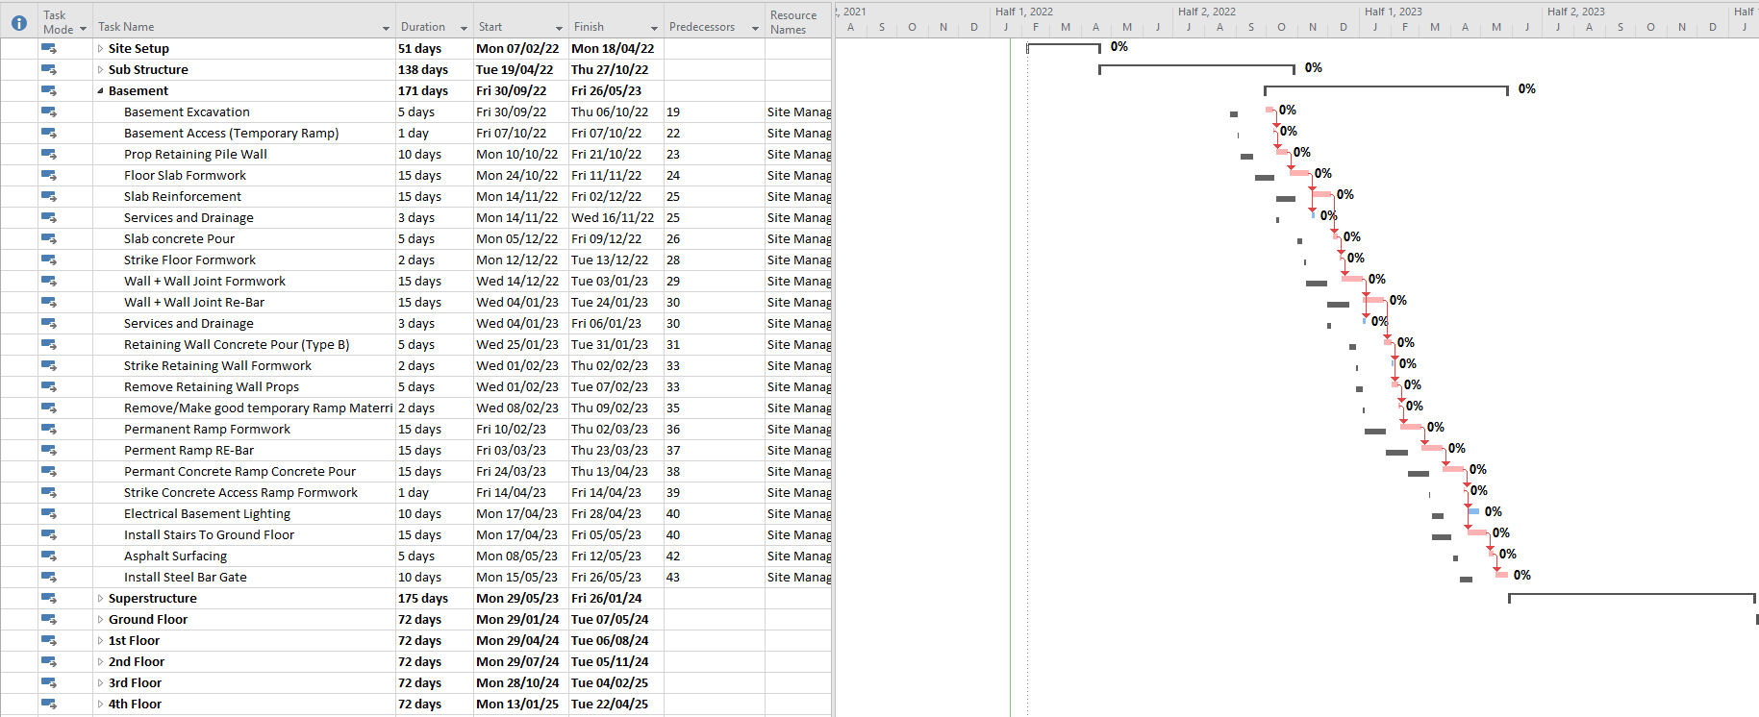
Figure 2 Basement Critical Path

Work Hours
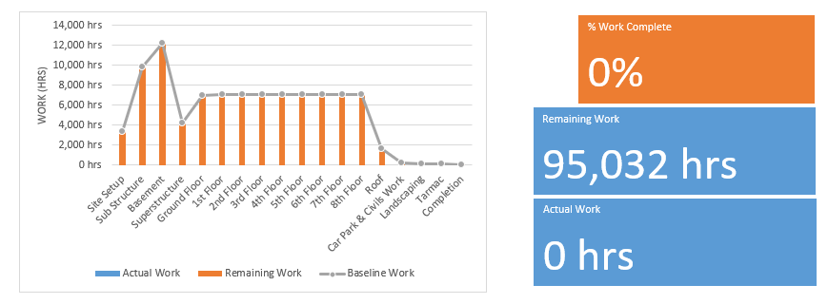
This Graph shows the required work hours that are required for each category within the building. As the programme focuses specifically into the basement the how’s can be seen to be the most in this section.

Figure 3 Total Hours Allocated to Each Category

Cost

Overview
This figure shows the estimated cost of the project. This includes plant cost, labour and material costs. This cost would have been calculated by considering how much of each resource is required throughout the project.
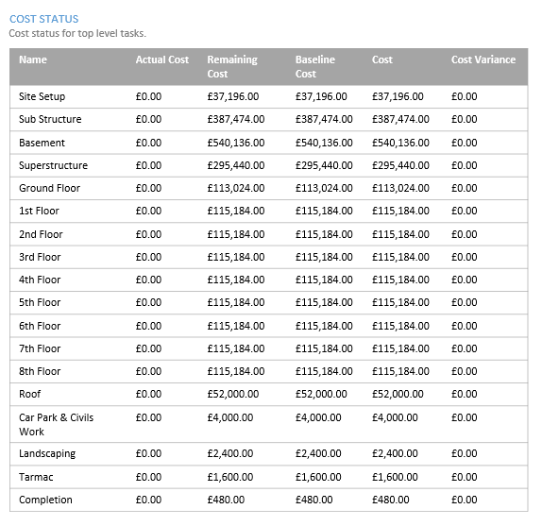
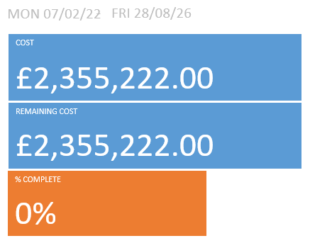
Figure 4 Cost Overview

Breakdown
This table shows how the predicted cost is made of each of the main tasks as part of the construction project. Again, as the project focuses specifically on the basement you can see that basement is going to cost the most.

Figure 5 cost Breakdown

Progress Versus Cost
This graph shows the cumulative cost of the project as it progresses through the construction phase. This graph would be used throughout the construction phase of the project to appropriately plan the appropriate spending for that point in the project spending to ensure that the project doesn’t go over budget.
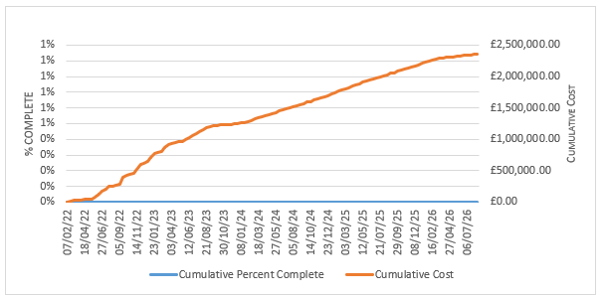
Figure 6 Cumulative Cost

Resource

Resource Sheet
This table shows every resource involved within this project. This included plant, labour and material that makes up all the costs. Each resources have a rate which can be used to estimate what every task will cost.
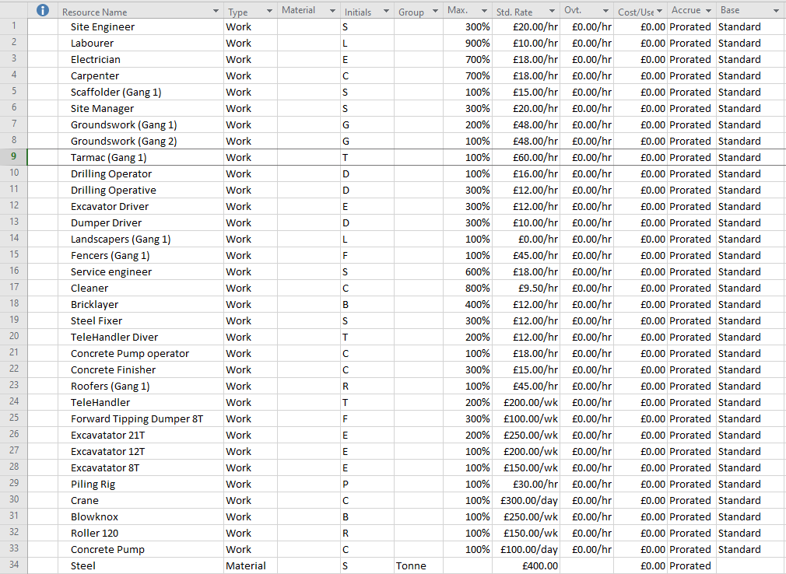
Figure 7 Resource Sheet

Resource Hours
Figure 8 breaks down at what date is each resource is required from start to finish. Between these dates the table also shows how many work hours are required of each the resources. This table will be able to be used throughout the construction process to keep on track of how many hours are left for each of the resources to complete their work.
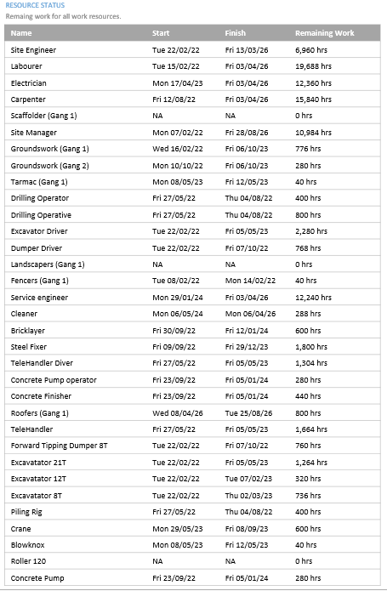

Figure 8 Resource Status

Delay Scenario

Critical Path with Delay
Figure 9 shows the programme with the concrete plant going on strike for 5 weeks. The gannt chart shows the addition of the delay which pushes the critical path away from the original baseline. The tasks prior to the CFA piling follow the original baseline as the need for concrete was not required but as the CFA piling requires concrete a lag of 25 days must be introduced because of the strike. As the CFA piling requires concrete and is on the critical path the project end date will be ushed on 5 weeks.
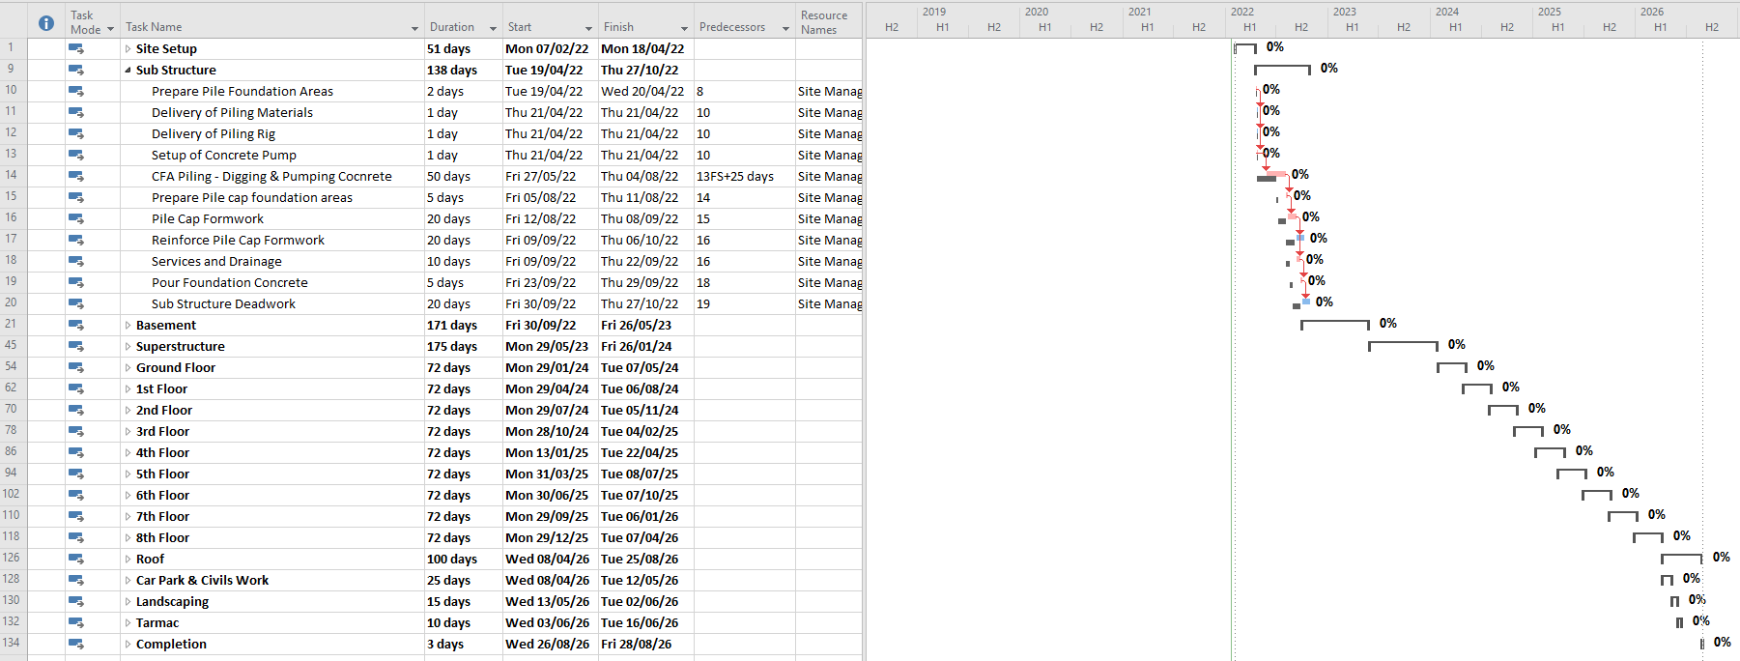
Figure 9 Delay shown on gannt chart

Delay With Baseline
Figure 10 clearly illustrates how each of the tasks within the construction project have been pushed further away from the original baseline, in turn pushing on the completion date. Again, you can see how all of the tasks are aligned with the original baseline prior to the delay that occurs when concrete is required for the CFA piling.
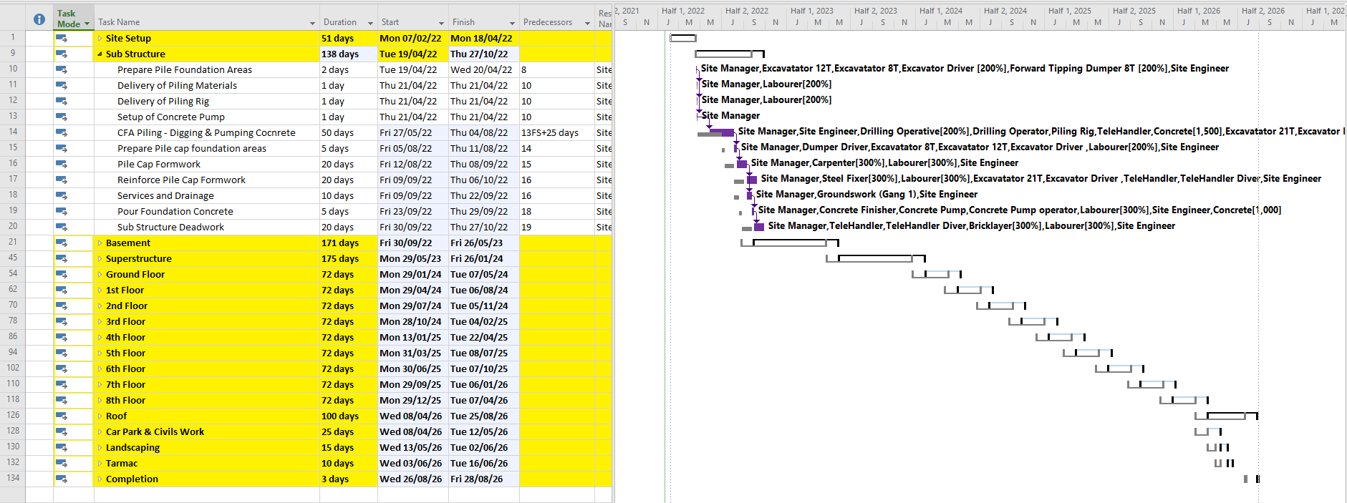
Figure 10 Delay with baseline

Contractual Implications
An event that delays work of a construction project is a delay event. The concrete plant going on strike would class as a concurrent delay. This is due to it not being either the clients or contractor’s fault. (Braimah, 2013)
The client could agree to stop work for 5 weeks until the strike is over. This would mean that the client would have to pay for all the resources left on standing until the 5 weeks are over. Labour however, if possible, could be placed elsewhere for the time being or could complete out of programmed works. If there is a penalty in the contract for late completion the client must arrange for a new completion date 5 weeks from the original programmed date so that the penalty would not be triggered. This would be called an extension of time.
Alternatively, A possible solution could be for the client come to an agreement with the contractor and decide if they are willing to pay extra to source concrete from a different supplier that would be situated further away. This would be if an extension of time would not be suitable as the completion date is crucial. However, this would have a cost implication as it will cost more for concrete to be delivered from a further distance. Aswell as the cost of delivery the time itself for the concrete to arrive on site could delay the rate in which the CFA piling could be completed. Proper planning would need to be put in place to ensure that concrete waggons are arranged to keep a continuous flow of concrete so that the Pilling rig is not on stop. However, having not being able to appropriately plan for the strike the concrete supplier may not be able to keep up with demand on such short notice.

Productivity and Incentivisation
There are multiple ways of incentivising people to encourage work productivity.
Clear Goals – Setting clear goals for the workforce can encourage them to continually better themselves in order to achieve them goals. If there is nothing to work towards in a workplace this can encourage a robotic workload and instead of the workforce continuously trying to push themselves, they are happy with producing the bare minimum.
Salary/Benefits/Job Security – Most likely most of the workforces’ main reason for being in work is to earn money. By increasing salaries and encouraging people to hit goals by introducing bonus’ this could increase the workload. Once the workforce is happy with these aspects and are happy with what they get in return for their labour they must then be happy with the security of these perks. This encourages a trust between the employee and employer.
Personal Life – Speaking to workers about their personal life is essential in finding out if it is affecting their work. Once identified possible solutions can be put in place to rectify the problem. An example of a possible solution would be to offer the appropriate time off to solves their personal issues. (Appelbaum, 2000)

Client Specific Scenario
To encourage the concrete supplier to produce concrete for the contract one possible option to increase business would be for the contractor to make an agreement with the concrete supplier to use them for future projects. This would guarantee future business for the company allowing them to introduce points talked about previously.
As part of this project the concrete company could be offered a higher rate than usual for the concrete if it is worth the ease of it being local and doesn’t outweigh the negatives of getting concrete from elsewhere.

References
Appelbaum, S. H., 2000. An analysis of the utilization and effectivness on non-financial incentives in small buissness, Concordia: Dover Finishing PRoducts.
Braimah, N., 2013. Construction Delay Analysis Techniques—A Review of application Issues and Improvement Needs, Brunel: Brunel University.
Scott, S.; Harris, R.A.; Greenwood, D. Assessing the new United Kingdom protocol for dealing with delay and disruption. J. Prof. Issues Eng. Educ. Pract. ASCE 2004, 130, 50–59.

