DEVELOPING INNOVATION AND CREATIVITY FOR BUSINESS ADVANTAGE
MODULE CODE – BMSW6102

University of Wales Trinity St David
BA LEADERSHIP & MANAGEMENT SKILLS FOR THE WORKPLACE

Executive summary
Why should organisations invest in innovation and creativity when it is known to be unscalable and unmeasurable, indefinite uncertainty, and plain risky? This paper looks at developing creativity and innovation for business advantage.
Alphabet previously known as Google has been named the most innovative company in 2021. The paper evaluates the overview of the innovation and use of innovation models. it looks at the complexity of innovation indicators, Leadership is a critical part of the innovation. The paper defines creativity and innovation and identifies some of the attitudes, barriers, and risks when adopting innovation and the role of the individual, team, and organisation in the creative and innovative process this involves exploration and exploitation. Excessive exploration at the expense of exploitation can be costly, as the tangible outcomes of exploration will only be realized in the distant future, and then only with considerable uncertainty. however, According to the resource-based view, innovation is a major source of competitive advantages in the era of the knowledge economy)
The research sources are from secondary sources, journals, books, websites, and YouTube
The Assignment was requested by the University of Wales Trinity St. David to be submitted on 25/3/2022.

Table of Contents
Introduction 3
An evaluation of an identified innovation opportunity within your chosen company. 4
An analysis of the models of innovation to support your identified innovation opportunity. 4
An indication of how the case study organisation would assess the effectiveness of the proposed innovation 7
An examination of an appropriate Leadership and Management style that aided The creative idea behind your identified innovation opportunity. 8
A discussion surrounding what is innovation and creativity and how they differentiate from each other. 10
How the creative thinking process can be applied to an individual, team, 13
organisational and industry level. 14
A discussion surrounding attitudes towards creativity and innovation to include an assessment of common barriers and risks involved with the organisation adopting 15
COMMON BARRIERS 15
RISKS 15
ATTITUDES 16
conclusion 17

Introduction

As marketplaces become more dynamic, interest in innovation, processes, and management has escalated. Organizations need to innovate in response to changing customer demands and lifestyles and to capitalise on opportunities offered by technology and changing marketplaces and structures, integrating innovation into the company culture is an important means to achieve success and foster innovation capabilities (Bullinger et al., 2007).
Alphabet, which was previously known as Google has made vast innovation initiatives of which both incremental and radical. Subsequently, it has been known as the most innovative company by Forbes magazine 2020
Developing creativity and innovation for business advantage has been the main goal of Alphabet and reflects on the mission statement Which is “Transparency, Voice, and Space” this forms the critical factors that serve as antecedents of innovation, which in turn lead to creativity and innovation.
The assignment will explore the evaluation of the innovation opportunity, an analysis of the innovation models used in the process and the indicators of the innovation as well as the leadership style used. Creativity and innovation are defined by exploring the similarity and differences, and by investigating the creative process in teams and individuals within the Alphabet organisation. Furthermore, this assignment will discuss barriers, risks, and attitudes towards innovation.

–

An evaluation of an identified innovation opportunity within your chosen company.

Alphabet is an internet-related umbrella company created in 2015 which was a restructuring move made by Google CEO Larry Page. This innovation opportunity narrowed Google’s scope by allowing other units to be subsidiaries. Thus allowing the different sectors to manage independently (Google Cloud, 2022) The structure and umbrella level are ambidextrous with a clearly defined leadership roles structure and the units are contextual with employees being more flexible. Alphabet has a high innovation rate and has taken a slant towards discontinuous innovation by upgrading better products in the market rather than being comfortable in a steady state, Auh and Menguc (2005) show that the level of competitiveness of the business environment influences the effectiveness of innovation orientations predicting firms' effectiveness and efficiency performance. As such Google has had fierce competition from Microsoft also a tech company this can explain its innovative environment.
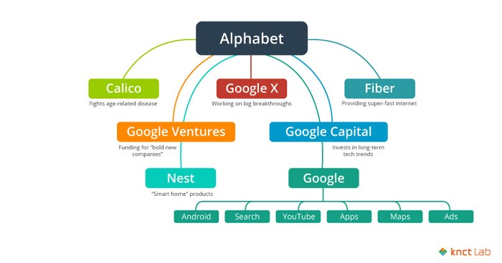
Alphabet Company Structure. Source: KNCT Lab

An analysis of the models of innovation to support your identified innovation opportunity.

Alphabet is a loosely interdependent unit. such dynamics, innovation, transformation, evolution, or reinvention call for conceptual clarity.
The independent units of the innovation models and processes are unique, with some being radical and others incremental. It uses open innovation to share information and gather knowledge for innovation.

George, 2015)

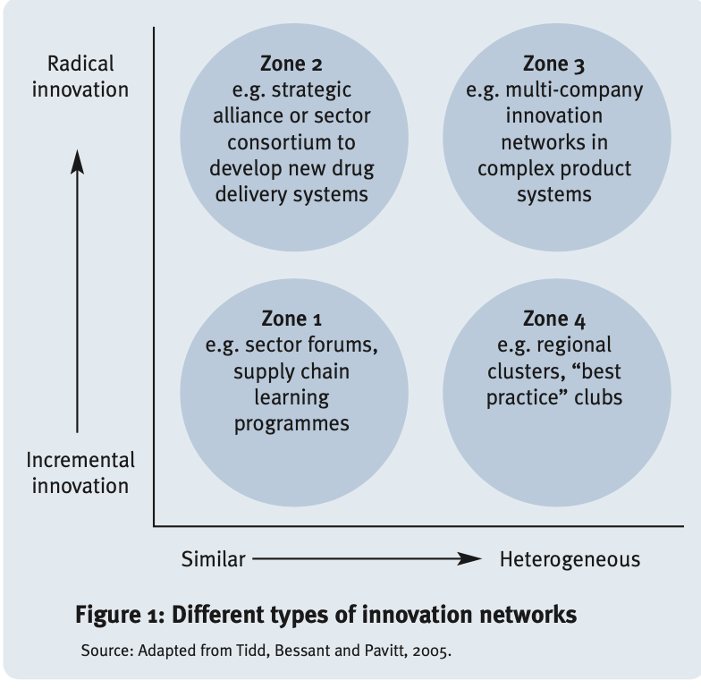

Some of the subsidiaries are listed below all in different sectors

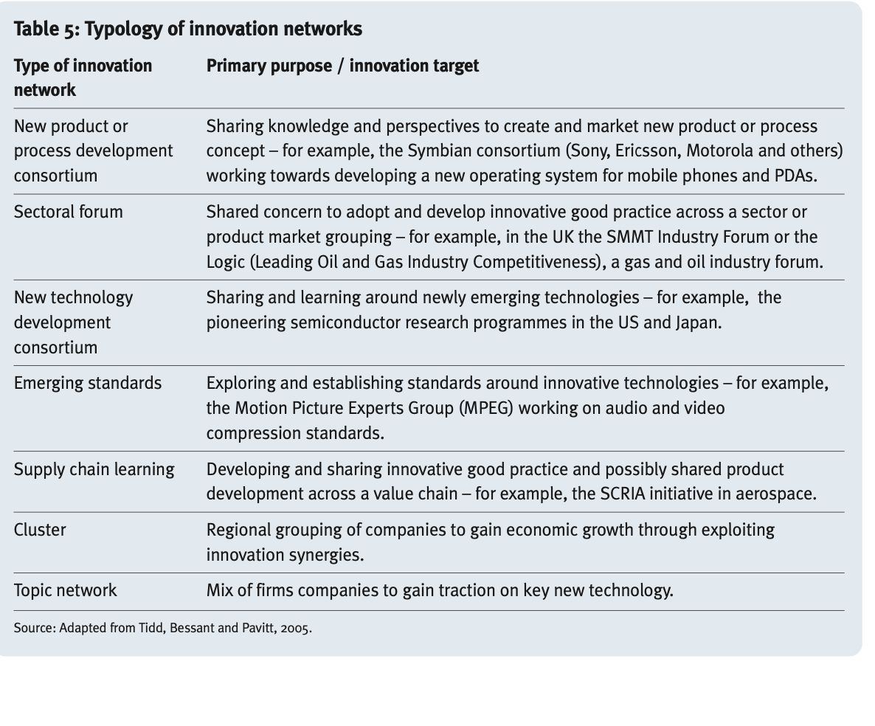

An indication of how the case study organisation would assess the effectiveness of the proposed innovation.

An indicator is considered a measured value that provides information about a specific phenomenon or a status quo. Information can be given in an aggregated form, which facilitates a focused evaluation (Born, 1997.) The choice of indicators should be based on and take into account the chosen innovative strategy and the objectives. in the scenario of Alphabet, the different units will have different indicators to reflect the different contexts in which they operate. Examples of indicators that indirectly and partially evaluate innovations are patents, research, and (R&D) budget (Hagedoorn and Cloodt, 2003) other indicators can be categories on the relationship between the rate of new product development and their antecedents, which are categorized into strategy, project, process, and team
.
Focusing on value creation which is not necessarily monetary like acquiring new mergers, increased reputation, and qualified staff also increases organisation competencies which is beneficial to all stakeholders.
Some of the indicators
- high market share
- customer satisfaction
- increased innovative products

The results can be used to better channel upcoming research on innovation decisions. Consequently, future research will enable policymakers and companies to improve their decision-making processes concerning innovation.
Nevertheless, it should be noted that in principle there is no universally correct measure of success in applying an innovation strategy. However, such a major indicator of the success of the application of the innovation strategy can be regarded as achieving the innovation objective

An examination of an appropriate Leadership and Management style that aided The creative idea behind your identified innovation opportunity.

“If your goals are ambitious enough, even failure will be a good achievement” ... CEO of google.
Numerous empirical studies have supported the notion that leadership style is an important determinant of an environment that fosters employee creativity. This is consistent with Yong’s (1994) assertion that one of the most significant forces for encouraging a creative climate is a trusting relationship between supervisor and subordinate. Literature relevant to Bass’s three leadership styles suggested several mechanisms through which transformational leaders create a climate that enhances organizational creativity that is, they encourage their followers to question assumptions, reframe problems, and approach old situations in new ways; all these behaviours are consistent with developing creative ideas (Wang and Rode 2010). Alphabet leadership encourages transparency and voice. Therefore transformational leadership will be positively related to the psychological climate for organizational creativity however laissez-faire leaderships style will be negatively related to the psychological climate for organizational creativity. Innovation leaders according to leadership forum 2006 were described as follows. They have a strong future and external focus, are curious and passionate about the case Therefore they cause a conducive environment for creativity and they also have a high tolerance for failure and risks. additionally, they have high emotional and intellectual intelligence. Some of the leaders of different units are listed below:
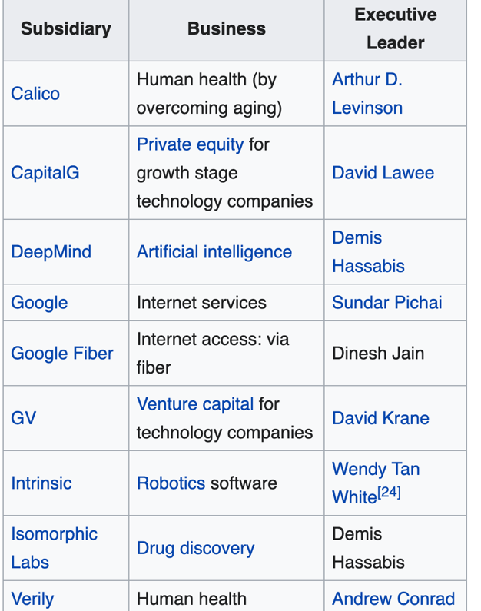

A discussion surrounding what is innovation and creativity and how they differentiate from each other.

Creativity in the workplace is defined as the process in which employees generate ideas to create, improve, or modify organizational products, policies, or procedures (Amabile 1996 and cummings1996) creativity is also defined as “the capability or act of conceiving something original or unusual.”(Hunter S, 2013) According to research on types of creativity conducted by Arne Dietrich Associate Professor of Psychology, she segmented creativity into four types which can be experienced by the same person at different times.
- Deliberate and cognitive creativities this use focused attention
- Emotional and spontaneous creativities stem from the amygdala
- Deliberate and Emotional
- Spontaneous and cognitive
The term innovation is derived from the Latin word Novus meaning new (Lewis&Short,1879) innovation has a plethora of definitions for this paper there are two definitions. One is” The multistage process whereby organisations transform ideas into new or improved products/services or processes, to advance, compete and differentiate themselves successfully in their marketplace." (Baregheh et al., 2009, p. 1334) the second definition by The Global Innovation Management Institute (GIMI) defines innovation as a way to create and capture new value in new ways. Baregheh et al grouped the definitions according to the theme. Organizational innovation can be grouped into four categories as products, process, position, and paradigm (Bessant et al., 2005). Paradigm Innovation, changes in the underlying mental models which frame what the organization does." (Bessant and Tidd, 2007, p. 13)

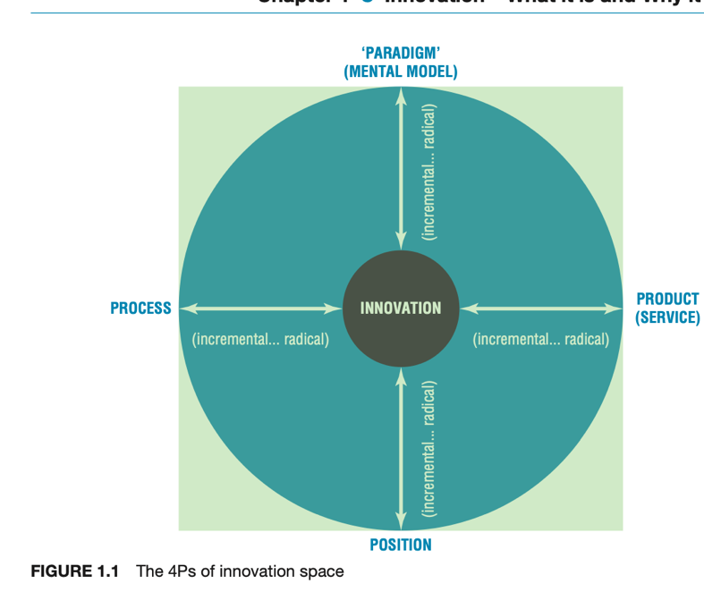

Through creativity and innovation are closely linked as part of a creative process they are not the same a notable difference is that creativity is not measurable. Brainstorming in a business meeting could be creative but action has to take place. Creativity is also subjective whereas innovation means new it can be radical or small incremental changes. The process is also replicable and scalable. Schumpeter talks of a process of ‘creative destruction’ where there is a constant search to create something new which simultaneously destroys the old rules and established new ones – all driven by the search for new sources of profits. In his view ‘[What counts is] competition, new products, and new income stream from the innovation, the new technology, the new source of supply, the new type of organization . . . competition which . . . strikes not at the margins of the profits and the outputs of the existing firms but their foundations and their very lives.
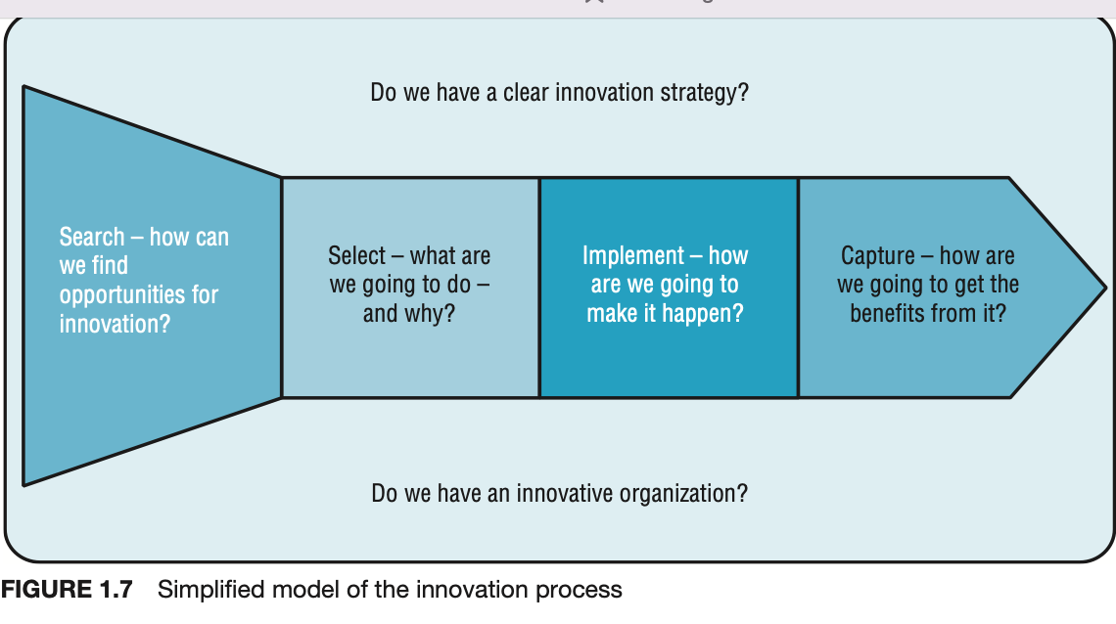
The importance of innovation in a business is to increase the organisation's capability for competitive advantage, it can also be used for survival. creativity makes the organisation dynamic.
Creativity and innovation can be fostered by leaders through having an innovative culture and knowledge management for instance reducing redundancies causing destruction of tacit knowledge. , lots of innovations depend on knowledge that has long been known but not applied to the current problem (Quintas et al,1997) another way of being innovative like in Google’s case is to be transparent. Meaning knowledge is easily stored and shared. Another way of organisation knowing is through feedback.
Innovation can be fostered and can not exist without creativity. Creativity does not only occur in arts and crafts, It can be spontaneous, focused, (Capilano et al )
.
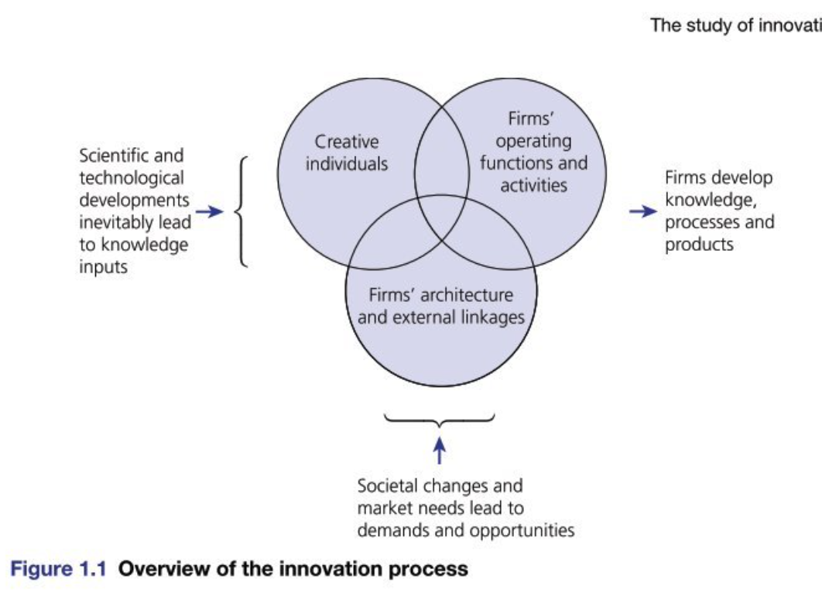
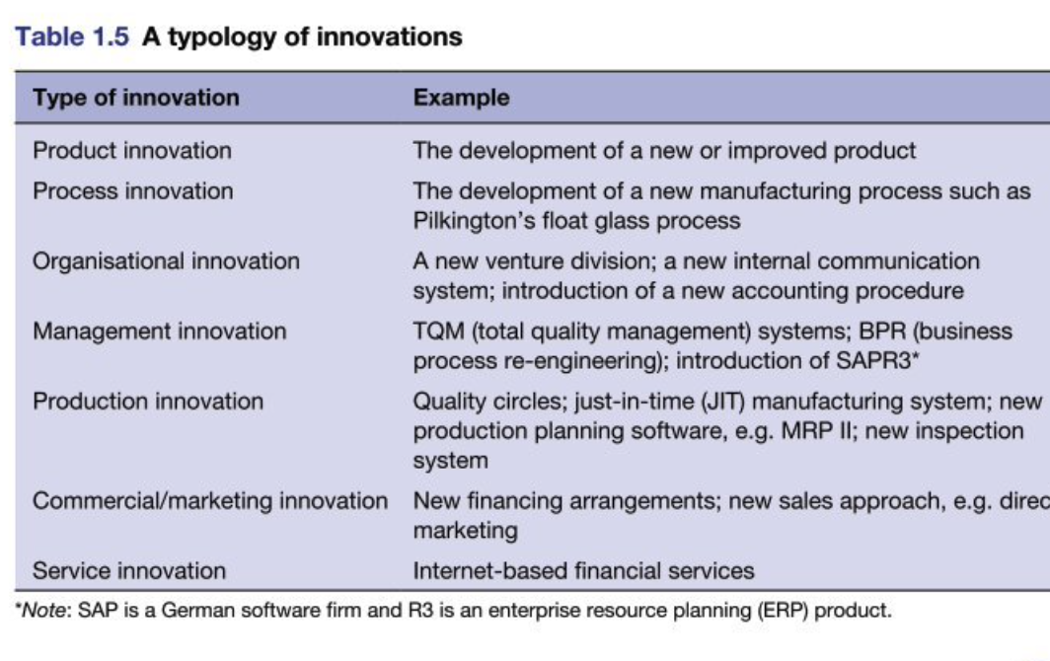

How the creative thinking process can be applied at an individual, team, or organisational level.

Individual creativity and organizational innovation are linked, the creativity of individuals feeds into the team and subsequently into the whole organisation. (Amabile and Pratt 2016), The relation is significant for both groups as creativity is important, without creativity nothing will be implemented so no innovation. Individual creativity relates to the whole job performance. Though creative people don’t have to be innovative. Innovation can be either process or product innovation. Therefore the individual requires more individual knowledge and creative self-efficacy to contribute to the team and be implemented by the organization (Ferreira et al)creativity can be intrinsic for example the individual being curious, or Extrinsic motivated to meet a deadline or challenge.

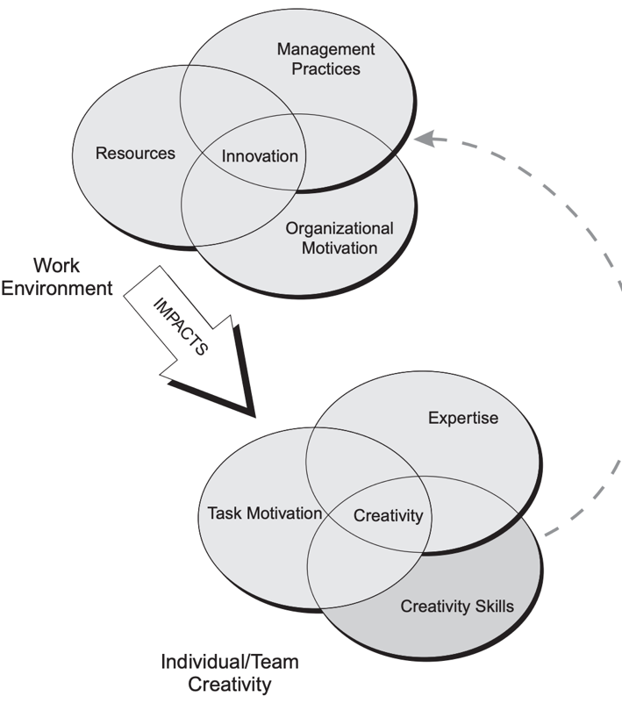

A discussion surrounding attitudes towards creativity and innovation to include an assessment of common barriers and risks involved with the organisation adopting

Common barriers

A common barrier to innovation Is that the actual success that is based on innovation cannot be captured the lack of resources e.g. capital, in the case of Alphabet the data on Research and development (R&D )expenses are given in a limited form, as many companies have strict confidentiality policies to secure their competitive advantage (Kleinknecht, 1993 ) explains the use the secrecy for competitive advantage. Unlike google small enterprises face the challenge of not having adequate capability this can be seen in the Resource-based view example of this are lack of qualified staff, information deficits, and technical information (Kleinknecht, 1989) R&D intensity seems to be influenced by knowledge and technology transfer activities (Arvanitis et al., 2008). R&D expenditures are accompanied by newly gained knowledge and by the building of networks among different organizations, research institutions, or universities (Cavdar and Aydin, 2015 other barriers include
- Lack of clear vision and strategy
- Not changing the culture
- Not able to identify new talent and non-creative ways of using resources.
- Lack of conducive environment for creativity for example authoritarian leadership
- Lack of system to enable innovation for instance Tesco has “the Red Door “ and gives an opportunity for new innovative ideas.

RISKS
“Every business and the very product has risks you cannot go around it “ Lee Iacocca American businessman. Born 1924
Partial thinking and understanding of the innovation process can be a risk. If the mental models are limited then the approach to implementing innovation can be a limited example of partial thinking
- Linear thinking an example is concentrating on only one aspect of the project. for example on R &D and not feedback.
- Seeing innovation as a major breakthrough and not including incremental innovation like in the case of Kodak, IBM, and Western Union.
- Not seeing the holistic effect of innovation. i.e. leadership, culture, and organisation capabilities.
Other factors are the technology that is too superior and fails to be user-friendly or having technology that is no longer needed due to a competitor producing better quality. Poor customer relationship management is also a risk. If the needs of the customer are not met this could be due to the time frame late delivery of products

ATTITUDES
The attitude is the main cultural implication for instance language translation can be a barrier to shared understanding. secondly, habits and assumptions can affect how people interact the negative result would be meeting deadlines, perception of risks, and delayed decision-making process. thirdly the increase in consumer awareness can affect brand reputation, more people are aware of the value chain, and in the information, age products can easily be traced which can cause reputation risk if regulations are not followed. Subsequently affects pricing and product performance. Political, Economic, Social, Technological, Legal, and Environmental changes (Pestle) factors are constantly changing and cause several variables. Decision-makers can have an attitude that the innovation is “too risky” on too uncertain this is when the likelihood of future events is unknown and unmeasurable.

conclusion
Alphabet previously known as Google made a radical change in 2015, By creating an umbrella company and having smaller subsidiary units. This has given the units more flexibility and the ability to innovate more. Due to its vast portfolio, the models vary according to the tasks. The innovation styles are both incremental and radical, with the use of open innovation promoting transparency and knowledge sharing. The indicators cannot all be captured but an increased market share, innovation of more new products, and increased overall organisation capability are reflected in a resource-based view which benefits all the stakeholders. Leadership plays a critical role in creativity and innovation in the organisation. Creativity can both be motivated by intrinsic and extrinsic within teams and individuals moreover the link between the team, and individual is significant. The risks, attitudes, and barriers

References
Amabile, Teresa M., et al. “Assessing the Work Environment for Creativity.” Academy of Management Journal, vol. 39, no. 5, Oct. 1996, pp. 1154–1184, 10.5465/256995.
Amabile, Teresa, and Harvard School. Harvard Business School Creativity and Innovation in Organizations. 1996.
Ang, Carmen. “Ranked: The Most Innovative Companies in 2021.” Visual Capitalist, 19 July 2021, www.visualcapitalist.com/ranked-the-most-innovative-companies-in-2021/. Accessed 19 Jan. 2022.
Bass, Bernard M. “Does the Transactional-Transformational Leadership Paradigm Transcend Organizational and National Boundaries?” American Psychologist, vol. 52, no. 2, 1997, pp. 130–139, 10.1037/0003-066x.52.2.130.
Ferreira, Jorge, et al. “Dynamic Capabilities, Creativity and Innovation Capability and Their Impact on Competitive Advantage and Firm Performance: The Moderating Role of Entrepreneurial Orientation.” Technovation, no. 92 -93, Dec. 2018, pp. 92–93, 10.1016/j.technovation.2018.11.004. Accessed 6 Mar. 2019.
George, Bill. “The World’s Most Innovative Company.” HuffPost, HuffPost, 28 Oct. 2015, www.huffpost.com/entry/the-worlds-most-innovativ_b_8406556. Accessed 14 Apr. 2022.
groupisd. “Leaders Can Turn Creativity into a Competitive Advantage.” ISD Global, 2016, www.groupisd.com/leaders-can-turn-creativity-into-a-competitive-advantage/. Accessed 14 Apr. 2022.
---. “Leaders Can Turn Creativity into a Competitive Advantage.” ISD Global, 2016, www.groupisd.com/leaders-can-turn-creativity-into-a-competitive-advantage/. Accessed 14 Apr. 2022.
Gryskiewicz, Stan, and Sylvester Taylor. Making Creativity Practical : Innovation That Gets Results. Greensboro, N.C., Centre For Creative Leadership, 2007.
Gupta, Ritu, and Pratyush Banerjee. “Antecedents of Organisational Creativity: A Multi-Level Approach.” Verslas: Teorija Ir Praktika, vol. 17, no. 2, 20 June 2016, pp. 167–177, 10.3846/btp.2016.624. Accessed 19 Dec. 2019.
Kleinknecht, Alfred, and Jeroen O.N. Reijnen. “Towards Literature-Based Innovation Output Indicators.” Structural Change and Economic Dynamics, vol. 4, no. 1, June 1993, pp. 199–207, 10.1016/0954-349x(93)90012-9. Accessed 11 July 2020.
Mindtools. “Porter’s Five Forces - the Framework Explained: Analyzing Competitiveness Using Michael Porter’s Strategic Model.” Mindtools.com, 2020, www.mindtools.com/pages/article/newTMC_08.htm. Accessed 30 Jan. 2022.
Peek, Sean. “Creativity Is Not Innovation (but You Need Both).” Business News Daily, businessnewsdaily.com, 24 July 2014, www.businessnewsdaily.com/6848-creativity-vs-innovation.html. Accessed 14 Apr. 2022.
Plater, Dan. “Innovation Hubs: Google’s New Alphabet ! - Dan Plater - Medium.” Medium, Medium, 5 Mar. 2018, medium.com/@danplater/innovation-hubs-googles-new-alphabet-f961f1bf10fa. Accessed 14 Apr. 2022.
Prajogo, Daniel I., and Pervaiz K. Ahmed. “Relationships between Innovation Stimulus, Innovation Capacity, and Innovation Performance.” R&D Management, vol. 36, no. 5, Nov. 2006, pp. 499–515, papers.ssrn.com Accessed 17 Nov. 2019.
Roubler. “Roubler.” Roubler UK, 2020, roubler.com/uk/resources/blog/category/innovation-technology/. Accessed 31 Jan. 2022.
TEDx Talks. “The Art of Innovation | Guy Kawasaki | TEDxBerkeley.” YouTube, 23 Feb. 2014, www.youtube.com/watch?v=Mtjatz9r-Vc. Accessed Mar. 20AD.
Tidd, Joe, et al. Managing Innovation ;Joe Tidd, John Bessant and Keith Pavitt : Integrating Technological, Market and Organizational Change. Chichester, Wiley, 2005.
Tidd, Joseph, and J R Bessant. Managing Innovation : Integrating Technological, Market and Organizational Change. 7th ed., Hoboken, Wiley, 2021.
warrilow. “Where Kotter’s 8 Steps Gets It Wrong.” Strategies-For-Managing-Change.com, 2019, www.strategies-for-managing-change.com/where-kotters-8-steps-gets-it-wrong.html. Accessed 30 Jan. 2022.

Task 1
“The most dangerous leadership myth is that leaders are born-that there is a genetic factor to leadership. That's nonsense; in fact, the opposite is true. Leaders are made rather than born. “—Warren Bennis

The lecture on leadership was extremely enlightening, it also emphasised on the importance of leadership considering that it kept appearing on every model. It was interesting to discover the role of leadership in the creative process. Looking at previous evaluations of leadership roles, each role changed according to the circumstances at hand. Find some of the styles listed below.
- Autocratic leadership style
- Bureaucratic leadership
- Paternalistic
- Democratic
- Laissez-faire
I was able to take a quiz in the lecture to establish my leadership style. surprisingly I discovered that my leadership style was autocratic this led to the question can leadership be learned or is it innate?
The results brought the link to other previously studied models a leader needs good communication skills, emotional intelligence, knowledge of culture, retaining and identifying good talent, good knowledge management this brought a holistic understanding of different leadership styles and the Leadership role of turning creativity to a competitive advantage, in the innovation process the leader took different roles as emulated by HBR article as follows;

- The Gardener fosters the conditions in which creativity can survive by preparing the ground in advance
- The Explorer leads from the front but does not instruct the members
- Player - Coach the leader is involved, engaged, and working closely with team members. This requires deep engagement with the ideas and knowledge of the desired project. This is a challenging role that involves nurturing new talent and asking strategic questions, providing spaces and tools that will encourage creativity
(Puccio, Mance, and Murdock, 2022), describe leadership as a factor that inspires change, while creativity is understood as a process leading towards the change. Involvement in creative thinking and stimulating other people’s creative ideas are the inalienable hallmarks of success in this process. Creative leaders stimulate the creativity of their subordinates, use their imagination to provide their staff with new directions of development, and build an organizational culture that is conducive to their creative ideas. They also provide structure or sort step-by-step guidance that completes the gaps in their ideas which makes it easier to visualise an end product, in comparison to this background, the issue of transformational leadership is revealed.
Several researchers have pointed to the role of leaders in Goal Clarity, results demonstrate the importance of problem definition in a creative process. In this scenario, it is assumed that people generally feel they are in a safe psychological work environment. Thus, leadership must link this to the innovation strategy (Callahan et al., 2021) It transpires that transformational leadership has a positive impact on the creativity of an individual. Leadership style in individual and team differs and this understanding helped me to link the strategic role of leadership when referring to the whole organisation. Additionally, Transformational leadership positively affects efficiency in the implementation of creative tasks, however. It can adversely affect original creativity because of the subordinates’ dependence on the leader that it this style generates (Kollman, Stöckmann, Krell, and Buchwald, 2011). However Laisssez-faire leadership encouraged a creative climate due to its hands-off approach but it was not conducive to innovation process (Hicks and Waddock, 2016).

Reference List
Manager, T., 2022. 9 Of The Most Popular Project Management Methodologies Made Simple. [online] The Digital Project Manager. Available at: <https://thedigitalprojectmanager.com/project-management-methodologies-made-simple/> [Accessed 13 April 2022].

Hicks, D. and Waddock, S., 2016. Dignity, Wisdom, and Tomorrow's Ethical Business Leader. Business and Society Review, 121(3), pp.447-462.
Puccio, G., Mance, M. and Murdock, M., 2022. Puccio, G. L., Mance, M., & Murdock, M. C. (2011). Creative Leadership Skills That Drive Change (2nd ed.). Los Angeles, CA Sage Publications. - References - Scientific Research Publishing. [online] Scirp.org. Available at: <https://www.scirp.org/(S(351jmbntvnsjt1aadkposzje))/reference/referencespapers.aspx?referenceid=2422640> [Accessed 13 April 2022].
Callahan, J., Bell, D., Davila, J., Johnson, S., Strauman, T. and Yee, C., 2021. Inviting ASPPB to address systemic bias and racism: Reply to Turner et al. (2021). American Psychologist, 76(1), pp.167-168.
Carter, S.M. and Greer, C.R. (2013). Strategic leadership: Values, styles, and organizational perform- ance. Journal of Leadership & Organizational Studies, 20: 375–393, http://dx.doi.org/10.1177/15 48051812471724.
Carter, E., 2013, Leadership and Innovation.

Task 2
HOW BUSINESS CAN BENEFIT FROM CREATIVITY AND INNOVATION

Creativity is not something where someone who has never worked in that field suddenly gets this marvellous idea. Creativity is relating a concept to a particular body of knowledge" John Hunt

Creativity is the beginning of the innovation process. Creativity and Innovation: identify opportunities for the company, within its area of expertise, and develop creative alternatives. It involves a degree of risks and barriers, it also Innovates in processes, patterns, and behaviours to find new solutions to new or old problems. According to Gupta and Banerjee (2016) therefore creativity and innovation work together to give an organization a Competitive advantage However, there is a clear distinction between the two. While creativity is the generation of novel and original ideas( Ferreira al ,2020), innovation is the implementation of them in a work setting (see West, 2002). Innovation is the specific tool of business, how they exploit change as an opportunity for a different business or service. It is capable of being presented as a discipline, capable of being learned, capable of being practised. According to the resource-based view, innovation is a major source of competitive advantages in the era of the knowledge economy. For example, is Accumulation of tacit knowledge is a competitive advantage because it cannot be replicated therefore successful innovation can make it more difficult for external imitation and allow a company to maintain its competitive advantages better. Some examples of how businesses can benefit from innovation for competitive advantage are:

- Strength of Patents protection, the business can benefit from patents
- Customer service by using innovative technology examples are robotics and Artificial intelligence.
- Several sources link growth to innovation. Therefore, it aids expansion., increase in market share.
- Having complex innovations that cannot be copied able and rare for instance having a machine that can not be easily copied like a robot with complex software. Is a competitive advantage.
- Timing is the first to innovate
- Having a Robust Platform like Alphabet where other subsidiaries can work
- By varying competitive factors for example, the cost price, quality, flexibility, and limited edition
Business model transformation and innovation are closely linked to each other, where modifying business models can drive innovation, or the business model itself can be subject to innovation (Zott et al., 2011). The transformation which results in a new definition of the existing product or service or adoption of new modes of value proposition, value creation, and value capture in an existing business is referred to as business model innovation.
A management model that has shown to be both unorthodox and successful in driving innovation is the Google model Google’s leadership, culture, HR/processes, and structure. (Strategos, 2021) another way that businesses can use innovation for competitive advantage is by including and forming an innovative strategy this can be done using VRIO analysis. The strategy can be built for sustained competitive advantage

- 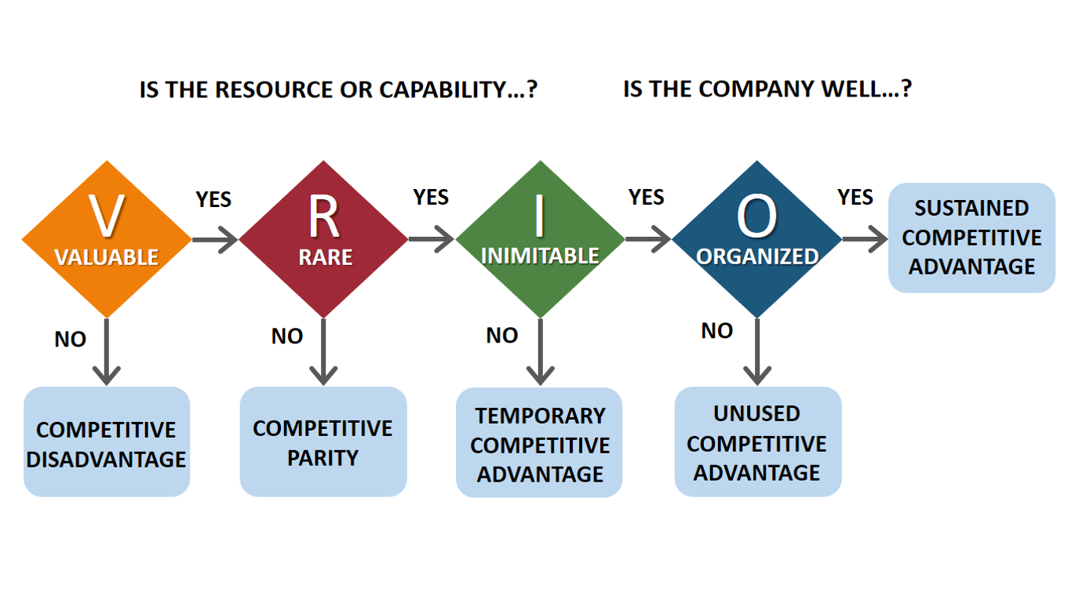

BAREGHEH, A., HEMSWORTH, D., ROWLEY, J. and DAVIES, D., 2012. The effect of organizational characteristics on position and paradigm innovation. Manchester, United Kingdom Manchester, Manchester: The International Society for Professional Innovation Management (ISPIM).
DZIALLAS, M. and BLIND, K., 2019. Innovation indicators throughout the innovation process: An extensive literature analysis. Technovation, 80-81, pp. 3-29.
FERREIRA, J., COELHO, A. and MOUTINHO, L., 2020. Dynamic capabilities, creativity and innovation capability and their impact on competitive advantage and firm performance: The moderating role of entrepreneurial orientation. Technovation, 92-93, pp. 102061.
LUTZ ALLEN, S., SMITH, J.E. and DA SILVA, N., 2013. Leadership Style in Relation to Organizational Change and Organizational Creativity: Perceptions from Nonprofit Organizational Members. Nonprofit management &amp; leadership, 24(1), pp. 23-42.
MEDCOF, J.W., R D Management - 2009 - ALBORS%E2%80%90GARRIGOS - Innovation Management and New Product Development by Paul Trott.
ŞIMŞEK, T., ÖNER, M.A., KUNDAY, Ö and OLCAY, G.A., 2022. A journey towards a digital platform business model: A case study in a global tech-company. Technological Forecasting and Social Change, 175, pp. 121372.

