Research in Practice. Dissertation Proposal. Rave, Culture & Design.

Student Name: Lauren Chard

Student Number: 1800919

Course: BA Graphic Design

Module: Level 5 Contextual Studies - 'Research In Practice’ (ADAD5004)

Word Count: 2,251

Lecturer: Donna Williams, Julia Lockheart

Rave, Culture, & Design
Proposed question for Independent Inquiry

In the short context of this study I will explore three keywords supported by three images, in integration with three visual designers, journalists and philosophers. Throughout investigating I will attempt to link the three keywords of rave, culture, and design to propose a question for my independent inquiry, exploring ideologies, communities, and spirituality. These relate artists Hattie Steward, Herbert Bayer, Production poster from the book ‘Rave Art’. These will coexist with journalist Simon Reynolds, psychologist FH Zervogiannis and philosophies from Yves Behar, The Bauhaus, Building of Success and The Golden Ratio.

Rave
A rave is a huge dance party that features live performances by DJs that would often play electronic music and dance music. Music would blast through massive amplifiers and subwoofers and produce a powerful, deep hard bass. This type of performance would display flashing lights, lasers, strobe lights with fog machines and would often project immense scaled visuals.
The genre is commonly known to originate from Chicago. (Decode Magazine, 2020:02). However, early British ravers were introduced to the culture by the 'acid' movement in the late 1980s (Omri, 2016:01). Music would also travel from summer events and parties from Ibiza, where raving claimed to be ‘born’. (Warren, 2007:01). Arranged in warehouses and even underground venues, people would dance until sunrise.
Electronic dance music (EDM) encompassed house, dubstep, progressive house and many others in 2010. ‘Raving’ now describes massive international festivals like Tomorrowland that attracted up to 400,000 thousand fans and world-famous DJ headliners (King, 2017:01).
In the eyes of adult society, the rave environment redeemed negatively due to the use of drugs and alcohol. Many people take drugs to escape from reality or to find more meaning in their present existence. Raves are contradictory to be experimental grounds. Young people have the purpose of searching for a sense of belonging and acceptance. It's seen as an opportunity, a challenge to which one can develop their limitations.
Humans need to experience harmony and peace. Ravers consider themselves to be a community. Where one can be who one is, without having to change one's views (FH, Zervogiannas, 2003:71).
Peace, love, unity, and respect (PLUR) is a philosophy involving ethical guidelines which include directions on how to act at a rave or club. To some participants, raves feel like religion (Reynolds, 1998:18). PLUR is important ideologically to the rave community because theoretically, the philosophy takes precedence over any chemical aspects of the rave scene.
In among the curation of illegal underground raves, drugs, and music, fashion became colourful and baggy, decorated with smiley faces and Om symbols. Rave tickets, flyers and posters depicted utopian worlds, with cyborgs and fractal landscapes, neon psychedelia with odalisque surrealism (Thorp, 2019:02). Ravers of Britain were creating one of the most original scenes and aesthetics since punk. And like punk, the era of raving left its mark on creatives.
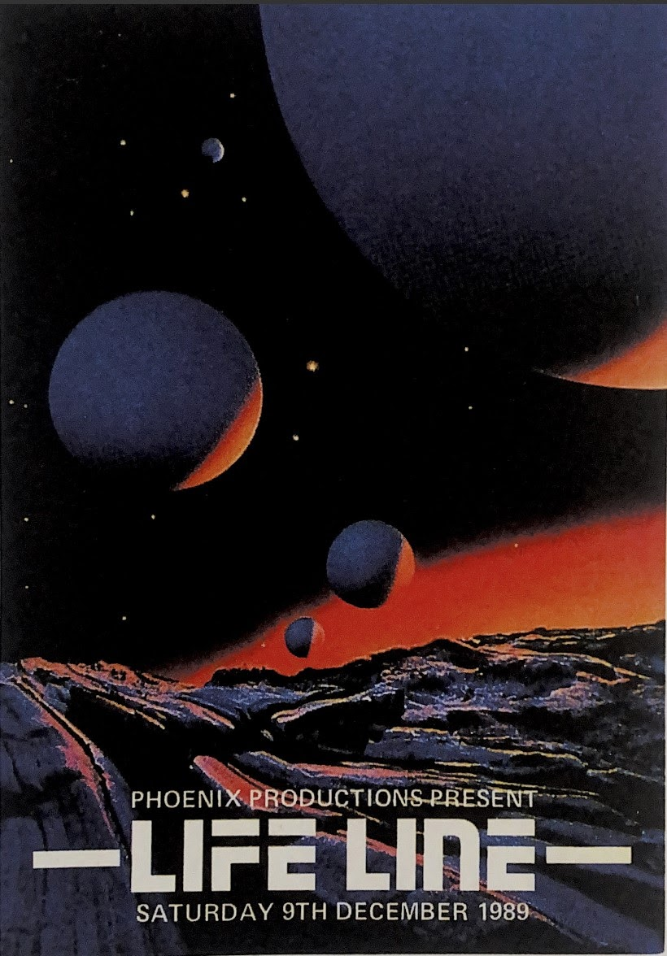
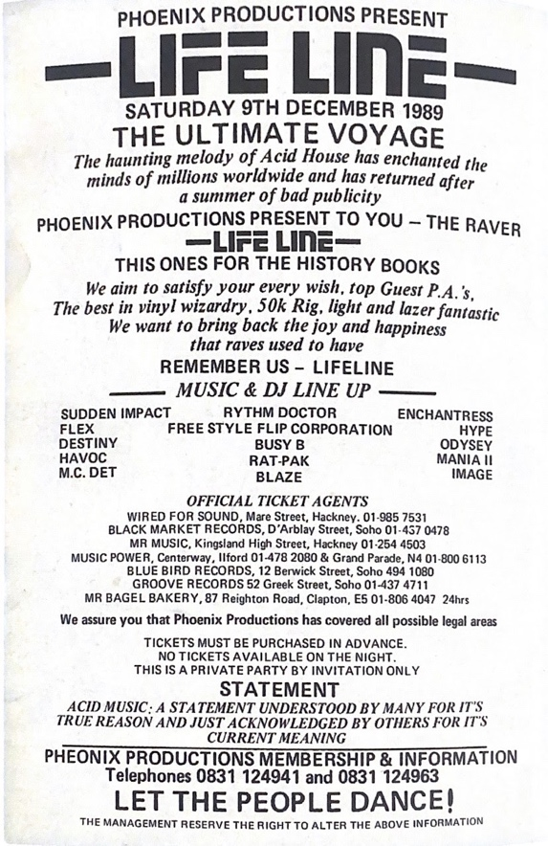

Lifeline Poster ‘Rave Art’ (Berlin, 2014:150)

Phoenix Productions present ‘The Ultimate Voyage’, LIFELINE event December 1898. The haunting melody of Acid House has enchanted the minds of millions worldwide and has returned after a summer of bad publicity. This flyer design struck me, it's one of my favourites. The book itself is full of extravagant designs. It’s so fascinating and surreal. Clubbing and nightlife have become a focal point of art gallery and museum collections in recent years, with their powerful combination of youthful abandon and dancefloor euphoria (Elephant, 2019:01). Rave posters from the 1980s feature conventional styles and aesthetics.
Typography is flamboyant and bold, neon-like colours, stencil and stamp like prints, delinquently imagery collaged together to serve a purpose that has become all but redundant in today's society of online promotion: advertising the wheres, whens and hows of the party (Gosling, 2016:02). The themes were vibrant to reflect their revellers and fonts large enough to read in 'chemical daze'.
The influence of work like this is represented in modern design. Even in today’s commercial graphic design and an example of this is the 2012 Olympics identity designed by Wolff Olins. Frank Ocean’s new visual album, ‘Blond’ released a 21st-century version of race culture’s imagery, warped lettering, glyphs and morphed tones. Thanks to the nature of early raves, flyers, posters and tickets. Even more specifically, the illegal underground events. Alongside the distinctive fashion era that also contributed fluorescent graphic signifiers. That frequently makes an appearance in today’s contemporary art and fashion runways.
Culture
Culture is the characteristics and knowledge of a distinct community, encompassing language, religion, cuisine, social habits, music and arts (Zimmermann, 2017:01). The word "culture" originates from the French term and Latin term "colere" which means ‘to tend to the earth and grow, or cultivation and nature which is something I found really interesting’ (Zimmermann, 2017:01).
There are many cultures in society, and there is constant change. In every culture change is inevitable. It has become relevant and key to our interconnected world. Today's world is made up of so many ethnically diverse societies that experience many disagreeing conflicts. Culture is no longer rigid, even if it ever was. It is essentially fluid and constantly in motion (Zimmermann, 2017:01). It is difficult to define culture down to one simple definition.
Max Weber has an interesting concept where culture is viewed as value. However, Max Scheler considers culture 'as the sphere' of ideals. Connoting the formation of art, religion, and philosophy. Against 'real material' which refers to economy, state and family. These are needs which structure the life of the spirit of a man. More so, culture without the spirit of man is simply not possible. Culture is 'highlighted as an expression of the essence of a person concerning the surrounding world' (Simply Philosophy 2020:01).
A man of spirit, the Swiss-born designer Yves Behar, founder and principal designer of Fuseproject - an industrial design and brand development firm. Behar is a man of his own methods and prescribes a direction for others to follow. Influenced by Modernist Dieter Rams, who in the 1970s depicted ten-point edict outline “good design”, Behar took it upon himself to curate his own ten commandments. Yves seeks out challenging projects with the potential to empower communities and democratize design. A designer whose creative brilliance is matched by drive for positive social change (Baily, 2017:03).
Cultural group members are subject to some degree ‘isolated from institutions and practices that work to socialize outsiders’ (Patten 2014: 52). This is what distinguishes one culture from another. With this in mind, it places significant ideology on the principle of institutions, to which individuals are subject to shape their own experience and influence members which are less involved, in some fundamental ways.
A large part of culture is that many people inside will have important connections, but which define them in multiple, distinct ways. This explains the ideology of why individuals remain attached to their culture, even when defining features shift, drastically or historically over time, even if they do not engage with some of its traditional aspects. (Stanford, 2020:1.4).
We live in a globalized world that continues to grow in our connections. It is important to understand and be aware of the impact of a visual message and how it can have an effect on society. In the design community it is critical to incorporate diversity, and correct representation in design work. Artists from many cultures are constantly engaging in cultural appropriation. Picasso was famous for appropriating motifs which originally came from the work of African carvers (J. Young, 2010).
Cultural appropriation is commonly practised in design today. Appropriation of another culture involves choosing only the elements that appeal to you and simply overlooking the rest, along with any valuable cultural context behind those elements. Cultural appreciation is the respectful borrowing of components from another culture with an interest in exploring ideas and diversifying one's self (Cuncic, 2020:06). But beyond the greatness and exploration it’s a practice that triggers genuine anxiety over the “watering down” of other culture. It’s explained it’s a combination of ‘fear and frustration’. Designers often experience loss of their more traditional craft, just this issue prompted Indian Graphic Designer Kawal Oberoi. Who launched his online Swatch Bharat platform, designed to promote indigenous aesthetic but is being continuously pushed out for more western looking designs (Long, 2020:01).
The same cultural crisis is being experience by Sadie Red Wing, a Native American student. She claims to push Native Americans to be “classified designers instead of primitive artists”. Sadie exclaim the issue of appropriation is not just lack of acknowledgement of ‘source material’, but how it is playing into the depicting the indigenous society. Native American design aesthetics are rooted symbol, icons and pictograms. Which is certainly appealing to some designers but there needs to a level of respect, Sadie claims. As experimenting with these element does not inherently cause harm, however, it’s when designs ‘resemble a family tree of signifies the specific group of people in a region (Long, 2020:01).

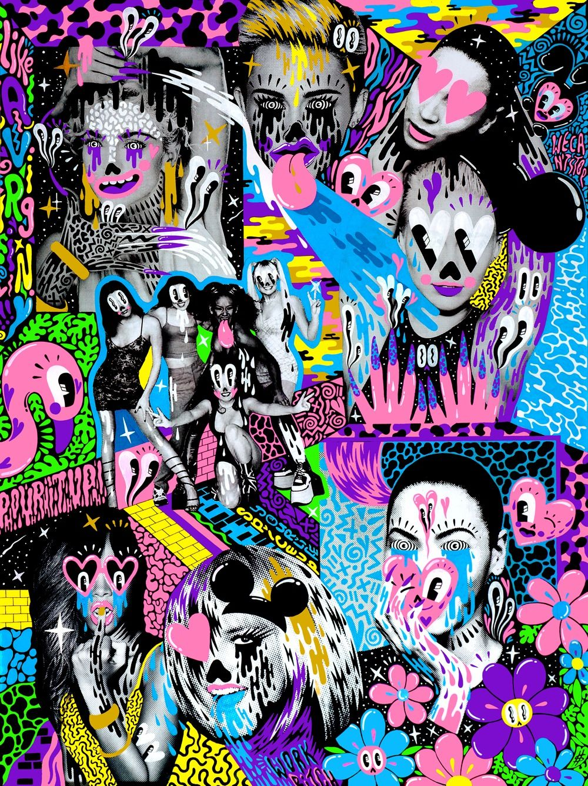

PopArt Collage, Illustration - Hattie Stewart, 2014

Design
Design is a plan or specification for the construction of an object; to create and execute an idea. Design can be architecture, fashion, product, and graphics. Design theory results in the fundamentals and principles of creating visual communication and all types of art. It's the concept of perceiving visual information that separates ideas of taste, styles and trends from the domain of aesthetics which are conventional to every person. The foundation of design; is photography, illustration, and visual arts. The common visual language connects designers and image-makers from history to the current day continent (Lundgren, 2020:01).
It’s essential to learn the design theory as a creator as it distinguishes you from a technician to a designer. When the principles such as balance, order, hierarchy, structure, colour, value, composition, scale, space, texture etc are understood you have the potential to solve a problem with a purpose that results in successful design (Lundgren, 2020:01).
Design theory is a system of ideas that explain how and why a design works. Design Theory gives the knowledge and the ability to combine form and function. Which is the foundation of a successful Design (Bauhaus; Building on Success). Bauhaus was one of the influential cultural movements of the 20th century. Its core objective was a radical concept: to reimagine the material world to reflect the unity of all the arts. (Bauhaus, 1919).
It was clear from the beginning that Bauhaus stood for creating beauty through purposeful design and uncompromised by mass production. It was about creating something straightforward and useful.
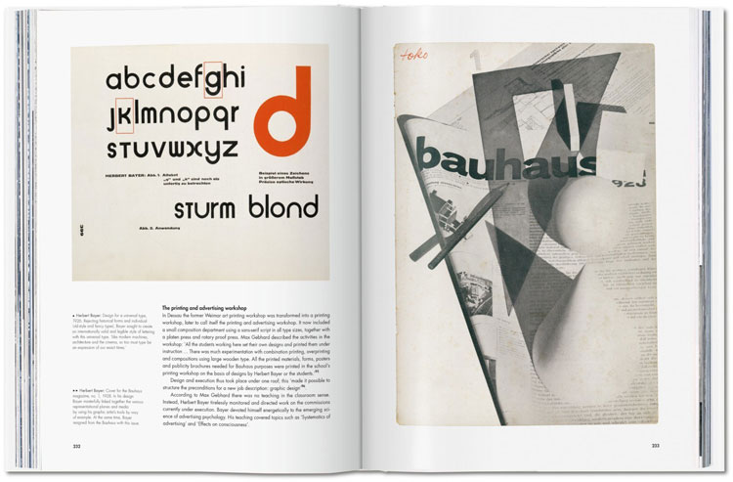
From the book 100 Years of Bauhaus Herbert Bayer’s Universal Alphabet (1925)

In 1925 the universal Bauhaus typeface was designed by Herbert Bayer. Designed functionally, accessible and noted for the combination of upper and lowercase characters into a single character set whilst eschewing serifs- which has been described as pleonastic and overly decorative. Bayer designed this universal typeface to make typesetting easier (Banks, 2019:05).
The key goal in design is to create clear and understandable designs; organised pages balanced with easily readable information which naturally results in a better experience for users. There are many tools out there including, rules, grids, columns to help make this happen.
The golden ratio is a mathematical ratio, found in many both natural and designed, that dictates most pleasing proportions of a shape or structure (Rae, 2020:01). The theory that date back historically to the time of Pi. It is something that has been used throughout design history by philosophers, architects and of course designers. To enable them to create aesthetically appealing, pleasing designs and structures. (Rae, 2020:02). The harmony of proportion has been recognised before Parthenon in Greece and the Pyramids in Egypt where architects leveraged this ratio to create a balance between structural essentials. The golden ratio can be leveraged in digital design through wireframes, logo design, development and final production designs. It's a fact that our brains are seemingly conditioned to prefer objects and images that use the golden ratio. It’s explained as a subconscious attraction and even the smallest of tweaks that make an image more like the golden ratio have a bigger impact on our brains.

Evaluating the construction of the word rave guided me to considerations of sub-genre topics such as rave art, rave music, substance abuse, psychedelia, and spirituality, all of which can be considered and taken under further investigation.
Throughout my studies and exploration of three keywords, contextualising these have led me to a lot of information, a lot of ideas, about the proposed question. There is a strong relationship between rave, culture and design. it was difficult to keep them segregated. I recognised that exploring rave culture led me to excitement and interest. However, as for culture, I was a little surprised it sparks much interest as I had previously studied culture and culture appropriation in comprehensive studies.
Are the following working questions “How has rave art influenced contemporary design?”, “Is the rave scene a distinct part of youth culture in the UK?”, “Are cultural traditions outdated in today’s contemporary world?”, “Why is substance abuse becoming more popular in youth culture?”, “Are raves considered spiritual experiences?” , “Does rave culture and spiritualism collide?”, “The birth of rave culture in the UK?”, “The beginning of psychedelic art in subculture in the 1960s?”, “Reflections on the direct influence of psychedelics on art?”, “How LSD influenced Western Culture?”.
The concepts of rave, rave culture, subculture, psychedelia, art, spiritualism, contemporary design, techno shamanism, odalisque surrealism have been considered for future exploration within independent research inquiry, under my working question for next year.

Biography
- https://www.technostation.tv/90s-rave-culture/ Magazine (Omri, 2016:01)
- https://www.decodedmagazine.com/house-techno-rave-culture-social-political-ramifications/ Magazine Article(Decoded, 2020:02)
- https://www.theguardian.com/music/2007/aug/12/electronicmusicThe Guardian Newspaper (Warren, 2007:01)
- https://www.electronicbeats.net/simon-reynolds/ Interview (Simon Renoylds, 2013)
- http://uir.unisa.ac.za/bitstream/handle/10500/19461/Zervogiannis__FH__18688857__Section3.pdf?sequence=3&isAllowed=y (FH Zervogiannas, 2003)
- ​​https://haenfler.sites.grinnell.edu/subcultures-and-scenes/edmrave-culture/ (King, 2017:01)
- https://fadmagazine.com/2019/04/16/the-art-of-rave-why-contemporary-art-loves-rave/ FAD Magazine, (Thorp, 2019:02)
- https://elephant.art/night-long-rave-nostalgia-became-part-contemporary-culture/ Magazine (Elephant, 2019:02)
- http://www.hattiestewart.com/about/
- https://eyeondesign.aiga.org/what-rave-culture-is-teaching-modern-graphic-designers/ (Gosling, 2016:01)
- https://www.livescience.com/21478-what-is-culture-definition-of-culture.html (Zimmermann, 2017:01)
- https://plato.stanford.edu/entries/culture/ (Stanford, 2020:)
- https://simplyphilosophy.org/category/culture/ (Stanford, 2020)
- http://blog.soton.ac.uk/wsapgr/2015/05/22/cultural-ownership-and-appropriation/ (J.Young, 2010)
- https://www.verywellmind.com/what-is-cultural-appropriation-5070458 (Cuncic, 2020:06)
- https://www.designweek.co.uk/issues/9-15-march-2020/cultural-appropriation-in-design/ (Long, 2020:01)
- https://alvalyn.com/what-is-design-theory/ (Lundgren, 2020)
- http://blog.soton.ac.uk/wsapgr/2015/05/22/cultural-ownership-and-appropriation/
- https://www.metmuseum.org/toah/hd/bauh/hd_bauh.htm#:~:text=The%20Bauhaus%20was%20founded%20in,unity%20of%20all%20the%20arts. (Bauhaus, 1919), (Winton, 2007).
- https://medium.com/thinking-design/the-golden-ratio-how-why-to-use-it-in-design-3ea6f943f8af (Rae, 2020:01
- Image Reference 1: Lifeline Poster ‘Rave Art’ Book (Berlin, 2014:150)
- Image Reference 2: https://www.pinterest.co.uk/pin/213850682281236882/
- Image Reference 3: https://www.designweek.co.uk/issues/18-24-february-2019/bauhaus-what-was-it-and-why-is-it-important-today/

