Physical Activity and B US electehavioural Regulation for Taking Part in Exercise
Introduction
Physical activity (PA) is fundamental to maintaining physical and psychological health. Regular exercise is associated with a reduced risk of chronic disease, enhanced mood, cognitive function, and improved overall wellbeing (Warburton & Bredin, 2017). Despite widespread recognition of these benefits, a large proportion of individuals fail to meet global physical activity guidelines (World Health Organisation, 2020). Understanding the psychological mechanisms that influence PA engagement is there for essential for developing effective, sustainable interventions.
A prominant framework used to explore motivation in exercise contexts is Self-Determination Theory (SDT; Deci & Ryan, 1985). SDT posits that motivation exists on a continuum ranging from amotivation (a lack of intention to act), through controlled motivation (external and introjected regulation), to autonomous motivation (identified, integrated, and intrinsic regulation). More self-determined forms of motivation are consistently linked to better adherence, enjoyment, and long-term participation in PA (Teixeira et al., 2012).
The Behavioural Regulation in Exercise Questionnaire – 3 (BREQ-3; Markland & Tobin, 2004) enables researchers to assess where individuals fall along this continuum. It has been widely used to examine motivational differences across populations and activity levels. For instance, research has shown that those who are more physically active often exhibit higher levels of intrinsic or integrated regulation, whereas less active individuals tend to rely more on external pressures or internalised guilt (Ingledew & Markland, 2008).
University students form an important demographic for studying PA behaviour. While this group is often perceived as active, factors such as academic workload, stress, and social distractions can disrupt exercise patterns and undermine motivation (Keating et al., 2005). Research has demonstrated that students’ motives for exercise can vary widely—from health and fitness goals to appearance-related and social motivations (Gaston & Prapavessis, 2014).
This report explores the relationship between behavioural regulation and physical activity levels in a sample of university students. Using data from the BREQ-3 and the International Physical Activity Questionnaire – Short Form (IPAQ-SF), the report compares motivational profiles between students with Moderate and High PA levels.
Method
Participants
Data were collected from 33 undergraduate students at the University of Wales, Trinity Saint David. Based on responses to the IPAQ-SF, participants were classified into two groups: Moderate activity level (n = 18) and High activity level (n = 15).
Measures
Participants completed two validated questionnaires:
BREQ-3 measured six types of behavioural regulation: amotivation, external, introjected, identified, integrated, and intrinsic.
IPAQ-SF assessed physical activity levels and categorised individuals into activity groups.
Procedure
Questionnaires were distributed online. Responses were anonymised, and group means, and standard deviations were calculated for each form of motivational regulation.
Design
A cross-sectional, between-groups design was employed to explore differences in motivational regulation across activity levels.
Results
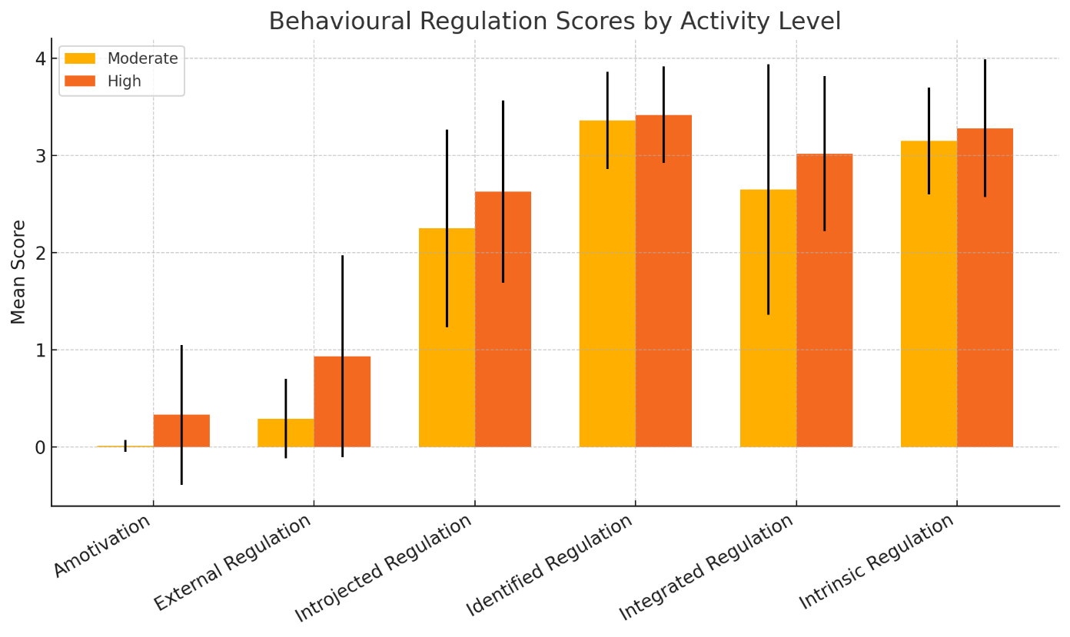
Regulation Type | Moderate (n = 18) | High (n = 15)
Amotivation | M = 0.01, SD = 0.06 | M = 0.33, SD = 0.72
External Regulation | M = 0.29, SD = 0.41 | M = 0.93, SD = 1.04
Introjected Regulation | M = 2.25, SD = 1.02 | M = 2.63, SD = 0.94
Identified Regulation | M = 3.36, SD = 0.50 | M = 3.42, SD = 0.50
Integrated Regulation | M = 2.65, SD = 1.29 | M = 3.02, SD = 0.80
Intrinsic Regulation | M = 3.15, SD = 0.55 | M = 3.28, SD = 0.71

Figure 1 Bar chart comparing mean regulation scores between Moderate and High activity groups.
Summary of Findings
Both groups demonstrated high levels of identified, integrated, and intrinsic motivation, suggesting a strong internal drive for exercise. The High activity group reported higher scores across all regulation types, including external regulation and amotivation—although the latter remained low overall. Introjected regulation was also higher in this group, indicating some internal pressure may coexist with more autonomous motivations.
Discussion
The findings align with the principles of Self-Determination Theory, which asserts that more autonomous forms of motivation are linked to greater engagement in physical activity (Deci & Ryan, 1985). Both the Moderate and High activity groups demonstrated high levels of self-determined motivation, with identified, integrated, and intrinsic regulation scoring highest. This suggests that students in both categories value exercise and find it enjoyable and personally meaningful.
As expected, participants in the High activity group scored slightly higher in intrinsic and integrated regulation, indicating a stronger internalisation of exercise behaviour. This is consistent with findings by Wilson et al. (2003), who reported that individuals with higher activity levels often view PA as part of their identity, resulting in more sustainable engagement Qualitative insights from student samples could provide a broader way of understanding of these trends for example, a student in the High activity group might say, “Going to the gym isn’t just about fitness anymore it’s part of who I am and how I cope with stress.” This reflects integrated regulation, where physical activity aligns with one’s self-concept. Another student might comment, “I genuinely enjoy playing football with my mate’s t’s the highlight of my week,” illustrating intrinsic motivation rooted in enjoyment and social connection.
Surprisingly, amotivation and external regulation were also higher in the High activity group, albeit still low overall. This suggests that even highly active individuals may experience mixed motives, including some external or controlled influences—perhaps related to social expectations, competition, or appearance concerns. These findings are supported by Sebire et al. (2009), who reported that individuals often engage in PA for multiple, sometimes conflicting, reasons.
The narrow standard deviation for identified regulation in both groups (SD = 0.50) suggests a shared belief in the value of PA among this student sample. In contrast, the larger variability in integrated regulation within the Moderate group (SD = 1.29) may indicate a transitional phase, where some individuals are beginning to internalise exercise as part of their identity, while others remain less integrated.
Practical Implications
Interventions aiming to increase PA among students should prioritise the development of autonomous motivation. Strategies such as autonomy-supportive coaching, peer-led goal setting, and reflective activities can promote internalisation. Educators could incorporate value-based goal frameworks to help students connect exercise to personal aspirations by having a mentor to set goals with students and help them work towards them to achieve their goals.
Limitations and Future Directions
This study’s cross-sectional design. The sample size was modest and drawn from a single university population, which may reduce generalisability. Future research could explore motivational regulation longitudinally or in more diverse cohorts, including non-student populations. Qualitative methods could also provide deeper insights into the lived experiences behind motivational patterns such as focus groups because it helps capture shared experiences between a group which helps collect data for the studies , also doing semi structed interviews provides deeper insights to understand personal motivations.

References
Deci, E. L., & Ryan, R. M. (1985). Intrinsic motivation and self-determination in human behaviour. New York: Plenum Press.
Gaston, A., & Prapavessis, H. (2014). Motives for exercise and physical activity among university students. Journal of Sport and Exercise Psycholgy, 36(1), 30–41.
Ingledew, D. K., & Markland, D. (2008). The role of motives in exercise participation. Psychology & Health, 23(7), 807–828.
Keating, X. D., Guan, J., Piñero, J. C., & Bridges, D. M. (2005). A meta-analysis of college students’ physical activity behaviors. Journal of American College Health, 54(2), 116–126.
Markland, D., & Tobin, V. (2004). A modification of the behavioural regulation in exercise questionnaire to include an assessment of amotivation. Journal of Sport and Exercise Psychology, 26(2), 191–196.
Sebire, S. J., Standage, M., & Vansteenkiste, M. (2009). Testing a self-determination theory model of exercise motivation in adolescent girls. European Journal of Social Psychology, 39(2), 256–272.
Teixeira, P. J., Carraca, E. V., Markland, D., Silva, M. N., & Ryan, R. M. (2012). Exercise, physical activity, and self-determination theory: A systematic review. International Journal of Behavioural Nutrition and Physical Activity, 9(1), 78.
Warburton, D. E., & Bredin, S. S. (2017). Health benefits of physical activty: A systematic review of current evidence. Current Opinion in Cardiology, 32(5), 541–556.
Wilson, P. M., Rodgers, W. M., Blanchard, C. M., & Gessell, J. (2003). The role of identity in exercise motivation. Journal of Applied Social Psychology, 33(2), 398–414.
World Health Organisation. (2020). Global recommendations on physical activity for health. Geneva: WHO Press.

