DIGITAL SKILLS AND RESEARCH METHODS
Teacher:
Dr. Renuga Jayakumar

Name of the Student:
Md. Shahin Ahmod
Group-8
Student ID: 1706992

Executive Summary
The executive summary is concerned with digital development and upgradation of students for higher studies and professional career. Today, students need to develop and upgrade their academic skills in higher education because after higher education they will apply for jobs which require skillful and competent employees. Therefore, the undergraduate and post-graduate students must prepare themselves to survive in this competitive market. The report provides some digital information by which an individual can prepare his or her professional career.
Table of Contents
Introduction 4
1. Research-informed Literature 5
2. Knowledge and Understanding of Subject 7
3. Analysis 8
4. Practical Application and Deployment 9
Cloud Storage Implementation 9
Electronic File Management 10
5. Skills for Professional Practice 11
Conclusion 13
References 14

Introduction
The report is concerned with the implementation of contemporary techniques for improvement of employability and workplace efficiency. Moreover, the report consists of strategies to gather information regarding skill development. The third part of the report discusses the impact of competence in workplace data handling. Recommendations regarding the future improvement of skills and expertise of an individual are also provided in this report. Skills like communication skills, research and analytical skills, adaptability, management skills and decision-making skills play a significant role in the professional life of an individual. Besides, the student must make a strategic time management to complete his or her project or job within the given deadline.

1. Research-informed Literature
Primary and Secondary resources
Initially, the undergraduate and post-graduate students can search information by primary and secondary resources, and after that, they can move on to electronic research for further research. Primary sources consist of research articles, historical documents like letters and diaries, literary texts as well as autobiographies and other personal accounts (Rusen, 2016). On the other hand, secondary sources consist of magazine articles, biographical books, television documentaries, library and scientific reviews. In social and natural science, the primary resources are often empirical studies, and the outcomes of the empirical studies are classically found in papers and scholarly articles delivered at the conferences. Besides, the key challenge here is to search efficiently, and the writers must use strategies to find sources that are most reliable and relevant to the given topic.
Implementing and finding electronic resources
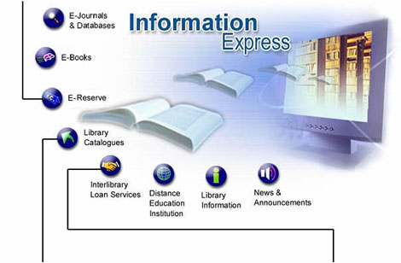
Figure 1: Sources of electronic resources
The students of higher education can find resources by using electronic resources like online search engines (for example, google and yahoo). The students can use GlobalSpec search engine to search information about the business. Moreover, the students can also go for academic search engines like google scholar and BASE search engine (Moore, 2011). Electronic resources also consist of CD-ROMs, online databases, audiobooks, e-books, industry blogs and online discussion groups. These electronic resources can be located in the catalog by using a keyword search. However, the same Boolean operator is implemented to refine database search, and it can help an individual to filter the results in popular search engines.
Trade Magazines
If the student knows the industry on which he or she will be working in future can search for trade magazines. Trade magazines are for those readers who have background knowledge about the industry (Downey, 2012). The purpose of these trade magazines is to inform and entertain the readers. If the student is an expert audience, then he or she can collect information from academic or scholarly journals. The writers of these publications assume that most of the readers are accustomed to the main topic of the journal.

2. Knowledge and Understanding of Subject
The main theme of this report is the use of digital literacy for the improvement of skills and competence of the students. A set of skills needed for full participation in a knowledge society is known as digital literacy. Digital literacy consists of the skills, behaviors and knowledge involving the efficient implementation of digital devices like laptops, tablets, desktop Pcs as well as smartphones. Today, Millennials are achieving huge success than the traditional type employees. The millennials have the skills to use the upgraded technologies. The main difference between digital literacy and computer literacy is computer literacy preceded digital literacy. The student needs to gain digital literacy for upgradation of their skills for professional development. The concept of the topic is based upon the improvement of technical skills of a student or an employee. Initially, the student must read technical books to gain knowledge about the implementation of technologies in various industries. When a person has the option to purchase a technical book locally, the person can still check the online reviews. The process of checking online reviews helps an individual to sort out between better and good technologies. Moreover, the student can read online tutorials or may follow YouTube (Ferrari, 2010). The main benefit of online tutorial over books is that they are timely accessible whenever needed and these tutorials are Couse free. More technical information can be collected by handing out to the geeks. Once a person participates in places like computer club, that person starts to make friends quickly, and the friends share lots of technical information about the industry on which they are working. The student can also subscribe to technical magazines. Technical magazines consist of programming and codes like Java or HTML/CSS5. With the help of these codes, the user can build software as demanded by the management of a company. CSS5 helps a person to build an official webpage. In this way, a student can collect technical resources and upgrade the skills and competence.

3. Analysis
Popular and academic journals are an essential source of information for the upgradation of skills and competence of the student. The students can search for a market publication like favorite magazines and newspapers, and these market publications must be different from the scholarly books in their approachability. Moreover, the magazines and newspapers are written for a broader audience. Students can get detailed analysis of the working of virtual assistant like Microsoft’s Cortana or Apple’s Siri in newspapers and magazines.
Implementation of Virtual Assistant
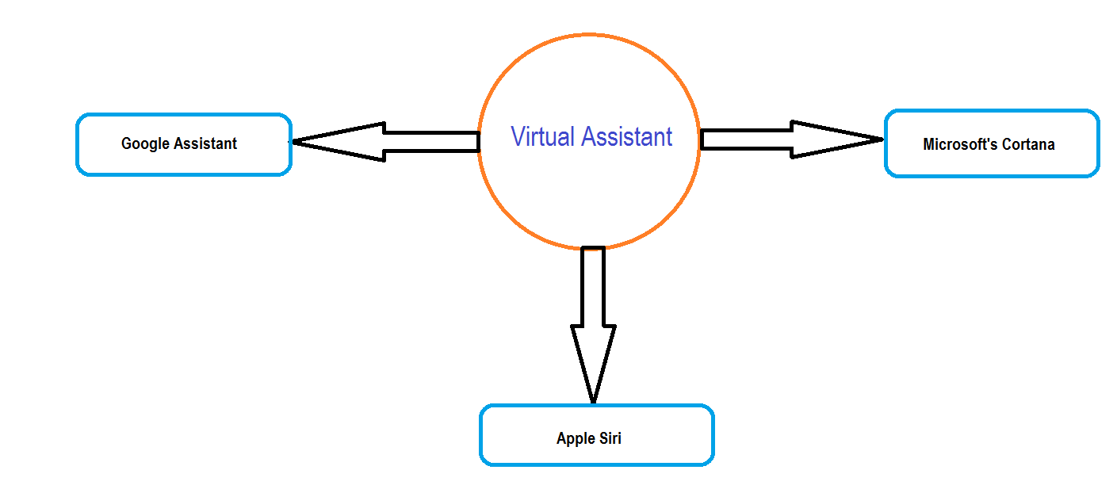
Figure 2: Some of the widespread virtual assistance in the world
Virtual assistants are internet-based assistants of individuals. Virtual assistants are also known as artificial intelligence. A virtual assistant works around the schedule of an individual to provide respective service whenever the person needs it (Kužnar et al., 2016). Additionally, virtual assistants are independent contractors which means the individuals do not even need to think about the vacation pay, payroll taxes, employee benefits like dental and health insurance, sick days and compensation of workers. Examples of the virtual assistant are Amazon's Alexa, Google Assistant, and Cortana of Microsoft. For google assistant, the employee or a student just need to say "OK Google" and find his or her required information to upgrade the academic and career skills. On the other hand, the critical benefit of Apple Siri lies with the fact that this virtual assistant is meant to be voice activate and seamless application and it does what it is supposed to do very well. The user needs to ask questions regarding any information in this virtual assistant applications. After receiving the voice of the user, the applications interpret user's voice input and responds accordingly.

4. Practical Application and Deployment
The application of modern techniques is crucial for the growth and development of workplace efficiency and employability. The advanced skills described here are all digital skills. Some of the contemporary methods of the workplace are discussed below:

Cloud Storage Implementation
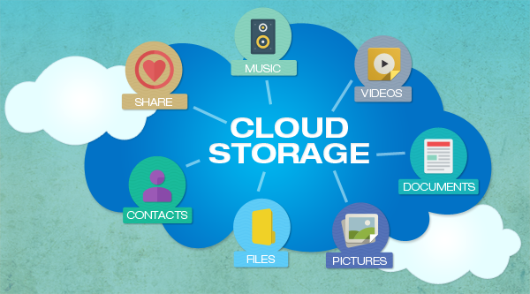
Figure 3: Use of Cloud Storage for daily activities
A model of data where digital information and data is stored in logical form is known as cloud storage. The physical environment of the cloud storage is managed and owned by the hosting business enterprise. The implementation of cloud storage is useful for improving the employability and workplace efficiency of an organization. During working hours, the employees can drag and drop files between their local storage and the cloud storage (Dufrasne et al., 2017). Cloud storage has an advantage that it provides access to the employees about using and accessing the file from anywhere through an internet connection. Moreover, cloud storage offers a backup plan system to the user where the user can store data on remote locations for backup. It is a cost-saving plan, and every organization implements cloud storage for storing their confidential information. Examples of cloud storage are google drive and dropbox. Both Google drives and drop boxes allow a user to take its documents and files anywhere and it also enables to manage photos efficiently. Cloud technologies help to send large files like videos quickly and thus workplace efficiency increases. With the help of cloud computing technology, the employees in the workplace can post a web link to the recipient via email (Yamato, 2016). Sometimes cloud storage becomes a topic of concern with the privacy and safety of relevant data stored in remote places.

Electronic File Management
Electronic file management will provide some benefits to the student and employees. Benefits of easy access to files and folders, searchable texts, cost-effectiveness, and security will help the student to manage and secure the data in a disciplined manner. If the data of the student are not organized well, file management will help the student to host the files (Document management - electronic document file format for long-term preservation, 2009). With the help of file management, the student or the employee can hold their data inside a folder and avoids the messiness. The students can simplify the difficult task of securing confidential information with a digital file management system. However, the electronic files do not go missing, and they do not quickly fall into the wrong hands if the individual forgets to provide a password to the folders. Moreover, electronic file management system eliminates loss of files, and the individual can manage large volumes of paper-based documents per day. In businesses, this file management system helps to improve the productivity of the customers as well as customer service (WU, 2017). Once the student has adequately adopted an electronic file management process, the person can sell obsolete and old printers and copiers that are no longer needed. A better file management system helps individuals to accomplish more work in the given interval of time, and that's why the employees can submit their projects within given deadlines.

5. Skills for Professional Practice

Figure 4: Customer Care Support department
In the workplace, data handling competence can found in the office of customer care management. Besides, the skills and competence need for managing information and data of customer must be present at every employee working in the customer care support department. Technical skills must be current at every employee working in customer care department. Data handling is the process of handling data employing collecting, analyzing and representing data to solve a particular question or a problem (Mamoulis, 2011). Moreover, if the employee has the skill to handle data in the workplace, then the data handling process will allow the person to make sense of information. The individual will be able to identify the trends and patterns to plan and predict the future. The employee with data handling skills has to deal with the customer database. They need to keep track of the customers with the help of customer database. A reliable data handling ability helps the individual and the organization to achieve minimization of the potential errors and risk that may occur in the workplace. When a person focuses on the data management, needs of users and data quality, the user gets clear when Excel is being stretched to the fragile limits. Sometimes Microsoft excel is not the perfect tool for a data management process. The student just has to keep data as consolidated as possible.
A good data handling technique helps an individual and a company to make profits. Data management consists of the process and policies implemented to make profits. Thus, data handling skills increase organizational performances and revenues. Technical skills are most significant for the low-level managers than for the higher-level administration. Most of the companies promote their managers from within the workplace to handle big data. The managers who are hired from within the workplace must have the skill to provide customer support handling data security. The managers must also have skills to generate reports and draft presentations by using Microsoft PowerPoint. Besides that, the hiring managers must have the skills to manage website content, marketing campaigns, and social media accounts. At last, the manager must offer technical support to the employees and the customers. According to Greco, Molinaro and Spezzano (2012), data is unimportant without the skills to analyze it. The prospects of the employees and students in mashing up and downloading data bring up concern about the accuracy, security as well as reliability of data.

Conclusion
The report concludes that the organizations and universities must train the employees and students with digital technology for improvement and upgradation of organizational performance and individual competence. Earlier, people were concerned with traditional methods to improve skills and competence. Today, the emergence of the Internet and digital technology has increased the quality of work and decreased the time of performance. As days are passing by, the implementation of digital technologies is becoming cost-effective and time-saving techniques. In the old days, the business firms used newspapers and televisions for their promotional purpose and now the emergence of social media has made the promotional job easier for companies and entrepreneurs.

References
Document management - electronic document file format for long-term preservation. (2009). Geneva: ISO copyright Office.
Downey, K. (2012). Managing Selection for Electronic Resources: Kent State University Develops a New System to Automate Selection. Journal of Electronic Resources Librarianship, 24(2), pp.127-137.
Dufrasne, B., Burns, C., Kalabza, W., Lengyel, S., Schill, P., Schoessler, C. and Solewin, S. (2017). IBM XIV storage system architecture and implementation.
Ferrari, E. (2010). Access Control in Data Management Systems. Synthesis Lectures on Data Management, 2(1), pp.1-117.
Greco, S., Molinaro, C. and Spezzano, F. (2012). Incomplete Data and Data Dependencies in Relational Databases. Synthesis Lectures on Data Management, 4(5), pp.1-123.
Kužnar, D., Tavčar, A., Zupančič, J. and Duguleana, M. (2016). Virtual assistant platform.
Mamoulis, N. (2011). Spatial Data Management. Synthesis Lectures on Data Management, 3(6), pp.1-149.
Moore, M. (2011). Keeping Current with Electronic Resources and Libraries. Journal of Electronic Resources in Medical Libraries, 8(3), pp.263-271.
Rusen, C. (2016). Windows 10 at work For Dummies.
WU, R. (2017). Analysis on Electronic File Management of Publishers. DEStech Transactions on Social Science, Education and Human Science, (icssm).
Yamato, Y. (2016). Cloud storage application area of HDD-SSD hybrid storage, distributed storage, and HDD storage. IEEJ Transactions on Electrical and Electronic Engineering, 11(5), pp.674-675.

