

LOCATION: Swansea | LLEOLIAD: abertawe
LEVEL 5 | LEFEL 5
EXAMINATION PERIOD | CYFNOD ARHOLIADAU
May 2021 | Mai 2021

MODULE CODE: ACCA5024
COD Y MODWL: ACCA5024
ADVANCED NETWORKING
TIME: 2 HOURS

Name : Michelle Wong

Student ID : WON17834179

Date & Time : 29/04/2021 10:10am

This is an individual practical test, held under examination conditions. You will be assigned three Switches and three Routers; you should configure these devices based on the given specifications. Handwritten notes are allowed

This paper is marked out of 100.

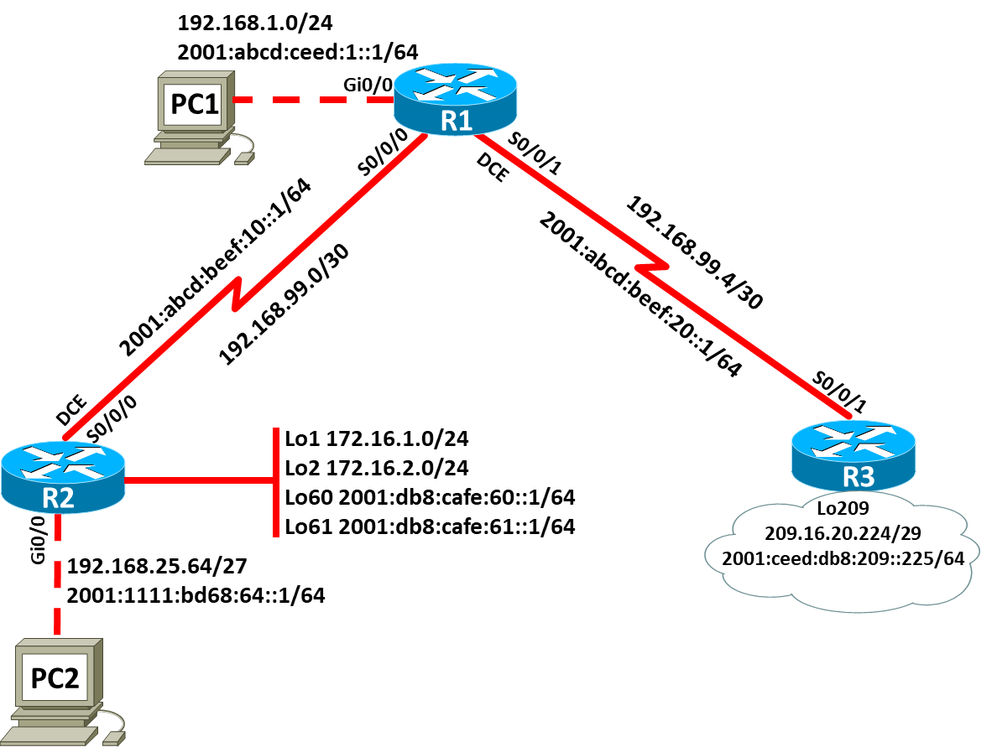
Topology

Addressing Table: IPv4 (5 marks)
Device | Interface | IP Address | Subnet Mask | Default Gateway
R1 | Gi0/0 | 192.168.1.1 | 255.255.255.0 | N/A
 | S0/0/0 | 192.168.99.1 | 255.255.255.252 | N/A
 | S0/0/1 | 192.168.99.6 | 255.255.255.252 | N/A
R2 | S0/0/0 | 192.168.99.2 | 255.255.255.252 | N/A
 | Gi0/0 | 192.168.25.66 | 255.255.255.224 | N/A
 | Lo1 | 172.16.1.1 | 255.255.255.0 | N/A
 | Lo2 | 172.16.2.1 | 255.255.255.0 | N/A
R3 | S0/0/1 | 192.168.99.5 | 255.255.255.252 | N/A
 | Lo209 | 209.16.20.225 | 255.255.255.248 | N/A
PC1 |  | 192.168.1.2 | 255.255.255.0 | 192.168.1.1
PC2 |  | 192.168.25.65 | 255.255.255.224 | 192.168.99.2

Addressing Table: IPv6 (5 marks)
Device | Interface | IPv6 Address | Link-local | Gateway
R1 | Gi0/0 | 2001:abcd:ceed:1::1/64 | FE80::1/10 | N/A
 | S0/0/0 | 2001:abcd:beef:10::2/64 | FE80::1/10 | N/A
 | S0/0/1 | 2001:abcd:beef:20::2/64 | FE80::1/10 | N/A
R2 | S0/0/0 | 2001:abcd:beef:10::1/64 | FE80::2/10 | N/A
 | Gi0/0 | 2001:1111:bd68:64::1/64 | FE80::1/10 | N/A
 | Lo60 | 2001:db8:cafe:60::1/64 | FE80::1/10 | N/A
 | Lo61 | 2001:db8:cafe:61::1/64 | FE80::1/10 | N/A
R3 | S0/0/1 | 2001:abcd:beef:20::1/64 | FE80::2/10 | N/A
 | Lo209 | 2001:ceed: db8:209::225/64 | FE80::1/10 | N/A
PC1 |  | 2001:abcd:ceed:1::2/64 | FE80::2/10
PC2 |  | 2001:1111:bd68:64::2/64 | FE80::2/10

Task 1: - Topology Creation (5 marks)
Using Packet Tracer software create the topology shown above and complete all tasks below.

Task 2: - Device Configuration (75 marks)

- On all devices,
  - Configure hostname on all devices
  - Set privilege EXEC password
  - Configure line console password
  - Set logging synchronous
  - Configure line VTY password
  - Disable DNS lookup
  - Set password encryption
  - Set banner “Authorized Users Only!”

- On all devices, configure interfaces with IPv4 and v6 addresses as shown in the topology

- On R1, configure IPv4 static route to R2 and R3 networks, excluding Lo209 network.

- On R2, configure IPv4 static route to R1 and R3 networks, excluding Lo209 network.

- On R3, configure IPv4 static router to R1 and R2 networks.

- Configure default static route to reach Lo209 network using next-hop ip address.

- Set the bandwidth on serial links to 512kbps.

- Set the clock rate on DCE to be 64000

- On R1, configure IPv6 static route to R2 and R3 networks, excluding Lo209 network.

- On R2, configure IPv6 static route to R1 and R3 networks, excluding Lo209 network.

- On R3, configure IPv6 static router to R1 and R2 networks.

- Configure IPv6 default static route to reach Lo209 network using next-hop ip address.

- Using 1024 bit RSA keys configure SSH access on R1. Use domain soac.com, username: admin and password: Sw@ns3a.

Task3: Network connectivity (10 marks)

Using ping command, verify end-to-end connectivity for both IPv4 and v6 networks:
From PC1, ping PC2. Is it successful? ___yes_____
From PC1, ping Lo209. Is it successful? ___yes_____
From PC2, ping Lo209. Is it successful? ___yes____

Verify SSH connectivity:
From PC1, establish telnet connection to R1. Is it successful? __no____(this should fail)
From PC1, establish SSH connection to R1. Is it successful? ___no___
Submission Requirement
The packet tracer file should be saved as “studentname_id” and uploaded onto Moodle. In addition to packet tracer file, you must also submit

- the output of show running-configuration command in a text file for all devices configured.
- This document with Task 3 completed

All documentation for your solution should be submitted electronically on Moodle.
It is your responsibility that you submit all the outputs and files correctly.

R1#show running-config
Building configuration...

Current configuration : 1624 bytes
!
version 15.1
no service timestamps log datetime msec
no service timestamps debug datetime msec
service password-encryption
!
hostname R1
!
!
!
enable password 7 0822455D0A16
!
!
!
!
!
!
no ip cef
no ipv6 cef
!
!
!
username admin privilege 15 password 7 08125B6E070A5616
!
!
license udi pid CISCO2901/K9 sn FTX15248JVL-
!
!
!
!
!
!
!
!
!
no ip domain-lookup
ip domain-name soac.com
!
!
spanning-tree mode pvst
!
!
!
!
!
!
interface GigabitEthernet0/0
ip address 192.168.1.1 255.255.255.0
duplex auto
speed auto
ipv6 address FE80::1 link-local
ipv6 address 2001:ABCD:CEED:1::1/64
!
interface GigabitEthernet0/1
no ip address
duplex auto
speed auto
shutdown
!
interface Serial0/0/0
bandwidth 512
ip address 192.168.99.1 255.255.255.252
ipv6 address FE80::1 link-local
ipv6 address 2001:ABCD:BEEF:10::2/64
clock rate 64000
!
interface Serial0/0/1
bandwidth 512
ip address 192.168.99.6 255.255.255.252
ipv6 address FE80::1 link-local
ipv6 address 2001:ABCD:BEEF:20::2/64
!
interface Vlan1
no ip address
shutdown
!
ip classless
ip route 192.168.1.0 255.255.255.0 Serial0/0/0
ip route 192.168.99.4 255.255.255.252 Serial0/0/0
ip route 0.0.0.0 0.0.0.0 192.168.99.2
ip route 192.168.25.64 255.255.255.224 Serial0/0/0
ip route 0.0.0.0 0.0.0.0 192.168.99.5
!
ip flow-export version 9
!
ipv6 route 2001:DB8:CAFE:60::/64 Serial0/0/0
ipv6 route 2001:DB8:CAFE:61::/64 Serial0/0/0
ipv6 route 2001:1111:BD68:64::/64 Serial0/0/0
!
!
banner motd ^CAuthorized Users Only!^C
!
!
!
!
!
line con 0
password 7 0822455D0A16
logging synchronous
login
!
line aux 0
!
line vty 0 4
password 7 0822455D0A16
login
!
!
!
End

R2#show running-config
Building configuration...

Current configuration : 2215 bytes
!
version 15.1
no service timestamps log datetime msec
no service timestamps debug datetime msec
service password-encryption
!
hostname R2
!
!
!
enable password 7 0822455D0A16
!
!
!
!
!
!
no ip cef
no ipv6 cef
!
!
!
username admin privilege 15 password 7 08125B6E070A5616
!
!
license udi pid CISCO2901/K9 sn FTX1524K3I8-
!
!
!
!
!
!
!
!
!
no ip domain-lookup
ip domain-name soac.com
!
!
spanning-tree mode pvst
!
!
!
!
!
!
interface Loopback1
ip address 172.16.1.1 255.255.255.0
!
interface Loopback2
ip address 172.16.2.1 255.255.255.0
!
interface Loopback60
no ip address
ipv6 address FE80::1 link-local
ipv6 address 2001:DB8:CAFE:60::1/64
!
interface Loopback61
no ip address
ipv6 address FE80::1 link-local
ipv6 address 2001:DB8:CAFE:61::1/64
!
interface GigabitEthernet0/0
ip address 192.168.25.66 255.255.255.224
duplex auto
speed auto
ipv6 address FE80::1 link-local
ipv6 address 2001:1111:BD68:64::1/64
!
interface GigabitEthernet0/1
no ip address
duplex auto
speed auto
shutdown
!
interface Serial0/0/0
bandwidth 512
ip address 192.168.99.2 255.255.255.252
ipv6 address FE80::2 link-local
ipv6 address 2001:ABCD:BEEF:10::1/64
!
interface Serial0/0/1
no ip address
clock rate 2000000
shutdown
!
interface Vlan1
no ip address
shutdown
!
ip classless
ip route 172.16.1.0 255.255.255.0 Serial0/0/1
ip route 172.16.2.0 255.255.255.0 Serial0/0/1
ip route 192.168.25.64 255.255.255.224 Serial0/0/1
ip route 192.168.99.0 255.255.255.252 Serial0/0/1
ip route 192.168.1.0 255.255.255.0 Serial0/0/1
ip route 192.168.1.0 255.255.255.0 Serial0/0/0
ip route 172.16.1.0 255.255.255.0 Serial0/0/0
ip route 172.16.2.0 255.255.255.0 Serial0/0/0
ip route 192.168.25.64 255.255.255.224 Serial0/0/0
ip route 192.168.99.0 255.255.255.252 Serial0/0/0
ip route 192.168.99.4 255.255.255.252 Serial0/0/0
ip route 0.0.0.0 0.0.0.0 192.168.99.1
!
ip flow-export version 9
!
ipv6 route 2001:ABCD:CEED:1::/64 Serial0/0/0
ipv6 route 2001:ABCD:BEEF:10::/64 Serial0/0/0
ipv6 route 2001:ABCD:BEEF:20::/64 Serial0/0/0
!
!
banner motd ^CAuthorized Users Only!^C
!
!
!
!
!
line con 0
password 7 0822455D0A16
logging synchronous
login
!
line aux 0
!
line vty 0 4
password 7 0822455D0A16
login
!
!
!
End

R3#show running-config
Building configuration...

Current configuration : 1986 bytes
!
version 15.1
no service timestamps log datetime msec
no service timestamps debug datetime msec
service password-encryption
!
hostname R3
!
!
!
enable password 7 0822455D0A16
!
!
!
!
!
!
no ip cef
no ipv6 cef
!
!
!
username admin privilege 15 password 7 08125B6E070A5616
!
!
license udi pid CISCO2901/K9 sn FTX152493R1-
!
!
!
!
!
!
!
!
!
no ip domain-lookup
ip domain-name soac.com
!
!
spanning-tree mode pvst
!
!
!
!
!
!
interface Loopback209
ip address 209.16.20.225 255.255.255.248
ipv6 address FE80::1 link-local
ipv6 address 2001:CEED:DB8:209::225/64
ipv6 address 2001:ceed: DB8:209::225/64
!
interface GigabitEthernet0/0
no ip address
duplex auto
speed auto
shutdown
!
interface GigabitEthernet0/1
no ip address
duplex auto
speed auto
shutdown
!
interface Serial0/0/0
no ip address
clock rate 2000000
shutdown
!
interface Serial0/0/1
bandwidth 512
ip address 192.168.99.5 255.255.255.252
ipv6 address FE80::2 link-local
ipv6 address 2001:ABCD:BEEF:20::1/64
clock rate 64000
!
interface Vlan1
no ip address
shutdown
!
ip classless
ip route 192.168.25.64 255.255.255.224 Serial0/0/1
ip route 172.16.1.0 255.255.255.0 Serial0/0/1
ip route 172.16.2.0 255.255.255.0 Serial0/0/1
ip route 172.16.2.0 255.255.255.0 Serial0/0/0
ip route 192.168.25.64 255.255.255.224 Serial0/0/0
ip route 172.16.1.0 255.255.255.0 Serial0/0/0
ip route 192.168.99.0 255.255.255.252 Serial0/0/1
ip route 192.168.1.0 255.255.255.0 Serial0/0/0
ip route 192.168.1.0 255.255.255.0 Serial0/0/1
!
ip flow-export version 9
!
ipv6 route 2001:1111:BD68:64::/64 Serial0/0/1
ipv6 route 2001:DB8:CAFE:60::/64 Serial0/0/1
ipv6 route 2001:DB8:CAFE:61::/64 Serial0/0/1
ipv6 route 2001:ABCD:CEED:1::/64 Serial0/0/1
ipv6 route 2001:ABCD:BEEF:10::/64 Serial0/0/1
ipv6 route 2001:1111:BD68:64::/64 Serial0/0/0
!
!
banner motd ^CAuthorized Users Only!^C
!
!
!
!
!
line con 0
password 7 0822455D0A16
logging synchronous
login
!
line aux 0
!
line vty 0 4
password 7 0822455D0A16
login
!
!
!
end

