Management Economics
Assessment 2

Module Code: LCBB5003
Student Name: Nikolay Petkov
Student ID: 2011288

Table of Contents
Introduction 3
Overview of the company and its product 3
Market analysis 5
Different Market structure 8
Consideration on different market structure and government intervention 12
Conclusion 15
References 16

Introduction
The following discussion of the study is focused on the market structure of a specific firm’s specific product. Furthermore, the study has analysed the previous market structure of the firm along with the importance of regulatory policies for effective business operation.

Overview of the company and its product
One of the major fast-moving consumer goods (FMCG) businesses is Unilever. The firm makes and distributes a range of household care goods, and also food and beverage commodities, skincare, and personal hygiene items through its holdings. They manufacture some of the most well-known brands in the industry amounting to over 400 brands in 190 countries (Unilever, 2022). Some of the commonly known products are notably Dove, Lynx, , Ben & Jerry's, , Knorr, Hellmann's, Vaseline, sunlight, Cif, Domestos, Horlicks, Magnum, Sunsilk, and many more (the Guardian, 2022). In the following discussion, the Personal Care product line which is will be focused on for detailed discussion.
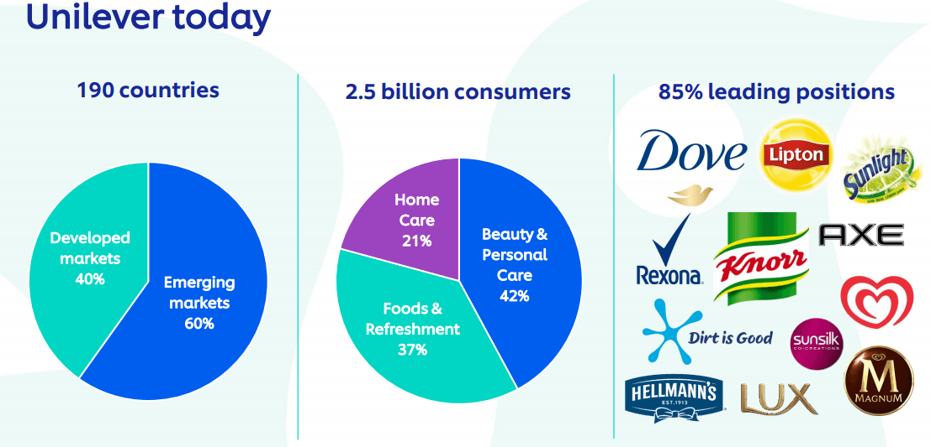

Figure 1: Unilever Products share Source: (Unilever, 2022)

The backbone of Unilever's corporate strategy is generating trustworthy, premium products that customers can rely on. Lever Brothers, a British soap producer, formed the basis of Unilever. The Sunlight Soap was one of their breakthrough market shifts in the 1890s. William Hesketh Lever, the father of Lever Brothers, went ahead with such an approach. The Lever Brothers were the first enterprise in Victorian England to promote hygiene due to this approach. Furthermore, the item was immediately replicated in other regions as it became successful in the UK, which enabled Lever Brothers to extend their customers overseas. Although incorporating companies from distinct nations were highly experimental the Lever Bros. and Margarine Unie merging started, both firms firmly believed that it would bring up more possibilities (Jones and Miskell, 2015). When Unilever marketed its commodities in America Latin in the 1930s, the company flourished significantly. Unilever launched a new initiative in the 1940s to sustain its prosperity, pushing its business in different fields like the manufacturing of food products and chemical products. Unilever also felt that they needed to emphasis the interplay across marketing and research which was much more significant than solely expanding their operations. Accordingly, Unilever enlarged its market by collaborating with two major US firms in 1944: the Pepsodent toothpaste business and the Thomas J. Lipton firm, which manufactures tea (Patton and Holstius, 2015).

Market analysis
Unilever has oriented its corporate structure upon cultivating well-known, elevated products that buyers can believe in and compete effectively in the dynamic and competitive consumer products industry. L'Oreal USA, Johnson & Johnson, P&G, and Kimberly-Clark are a few of the leading firms operating in the personal care industry (the Guardian, 2022). The approach a business perceives competitiveness when offering goods and services is driven by market structure. Based on the market one competes in and the price of products being treated with, the structures can differ from one degree to the other (Ellickson,2013). The four market structures that are conceptually in effect are
- Perfect competition
- Monopoly market
- Oligopoly
- Monopolistic competition.

When both producers and consumers are in substantial populations, there is perfect competition. This implies that no single player will get a huge impact on the business as a whole. In this market structure, a company's presence, disappearance, or change of attitude will have little influence on the price, supply and demand (Cheng, 2021). The market pressures are already free to conduct in great strength. As a function of buyers' perspective that all goods in this sector seem to be the same, determining which one to choose is discretionary (Feenstra, 2010).
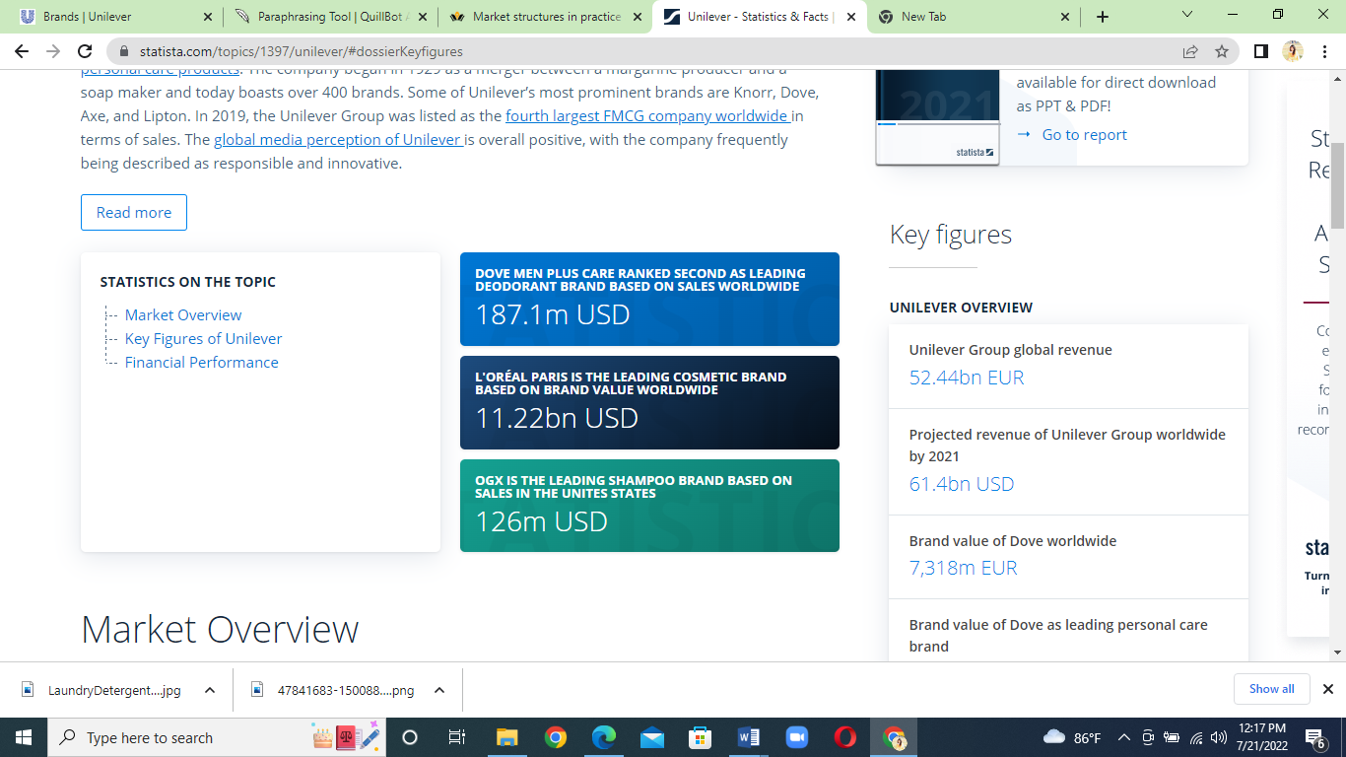

Figure 2: Unilever persona care product market raking Source: (Unilever, 2021)
The majority of Personal care products, therefore, do not function in this manner. People are typically selective when purchasing these products, particularly when such products have an influence on health and particular look (Volkov and Smith, 2015). As per the corporation's background, Unilever is not the form whose influence on the market is not recognized by both users and its opponents. Even Unilever holds a large number of market shares in the personal care brands both in the UK market and global market. It has around 26% market share in the personal care products market (Cheng, 2021). Therefore, it is entirely incorrect to claim that Unilever functions in a market system with perfect competition.
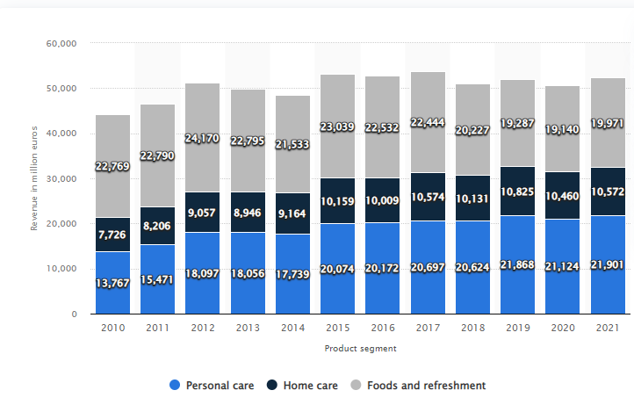
Figure 3: Unilever Group's global revenue 2010- 2021 Source: (Statista, 2022)

A version of imperfect competition termed monopolistic competition sets various manufacturers against each other while still selling goods that are identifiable from one another (for instance, by branding or performance) and are thus not complete alternatives. A monopolistic market has several sellers and buyers who trade in commodities that are good substitutes for one another but are not precisely the same. While not completely similar in nature, Lux, Rexona, Dove Soap, Pear Soap, are near counterparts for each other. Customers can buy products from enterprises at their own pricing. So it is certain that the personal care product line Dove of Unilever plays in the monopolistic market.
It accomplished the strongest revenue rise in 10 years, with a 4.5 % surge in sales and a volume increase of 1.6 %. Unilever’s 13 Billion-Euro brands have seen a growth of 6.4%. Priority countries in the US, China, and India witnessed the expansion of 14.3%, 13.4%, and 3.7 %, accordingly. It outperformed global channel expansion in e-commerce by 44%, boosting e-commerce to 13% of overall sales (Unilever, 2022).
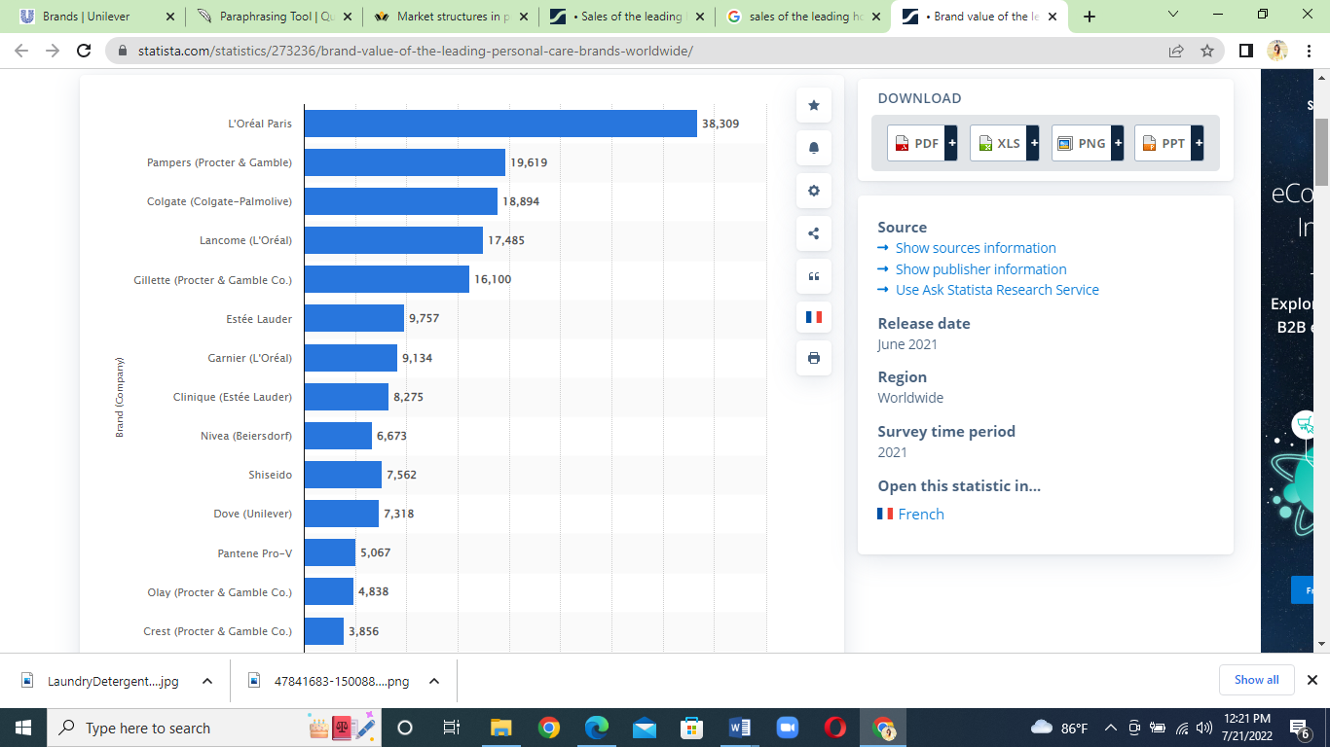

Figure 4: Brand value of the leading personal care brands worldwide in 2021 Source: (Statista, 2022)
Competitive companies prepare their comparable items apart from each other using different promotional practices, branding, and slightly varied standards of quality. Firms can charge greater prices for lesser amounts of products by offering their products. New firms can penetrate a monopolistic industry with very few impediments in their way (Hunt, 2010). The newcomer can also relatively easily exit the business. Among the key players of Unilever, the soap market has several competitors and their products are not identical in appearance, fragrance, or quality of the product. Furthermore, the pricing of the product s determined by the firm. So considering all these aspects we can say that the personal care product line- Soap is functioning in a monopolistic competition market structure.

Different Market structure
When the personal care product line like Dove launched in the market, there were a few brands like Unilever theta operated in the market. Market competition was lower than compared to the present market structure. Furthermore, the new entry of other brands was less possible in the early 20’s and before that period.
Key market players
- L’Oréal Paris
- Proctor and Gamble
- Unilever
- Beiersdorf AG
- Johnson and Johnson

Key market players
Highly competitive market without dominant market players

When a small number of firms dominate the economy and derive the biggest share, an oligopolistic market system is formed. This is apparent from its market dominance. A market structure defined as an oligopoly is composed of a smaller variety of companies that jointly have great influence over a specific area of activity (Castelan et al., 2021). Considering the group's substantial market control, none of the major corporations can disrupt the others or simply remove users. In an oligopoly, very few completely dominant firms, therefore, provide a large percentage of the items & services and affect important actions in favour of the other competitors. In the year 2000, it ranked 54th on the Fortune 500 list of the largest firms in Europe in terms of revenue (Volkov and Smith, 2015). It was difficult for new options to penetrate the market as a result of this dominant market control and the strict uniformity regulations. Because the items of corporations like Unilever, Procter & Gamble and others are dominating the global marketplace, the sectors in which Unilever competed previously were typified by oligopoly. In an oligopolistic market structure, a small group of prominent companies that manufacture identical or comparable products controls the market (Bloch, Eaton and Rothschild, 2014).
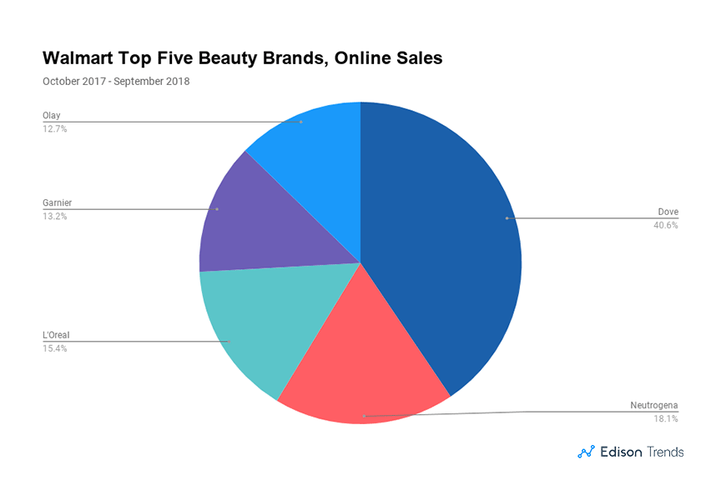
Figure 5: Personal care product selling in Walmart Source: (Mazzeo, 2012)

In this marketplace, it is complicated to access and leave the market. Because there were so few players in the market, notably Procter & Gamble and Colgate-Palmolive, price differences were strongly influenced by rival assessments. The selection of the quality attributes was also determined by the expectations and behaviours of the market (Chhabra, 2018). The firm's primary goal was consistent pricing. In this circumstance, branding was yet another benefit over the competitors which is used in the pricing structure.

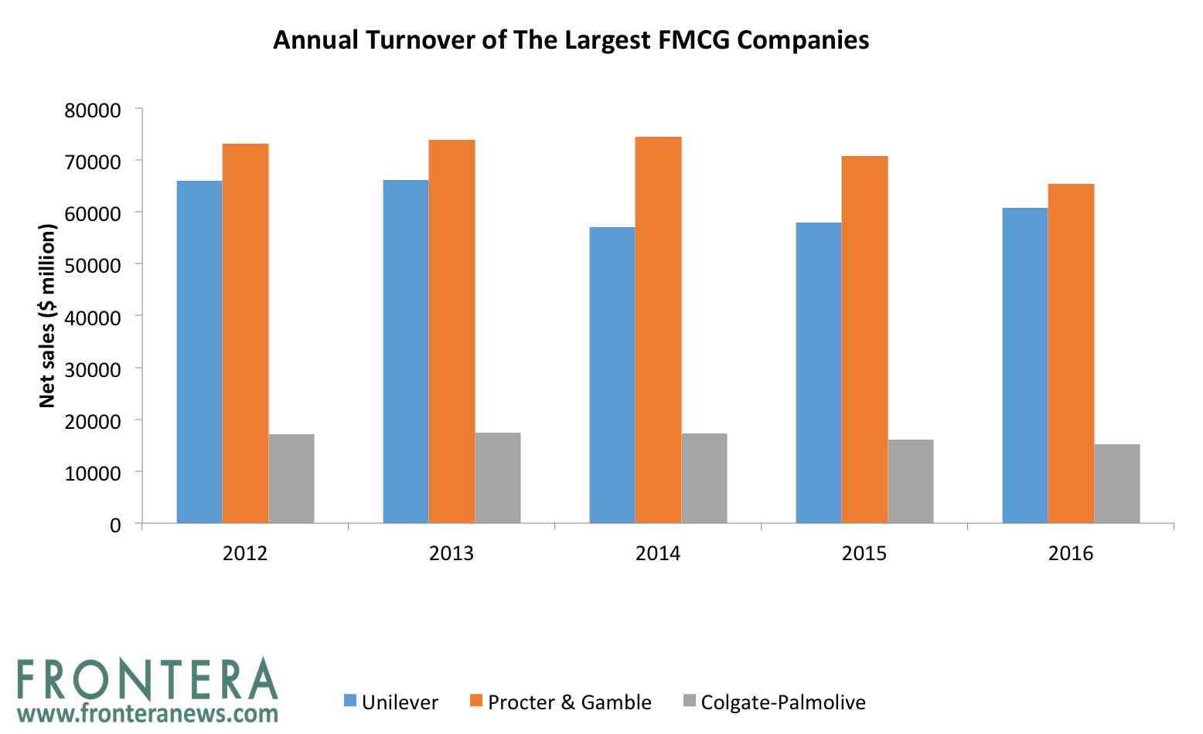

Figure 6: Turnover of largest FMGC brands Source: (Frontera, 2018)
As the marketplace continues to improve, deodorants and soap products showed robust growth and established dominance in North America. Consumers have welcomed well the introduction of Dove refilling antiperspirant in the US. Dove, Rexona, and all participated in the mid-single-digit increase in hair care, and fashion in North America continued its competitive growth (Singh, 2020). South Asia and Africa had rapid expansion in oral care. Additionally, the market competition increased with various types of similar products from 2010 and the percentage of new entrants in the market increased gradually. One of the major competitors in the early 20’s was Nivea, P&G products (Mazzeo, 2012).

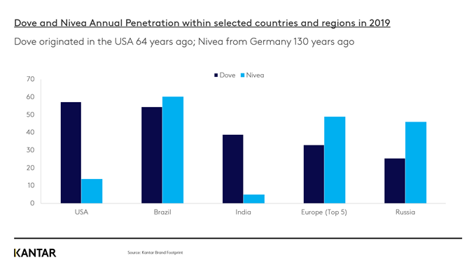
Figure 7: Dove and Nivea market penetration in 2019 Source: (Cawthray and Murphy, 2022)

- Few Corporations with a Significant Market Share
However, a market may comprise thousands of buyers, it can be considered as an oligopoly market if the overall market shares of the top companies listed are higher than 50%. This is a function of the market being regulated by a few manufacturers who have the majority of the market share (Mallozzi and Morgan, 2015).
- Strong Barriers of entry
Several hurdles to entrance let oligopolistic corporations preserve their predominance. Customer loyalty, trademarks, and steep start-up expenses are just a few factors. These present a challenge for potential entrants to create a position in the marketplace and acquire consumers.
- Each Firm Has Restricted Market Dominance On Its Own
As players are comparably "powered," an oligopolistic business cannot control prices or production. Generally communicating, this controls the industry. Yet because a single firm cannot flourish, it also facilitates teamwork (Mallozzi and Morgan, 2015).
- Rigid pricing
Prices with the perfect competition are roughly above input costs, leaving enterprises with limited revenues. Due to the collective market control, oligopolies frequently maintain premium prices in terms of generating increased profits.
- Demand Curve Indeterminacy
In market forms other than oligopolistic, a business must interact with an uncertain demand curve. However, beyond the instances where the degree of interdependence is well established, it is difficult to construct a demand curve for such producers due to the interdependence of the oligopolists (Corchón and Marcos, 2012) .
- Interdependence
The interdependence of the many companies in the decision-making mechanism is the prominent element of an oligopoly. All enterprises in an oligopolistic market are aware of this fact. If an industry is composed of a limited amount of significant companies and one of these firms conducts a large-scale promotional campaign or introduces a new production system that quickly encapsulates the market, it will definitely provoke countermoves from other companies in the industry (Mallozzi and Morgan, 2015).. Eventually, the market turned out to be a monopolistic market competition maker with numerous new entrants.

Consideration on different market structure and government intervention
From the present market perspective, the personal care product line- Dove is in the monopolistic market competition structure and it should retain its position in the market. Buyers will have the flexibility to choose among a range of goods and services in a marketplace with monopolistic competition (Hagiu, 2016). The range of products is higher in the monopolistic competition market than it is in a monopoly market. Due to the severe competitive forces, firms attempt to be creative and increase the quality of their products and service capabilities. This is favourable for the business because creativity will push it forward (Julien and Sanz, 2015). Low entry barriers suggest that a lot of suppliers and manufacturers will continually enter the industry. This is a very favourable outcome for both consumers and the business at large.
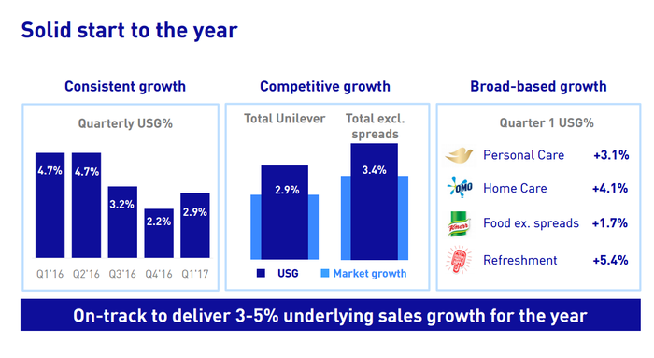
Figure 8 : Unilever market growth , Source : (Unilever, 2022)
Monopolistic competition generates a vibrant competitive marketplace. Since one business cannot monopolize the marketplace, there is proper competition as the customer base is distributed among different ventures. So as a result Unilever can focus on its product development by maintaining positive priding of the product in terms of maintaining the quality of the product. But if the business shifts towards a perfect competitive market then because of higher market competition the brand could lose its identity and also market revenue in near future (Pospelov and Radionov, 2014). Furthermore, there will be no scope for product development or innovation due to marginal profit making in the perfect competitive market. On the other hand, in the case of oligopoly market conditions consumer rights can be manipulated by the industries and eventually there will be more legislative restrictions in such a market structure (Silva, 2017). Additionally, in today’s dynamic market keeping the market domination will be costlier for the brand. Again the personal product lines are dynamic products that change over time so being in the monopolistic market Unilever can reap the best advantage from the market.
Therefore, it can be stated that considering the personal care products industry's dynamic nature and market competitiveness, the brand should focus on the existing market structure to lead the market by proving higher quality products to its users.

Government intervention is essential to secure the industry’s, consumers and companies' fundamental interests. Robust, stable regulatory structures enhance industry performance in the global market while maintaining the economy as agile and scalable as feasible. Government intervention can preserve the protection, integrity, and basic protections (Deloitte, 2022). A product like personal care are sensitive product line in terms of consumer perspective and proper standards, quality should be ensured without harming the environment. In recent times there have been allegations about environmental damages, and animal oppression in terms of testing the products. Moreover, it is alarming issues that many of the products contain harmful ingredients that can be vulnerable to human health (Sampaothong, 2018). Government oversight is critical for controlling FMCG manufacture, distribution, promotion, and consumer sales strategies. Due to the complexity, it involves a lot of time, effort, and budget to guarantee consistency, which in some situations can significantly impact a product's performance.
With generation Z being extremely pervasive as buyers, customer satisfaction is becoming more important. Social media activities are prevalent among generation Z, and they are more inclined to argue for bad-governance firms (Sampaothong, 2018). As a reason, non-compliance with government regulations can undermine a company's image at any level. The retail and consumer products businesses are struggling with a range of factors that will affect the industry in which they participate over the next coming years. Even though each of these patterns is substantial in itself, the intricacy of the problems increases due to their expanding interconnection and the possible consequences of their cumulative influence.

Due to challenges including fast growth in emerging nations, technologically sophisticated consumers, and a concentration on sustainability and responsible procurement of products, greater government intervention is necessary for the market (Lekhanya, Olajumoke and Nirmala, 2022). Governments are considering more aggressive approaches to the supervision of several areas of consumer items in a developing policy requirement.
Governments are now being driven to evaluate the mechanisms of control in consumer goods as a result of rising concerns about global health, social issues, and ecological sustainability. Although there are many reasons that can influence regulatory interventions, it suggests that the most important ones are escalating financial pressure, expanding inclination to move in to protect health and safety, alleviating unfavourable social implications, and attempting to eliminate the harmful effects on the environment of the industry.
As a result, it can be said that more government intervention is necessary to ensure quality products in the markets, considering the increasing market circumstances.

Conclusion
Market structure is fundamental as it has an influence on the intentions, incentives, and decisions made by market players operating in this market. The discussed study will help the reader in understanding the market structure of the leading FGMC brand in the international market.

References
Bloch, H., Eaton, B. and Rothschild, R., 2014. A Dynamic Model of Oligopolistic Market Structure, Featuring Positioning Investments. International Journal of the Economics of Business, 21(3), pp.379-411.

Castelan, C., Araar, A., Malásquez, E., Olivieri, S. and Vishwanath, T., 2021. Distributional Effects of Competition: A Simulation Approach. SSRN Electronic Journal,.

Cawthray, B. and Murphy, P., 2022. Examining the enduring success of Dove and Nivea. [online] Kantar.com. Available at: <https://www.kantar.com/inspiration/brands/examining-the-enduring-success-of-dove-and-nivea> [Accessed 21 July 2022].

Cheng, Y., 2021. Analysis on the Opportunities and Challenges of Unilever’s Differentiated Competition by Using SWOT and PEST. Proceedings of the 6th International Conference on Economics, Management, Law and Education (EMLE 2020),.

Chhabra, D., 2018. Factors Affecting Consumer Buying Behaviour and Decision Making Process towards FMCG Products. Journal of Advances and Scholarly Researches in Allied Education, 15(6), pp.131-139.

Corchón, L. and Marcos, F., 2012. Price Regulation in Oligopolistic Markets. ISRN Economics, 2012, pp.1-10.

Deloitte, 2022. Regulatory trends in the consumer goods industry. [online] Www2.deloitte.com. Available at: <https://www2.deloitte.com/content/dam/Deloitte/global/Documents/Consumer-Business/dttl_cb_Regulation%20in%20CP_POV.pdf> [Accessed 21 July 2022].

Feenstra, R., 2010. Measuring the gains from trade under monopolistic competition. Canadian Journal of Economics/Revue canadienne d'économique, 43(1), pp.1-28.

Hagiu, A., 2016. Monopolistic Competition Between Differentiated Products with Demand for More Than One Variety. SSRN Electronic Journal,.

Hunt, S., 2010. The Theory of Monopolistic Competition, Marketing’s Intellectual History, and the Product Differentiation Versus Market Segmentation Controversy. Journal of Macromarketing, 31(1), pp.73-84.

Jones, G. and Miskell, P., 2015. European integration and corporate restructuring: the strategy of Unilever, c.1957–c.1990. The Economic History Review, 58(1), pp.113-139.

Julien, L. and Sanz, N., 2015. Monopolistic competition, transaction costs and multiple equilibria. Economics Letters, 87(1), pp.21-26.

Lekhanya, L., Olajumoke, N. and Nirmala, D., 2022. Exploring fast moving consumer goods (FMCG) small, medium and micro enterprises manufacturers’ need for innovation to achieve growth.

Mallozzi, L. and Morgan, J., 2015. Oligopolistic Markets with Leadership and Demand Functions Possibly Discontinuous. Journal of Optimization Theory and Applications, 125(2), pp.393-407.

Mazzeo, M., 2012. Product Choice and Oligopoly Market Structure. The RAND Journal of Economics, 33(2), p.221.

Patton, C. and Holstius, K., 2015. Unilever: A Marketing Giant. Developments in Marketing Science: Proceedings of the Academy of Marketing Science, pp.603-606.

Pospelov, I. and Radionov, S., 2014. On the Social Efficiency in Monopolistic Competition Models. SSRN Electronic Journal,.

Rubin, M., 2016. Corporate Social Responsibility, Risk Diversification, and Firm Value: Does Corporate Social Responsibility Diversify Risk. SSRN Electronic Journal,.

Sampaothong, S., 2018. Brand loyalty for domestic and global brands: A case of Thai fast-moving consumer goods. Business and Economic Horizons, 14(3), pp.615-625.

Silva, M., 2017. New monetarism with endogenous product variety and monopolistic competition. Journal of Economic Dynamics and Control, 75, pp.158-181.

Singh, A., 2020. Effect of Low Price on Respondents While Purchasing FMCG Products: An Empirical Study. International Journal of Psychosocial Rehabilitation, 24(5), pp.5658-5663.

Statista, 2022. Brand value of the leading personal care brands worldwide 2021 | Statista. [online] Statista. Available at: <https://www.statista.com/statistics/273236/brand-value-of-the-leading-personal-care-brands-worldwide/> [Accessed 21 July 2022].

Statista, 2022. Unilever Group's global revenue 2021 | Statista. [online] Statista. Available at: <https://www.statista.com/statistics/269190/global-revenue-of-the-unilever-group-since-2007/> [Accessed 21 July 2022].

Sundström, M. and Hjelm-Lidholm, S., 2020. Re-Positioning Customer Loyalty in a Fast Moving Consumer Goods Market. Australasian Marketing Journal, 28(1), pp.30-34.

the Guardian, 2022. Company profile for Unilever. [online] the Guardian. Available at: <https://www.theguardian.com/sustainable-business/profile-unilever> [Accessed 21 July 2022].

Unilever, 2022. Personal Care. [online] Unilever. Available at: <https://www.unilever.com/brands/personal-care/> [Accessed 21 July 2022].

Unilever, 2022. Strong full-year results demonstrate Unilever’s resilience and agility. [online] Unilever. Available at: <https://www.unilever.com/news/press-and-media/press-releases/2021/strong-full-year-results-demonstrate-unilevers-resilience-and-agility/> [Accessed 21 July 2022].

Volkov, N. and Smith, G., 2015. Corporate diversification and firm value during economic downturns. The Quarterly Review of Economics and Finance, 55, pp.160-175.

