Pre-Christmas meet up!

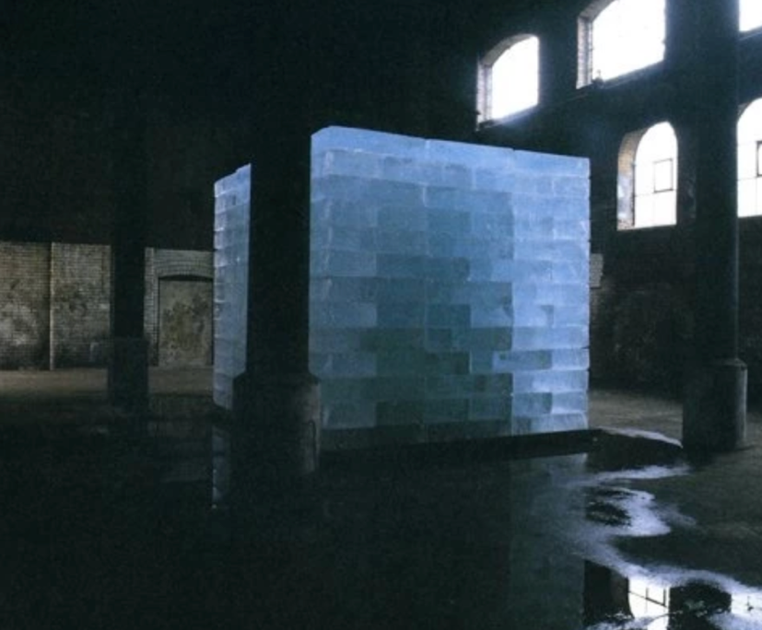

https://www.youtube.com/watch?v=BLSmrT6y5T0 Ice music
Join us, if you can, for a pre-Christmas meet up, bring your own, on-line festive beverage and/or pastry, air your Christmas jumper, sing us a carol, or not!

See you there, on Teams at 3 pm on Friday 11th December, link bellow:

________________________________________________________________________________
Join Microsoft Teams Meeting
________________________________________________________________________________

