Assessment 2 - Community Engagement

Contents
Introduction 3
Main Body 4
Types of community engagement 5
Community Mapping 7
Community engagement through social media 7
Conclusion 9
References 10

Introduction
The assignment will be reflecting on the concept of communication engagement. It would also be suggesting policy and principles enhance communication engagement which will also help in increasing the engagement of stakeholders as well. The assignment will also be reflecting on the effectiveness of coordinating a community segment programme. The reflection would be stating the difference between the engagement of stakeholders through the use of social media and the campaign that depicts community engagement. The reflection would also be discussing the gaps in the practices that help increase community segment and suggested effective techniques that would help fill the gaps. It would also be discussing the effect of inclusion, active consultation, stakeholders’ participation and effective communication on community engagement. It would also be discussing the research methods used to conduct the analysis for mapping social engagement through social media and suggest pers practices to increase community engagement.

Main Body
Community engagement is a procedure of working participatory with the community stakeholders and citizens to improve the environmental and social and cultural issues that impact the well-being of the citizens and community (Rahman et al., 2022). Community engagement is a complex process and requires resources such as funding, time and individual skills and mindset to develop and contribute to the community. Since the health issues of the COVID-19 pandemic crisis, the main focus on effective community engagement and coordination with the stakeholders is seen to be increasing as it helps in improving and developing the citizens and the society (Corbin et al., 2021).
The UK government is emphasising its focus on enhancing the community segment as there is been a rise in crime. The main areas that are facing an increase in crime after the pandemic hit are Wales, England and Northern Ireland. The latest crime reports analysis is a 1.18% increase in the crime rate in the UK which can be quite risky to the well-being of the organisation (crimerate.co.uk,2022)
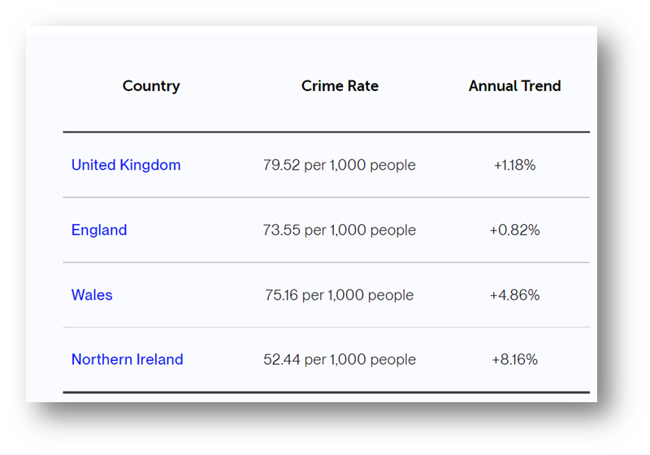
Figure 1: Crime Rate in the UK in the year 2021-2022
(Source: crimerate.co.uk, 2022)
With the end of COVID-19 restrictions and a decrease in the negative impact of the pandemic on the well-being of the community and civilians the UK faced an increase in the rates of crime in the neighbourhood and to manage the rising crime rates the government implement “Safety in Neighbourhood” The main focus of implement, the campaign was to increase community engagement and help reduce the risk factors in the neighbourhood. The policy was implemented with the partnership of an external and one of the largest crime reduction movements in the UK which is a grid of the UK corporate business, voluntary organisations and police which helps in increasing community segment along with improving the community well-being factors. The only disruptive gap within the policy regulations and procedure is that it is not applicable globally.

Types of community engagement
- Community engagement with the main aim of community development, growth and improvement – In a community engagement process which focuses on community development every community individual and stakeholders play a significant role in various aspects of the processing (Kassen, 2021). This type is also known as community building and motivates community stakeholders in involved and engage in the development process.
- Community segment within the consultation and strategic decision-making process – Also known as consultation and decision making is practised by various firms such as; schools, government departments and health services. This organisation is required to consult the communities in regards to various issues. The tool that the organisation can implement in the segment community in consumption ion and strategic decision-making process is the Spectrum Public Participation by the IAPs (International Associated of Public Participation). This tool helps in understanding the level of community engagement in the decision-making process and consultation. The below figure is an example of the process that the toll uses in identifying the level of community engagement.
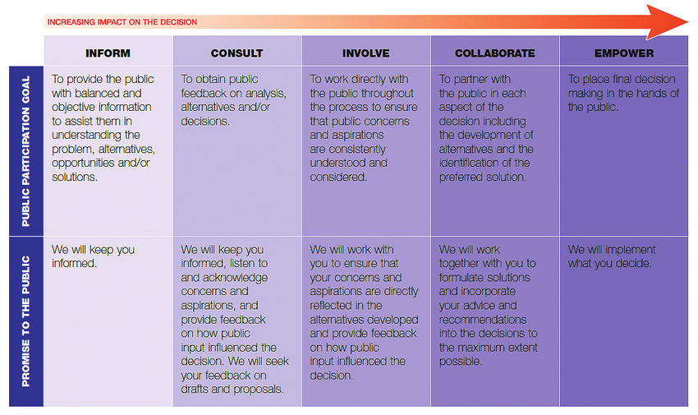
Figure 2: The Spectrum Public Participation by the IAPs
(Source: researchgate.net, 2022)

- Community engagement helps the organisation or the business enterprises in developing to offer products and services that help achieve the main objective – This type of community segment focuses on offering services that would benefit carotene the organisational goal. Various organisations rely on community engagement to achieve the goal of the organisation (Vincent et al., 2021). Some of the major exhale is the charity event and non-profitable campaigns that depend on community engagement to achieve the main aim.
- Community engagement is a process of social change activity or as a part of the voluntary movements of an organisation or community – Community engagement that focuses on benefitting social change and development This type of community engagement is where an organisation is not a part of the community, for example, government departments and voluntary charity departments. These organisational depends hold a level of high power in implementing decisions. Normally the social movement and voluntary community require an external organisation for funding the movements and implementing decisions which generate different fluctuations (Christens et al., 2021). The main roles that social activities play in the engineering community are as citizens, reformers, rebels and change agents All the roles of the activist hold a significant position in the community engagement.

Community Mapping
Community mapping is a tool that helps in understanding and identifying the community engagement level. The tool for identifying the community characteristics, visuals and geographics. Community mapping consists of four steps which are; pre-mapping, mapping, taking action, maintaining evaluation and staining mapping efforts. Engaging the community in community mapping will help in developing an understanding in regards to new resources for development and sustainable goals, identifying the effectiveness of the resources, and enhancing the collaboration and coordination of resources for enhancing the development and growth. The main aim of implementing community mapping is to gain knowledge in regards to funding resources and benefitting collaborative processes and policies. It also benefits in generating opportunities for meeting the requirement of the younger generation with disability. It also helps in enhancing the collaboration and coordination with stakeholders and innovating new legislation for enhancing improvements and effective active the goals and objectives for the betterment of the society and community.

Community engagement through social media
Various community practices community engagement through social media as it holds significant power in today’s generation (Senabre et al., 2021). There are various governments, cities and community representatives who hold an official account on social media platforms to understand the behaviours of their actions on the community and the impact of the decision made on the community civilians. This helps them direct connect to the main issue of the problem and develop an effective solution to the problem. Various social media platforms such as Instagram, Facebook and Twitter are used to create a direct segment between the civilians and governments with minimum to no expense.
As the pandemic hit the globe the work and meetings shifted to virtuality and social media platforms were the main aspects in effectively segmenting the community virtually in various community activities (Andryani et al., 2022). With the travel and gathering restrictions to reduce the spread of infection the effective means of engaging remotely with the community stakeholders was only possible with social media.
Power of social media
The social media engagement level generally depends on the social media platforms (Shahbaznezhad et al., 2021). Understanding the social media engagement and usage by the civilians will help the government in enhancing its engagement efforts. The usage of the social media platforms differs by the aspects such as; educational attainment, gender and age, but the power of social media on all aspects whether it be government, the business or individual is high and is considered to be one of the most powerful communities’ engagement tools. The usage of the social media platforms differs by the aspects such as; educational attainment, gender and age, but the power of social media on all aspects whether it be government, the business or individual is high and is considered to be one of the most powerful communities’ engagement tools.
Benefits of using social media in community engagement
- Having a transparent and direct community engagement – Social media is a platform which benefits from having a transparent and direct community engagement. It helps in gaining a direct and transparent perspective of the civilian in the community on the development and progress activities.
- Understanding the targeting audience – Social media can be user-friendly and will help in understanding the civilians effectively. Various cities use their official social media accounts in posting about the development projects in the cities which help indirect community sent with the development and improvement activities of the city.
- Effectively connecting with civilians – Using social media to connect with the civilians and their data will help in identifying the needs and demands of the civilian. By unpaid g the improvement and development projects and the process will help motivate community engagement and even target a certain group of individuals for developments and improvements programs.

Conclusion
Community engagement is a procedure of working participatory with the community stakeholders and citizens to improve the environmental and social and cultural issues that impact the well-being of the citizens and community. The UK government is emphasising its focus on enhancing the community segment as there is been a rise in crime. The main areas that are facing an increase in crime after the pandemic hit are Wales, England and Northern Ireland. Community mapping is a tool that helps in understanding and identifying the community engagement level. The tool for identifying the community characteristics, visuals and geographics. Community mapping consists of four steps which are; pre-mapping, mapping, taking action, maintaining evaluation and staining mapping efforts. ¬¬Engaging the community in community mapping will help in developing an understanding in regards to new resources for development and sustainable goals, identifying the effectiveness of the resources, and enhancing the collaboration and coordination of resources for enhancing the development and growth. The main aim of implementing community mapping is to gain knowledge in regards to funding resources and benefitting collaborative processes and policies.
The assignment has reflected on the concept of communication engagement. It also has suggested policy and principles enhance communication engagement which will help in increasing the engagement of stakeholders as well. The assignment also will reflect on the effectiveness of coordinating a community engagement programme. The reflection would state the difference between the engagement of stakeholders through the use of social media and the campaign that depicts community engagement. The reflection would also discuss the gaps in the practices that help increase community segment and suggested effective techniques that would help fill the gaps. It would also discuss the effect of inclusion, active consultation, stakeholders’ participation and effective communication on community engagement. It would also discuss the research methods used to conduct the analysis for mapping social engagement through social media and suggest best practices to increase community engagement.

References
Andryani, K., Amanova, F.Y. and Nurdiarti, R.P., 2022. Online Media to Address Violence against Women during COVID-19 Pandemic. Jurnal ASPIKOM, 7(1), pp.84-97.
Christens, B.D., Gupta, J. and Speer, P.W., 2021. Community organizing: Studying the development and exercise of grassroots power. Journal of Community Psychology, 49(8), pp.3001-3016.
Corbin, J.H., Oyene, U.E., Manoncourt, E., Onya, H., Kwamboka, M., Amuyunzu-Nyamongo, M., Sørensen, K., Mweemba, O., Barry, M.M., Munodawafa, D. and Bayugo, Y.V., 2021. A health promotion approach to emergency management: effective community engagement strategies from five cases. Health promotion international, 36(Supplement_1), pp.i24-i38.
Crimerate.co.uk, 2022 UK Crime Rates 2021-2022 [Online] Assessed through https://crimerate.co.uk/ [Assessed on 11th May 2022]
Kassen, M., 2021. Understanding decentralized civic engagement: Focus on peer-to-peer and blockchain-driven perspectives on e-participation. Technology in Society, 66, p.101650.
Rahman, M.K., Masud, M.M., Akhtar, R. and Hossain, M.M., 2022. Impact of community participation on sustainable development of marine protected areas: Assessment of ecotourism development. International Journal of Tourism Research, 24(1), pp.33-43.
Researchgate.net, 2022 IAP2 Spectrum of Participation. From the International Association for Public Participation IAP2 Public Participation Spectrum. [Online] Assessed through https://www.researchgate.net/figure/IAP2-Spectrum-of-Participation-From-the-International-Association-for-Public_fig3_301627763 [Assessed on 11th May 2022]
Senabre Hidalgo, E., Perelló, J., Becker, F., Bonhoure, I., Legris, M. and Cigarini, A., 2021. Participation and co-creation in citizen science. Chapter 11. In: Vohland K. et al.(Eds). 2021. The Science of Citizen Science. Springer. https://doi. org/10.1007/978-3-030-58278-4. pp: 199-218.
Shahbaznezhad, H., Dolan, R. and Rashidirad, M., 2021. The role of social media content format and platform in Users' engagement behavior. Journal of Interactive Marketing, 53, pp.47-65.
Vincent, N., Li, H., Tilly, N., Chancellor, S. and Hecht, B., 2021, March. Data leverage: A framework for empowering the public in its relationship with technology companies. In Proceedings of the 2021 ACM Conference on Fairness, Accountability, and Transparency (pp. 215-227).

