Natasha Jones
ECSO4002
2317776
This essay will describe the way in which one agent of socialization can influence the development of identity in an individual. ‘Agents of socialization teach people what society expects of them’ (Nickerson, 2023 np). They advise the individual of what is right and wrong in society and give them the skills they need to thrive as members of their culture (Nickerson, 2023, np). The agent of socialization that’s this essay will focus on is family and how they influence the identity of an individual. It will explore how a family can play a significant role in a child identity and how it can affect a child’s identity. How a family’s bond is a vital part of a child’s life and how a family’s dynamic and conflict within a family can affect a child’s identity.
Nickerson (2023, np) suggests that socialization is learning of the customs and norms of a society, through socialization people learn to behave in a way that is acceptable to their culture. The socialization we receive as a child has an enduring affects on our capability to interact with others in society (Kumafri, nd). Dr Kumafri (nd) suggests that ‘the child’s first world is that of his/hers family’. According to Karkashadze, Kuprashvili and Gugeshashvili (2023, pp.5) ‘family is the most important agents of socialization, as children are completely dependant on the guardian’. Family take on the responsibility of influencing a child’s education, their cultural values and their approach on attitude towards others and themselves (Karkashadze, Kuprashvili, Gugeshashvili, 2023, pp.5). The parents of a child can influence a child two ways directly and indirectly (Anishalehal, 2016). The direct way is to teach the child values for example, what is right and wrong, how to interact with others, rules and their expectations. Indirectly the child will learn from their parents by watching the parents make decisions and determine right and wrong for themselves, they will also watch a parent interact and socialize with others and learn from this (Anishalehal, 2016). The reason why family is considered the first agent of socialization is due to the family being the first social group a child interacts with (Nickerson, 2023, np). Martinez-Escdero, Villarejo, et al (2020, np) suggests that a parents own socializing actions can lead to a child’s self-regulations for example self-control with regards to social norms (Martinez-Escdero, Villarejo, et al, 2020). Green (2017, np) proposes that ‘a parent provides their child with his/hers first glimpse of social behaviour, how to handle conflicts, engage in conversation with others and navigate day-to-day interactions’ (Green, 2017, np). The level to which you bond with a child can either have a positive or negative social interaction in their early childhood years and follow through to their adolescence (Green, 2017, np). Family plays a significant role in forming a child’s social identity, they can influence they way a child sees themselves and others and the way to understand social norms and values that exist in society (Faizah, 2023, p.1). However, Faizah (2023, pp.2) suggest that in modern society changes will also affect the role of how the family shape the child’s social identity. According to Faizah (2023, pp.3) ‘technological developments and urbanization and shifts in social values can affect family dynamics and the way they shape a child’s social identity’ (Faizah, 2023, pp.2).
Interaction with family can either build up or break down an individual’s self-confidence. A family that are united and communicate can help a child gain confidence (Writer, 2023). Writer (2023, np) suggests that a child that is allowed to purse and is encouraged to purse their own possibilities typically gain considerably more confidence and individuality. Family life can also have an influence on career choices. Families that impose high standards and encourage hard work are more often to raise children that are more ambitious and motivates (Writer, 2023, np).
‘A family’s bond is a vital part of all human societies’ (Manzi, Scabini, 2011, pp569). The family is an uniquely importance to the study of identity (Mazi, Scabini, 2011, pp569). The family values define what is meaningful to a family for example, spiritual and religious values, family traditions, financial values, family work ethic and moral values (Zitzman, 2024). These examples of family values and beliefs characterize what a family thinks are important and what is good (Zitman, 2024). Zitman suggest that ‘no child is born with a set of values, children must be taught them by family’ (2024).

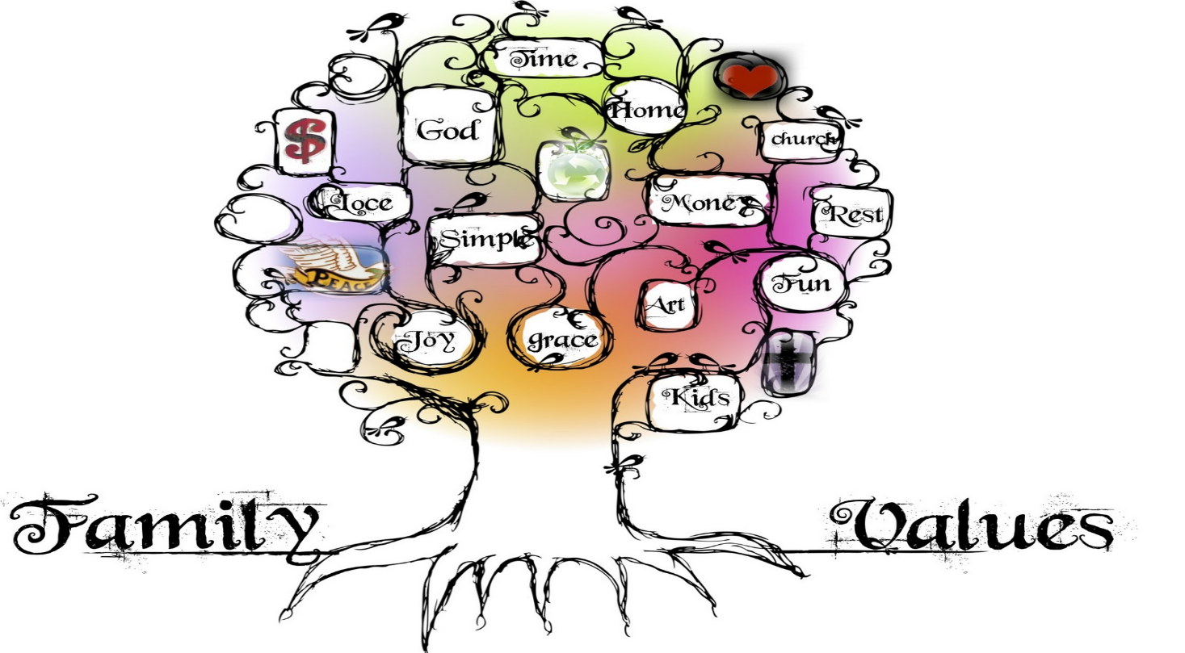
(Family Values, 2010)
Family dynamics play a big role in shaping a family as family members tend to rely on each other for physical, emotional and economic support. They are a primary source for relationship security or stress (Jabbari, School, Rouster, 2023). Jabbari et al propose that a ‘secure and supportive family will provide advice, love and care whereas a unsettled and stressful family are burdened with arguments’ (Jabbari, School, Rouster, 2023). Several elements can effect a family dynamic a few examples are mutuality, flexibility, stability. Jabbari et al, suggest that mutuality a shared feeling of warmth and cohesion, has been recognized as one of the most vital contributing factors (Jabbari, School, Rouster, 2023). Jabbari et al, argues that ‘family itself has transformed over the years’ (2024). Previous generations would stay close to each other and helped with rising the children, now it is more common for families to be spread across the country and family members be less involved in each others lives (Jabbari, School, Rouster, 2023).
Conflict within a family can occur in most families whether it be between biological parents, stepparents, grandparents and separated and divorced parents, this can cause impact on a child and have negative impact on their identity (Barnardo’s, 2024). Harmful conflict like shouting or aggressive arguments between parents or being disrespectful to each other is likely to be noticed by a child. As adults we should remain calm and respectful around children as they look up to us as role models and provide them with important skills for their future interaction with others (Barnardo’s, 2024). Conflict between parents can place a child at risk and cause damaging effects on their mental health and behaviour, it can put a child at risk of having problems at school, negative peer relationships can also go as far as causing a child to start smoking and cause substance misuse (GOV, 2021).
Experience we have as children plays a huge impact on how we grow and develop. The two factors that play a part in our metal wellbeing are the quality of our attachment relationships and our experience of adverse childhood experiences (NHS, 2024). Attachments are a pattern ‘of relationships a child has had with its parents or carer early on in its live’ (NHS, 2024). The way a parent responds to a child will have impact on the child’s future attachment style. If a child has had a positive relationship with the parent the child will as well have a positive feeling for itself and others, where as a child that is not cared for and not shown a positive attachment will find it hard to manage its feelings and behaviour and will lead them to have difficulties with mental wellbeing and relationships (NHS, 2024). The NHS (2024) states that adverse childhood experiences (ACEs) are ‘Highly stressful, and potentially traumatic events that occur during a child’s childhood or adolescence’ (NHS, 2024). Some examples of ACEs are sexual abuse, emotional abuse, living with someone who abused drugs or alcohol, exposure to domestic violence or physical abuse (NHS, 2024). According to National Institute for health and care excellence (NICE, 2015) “infants are born equipped with a range of innate behaviours to maximise their survival” (NICE, 2015 np). Attachment behaviour allows an infant to lure others towards them in a moment of need. A baby who has experienced a secure attachment relationship will develop a fairly firm expectation of feeling safe and protected which will allow a infant to explore their world more positively (NICE, 2015). When a child is feeling stressed, unwell or frightened their attachment system becomes alerted which causes the child to get upset and look for reassurance from a primary attachment for example a parent or carer, once this has been achieved the attachment system will deactivate (NICE, 2015).
To conclude socialization is learning of the customs and norms of a society, through socialization people learn to behave in a way that is acceptable to their culture. The socialization we receive as a child plays a vital role in who we become as an adult. The parents or carer of a child are the most important people that mould a child’s identity. A family’s influence can be responsible for a child’s education, values and norms. The families role as a agent of socialization is to teach a child how to socialize and interact with others, they must act appropriately in front of a child, teach them how to handle conflict engage in conversation with others and how to exists in society. Interaction with family can either make or break an individual’s self-confidence. A family that come together and communicate will help a child gain confidence. Conflict in a family can cause harm to a child’s identity and can have lasting effects such as mental health and behavioural problems. Attachments are patterns of relationships that a child has had with its parents or carer early on in its life, these can effect the identity of a child. From my research I have learned that family are the first and one of the most important agents of socialization. They can have a positive or negative effect on the way the form a child’s identity.

References
Anishalehal (2016) The importance of family, Does Family Shape our Identity? Available at https://familyrelationshipblog.wordpress.com/author/anishalehal/ (Accessed on 5/02/24)
Barnardo’s (2024) Families, Parental conflict. Available at https://families.barnardos.org.uk/families/parental-conflicts (Accessed on 7/02/24)
Dr Kumari, A (nd), Agencies of Socialization. Available at https://magadhmahilacollege.org/wp-content/uploads/2020/09/Agencies-of-Socialization.pdf (Accessed on 5/02/24)
Faizah, S, (2023) Centre of open science, The Role of the Family in Forming Children’s Social Identity Family Sociological Perspective, Available at https://osf.io/search?activeFilters=%5B%5D&q=THE%20ROLE%20OF%20THE%20FAMILY%20IN%20FORMING%20CHILDREN%27S%20SOCIAL%20IDENTITY%20FAMILY%20SOCIOLOGICAL%20PERSPECTIVE&sort=-relevance&view_only= (Accessed on 6/02/24)
Family Values Image (2010) Predby-Musings. Available at http://www.presbymusings.com/2010/08/family-values-week-3-simple-living.html (Accessed on 7/02/24)
GOV (2021) Reducing parental conflict: the impact on children, Explore the Impact of Parental Conflict on Children and Young People. Available at https://www.gov.uk/guidance/reducing-parental-conflict-the-impact-on-children (Accessed on 7/02/24)
Green, A, (2017) How to adult, How Parents Affect a Child’s Socialization. Available at https://howtoadult.com/personal-relationships-affect-child-development-6927.html (Accessed on 6/02/24)
Jabbari, B, School, C, Rouster, A (2023) StatPearls, Family Dynamics. Available at https://www.ncbi.nlm.nih.gov/books/NBK560487/ (Accessed on 7/02/24)
Karkashadze, N, Kuprashvili, T, Gugeshashvili, T (2023) International journal of innovative technologies in social science, The Role of the Family in the Socialization of the Individual, Contemporary Problems and Perspectives. 1(37) pp.5. Available at https://www.researchgate.net/publication/368644774_THE_ROLE_OF_THE_FAMILY_IN_THE_SOCIALIZATION_OF_THE_INDIVIDUAL_CONTEMPORARY_PROBLEMS_AND_PERSPECTIVES (Accessed on 5/02/24)
Martinez-Escdero, J, Villarejo, S, et al, (2020) National library of medicine, Parental Socialization and it’s Impact Across the Lifespan, 10(6), Available at https://www.ncbi.nlm.nih.gov/pmc/articles/PMC7349393/ (Accessed on 5/02/24)

National Institute for Health and Care Excellence (2015), Children’s Attachment: Attachment in Children and Young People Who are Adopted from Care, in Care or at High Risk of Going into Care. Vol 26. Available at https://www.ncbi.nlm.nih.gov/books/NBK356196/#:~:text=1.1.,when%20they%20are%20not%20distressed. (Accessed on 07/02/24)
NHS (2024) Adverse Childhood Experiences (ACEs) and Attachment. Available at https://mft.nhs.uk/rmch/services/camhs/young-people/adverse-childhood-experiences-aces-and-attachment/ (Accessed on 7/02/24)
Nickerson, C (2023) Simply Sociology, Agents of Socialization: Definition and Examples. Available at https://simplysociology.com/agents-of-socialization.html (Accessed on 5/02/24)
Nickerson, C (2023) Simply Sociology, The First Agents of Socialization: Family. Available at https://simplysociology.com/first-agent-of-socialization.html (Accessed on 5/02/24)
Scabini, E, Manzi, C (2011) Family Process and Identity, pp.569. Available at https://www.researchgate.net/publication/251383824_Family_Processes_and_Identity (Accessed on 6/02/24)
Writer, S (2023) Reference, How Does Family Shape Identity? Available at https://www.reference.com/world-view/family-shape-identity-6347878ecae1ba79 (Accessed on 6/02/24)
Zitman, B (2024) Family values, What are Family Values and Why are they Important? Available at https://www.beliefnet.com/love-family/family-values.aspx (Accessed om 6/02/24)

