Assessment 2
Marketing Fundamentals

Student Name: Florentina Joita
ID Student:2124448

Contents
Introduction 3
Internal and external analysis of a company 3
Main stages in marketing process 3
PESTLE analysis of KFC 4
SWOT analysis of KFC 6
Segmentation, targeting and positioning of KFC 9
Marketing mix of KFC 10
Recommendation 12
Conclusion 12
References 13

Introduction
The industrial sector has been producing consumer products for a long time (Piercy, 2017). The items were designed and selected to meet the needs of a wide range of customers. A variety of product positioning strategies were tested prior to release to the market. Market segmentation for the commodities was done after extensive market research and evaluation. This report shows the internal and external analysis of KFC along with the segmentation, targeting, position and Marketing mix of KFC.

Internal and external analysis of a company
Marketing
Value-added solutions for customers, clients/partners, and civilization as a whole are produced, conveyed, delivered, and exchanged via marketing. A basic concept of marketing is "fruitfully satiating desires." Through the creation, sale, and exchange of high-value goods and services, marketing allows individuals and organisations to get what they want out of the world(Piercy, 2017).

Main stages in marketing process
When that comes to media, there are a variety of ways to get in touch with your target audience. Nevertheless, which approach is the most effective? In this case, there is no "one size fits all" answer since each company is unique and requires a tailored marketing plan. Researching, thinking, coding, interacting, and capturing are just some of the activities you should do while establishing a promotional strategy for your company(Yeung, 2018).
Businesses must do market research before entering a new market. In order to proceed, they must first understand the market and customer preferences.
It's important for companies in the market to do market research in order to get insights about their customers, such as figuring out how a business fulfils their needs and using that information to develop sales strategies.
The only way to distinguish one's company from the others is to know what the competition is doing. Also essential is the ability to learn from the successes and failures of other companies and to know what to avoid. The more you know about your competition, the more you can save both time and money when trying to enter a new market.
Companies should be aware of the Micro-environment and the Macro-environment before they begin operations. Your company's microenvironment is the world inside. A company's competitors and customers are included in the macroenvironment. Understanding both might help you choose the appropriate market for your products or services.

PESTLE analysis of KFC
PESTLE Analysis is a look at how KFC plans to market itself in the future. An analysis of KFC's PESTLE (political, economic, social and technological) factors as well as the company's legal and environmental ramifications is carried out. In the PESTLE Analysis, the various external factors that affect a brand's business are identified(Blythe, 2014).
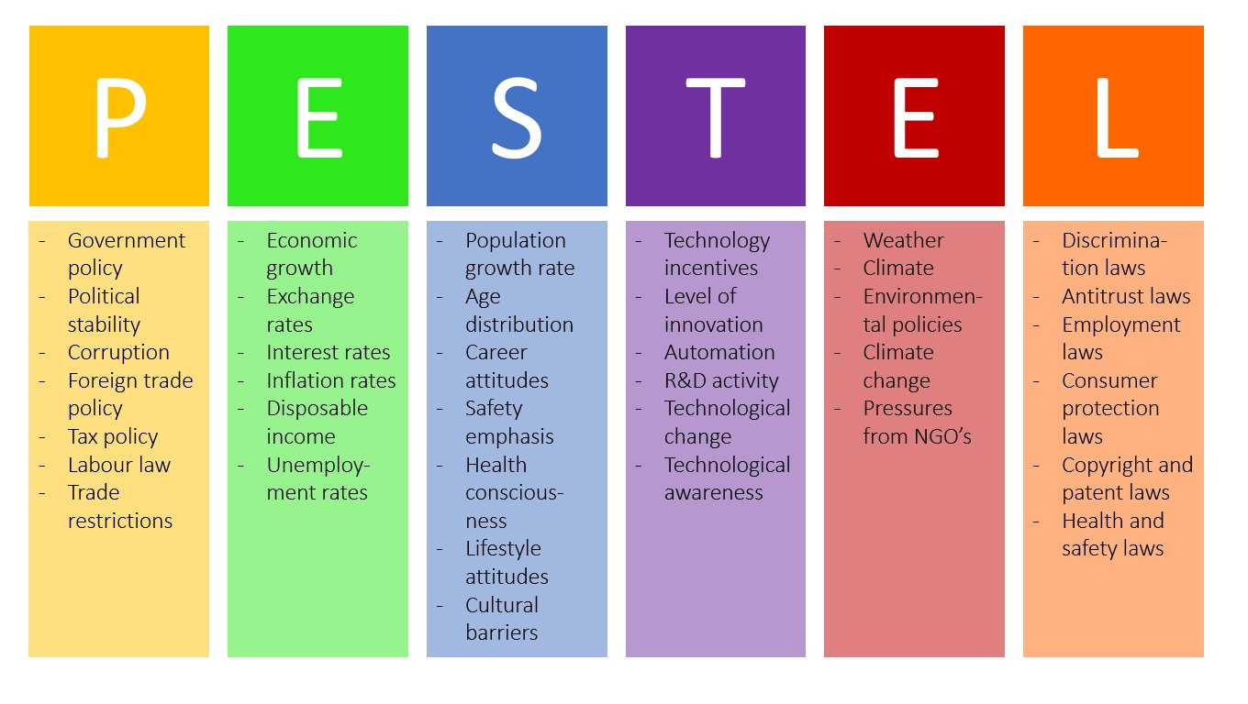
Figure 1 PESTLE (Blythe, 2014)
Political factors
When the term "fried chicken" became connected with the brand, KFC decided to alter its name to "KFC" in order to boost the company's image. KFC is one of the few fast food chains whose name incorporates the term "unhealthy," unlike Burger King and McDonald's, where its burgers is still nutritious. To avoid having to entirely revamp their name and image, KFC opted to exclude the phrase "fried." By erasing the word "fried chicken" from customers' minds, KFC hopes to "forget" the connection between unhealthy food and the fast food chain's fried chicken(Blythe, 2014).
Economic factors
In the wake of the covid-19 pandemic, KFC's annual revenue has fallen dramatically. For months, hotels and restaurants throughout the world have been put on lockdown. The government and the media were promoting a sense of social isolation. It was imperative that the virus be thoroughly vaccinated, or the economy would continue to decline. As of late, KFC has began marketing vegan options to the growing vegetarian population. The brand has undergone a tremendous evolution as a result of this. There should be more options for vegan food on the menu. Increased sales and revenue would be a benefit to the company's overall success in the market(Blythe, 2014).
Social factors
For a long time, low-wage restaurant employees' exploitation has been an issue. It is one of their worries that many of the animals served on the menu are injected with hormones, kept in confined cages throughout their lives, and made to acquire more fat than is naturally present in their bodies." Among PETA's many demands is that consumers refrain from doing business with companies that use animals in their goods (Blythe, 2014).
Technological factors
Technology advancements are quickly adopted by KFC(Blythe, 2014). Working conditions may be improved by using new technologies, according to management. KFC, for example, makes use of voice-activated tests while training new employees. Due to the fact that younger employees are more technologically adept and quick to pick up and use new workplace technologies, this is a problem (Blythe, 2014).
Legal factors
KFC is presently present in more than 120 countries across the world. For the company to stay in business, it must follow by the rules of each jurisdiction. Taxes must be paid, labour standards must be adhered to, and all restaurants must be in compliance with all regulations. A lawsuit or perhaps a closure are both possibilities if they break any of the laws (Blythe, 2014).
Environment-related factors
Customer concerns have shifted to include the environment and a company's long-term sustainability, as well. This is something KFC is aware of, and the company has taken a number of steps over the years to make the company more environmentally friendly and reduce carbon waste. One of KFC's environmentally friendly practises is the use of biodegradable paper and recyclable materials. More than 14000 metric tonnes of plastic packaging have been saved by the fast-food restaurant as a result of its efforts (Blythe, 2014).
KFC is a well-known fast-food chain even in the 21st century. It's important for the company to focus on enhancing customer satisfaction in the face of recent political gaffes and mistakes. Revenues in certain locations have already begun to rise as a result of the new policy. If the company is able to avoid thorny corporate ties and adhere to the norms and regulations of the fast-food industry, it is bound to succeed(Blythe, 2014).

SWOT analysis of KFC
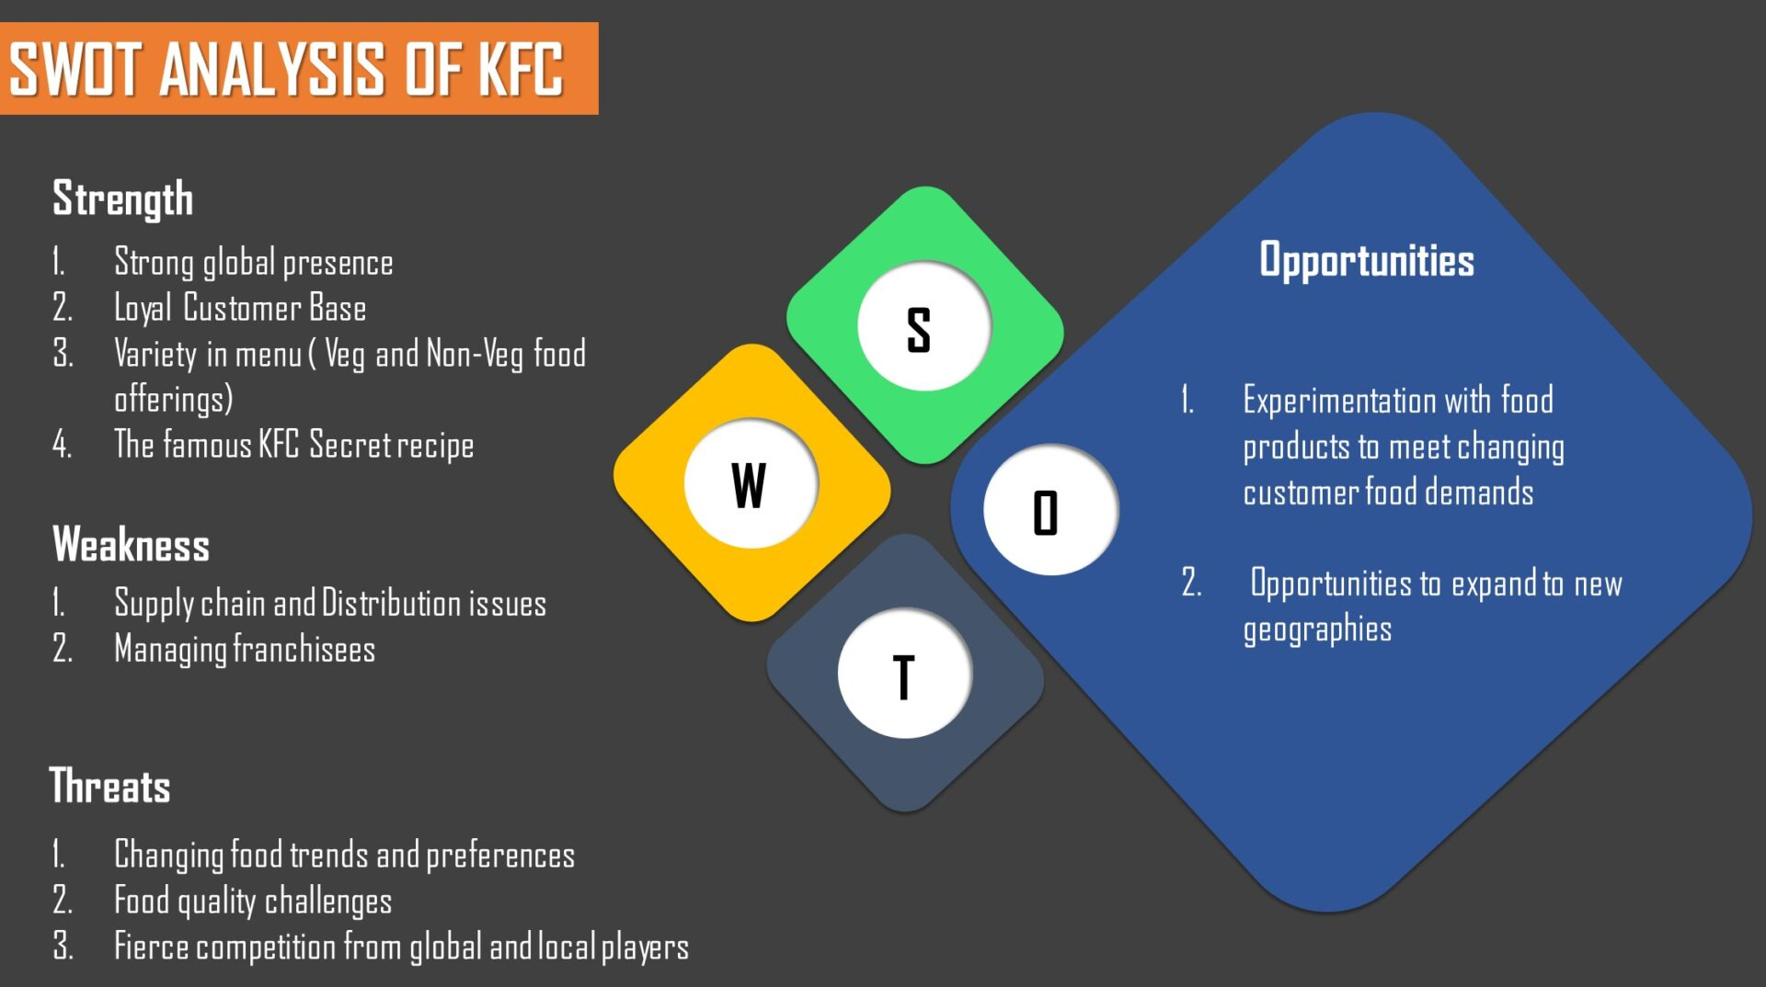
Figure 2 SWOT (Uddin, 2020)
Strengths
- For the year 2020, Forbes ranked KFC as the 96th most brand in the world, with an estimated brand worth of $8.3 billion. In the fast food, hotel, and restaurant sectors, KFC is a household name(Uddin, 2020).
- For many years, KFC has guarded its secret recipe for generating crispy, succulent, and tasty chicken. It contains 11 uncommon spices and plants that aren't widely known.
- KFC has a diverse menu that caters to both meat eaters and those who are vegetarians or vegans. So that clients can see what they're ordering, the company offers meals in clear cardboard containers. Menu items include meals for the whole family, traditional combinations, kids' meals, hot wings, classic dinners, and popcorn nuggets, to name just a few.
- Over 150 countries, KFC has established 22,621 hotel chains. In the near future, the company plans to establish other locations. It shows that the company has been constantly increasing in size since its founding.
Weaknesses
- For years, KFC has struggled with a lack of consistency in the supply of chicken at hotels. Some UK companies were compelled to shut down as a result of this. For any business that loses a franchise, the loss of revenue is permanent. In order to manage supply chain, logistics, and marketing, a significant amount of money is necessary. Any time a franchisee fails to provide the items as promised, the business is doomed (Uddin, 2020).
- In the event of a menu disagreement or other management problems, if franchisees fail to uphold quality standards and adhere to operating protocols. KFC, the parent firm, is to blame for all of this. Consequently, the company suffers a loss of income.
Opportunities
- The health-conscious customer base of KFC is now able to choose from vegan menu items. That's a smart move on the firm's behalf. If it wants to keep up with its competitors, it should expand its vegetarian menu to include vegan options as well. Non-meat eaters would find it appealing(Uddin, 2020).
- KFC's vulnerability might become a strength if consumer demand for healthier menu items increases.
- KFC may take full advantage of this opportunity and expand its customer base.
- With the addition of pork, beef, or merely vegetarian cuisine to its menu, KFC may reach a wider audience and attract more consumers.
Threats
- All KFC restaurants and hotels have been forced to close as a result of the covid-19 outbreak. There is still a sense of social isolation. People are being advised by the government and the media to stay away from public places. As a result of all these circumstances, the brand's business is in risk(Uddin, 2020).
- Expenses such as raw material and labour costs have risen due to waste management and resource shortages. Retail prices rise as a result of higher operational expenses, which impacts the whole selling of the firm. The expense of following the law and rules has also increased.
- Franchising is a profitable business concept as long as everything goes according to plan. The parent brand loses when franchisees make poor business choices. Verbal marketing travels even faster in the age of social media.
- Market growth rates of competitors like McDonald's and Burger King pose a big threat to KFC. Several new and established companies are vying for market share with their own unique menu items. As a whole, the competitive environment has harmed KFC's profitability.
After doing a comprehensive swot analysis, we determined that KFC is also one of the world's most popular brands. As the pandemic of covid-19 continues to spread and food prices continue to rise, these are all serious threats to the brand. In order to stop them, KFC should capitalization its brand name and trade knowledge in order to prevent them(Uddin, 2020).

Segmentation, targeting and positioning of KFC
The partitioning of the world into continents and countries
In other words, it's the division of a market geographically into smaller and smaller parts. In addition to operating in the United States, KFC has other outlets across the world. KFC's products are tailored to meet the needs of its customers in the regions where they operate, and this can be quantified. Geographic segregation is common in several countries, such as Australia. Over 590 locations may be found throughout Australia under this brand name (Weder di Mauro, 2001).
Demographic segmentation.
According to a recent study, demographic segmentation is the practise of categorising a market based on factors such as income and demographics. KFC divides the market into the following segments based on demographics:
- Age range of 6 to 65.
- Men and women are also welcome.
- Earnings of at least $150
- A job title is not known.
Psychographic classification
A market may be segmented based on lifestyle, personality, or social class characteristics using psychographic segmentation (Fill, 2014). Based on psychographic features, KFC has divided its customers into three groups:
- There are three main social class divisions: middle class, high class, and lower class.
- Living a Life of Extravagance and Extravagance
- Individuals who are gregarious, authoritarian, and ambitious.
Positioning in the market
Product or brand comparisons with those of its competitors the ultimate goal of this approach is to maintain a distinct, distinctive, and valuable position in the minds of consumers. KFC menu items were once only available to the country's wealthiest citizens. Following a succession of price cuts and promotions, people are increasingly purchasing in big numbers. So, KFC has lowered its size. Successfully using the same trademarks and placing a product, KFC has achieved this goal (Baack, 2013).
Targeting
People who like eating fried chicken make up the majority of KFC's target audience. Between the ages of six and 45, the majority of KFC customers are regulars. KFC's meals may be used as a venue for family gatherings or social gatherings (Baack, 2013).

Marketing mix of KFC
There are a variety of marketing strategies available, including new product development, pricing analysis, and public relations strategy. KFC's market success is aided by these business approaches based on the KFC marketing mix (Baack, 2013).
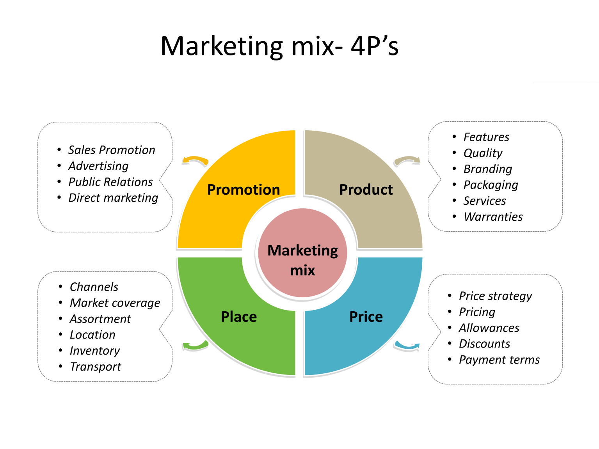
Figure 3 <arketing mix (Baack, 2013)
Product
KFC is the most well fast food restaurant renowned for its hamburgers and other casual food products (Kotler, 2017). For years, KFC has been recognised for its fried chicken and as a rival to the burger fast food market. Pressure-fried chicken nuggets prepared with an 11-ingredient secret mix are the original product. Extra Crispy Chicken, specialty sides, and cornbread muffins to round out selection at Kentucky Fried Chicken. In 1990, KFC extended its menu to include foods like Chicken Fillet Burgers & Wraps, but also salads, baked fries, desserts, and drinks made from chicken. The product options of KFC have been adjusted to match local demands and customer preferences. KFC's brand development strategy involves approximately 300 distinct menus in various areas of the globe. Local tastes have encouraged the corporation to manufacture new culinary delicacies in the country of operation. KFC and McCormic Group have a long-standing relationship together about components including sauces, broths, and spices. KFC's agreement with PepsiCo implies that the great majority of its drinks are Pepsi, but there are outliers in select regions.
Promotion
KFC has been using the tagline "Finger Lickin' Good" for a long time. However, the sentence has been temporarily removed in order to represent the market scenario in the year of 2020(Baack, 2013). Similarly, one of its advertising was banned for using a pun that sounds uncannily like a swear word in its headlines. Apart from traditional media, KFC is quite active on social media as part of its marketing efforts. Their official Facebook page, for instance, has 56 million fans. There are just 1.6 million followers on Instagram for it. Similarly, it has just 51 thousand subscribers on YouTube in the United Kingdom and Ireland.
Price
KFC's menu is competitively priced, and they've come up with creative ways to compete in a variety of sectors(Baack, 2013). In metropolitan and semi-urban regions, families of young people who are upper middle class or middle class are KFC's primary target market. A cheaper price point initially enticed consumers, but as demand grew and demand fell, so did the price. Pricing is also comparable with the rest of the field. The cost of a KFC meal varies depending on the location. It is possible to purchase items alone or as part of a bundle or combo. For $5, you can have a burger; for $15, you can get a combo meal that includes a beverage. Bundle pricing is less than the total cost of all the products together. In price-sensitive regions like Asia and Africa, it is tremendously lucrative. Every year, the company sells more than $23 billion worth of merchandise globally.
Place
This strategy focuses on finding places where the company's products may be sold to potential customers(Housden, 2010). When it comes to designing the grounds of its restaurants around the country, the marketing team at KFC sticks to the tried-and-true methods. As a result of KFC's present size and dominance, they've developed techniques for attracting and retaining a devoted following. Counting KFC and its subsidiaries, it has more than 15,000 locations in more than 100 countries. There are several KFC locations that are close to educational institutions, such as schools, universities, companies, and more. As a result, the country's younger population consumes much more fast food than its older citizens(Jobber, 2016).

Recommendation
Increase market share with the KFC Grilled Chicken. Because of health concerns, many individuals, including myself, avoid eating KFC. In order to appeal to consumers of all economic levels, KFC should cut its prices. The establishment of a free or low-cost lunch targeted at the working class might help achieve this goal. In order to attract more of these customers, KFC has to extend its vegetarian menu. As a company's management, KFC should focus on product quality. Maintaining a constant eye on the product's quality is particularly vital late at night. In order to get a larger portion of the fast-growing markets, KFC should provide additional outlets, such as those found in shopping malls, colleges, and theme parks.

Conclusion
Employees at KFC enjoy a good work environment because to KFC's welcoming corporate culture, however there are certain management issues that must be addressed. KFC's food and service are excellent. KFC has a constant stream of new chicken and food products, which contributes in the company's growth and profitability. This generation is worried about their health and hypertension, therefore if KFC offers or adds fresh products such as fruits and vegetables to their menu, it may increase sales since even vegetarians may join KFC and enjoy the gorgeous ambiance. KFC is doing a fantastic job in all four of these areas.

References
Kotler P, Armstrong G, Harris, L, Piercy, N., (2017), Principles of Marketing, 7th Edition, Pearson
Anand, D. and Yeung, D., 2018. Employee development and its effect on employee performance at KFC Restaurant Brands.
Schiffer, M. and Weder di Mauro, B., 2001. Firm size and the business environment (No. BOOK). The World Bank; International Finance Corporation.
Blythe, J., (2014), Principles and Practice of Marketing, 3rd edition, Sage
Uddin, S.M., 2020. Operational strategies and management of KFC: An enquiry. EPRA International Journal of Research and Development (IJRD), 5(4), pp.172-179.
Baines, P., Fill C., Page, K., (2014) Marketing, Oxford, 2nd edition
Clow, K., Baack, D., (2013), Integrated Advertising, Promotion and Marketing Communications 6e, Pearson
Housden, M., (2010), Marketing Information and Research, Butterworth Heinemann
Jobber, D., (2016) Principles and Practice of Marketing, McGraw Hill 8th edition

