Link to presentation : https://uowtsd.sharepoint.com/teams/presentation720_GRP/Shared%20Documents/General/Recordings/New%20channel%20meeting-20231030_215959-Meeting%20Recording.mp4?web=1
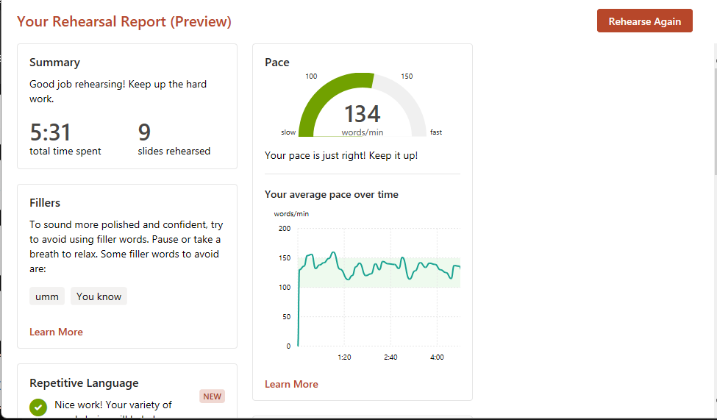
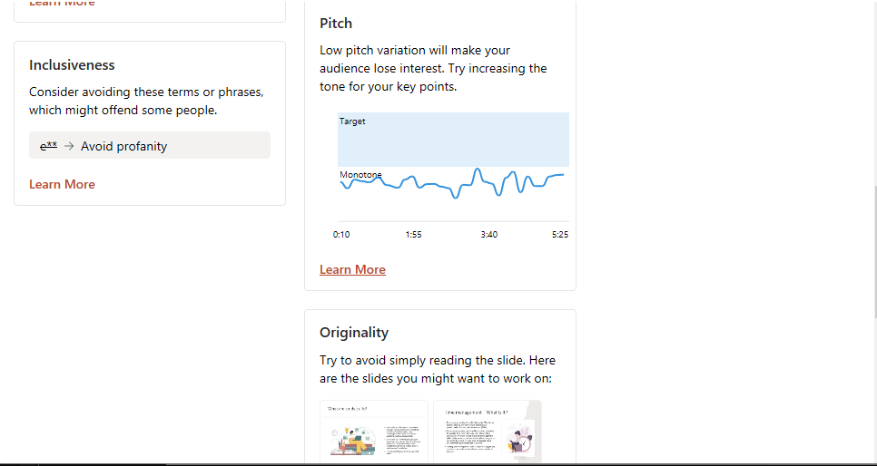
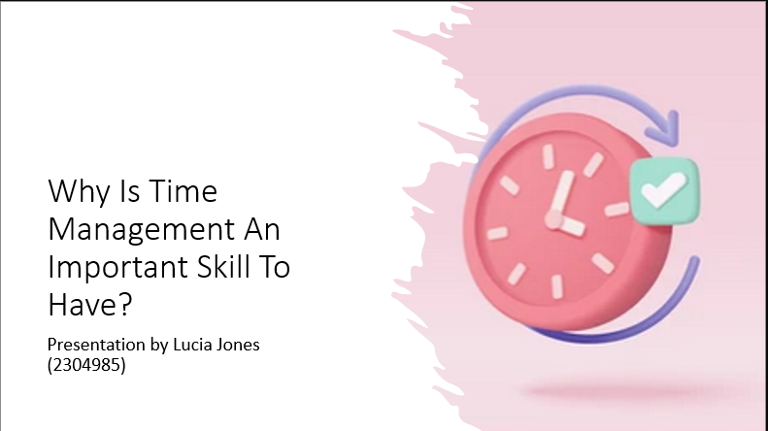
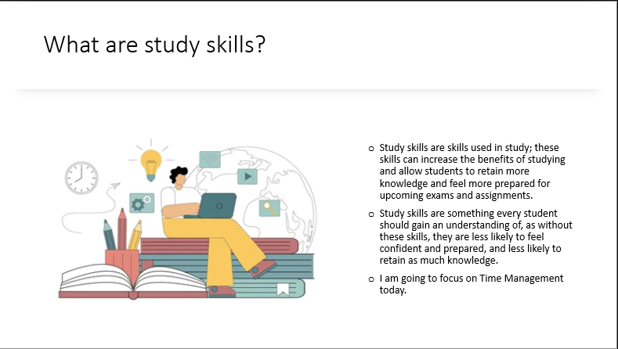
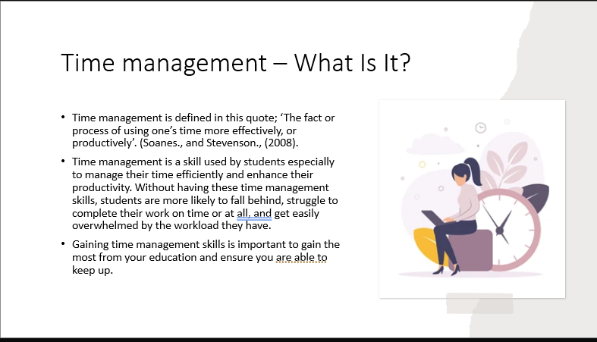
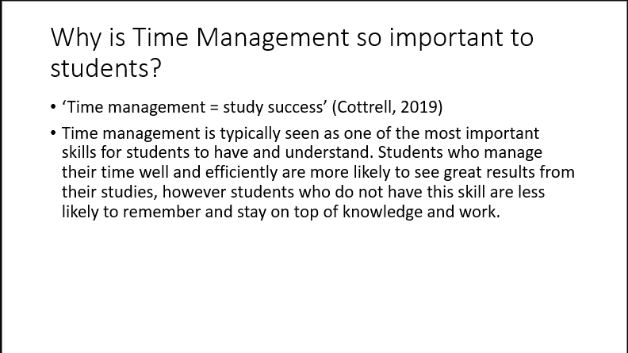
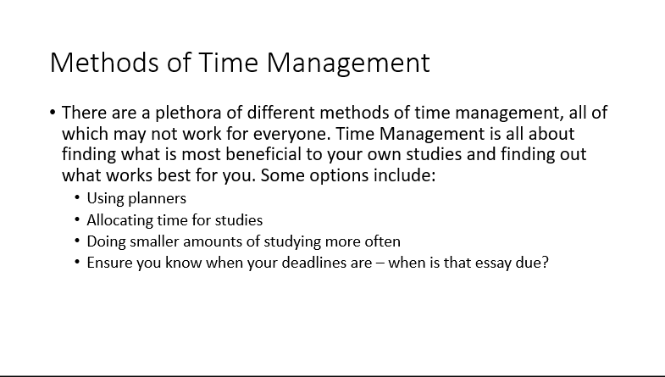
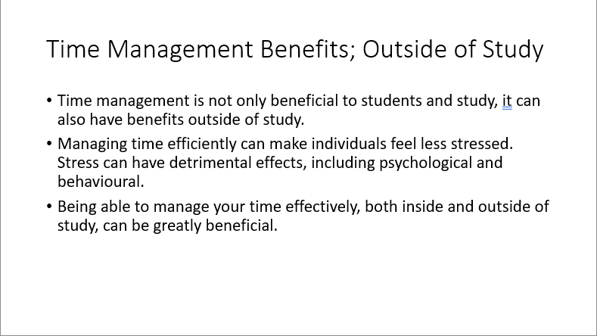
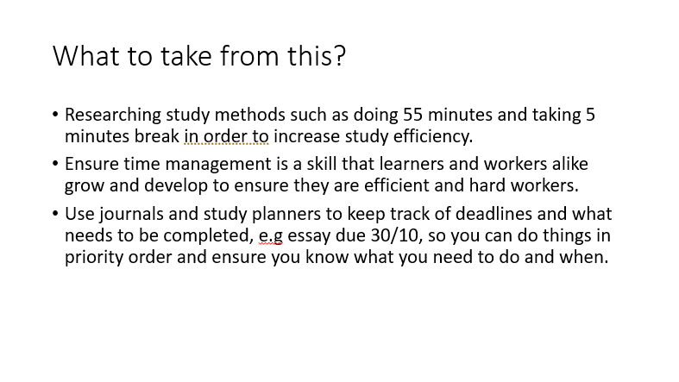
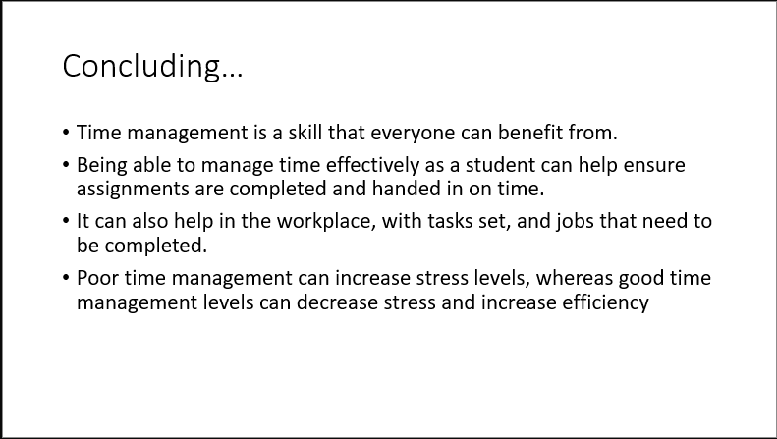
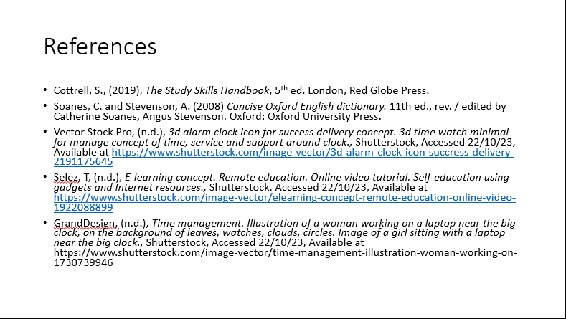
Reflective Essay
Before writing this essay, I completed a presentation about study skills, specifically time management.
Reflection is looking back at actions we take and planning to improve. Reflective processes allow us to analyze our past efforts and create plans on how to improve mistakes we made, for example, in a presentation, or in a conversation throughout the day. Reflection can be done on the spot, or after the fact. According to Conway (1994), reflection can be defined as “A process of looking back on what has been done and pondering it and learning lessons from what did or did not work… The act of deliberation, when the practitioner consciously stops and thinks what shall I do now?”
Reflection is a process everyone takes part in throughout their lives. One theorist of reflection is John Dewey. According to Dewey, 1944, there are 6 stages to reflection.
- An experience
- Spontaneous interpretation of the experience
- Naming the problem(s) or question(s) that arises out of the experience
- Generating possible explanations for the problem(s) or question(s) posed
- Ramifying the explanations in to full-blown hypotheses
- Experimenting or testing the selected hypotheses.
Out of these 6, I believe 1-5 are relevant to my presentation, as I have not experimented or tested my improvements as of now.
First is the experience. The experience is, in this case, my presentation. Secondly, we have the spontaneous interpretation of the experience. This would be how I felt about my presenting during my presentation. Third we have naming the problems and questions that arise from the experience, which would be me identifying issues I found with my presentation alongside presenter coach. Next we have generating possible explanations for the problems / questions, which would be, for example, I found this hard because of this. Finally, ramifying the explanations in full blown hypotheses, which is, for example, If I do this, I should reduce this problem, and therefore improve my presentations in the future.
I will now go reflect on the issues I faced following this model of reflection.
Firstly, the experience, which was structuring my presentation. Secondly, my immediate thoughts. Having never done an essay of this sort before, I found it difficult to recognize what points I should include and where. I felt stressed and worried I would be unable to provide all of the relevant information in an efficient and concise manner within the 5 minutes and 30 seconds allowance. Following point 3, after the fact, I believe that I struggled most with not having a set list of points to follow, and found it hard as this is my first presentation. I felt worried that my structure wasn’t correct or I was missing points. Referring back to point 4, I believe that I found this hard as I have never done this sort of presentation before, which made me feel as though I was in the deep end with structure and made me feel as though I was doing it wrong. Lastly, point 5. In my opinion, I need to allow myself to let go of the need for a set structure, think through it logically, and include what I feel is relevant information. Doing this will allow me to reduce my stress, and push myself to gain a deeper understanding of how to structure a presentation.
Secondly, according to presenter coach, I need to vary my pitch. At the time (2) I did not see any issue with my pitch, however looking at my feedback (3) I see that presenter coach says I am speaking too monotone. (4) In my opinion, I think this is due to me speaking in a monotone voice in everyday life, especially when I am focused on something else, in this case, presenting. I find it difficult to focus on varying my pitch. Lastly (5), I believe that this is something I need to work on by practicing varying my pitch, so when I present I come across more interesting and my audience is able to engage more in what I am sharing.
I believe throughout my presentation, my biggest issue was my use of filler words. Even during my presentation (2), I felt as though I was stuttering and stumbling over my words, trying to find what I wanted to say and coming out with “umm” or “like”. I believe that this was my biggest downfall throughout my presentation. It makes me come across as less confident, or as though I do not know what I am talking about, and can be less engaging for the audience (3). I believe this is due to me struggling to find the appropriate words and explanations for what I want to say (4), amplified by nerves due to presenting. To fix this (5), I believe I need to prepare support such as cue cards or a script, so I have a summary of what I want to say and I am able to say it in a concise and engaging manner.
Following on from my last point, I believe I also struggled with originality. During my presentation, I found myself reading off my slides instead of summarizing them at points (2). This is due to me being nervous and struggling to find the appropriate words. I noticed during my presentation, if I wasn’t sure what I wanted to say, I would just read from my slides until I regained my momentum and continued with the flow of the presentation (3). In hindsight, I believe that this is due to nerves, and losing what I wanted to say (4). To correct this (5), I believe that the best course of action would be to, once again, have cue cards to help me keep the flow and stay on track.
Next, I would like to discuss the point made of using profanity. This is something brought up by presenter coach, which I know is not true. I did not use profanity or foul language at any point during my presentation, however it says I did. This leads me to question the validity of this programme, as I would be aware if I used any non-inclusive or foul language and I can confirm I did not.
In conclusion, I believe I have a multitude of points I need to reflect on, and I will work towards improving my future presentations following presenter coach’s guidance and corrections. In the future I will take into account what went wrong for me at this stage and aim to better myself and my presenting skills to enhance my ability to complete presentations.
References
Conway, 1944. Definitions of Reflection. Available at: https://www.nottingham.ac.uk/nmp/sonet/rlos/placs/critical_reflection/origins/reflection_definitions.html Accessed (29/10/23)
Rodgers, C. (n.d.) Defining Reflection: Another Look at John Dewey and Reflective Thinking. Available at : https://www.canr.msu.edu/bsp/uploads/files/Reading_Resources/Defining_Reflection.pdf Accessed (29/10/2023)

